Software Testing and Debugging
Debugging Report: Shopping Cart Module
Week 3 Task
Submitted by: Pratham
Source code: https://github.com/pratham514/week3-testing-debugging

1. Requirements Checklist
This table lists every requirement from the task brief and shows where it is covered in this report and in the repository.
Requirement from the brief | Where it is covered | Status
Select or create small software with deliberate bugs (syntax, logic) | Section 3 and Section 7; buggy/cart_syntax_error.py and buggy/cart_buggy.py (15 bugs) | Done
Unit tests that detect at least 80% of potential issues | Section 6 and Section 10; tests/test_cart.py: 39 tests detect 15 of 15 bugs (100%) | Done
Use debugging tools to step through the code | Section 8; three real pdb sessions (bugs B1, B2, B10) with transcripts | Done
Document the errors found | Section 7: bug register with all 15 bugs | Done
Document the strategies used to fix them | Section 8 and Section 7 (fix column) | Done
Refactor the code after debugging | Section 9; src/cart.py with before/after metrics | Done
Lessons learned | Section 11 | Done
Deliverable: zip with source code, test cases and debugging report | GitHub repository and zip file; report also in docs/ | Done
Evaluation: test effectiveness and coverage | Section 6 and Section 10: 39 tests, 100% line coverage, 100% bug detection | Done
Evaluation: code quality improvement | Section 9: docstrings 0% to 95%, type hints 0% to 100%, magic numbers 5 to 1 | Done

2. Objective
The goal of this task is to gain hands-on experience of testing strategies and debugging techniques. I wrote a small shopping-cart module that contains deliberate bugs, wrote unit tests that expose them, stepped through the code with the Python debugger (pdb) to find root causes, fixed each bug, and then refactored the code to improve maintainability and performance.
Everything in this report was produced by running the code. All numbers and terminal outputs shown are real results saved in the docs/results folder of the repository.

3. Software Under Test
The module is a shopping cart (ShoppingCart class). It was chosen because it has enough rules to hide many kinds of bugs (validation, boundaries, rounding, state) while staying small enough to understand fully.

3.1 Specification (the rules the code must follow)
Area | Rule
Adding items | Price must be greater than 0. Quantity must be a positive whole number. Adding an item that is already in the cart increases its quantity.
Removing items | Removing without a quantity deletes the item. Removing a quantity reduces it; removing all units deletes the item; removing more than the cart holds is an error; removing a missing item is an error.
Money | Subtotal is the sum of price times quantity. All money values are rounded to 2 decimals.
Coupons | SAVE10 gives 10% off. SAVE20 gives 20% off and needs a subtotal of at least 100.00. Codes are case-insensitive and ignore surrounding spaces. Unknown codes are an error. Only one coupon is active at a time. If the subtotal later drops below the minimum, the discount stops applying.
Tax | Default rate 8%, charged on the price after the discount.
Statistics | Average item price is per unit (0.0 for an empty cart). Most expensive item is the one with the highest unit price (None if empty).

3.2 Worked example of correct behaviour
A cart holds 2 books at 50.00 (subtotal 100.00). Coupon SAVE10 gives a discount of 10.00. Tax is 8% of 90.00 = 7.20. The total is 97.20. The original buggy code returned a tax of 8.00 and a total of 98.00 for this cart (bug B10, Section 8.3).

4. System Architecture Diagram
Figure 1 shows how the parts of the project fit together. The same test file runs against either the original buggy module or the fixed module, selected by the environment variable CART_MODULE. The tools folder contains scripts that measure the quality of the tests and the code.
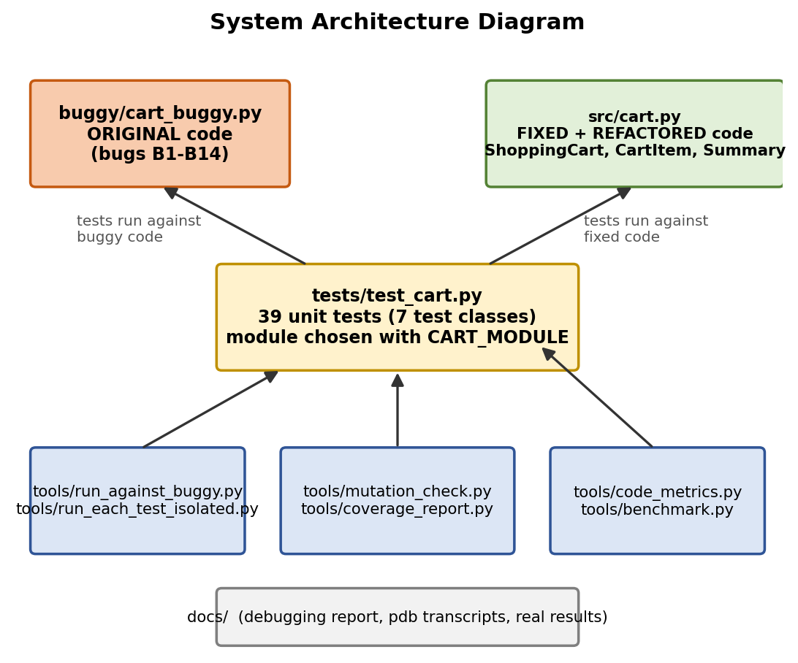
Figure 1: System Architecture Diagram
Text version of Figure 1 (for readers who cannot view images):
tests/test_cart.py (39 unit tests)
|-- CART_MODULE=cart_buggy --> buggy/cart_buggy.py ORIGINAL code, bugs B1-B14
|-- CART_MODULE=cart (default) --> src/cart.py FIXED + REFACTORED code
|-- ShoppingCart (cart logic)
|-- CartItem (one line: price, quantity)
|-- Summary (subtotal, discount, tax, total)

tools/ (measure quality) docs/ (report and evidence)
run_against_buggy.py, run_each_test_isolated.py Debugging_Report.docx
mutation_check.py, coverage_report.py debug_sessions/ (pdb transcripts)
code_metrics.py, benchmark.py results/ (real tool output)
repro_b1.py, repro_b2.py, repro_b10.py diagrams/

File | Purpose
buggy/cart_syntax_error.py | First draft containing the syntax error (bug B0).
buggy/cart_buggy.py | Original code with logic bugs B1 to B14. Each bug is marked with a comment.
src/cart.py | Fixed and refactored code.
tests/test_cart.py | 39 unit tests in 7 test classes.
tools/*.py | Scripts for running the tests on buggy code, mutation check, coverage, metrics, benchmark and pdb reproductions.
docs/ | This report, pdb transcripts, real tool output and diagrams.

5. Testing and Debugging Workflow Diagram
Figure 2 shows the process followed in this exercise. The loop in the middle was repeated for each bug: reproduce, debug, fix, re-run the tests.
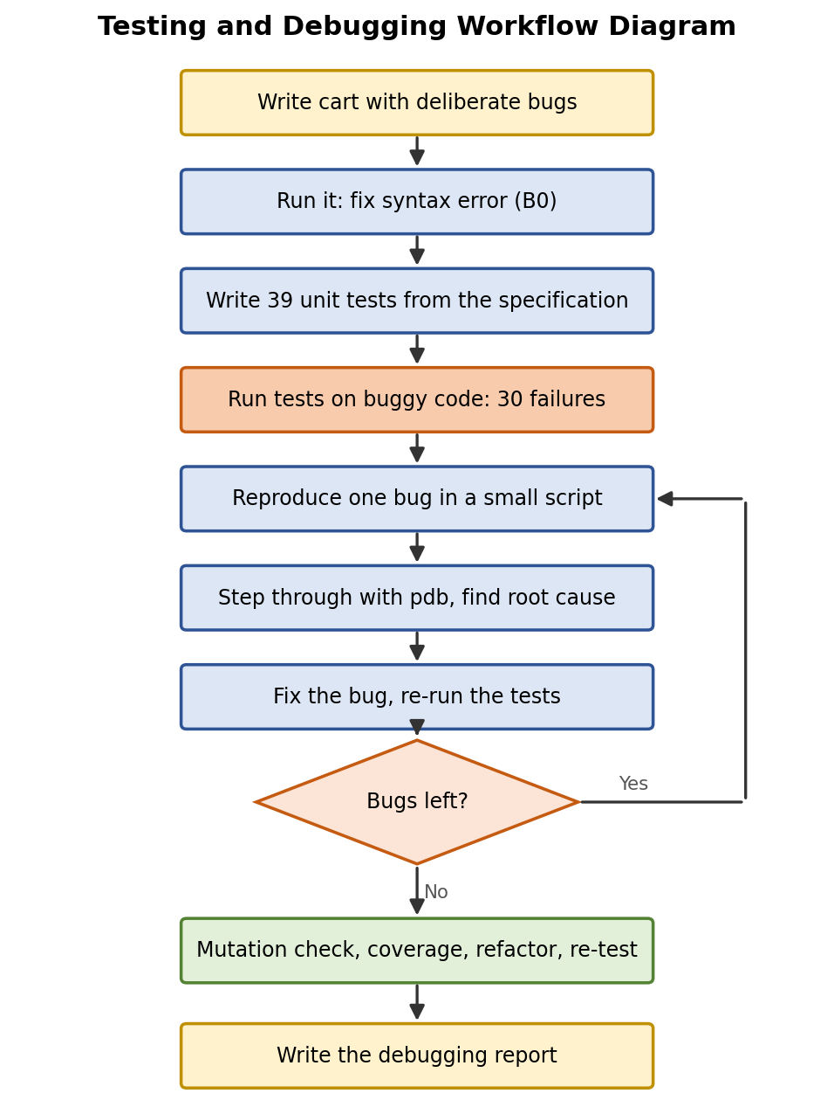
Figure 2: Testing and Debugging Workflow Diagram
Text version of Figure 2:
- Write the cart with deliberate bugs.
- Run it and fix the syntax error (B0), so the file can be imported.
- Write 39 unit tests from the specification, not from the code.
- Run the tests on the buggy code. Result: 30 failures.
- For each failing area: reproduce the bug in a small script.
- Step through the code with pdb and find the root cause.
- Fix the bug and re-run the tests. If bugs remain, go back to step 5.
- When all tests pass: run the mutation check and coverage, then refactor and re-test.
- Write the debugging report.

6. Testing Strategy

6.1 Principles
- Tests were written from the specification (Section 3.1), before any bug was fixed, so they check what the code should do, not what it happens to do.
- Boundary value testing: price 0, SAVE20 at exactly 100.00 and at 99.99, removing exactly all units, removing more than available.
- Equivalence partitioning and negative testing: valid and invalid prices, quantities (0, negative, 1.5), coupon codes (valid, lower-case, with spaces, unknown).
- State-based testing: two carts must not share data, and a coupon must stop applying when the subtotal falls below its minimum.
- Hand-calculated expected values: every money value in a test was worked out on paper first (for example 97.20 in Section 3.2).
- Independent tests: every test builds its own cart in setUp, so one test cannot affect another.

6.2 Test suite overview
Test class | Tests | What it covers | Bugs targeted
AddItemTests | 8 | Adding items, merging quantities, invalid price and quantity | B2, B3, B4
RemoveItemTests | 6 | Removing whole item, part, exact amount, too many, missing item | B5
MoneyTests | 7 | Subtotal, rounding, tax, tax after discount, custom tax rate | B6, B10
CouponTests | 10 | SAVE10, SAVE20, boundaries, unknown code, case, spaces, replacing, discount after removal | B7, B8, B9, B14
StatisticsTests | 5 | Average per unit, empty cart, most expensive item, total quantity | B11, B12, B13
ReceiptTests | 1 | Receipt lines and totals | B10 (indirect)
IsolationTests | 2 | Carts must not share items or coupons | B1
Total | 39 |  | B0 is detected at import

6.3 How test effectiveness was measured
The task requires tests that detect at least 80% of the potential issues. Two measurements were used:
- Bug detection rate (mutation check): tools/mutation_check.py re-introduces each of the 15 bugs, one at a time, into a copy of the fixed code and runs the test suite. A bug counts as detected if at least one test fails. Result: 15 of 15 detected (100%). Full output is in Section 10.
- Line coverage: tools/coverage_report.py measures which lines of src/cart.py run during the tests. Result: 107 of 107 executable lines covered (100%).

7. Bug Register
All 15 bugs, how each one shows up, why it happens, how it was fixed and which test catches it.
ID | Type | Symptom (what you see) | Root cause | Fix / detected by
B0 | Syntax | SyntaxError: expected ':' when the file is imported | Missing colon after def add_item(...) | Add the colon. Found at the first run; the whole test file cannot import.
B1 | State | A brand-new cart already contains items from earlier carts | items={} default argument is created once and shared by every cart | Create the dict inside __init__. IsolationTests (27 tests fail with the bug present).
B2 | Logic | Adding "Pen" 2 then 3 gives quantity 3, not 5 | Assignment replaces the quantity instead of adding to it | item.quantity += quantity. test_adding_existing_item_increases_quantity.
B3 | Boundary | A price of 0 is accepted | Check uses < 0 instead of <= 0 | Use <= 0. test_price_zero_rejected.
B4 | Validation | Quantity 0, -3 and 1.5 are accepted | Quantity is never validated | Add _check_quantity. 4 tests.
B5 | Logic | Removing all units leaves the item with quantity 0; removing more than owned silently deletes it | No upper-limit check; deletes only when result is below 0 | Raise ValueError if too many; delete when equal. 2 tests.
B6 | Numeric | 0.1 + 0.2 gives 0.30000000000000004 | Floating-point result never rounded | round(..., 2). test_subtotal_is_rounded.
B7 | Boundary | SAVE20 rejected at exactly 100.00 | > 100 used instead of >= 100 | Compare with < minimum. test_save20_accepted_at_exactly_100.
B8 | Error handling | Unknown coupon code does nothing, with no error | No else branch | Raise ValueError. test_unknown_coupon_raises.
B9 | Input | "save10" is ignored | Code compared as typed | strip().upper(). test_coupon_code_is_case_insensitive.
B10 | Logic | Tax 8.00 instead of 7.20 for the example in Section 3.2 | Tax computed on the subtotal before the discount | Tax on subtotal minus discount. test_tax_is_charged_after_discount.
B11 | Logic | Average of 6.00 (3 pens) and 14.00 (1 book) shows 10.0, expected 5.0 | Divides by number of distinct items, not units | Divide by total units. test_average_price_is_per_unit.
B12 | Runtime | ZeroDivisionError for an empty cart | No guard before dividing | Return 0.0 if no units. test_average_price_of_empty_cart_is_zero.
B13 | Logic | Cheap item with large quantity reported as most expensive | Compared index [1] (quantity) instead of [0] (price) | Use named attribute .price. test_most_expensive_item_uses_price.
B14 | State | SAVE20 keeps discounting after items are removed and subtotal < 100 | Minimum checked only when the coupon is applied | Re-check the minimum when calculating. test_save20_stops_applying_if_subtotal_drops_below_100.

8. Debugging Sessions
Each session follows the same method: (1) observe the failing behaviour, (2) reproduce it in a tiny script, (3) form a hypothesis, (4) set a breakpoint with pdb and inspect the variables, (5) confirm the root cause, (6) fix and re-run the tests. The transcripts below are real pdb output, saved in docs/debug_sessions.

8.1 Bug B0: syntax error (found by running the file)
Symptom: Python refuses to run the file. The error message points at the exact line.
File "buggy/cart_syntax_error.py", line 14
def add_item(self, name, price, quantity=1) # <-- B0: missing colon
^^^^^^^^^^^^^^^^^^^^^^^^
SyntaxError: expected ':'

Cause: a colon is missing at the end of the function definition. Fix: add the colon. Tool used: the Python error message (no debugger needed for syntax errors).
Before: def add_item(self, name, price, quantity=1)
After: def add_item(self, name, price, quantity=1):

8.2 Bug B2: adding an existing item overwrites its quantity (pdb)
Symptom: adding "Pen" with quantity 2 and then quantity 3 gives 3, but the expected result is 5 (small script tools/repro_b2.py).
Hypothesis: the second call to add_item does not add to the existing quantity. Breakpoint: line 16 of cart_buggy.py (the if name in self.items check). Commands used: break, continue, p (print), next.
> tools/repro_b2.py(1)<module>()
-> """Reproduce bug B2: adding an existing item should add to its quantity."""
(Pdb) Breakpoint 1 at buggy/cart_buggy.py:16
(Pdb) > buggy/cart_buggy.py(16)add_item()
-> if name in self.items:
(Pdb) ('Pen', 2.5, 2)
(Pdb) {}
(Pdb) > buggy/cart_buggy.py(16)add_item()
-> if name in self.items:
(Pdb) ('Pen', 2.5, 3)
(Pdb) {'Pen': [2.5, 2]}
(Pdb) True
(Pdb) > buggy/cart_buggy.py(17)add_item()
-> self.items[name] = [price, quantity] # B2: overwrites instead of adding
(Pdb) --Return--
> buggy/cart_buggy.py(17)add_item()->None
-> self.items[name] = [price, quantity] # B2: overwrites instead of adding
(Pdb) {'Pen': [2.5, 3]}
(Pdb)

Reading the transcript: on the second call the item is already in the cart ("name in self.items" is True, with quantity 2). After executing two more lines, the item holds [2.5, 3]. The old quantity of 2 was thrown away, because the line self.items[name] = [price, quantity] replaces the whole entry. Root cause confirmed.
Before: self.items[name] = [price, quantity] # runs for existing items too
After: item.quantity += quantity # add to the existing quantity

8.3 Bug B10: tax charged before the discount (pdb)
Symptom: for 2 books at 50.00 with coupon SAVE10, the tax is 8.0 and the total 98.0. By hand the tax should be 7.2 and the total 97.2 (tools/repro_b10.py).
Strategy: break inside tax() and evaluate the candidate formulas directly in the debugger. This tests the hypothesis without editing any code.
> tools/repro_b10.py(1)<module>()
-> """Reproduce bug B10: tax must be charged on the price AFTER the discount."""
(Pdb) Breakpoint 1 at buggy/cart_buggy.py:69
(Pdb) > buggy/cart_buggy.py(69)tax()
-> return self.subtotal() * self.tax_rate # B10: tax on price BEFORE discount
(Pdb) 100
(Pdb) 10.0
(Pdb) 90.0
(Pdb) 0.08
(Pdb) 8.0
(Pdb) 7.2
(Pdb)

Reading the transcript: the subtotal is 100 and the discount is 10.0, so the discounted price is 90.0. The code computes subtotal x rate = 8.0 (wrong). The expression (subtotal - discount) x rate gives 7.2 (correct). Root cause confirmed without changing a file.
Before: return self.subtotal() * self.tax_rate
After: taxable = subtotal - discount
tax = round(taxable * self.tax_rate, 2)

8.4 Bug B1: mutable default argument shares state between carts (pdb)
Symptom: a brand-new cart already contains an item added to a different cart. Even worse, 27 unrelated tests fail when this bug is present, because every test shares the same dictionary. This is why bug B1 had to be understood first (tools/repro_b1.py).
Hypothesis: both carts use the same dictionary object. Strategy: print the identity (id) of the items dict in both constructor calls, and look at the function defaults.
> tools/repro_b1.py(1)<module>()
-> """Reproduce bug B1: two separate carts should not share their items."""
(Pdb) Breakpoint 1 at buggy/cart_buggy.py:8
(Pdb) > buggy/cart_buggy.py(8)__init__()
-> self.tax_rate = tax_rate
(Pdb) 140131330107008
(Pdb) {}
(Pdb) > buggy/cart_buggy.py(8)__init__()
-> self.tax_rate = tax_rate
(Pdb) 140131330107008
(Pdb) {'Pen': [2.5, 1]}
(Pdb) (0.08, {'Pen': [2.5, 1]})
(Pdb)

Reading the transcript: both constructor calls print the same id (140131330107008), so they hold the very same dictionary. In the second call the dictionary already contains {'Pen': [2.5, 1]}. The last line shows the cause: __init__.__defaults__ stores the dictionary as a default value, and Python creates default values only once, when the function is defined.
Before: def __init__(self, tax_rate=0.08, items={}):
self.items = items
After: def __init__(self, tax_rate: float = TAX_RATE) -> None:
self._items: Dict[str, CartItem] = {} # new dict for every cart

8.5 The remaining bugs (short walkthroughs)
- B6 (rounding): the Python shell shows the problem directly: 0.1 + 0.2 prints 0.30000000000000004. Fix: round money values to 2 decimals.
- B3, B7 (boundaries): found by reading the specification and testing the boundary values 0 and 100.00 exactly. An operator one step off (< instead of <=, > instead of >=) only fails at the boundary, which is why ordinary values never reveal it.
- B5 (remove_item): a test that removes exactly all units showed a leftover item with quantity 0, and a test that removes too many showed no error. Both come from the same missing upper-limit check.
- B8, B9, B14 (coupons): found by testing unusual inputs (unknown code, lower-case code) and an unusual sequence (apply SAVE20, then remove items).
- B11, B12, B13 (statistics): found with simple hand-calculated examples: average of 3 pens at 2.00 and 1 book at 14.00 must be 5.0, empty cart must not crash, and a laptop at 900 must beat 10 pens at 2.

9. Refactoring and Code Quality Improvement
Refactoring was done only after all bugs were fixed and all 39 tests passed, so the tests acted as a safety net: after each change the suite was re-run and stayed green.

9.1 What was changed
- Replaced the item lists [price, quantity] with a CartItem dataclass, so code reads item.price instead of item[0] (this removes the cause of bug B13).
- Moved the magic numbers (0.08, 0.10, 0.20, 100) into named constants TAX_RATE and COUPONS.
- Replaced the if/elif chain of coupons with a table (a dictionary), so a new coupon is one new line.
- Added validation helpers _check_price and _check_quantity instead of repeating checks.
- Added a Summary dataclass and a summary() method that calculates subtotal, discount, tax and total in one pass; the old code recalculated the subtotal many times.
- Added docstrings and return type hints to every function.
- Made the internal data private (_items, _coupon), so outside code cannot corrupt it.

9.2 Measured improvement
Metric | Before (buggy) | After (fixed)
Docstring coverage | 0% | 95%
Functions with return type hints | 0% | 100%
Magic numbers inside functions | 5 | 1
Average cyclomatic complexity | 2.1 | 1.9
Maximum cyclomatic complexity | 4 | 5
Code lines (without blanks and comments) | 73 | 137
Unit tests passing | 9 of 39 | 39 of 39
Line coverage by the tests | not applicable | 100%
Honest reading of the table: the code became longer (73 to 137 lines) because of docstrings, type hints, the two dataclasses and the validation helpers. The average complexity per function went down slightly, and the maximum rose from 4 to 5 because validation and the coupon rules are now complete (the original code skipped them). The main gains are correctness, documentation and clarity.
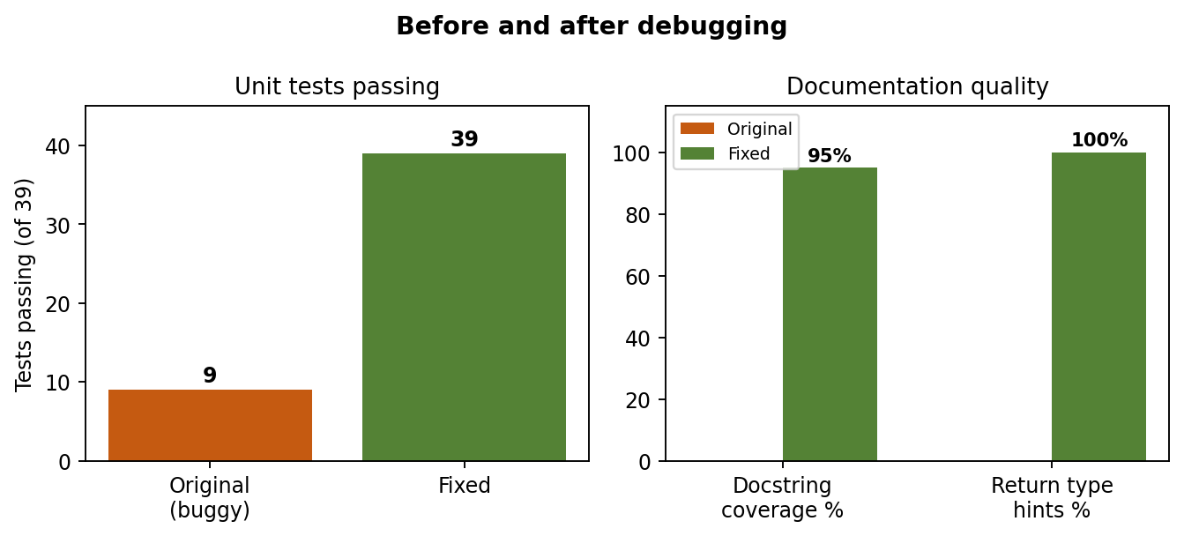
Figure 3: Before and after debugging (tests passing and documentation quality)

9.3 Performance
tools/benchmark.py builds a cart with 2000 items and times 50 calls (best of 5 runs).
Operation | Before | After | Speed-up
receipt() | 0.089 s | 0.072 s | 1.2x
total() | 0.009 s | 0.004 s | 2.3x
The gain comes from calculating the subtotal once in summary() instead of repeatedly. The improvement for receipt() is small because most of its time is spent formatting the item lines, which is expected.

10. Results and Demonstration
This section shows the real output of the tools, so every claim in the report can be checked. To reproduce any output, run the command shown above it from the root folder of the repository.

10.1 Unit tests on the original buggy code (30 failures)
Command: python tools/run_against_buggy.py

----------------------------------------------------------------------
Ran 39 tests in 0.002s

FAILED (failures=30)

(first lines of the failure list)
FAIL: test_adding_existing_item_increases_quantity
FAIL: test_negative_quantity_rejected
FAIL: test_non_integer_quantity_rejected
FAIL: test_price_zero_rejected
FAIL: test_zero_quantity_rejected
FAIL: test_coupon_code_ignores_surrounding_spaces

9 of 39 tests pass and 30 fail. Because of bug B1 the tests contaminate each other. Running every test in its own process (tools/run_each_test_isolated.py) shows how many fail because of their own bug:
22 of 39 tests fail against the buggy code when run in isolation:

10.2 Unit tests on the fixed code (all pass)
Command: python -m unittest discover -s tests -v
test_add_single_item (test_cart.AddItemTests.test_add_single_item) ... ok
test_add_with_quantity (test_cart.AddItemTests.test_add_with_quantity) ... ok
test_adding_existing_item_increases_quantity (test_cart.AddItemTests.test_adding_existing_item_increases_quantity) ... ok
test_negative_price_rejected (test_cart.AddItemTests.test_negative_price_rejected) ... ok
test_negative_quantity_rejected (test_cart.AddItemTests.test_negative_quantity_rejected) ... ok
test_non_integer_quantity_rejected (test_cart.AddItemTests.test_non_integer_quantity_rejected) ... ok
test_price_zero_rejected (test_cart.AddItemTests.test_price_zero_rejected) ... ok
test_zero_quantity_rejected (test_cart.AddItemTests.test_zero_quantity_rejected) ... ok
...
----------------------------------------------------------------------
Ran 39 tests in 0.001s

OK

10.3 Bug detection rate (mutation check)
Command: python tools/mutation_check.py. Each bug is re-introduced alone into the fixed code; DETECTED means at least one test fails.
Baseline (fixed code): all tests pass

Bug Result Failing tests Description
B0 DETECTED 1 syntax error: missing colon after add_item signature
B1 DETECTED 27 mutable default argument shares items between carts
B2 DETECTED 1 adding an existing item overwrites quantity
B3 DETECTED 1 price 0 accepted (< instead of <=)
B4 DETECTED 4 quantity never validated
B5 DETECTED 2 remove_item leaves quantity 0 and allows over-removal
B6 DETECTED 1 subtotal not rounded
B7 DETECTED 1 SAVE20 boundary: > 100 instead of >= 100
B8 DETECTED 1 unknown coupon silently ignored
B9 DETECTED 1 coupon code is case-sensitive
B10 DETECTED 2 tax charged before discount
B11 DETECTED 1 average divides by distinct items, not units
B12 DETECTED 1 average crashes on empty cart
B13 DETECTED 1 most_expensive_item compares quantity
B14 DETECTED 1 coupon minimum not re-checked after items change

Detected 15 of 15 bugs = 100% (target: at least 80%)

Result: 15 of 15 bugs detected (100%), which is above the required 80%.

10.4 Line coverage
Command: python tools/coverage_report.py
Tests run: 39, failures: 0
File: src/cart.py
Executable lines: 107 Covered: 107 Missed: 0
Line coverage: 100.0%

10.5 Code metrics
Command: python tools/code_metrics.py
Metric BEFORE (buggy/cart_buggy.py) AFTER (src/cart.py)
Code lines (no blanks/comments) 73 137
Functions/methods 14 19
Docstring coverage 0% 95%
Functions with return type hints 0% 100%
Max cyclomatic complexity 4 5
Average cyclomatic complexity 2.1 1.9
Magic numbers inside functions 5 1

10.6 Demonstration of the fixed module
A short session with the fixed cart (the example from Section 3.2):
Subtotal: 100
Discount: 10.0
Tax: 7.2
Total: 97.2

Book 2 x 50.00 = 100.00
--------------------------------------
Subtotal: 100.00
Discount: -10.00
Tax: 7.20
Total: 97.20

11. Lessons Learned
- Reproduce first, then debug. A five-line script that shows the wrong result made every pdb session short and focused.
- Shared state hides other bugs. Bug B1 made 27 unrelated tests fail. Fixing the shared state first would have cleared most of the noise. Tests must be independent, so each test creates its own objects.
- Boundary values find the subtle bugs. B3, B5 and B7 only fail at exact values such as 0 and 100.00. Normal example values would never have found them.
- Calculate the expected answer by hand before running the code. The wrong tax in B10 was only noticed because the expected value 7.20 was known in advance.
- Test the tools that test your code. The mutation script first reported bug B1 as "missed" because Python reused a stale cached copy of the module; checking one case manually (27 tests failed) exposed the problem. The per-test script first reported that all 39 tests fail because of a wrong command-line option. Both were fixed by comparing with a manual run. A measurement tool that has not been verified can give confident but wrong numbers.
- Use the debugger to test hypotheses, not just to look. In B10 the correct formula was evaluated inside pdb before any code was changed.
- Refactor only when the tests are green. The 39 tests stayed green through every refactoring step, which is the reason refactoring was safe.
- Report numbers honestly. The refactored code is longer, and the speed-up for receipt() is modest. The real gains are correctness, readability and documentation.
- Prefer data structures that make mistakes hard. Replacing item[0] and item[1] with named attributes removed the whole class of bug B13.

12. Conclusion
The shopping-cart module started with 15 bugs: one syntax error and 14 logic, state and boundary bugs. A suite of 39 unit tests detects all 15 (100%, target 80%) and covers 100% of the lines of the fixed code. Three of the bugs were traced with pdb, and every bug was explained, fixed and linked to the test that guards it. The refactoring improved readability, documentation and performance without changing behaviour, as shown by the unchanged passing test suite.
Source code, tests, tools and this report: https://github.com/pratham514/week3-testing-debugging

