CarePulse Healthcare Platform
System Design — Complete Diagram Document
Diagrams Included
1. Context Diagram (Level 0 DFD)
2. Level 1 Data Flow Diagram (DFD)
3. System Architecture Diagram
4. Authentication & Authorization Flow
5. Appointment Booking Flow
6. Symptom Checker Flow Diagram
7. Entity Relationship Diagram (ERD)
8. Use Case Diagram — Role-Based Access
9. MedAssist AI Interaction Flow
March 2026

Diagram 1: Context Diagram (Level 0 DFD)
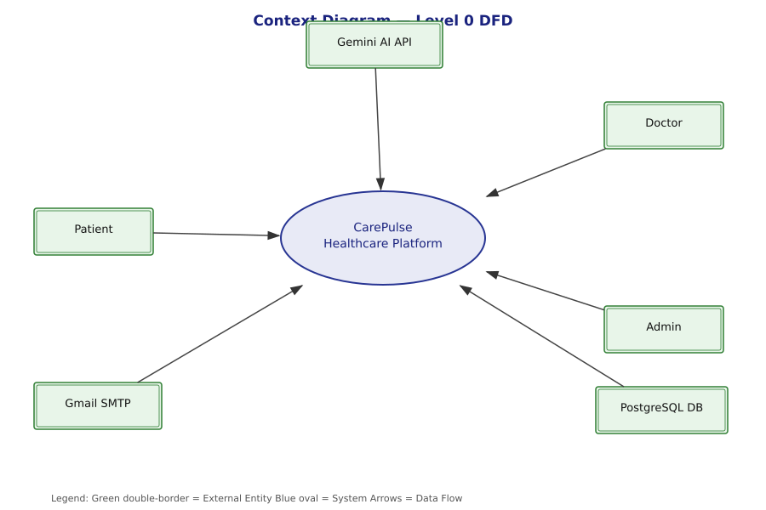
Description & Explanation
The Context Diagram shows CarePulse as a single system (oval center) with all external entities that interact with it.
External Entities:
• Patient — Logs in, books appointments, checks symptoms, uses AI chat
• Doctor — Views patients, issues prescriptions, manages appointments
• Admin — Manages users, views analytics, controls all system settings
• Gemini AI API — Google's AI service used by MedAssist and symptom analysis
• Gmail SMTP — Email server used to send OTP codes for password reset
• PostgreSQL DB — Main database storing all system data (70,000+ hospitals, users, records)
All data flows pass through the central CarePulse system, which validates, processes, and routes every request.

Diagram 2: Level 1 Data Flow Diagram
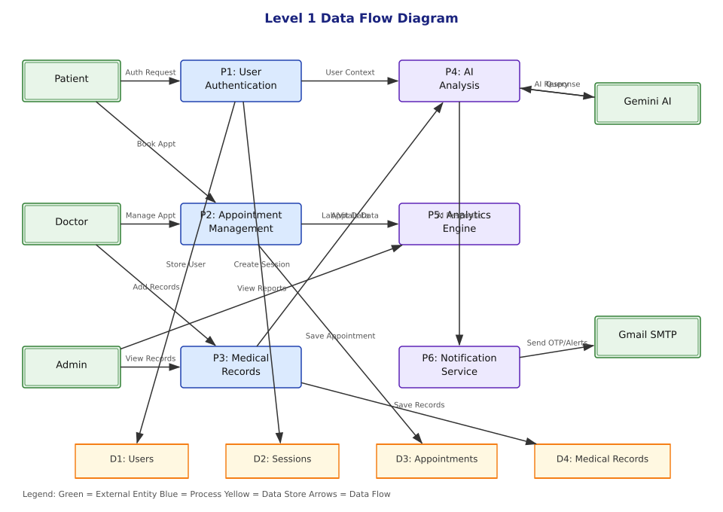
Description & Explanation
The Level 1 DFD breaks CarePulse into 6 core processes showing how data flows between actors, processes, and data stores.
Processes:
• P1: User Authentication — Handles login, registration, sessions, OTP reset
• P2: Appointment Management — Booking, conflict detection, status updates
• P3: Medical Records — Patient vitals, prescriptions, health history
• P4: AI Analysis — Integrates with Gemini API for MedAssist and symptom analysis
• P5: Analytics Engine — ML risk prediction, outbreak detection, platform stats
• P6: Notification Service — OTP emails, appointment confirmations
Data Stores: Users DB, Sessions DB, Appointments DB, Medical Records DB

Diagram 3: System Architecture Diagram
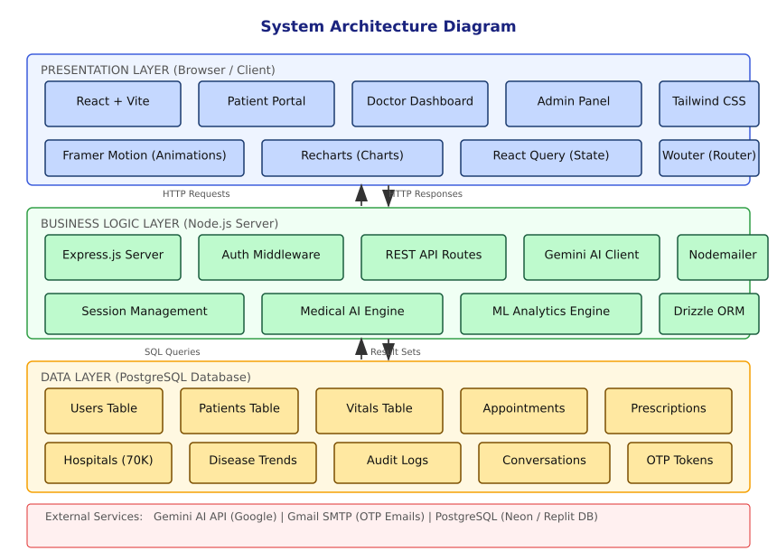
Description & Explanation
The System Architecture shows CarePulse in 3 horizontal layers:
Layer 1 — Presentation (Browser/Client):
React + Vite frontend with Patient Portal, Doctor Dashboard, and Admin Panel.
Uses Tailwind CSS for styling, Framer Motion for animations, Recharts for charts.
Layer 2 — Business Logic (Node.js/Express Server):
Express.js handles HTTP requests. Modules include Auth Middleware, REST API Routes,
Medical AI Engine (symptom checker), ML Analytics Engine, and Nodemailer for emails.
Layer 3 — Data (PostgreSQL Database):
Stores Users, Patients, Vitals, Appointments, Prescriptions, Hospitals (70K+), Audit Logs.
External Services: Gemini AI API for MedAssist, Gmail SMTP for OTP delivery.

Diagram 4: Authentication & Authorization Flow
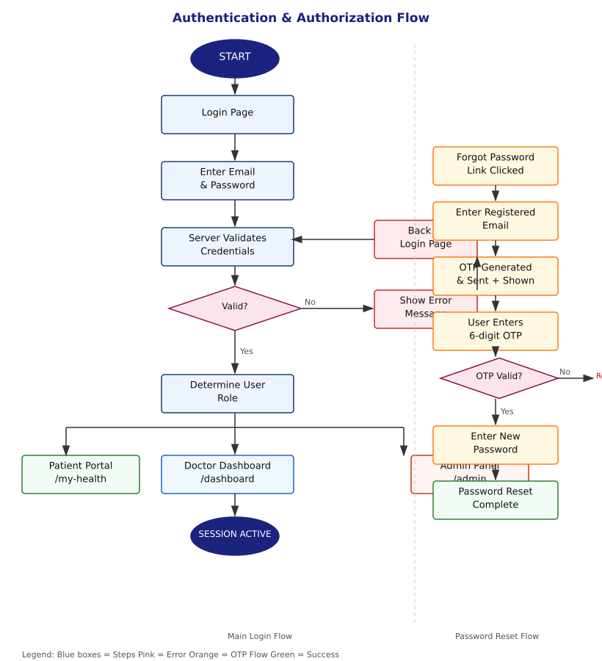
Description & Explanation
This diagram shows two parallel authentication flows:
Main Login Flow (left):
1. User opens Login Page and enters email + password
2. Server validates credentials against hashed password in DB
3. If valid: role is determined (Patient/Doctor/Admin) and user is routed to their portal
4. If invalid: error is shown and user returns to login
Password Reset Flow (right):
1. User clicks 'Forgot Password' and enters their registered email
2. Server generates a 6-digit OTP, saves it, sends via Gmail, and displays it on screen
3. User enters OTP — if valid, new password is set; if invalid, user retries
Session management uses connect-pg-simple for PostgreSQL-backed sessions.

Diagram 5: Appointment Booking Flow
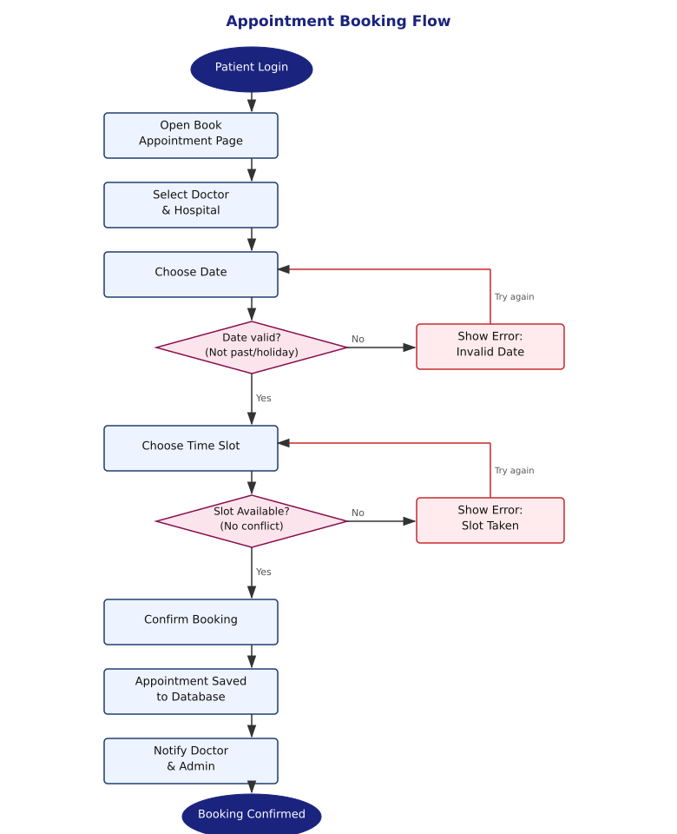
Description & Explanation
The Appointment Booking Flow shows the step-by-step process for scheduling an appointment:
1. Patient logs in and opens the Appointment Booking page
2. Patient selects a Doctor and Hospital from the database
3. Patient picks a Date — system validates: not in the past, not a public holiday (India)
If date is invalid: error shown, patient picks another date
4. Patient selects a Time Slot — system checks for appointment conflicts in the database
If slot is taken: error shown, patient picks a different time
5. Patient confirms — appointment saved to database
6. Doctor and Admin receive notifications about the new booking
7. Patient receives booking confirmation
Holidays are validated using India's official public holiday list (IST timezone).

Diagram 6: Symptom Checker Flow
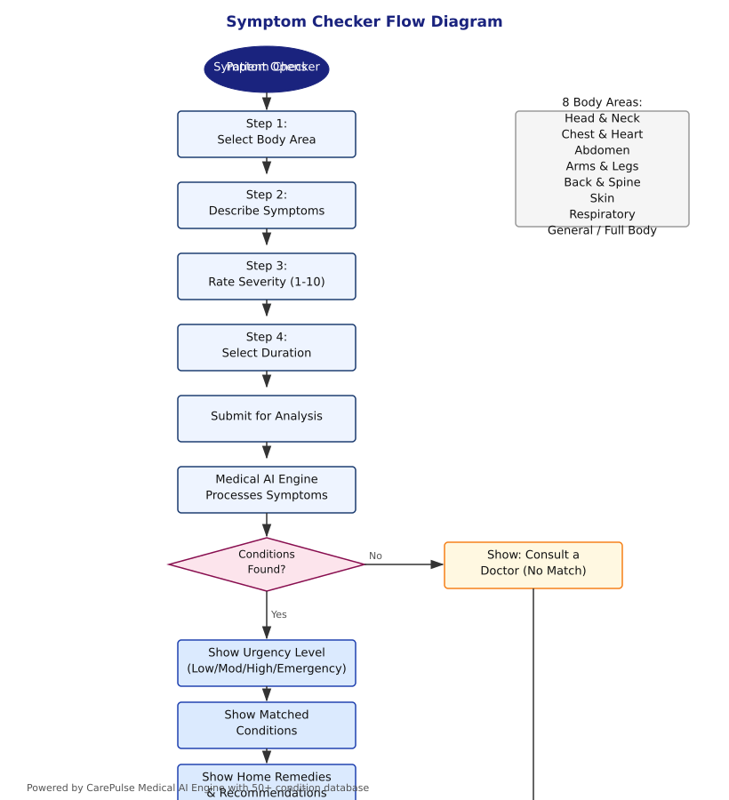
Description & Explanation
The Symptom Checker is a 4-step wizard followed by AI-powered analysis:
Step 1 — Select Body Area: 8 options (Head & Neck, Chest & Heart, Abdomen,
Arms & Legs, Back & Spine, Skin, Respiratory, General / Full Body)
Step 2 — Describe Symptoms: Free-text input of what the patient is experiencing
Step 3 — Rate Severity: Slider from 1 (mild) to 10 (severe)
Step 4 — Select Duration: 6 options from 'Less than 24 hours' to 'Chronic'
Analysis Engine: Scores all 50+ medical conditions against described symptoms using
keyword matching, synonym expansion, and body-area weighting. Symptoms are the
primary scoring factor — body area is only a secondary hint.
Results: Urgency level (Low/Moderate/High/Emergency), matched conditions with
relevance score, home remedies, and recommended actions including emergency numbers.

Diagram 7: Entity Relationship Diagram (ERD)
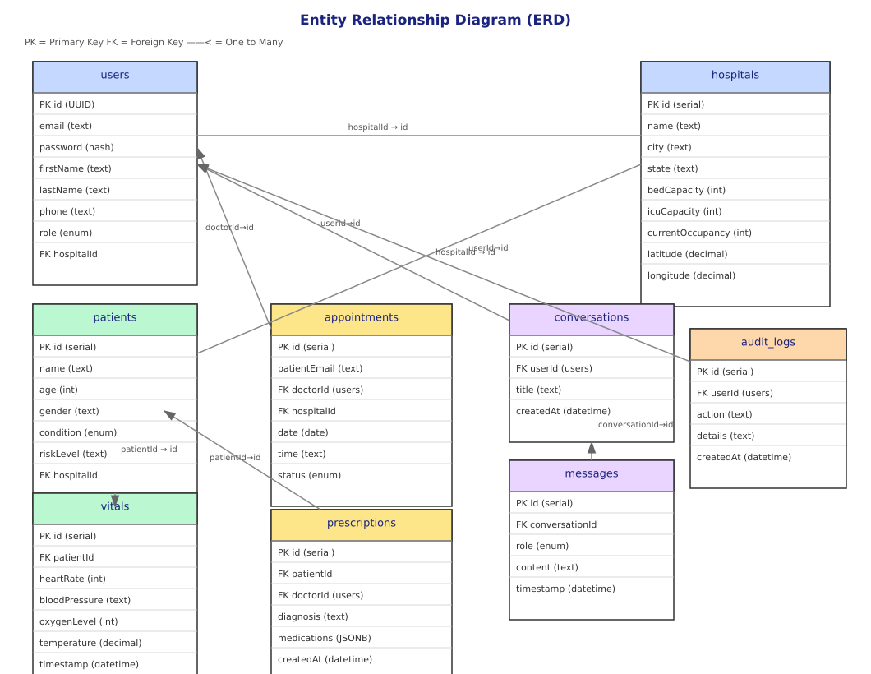
Description & Explanation
The ERD shows all database tables and their relationships:
• users — Core table for all accounts (patients, doctors, admins). FK to hospitals.
• hospitals — 70,000+ Indian hospitals with location, bed capacity, and occupancy.
• patients — Clinical patient records with risk level and condition status. FK to hospitals.
• vitals — Time-series health readings (heart rate, BP, oxygen, temperature). FK to patients.
• appointments — Bookings with date, time, and status (scheduled/completed/cancelled).
FK to doctorId (users) and hospitalId (hospitals).
• prescriptions — Doctor-issued prescriptions with medications in JSONB format.
FK to patientId and doctorId (users).
• conversations + messages — MedAssist AI chat history. FK to userId (users).
• audit_logs — All admin/doctor actions for compliance tracking. FK to userId.
Key: One User can have many Conversations; one Patient can have many Vitals records.

Diagram 8: Use Case Diagram
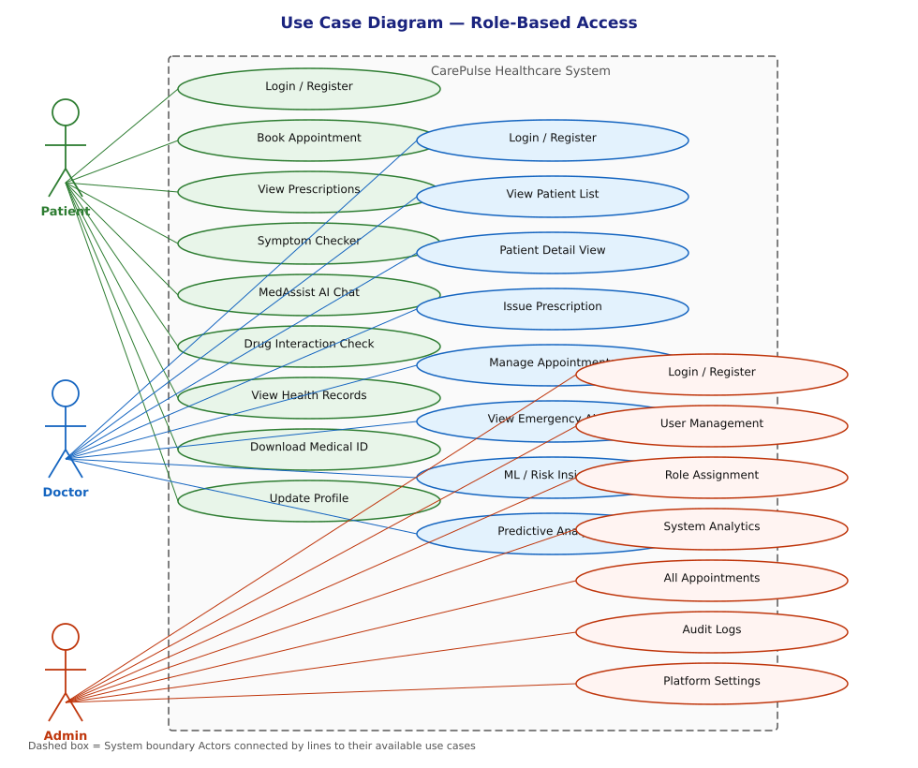
Description & Explanation
The Use Case Diagram shows which features are accessible by each user role:
Patient (green) — 9 use cases:
Login/Register, Book Appointment, View Prescriptions, Symptom Checker,
MedAssist AI Chat, Drug Interaction Check, View Health Records,
Download Medical ID, Update Profile
Doctor (blue) — 8 use cases:
Login/Register, View Patient List, Patient Detail View, Issue Prescription,
Manage Appointments, View Emergency Alerts, ML/Risk Insights, Predictive Analytics
Admin (red) — 7 use cases:
Login/Register, User Management, Role Assignment, System Analytics,
Manage All Appointments, Audit Logs, Platform Settings
Note: Admin inherits all Doctor capabilities plus system administration features.

Diagram 9: MedAssist AI Interaction Flow
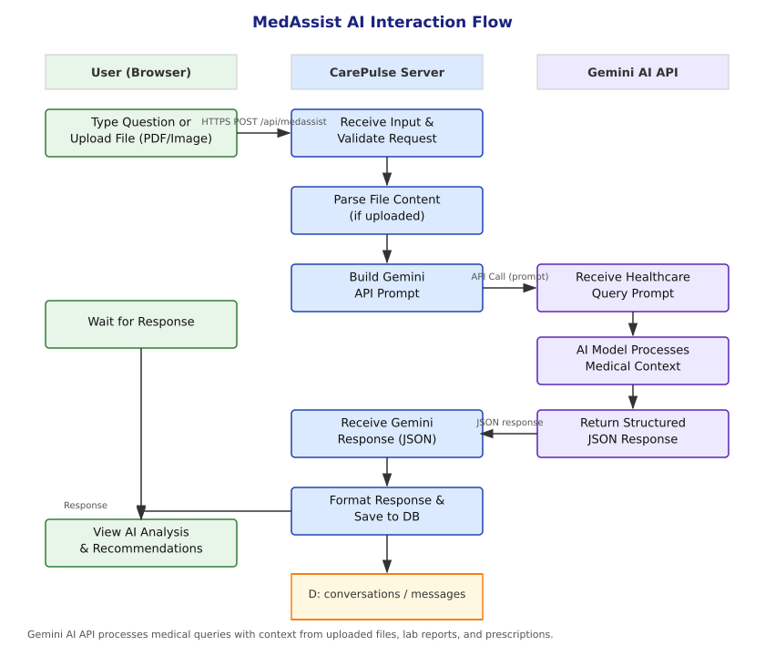
Description & Explanation
The MedAssist AI flow shows how user queries are processed by the Gemini AI API:
Column 1 — User (Browser):
User types a medical question or uploads a file (PDF, image of lab report or prescription)
Column 2 — CarePulse Server:
1. Validates the incoming request and checks authentication
2. If file uploaded: extracts and parses text content from PDF/image
3. Constructs a detailed medical context prompt for Gemini
4. Receives JSON response from Gemini and formats it for display
5. Saves the conversation and messages to the database
Column 3 — Gemini AI API (Google):
1. Receives the structured healthcare query prompt
2. Processes with full medical knowledge context
3. Returns structured JSON with analysis, recommendations, and disclaimers
Every response includes a medical disclaimer reminding users to consult a doctor.

