**Database Management System**

## Department of Computer Science & Engineering

**Ecommerce Management System**

SUBMITTED BY

|  |
| --- |
| Name: Pratham Manja |
| SRN: PES2UG20CS253 |
| V Sem Section D |

# Short Description and Scope of the Project

In this modern era of online shopping no seller wants to be left behind, moreover due to its simplicity the shift from offline selling model to an online selling model

Is witnessing a rampant growth.

Therefore, as an engineer our job is to ease the path of this transition for the seller. Amongst many things that an online site requires the most important is a database system. Hence in this project we are planning to design a database where small clothing sellers can sell their product online.

**ER Diagram**

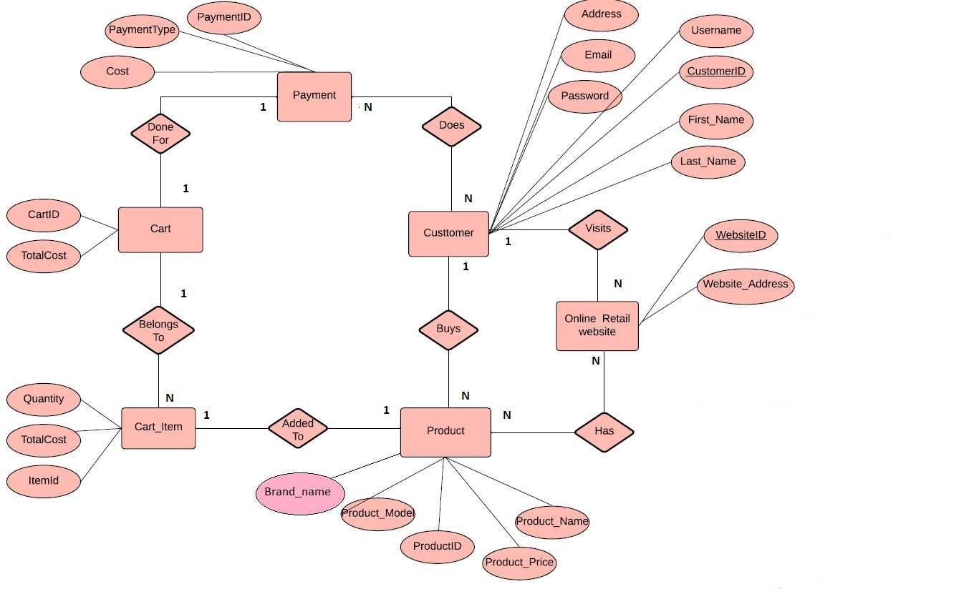

# Relational Schema

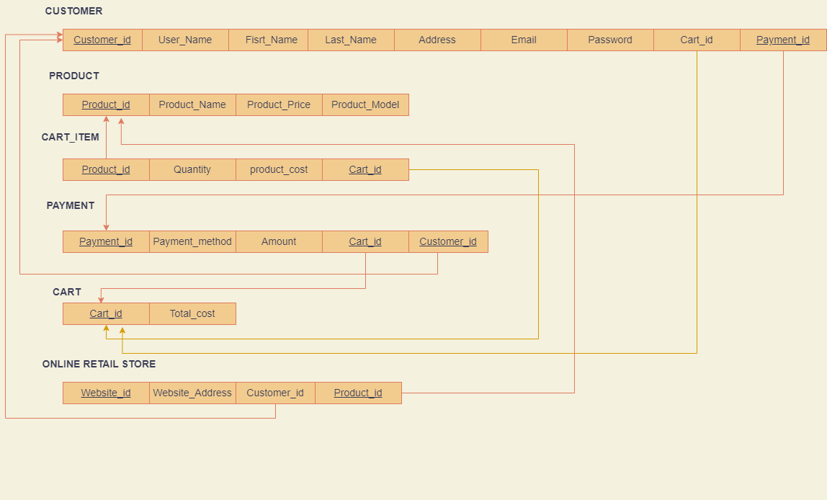

**DDL statements - Building the database**

CREATE TABLE Cart

(

Cart_id VARCHAR(7) NOT NULL,

totalcost double,

PRIMARY KEY(Cart_id)

);

CREATE TABLE Cart_Item

(

quantity int,

totalcost double,

itemid varchar(10) NOT NULL

);

CREATE TABLE Payment

(

payment_id VARCHAR(7) NOT NULL,

payment_date DATE NOT NULL,

Payment_type VARCHAR(10) NOT NULL,

total_amount double,

primary key(payment_id)

);

CREATE TABLE Customer

(

Customer_id VARCHAR(6) NOT NULL,

username VARCHAR(10) NOT NULL,

password VARCHAR(5) NOT NULL,

F_Name VARCHAR(20) NOT NULL,

L_Name VARCHAR(20) NOT NULL,

Email varchar(30),

Address VARCHAR(20) NOT NULL,

Pincode int NOT NULL,

Phone_number long NOT NULL,

PRIMARY KEY (Customer_id)

);

CREATE TABLE Product

(

Product_id VARCHAR(7) NOT NULL,

product_name varchar(20) NOT NULL,

Type VARCHAR(7) NOT NULL,

Color VARCHAR(15) NOT NULL,

size VARCHAR(2) NOT NULL,

Cost int NOT NULL,

PRIMARY KEY (Product_id)

);

CREATE TABLE website

(

websiteID varchar(20),

website_address varchar(30) NOT NULL,

primary key(websiteID)

);

alter table customer add cart_id varchar(7);

alter table customer add payment_id varchar(7);

alter table website add customerID varchar(20);

alter table website add productID varchar(20);

alter table cart_item add cart_id varchar(7)

# INSERT INTO customer VALUES("USR_001","Ajit","A@123","Ajit","Ullal","Ajit.Ullal@gmail.com","10 Janpath",560001,3816958050,"p_07","c_01"),

# -> ("USR_002","Ali","A@1234","Muhammed ","Ali","Muhammed.Ali@gmail.com","10 Downing",560003,4231847857,"p_05","c_02"),

# -> ("USR_003","Deepak","D@1234","Sai Deepak","Reddy","SaiDeepak.Reddy@gmail.com","14 Kailsh Marg",600001,6570774843,"p_01","c_03"),

# -> ("USR_004","Rudra","R@123","Rudra","Agarwal","Rudra.Agarwal@gmail.com","5 Lohia Garden",600042,6496570681,"p_03","c_04"),

# -> ("USR_005","Rahul","R@1234","Rahul","Khanna","Rahul.Khanna@gmail.com","1 Pink Street",600067,7425133771,"p_06","c_05"),

# -> ("USR_006","Nirmala","N@123","Nirmala","Seturaman","Nirmala.Seturaman@gmail.com","3 Blue Avenue",560105,4758964089,"p_04","c_06"),

# -> ("USR_007","Smriti","S@123","Smriti","Irani","Smriti.Irani@gmail.com","4 Banyan Avenie",575014,6461137242,"p_045","c_07"),

# -> ("USR_008","Ajit1","A@043","Ajit","Sethi","Ajit.Sethi@gmail.com","6 Poes Garden",575001,1360250412,"p_08","c_08"),

# -> ("USR_009","Arjun","A@0435","Arjun","Allu","Arjun.Allu@gmail.com","7 Dhamaka street",575020,2882164015,"p_039","c_09"),

# -> ("USR_010","Samanta","S@043","Samanta","Prabhu","Samanta.Prabhu@gmail.com","8 Clone Colony",600042,9049771843,"p_02","c_10"),

# -> ("USR_011","Kiran ","K@043","Kiran ","Bedi","Kiran .Bedi@gmail.com","56 Brigade Road",560003,7473996070,"p_036","c_11"),

# -> ("USR_012","Rahul 1","R@12348","Rahul ","Gandhi","Rahul .Gandhi@gmail.com","Mirza road",475001,3390002752,"p_09","c_12"),

# -> ("USR_013","Rashkit ","R@0438","Rashkit ","Shetty","Rashkit .Shetty@gmail.com","JC Road",560009,2004741304,"p_052","c_13"),

# -> ("USR_014","Rishi","R@0438","Rishi","Sunak","Rishi.Sunak@gmail.com","Anna Sali",600034,9700179138,"p_041","c_14"),

# -> ("USR_015","Vedavalli","V@043","Vedavalli","Srinath","Vedavalli.Srinath@gmail.com","Church Street Bangalore",560054,6887094275,"p_030","c_15"),

# -> ("USR_016","Subbu","S@0438","Subbu","Saravana","Subbu.Saravana@gmail.com","American Street",600043,7924300460,"p_046","c_16"),

# -> ("USR_017","Sheela","S@04389","Sheela","Dixit","Sheela.Dixit@gmail.com","Kasturba Road",560048,4042496048,"p_032","c_17"),

# -> ("USR_018","Margaret","M@043","Margaret","Alva","Margaret.Alva@gmail.com","New BEL Road",560008,6722757665,"p_89","c_18"),

# -> ("USR_019","Arun","A@04384","Arun","Kumar","Arun.Kumar@gmail.com","Mint Street",600046,5350962878,"p_067","c_19");

INSERT INTO payment VALUES(20850,"2020-08-29","UPI",998,"c_01","USR_001"),

(26785,"2020-11-26","credit_card",3595,"c_02","USR_002"),

(72957,"2020-07-26","debit_card",1199,"c_03","USR_003"),

(87036,"2020-12-09","net_banking",2299,"c_04","USR_004"),

(29706,"2020-04-13","UPI",3596,"c_05","USR_005"),

(99218,"2020-06-03","UPI",1598,"c_06","USR_006"),

(73469,"2020-06-01","UPI",998,"c_07","USR_007"),

(49136,"2020-09-21","debit_card",3594,"c_08","USR_008"),

(61544,"2020-07-30","credit_card",1199,"c_09","USR_009"),

(27205,"2020-06-04","credit_card",6897,"c_10","USR_010"),

(40522,"2020-12-12","credit_card",1798,"c_11","USR_011"),

(72876,"2020-11-23","net_banking",3995,"c_12","USR_012"),

(51809,"2020-12-04","COD",3493,"c_13","USR_013"),

(47628,"2020-12-07","COD",2396,"c_14","USR_014"),

(54260,"2020-06-17","UPI",2309,"c_15","USR_015"),

(31888,"2020-08-23","UPI",1497,"c_16","USR_016"),

(69723,"2020-10-01","net_banking",1199,"c_17","USR_017"),

(12763,"2020-11-13","net_banking",11495,"c_18","USR_018"),

(37625,"2020-05-14","UPI",1798,"c_19","USR_019");

INSERT INTO cart VALUES("c_01",998),

("c_02",3595),

("c_03",1199),

("c_04",2299),

("c_05",3596),

("c_06",1598),

("c_07",998),

("c_08",3594),

("c_09",1199),

("c_10",6897),

("c_11",1798),

("c_12",3995),

("c_13",3493),

("c_14",2396),

("c_15",2309),

("c_16",1497),

("c_17",1199),

("c_18",11495),

("c_19",1798);

INSERT INTO cart_item VALUES(2,"","p_01","c_01"),

(4,"","p_02","c_02"),

(1,"","p_03","c_17"),

(5,"","p_04","c_18"),

(2,"","p_05","c_19"),

(9,"","p_06","c_06"),

(3,"","p_01","c_16"),

(2,"","p_02","c_02"),

(1,"","p_03","c_03"),

(1,"","p_04","c_04"),

(4,"","p_05","c_05"),

(2,"","p_06","c_06"),

(2,"","p_01","c_07"),

(6,"","p_02","c_08"),

(1,"","p_03","c_09"),

(3,"","p_04","c_10"),

(2,"","p_05","c_11"),

(5,"","p_06","c_12"),

(7,"","p_01","c_13"),

(4,"","p_02","c_14"),

(2,"","p_03","c_15");

INSERT INTO website VALUES("web_001","www.myntra.com","USR_010","p_02"),

("web_002","www.amazon.com","USR_012","p_06"),

("web_003","www.flipcart.com","USR_003","p_05"),

("web_004","www.zstore.com","USR_015","p_01"),

("web_005","www.maxstore.com","USR_017","p_02"),

("web_006","www.fbb.com","USR_018","p_03"),

("web_007","www.h&m.com","USR_001","p_04"),

("web_008","www.allensolly.com","USR_004","p_05"),

("web_009","www.zara.com","USR_019","p_06");

INSERT INTO product VALUES("p_01","Blue_tshirt","shirt","blue","S ",499),

("p_02","black_tshit","shirt","black","S",599),

("p_03","green_shirt","shirt","green","M",1199),

("p_04","yellow_jacket","jacket","yellow","L",2299),

("p_05","black_trousers","trousers","black","M",899),

("p_06","red_shirt","shirt","red","L",799);

**Join Queries**

Showcase at least 4 join queries

Write the query in English Language, Show the equivalent SQL statement and also a screenshot of the query and the results

Getting the total cost that each customer has to pay

Select customer.F_Name,customer.L_Name,cart.total_cost from cart inner join customer on customer.cart_id= cart.cart_id;

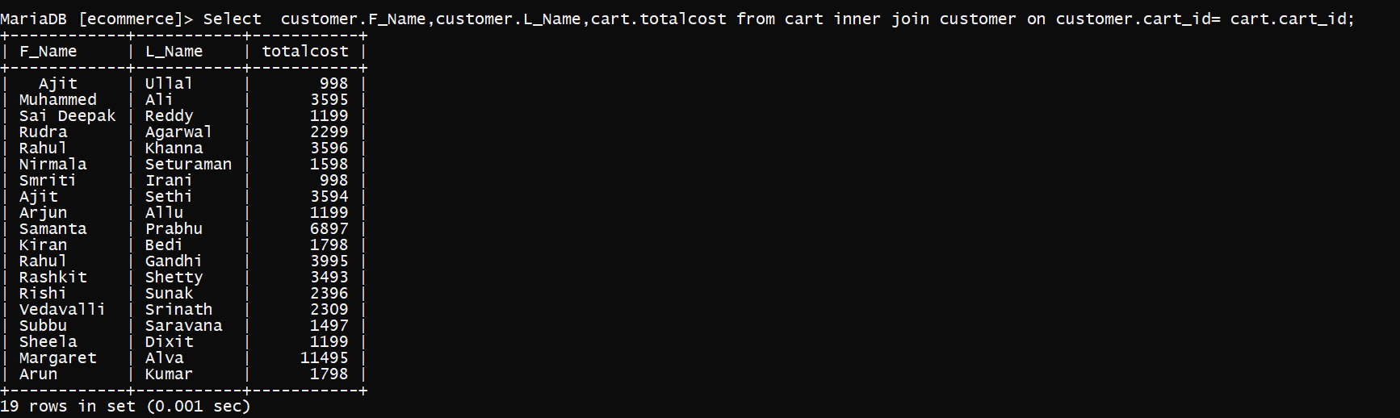

Getting the number of items in each cart

Select cart.cart_id,count(*) as total_item from cart inner join cart_item on cart.cart_id=cart_item.cart_id

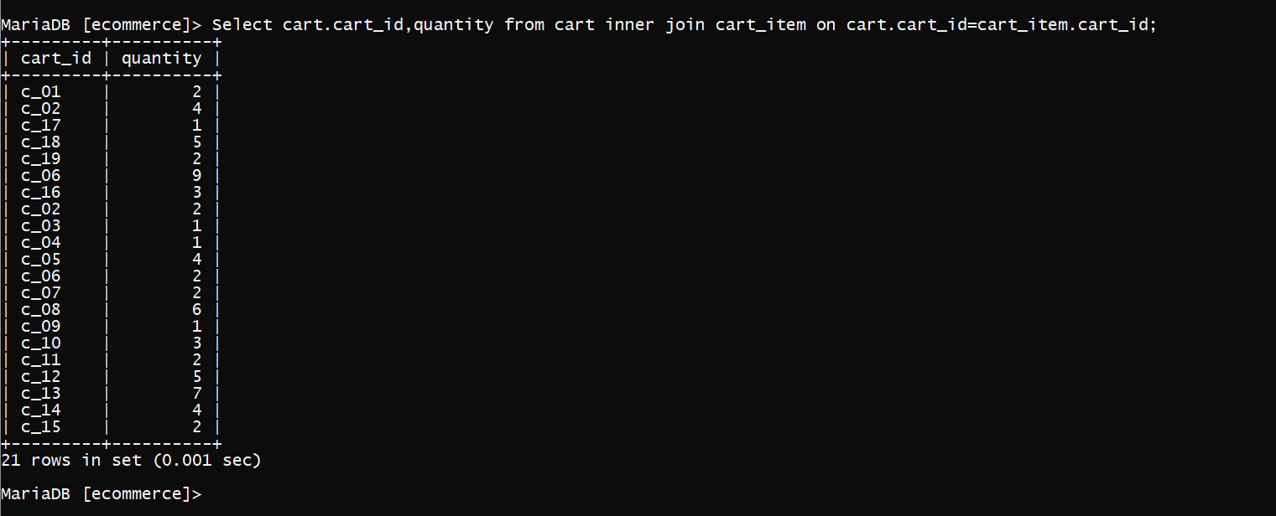

# Aggregate Functions

Showcase at least 4 Aggregate function queries

Write the query in English Language, Show the equivalent SQL statement and also a screenshot of the query and the results

Select cart_id,count(*) from cart_item group by cart_id;

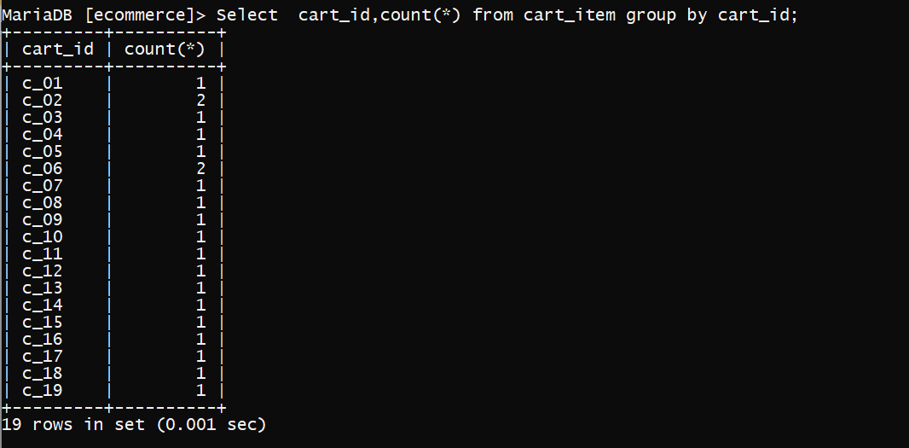

Select payment_type,count(*) from payment group by payment_id

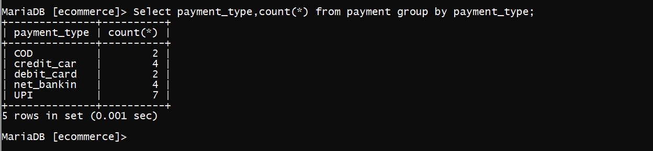

# Set Operations

Showcase at least 4 Set Operations queries

Write the query in English Language, Show the equivalent SQL statement and also a screenshot of the query and the results

Customers who have registered and may have visited the website

Select customer_id from customer union select customerID from website;

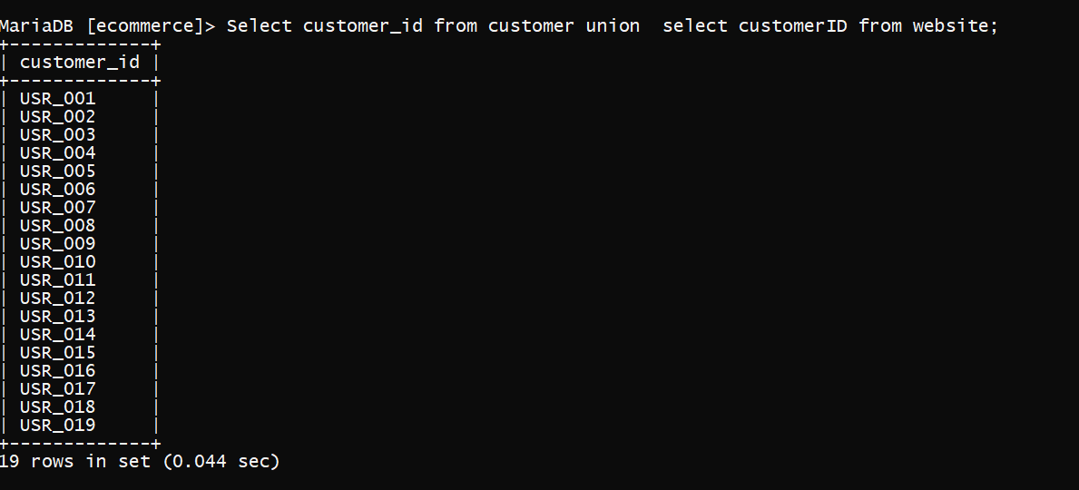

Products available in the website

Select product_id,product_name from product where product_id exists in (select productID from website);

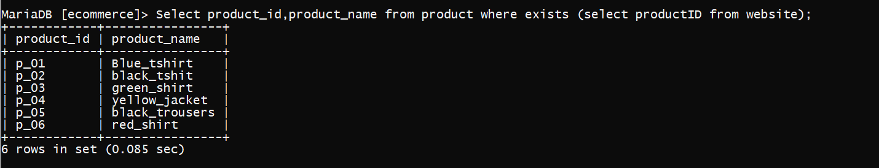

# Functions and Procedures

Create a Function and Procedure. State the objective of the function / Procedure. Run and display the results.

Create Function ticket_no(user varchar(7))

Returns varchar(100)

Deterministic

Begin

Declare cnt int;

Declare msg varchar(100);

Set cnt = (Select totalcost From cart where cart_id in (select cart_id from customer where user_id=user));

If cnt > 10000 Then

Set msg = Concat(‘money spent - ',Convert(cnt,char),' daily limit reached');

Else

SET msg = Concat(‘money spent - ',Convert(cnt,char));

End if;

Return msg;

End &&

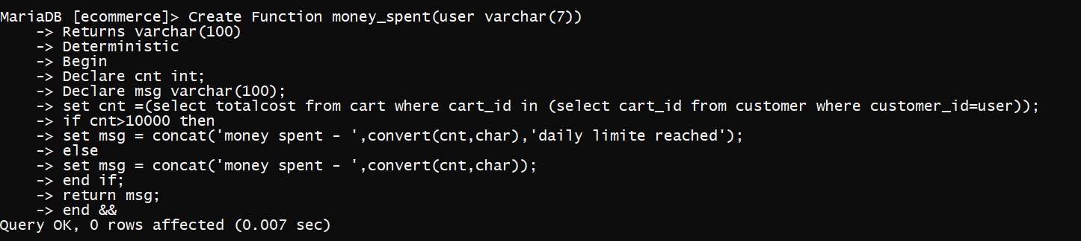

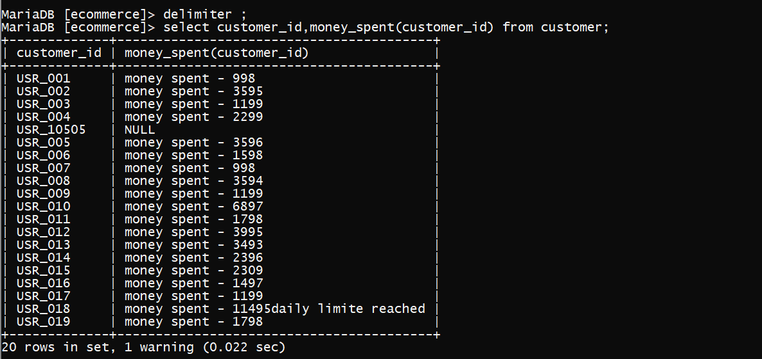

DELIMITER $$

CREATE procedure products_sold(

IN item varchar(7) ,OUT msg varchar(30))

BEGIN

DECLARE cnt int;

set cnt= (select sum(quantity) from cart_item group by itemid where itemid=item);

IF cnt = 0 THEN

set msg= ‘no items sold’;

ELSE

set msg=concat(’items sold-‘,convert(cnt,char));

END IF;

END;$$

DELIMITER ;

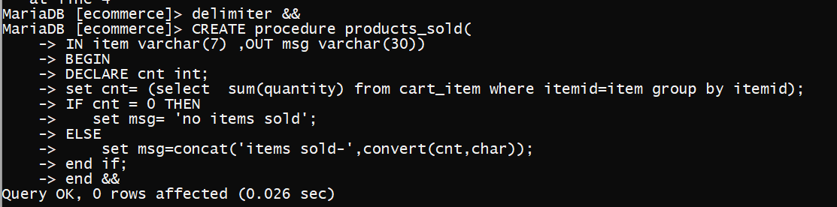

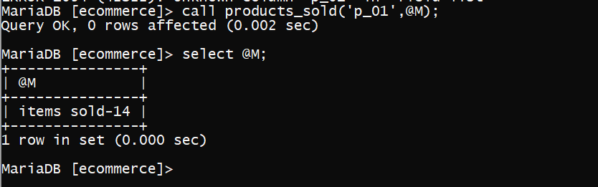

# Triggers and Cursors

Create a Trigger and a Cursor. State the objective. Run and display the results.

create trigger ph_no_check

before insert

on customer

for each row

begin

declare error_msg varchar(255);

set error_msg=’illegal phone number';

if ( new.Phone_number < 1000000000) then signal sqlstate '45000' set message_text=error_msg;

end if;

end &&

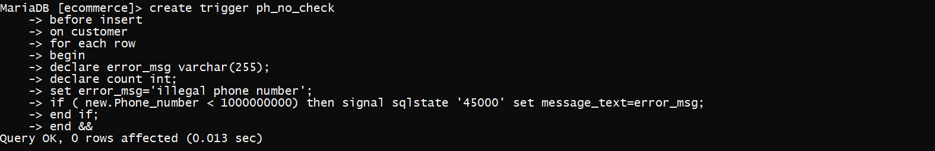

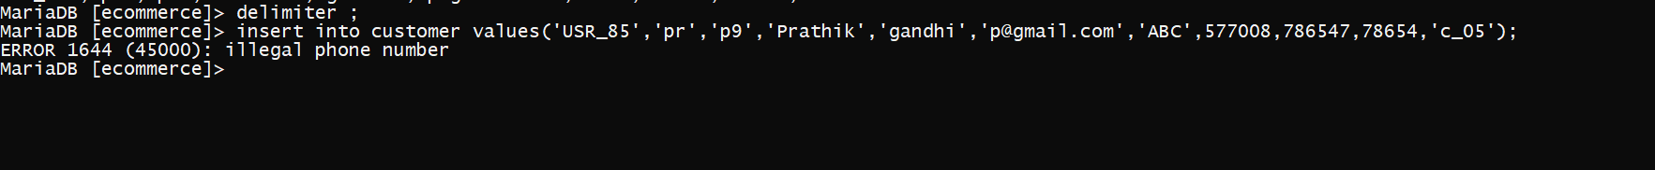

# Developing a Frontend

The frontend should support

1. Addition, Modification and Deletion of records from any chosen table
2. There should be an window to accept and run any SQL statement and display the result

from tkinter import *

import random

import mysql.connector as a

con = a.connect(host="localhost",user="root",passwd="",database="ecommerce")

root = Tk()

l1=Label(root,text="Add Customer Information")

l1.grid(row=0,column=0)

root.title("")

root.geometry("500x500")

mylabel1 = Label(root,text=" ",bd="35")

mylabel1.grid(row=1, column=0)

mylabel2 = Label(root,text="NEW USER",anchor=CENTER,bg="light blue",bd="20")

mylabel2.grid(row=7, column=1)

l1=Label(root,text="Customer Registration",bd=20,relief="ridge",bg="light blue",width=20,font=('arial',30, 'bold'))

l1.place(x=0,y=0)

customer_data = []

l2=Label(root,text="customer id:")

l2.grid(row=8,column=0,sticky="W")

value=(random.randint(10002,11100))

value = 'USR_'+str(value)

e = Label(root,text = value, font=('arial', 10, 'bold'))

e.place(x=150,y=165)

l10=Label(root,text="username:")

l10.grid(row=9,column=0,sticky="W")

e10 = Entry(root,width=40)

e10.grid(row=9,column=1)

l3=Label(root,text="password:")

l3.grid(row=10,column=0,sticky="W")

e1 = Entry(root,width=40)

e1.grid(row=10,column=1)

l3=Label(root,text="First name:")

l3.grid(row=11,column=0,sticky="W")

e2 = Entry(root,width=40)

e2.grid(row=11,column=1)

l4=Label(root,text="last name :")

l4.grid(row=12,column=0,sticky="W")

e3 = Entry(root,width=40)

e3.grid(row=12,column=1)

l5=Label(root,text=" Email:")

l5.grid(row=13,column=0,sticky="W")

e4 = Entry(root,width=40)

e4.grid(row=13,column=1)

l7=Label(root,text="Address:")

l7.grid(row=14,column=0,sticky="W")

e6 = Entry(root,show="*",width=40)

e6.grid(row=14,column=1)

l8=Label(root,text="pincode:")

l8.grid(row=15,column=0,sticky="W")

e7 = Entry(root,width=40)

e7.grid(row=15,column=1)

l9=Label(root,text="phone number:")

l9.grid(row=16,column=0,sticky="W")

e8 = Entry(root,width=40)

e8.grid(row=16,column=1)

def funcAddUser():

data1= [value,e10.get(),e1.get(),e2.get(),e3.get(),e4.get(),e6.get(),e7.get(),e8.get(),'12763','c_04']

sql1="insert into customer values(%s,%s,%s,%s,%s,%s,%s,%s,%s,%s,%s)"

c=con.cursor()

c.execute(sql1,data1)

con.commit()

message = " Your account has been sucessfully created "

lb4 = Label(root, text = message,fg="green")

lb4.grid(row=16, column =1)

b1 = Button(root,text="Add User",command=funcAddUser)

b1.grid(row=17,column=1)

root.mainloop()

