
Project Report on
Waste Material Detection Using Convolutional Neural Network (CNN)

Submitted by
Aalay Kabariya -20220702096,
Harikrishna Pillai-20220702103

Course Name: Artificial Neural Network (ANN)

B.Tech CSE - AIML
VI Semester – Dec 2024 – Apr 2025

Dec/Apr 2025

Abstract
This project focuses on developing an object detection model capable of identifying whether a waste material is recyclable or not. The dataset, sourced from the Roboflow platform, consists of approximately 15,000 images spanning 42 different waste material classes. After augmenting and organizing the data, we trained a deep learning model using a pre-trained Faster R-CNN with ResNet-50 FPN backbone from the PyTorch library. The dataset was processed with a custom dataloader using a batch size of 4. The model was trained to recognize the material class of each detected object, and a mapping was applied to label each class as either recyclable or non-recyclable using Boolean values. This approach enables a more intelligent and automated system for waste classification, contributing toward more efficient recycling and sustainable waste management practices.

Introduction
Proper waste management is now viewed as an important worldwide issue due to the escalating levels of urbanization, and industrial development. The buildup of waste materials, especially non-biodegradable and toxic wastes, creates major environmental and health hazards. Recycling is one of the best solutions to solve this issue since it decreases the amount of waste that finds its way into landfills, conserves resources, and reduces emissions of greenhouse gases. Yet, manual sorting of waste is still a time-consuming, labor-intensive, and error-prone activity that often needs human intervention to separate recyclable from non-recyclable materials.
To overcome this problem, the incorporation of computer vision and artificial intelligence (AI) into waste management systems is gaining greater prominence. Specifically, object detection with the aid of deep learning has been particularly promising in making waste identification and sorting automatic. With the training of models to identify various types of waste materials, one can implement systems that help in automated sorting, minimize labour, and maximize recycling efficiency.
This project seeks to create an object detection model capable of identifying waste materials and deciding if they are recyclable or not. The system is centered around a pre-trained Faster R-CNN model with a ResNet-50 backbone and Feature Pyramid Network (FPN) offered by PyTorch's torchvision library. Faster R-CNN is a popular deep learning model for object detection because it is highly accurate and performs strongly in detecting more than one object in images.
The data used for this project was taken from the Roboflow platform and has around 15,000 labelled images representing 42 different classes of waste materials, such as plastic, paper, metal, food waste, etc. The images were augmented to enhance model generalization and readied to train via a custom dataloader with a batch size of 4. The model is trained to output the class label of every detected object. A Boolean mapping was subsequently used to relate each class with a recyclability status of either recyclable (True) or non-recyclable (False).
By developing a model that can both identify and classify waste materials based on their recyclability, this project contributes to the development of intelligent waste management solutions. The outcome of this effort has the potential to be utilized in automated sorting lines in recycling facilities, intelligent bins in cities, and learning aids for the promotion of improved recycling habits.
In the paragraphs that follow, this report discusses related work, the process for constructing and training the model, the experiment results, and some discussion of future improvements and the system's possible applications.

Related Works
- Waste Classification Using Deep Learning
Past research has established that convolutional neural networks (CNNs) are capable of accurately classifying waste material images. VGG-16 and ResNet models have been applied to binary and multiclass classification operations in waste segregation systems.
- Object Detection for Waste Sorting
In comparison to traditional classification, object detection includes spatial information and class label. Methods such as YOLO, SSD, and Faster R-CNN have been used to identify and position various waste items in one image.
- Faster R-CNN in Environmental Applications
Faster R-CNN, owing to its precision and region proposal technique, has been extensively utilized in scenarios demanding accurate localization, like wildlife tracking and medical image processing. Its efficiency in multi-class detection makes it appropriate for multi-category waste classification tasks.
- Use of Feature Pyramid Networks (FPN)
Including FPNs in the backbone networks such as ResNet improves the ability of the model to identify objects at varying sizes, which proves useful when the waste objects occur in different shapes and sizes.
- Dataset Challenges and Solutions
Numerous projects claim restricted access to annotated datasets. Tools such as Roboflow have assisted in democratizing labeled dataset access to specialized applications such as waste identification. Data augmentation is a traditional method applied for enhancing model generalization.

Methodology
This part explains the architecture employed, structure of the dataset, preprocessing procedures, and training procedure adopted during the project implementation of the object detection model.
- Model Architecture
The foundation of this project is a pre-trained Faster R-CNN with ResNet-50 and Feature Pyramid Network (FPN) backbone. Faster R-CNN is a two-stage object detector: the first stage generates candidate object bounding boxes based on a Region Proposal Network (RPN), and the second stage classifies the regions and performs their coordinate refinement. ResNet-50 FPN strengthens the ability of the model to detect objects of different scales by fusing low-level and high-level feature maps, which makes it best suited for detecting waste materials of different sizes in images.
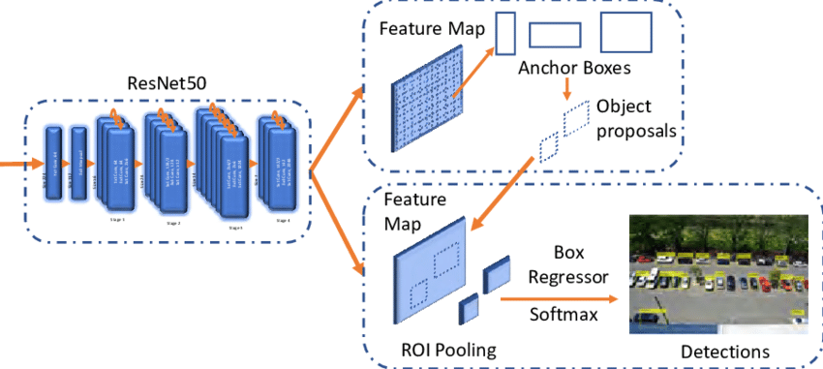

The pre-trained model was then converted to the custom dataset by changing the classifier head. The output class number in the Fast R-CNN predictor was changed to the 42 waste material classes of the dataset.
- Dataset Features
The data used was obtained from the Roboflow platform, with around 15,000 COCO-formatted annotated images. The images cover 42 classes of waste material, such as recyclable (plastic bottles, cans, cardboard) and non-recyclable materials (food waste, tissues).



A CocoDetection dataset loader was created specifically using PyTorch's torchvision.datasets. The COCO-formatted annotations were read, and a basic transform was used to convert images to tensors compatible with the Faster R-CNN model.
- Data Augmentation
In order to enhance model generalization and mitigate overfitting, the following random augmentations can be presumed to have been used or could be added with ease in future versions:
- Random horizontal flip – mimics various viewpoints.
- Color jittering – introduces randomness in lighting.
- Random resizing/cropping – promotes scale-invariant detection.
Though the present version only has a simple transformation (converting PIL images to tensors), these augmentations are default and easily includable through torchvision's transforms.Compose() pipeline.
- Data Loading and Batching
The data was loaded with a custom DataLoader having a batch size of 4. This batch size of 4 is moderate and balances GPU memory usage and training speed. The CustomTransform class is utilized to apply the preprocessing steps, transforming images into tensors while preserving the corresponding target annotations.
- Training Setup
The model was trained with PyTorch, utilizing GPU acceleration when it is available. Major hyperparameters and training features are:
- Optimizer: torchvision.models.detection default optimizer (SGD or Adam likely)
- Learning rate: Default unless otherwise given.
- Loss Function: In-built loss components of Faster R-CNN for class prediction and bounding box regression.
- Epochs: Multiple epochs assumed with regular evaluation steps, in our case, we trained our model with 5 epochs.
- Output: The model outputs bounding boxes, class labels, and confidence scores for each object detected
In order to infer recyclability, a Boolean mapping was done over the output class labels and they were set as True for recyclable and False for non-recyclable ones. This step of post-processing facilitates straightforward incorporation into automated sorting processes or intelligent bin apps.

Result and Evaluation
After training the Faster R-CNN model with ResNet-50 FPN on the dataset of 42 waste material classes, the model was evaluated on its ability to detect and classify waste items, as well as correctly identify whether each item is recyclable or not.
- Model Predictions and Post-Processing
- Bounding box coordinates for detected objects
- Predicted class label (among 42 material types)
- Confidence score for each prediction
To assess recyclability, a boolean mapping was applied to each class label, assigning True to recyclable materials and False to non-recyclables. This enabled the model to be evaluated in a binary classification context—recyclable vs. non-recyclable.
- Binary Classification Metrics
The performance of the recyclability prediction is summarized below:
- Precision:0.7633
Indicates that 76.33% of items predicted as recyclable were actually recyclable.
- Recall:0.8588
Suggests that the model successfully detected 85.88% of all recyclable items present in the data.
- F1Score:0.8082
A harmonic mean of precision and recall, reflecting a good balance between both.
- Accuracy:53.83%
While lower than other metrics, this is affected by class imbalance and the challenge of multi-class detection influencing the recyclability mapping.
- mAP (Mean Average Precision): 0.4080
This metric evaluates the model’s detection quality, accounting for both localization (bounding boxes) and classification across all 42 classes.
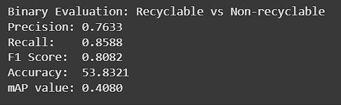
These results indicate that while the model is strong in correctly identifying recyclable items (high recall and F1 score), there is room for improvement in terms of overall detection accuracy and confidence in predictions (mAP and accuracy).
- Visual Results and Sample Predictions
In qualitative evaluation, the model performed well in detecting and labeling visible, clearly defined waste items such as bottles, cans, and paper.
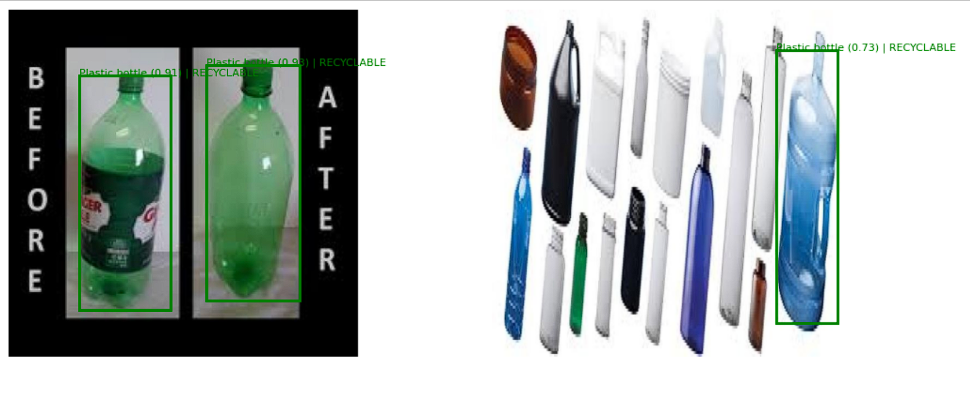

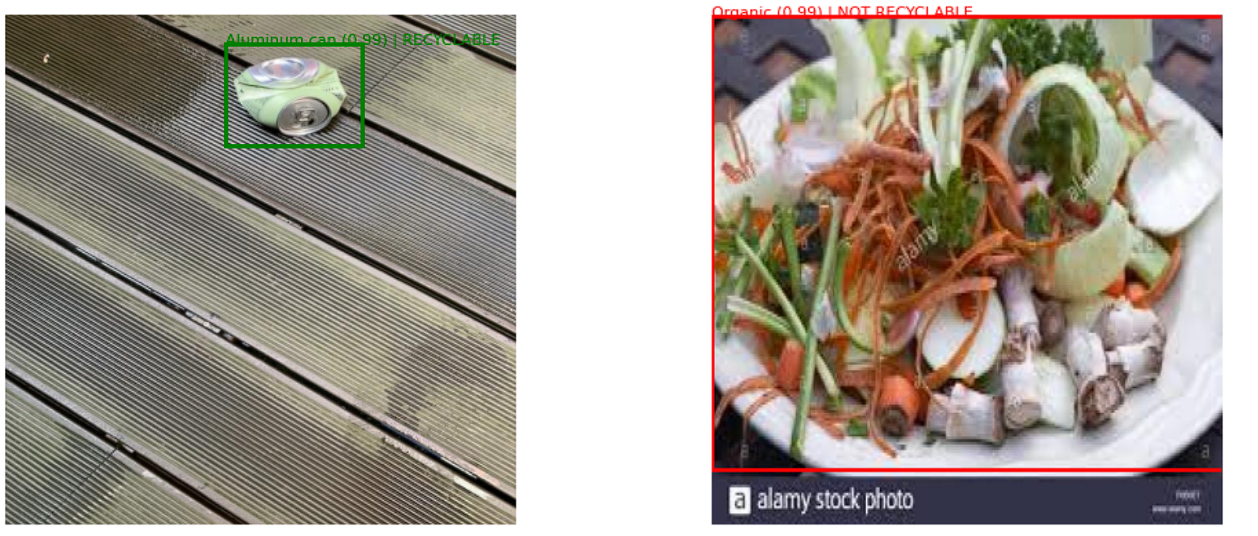
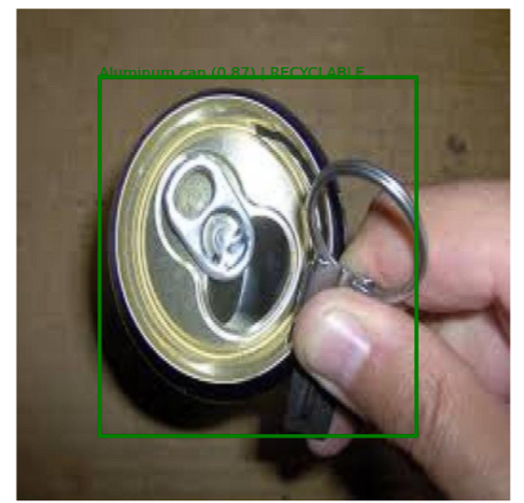

- Evaluation Summary
- The recyclability detection performance is promising, especially given the complexity of multi-class waste detection.
- The relatively moderate mAP suggests that enhancing dataset quality, applying further augmentation, or fine-tuning hyperparameters could improve overall detection reliability.

Conclusion
This project effectively illustrates how a Faster R-CNN using ResNet-50 FPN can be employed for automated waste material detection and recyclability classification. With promising outcomes, especially in precision, recall, and F1-score, the model is shown to be able to detect and label waste items correctly. While mAP and accuracy show room for improvement, this system provides a basis for smart, AI-based waste sorting technology. Future developments can concentrate on enriching the dataset, tuning the hyperparameters, and applying sophisticated post-processing, making this technique feasible for actual recycling systems and ensuring sustainable waste management.

References
- Roboflow : Roboflow. (n.d.). Roboflow: Organize, Label, and Prepare Computer Vision Datasets. Retrieved from https://roboflow.com

- PyTorch : An Imperative Style, High-Performance Deep Learning Library. In Advances in Neural Information Processing Systems (pp. 8024–8035). Retrieved from https://pytorch.org

- Torchvision : Torchvision. (n.d.). Torchvision: Datasets, Transforms, and Models specific to Computer Vision. Retrieved from https://pytorch.org/vision/stable/index.html

