BRACT’s
Vishwakarma Institute of Technology, Pune
Practical Implementation Sheet
Department: CSE-AI Semester: 5 Academic Year: 2026-27
Division: E Batch: 3 Practical No: 1
Roll no: 63 PRN No: 12410410 Name of Student: Pratham Shelke
Subject Name : Deep Learning

Problem Statement : Install and configure TensorFlow/Keras in Google Colab. Perform data preprocessing, normalization, train-test split, and visualization on a sample dataset.

Algorithm :
- Start Google Collab and create a new notebook.
- Import the required libraries such as TensorFlow, NumPy, Pandas, Matplotlib, and Scikit-learn.
- Load a sample dataset (Iris Dataset).
- Display the first few records of the dataset.
- Check for missing values and dataset information.
- Separate features (X) and target labels (y).
- Normalize the feature values using Min-Max Scaling.
- Split the dataset into training and testing sets using an 80:20 ratio.
- Visualize the dataset using scatter plots and histograms.
- Import TensorFlow and Keras to verify successful installation.
- Display TensorFlow and Keras versions.
- Print the shapes of training and testing datasets.
- Observe and analyze the output.

Code :
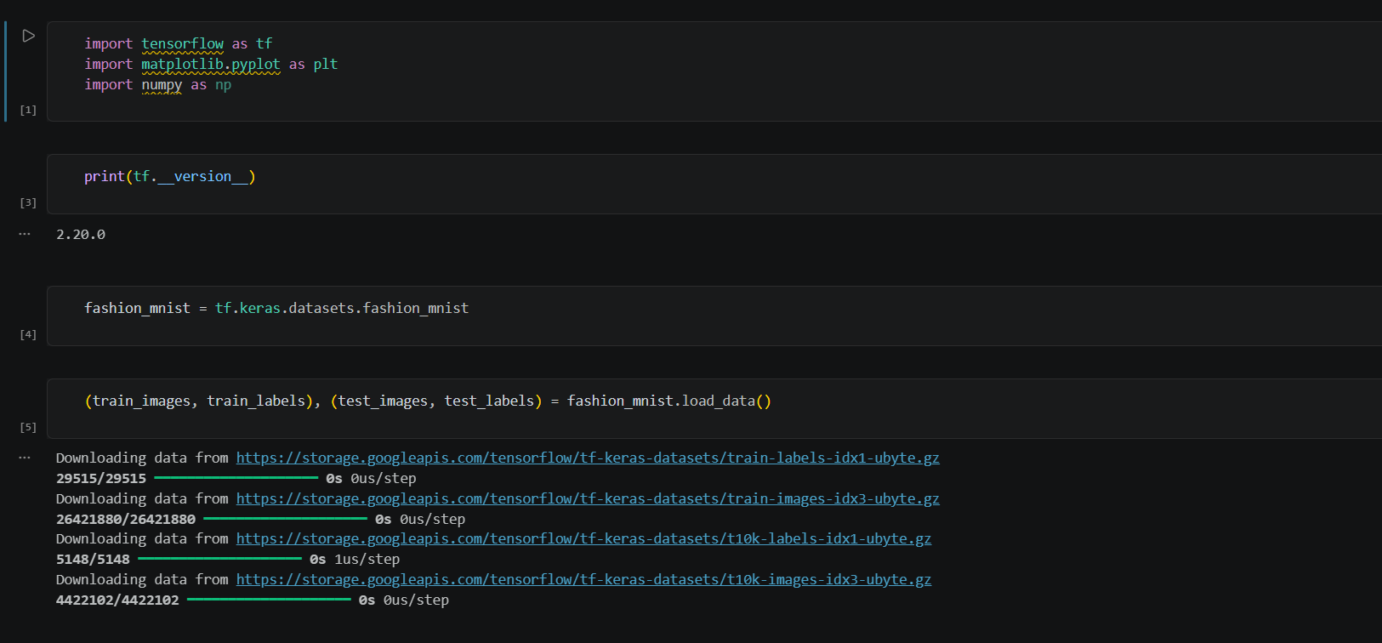
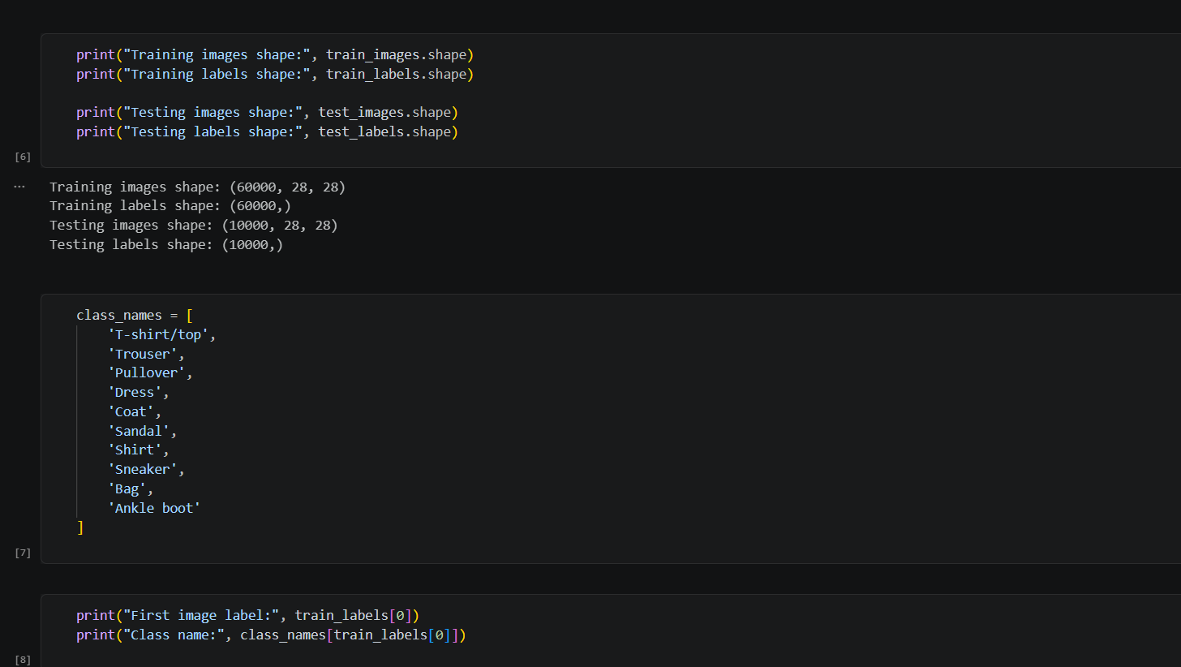
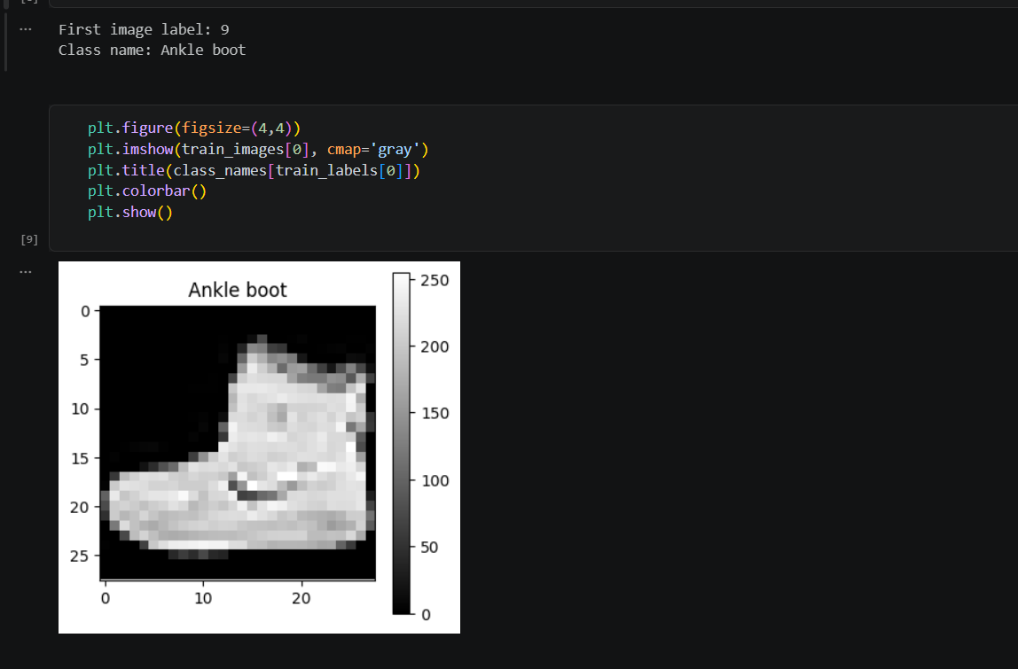
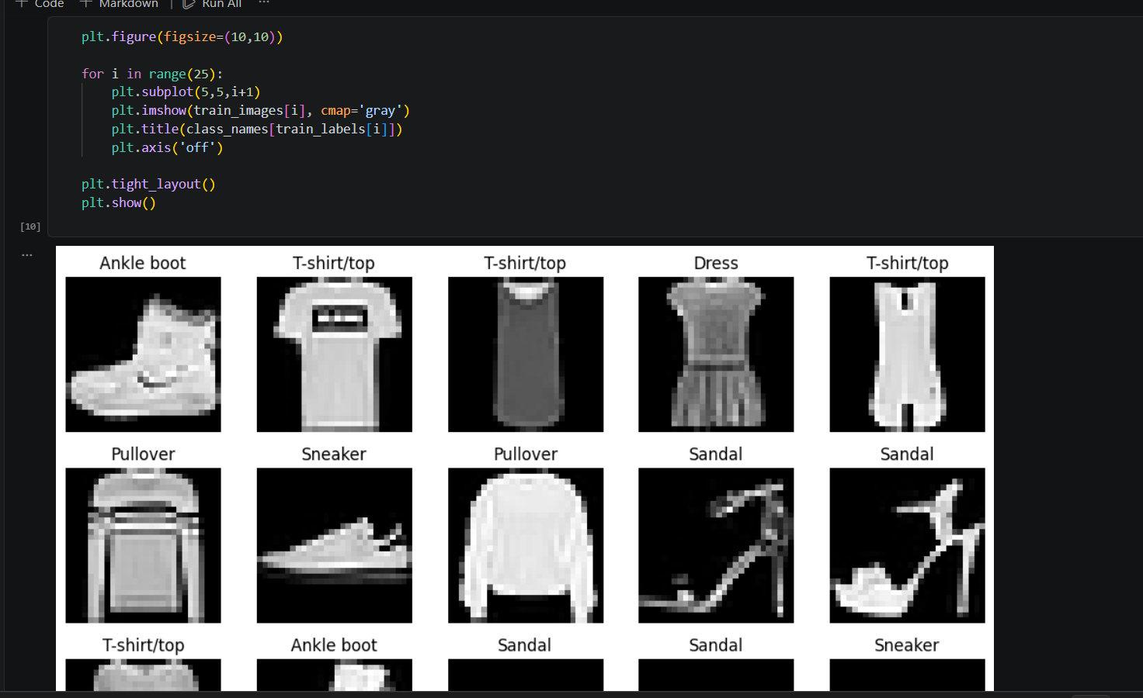
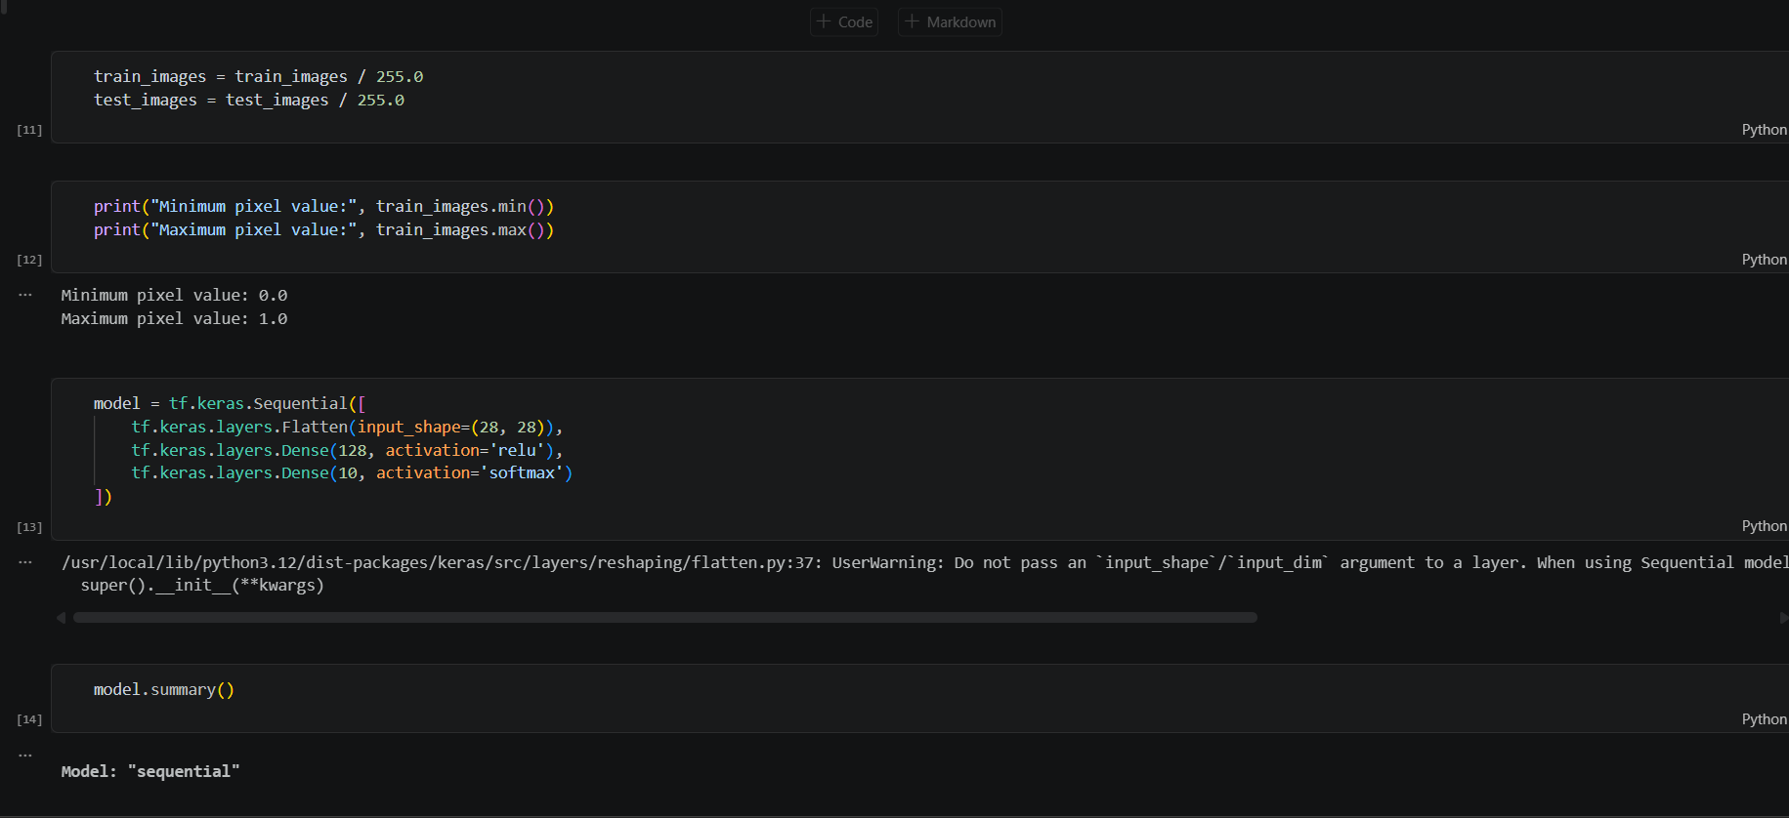
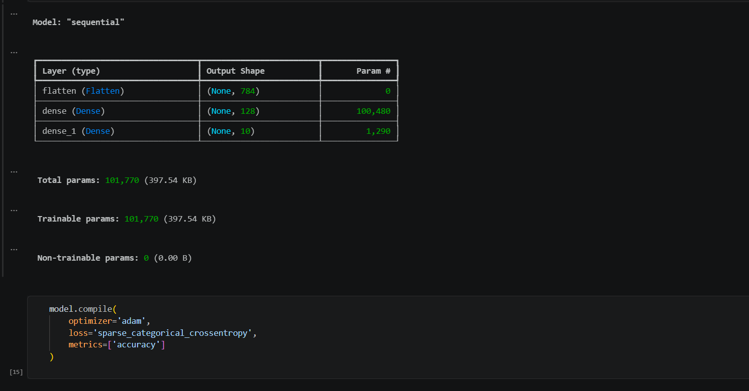
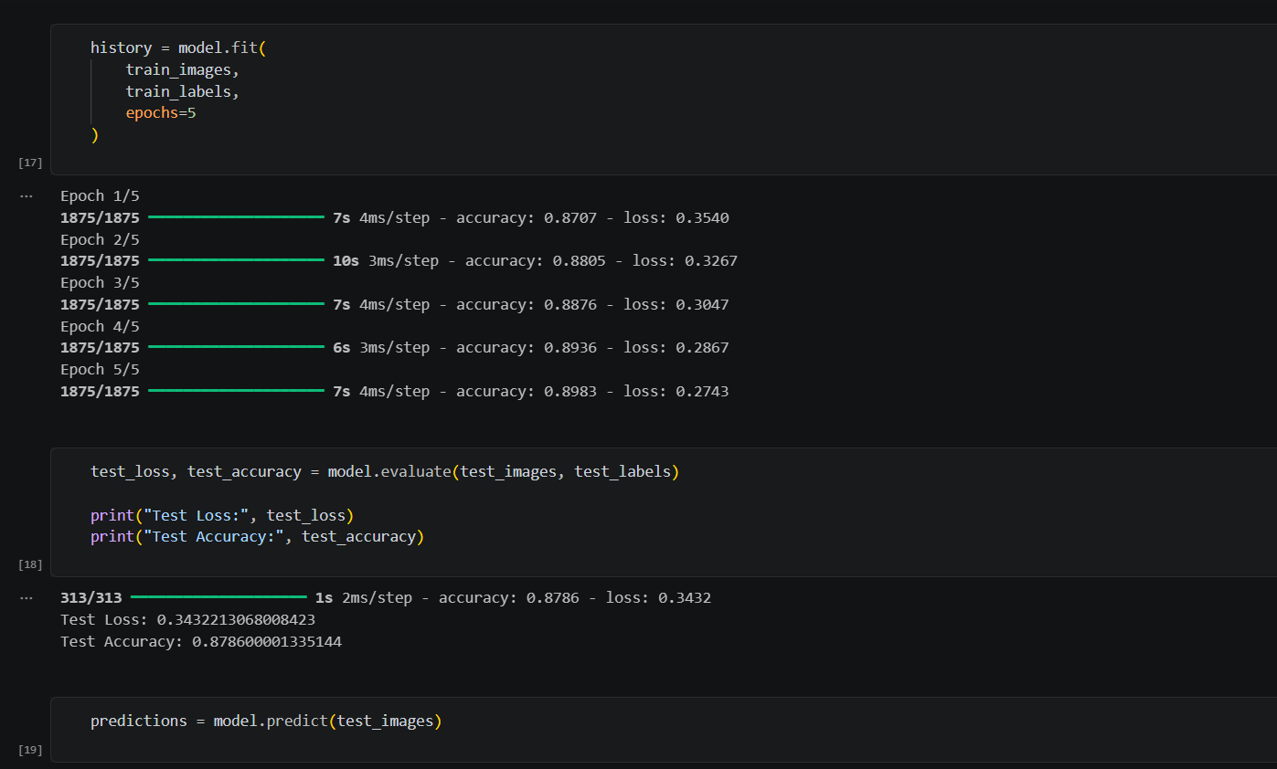
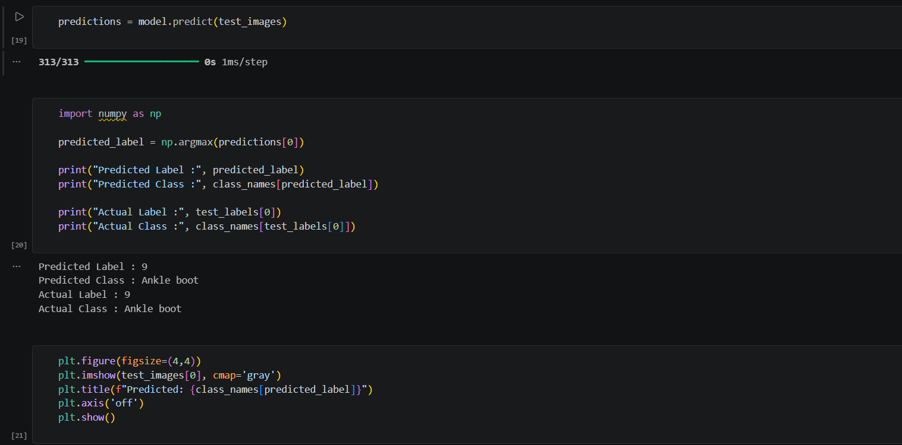
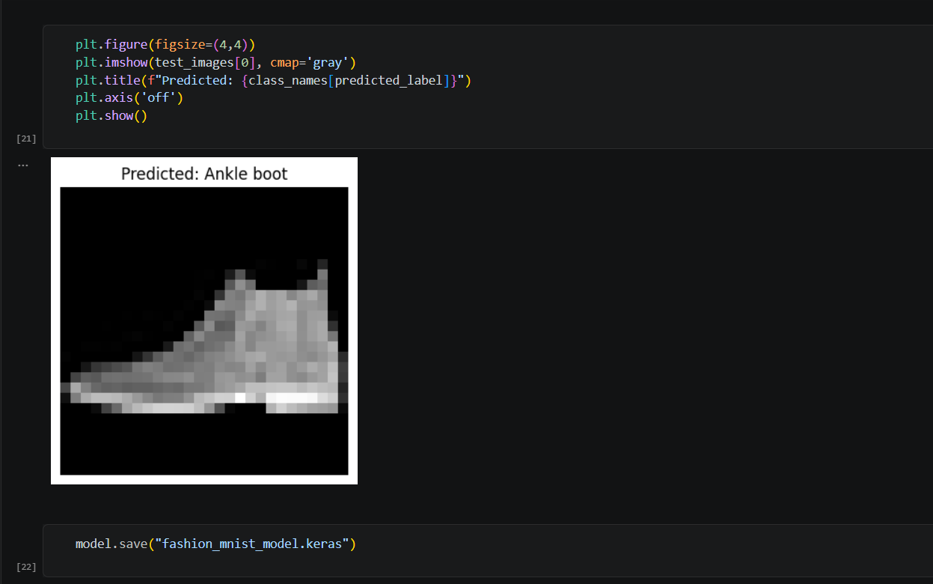
Output :
