BRACT’s
Vishwakarma Institute of Technology, Pune
Practical Implementation Sheet
Department: CSE-AI Semester: 5 Academic Year: 2026-27
Division: E Batch: 3 Practical No: 2
Roll no: 63 PRN No: 12410410 Name of Student: Pratham Shelke
Subject Name : Deep Learning

Problem Statement :- Design and implement a Multilayer Perceptron (MLP) for classification of the Iris or Wine dataset, and evaluate its performance using accuracy and a confusion matrix.
Algorithm :
- Import the required libraries..
- Load the Iris dataset containing:
150 flower samples
4 input features:
- Sepal Length
- Sepal Width
- Petal Length
- Petal Width
3 output classes:
- Setosa
- Versicolor
- Virginica

- Split the dataset into:
Training set(80%)
Testing set(20%)
- Standardize (normalize) the feature values using StandardScaler.
- Create the Multilayer Perceptron (MLP) model by specifying:
• Hidden layer with 10 neurons
• ReLU activation function
• Adam optimizer
• Maximum iterations = 500

- Train the MLP model using the training dataset.
- Use the trained model to predict the flower species for the testing dataset.
- Evaluate the model by calculating:
• Accuracy
• Precision
• Recall
• F1-score
• Confusion Matrix

Step 9: Plot the following graphs:
- Scatter Plot of Iris dataset
- Training Loss Curve
- Confusion Matrix
- Accuracy Bar Chart
Step 10: Display the evaluation results and graphs.

Code :
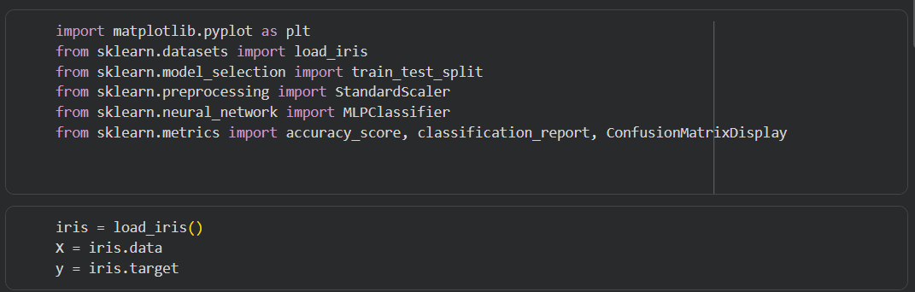
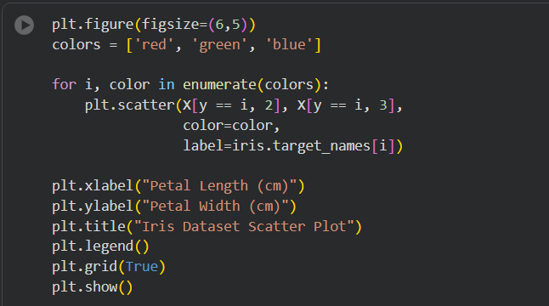
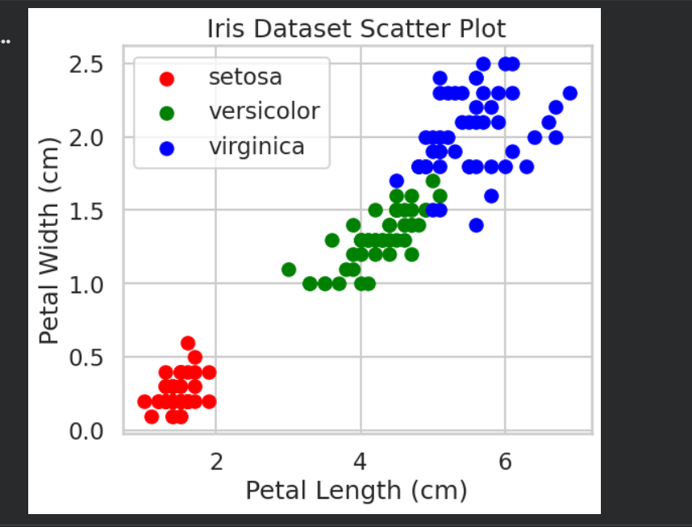
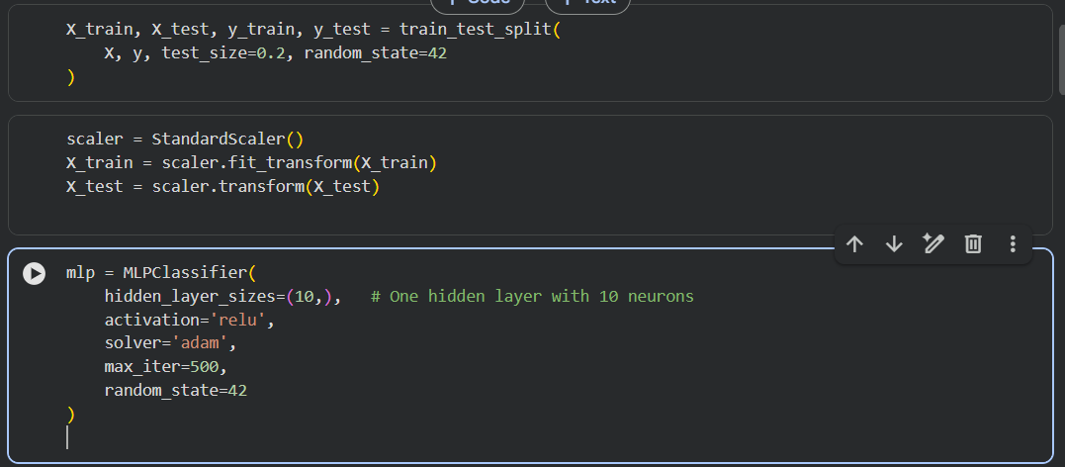
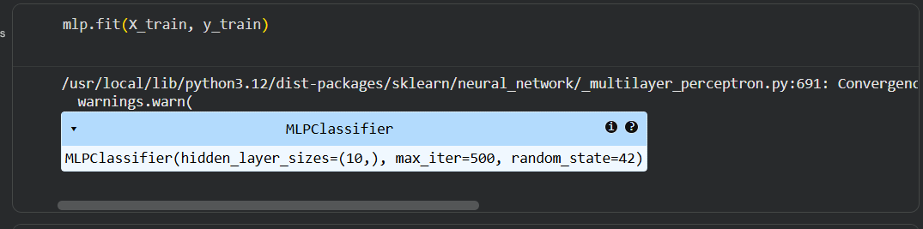
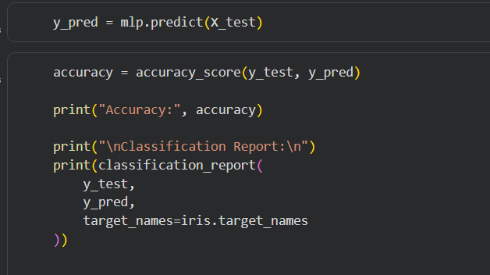
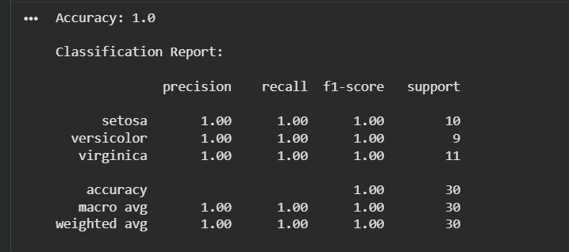
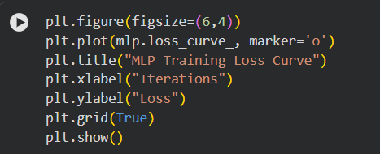
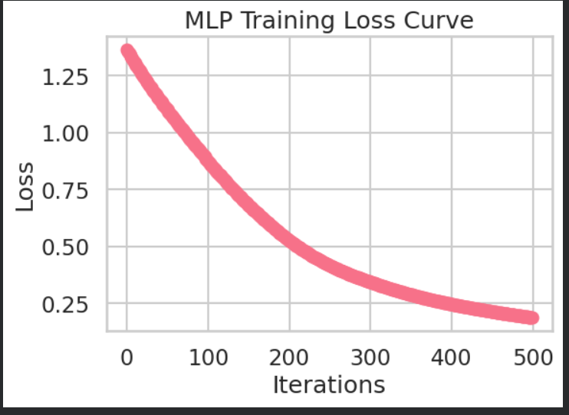
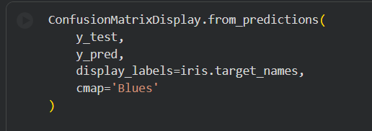
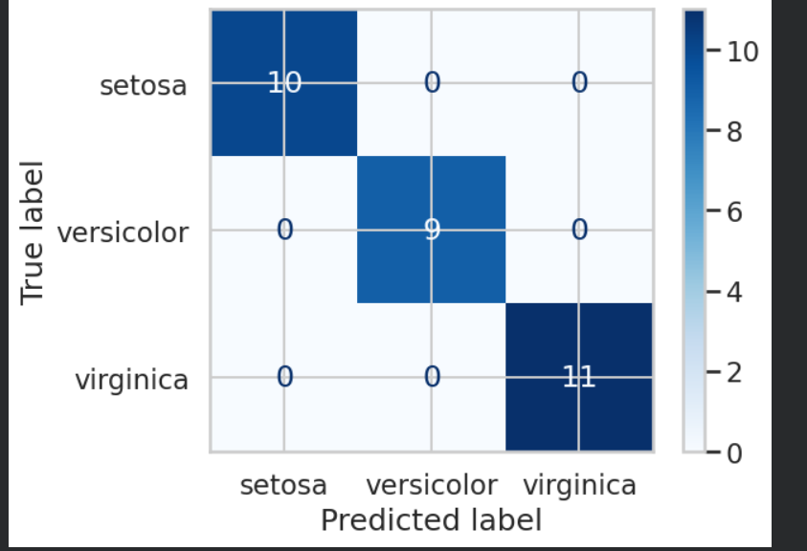
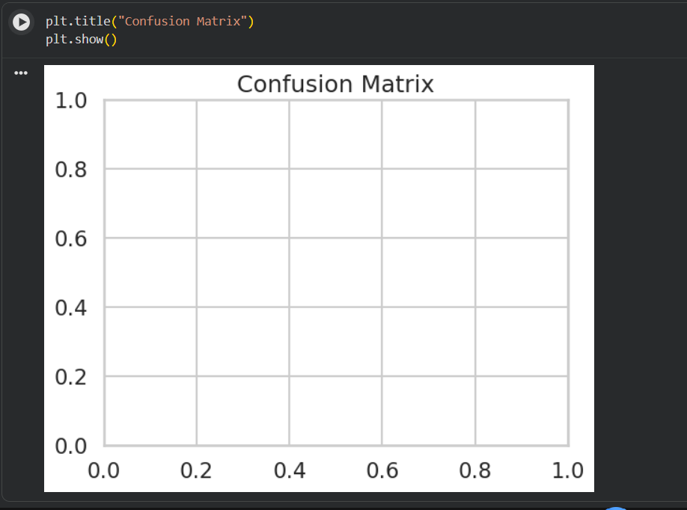
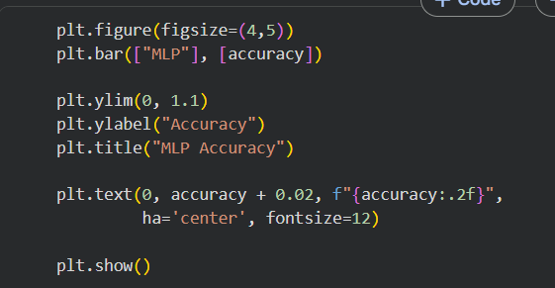
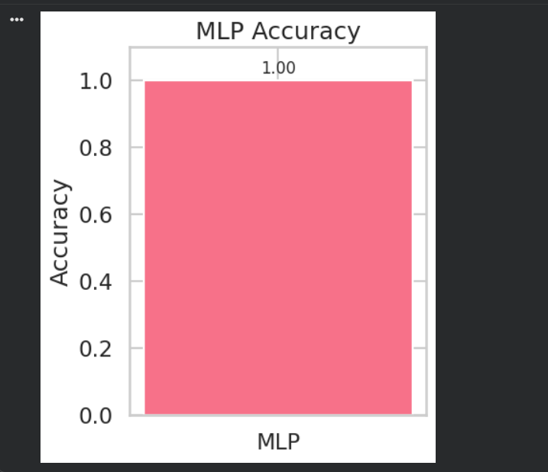

Output :
