GroundUp AI
Use Case Diagrams and Role Explanations
Website product documentation: actors, use cases, and the draw cycle
GroundUp AI helps real estate developers know where every dollar is going, where every delay is coming from, and whether project profit is at risk. It is the owner-side control layer for financial visibility, draw tracking, delay attribution, and profit-risk reporting.

1. Core concept
The platform keeps four data streams separate and reconciles them, instead of mixing them in one screen:
- Budget is the plan: budget sheet and schedule-of-values lines.
- Expenses are actual spend, supplied by the CFO as the expense sheet.
- Draws are lender funding: requested, approved, and funded amounts.
- Timeline compares planned and actual milestones and explains delay.

2. Roles at a glance
Role | Type | Main responsibility | Access
Owner / Developer | Internal | Provides all documents, chooses the GC and GC type, approves change orders, tracks missing items, builds the draw packet, shares investor previews | Full
CFO / Accounting | Internal | Provides the expense sheet, matches expenses to budget lines, reconciles draws, exports variance reports | Financial modules
Project manager | Internal | Updates milestones, logs inspection status, tracks delay sources | Timeline and evidence
Investor / Partner | External | Views project health, next funding event, and monthly update | Read-only
GC (fixed contract) | External | Submits milestone claims, completion proof, and change orders | Limited submission
GC (daily updates) | External | Posts daily updates, invoices and costs, daily photos, and change orders | Limited submission

The owner decides which GC type applies to each project. Admin or coordinator work (collecting documents, tracking missing items, building the draw packet) belongs to the owner.

3. Combined use case diagrams
Each project has one GC, and the owner chooses the GC type. The platform therefore has two combined diagrams: one for a project with a fixed contract GC and one for a project with a daily-updates GC. Both show every other actor: owner, project manager, investor, and CFO. Purple marks the internal team and teal marks external parties.

3.1 Project with a fixed contract GC
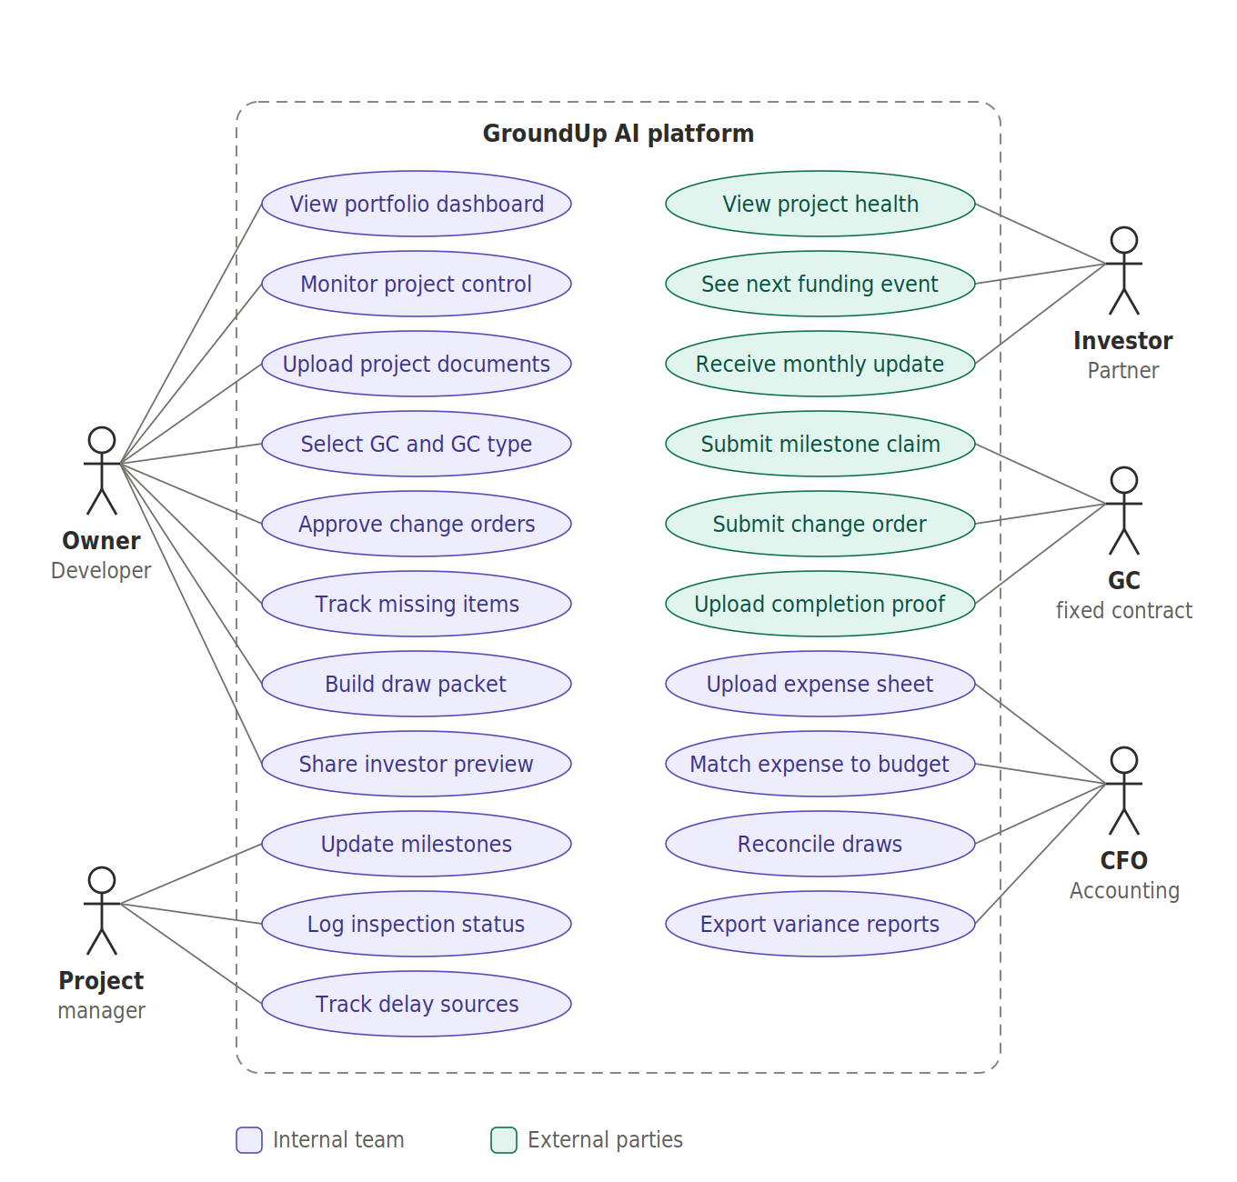
The GC submits milestone claims, completion proof, and change orders. The owner pays on milestones and does not see subcontractor-level invoices.

3.2 Project with a daily-updates GC
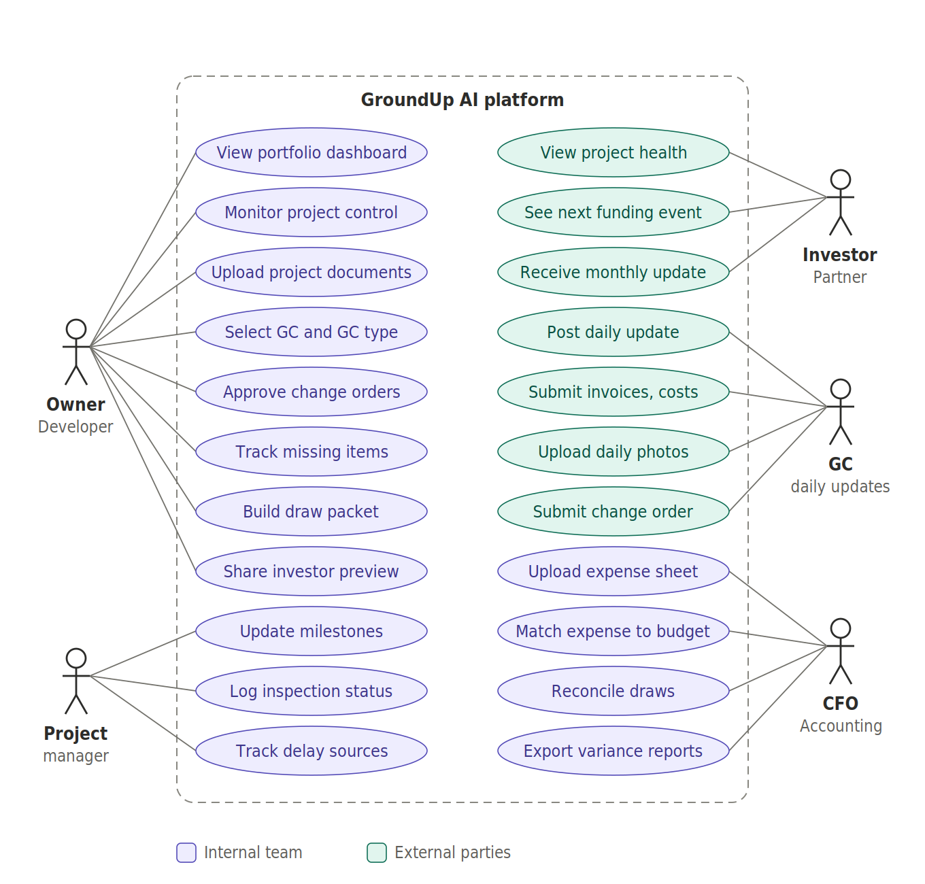
The GC posts daily updates, invoices and costs, and daily photos, plus change orders. The owner sees granular costs with the GC's markup shown separately.

4. Use cases by role

4.1 Owner / Developer
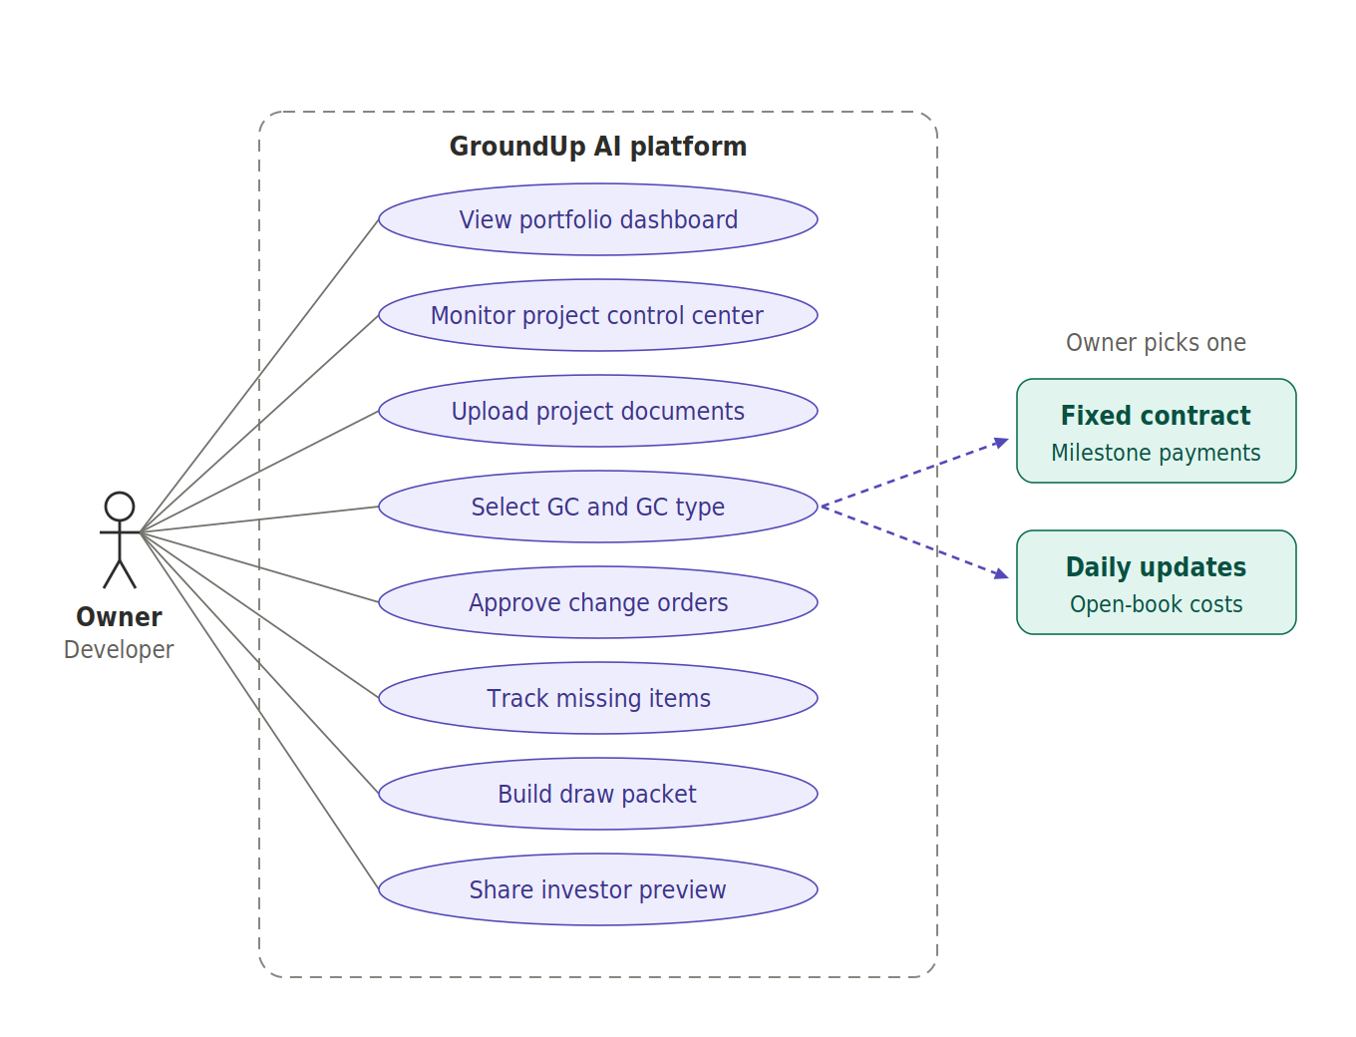
Goal: know financial health, profit, schedule risk, and what decision to make next. The owner is the primary buyer and the central role.
Use case | What the owner does | Outcome
View portfolio dashboard | Opens the home screen with project cards showing status, cash gap, delay days, next draw, and top alerts | Sees which project needs attention today
Monitor project control center | Reviews timeline (planned, actual, and expected start and completion), budgeted amount, actual spend, lender funded amount, progress %, photos and evidence, inspection status, fund status, units sold | One screen shows whether the project is healthy and why it drifts
Upload project documents | Uploads the documents listed below | Source of truth for budget, timeline, and loan data
Select GC and GC type | Chooses the GC and marks the contract as fixed or daily updates | Enables the matching GC workflow
Approve change orders | Reviews cost, reason, and impact on budget and timeline, then approves or rejects | No hidden or inflated change orders
Track missing items | Reviews outstanding documents and draw conditions | Nothing blocks a draw unnoticed
Build draw packet | Selects the draw period; the system lists eligible budget lines, invoices, photos, and open lender conditions and produces a portal-entry summary | Clean packet the owner submits through the lender portal
Share investor preview | Generates the read-only project health view | Investor confidence without exposing every invoice
Documents the owner provides
- Budget sheet and SOV (schedule of values)
- GC contract
- Timeline
- Bank statement
- Loan approval statement
- HUD statement
- Land acquisition statement

4.2 CFO / Accounting
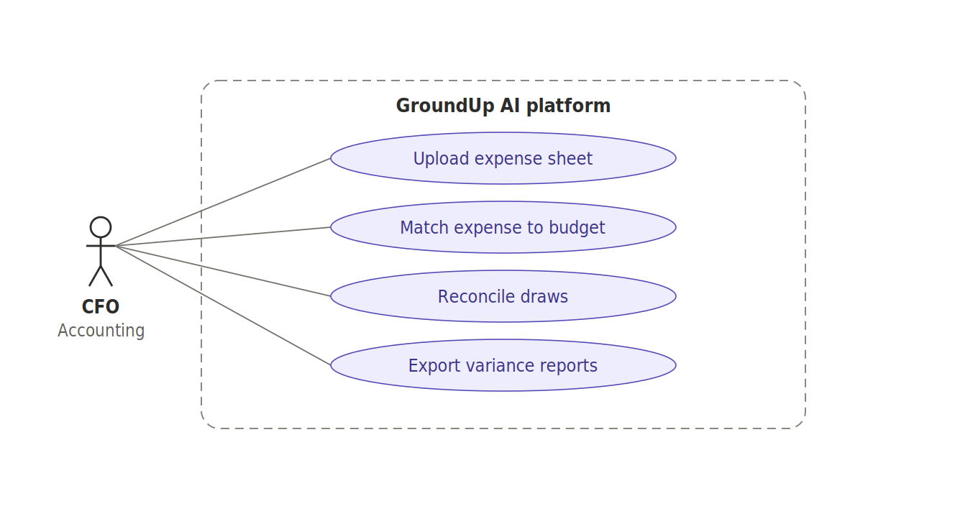
Goal: accurate expense categories, reconciliation, and budget variance. The CFO provides the expense sheet and the work that follows from it.
Use case | What the CFO does | Outcome
Upload expense sheet | Imports actuals (vendor, date, amount, description, payment status); the system normalizes vendors, dates, amounts, and categories | Clean ledger of actual spend
Match expense to budget | Confirms or corrects the system's match of each expense to a budget line; low-confidence rows go to a review queue | Budget vs actual and funded vs spent stay current
Reconcile draws | Compares actual spend with requested, approved, and funded draws | Cash gap and spend not yet drawn are visible
Export variance reports | Produces expense sheet, budget variance report, draw history, and summaries as Excel or PDF | Ready to share with owner, lender, or partners
AI suggests matches but never changes financial data without the CFO's approval.

4.3 Project manager
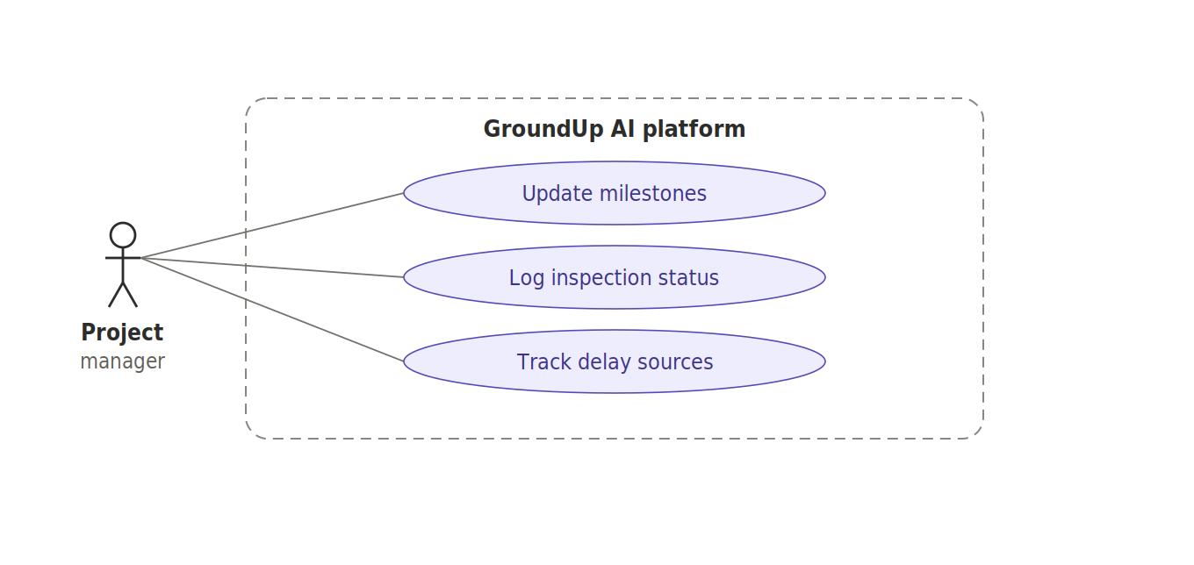
Goal: trade progress, inspections, and schedule slippage, with evidence behind each update.
Use case | What the PM does | Outcome
Update milestones | Records actual start and completion dates, expected completion, progress %, and photo evidence against the planned timeline | Timeline reflects reality
Log inspection status | Marks each inspection as scheduled, passed, failed, or delayed and attaches reports | Inspection risk is visible
Track delay sources | Tags the cause of a slip (plumbing, electrical, permit, inspection, GC coordination); the system records delay days and estimated interest and carry cost | Owner sees who or what causes delay and what it costs
Example: an electrical rough inspection planned for February happens in March. The app shows it 45 days late and ties that delay to the budget impact the owner sees.

4.4 Investor / Partner
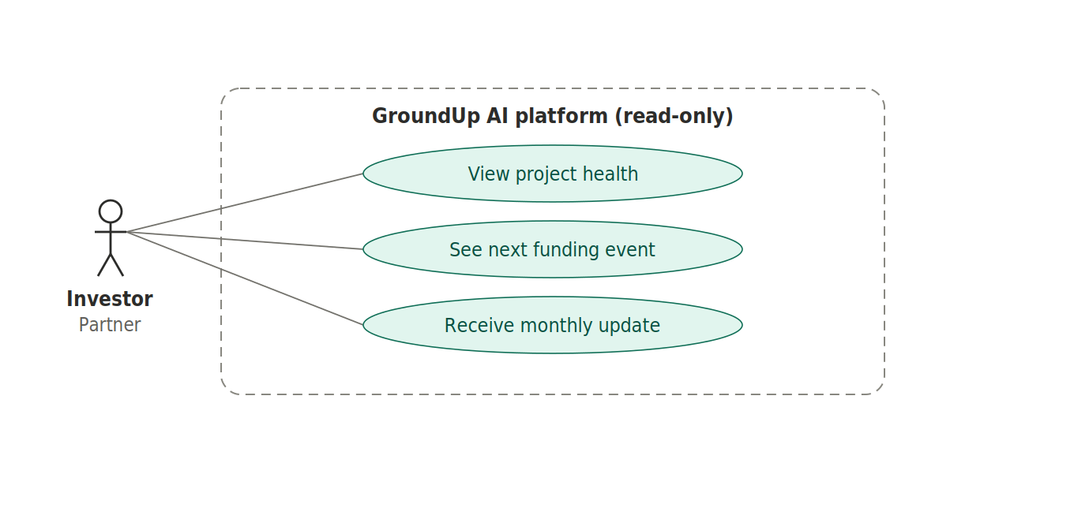
Goal: capital invested, project status, expected ROI, risk, and the next funding event. Access is read-only and exists only when the owner shares it.
Use case | What the investor sees | Outcome
View project health | Budget vs actual summary, timeline health, risk level, units sold | Confidence without detail overload
See next funding event | The upcoming draw and its expected timing | Knows when capital moves
Receive monthly update | Generated narrative update that the owner approves before sending | Regular, consistent reporting
Individual invoices, vendor-level detail, and internal issues stay hidden.

4.5 GC (fixed contract)
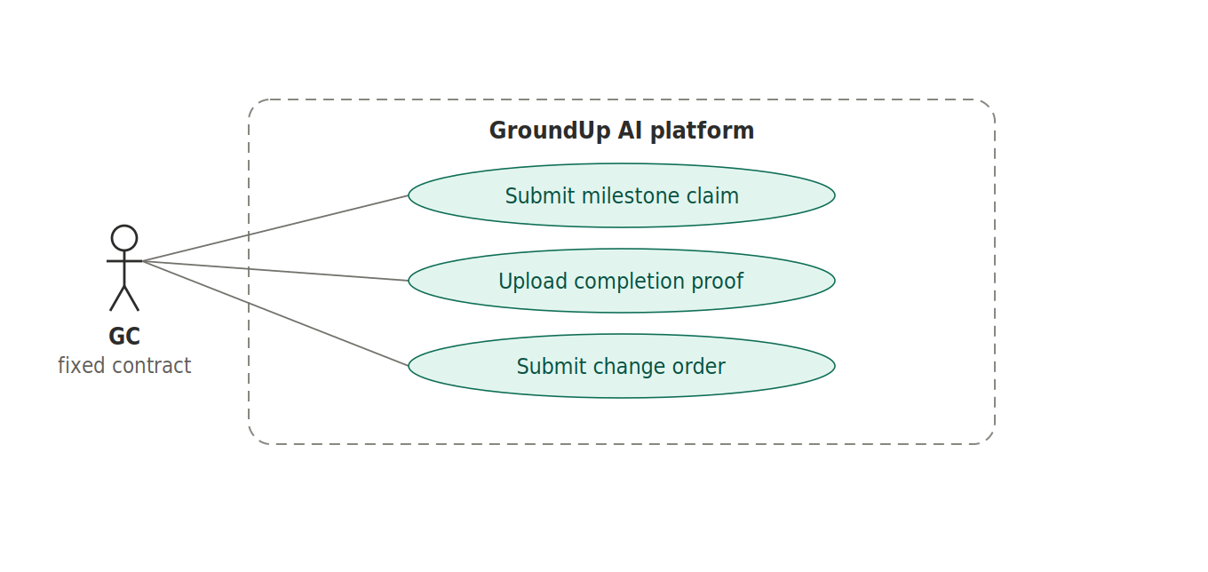
Goal: get paid on agreed milestones. The owner chooses this GC type when the project is a fixed or milestone contract, for example $2M total with site work $300K, framing $400K, and mechanical $350K.
Use case | What the GC does | Outcome
Submit milestone claim | Requests payment when a milestone is complete | Owner sees milestone status and payment due
Upload completion proof | Attaches photos and documents showing the milestone is done | Payment is backed by evidence and inspection
Submit change order | Enters scope, cost, and reason for work outside the contract | Routed to the owner for approval

4.6 GC (daily updates)
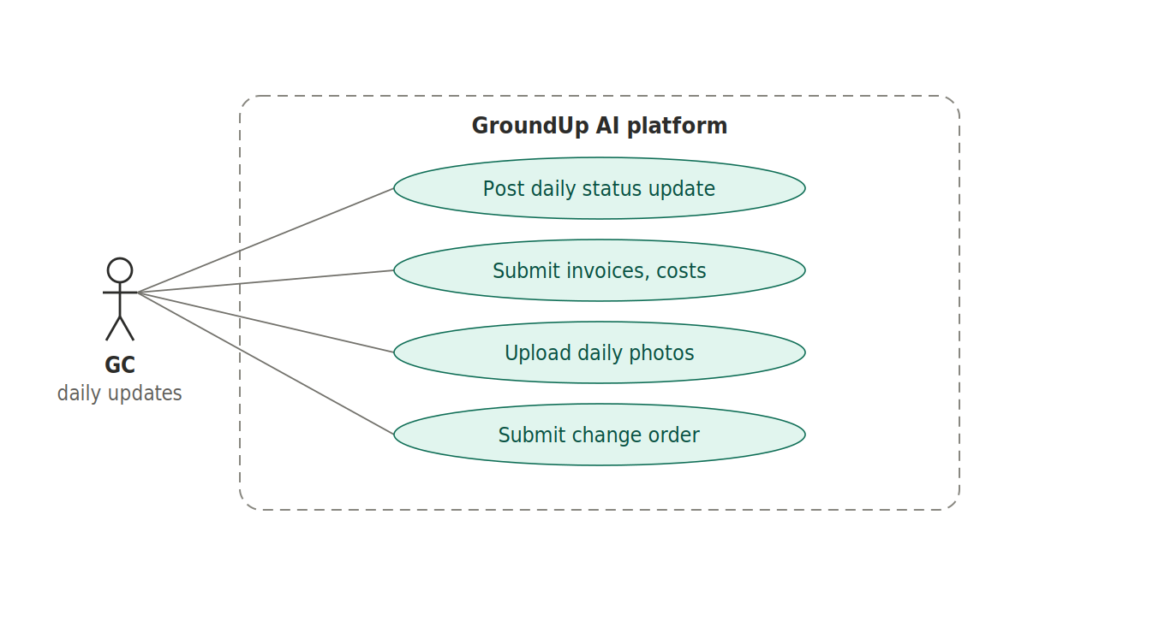
Goal: keep the owner informed every day while costs are tracked openly. The owner chooses this GC type for open-book, cost-plus, or partnership projects.
Use case | What the GC does | Outcome
Post daily status update | Reports progress, issues, and expected completion each day | Timeline and delay tracking stay current
Submit invoices, costs | Uploads invoices, checks, card transactions, and line-item costs | Granular actual cost for CFO reconciliation
Upload daily photos | Attaches site photos as progress proof | Evidence for progress % and inspections
Submit change order | Enters scope, cost, and reason for added work | Routed to the owner for approval
Fixed contract vs daily updates
 | Fixed contract GC | Daily-updates GC
Contract | Fixed total with milestone payments | Open-book / cost-plus: actual costs plus the GC's markup or profit share
Owner sees | Milestone status and payment due, without subcontractor invoice noise | Granular costs, with the GC's markup shown separately
Reconciliation | Pay on milestone, backed by proof and inspection | Line-item reconciliation of invoices, checks, and card transactions

A GC never chooses the type; the owner sets it per project. In v1 the GC is an input source, not the primary customer.

5. Draw cycle flow
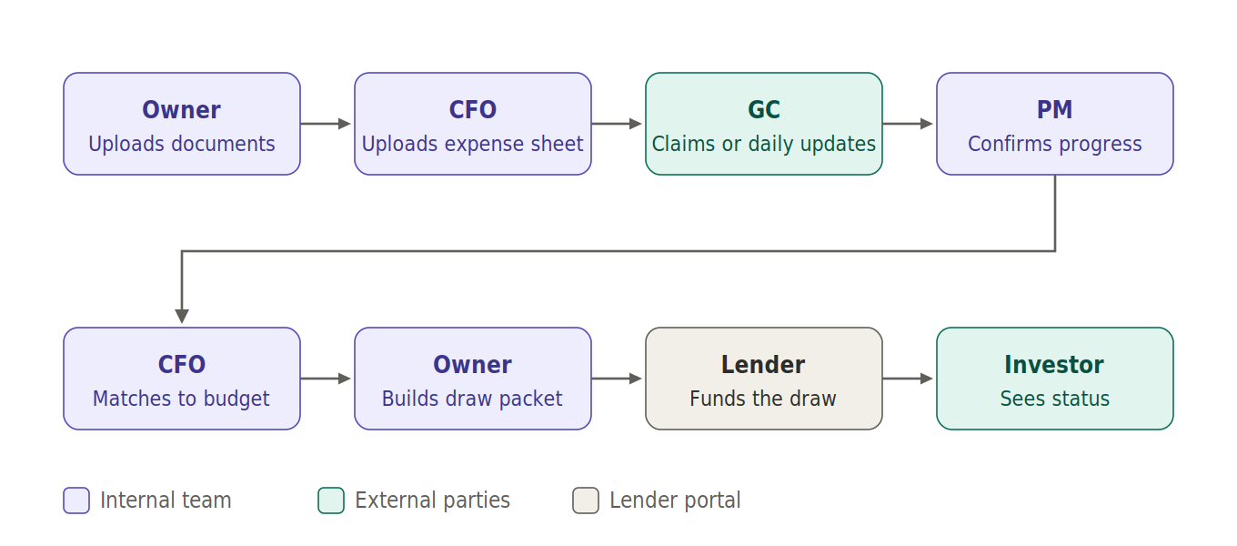
- Documents and spend: the owner uploads project documents, the CFO uploads the expense sheet, and the GC submits claims or daily updates.
- Progress: the PM confirms progress and inspections.
- Matching: the CFO matches expenses to budget lines.
- Packet: the owner checks missing items and builds the draw packet.
- Submission: the owner submits through the lender portal, and the lender funds the draw.
- Reporting: the investor sees the updated funding status.

6. Business rules
- Budget, expenses, draws, and timeline stay separate and are reconciled in reporting.
- AI suggests; humans approve. No financial data changes silently.
- GroundUp AI prepares draw packets but does not replace the lender portal.
- The owner selects the GC type per project.
- All change orders go to the owner for approval.
- Investors have read-only access to summaries, not internal detail.

