# **Sample BLOG App using MEAN Step-By-Step Guide**

# Initial Setup

* Create project folder (say sample-blog)
* Route to that folder using command-prompt (Git bash)
* npm init : to create package.json



Package.json is as follows:

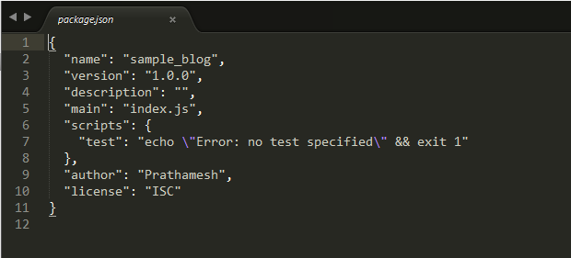

Install express: framework for nodejs via command npm install express –save

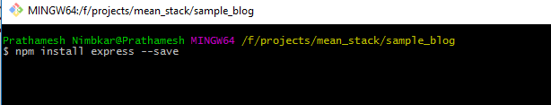

* - - save will save its dependencies in package.json and installs latest version of express.js to the application

# Create server.js file

* Create server.js file inside application folder with following code

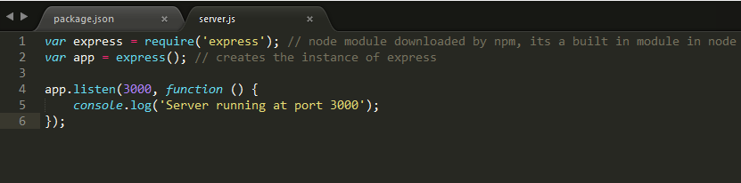

# Create static files (inside public folder)

* Serve static content for the app from the “public” directory in the application directory
* Add following code in server.js



* Create folder name as ‘public’ inside application
* Add index.html with some dummy content as <h2>Hello World! MEAN - Sample Blog</h2>
* Run server.js , this would output as

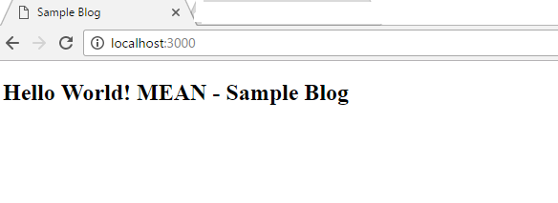

* Create <form> for entering Title and Blog using bootstrap
* Add AngularJS to libs folder and other related libraries in respective folder for eg : libs/css/bootstrap/bootstrap.css and so on…
* Add np-app=”SampleBlogApp” as module and add respective code in app/app.js



* The html/form be like

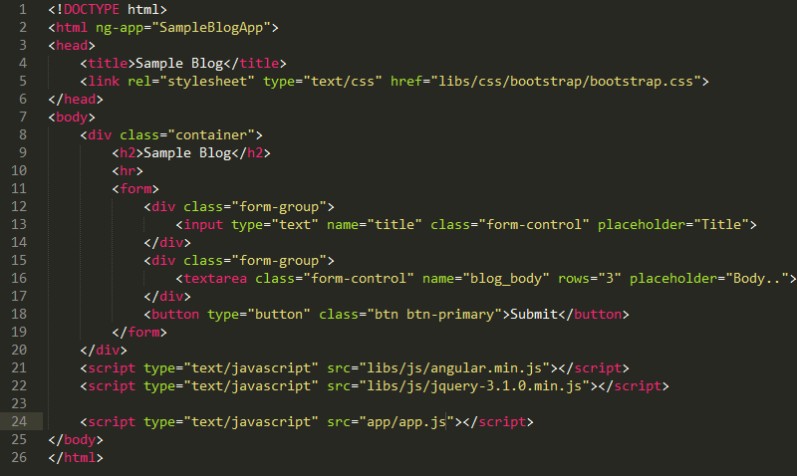

* This would output as

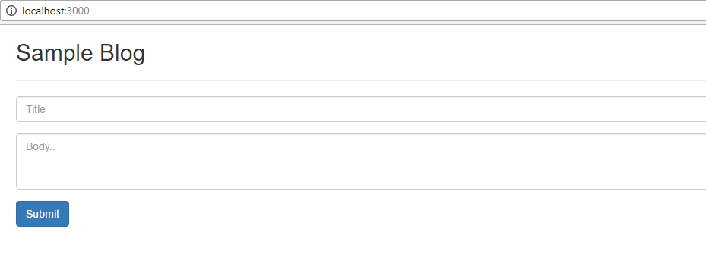

* Add code to get user inputs

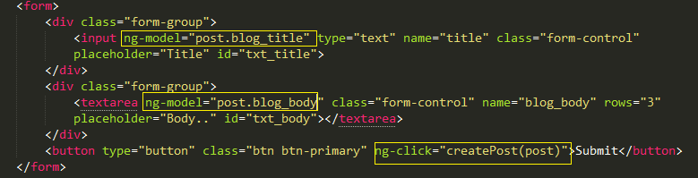

* This will output as

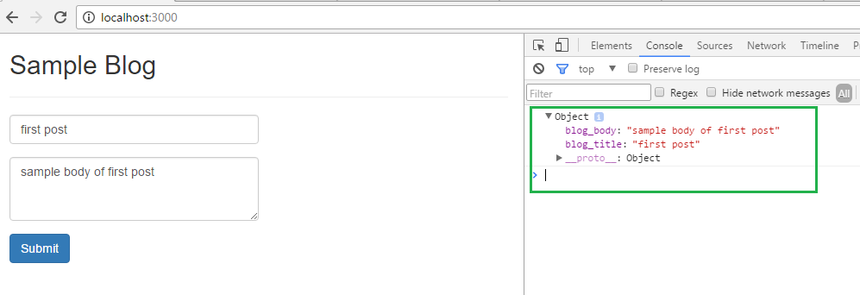

# POST form data to server

* Create Angular service as ‘SampleBlogService’ and inject $http to fire POST call to send the form data to server
* We use defer/promise

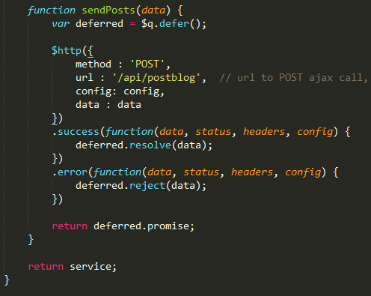

# Server side POST call handling

* Add POST call for handling REST call from UI side for url : /api/postblog
* With this call in place error 404 will be removed
* The server.js will have following call to handle this POST call



* This will output as “server responds to createPost ” on command lien console

# Add body-parser