*FLOWCHART*

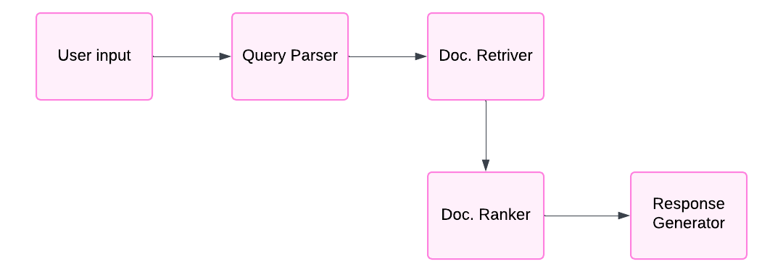

**Multi-Agentic Retrieval System**