Name:Prathamesh Channe

Roll : 64

Sub : Honors[MERN stack]

Assignment 1: CRUD application using react

Read-me file is added to with steps to run the code

Screen shots are added from next page onwards

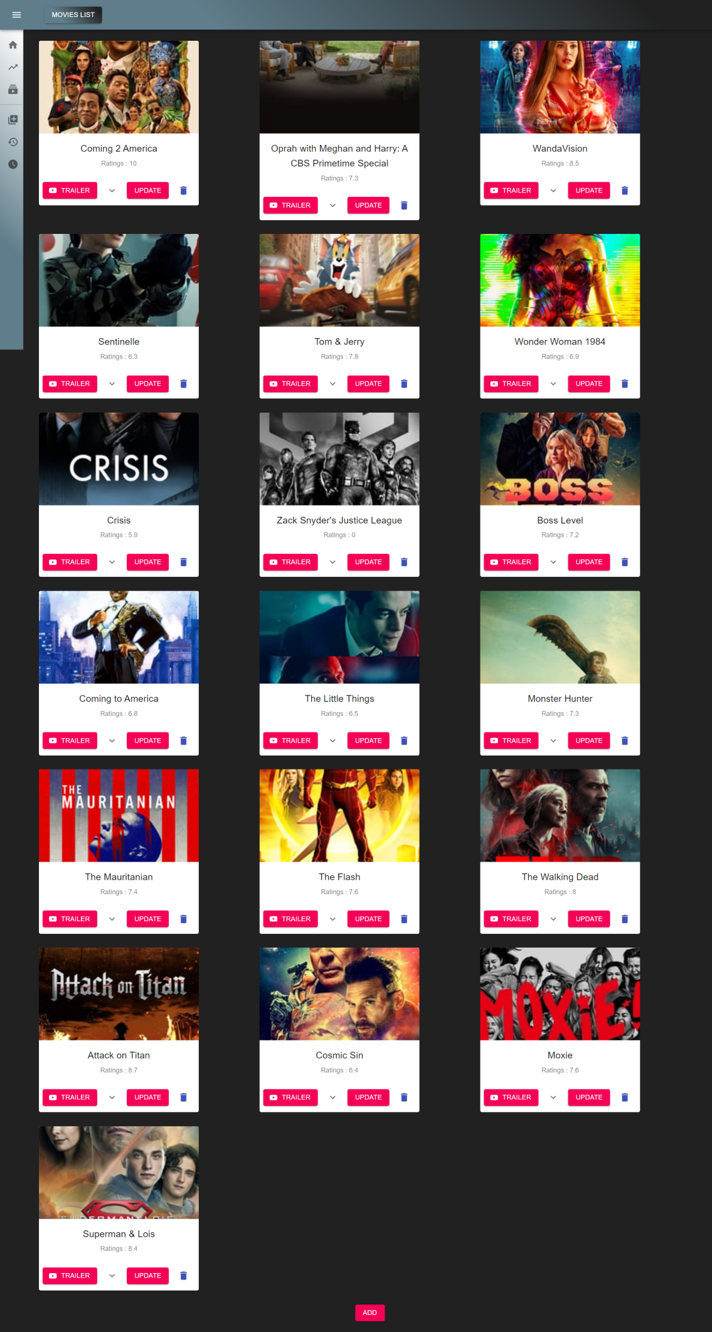

Add a movie card:

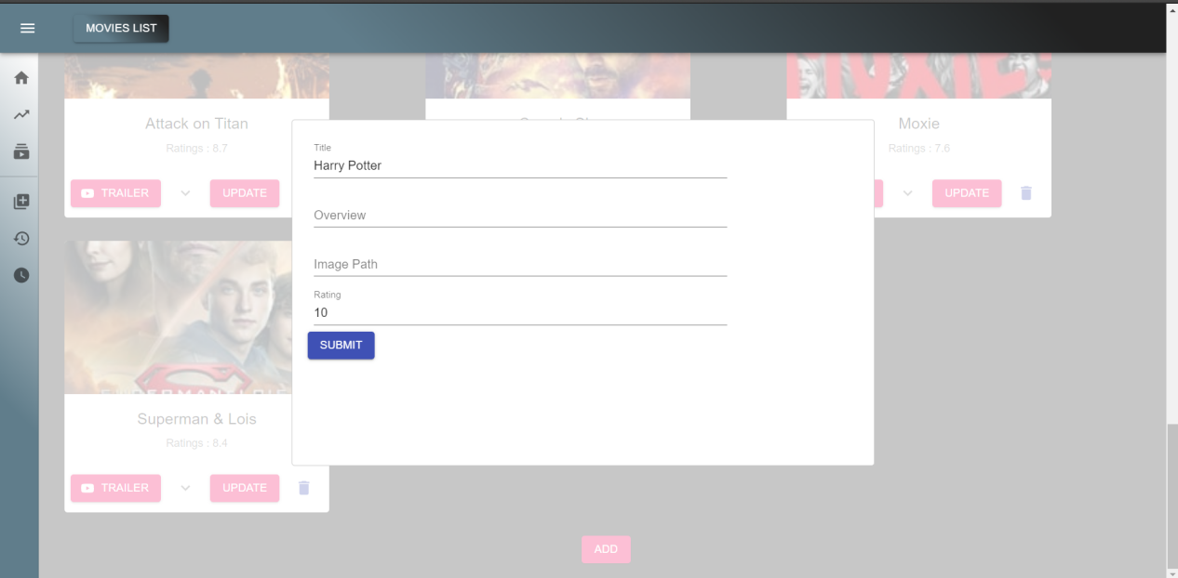

New card added:

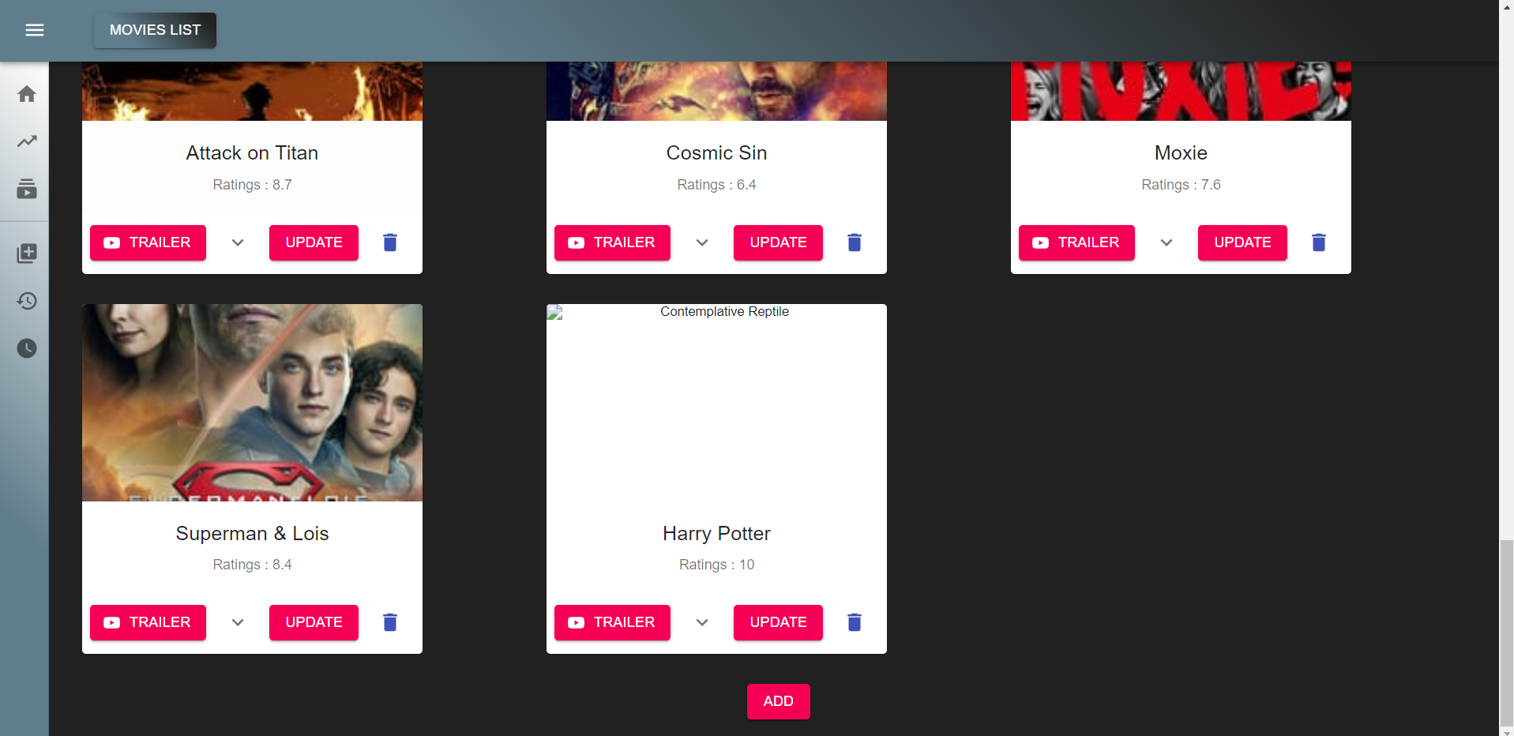

Update a movie card:

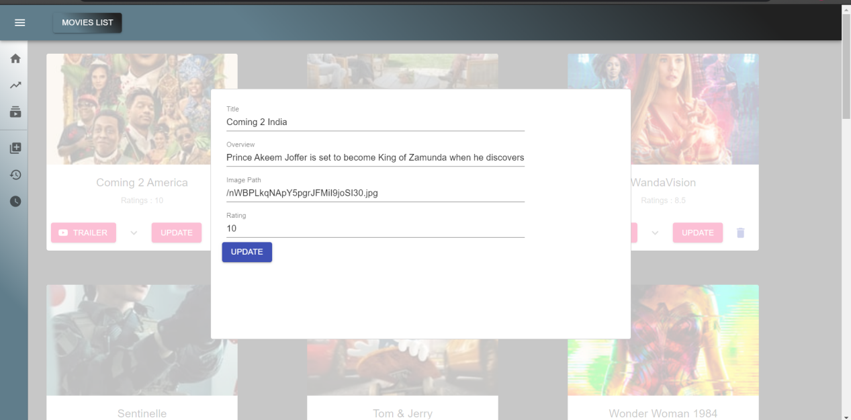

Card updated: Coming 2 Usa -> Coming 2 India

