Creating Docker image for User Server:

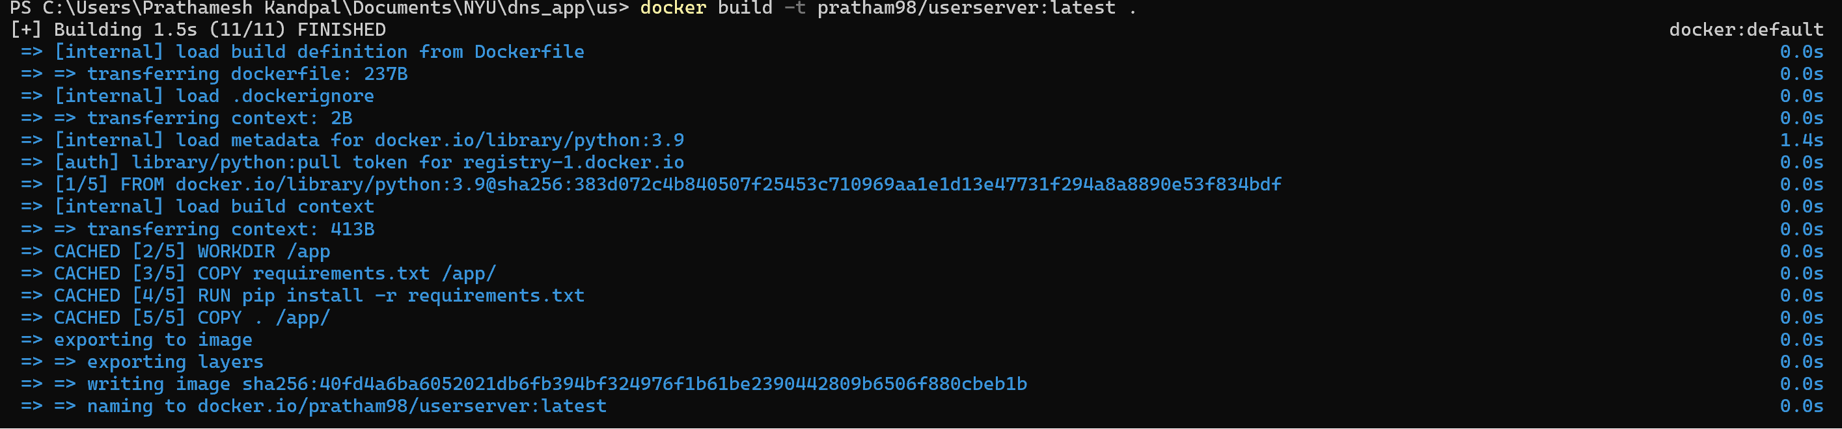

Creating Docker Image for Fibonacci Server:

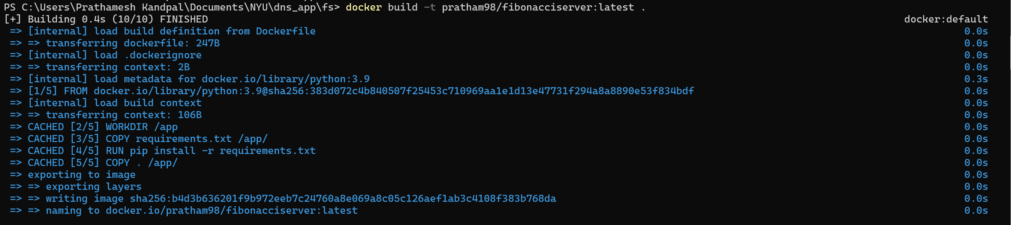

Creating Docker Image for Authoritative Server:

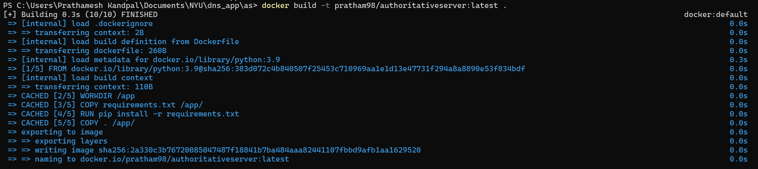

Creating a Docker network:  


Running the containers:  
 

Running inspect command to find IP Address of containers:

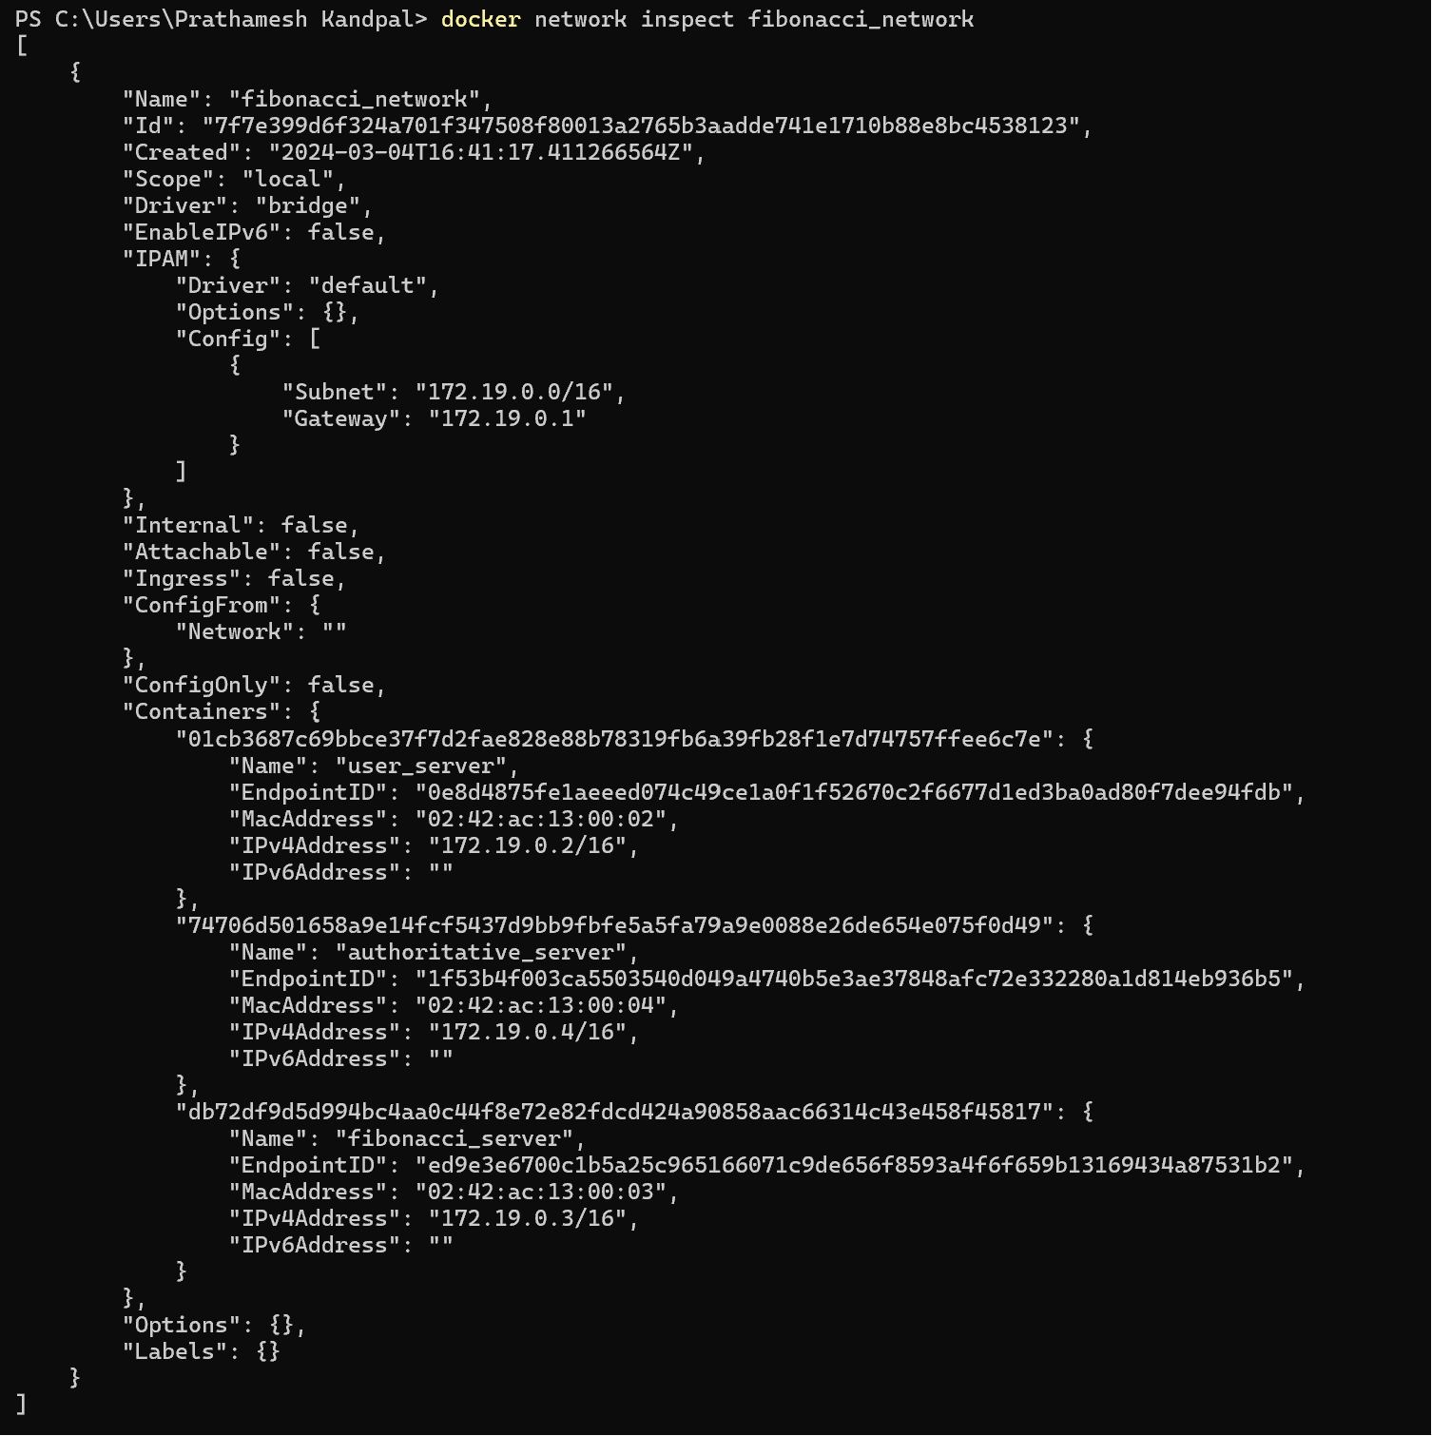

Pushing docker containers on docker hub:

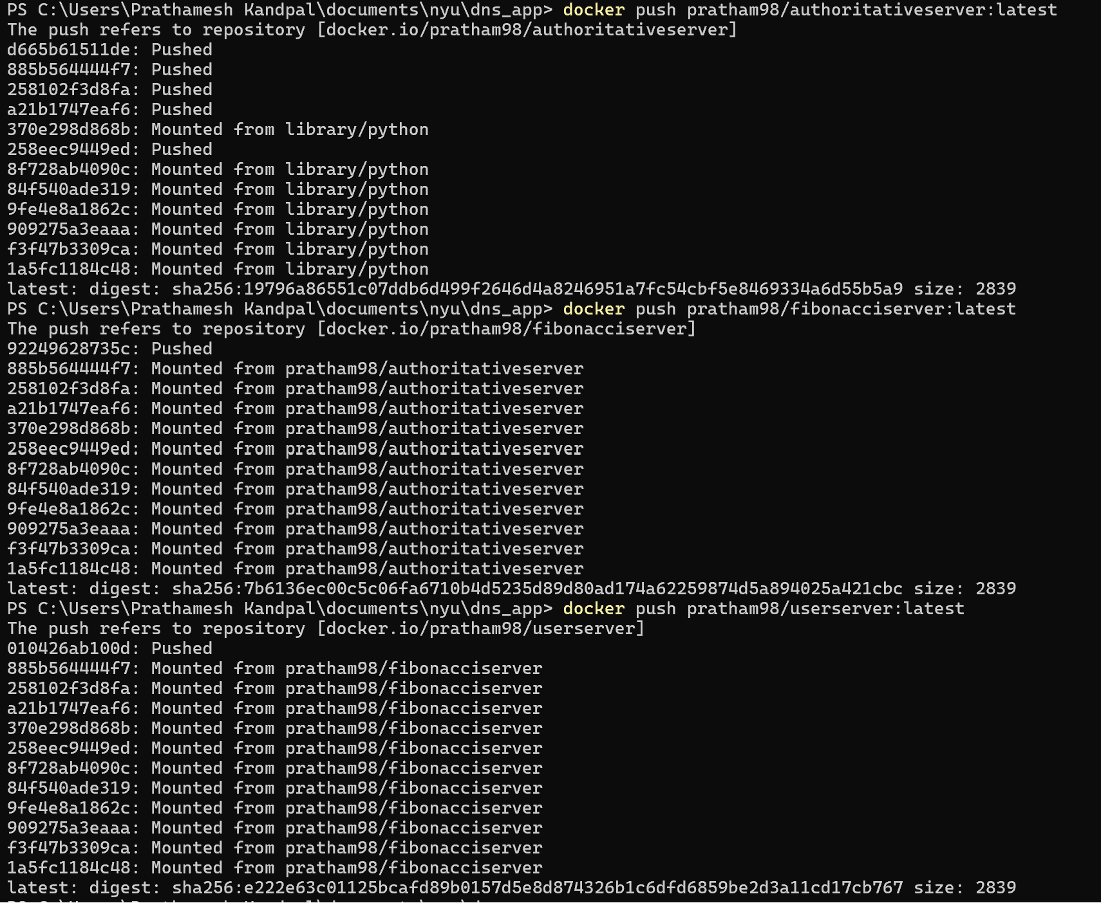  
Running test application:  


Deploying DNS file to Azure/Kubernetes:

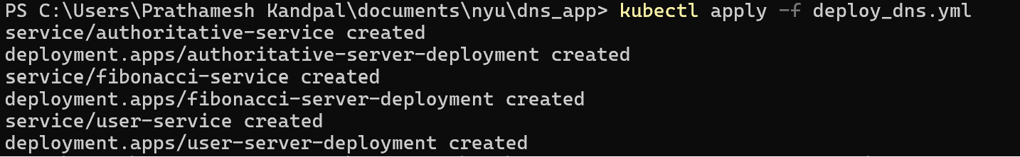

Commit to GitHub:

[prathamesh-kandpal/dns_app (github.com)](https://github.com/prathamesh-kandpal/dns_app)

