**CSCE 453 Assignment 2**

**Due: June 15, 2021 at 11:59pm on BeachBoard**

In this assignment, you will develop a simple photo album. The objective of this assignment is to practice what we learned in the class about activities and fragments

**Project Setup:**

The project contains just one activity (main). The main activity contains two fragments. The upper fragment shows pictures. The lower fragment shows the album controls (See snaps below)

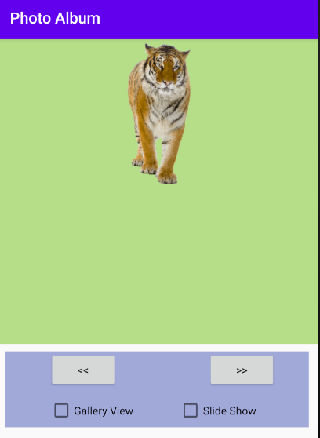

**Project description**

1. Once your app runs, the first image will be shown by default.
2. In this case the previous “<<” button is disabled.
3. Clicking the next “>> ”button will allow you to navigate to the next picture. And the “<<” will be enabled after you move to the second picture.
4. When you reach the end of images list the “>>” button will be disabled.
5. By clicking “>>” or “<<” you are going to replace the current fragment with another one with the correct image loaded (Check the example we did in the class, to find how to pass data to a fragment).
6. If a user checks Slide show then the images will be changed automatically based on a predefined time.
7. For images, you can use animal images or any other images.
8. Make your interface as clean as possible.
   1. Controls properly aligned.
   2. You don’t need to optimize the app for both tablets and phones. Choose one device and make the interface as perfect as possible for that.
   3. Colors are your choice, do not choose a color I don’t like!
   4. Be creative on the interface design, while you keep everything the same as this document, try to experiment and find little things such as control shadows, borders, fonts, etc

**Grading Requirements:**

1. (2pts) In an Activity the controls must be
   1. Properly aligned
   2. Work in both tablet and mobile (Just centralizing on the tablet screen would be sufficient for now)
2. (5pts) Your code should work exactly based on this document. If any part of the project is not clear to you it is your responsibility to ask me and clarify it. (Any misunderstanding in demo time is not acceptable)
3. (2pts) Coding style includes:
   1. Proper coding standard.
      1. Proper variable name
      2. Proper control name
      3. Proper Activity and resource name
   2. Comments
      1. On- line comment for code and block of code that does a certain task
      2. Any costume method, require comments explaining the functionality of the code (No more than 2-3 lines, this also can be a description of the inputs and outputs variables)
4. (6pts) Code presentation: In the presentation day, you will be asked about your code. Also, you should be able to explain methods and codes added by Android Studio as much as we covered in the class (onCreate for example).