**Question:**

Identify the number of islands from the adjacency matrix, where an "island" refers to a connected component within a graph, where the adjacency matrix represents edges between vertices or nodes. Suppose the amount of time to distribute resources between the nodes of island depends on the island’s Network Density, then identify the island which is most efficient.

|  |  |  |  |  |  |  |  |  |
| --- | --- | --- | --- | --- | --- | --- | --- | --- |
|  | A | B | C | D | E | F | G | H |
| A | 0 | 0 | 1 | 0 | 0 | 0 | 1 | 0 |
| B | 0 | 0 | 0 | 0 | 1 | 0 | 0 | 0 |
| C | 1 | 0 | 0 | 1 | 0 | 0 | 1 | 0 |
| D | 0 | 0 | 1 | 0 | 0 | 0 | 1 | 0 |
| E | 0 | 1 | 0 | 0 | 0 | 1 | 0 | 1 |
| F | 0 | 0 | 0 | 0 | 1 | 0 | 0 | 0 |
| G | 1 | 0 | 1 | 1 | 0 | 0 | 0 | 0 |
| H | 0 | 0 | 0 | 0 | 1 | 0 | 0 | 0 |

Network Density = Actual Connections / Potential Connections

Potential Connections = n(n-1)/2

Note:

The edges are undirected. If A, B, C, D form an island then name the island as A-B-C-D in alphabetical order.

|  |  |
| --- | --- |
| **Options:**  **(A)** : A-C-G  **(B)** : B-E-F-H | **(C)** : A-C-D-G  **(D)** : E-F-H |

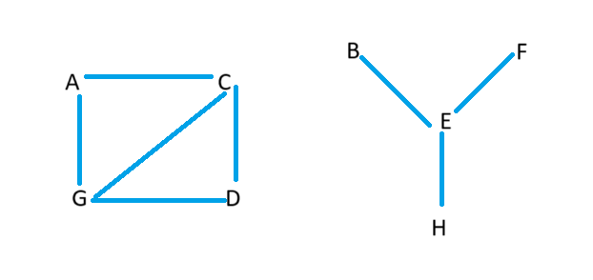**Answer:**

|  |  |
| --- | --- |
| Identifying islands: |  |
| Island 1: A-C-D-G | Island 2: B-E-F-H |
|  |  |
| Calculating Network Density for each island: |  |
| For Island 1 (A-C-D-G):  - Actual Connections = 5  - Potential Connections = 4(4-1)/2 = 6  - Network Density = Actual Connections / Potential Connections = 5 / 6 ≈ 0.833 | For Island 2 (B-E-F-H):  - Actual Connections = 3  - Potential Connections = 4(4-1)/2 = 6  - Network Density = Actual Connections / Potential Connections =3/ 6 = 0.5 |

The island with the highest Network Density is Island 1 (A-C-D-G), making it the most efficient in terms of resource distribution between its nodes.