SLE-3: Architectural Design (Full C4 Model)
Course: 02AML204 — Introduction to Artificial Intelligence
PRN: 25UAM091
Name: Prathamesh Shivaji Shingate
Division: B
Date: 01-10-2026
GitHub Link: https://github.com/prathamesh123375
1. System Title & Short Description
Maze Solving & Profiling System (DFS vs BFS). This is the same system I built in SLE-1 and profiled in SLE-2. It generates a random “perfect” maze (a spanning tree carved with a randomized-DFS backtracker, so exactly one path joins any two cells) and finds a path from the top-left to the bottom-right cell using two uninformed search algorithms: iterative stack-based DFS and queue-based BFS. The problem it solves is a fair comparison of the two strategies: both run on the same maze with the same neighbour order, the nodes expanded are counted, each run is timed, and the solvers are profiled with cProfile to see where the time goes.
2. Context Diagram (Level 1)
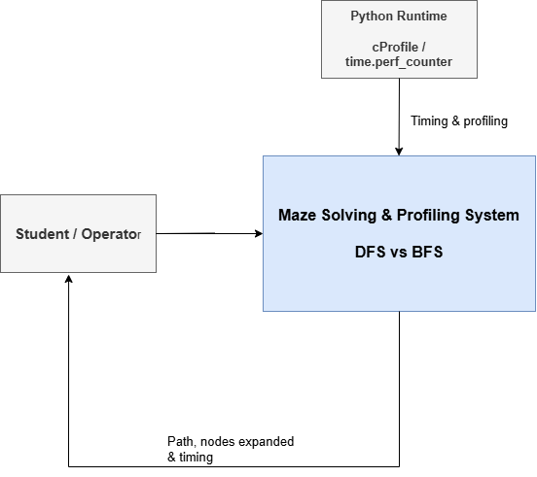
Short explanation: The Student (operator) runs the experiment script and chooses the maze sizes (5x5, 12x12, 25x25). The Maze Solver & Profiling System returns the path found, the nodes expanded and the timing. It depends on three outside things only: the Python runtime (cProfile and time.perf_counter) for measuring, draw.io tool for drawing charts, and the SLE-2 Word report, where the figures and tables are finally used. There is no database or network service.
3. Container Diagram (Level 2)
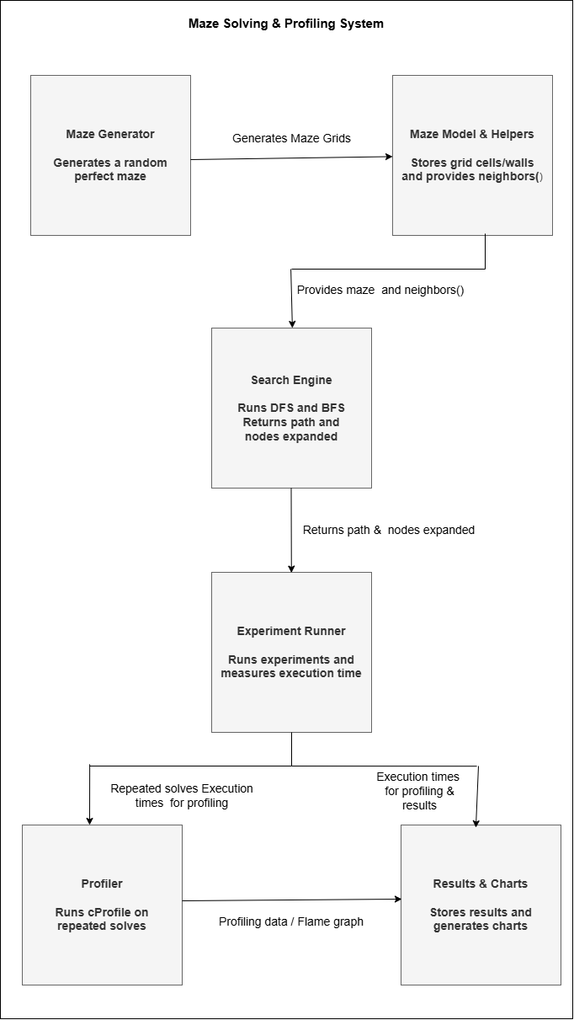
Explanation of each container:
- Maze Generator: generate_maze() carves a perfect maze with a randomized-DFS backtracker.
- Maze Model & Helpers: grid cells and walls, plus neighbors(), which gives reachable cells in a fixed order (Up, Left, Down, Right).
- Search Engine: dfs_solve() and bfs_solve() find the start-to-goal path and return it with the nodes-expanded count.
- Experiment Runner: run_experiments.py generates mazes, calls both solvers (5 runs on each of 3 sizes) and times them with time.perf_counter().
- Profiler: runs cProfile on 200 repeated solves of the 25x25 maze to produce the flame graph.
- Results & Charts: stores the numbers in results.json and the scripts that turn them into charts and figures.
4. Component Diagram (Level 3) — Search Engine
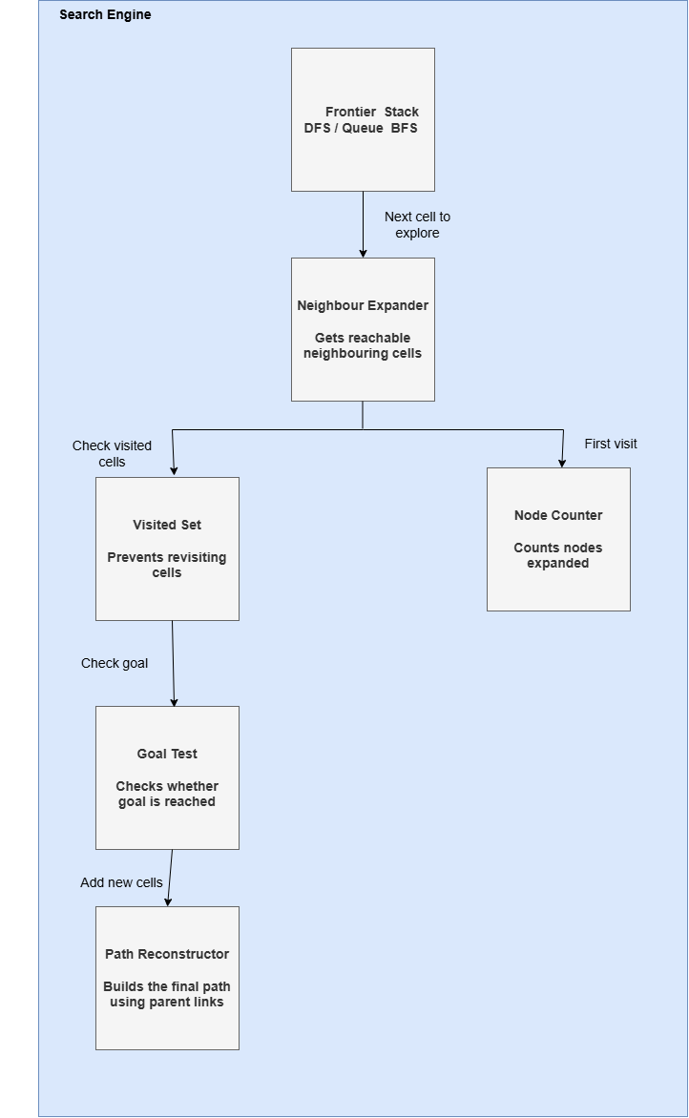
Short explanation: I chose the Search Engine because it is the heart of the system. The Frontier holds cells waiting to be explored (a stack in DFS, a deque in BFS) and is the only real difference between the two algorithms. The Visited Set prevents loops, the Node Counter adds 1 on each first visit, and the Goal Test checks for the goal. If it is not the goal, the Neighbour Expander gets the next cells from neighbors(), records their parents and pushes them into the Frontier; at the goal, the Path Reconstructor follows the parents back to build the path.
5. Code Level Overview (Level 4)
Main functions / scripts:
- generate_maze() : builds the random perfect maze (randomized-DFS backtracker).
- neighbors() : returns the reachable adjacent cells in the fixed order Up, Left, Down, Right; shared by both solvers.
- dfs_solve() : iterative DFS using a list as a stack; returns (path, nodes expanded).
- bfs_solve() : BFS using a deque as a queue; returns (path, nodes expanded).
- shared cell helpers : small functions for handling cells and the grid, used by the generator and both solvers.
- run_experiments.py : runs 5 runs x 3 maze sizes, times with time.perf_counter() and writes results.json.
- cProfile run : 200 repeated solves of each algorithm on the 25x25 maze, used for the flame graph.
6. Design Decisions
- Separate generator, solver and runner: both algorithms get the identical maze, so the comparison is fair.
- One shared neighbors() with a fixed order: the only difference between DFS and BFS is the Frontier (stack vs queue), so any gap in results comes from the strategy itself.
- Timing and profiling kept apart: times come from perf_counter and the node counter inside each solver, because cProfile adds overhead; cProfile is used only for the flame graph.
- Results saved in results.json: charts and tables can be rebuilt without re-running the experiments. I kept it to 6 containers so it stays readable.
7. AI Contribution Note
- AI tools used: Claude (Anthropic).
- What AI helped with: drafting the three C4 diagrams (generated with a draw.io script, not copied from the internet), structuring this document and polishing the wording of the explanations.
- What I did myself: chose to continue from my own SLE-1/SLE-2 maze solver, matched the containers, components and function names to my actual code, and reviewed every design decision so that I can explain it in my own words.
8. Conclusion
Drawing the four C4 levels showed me a system from the big picture down to the code. The Context diagram fixed the system boundary, the Container diagram showed the separation of generating, searching, measuring and reporting, and the Component diagram showed that DFS and BFS share almost everything except the Frontier data structure. That fits my SLE-2 result, where BFS expanded about 2.9x fewer nodes and ran about 4.1x faster on the 25x25 maze. A clear structure also makes the system easy to extend: adding A* later would mainly change the Frontier (a priority queue) and add a heuristic, without touching the generator, runner or charts.

