# FCFS

import java.util.*; public class FCFS {

public static void main(String args[]) { Scanner sc = new Scanner(System.in); System.out.println("enter no of process: "); int n = sc.nextInt();

int pid[] = new int[n]; // process ids int ar[] = new int[n]; // arrival times

int bt[] = new int[n]; // burst or execution times int ct[] = new int[n]; // completion times

int ta[] = new int[n]; // turn around times int wt[] = new int[n]; // waiting times

int temp;

float avgwt = 0, avgta = 0;

for (int i = 0; i < n; i++) {

System.out.println("enter process " + (i + 1) + " arrival time: "); ar[i] = sc.nextInt();

System.out.println("enter process " + (i + 1) + " brust time: "); bt[i] = sc.nextInt();

pid[i] = i + 1;

}

// sorting according to arrival times

for (int i = 0; i < n; i++) {

for (int j = 0; j < n - (i + 1); j++) {

if (ar[j] > ar[j + 1]) { temp = ar[j]; ar[j] = ar[j + 1]; ar[j + 1] = temp; temp = bt[j]; bt[j] = bt[j + 1]; bt[j + 1] = temp; temp = pid[j]; pid[j] = pid[j + 1]; pid[j + 1] = temp;

}

}

}

// finding completion times for (int i = 0; i < n; i++) {

if (i == 0) {

ct[i] = ar[i] + bt[i];

} else {

if (ar[i] > ct[i - 1]) {

ct[i] = ar[i] + bt[i];

} else

ct[i] = ct[i - 1] + bt[i];

}

ta[i] = ct[i] - ar[i]; // turnaround time= completion time- arrival time wt[i] = ta[i] - bt[i]; // waiting time= turnaround time- burst time avgwt += wt[i]; // total waiting time

avgta += ta[i]; // total turnaround time

}

System.out.println("\npid arrival brust complete turn waiting"); for (int i = 0; i < n; i++) {

System.out.println(pid[i] + " \t " + ar[i] + "\t" + bt[i] + "\t" + ct[i] + "\t" + ta[i] + "\t" + wt[i]);

}

sc.close();

System.out.println("\naverage waiting time: " + (avgwt / n)); // printing average waiting time.

System.out.println("average turnaround time:" + (avgta / n)); // printing average turnaround time.

}

}

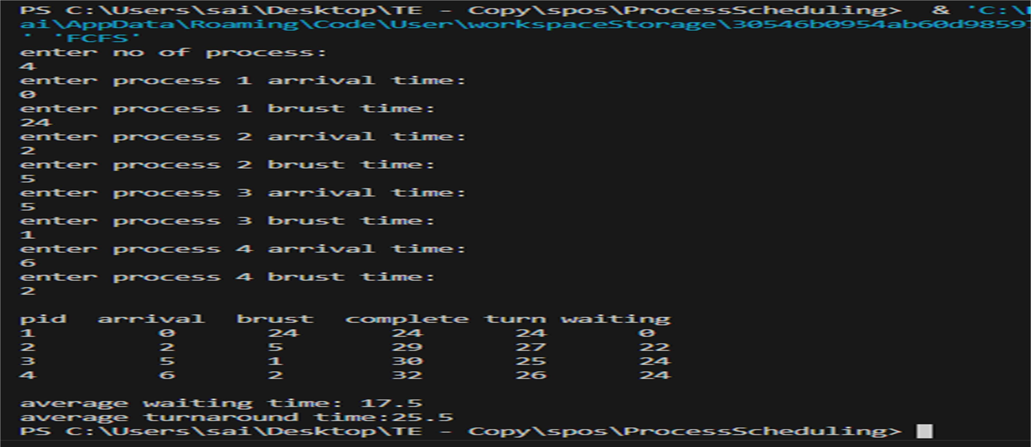

# Premptive SJF

import java.util.Scanner; public class SJF {

public static void main(String[] args) { Scanner sc = new Scanner(System.in); System.out.println("enter no of process: "); int n = sc.nextInt();

int pid[] = new int[n]; // process ids int ar[] = new int[n]; // arrival times

int bt[] = new int[n]; // burst or execution times int ct[] = new int[n]; // completion times

int ta[] = new int[n]; // turn around times int wt[] = new int[n]; // waiting times

int f[] = new int[n]; int k[] = new int[n];

int temp, tot = 0, st = 0; float avgwt = 0, avgta = 0;

for (int i = 0; i < n; i++) {

System.out.println("enter process " + (i + 1) + " arrival time: "); ar[i] = sc.nextInt();

System.out.println("enter process " + (i + 1) + " brust time: "); bt[i] = sc.nextInt();

k[i] = bt[i]; pid[i] = i + 1;

}

while (true) {

int min = 99, c = n; if (tot == n)

break;

for (int i = 0; i < n; i++) {

if (ar[i] <= st && f[i] == 0 && bt[i] < min) { min = bt[i];

c = i;

}

}

if (c == n) st++;

else {

bt[c]--; st++;

if (bt[c] == 0) { ct[c] = st;

f[c] = 1;

tot++;

}

}

}

for (int i = 0; i < n; i++) {

ta[i] = ct[i] - ar[i];

wt[i] = ta[i] - k[i]; avgwt += wt[i]; avgta += ta[i];

}

System.out.println("pid arrival burst complete turn waiting"); for (int i = 0; i < n; i++) {

System.out.println(pid[i] + "\t" + ar[i] + "\t" + k[i] + "\t" + ct[i] + "\t" + ta[i] + "\t" + wt[i]);

}

System.out.println("\naverage tat is " + (float) (avgta / n)); System.out.println("average wt is " + (float) (avgwt / n)); sc.close();

}

}

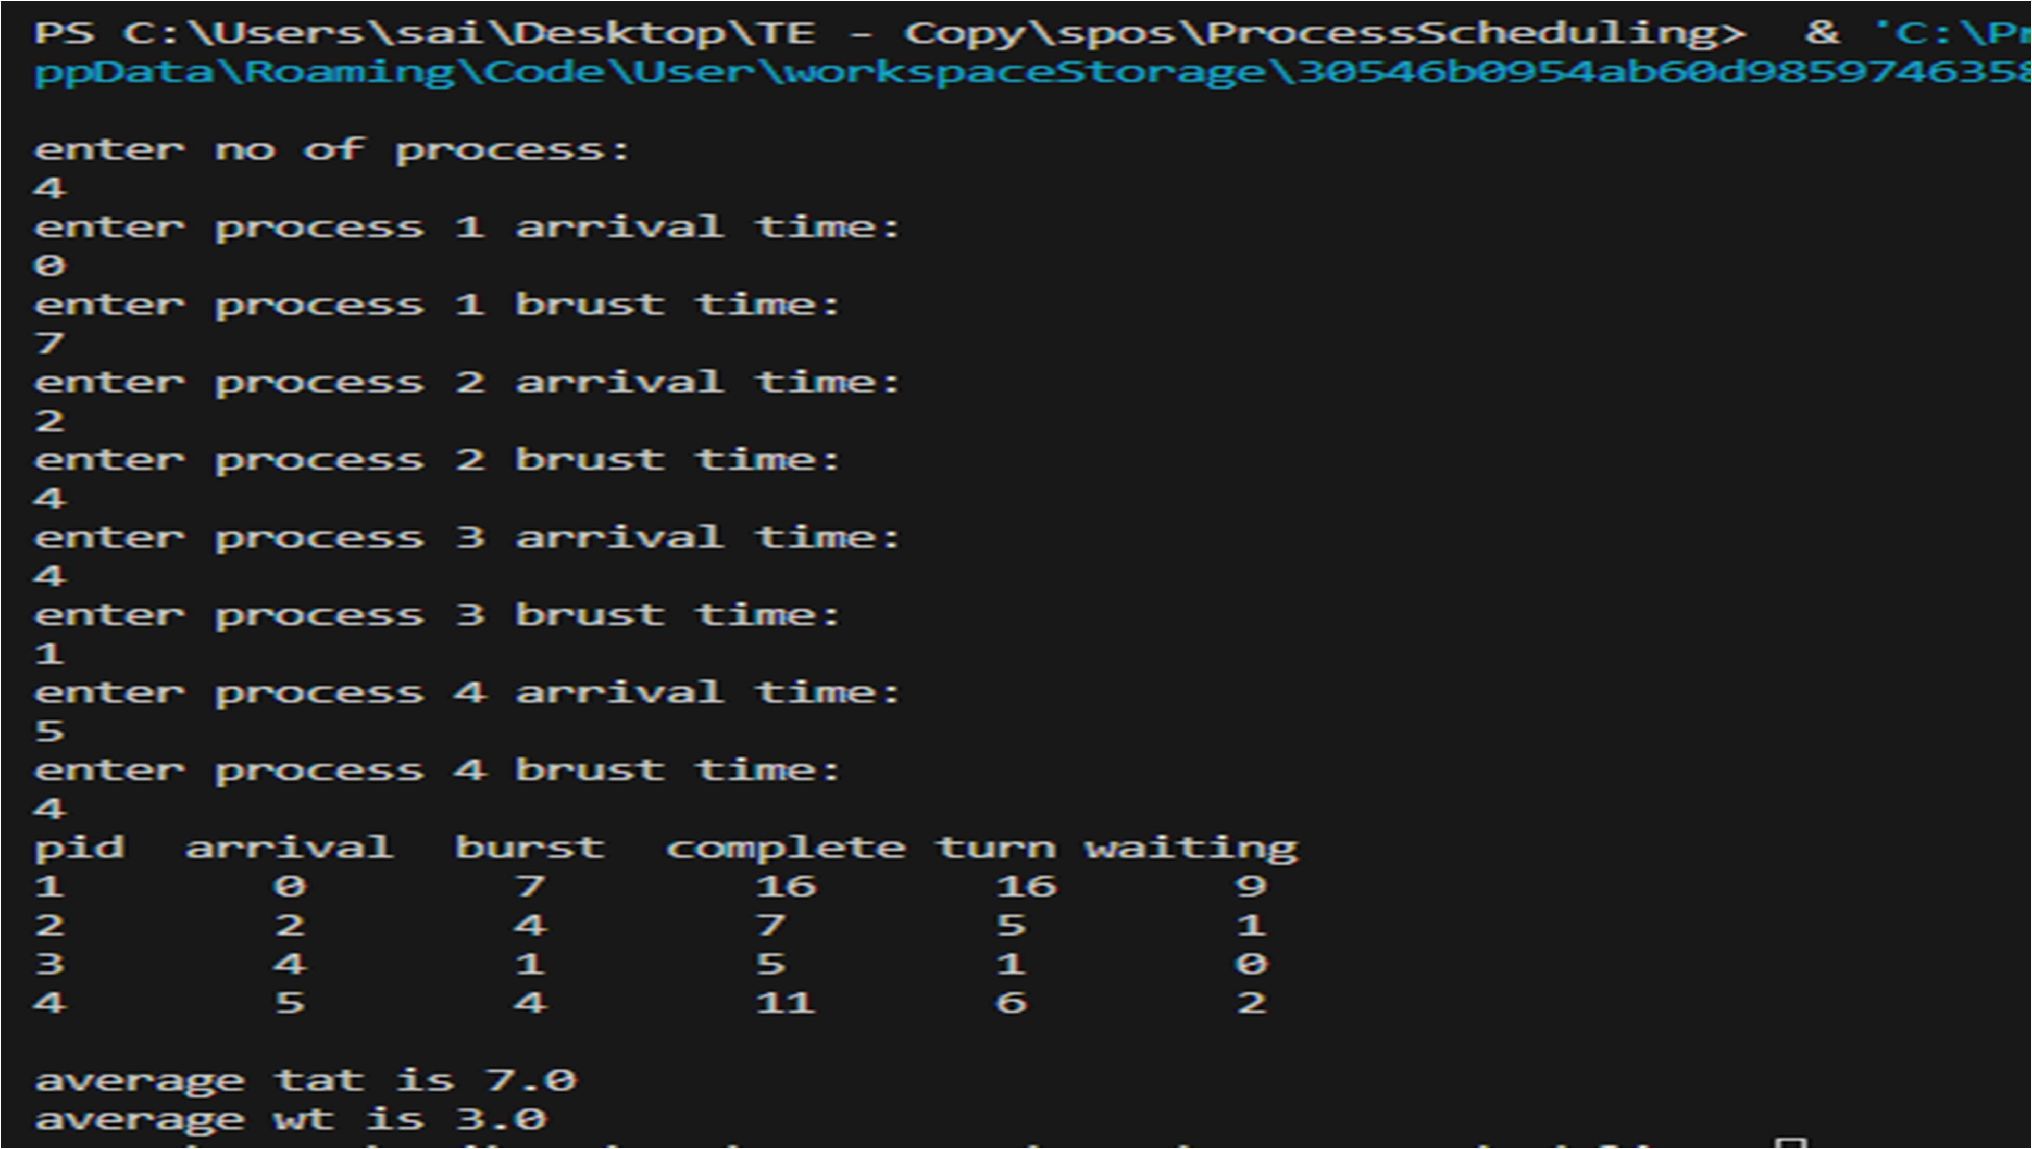

# Priority

import java.util.Scanner; public class Priority {

public static void main(String[] args) { Scanner sc = new Scanner(System.in);

System.out.println("Enter the number of processes:"); int n = sc.nextInt();

int i, pos=0, temp;

System.out.println("Enter the burst times:"); int p[] = new int[n];

int bt[] = new int[n]; //burst time int pt[] = new int[n]; //priority time int wt[] = new int[n]; //waiting time

int tat[] = new int[n]; //turn-around time

for (i = 0; i < n; i++) { p[i] = i + 1;

bt[i] = sc.nextInt();

}

System.out.println("Enter priority time:"); for (i = 0; i < n; i++) {

pt[i] = sc.nextInt();

}

for (i = 0; i < n; i++) { pos = i;

for (int j = i + 1; j < n; j++) { if (pt[j] < pt[pos]) {

pos = j;

}

}

temp = pt[pos]; pt[pos] = pt[i]; pt[i] = temp;

temp = p[pos]; p[pos] = p[i];

p[i] = temp;

temp = bt[pos]; bt[pos] = bt[i]; bt[i] = temp;

}

wt[0] = 0;

/*for(i=1;i<n;i++)

{

wt[i]=0;

for(int j=0;j<i;j++) wt[i]+=bt[j];

}*/

for (i = 1; i < n; i++) {

wt[i] = wt[i - 1] + bt[i - 1];

}

System.out.println("Process\tBT\tpriority\twaiting time\tTAT");

for (i = 0; i < n; i++) { tat[i] = bt[i] + wt[i];

System.out.println(p[i] + "\t" + bt[i] + "\t" + pt[i] + "\t\t" + wt[i] + "\t\t" + tat[i]);

}

}

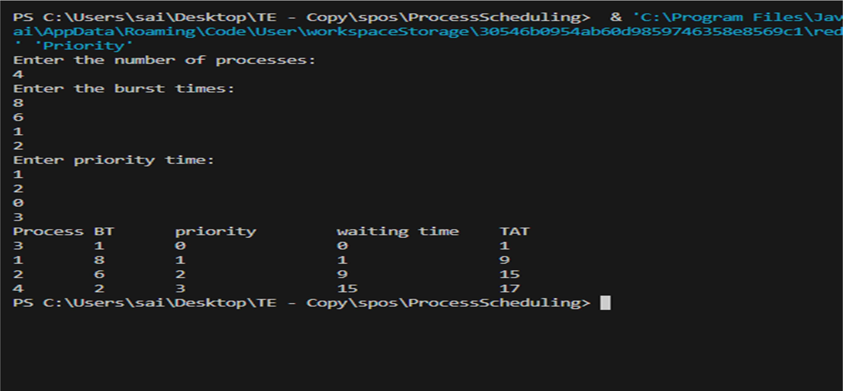}

# Round Robin

import java.util.Scanner; public class RoundRobin

{

public static void main(String args[])

{

int n,i,qt,count=0,temp,sq=0,bt[],wt[],tat[],rem_bt[]; float awt=0,atat=0;

bt = new int[10]; wt = new int[10]; tat = new int[10];

rem_bt = new int[10];

Scanner s=new Scanner(System.in);

System.out.print("Enter the number of process (maximum 10) = "); n = s.nextInt();

System.out.print("Enter the burst time of the process\n"); for (i=0;i<n;i++)

{

System.out.print("P"+i+" = "); bt[i] = s.nextInt();

rem_bt[i] = bt[i];

}

System.out.print("Enter the quantum time: "); qt = s.nextInt();

while(true)

{

for (i=0,count=0;i<n;i++)

{

temp = qt; if(rem_bt[i] == 0)

{

count++; continue;

}

if(rem_bt[i]>qt) rem_bt[i]= rem_bt[i] - qt; else

if(rem_bt[i]>=0)

{

temp = rem_bt[i];

rem_bt[i] = 0;

}

sq = sq + temp; tat[i] = sq;

}

if(n == count) break;

}

System.out.print(" "); System.out.print("\nProcess\t Burst Time\t Turnaround Time\t Waiting Time\n"); System.out.print(" "); for(i=0;i<n;i++)

{

wt[i]=tat[i]-bt[i]; awt=awt+wt[i]; atat=atat+tat[i];

System.out.print("\n "+(i+1)+"\t "+bt[i]+"\t\t "+tat[i]+"\t\t "+wt[i]+"\n");

}

awt=awt/n; atat=atat/n;

System.out.println("\nAverage waiting Time = "+awt+"\n"); System.out.println("Average turnaround time = "+atat);

}

