**MSc.(Computer Science) Semester-I**

**Name: Aditya Suresh Mazire Roll No: 518**

**Paper III (Bioinformatics)**

|  |  |  |  |  |
| --- | --- | --- | --- | --- |
|  |  | **INDEX** |  |  |
| **NO** | **DATE** | **TITLE** | **PAGE NO** | **SIGN** |
|  |  |  |  |  |
| 1 |  | Complementary DNA Sequence | 2 |  |
| 2 |  | Identity of Two protein sequence | 4 |  |
| 3 |  | Pairwise Sequence Alignment | 6 |  |
| 4 |  | Similarity between two protein sequence | 8 |  |
| 5 |  | Multiple Sequence Alignment | 10 |  |
| 6 |  | Motif Finding | 14 |  |
| 7 |  | Perform a BLAST search on any genes sequence and write a code to count the no of repetition of each nucleotide in the sequence | 16 |  |
| 8 |  | Regular Expression | 18 |  |
| 9 |  | Fingerprint | 20 |  |

**Practical No: 1**

**Aim:** Write a Python/Java code to find the Complementary DNA Sequence

**Code:**

def complementary_strand_find(dna_strand):

complementary_strand = ""

for base in dna_strand:

if base == "A" :

complementary_strand += "T"

elif base == "T" :

complementary_strand += "A"

elif base == "U" :

complementary_strand += "A"

elif base == "G" :

complementary_strand += "C"

elif base == "C" :

complementary_strand += "G"

elif base == "Y" :

complementary_strand += "R"

elif base == "R" :

complementary_strand += "Y"

else :

print("Wrong input")

complementary_strand = None

break

return complementary_strand

if __name__ == "__main__":

dna_strand = "GGTACTTGCCAT"

print("DNA strand is:",

dna_strand)

print("complementary strand is:",

complementary_strand_find(dna_strand))

**Output:**

DNA strand is: GGTACTTGCCAT

complementary strand is: CCATGAACGGTA

**Practical No: 2**

**Aim:** Write a Python/Java code to find the identity value of a given sequences. Take the sequence from user.

**Code:**

se1=input("Enter the first sequence::") se2=input("Enter the second sequence::")

seq1=list(se1) seq2=list(se2)

def find_identity(a,b): gap(a,b)

print(a) print(b) score=0 length=len(a)

total_elements=len(a)*len(b) for i in range(0,length):

for j in range(0,length): if(a[i]==b[j]):

score=score+1 identity=(score/total_elements)*100 print("Matching Score::",score) print("Identity of the sequences::",identity)

def gap(a,b): if(len(a)==len(b)):

print() else:

k=int(input("enter the position to insert gap ::")) if (len(a)<len(b)):

1. insert(k,'-') else:
2. insert(k,'-') return(a,b)

find_identity(seq1,seq2)

**Output:**

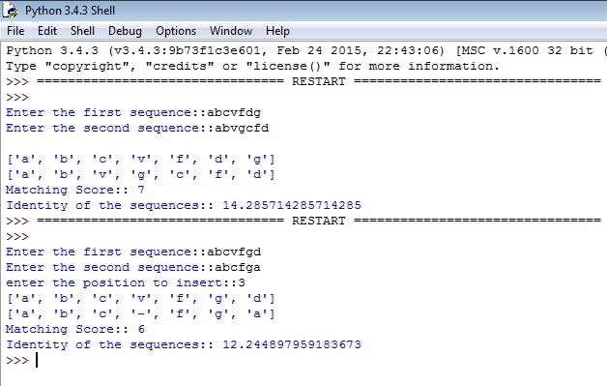

**Practical No: 3**

**Aim:** Write a Python/Java code to perform pairwise alignment. Take 2 sequences from user and calculate the score.

**Code:**

se1=input("Enter the first sequence::") se2=input("Enter the second sequence::") seq1=list(se1)

seq2=list(se2) score=[]

def Pairwise_alignment(a,b): gap(a,b)

print(a) print(b) value=0 length=len(a)

for i in range(0,length): if(a[i]==b[i]):

score.append('1') value=value+1

else:

score.append('0') print(score) print(value)

def gap(a,b): if(len(a)==len(b)):

print() else:

k=int(input("enter the position to insert::")) if (len(a)<len(b)):

1. insert(k,'-') else:
2. insert(k,'-') return(a,b)

Pairwise_alignment(seq1,seq2)

**Output:**

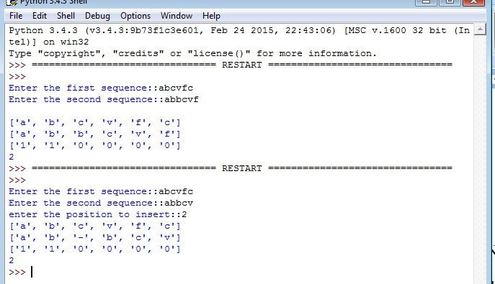

**Practical No: 4**

**Aim:** Write a Python/Java code to find the Similarity value of a given sequences. Take the sequence fromuser.

**Code:**

sequence_one=input("Enter the first sequence: ") sequence_two=input("Enter the second sequence: ") how_many=int(input("How many elements for similarity condition?")) similarities=[]

for i in range(0,how_many): a=input("Enter an element: ")

c=int(input("How many elements is it similar to? ")) similarities.append([])

similarities[i].append(a)

for j in range(0,c):

b=input("What is it similar to? ") similarities[i].append(b)

def compare(o,t,s): print(o)

print(t) print(s)

#checking if similar score=0

for i in range(len(o)): for j in range(len(s)):

if o[i] in s[j] and t[i] in s[j] and o[i] != t[i]: score+=1

#calculating similarity similarity= (score*100)/len(o) return similarity

print(compare(list(sequence_one),list(sequence_two),similarities),"%")

**Output:**

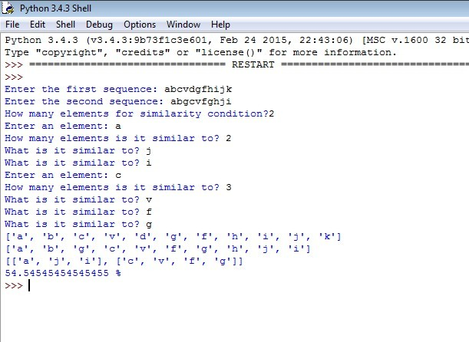

**Practical No: 5**

**Aim:** Enter genome of five different organism and write a python/java program to find consensus sequence using Multiple Sequence Alignment (MSA) technique.

**Code:**

import java.io.*; import java.util.*; public class Consensus

{

public static void main(String str[]) throws IOException

{

int n, i,j,k,count; String seq[],cons[];

ArrayList<Integer> a = new ArrayList<Integer>(); ArrayList s = new ArrayList();

BufferedReader br=new BufferedReader(new InputStreamReader(System.in)); System.out.println("Enter the no of Sequences"); n=Integer.parseInt(br.readLine());

seq=new String[n]; System.out.println("Enter sequences"); for(i=0;i<n;i++)

seq[i]=br.readLine();

cons=new String[seq[0].length()]; for(j=0;j<seq[0].length();j++) cons[j]=" "; for(j=0;j<seq[0].length();j++)

{

a.clear();

s.clear(); for(i=0;i<n;i++)

{

count=1; for(k=i+1;k<n;k++)

{

if(seq[i].charAt(j)==seq[k].charAt(j)) count++;

}

System.out.println("count="+count); a.add(count); s.add(seq[i].charAt(j));

}

/**Updated Snippet 1**/ Set<String> set = new HashSet<>(s);

ArrayList setlist = new ArrayList(set); Collections.sort(setlist);

if (setlist.contains('-') &&setlist.size()==2){ cons[j]+="-"+setlist.get(1);

}

else if (setlist.size()==1){ cons[j]+="-"+setlist.get(0);

}

else{

int m = Collections.max(a);

int index=a.indexOf(m); System.out.println("Max="+m); cons[j]+=s.get(index); System.out.println("index="+index); for(i=index+1;i<a.size();i++)

{

if(a.get(i)==m) cons[j]+="/"+s.get(i);

}

}

}

System.out.println("Consensus="); for(j=0;j<seq[0].length();j++){

/**Updated Snippet 2**/ if(cons[j].length()==2) System.out.print(cons[j].toLowerCase()); else if(cons[j].length()==3) System.out.print(cons[j].replace("-","")); else

System.out.print(cons[j]);

}

}

**Output:**

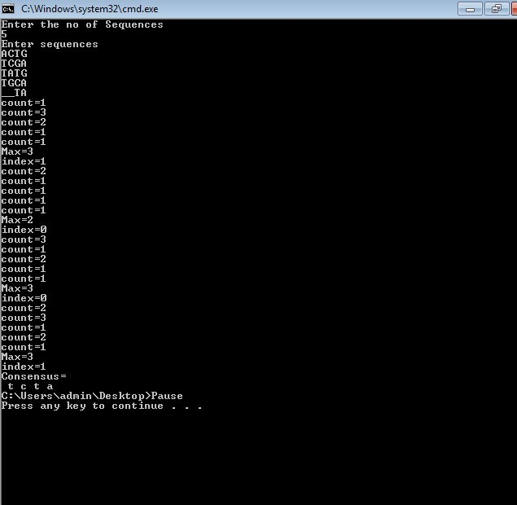

**Practical No: 6**

**Aim:** Write a Python/Java code to find motif in a given sequence. **Code:**

import random

l=int(input("Enter the length of motif")) file=open("mot.txt","r")

r=file.read() print("Sequence",r) size=len(r)

print("Size of the sequence",size) pos=random.randint(0,len(r)-5) #pos=1

print("Position",pos) motif=r[pos:pos+l] print("Motif",motif) i=pos+1 while(i<=size-1):

if(motif==r[i:i+1]): str1=r[i:i+1] print("Match motif",str1)

file1=open("motoutput.txt","a") file1.write(str1+" ")

i+=1

**Output:**

Enter the length of motif4

Sequence AGAAGTTCGAGAAGCCGTAGT

Size of the sequence 21 Position 0

Motif AGAA

**Practical No: 7**

**Aim**: Perform a BLAST search on any genes sequence and writer a java/python code to count the no of repetition of each nucleotide in the sequence.

Code: file=open("genes.txt","r") r=file.read()

size=len(r) score_A=0 score_C=0 score_T=0 score_G=0

for i in range(size): if(r[i]=='A'):

score_A+=1 elif (r[i]=='C'): score_C+=1 elif (r[i]=='T'): score_T+=1 elif (r[i]=='G'): score_G+=1

print("score of A is ",score_A) print("score of C is ",score_C) print("score of T is ",score_T) print("score of G is ",score_G) **Output:**

score of A is 6

score of C is 4

score of T is 7 score of G is 6

**Practical No: 8**

**Aim:** Generate a regular expression enter three protein sequence of three different organism. Write Python/Java code to find regular expression for this sequences.

**Code:**

def gen_reg_exp(seq_list, no_of_col): final_list=[]

for colnum in range(no_of_col): collist=[]

for colseq in seq_list: collist.append(colseq[colnum])

if len(set(collist))==len(collist): #print(final_list) final_list.append('x')

else:

if len(set(collist))==1: final_list.append(collist[0])

else:

final_list.append(''.join(set(collist))) display_output(final_list)

def display_output(final_list): print(*final_list, sep='-')

no_of_seq=int(input("Enter the number of sequence: ")) print("Enter all the sequences")

seq_list=[]

for _ in range(no_of_seq): seq_list.append(list(map(str, input("").split())))

gen_reg_exp(seq_list, len(seq_list[0]))

**Output:**

Enter the number of sequence: 4 Enter all the sequences

A D L G A V F A L C D R Y F Q S D V G P R S C F C E R F Y Q A D L G R T Q L R C D R Y Y Q A D I G Q P H S L C E R Y F Q

SA-D-IVL-G-x-x-x-x-FRL-C-ED-R-YF-YF-Q

**Practical No: 9**

**Aim:** Enter six protein sequence of different organism and write a program to find a fingerprint of sequence.

**Code:**

def solve_fingerprint(seq_list, no_of_col): seq_dict=dict()

for colnum in range(no_of_col): counta,countc,countt,countg=0,0,0,0 for colseq in seq_list:

if colseq[colnum]=='A': counta+=1

elif colseq[colnum]=='T': countt+=1

elif colseq[colnum]=='C': countc+=1

elif colseq[colnum]=='G': countg+=1

seq_dict[colnum]=[counta,countc,countt,countg] display_results(seq_dict)

def display_results(seq_dict): print("\tA \tC \tT \tG")

for key in seq_dict: print("\n",*seq_dict[key],sep="\t")

no_of_seq=int(input("Enter the number of sequence: ")) print("Enter all the sequences")

seq_list=[]

for _ in range(no_of_seq): seq_list.append(list(map(str, input("").split())))

solve_fingerprint(seq_list,len(seq_list[0]))

Output:

Enter the number of sequence: 4

Enter all the sequences A C T G A T G

A T C A G A A A T A A G C A A G T T A G C

|  |  |  |  |
| --- | --- | --- | --- |
| A | C | T | G |
| 4 | 0 | 0 | 0 |
| 0 | 1 | 2 | 1 |
| 1 | 1 | 2 | 0 |
| 2 | 0 | 1 | 1 |
| 2 | 0 | 0 | 2 |
| 1 | 1 | 1 | 1 |
| 2 | 1 | 0 | 1 |