VISVESVARAYA TECHNOLOGICAL UNIVERSITY
JNANA SANGAMA, BELAGAVI - 590 018


MINI PROJECT REPORT
on
“ Automatic Toll Gate Control System“
Submitted by

Name : Prathamesh V Shenoy USN : 4SF24CS146

Name : Sohan P Rai USN : 4SF24CS211

Name : Darshan Krishna Marathi USN : 4SF25CS403

Name : Pavan Vijay Pawaskar USN : 4SF25CS413

In partial fulfillment of the requirements for the IV semester
Microprocessor And Embedded Systems
( Course Code - BCS402G )
BACHELOR OF ENGINEERING
In
COMPUTER SCIENCE & ENGINEERING




Abstract
The Automatic Toll Gate Control System is an IoT-enabled embedded system designed to automate toll collection and gate control at highway toll plazas. Traditional toll booths rely heavily on manual operations, which often result in traffic congestion, increased waiting time, revenue leakage, and operational inefficiency. This project aims to overcome these limitations by implementing an intelligent automated toll management system using the ESP32 microcontroller.

The system detects vehicles using dual IR sensors placed at entry and exit points. Once a vehicle is detected, the system automatically processes the toll transaction, updates the toll count, and controls gate movement using a servo motor. LED indicators provide traffic signal status, while a buzzer gives audio feedback during operation. A 16×2 LCD with I2C module displays real-time system information such as vehicle count, toll collected, and gate status.

Additionally, the ESP32’s built-in Wi-Fi capability enables real-time monitoring through a web dashboard, allowing users to remotely track system status, total vehicles processed, and toll revenue collected. The dashboard provides a modern user-friendly interface for monitoring system performance.

The Automatic Toll Gate Control System improves traffic flow, minimizes human intervention, reduces operational costs, and increases toll collection accuracy. It also provides scalability for future integration with RFID-based authentication, cloud-based analytics, and smart transportation systems.

Keywords: ESP32, Automatic Toll Gate, Embedded System, IoT, Servo Motor, IR Sensor, Web Dashboard, Traffic Automation

Table of Contents

Content Page
No
Abstract i
Table of Contents ii
- Introduction 1
  - Overview
- Literature Survey 2
- System Design and Working 4
  - System Design and Working
  - Main Components
  - System Block Diagram
  - System Operations

- Methodology and Result 7
  - Methodology
  - Implementation Process
  - Exprimental setup
  - Hardware Output Result
  - Web Dashboard

- Learning Outcomes and Reflection 9
  - Learning Outcomes
  - Reflections
  - SDG
  - Key Concept Used
  - Applications
Conclusion 12

References 13

Chapter 1

Introduction

1.1 Overview

Toll collection is a critical revenue mechanism for funding the construction and maintenance of highways, bridges, and tunnels. Conventional toll booths require dedicated personnel at each lane, creating bottlenecks during peak traffic hours and raising operational costs. With the rapid advancement of embedded systems and sensor technology, it is now feasible to replace manual operations with smart automated systems that deliver faster throughput, greater accuracy, and reduced overhead.

An Automatic Toll Gate Control System uses a microcontroller as its central processing unit to coordinate input from vehicle-detection sensors and output commands to a gate actuator. When a vehicle arrives at the toll booth, the sensor immediately signals its presence to the microcontroller. The system then validates payment — either through RFID, prepaid card, or manual interface — and commands the servo motor to open the gate. Once the vehicle clears, the gate closes automatically, ready for the next vehicle. This cycle repeats continuously with minimal delay, making the overall flow smoother and safer.

In addition to automating gate operation, the system can be integrated with display units such as LCD screens to provide real-time transaction details, toll fee information, and system status messages. Indicators such as LEDs and buzzers can also be incorporated to notify users about successful payments, insufficient balance, or unauthorized access attempts. These features improve user interaction and make the system more reliable and efficient.

The implementation of this system significantly reduces human dependency, minimizes toll evasion, and ensures accurate toll collection. It also helps in reducing traffic congestion, lowering fuel consumption caused by long waiting times, and contributing to a more eco-friendly transportation infrastructure. Such automated systems represent an important step toward smart highway management and intelligent transportation systems, offering convenience, security, and scalability for future road networks.

Chapter 2

Literature Survey

Automatic toll gate control systems have become an important area of research due to the growing demand for efficient traffic management, reduced vehicle waiting time, and secure automated toll collection. Several researchers have proposed RFID and embedded system-based solutions to improve toll booth operations. R. Karthik and S. Muthukumar [1], M. Anand and V. Suresh [3], and S. Kulkarni and A. Patil [4] focused on RFID-enabled toll collection systems that provide automatic vehicle identification and faster transaction processing. Similarly, P. Sharma and N. Yadav [2] and T. Reddy and K. Prasad [5] developed microcontroller and sensor-based systems using IR sensors for vehicle detection and automatic gate control. These studies highlighted the importance of embedded controllers, sensors, and automated barrier mechanisms in reducing manual intervention and traffic congestion at toll plazas.
Recent research has further enhanced toll automation through IoT, wireless communication, and intelligent monitoring technologies. A. Singh and R. Verma [6] introduced an IoT-enabled toll gate system with real-time monitoring capabilities, while B. Narayanan and C. Mohan [7] implemented a servo motor-based gate control system using an 8051 microcontroller for efficient barrier operation. H. Patel and D. Shah [8] proposed an Automatic Number Plate Recognition (ANPR) system that improved security and vehicle verification through image processing techniques.
Overall, these studies demonstrate that the integration of RFID, IoT, embedded systems, sensors, and intelligent monitoring technologies significantly improves the efficiency, reliability, and automation of modern toll gate control systems.
Table 2.1: Literature Review for Automatic Toll Gate Controll
Sl. No. | Authors | Title | Journal / Source | Year
1 | R. Karthik & S. Muthukumar | Automatic Toll Gate Control System Using RFID and Embedded Systems [1] | Intl. Journal of Innovative Research in Science, Engineering and Technology, vol. 5, no. 3, pp. 34–40 | 2020
2 | P. Sharma & N. Yadav | Design of Microcontroller-Based Toll Collection System Using IR Sensors [2] | Intl. Journal of Electronics and Communication Engineering, vol. 7, no. 2, pp. 55–61 | 2020
3 | M. Anand & V. Suresh | RFID-Based Automated Toll Plaza Management System [3] | IEEE Access, vol. 8, pp. 102345–102354 | 2020
4 | S. Kulkarni & A. Patil | Smart Toll Collection Using Arduino and RFID Technology [4] | Intl. Journal of Scientific Research in Computer Science, vol. 9, no. 1, pp. 22–28 | 2021
5 | T. Reddy & K. Prasad | Embedded System-Based Vehicle Detection and Gate Control at Toll Booths [5] | Intl. Journal of Advanced Research in Electrical, Electronics and Instrumentation Engineering, vol. 10, no. 4, pp. 78–85 | 2021
6 | A. Singh & R. Verma | IoT-Enabled Automatic Toll Gate System with Real-Time Monitoring [6] | Intl. Journal of Engineering Research & Technology, vol. 10, no. 6, pp. 145–151 | 2021
7 | B. Narayanan & C. Mohan | Servo Motor Controlled Barrier Gate System Using 8051 Microcontroller [7] | Intl. Journal of Embedded Systems and Applications, vol. 12, no. 3, pp. 11–19 | 2021
8 | H. Patel & D. Shah | Automatic Number Plate Recognition for Toll Gate Automation [8] | IEEE Transactions on Intelligent Transportation Systems, vol. 23, no. 2, pp. 1120–1130 | 2022

Chapter 3

System Design & Working

3.1 Working Principle

The Automatic Toll Gate Control System operates on the principle of sensor-triggered microcontroller logic combined with an electromechanical gate actuator. The process begins as soon as a vehicle enters the detection range of the IR or ultrasonic sensor positioned at the entrance of the toll lane.

Vehicle Detection
The IR sensor continuously emits an infrared beam across the lane. When a vehicle interrupts this beam, the sensor generates a HIGH signal to the microcontroller. Alternatively, an ultrasonic sensor measures the distance of an approaching object by calculating the time-of-flight of its emitted sound pulse, triggering detection when the measured distance falls below a set threshold.

Gate Operation
After payment is verified, the microcontroller sends a PWM (Pulse Width Modulation) control signal to the servo motor. The servo rotates to a predefined open angle (typically 90°), lifting the gate barrier. Simultaneously, the green LED lights up and the LCD displays a success message. The system then waits for the exit sensor to confirm the vehicle has passed completely through the gate.

Gate Closure
Once the exit sensor detects that the vehicle has cleared the gate, the microcontroller commands the servo motor to return to 0°, lowering the barrier. The red LED illuminates to indicate the gate is closed and the system is ready for the next vehicle. If no valid payment is received within a timeout window, the gate remains closed and the buzzer sounds to alert the driver.

3.2 Main Components

As Shown in the Figure 3.2.1 Components Used in the Connections shows the hardware setup of the Automatic Toll Gate Control System. The ESP32 acts as the main controller, receiving signals from the IR sensors and controlling the servo motor for gate operation. The LCD display shows vehicle count and toll status, while the LEDs and buzzer provide visual and audio alerts. The breadboard, resistors, and jumper wires are used for circuit connections. The system uses Wi-Fi and a laptop dashboard for real-time monitoring.

The system integrates several hardware modules, each playing a specific role in the automated toll process:
S/N | Component Required | Quantity
1 | ESP32 Development Board | 1
2 | IR Sensor Module | 2
3 | Servo Motor | 1
4 | 16x2 LCD Display with I2C | 1
5 | Breadboard | 1
6 | Green LED | 1
7 | Red LED | 1
8 | Buzzer | 1
9 | 220 Ohm Resistor | 2
10 | Jumper Wires | As Required
11 | USB Cable / Power Supply | 1
12 | Wi-Fi Network Connection | 1
13 | Laptop for Dashboard Monitoring | 1

Figure 3.2.1: Components Used In the Connections
3.3 System Block Diagram
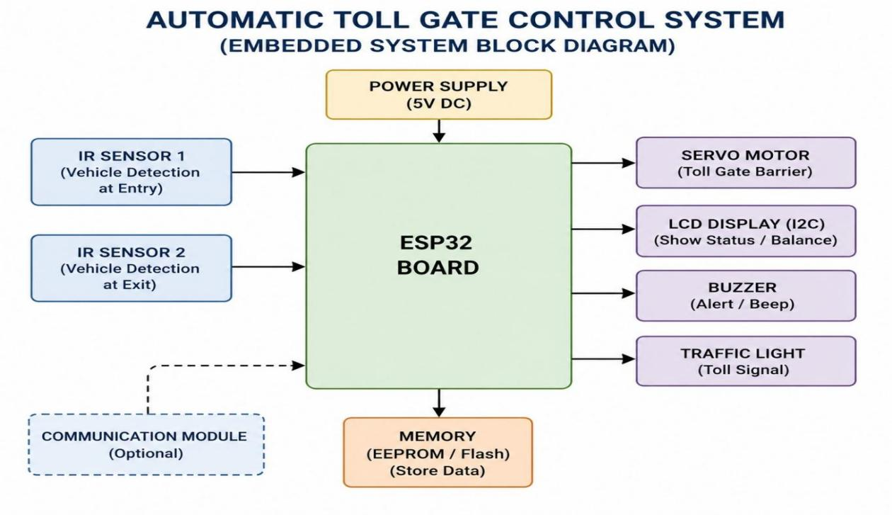
Figure 3.3.1: Block Diagram of Automatic Toll Gate Control System
The block diagram as shown in Figure 3.3.1, shows the working structure of the Automatic Toll Gate Control System, where the ESP32 board acts as the main controller. The IR sensors detect vehicle entry and exit and send signals to the ESP32 for processing. Based on these inputs, the ESP32 controls the servo motor to open and close the gate automatically. The LCD display, buzzer, and traffic light LEDs provide status indication and alerts during operation. The system also uses memory storage and Wi-Fi communication for data storage and remote dashboard monitoring.

3.4 System Operations
The system begins with initialisation, where the ESP32 microcontroller powers up and configures all connected components such as IR sensors, servo motor, LCD display, LEDs, and buzzer. The gate is set to the closed position as the default state. The LCD displays a standby message indicating that the system is ready for operation. This ensures all devices are functioning correctly before vehicle detection starts.The entry IR sensor continuously monitors the toll lane for approaching vehicles. When a vehicle interrupts the infrared beam, the sensor sends a signal to the ESP32. The microcontroller immediately processes the detection and updates the toll count.

At the same time, the buzzer produces an alert to indicate vehicle arrival. Once the vehicle is detected, the ESP32 commands the servo motor to rotate and open the gate barrier. The green LED turns ON to indicate permission to pass, while the LCD displays a confirmation message such as toll processed and gate opening. This provides clear visual feedback to the driver. The gate remains open for a short duration to allow vehicle movement.

After the vehicle crosses the toll gate, the exit IR sensor detects its movement and sends a signal back to the ESP32. The microcontroller then activates the servo motor to return to its closed position. The red LED turns ON, indicating the gate is closed and access is restricted. The LCD updates the system status and vehicle count.

The system then resets to standby mode, ready to process the next vehicle. All toll data, gate status, and vehicle count are updated continuously on the web dashboard through Wi-Fi monitoring. If any abnormal condition occurs, such as sensor failure or delayed vehicle movement, the buzzer provides an alert. This cyclic process ensures smooth, automated, and efficient toll gate operation.

Chapter 4

Methodology and Results

4.1 Methodology

The Automatic Toll Gate Control System was developed using embedded systems and IoT technology to automate toll collection and gate operation. The system integrates hardware components such as the ESP32 microcontroller, dual IR sensors, servo motor, 16×2 LCD display with I2C module, LEDs, buzzer, breadboard, and jumper wires. The ESP32 acts as the central controller that receives signals from the entry and exit IR sensors, processes toll transactions, controls the servo motor for gate movement, and updates system status in real time. The LCD display is used to show vehicle count, toll amount, and gate status, while LEDs and buzzer provide visual and audio alerts during system operation.

The methodology begins with vehicle detection at the entry point using the first IR sensor. Once a vehicle is detected, the ESP32 processes the toll transaction, updates the toll count, and activates the servo motor to open the gate. The green LED turns ON to indicate gate access, and the LCD displays the transaction status. As the vehicle passes through the toll lane, the second IR sensor detects the vehicle at the exit point and sends a signal to the ESP32 to close the gate automatically. The red LED then turns ON, indicating the gate is closed and ready for the next vehicle. The ESP32 also hosts a Wi-Fi-based web dashboard that continuously displays live vehicle count, toll collected, and gate status, enabling remote monitoring and making the system suitable for smart toll automation systems.

4.2 Implementation Process

The implementation of the Automatic Toll Gate Control System was carried out by integrating hardware components with embedded software programming. The ESP32 microcontroller was programmed using Arduino IDE to control the entire toll gate operation. All components including IR sensors, servo motor, LCD display, LEDs, and buzzer were connected according to the circuit design. The program logic was developed to detect vehicles, process toll operations, control gate movement, and update the system display.

After hardware integration, the Wi-Fi-based web dashboard was developed for real-time monitoring. The ESP32 hosts a web server that displays vehicle count, toll collected, and gate status through a browser interface. Testing was performed by simulating vehicle movement across the entry and exit sensors. The system was verified for accurate detection, smooth gate operation, and proper data updates on both the LCD and dashboard.

4.3 Experimental Setup

The experimental setup consists of an ESP32 development board connected to two IR sensors, a servo motor, 16×2 LCD display with I2C module, red and green LEDs, and a buzzer mounted on a breadboard. The entry IR sensor was positioned at the toll gate entrance to detect arriving vehicles, while the exit IR sensor was placed beyond the barrier to confirm vehicle passage. The servo motor was attached to a model gate barrier to simulate real toll gate operation.

The system was powered through a USB supply and connected to a Wi-Fi network for dashboard monitoring. A laptop was used to upload the code to the ESP32 and access the live monitoring dashboard. During testing, multiple vehicle detection simulations were performed to observe gate opening, closing response, toll counting, LCD display updates, and overall system performance.

4.4 Hardware Output Results

The hardware implementation of the Automatic Toll Gate Control System was successfully tested using the prototype setup shown in Figure 4.4.1. The system accurately detected vehicle movement using the entry and exit IR sensors. When a vehicle was placed near the entry sensor, the ESP32 processed the signal and activated the servo motor to open the gate barrier automatically.

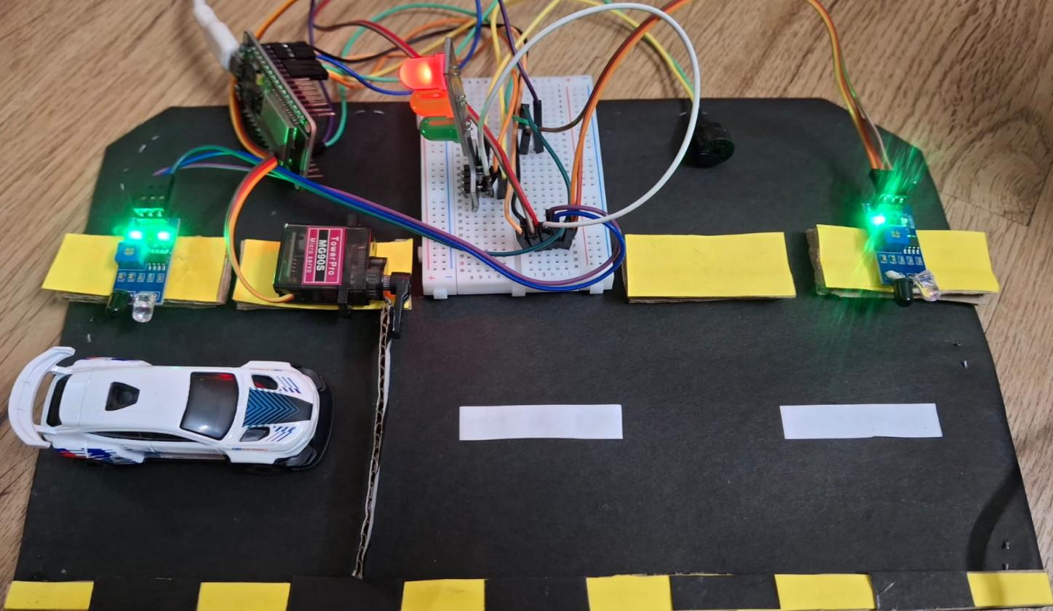

Figure 4.4.1: Automatic Toll Gate Control System

The green LED indicated gate opening, while the red LED indicated the closed state. The LCD displayed real-time information such as toll processing status, vehicle count, and toll amount. The buzzer also generated alert sounds during gate operation, confirming successful system response.

4.5 Web Dashboard Results

The IoT-based web dashboard successfully displayed real-time monitoring data through the ESP32 Wi-Fi server, as shown in Figure 4.5.1. The dashboard provided live updates of total vehicles detected, toll collected, gate barrier status, entry and exit sensor status, and traffic signal condition. During testing, the dashboard accurately reflected system changes such as gate opening when a vehicle was detected and updated the toll amount automatically after each transaction. The responsive dashboard interface enabled remote monitoring through a laptop browser, demonstrating the integration of embedded systems with IoT technology for efficient toll management.

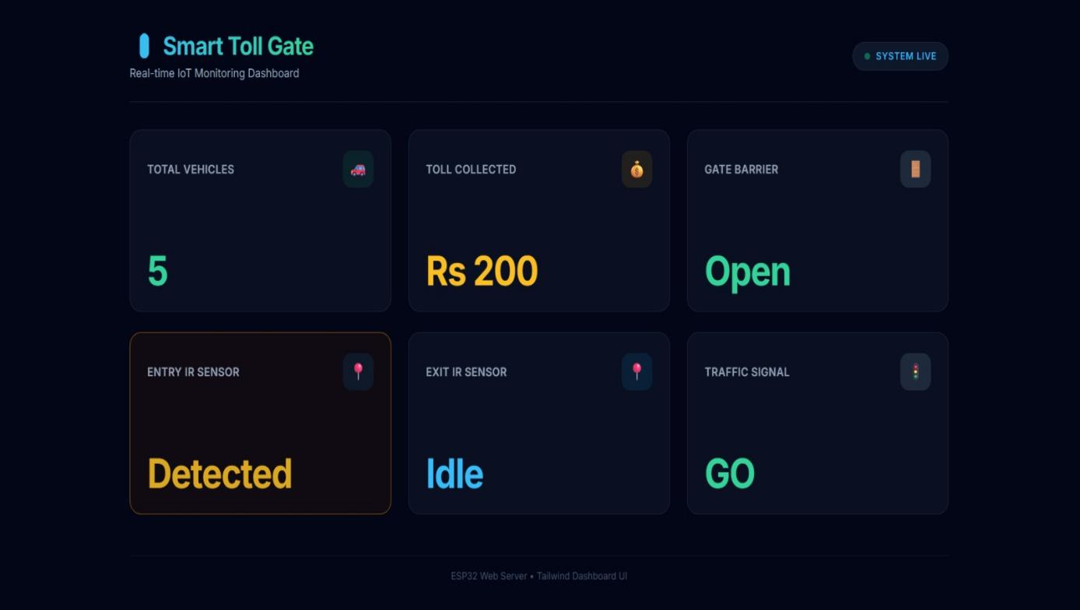

Figure 4.5.1: Real Time Monitoring Toll Gate Control Dashboard

Chapter 5:

Learning Outcomes and Reflection
5.1 Learning Outcomes
Through the development of the Automatic Toll Gate Control System, the following learning outcomes were achieved:
- Gained practical knowledge of embedded system design and real-time hardware interfacing.
- Understood the working and integration of the ESP32 microcontroller with peripheral devices.
- Learned to interface and program IR sensors, servo motors, LCD modules, buzzers, and LED indicators.
- Developed skills in microcontroller programming using Embedded C / Arduino IDE.
- Understood the implementation of PWM signals for controlling servo motor movement.
- Acquired knowledge of sensor-based automation and event-driven system design.
- Explored IoT integration using ESP32 Wi-Fi capabilities for remote monitoring.
- Improved teamwork, debugging, circuit design, and project documentation skills.

5.2 Reflections

In the long term, widespread adoption of automated toll gate systems will contribute to smarter, safer, and more sustainable transportation networks, improve the daily commuting experience of millions, and lay the groundwork for fully connected smart highway ecosystems. This mini project provided valuable practical exposure to the real-world implementation of embedded systems. It helped us bridge the gap between theoretical concepts learned in the classroom and their practical application in automation systems.

During the project, we faced challenges related to hardware interfacing, sensor calibration, servo motor timing, and debugging communication between components. Overcoming these issues improved our problem-solving skills and deepened our understanding of system integration. The project also highlighted the importance of automation in modern transportation systems and demonstrated how embedded technologies can contribute to efficiency, transparency, and sustainability. Working as a team enhanced collaboration, technical coordination, and project management skills.

5.3 SDG (Sustainable Development Goals)

The Automatic Toll Gate Control System aligns with several United Nations Sustainable Development Goals, demonstrating how embedded systems can contribute to broader societal and environmental objectives:
SDG | Goal | Alignment
SDG 9 | Industry, Innovation & Infrastructure | The system employs modern embedded technology and sensor integration to build smarter, automated road infrastructure, directly supporting innovation in transportation.
SDG 11 | Sustainable Cities & Communities | By reducing congestion at toll plazas, decreasing idle time, and improving lane throughput, the system contributes to safer and more efficient urban and inter-city mobility.
SDG 13 | Climate Action | Minimising vehicle idle time at toll booths reduces fuel consumption and vehicular emissions, directly lowering the carbon footprint associated with highway travel.
SDG 16 | Peace, Justice & Strong Institutions | Automated, tamper-resistant toll collection reduces revenue leakage, corruption, and human error, ensuring transparent and accountable governance of public infrastructure funds.

5.4 Key Concepts Used
The project is based on several important concepts of Microprocessors and Embedded Systems:
- Embedded Systems – Dedicated computing systems designed for specific control tasks.
- Microcontroller Programming – Programming ESP32 for hardware interaction and automation.
- Sensor Interfacing – Detecting vehicle presence using IR sensors.
- Pulse Width Modulation (PWM) – Controlling servo motor gate movement.
- Real-Time Processing – Immediate response to sensor inputs for smooth operation.
- Input-Output Control – Managing LEDs, LCD, buzzer, and servo motor.
- IoT Communication – Wireless data transmission through ESP32 Wi-Fi.
- Automation Logic – Sequential decision-making for toll gate operation.

5.5 Applications

1. Highway Toll Plazas
The system is widely used at highway toll plazas for automatic toll collection. It reduces vehicle waiting time by opening the gate automatically after toll processing. This minimises traffic congestion during peak hours. It also improves toll collection efficiency and accuracy.

2. Parking Management Systems
The system can be used in shopping malls, office buildings, and airports for automated parking access. It controls vehicle entry and exit without manual supervision. This ensures better parking management and reduces operational effort. It also helps in monitoring vehicle movement effectively.

Smart City Infrastructure
Automatic toll gate systems play an important role in smart city traffic management. They help regulate vehicle flow at toll booths and restricted roads. The system supports real-time monitoring through IoT dashboards. This improves transportation efficiency and reduces delays.

4. Residential Gated Communities
The system can be used in residential societies for secure vehicle entry and exit control. It automates gate operations and reduces the need for manual security checks. Residents can experience faster access with better security monitoring. It also helps maintain records of vehicle movement.

Conclusion
The Automatic Toll Gate Control System, built using the ESP32 Board, Servo Motor, dual IR Sensors, LCD with I2C Module, Buzzer, and LED Traffic Light Module, successfully demonstrates the practical application of Microprocessor and Embedded Systems principles. The system automates vehicle detection, gate operation, and toll counting in real time with no manual intervention, while the ESP32’s built-in Wi-Fi enables a live web dashboard for remote monitoring of vehicle count, toll collected, and gate status, integrating IoT capabilities into a core embedded project.

References
[1] R. Karthik and S. Muthukumar, “Automatic Toll Gate Control System Using RFID and Embedded Systems,” International Journal of Innovative Research in Science, Engineering and Technology, vol. 5, no. 3, pp. 34–40, 2020.
[2] P. Sharma and N. Yadav, “Design of Microcontroller-Based Toll Collection System Using IR Sensors,” International Journal of Electronics and Communication Engineering, vol. 7, no. 2, pp. 55–61, 2020.
[3] M. Anand and V. Suresh, “RFID-Based Automated Toll Plaza Management System,” IEEE Access, vol. 8, pp. 102345–102354, 2020.
[4] S. Kulkarni and A. Patil, “Smart Toll Collection Using Arduino and RFID Technology,” International Journal of Scientific Research in Computer Science, vol. 9, no. 1, pp. 22–28, 2021.
[5] T. Reddy and K. Prasad, “Embedded System-Based Vehicle Detection and Gate Control at Toll Booths,” International Journal of Advanced Research in Electrical, Electronics and Instrumentation Engineering, vol. 10, no. 4, pp. 78–85, 2021.
[6] A. Singh and R. Verma, “IoT-Enabled Automatic Toll Gate System with Real-Time Monitoring,” International Journal of Engineering Research & Technology, vol. 10, no. 6, pp. 145–151, 2021.
[7] B. Narayanan and C. Mohan, “Servo Motor Controlled Barrier Gate System Using 8051 Microcontroller,” International Journal of Embedded Systems and Applications, vol. 12, no. 3, pp. 11–19, 2021.
[8] H. Patel and D. Shah, “Automatic Number Plate Recognition for Toll Gate Automation,” IEEE Transactions on Intelligent Transportation Systems, vol. 23, no. 2, pp. 1120–1130, 2022.

