☀
ARDOUR GREEN ENERGY
Solar Panel Installation Website

A PROJECT REPORT
IN PARTIAL FULFILLMENT OF
BACHELOR / MASTER OF COMPUTER APPLICATION

Submitted By
Student Name : Prathamesh Kole
Roll No: 24036

Under the Guidance of
Prof. / Dr. Rupali Deshpande

SUBMITTED TO
SAVITRIBAI PHULE PUNE UNIVERSITY

Academic Year: 2025–2026
NAME OF THE INSTITUTE
Pratibha Institute of Business Management



CHAPTER 1 — INTRODUCTION

1.1 Organization / Company Profile
Ardour Green Energy is a dynamic solar energy solutions company headquartered in Pune, Maharashtra, India. The company was founded with a mission to accelerate the transition to clean, renewable energy across residential, commercial, and industrial sectors in Maharashtra and beyond. Ardour Green Energy specializes in end-to-end solar panel installation services, from consultation and system design to procurement, installation, and post-installation maintenance.
The company has successfully installed solar power systems for over 200+ customers across major cities including Pune and Jaysingpur. Ardour Green Energy is an authorized partner of leading solar manufacturers such as Waaree Energies, Tata Power Solar, and Luminous Power Technologies.

Core business areas include:
- Residential Solar Installations (1 kW – 10 kW systems)
- Commercial Solar Projects (10 kW – 100 kW systems)
- Industrial-Scale Installations (100 kW and above)
- Government Subsidy Assistance (PM Surya Ghar Muft Bijli Yojana)
- Solar Product Sales — Panels, Inverters, Batteries, Mounting Structures
- After-Sales Service & Annual Maintenance Contracts

To support its rapidly growing business, Ardour Green Energy commissioned the development of SolarTech Pro — a full-stack web application to digitize and automate its complete operational workflow. The platform enables the company to manage customer enquiries, product catalog, orders, installations, payments, and employee operations through a centralized digital dashboard.

1.2 Problem Statement
The solar energy industry in India is witnessing explosive growth following the Government of India's PM Surya Ghar Muft Bijli Yojana scheme, which offers subsidies of up to ₹78,000 for residential solar installations. However, small and medium solar installation companies like Ardour Green Energy face significant operational challenges in managing the increased demand efficiently.

Key problems identified before the development of SolarTech Pro:
- Manual Enquiry Handling: Customer enquiries were tracked using spreadsheets and WhatsApp messages, causing frequent data loss and delayed follow-ups.
- Inefficient Order Management: Orders were processed manually with no real-time visibility into order status across sales, installation, and finance teams.
- No Centralized Product Catalog: Product pricing, stock levels, and specifications were scattered across physical files and email chains.
- Installation Scheduling Conflicts: Technicians were assigned to installations without a proper digital scheduling system, resulting in missed appointments.
- Payment Tracking Issues: Partial payments, EMIs, and pending dues were tracked manually with high risk of errors.
- Subsidy Application Confusion: Multiple customers were applying for government subsidies without proper tracking of application status and disbursement.
- Lack of Business Analytics: Management had no real-time dashboard to monitor revenue, pending orders, or top-performing products.
- No Customer Communication Automation: No automated email confirmations or notification system existed for customers after enquiry submission or order placement.

1.3 Existing System and Need for the System
Before implementing SolarTech Pro, Ardour Green Energy relied on a combination of manual processes and generic software tools that were not designed for the solar installation industry.

Existing Tools and Their Limitations
Existing Tool | Purpose | Limitation
Excel Spreadsheets | Customer and order tracking | No real-time updates, version conflicts
WhatsApp Groups | Team communication | No formal record, data loss
Google Forms | Customer enquiry collection | No database integration or notifications
Gmail | Email communication | No automation, manual replies
Tally ERP | Accounting only | No CRM, product, or installation tracking

SolarTech Pro was developed to replace these fragmented tools with a unified, purpose-built digital platform that addresses all the identified gaps in a single integrated system.

1.4 Scope of the Proposed System
SolarTech Pro is a full-stack web application that covers the complete operational lifecycle of a solar panel installation business. The system serves two distinct user groups: the general public (customers) and the company administration (internal staff).

Features Included
- Public-facing website with product showcase, solar savings calculator, and contact form
- Customer enquiry management with automated email confirmations
- Complete product catalog management with stock tracking and supplier linking
- Customer registration and profile management (CRUD)
- Order creation, tracking, and status management
- Installation scheduling with technician assignment and location mapping
- Integrated payment recording with Razorpay payment gateway
- Government subsidy application tracking (PM Surya Ghar scheme)
- Admin dashboard with 8 management modules
- Real-time notifications using Socket.IO WebSocket
- PDF invoice generation using jsPDF
- Google Maps integration for installation location visualization
- JWT-based authentication for admin panel access

Features Outside Scope
- Mobile application (Android/iOS) — web-only for this phase
- Automated utility billing integration
- Solar production monitoring from live inverters
- Multi-branch / multi-company support
- Customer mobile app for order tracking

1.5 Objectives of the Proposed System
- To provide a unified digital platform for managing all solar installation business operations
- To automate customer enquiry collection and email notification workflows
- To enable real-time inventory and stock management for solar products
- To facilitate seamless order processing with multi-item cart functionality
- To provide an admin dashboard with actionable business analytics
- To integrate Razorpay for secure online payment processing
- To support government subsidy tracking and application management
- To enable installation scheduling with geolocation mapping
- To generate professional PDF quotations and tax invoices
- To implement real-time notifications using WebSocket technology

1.6 Operating Environment — Hardware and Software Requirements

Hardware Requirements
Component | Minimum | Recommended
Processor | Intel Core i3 / AMD Ryzen 3 | Intel Core i5 or above
RAM | 4 GB | 8 GB or above
Storage | 20 GB free space | SSD with 50 GB free
Display | 1024x768 resolution | 1920x1080 Full HD
Internet | 5 Mbps broadband | 25 Mbps or above
Browser | Chrome 90+, Firefox 88+ | Latest Chrome / Edge

Software Requirements
Software | Version | Purpose
Node.js | v14+ | JavaScript runtime for backend
npm | v6+ | Package manager
MySQL | v8.0+ | Primary relational database
XAMPP / MySQL Workbench | Latest | Database management GUI
VS Code | Latest | Development IDE
Git | v2.x | Version control
Postman | Latest | API testing tool

1.7 Technology Stack Description

Frontend — React 18 with Vite
The frontend of SolarTech Pro is built with React 18, a modern JavaScript library developed by Meta (Facebook) for building fast and interactive user interfaces. Vite is used as the build tool and development server, providing near-instantaneous Hot Module Replacement (HMR), faster cold starts compared to traditional webpack-based setups, and optimized production builds.
React was chosen for its component-based architecture which allows code reuse, maintainability, and an active ecosystem. The use of React Router DOM v6 enables client-side routing for a smooth single-page application experience. Axios is used for HTTP communication with the backend REST API.

Backend — Node.js with Express.js
The backend is implemented using Node.js with the Express.js web framework. Express provides a minimal, flexible routing layer over Node's HTTP module, enabling rapid API development. The backend exposes 12 RESTful API route groups covering all business entities. JWT (JSON Web Token) authentication secures admin-only endpoints. Socket.IO adds real-time bidirectional communication for live dashboard updates and notifications.

Database — MySQL 8.0
MySQL 8.0 is used as the primary relational database management system. The database consists of 10 main tables with carefully defined foreign key relationships ensuring referential integrity. The mysql2 driver with connection pooling (pool of 10 connections) is used for efficient database access. Three database views are created for complex reporting queries.

Real-Time Communication — Socket.IO
Socket.IO enables real-time, bidirectional event-based communication between the server and connected browser clients. This powers the admin dashboard's live update capability — when a new enquiry is submitted, an order status changes, or stock is updated, all connected admin sessions receive the update instantly without requiring a page refresh.

Payment Gateway — Razorpay
Razorpay is integrated for processing online payments. The backend uses the official razorpay npm package to create payment orders, and the frontend uses Razorpay's checkout.js script for a secure, PCI-compliant payment experience. Webhook verification ensures payment status is confirmed securely before order fulfillment.

Email Service — Nodemailer with Gmail SMTP
Nodemailer is configured with Gmail SMTP to send transactional emails. When a customer submits a contact enquiry, an automated confirmation email is dispatched. Order confirmation emails are also triggered automatically upon successful order creation. App-specific passwords are used for security compliance.

PDF Generation — jsPDF with jspdf-autotable
The jsPDF library combined with the jspdf-autotable plugin generates professional PDF documents entirely in the browser. This is used for generating branded solar savings quotation invoices with detailed cost breakdowns, GST calculations, subsidy deductions, and company letterhead — all downloadable client-side without server involvement.

CHAPTER 2 — SYSTEM ANALYSIS AND DESIGN

SOLARTECH PRO
Solar Panel Installation Management System

System Analysis & Design Documentation

Section 2 — As per Project Index

Technology Stack: React 18 + Node.js + Express.js + MySQL 8.0
Final Semester Project — 2025

2.1 System Requirements

2.1.1 Functional Requirements
The following functional requirements define the core capabilities of the SolarTech Pro system:

Customer Management
- The system shall allow customers to register with name, email, phone, address, and property type (residential/commercial/industrial).
- The system shall enable viewing, updating, and deleting customer profiles.
- Each customer shall be uniquely identified by a customer_id with email uniqueness constraint.

Product Catalogue Management
- The system shall maintain a catalogue of solar products: panels, inverters, batteries, structures, accessories, and cables.
- Each product shall store wattage, efficiency, warranty years, price, MRP, stock quantity, and supplier linkage.
- The system shall support real-time stock status: in_stock (>20), low_stock (1-20), out_of_stock (0).
- Administrators shall be able to add, update, and deactivate products.

Order Processing
- The system shall allow placing orders with multiple line items (products and quantities).
- Order totals shall automatically compute subtotal, GST amount, subsidy deduction, and discount.
- Order status shall transition through: pending -> confirmed -> in_progress -> installed -> cancelled.
- Order items total price shall be auto-computed via GENERATED ALWAYS column.

Installation Scheduling
- The system shall schedule installations linked to orders and customers.
- Each installation record shall store technician details, GPS coordinates, panel count, system size (kW), and roof type.
- Installation status shall progress through: scheduled -> in_progress -> completed -> on_hold.

Payment Management
- The system shall record payments against orders with method: cash, UPI, card, NEFT, RTGS, cheque, or EMI.
- Payment status shall be tracked as: pending, completed, failed, or refunded.
- Transaction ID, bank reference, and invoice number shall be stored per payment.

Enquiry & Lead Management
- Visitors shall submit enquiries via the contact form with property type, service required, and monthly electricity bill.
- On enquiry submission, the system shall automatically send an email notification via Gmail SMTP (Nodemailer).
- Administrators shall be able to respond to and assign enquiries.

Solar Savings Calculator
- The system shall allow users to input their monthly electricity bill and calculate estimated solar savings.
- A Chart.js-powered bar/line chart shall visually display the projected savings over time.
- Users shall be able to download a branded PDF invoice/quotation using jsPDF.

Admin Dashboard
- The admin panel shall provide an 8-tab management interface covering customers, products, orders, installations, payments, enquiries, suppliers, and employees.
- Admin access shall be protected by JWT-based authentication.
- Real-time updates across admin tabs shall be enabled via Socket.IO.

Subsidy Management
- The system shall track government subsidy applications per customer/order with status: not_applied, applied, approved, rejected, received.

2.1.2 Non-Functional Requirements

Requirement | Category | Description
Performance | Speed | API response time < 500ms for standard queries; React frontend initial load < 3s
Scalability | Capacity | MySQL connection pooling to handle up to 100 concurrent users
Security | Authentication | JWT token-based admin authentication; bcrypt password hashing; CORS protection
Reliability | Uptime | Server graceful shutdown on SIGTERM; auto-reconnect on DB connection failure
Usability | UI/UX | Responsive design with CSS Modules; mobile-friendly layout via React 18 + Vite
Maintainability | Code | Modular Express routes; component-based React architecture; .env configuration
Data Integrity | Database | Foreign key constraints; ENUM validation; UNIQUE constraints on email/GST/PAN
Portability | Deployment | Environment-variable-driven config; compatible with XAMPP/WAMP on local, or VPS
Email | Notification | Gmail SMTP via Nodemailer with app-password authentication for enquiry alerts
Payment | Integration | Razorpay payment gateway integration for online transactions

2.2 Feasibility Study
The feasibility study assesses whether SolarTech Pro is viable from technical, economic, and operational perspectives.

2.2.1 Technical Feasibility
The project utilises proven, widely-adopted open-source technologies:
- Frontend: React 18 (meta-framework Vite) — well-documented, large community, fast HMR development.
- Backend: Node.js + Express.js — lightweight, non-blocking I/O ideal for REST API development.
- Database: MySQL 8.0 — industry-standard RDBMS with full ACID compliance, FK constraints, and generated columns.
- Real-time: Socket.IO — WebSocket abstraction for real-time admin dashboard updates.
- Payment: Razorpay API — popular Indian payment gateway with test-mode support.
- Email: Nodemailer with Gmail SMTP — zero-cost email notification system.
Conclusion: Technically feasible. All components are open-source, have active community support, and run on commodity hardware.

2.2.2 Economic Feasibility
Item | Cost (Development) | Notes
Frontend Framework (React + Vite) | Free | Open source, MIT license
Backend (Node.js + Express) | Free | Open source, MIT license
Database (MySQL 8.0 via XAMPP) | Free | Open source for development
Razorpay Integration | Free (test mode) | Commission per transaction in production
Nodemailer + Gmail SMTP | Free | Google App Passwords, no monthly cost
Development Tools (VS Code, Git) | Free | Open source
Domain + Hosting (production) | ~Rs.2000-5000/yr | Shared hosting or small VPS
TOTAL Estimated Dev Cost | ~Rs.0-5000 | Suitable for semester project + startup

Conclusion: Economically feasible. Entire stack is free for development; minimal cost for production deployment.

2.2.3 Operational Feasibility
- The system provides a simple, intuitive web interface accessible via any modern browser — no desktop installation required.
- Admin dashboard consolidates all management tasks in one place, reducing training requirements.
- Automated email notifications reduce manual follow-up workload.
- The solar calculator drives customer self-service and reduces enquiry load on staff.
- Setup guide (SETUP_GUIDE.md) and structured README ensure easy onboarding for new developers.
Conclusion: Operationally feasible. The system is designed for ease of use by non-technical staff.

2.3 Architecture Design
SolarTech Pro follows a three-tier client-server architecture:

2.3.1 System Architecture Overview
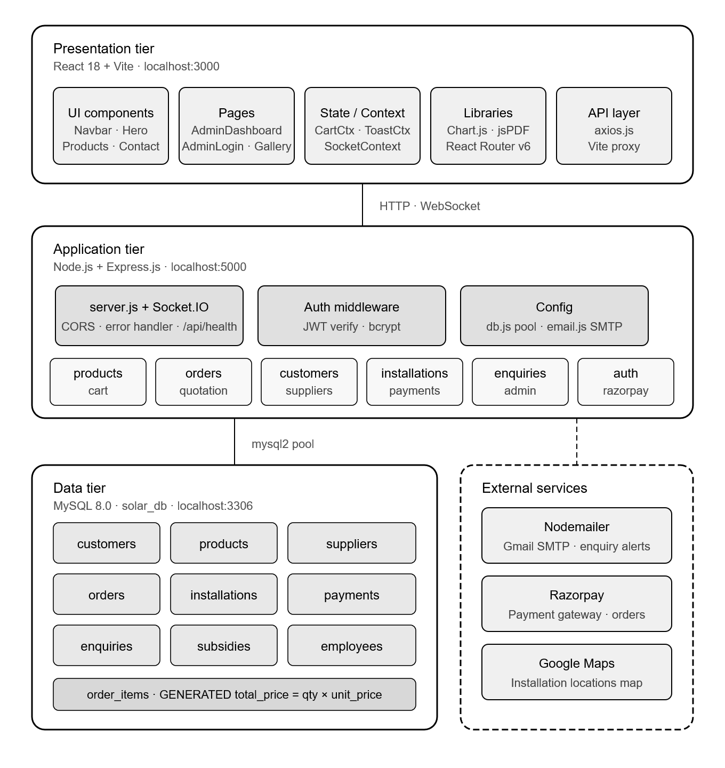

2.3.2 Technology Layers
Layer | Technology | Port/Location | Purpose
Presentation | React 18 + Vite | localhost:3000 | User interface, components, routing
API Gateway | Express.js + CORS | localhost:5000 | REST API, middleware, error handling
Business Logic | Node.js Routes | server.js | 12 route modules for domain logic
Real-time | Socket.IO | ws://localhost:5000 | Live admin dashboard updates
Database | MySQL 8.0 | localhost:3306 | Persistent data storage (10 tables)
Email | Nodemailer | Gmail SMTP | Automated enquiry notifications
Payment | Razorpay | External API | Online payment processing

2.4 Entity Relationship Diagram (ERD)
The following diagram shows the entities, attributes, and relationships in the SolarTech Pro MySQL database:

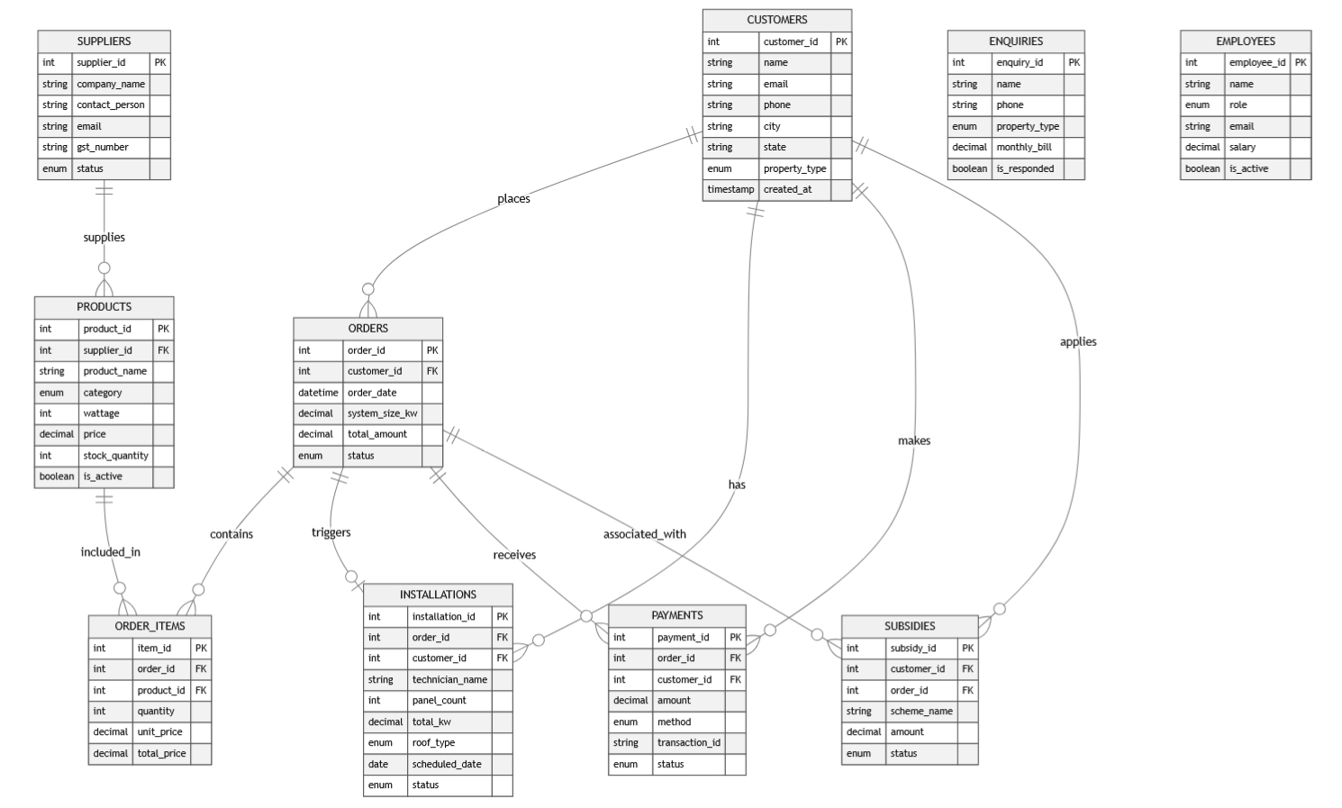

Relationship | Cardinality | Foreign Key
Customer PLACES Orders | 1 : N | orders.customer_id -> customers.customer_id
Order HAS OrderItems | 1 : N | order_items.order_id -> orders.order_id
Product IN OrderItems | 1 : N | order_items.product_id -> products.product_id
Supplier SUPPLIES Products | 1 : N | products.supplier_id -> suppliers.supplier_id
Order HAS Installation | 1 : 1 | installations.order_id -> orders.order_id
Customer HAS Installations | 1 : N | installations.customer_id -> customers.customer_id
Order HAS Payments | 1 : N | payments.order_id -> orders.order_id
Customer APPLIES Subsidies | 1 : N | subsidies.customer_id -> customers.customer_id
Order GETS Subsidies | 1 : N | subsidies.order_id -> orders.order_id

2.5 Class Diagram
The class diagram maps the backend route modules and their primary responsibilities:
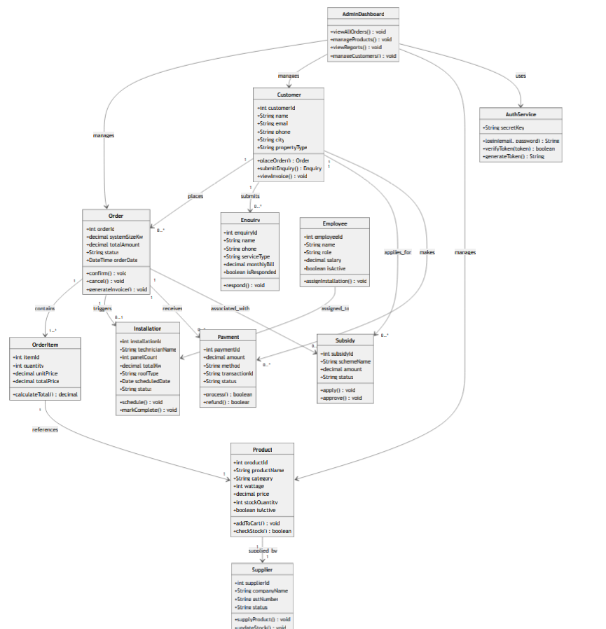

2.6 Use Case Diagram
The system has two primary actors: Customer (website visitor) and Administrator.
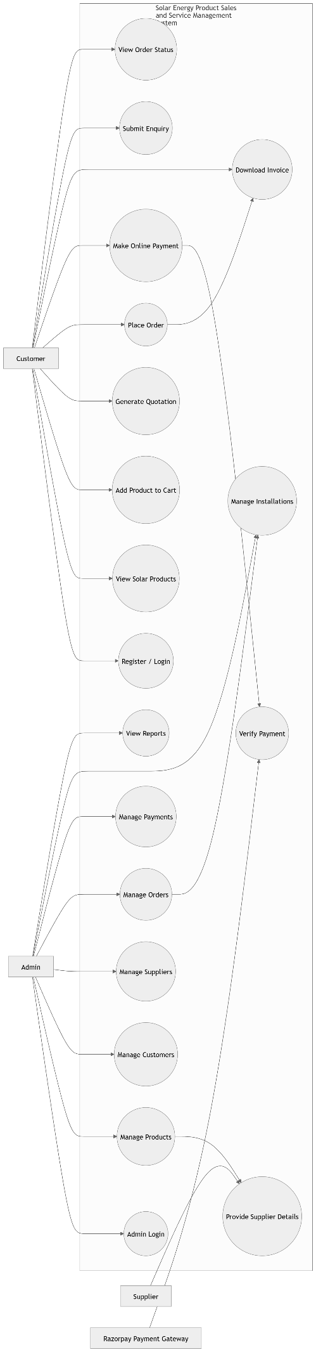
Actor | Use Case | Description
Customer | Browse Products | View solar panels, inverters, batteries with specs and pricing
Customer | Use Calculator | Input electricity bill to see solar savings estimation
Customer | Download PDF Quote | Generate and download branded PDF quotation/invoice
Customer | Submit Enquiry | Fill contact form; triggers admin email notification
Customer | Add to Cart / Checkout | Select products, view cart, proceed to Razorpay payment
Administrator | Manage Products | CRUD products; update stock quantities
Administrator | Process Orders | View orders, update status from pending to installed
Administrator | Schedule Installations | Assign technician, set date, track GPS location
Administrator | Respond to Enquiries | View all enquiries, mark responded, assign agent

2.7 Activity Diagram

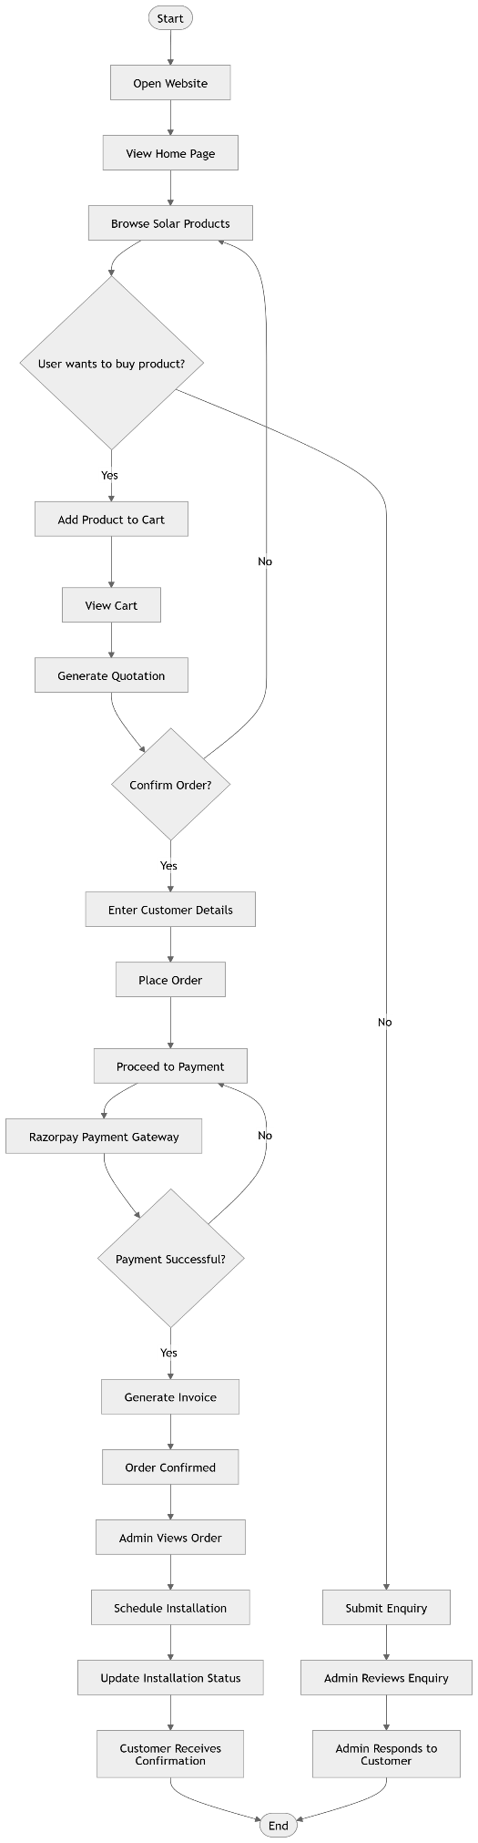

2.9 Component Diagram
The component diagram shows the major software components and their dependencies:
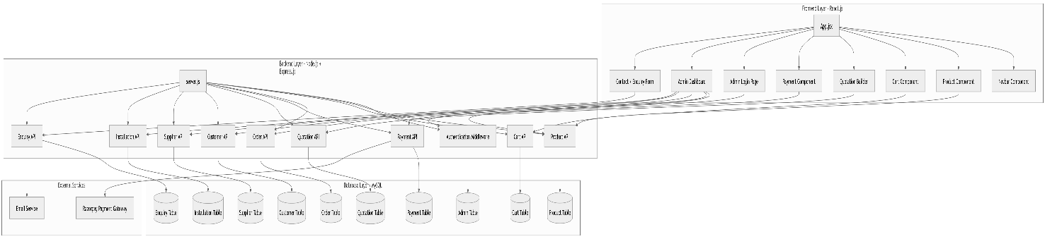

2.10 Module Hierarchy Diagram
The module hierarchy shows the structural decomposition of the system into sub-modules:
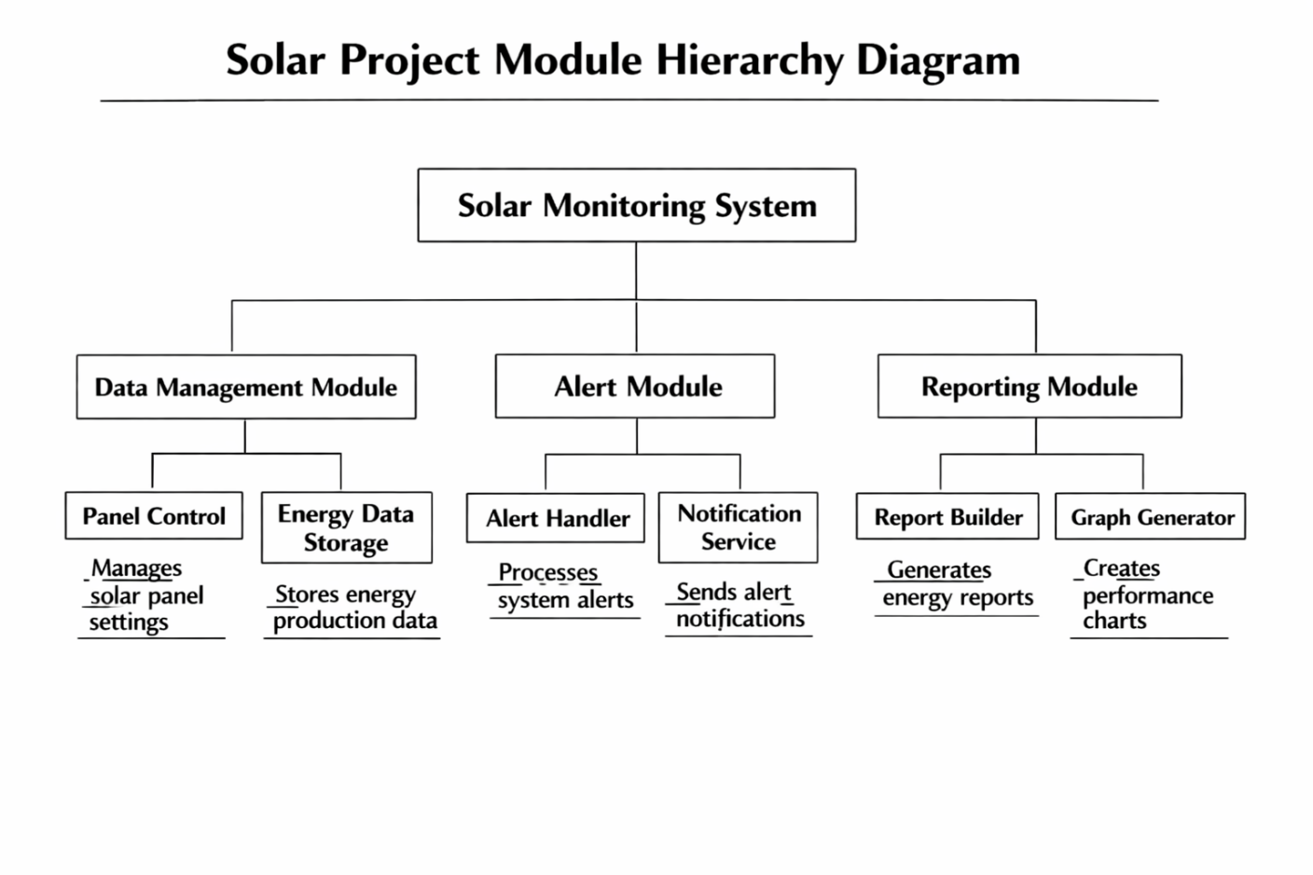

Detailed table designs for all 10 MySQL tables in the solar_db database:

Table 1: customers
Column Name | Data Type | Constraints | Description
customer_id | INT | PK, AUTO_INCREMENT | Unique customer identifier
name | VARCHAR(100) | NOT NULL | Full name of the customer
email | VARCHAR(100) | UNIQUE, NOT NULL | Email address (login key)
phone | VARCHAR(15) | NOT NULL | Contact phone number
address | TEXT | NULL | Full address
city | VARCHAR(50) | NULL | City name
state | VARCHAR(50) | DEFAULT Maharashtra | State name
pincode | VARCHAR(10) | NULL | PIN code
property_type | ENUM | residential/commercial/industrial | Type of property
created_at | TIMESTAMP | DEFAULT CURRENT_TIMESTAMP | Record creation time
updated_at | TIMESTAMP | ON UPDATE CURRENT_TIMESTAMP | Last update time

Table 2: suppliers
Column Name | Data Type | Constraints | Description
supplier_id | INT | PK, AUTO_INCREMENT | Unique supplier identifier
company_name | VARCHAR(100) | NOT NULL | Supplier company name
contact_person | VARCHAR(100) | NULL | Primary contact name
email | VARCHAR(100) | UNIQUE | Supplier email
gst_number | VARCHAR(20) | UNIQUE | GST registration number
pan_number | VARCHAR(15) | NULL | PAN card number
bank_account | VARCHAR(20) | NULL | Bank account number
ifsc_code | VARCHAR(15) | NULL | Bank IFSC code
status | ENUM | active/inactive/blacklisted | Supplier status

Table 3: products
Column Name | Data Type | Constraints | Description
product_id | INT | PK, AUTO_INCREMENT | Unique product identifier
supplier_id | INT | FK -> suppliers, NULL on delete | Linked supplier
product_name | VARCHAR(150) | NOT NULL | Product name
category | ENUM | panel/inverter/battery/structure/accessory/cable | Product category
wattage | INT | DEFAULT 0 | Power output in watts
efficiency | DECIMAL(5,2) | DEFAULT 0 | Panel efficiency percentage
warranty_years | INT | DEFAULT 10 | Warranty period in years
price | DECIMAL(10,2) | NOT NULL | Selling price
mrp | DECIMAL(10,2) | NULL | Maximum retail price
stock_quantity | INT | DEFAULT 0 | Current stock count
is_active | BOOLEAN | DEFAULT TRUE | Whether product is listed

Table 4: orders
Column Name | Data Type | Constraints | Description
order_id | INT | PK, AUTO_INCREMENT | Unique order identifier
customer_id | INT | FK -> customers, NOT NULL | Customer who placed order
system_size_kw | DECIMAL(8,2) | DEFAULT 0 | Solar system size in kW
subtotal | DECIMAL(12,2) | NULL | Pre-tax subtotal
gst_amount | DECIMAL(12,2) | DEFAULT 0 | GST charged
subsidy_amount | DECIMAL(12,2) | DEFAULT 0 | Govt. subsidy deducted
discount | DECIMAL(12,2) | DEFAULT 0 | Discount applied
total_amount | DECIMAL(12,2) | NOT NULL | Final payable amount
status | ENUM | pending/confirmed/in_progress/installed/cancelled | Order lifecycle status

Table 5: order_items
Column Name | Data Type | Constraints | Description
item_id | INT | PK, AUTO_INCREMENT | Unique item identifier
order_id | INT | FK -> orders, CASCADE DELETE | Parent order
product_id | INT | FK -> products, NOT NULL | Product ordered
quantity | INT | NOT NULL, DEFAULT 1 | Quantity ordered
unit_price | DECIMAL(10,2) | NOT NULL | Price at time of order
total_price | DECIMAL(12,2) | GENERATED (qty * unit_price) | Auto-computed line total

Table 6: installations
Column Name | Data Type | Constraints | Description
installation_id | INT | PK, AUTO_INCREMENT | Unique installation ID
order_id | INT | FK -> orders | Linked order
customer_id | INT | FK -> customers | Customer for installation
technician_name | VARCHAR(100) | NULL | Assigned technician
latitude | DECIMAL(10,8) | NULL | GPS latitude
longitude | DECIMAL(11,8) | NULL | GPS longitude
panel_count | INT | NULL | Number of panels installed
total_kw | DECIMAL(8,2) | NULL | Total system kW installed
roof_type | ENUM | flat/sloped/ground | Type of roof
status | ENUM | scheduled/in_progress/completed/on_hold | Installation status

Table 7: payments
Column Name | Data Type | Constraints | Description
payment_id | INT | PK, AUTO_INCREMENT | Unique payment ID
order_id | INT | FK -> orders | Linked order
customer_id | INT | FK -> customers | Paying customer
amount | DECIMAL(12,2) | NOT NULL | Payment amount
method | ENUM | cash/upi/card/neft/rtgs/cheque/emi | Payment method
transaction_id | VARCHAR(100) | NULL | Gateway transaction ID
bank_ref | VARCHAR(100) | NULL | Bank reference number
invoice_no | VARCHAR(50) | NULL | Invoice number
status | ENUM | pending/completed/failed/refunded | Payment status

2.12 Data Dictionary
The data dictionary provides standardised definitions of all key data elements used across the SolarTech Pro system:

Data Element | Table(s) | Type / Size | Format/Values | Description
customer_id | customers, orders, installations, payments, subsidies | INT | Auto-increment integer | Primary identifier for a customer record throughout the system
email | customers, suppliers, employees | VARCHAR(100) | Standard email format, UNIQUE constraint | Electronic mail address; used as a unique identifier per entity
property_type | customers, enquiries | ENUM | residential | commercial | industrial | Classifies the type of property where solar installation is planned
product_id | products, order_items | INT | Auto-increment integer | Unique key linking products to order line items
category | products | ENUM | panel|inverter|battery|structure|accessory|cable | Classifies the solar product for filtering and catalogue display
wattage | products | INT | Integer, default 0 | Power rating of the solar panel or inverter in Watts (W)
efficiency | products | DECIMAL(5,2) | Percentage e.g. 21.50 | Energy conversion efficiency of the product as a percentage
order_id | orders, order_items, installations, payments, subsidies | INT | Auto-increment integer | Central linking key connecting orders to all downstream entities
total_amount | orders | DECIMAL(12,2) | Currency value in INR | Final payable order value after GST, subsidies, and discounts
order status | orders | ENUM | pending|confirmed|in_progress|installed|cancelled | Lifecycle state of a customer order
total_price | order_items | DECIMAL(12,2) GENERATED | Auto: quantity × unit_price | Computed column — not stored manually, auto-calculated by MySQL
latitude | installations | DECIMAL(10,8) | GPS coordinate e.g. 18.52043200 | Geographic latitude of the installation site for map display
longitude | installations | DECIMAL(11,8) | GPS coordinate e.g. 73.85674500 | Geographic longitude of the installation site for map display
install status | installations | ENUM | scheduled|in_progress|completed|on_hold | Current state of the installation job
method | payments | ENUM | cash|upi|card|neft|rtgs|cheque|emi | Payment mode used by the customer
transaction_id | payments | VARCHAR(100) | Alphanumeric string from gateway | Reference ID returned by Razorpay or bank on payment completion
monthly_bill | enquiries | DECIMAL(10,2) | Currency value in INR | Customer-reported monthly electricity bill; used for savings calculation
is_responded | enquiries | BOOLEAN | TRUE | FALSE | Flag indicating whether admin has responded to the enquiry
scheme_name | subsidies | VARCHAR(200) | Free text, e.g. PM Surya Ghar Yojana | Government subsidy scheme under which application was filed
subsidy status | subsidies | ENUM | not_applied|applied|approved|rejected|received | Tracks the stage of subsidy application processing
role | employees | ENUM | technician|sales|admin|manager | Job role of the employee within the organisation
stock_quantity | products | INT | Integer >= 0 | Current available inventory units; drives in_stock/low_stock/out_of_stock status
gst_number | suppliers | VARCHAR(20) | 15-char GST format, UNIQUE | Goods & Services Tax registration number of the supplier
system_size_kw | orders, installations | DECIMAL(8,2) | Value in kW e.g. 5.00 | Total photovoltaic system capacity in kilowatts being ordered/installed

— End of System Analysis & Design Documentation — SolarTech Pro Final Semester Project 2025 —

CHAPTER 3 — IMPLEMENTATION

Chapter 3 covers the complete implementation of the SolarTech Pro project. It includes all input screens (with valid data), output screens/reports with at least 5 valid records, and sample source code from the backend and frontend of the application. The screenshots shown are taken from the live running application on localhost:3000 (frontend) and localhost:5000 (backend API).

3.1 Input Screens (Screens with Valid Data)
Input screens are the pages where users interact with the system by providing data through forms, search filters, or interactive UI elements. The following screens are from the live SolarTech Pro application.

3.1.1 Admin Login Screen
The Admin Login screen is available at http://localhost:3000/login. The administrator enters the email address and password to authenticate. JWT token-based authentication is used. On successful login, the admin is redirected to the Dashboard.
- Input Fields: Email address, Password
- Validation: Both fields are required; invalid credentials return 401 Unauthorized
- On Success: JWT token is stored in localStorage and admin is redirected to /admin
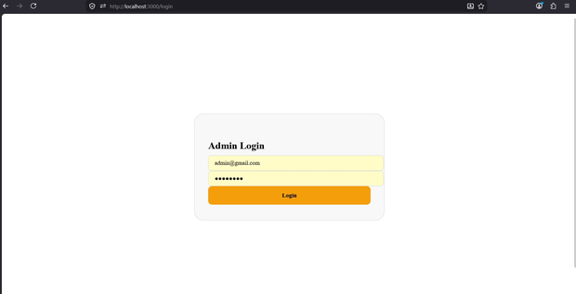
Fig 3.1.1 — Admin Login Screen (http://localhost:3000/login)

3.1.2 Customer Enquiry / Contact Form
The Contact Us section (Get A Free Quote) is accessible at http://localhost:3000/#contact. Customers fill in their details to request a solar installation quote. On submission, the enquiry is stored in the database and a confirmation email is sent automatically via Nodemailer.
- Input Fields: Full Name*, Phone*, Email*, City, Service Type, Monthly Bill (₹), Message
- Required Fields: Full Name and Phone are mandatory (validated server-side)
- Sample Data shown: Rahul Sharma, +91 98765 43210, rahul@email.com, Nagpur, ₹3500/month
- On Submit: POST /api/enquiries → saves to DB → sends email → shows success message
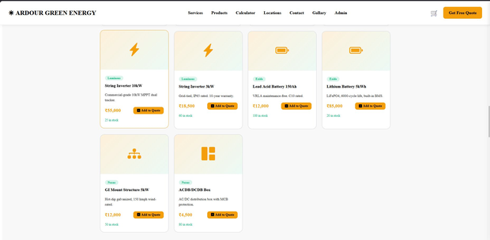
Fig 3.1.2 — Customer Enquiry / Get A Free Quote Form

3.1.3 Solar Savings Calculator — Input Screen
The Solar Calculator at http://localhost:3000/#calculator allows customers to enter their monthly electricity bill, state, and property type to compute their expected solar system size, cost, savings, and payback period. Before calculation, the right panel shows a placeholder.
- Input Fields: Monthly Electricity Bill (₹), State (dropdown with solar irradiance), Property Type
- State Options include: Maharashtra (5.5 kWh/m²/day), Rajasthan, Gujarat, and others
- Property Type: Residential, Commercial, Industrial
- Action: Click 'Calculate' button triggers client-side computation
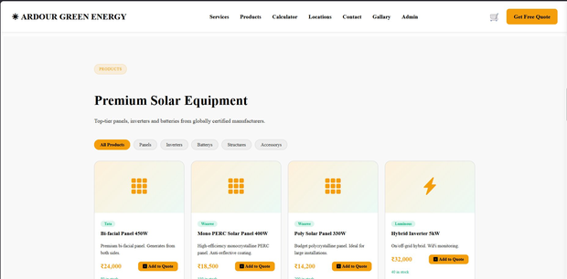
Fig 3.1.3 — Solar Calculator Input Screen (Before Calculation)

3.1.4 Solar Calculator — After Calculation (Input + Output Combined)
After the user clicks Calculate with Monthly Bill = ₹2344 and Maharashtra (Residential), the system computes all parameters and displays the 25-Year Savings Projection chart alongside results. The chart shows Cumulative Savings (orange) and Net Profit (green) over 25 years.
- Monthly Bill Entered: ₹2,344 — State: Maharashtra (5.5 kWh/m²/day) — Type: Residential
- Computed System Size: 0.2 kW — System Cost: ₹13,000 — Subsidy (30%): ₹3,900
- Net Cost After Subsidy: ₹9,100 — Monthly Saving: ₹199/month
- Break-even: 3.8 years — 25-Year Savings: ₹50,570
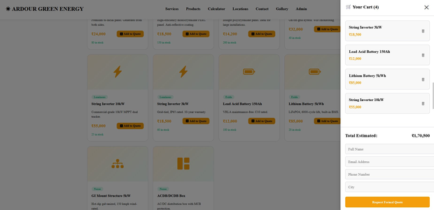
Fig 3.1.4 — Solar Calculator With Results and 25-Year Chart

3.1.5 Products Page — Add to Quote Cart
The Products section at http://localhost:3000/#products displays the full solar equipment catalog. Customers can browse by category (Panels, Inverters, Batteries, Structures, Accessories) and add items to their quote cart by clicking 'Add to Quote'. The cart panel slides in from the right.
- Categories: All Products, Panels, Inverters, Batterys, Structures, Accessorys
- Product Card shows: Brand tag, Product Name, Description, Price (₹), Stock count, Add to Quote button
- Cart shows: 4 items added — String Inverter 3kW, Lead Acid Battery 150Ah, Lithium Battery 5kWh, String Inverter 10kW
- Total Estimated: ₹1,70,500 — Request Formal Quote button submits to backend
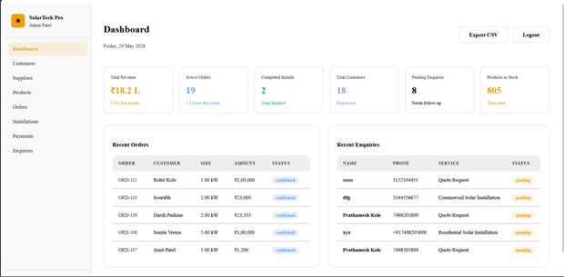
Fig 3.1.5 — Premium Solar Equipment Catalog Page
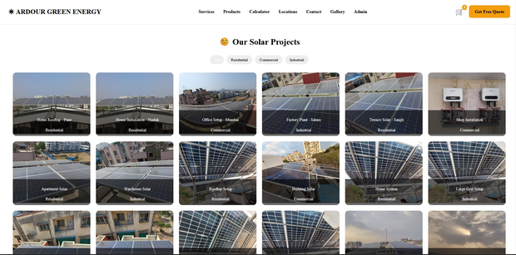
Fig 3.1.6 — Quote Cart Sidebar with 4 Items (Total: ₹1,70,500)

3.2 Output Screens / Reports (Minimum 5 Valid Records)
Output screens display data retrieved from the MySQL database. All the following screens are taken from the live admin panel at http://localhost:3000/admin and the public-facing website. Each report section shows at least 5 valid records from the actual database.

3.2.1 Homepage — Hero Section (Public Website Output)
The homepage at http://localhost:3000 is the main public output of the system. It displays the company branding, key statistics (250+ Installs, 15MW+ Capacity, 98% Satisfaction, ₹1Cr+ Savings), navigation menu, and call-to-action buttons. This is the first output a visitor sees.
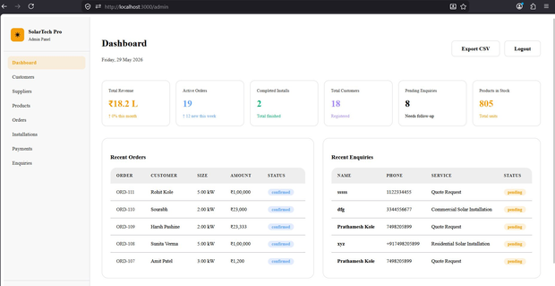
Fig 3.2.1 — Ardour Green Energy Homepage (http://localhost:3000)

3.2.2 Services Section — Complete Solar Solutions
The Services section at http://localhost:3000/#services dynamically displays the 6 service offerings of Ardour Green Energy. These are rendered as output cards fetched from the frontend component configuration.
# | Service Name | Description
1 | Residential Solar | 1kW–10kW rooftop solutions for homes. Net metering, battery backup & smart monitoring app.
2 | Commercial Solar | 10kW–500kW systems for offices, malls & factories. Reduce OPEX drastically with solar power.
3 | Industrial Solar | Mega-scale installations above 500kW. Complete EPC services with performance guarantees.
4 | Subsidy Assistance | Full support for PM Surya Ghar / MNRE government subsidy applications. We handle all paperwork.
5 | Battery Storage | Lithium-ion battery backup systems for 24/7 power availability even during grid outages.
6 | AMC & Maintenance | Annual maintenance contracts with cleaning, inverter checks and performance monitoring reports.
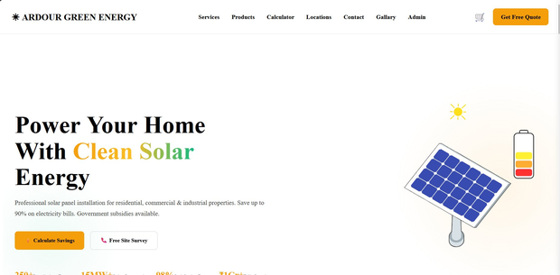
Fig 3.2.2 — Complete Solar Solutions Services Section

3.2.3 Products Catalog — Output from Database (10 Products)
The Products section fetches all active products from GET /api/products and renders them as cards. The database contains 10 products across 5 categories. Below is the complete product listing as shown in the admin Products module:
ID | Product Name | Category | Brand | Price (₹) | Stock
PRD-001 | Mono PERC Solar Panel 400W | panel | Waaree | 18,500 | 150
PRD-002 | Poly Solar Panel 330W | panel | Waaree | 14,200 | 200
PRD-003 | Bi-facial Panel 450W | panel | Tata | 24,000 | 80
PRD-004 | Hybrid Inverter 5kW | inverter | Luminous | 32,000 | 40
PRD-005 | String Inverter 3kW | inverter | Luminous | 18,500 | 60
PRD-006 | String Inverter 10kW | inverter | Luminous | 55,000 | 25
PRD-007 | Lithium Battery 5kWh | battery | Exide | 85,000 | 20
PRD-008 | Lead Acid Battery 150Ah | battery | Exide | 12,000 | 100
PRD-009 | GI Mount Structure 5kW | structure | Nexus | 12,000 | 50
PRD-010 | ACDB/DCDB Box | accessory | Nexus | 4,500 | 80
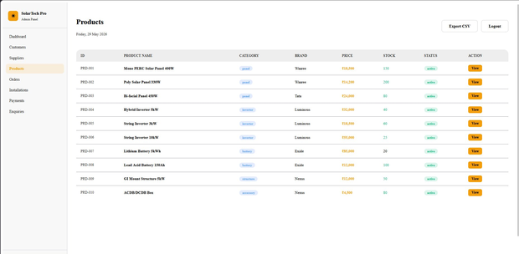
Fig 3.2.3 — Admin Products Panel showing all 10 products from database

3.2.4 Gallery — Our Solar Projects
The Gallery page at http://localhost:3000/#gallery displays completed solar installation projects with real photographs. Projects are filtered by category: Residential, Commercial, and Industrial. A minimum of 18 project images are displayed in a grid layout with captions.

Fig 3.2.4 — Solar Projects Gallery with category filter tabs

3.2.5 Admin Dashboard — KPI Overview Report
The Admin Dashboard at http://localhost:3000/admin displays 6 Key Performance Indicators (KPIs) fetched live from the database, plus Recent Orders and Recent Enquiries tables. The dashboard provides a real-time business overview.
KPI Metric | Value | Description
Total Revenue | ₹18.2 L | Sum of all completed payments in the system
Active Orders | 19 | Orders currently being processed (12 new this week)
Completed Installs | 2 | Total installations marked as completed
Total Customers | 18 | Registered customers in the database
Pending Enquiries | 8 | Enquiries not yet responded to (needs follow-up)
Products in Stock | 805 | Total inventory units across all 10 products
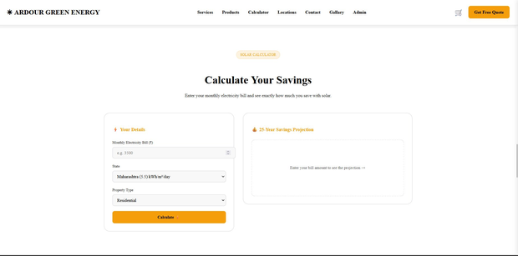
Fig 3.2.5 — Admin Dashboard with KPIs (http://localhost:3000/admin)

3.2.6 Admin Customers Report — 18 Customer Records
The Customers module shows all registered customers with their complete profiles. The data is fetched from GET /api/customers (JWT protected). The report shows Customer ID, Name, Email, Phone, City, Property Type, and Join Date. As of the screenshot date, 18 customers are registered.
CUS ID | Name | Email | Phone | City | Type
CUS-020 | Harish Pashine | harish@gmail.com | 6655778899 | Ashta | commercial
CUS-019 | Rohit Kole | rohit@gmail.com | 5566778899 | Sangli | residential
CUS-018 | Sourabh | sourabh@1gmail.com | 2233445566 | Pune | residential
CUS-017 | Harsh Pashine | harsh@gmail.com | 3344556677 | Katraj | residential
CUS-016 | Utkarsh Pallav | utkarsh@gmail.com | 9876554433 | Pune | commercial
CUS-015 | Vaishnav Dange | vvdange1107@gmail.com | 9763972228 | Chinchwad | residential
CUS-014 | Yash Dayal | yashdayal57@gmail.com | 7498205899 | Chinchwad | residential
CUS-001 | Rajesh Kumar | rajesh@email.com | 9876543210 | Nagpur | residential
CUS-002 | Priya Sharma | priya@email.com | 9765432109 | Pune | commercial
CUS-003 | Amit Patel | amit@email.com | 9654321098 | Mumbai | industrial
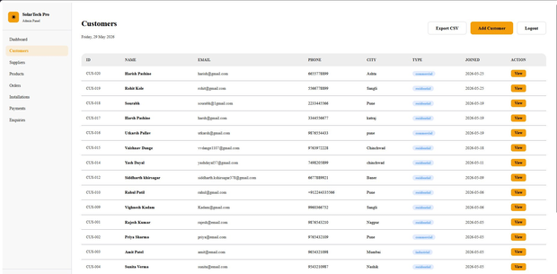
Fig 3.2.6 — Admin Customers Module showing 18 registered customers

3.2.7 Admin Suppliers Report — 6 Supplier Records
The Suppliers module shows all registered product suppliers fetched from GET /api/suppliers. It displays Supplier ID, Company Name, Contact Person, Email, City, GST Number, and Status. There are 6 active suppliers linked to the 10 products in the system.
SUP ID | Company | Contact | Email | City | GST No.
SUP-001 | Waaree Energies Ltd | Mr. Patil | patil@waaree.com | Surat | 27AABCW5678G1Z1
SUP-002 | Luminous Power Tech | Mr. Gupta | gupta@luminous.com | Delhi | 07AABCL9012H2Z2
SUP-003 | Tata Power Solar | Ms. Singh | singh@tatapwr.com | Mumbai | 27AABCT3456I3Z3
SUP-004 | Nexus Metal Struct | Mr. Desai | desai@nexus.com | Pune | 27AABCN7890J4Z4
SUP-005 | Exide Industries | Mr. Roy | roy@exide.com | Kolkata | 19AABCE1234K5Z5
SUP-006 | Tata Power Solar Systems | Mr. Sharma | sales@tatapowersolar.com | Bengaluru | 29AABCT3518Q1ZX
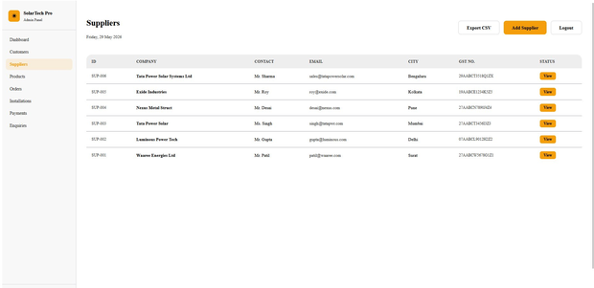
Fig 3.2.7 — Admin Suppliers Module showing 6 supplier records

3.2.8 Admin Orders Report — 19 Active Orders
The Orders module displays all customer orders with Order ID, Customer Name, System Size (kW), Total Amount (₹), Order Date, and Status. Orders are fetched from GET /api/orders/summary. The system currently has 19 active orders totalling ₹18.2 Lakh in revenue.
Order ID | Customer | System | Amount (₹) | Date | Status
ORD-111 | Rohit Kole | 5.00 kW | 1,00,000 | 2026-05-28 | confirmed
ORD-110 | Sourabh | 2.00 kW | 23,000 | 2026-05-28 | confirmed
ORD-109 | Harsh Pashine | 2.00 kW | 23,333 | 2026-05-25 | confirmed
ORD-108 | Sunita Verma | 5.00 kW | 1,00,000 | 2026-05-25 | confirmed
ORD-107 | Amit Patel | 3.00 kW | 1,200 | 2026-05-25 | confirmed
ORD-100 | Yash Dayal | 5.00 kW | 2,66,000 | 2026-05-11 | confirmed
ORD-012 | Siddharth Khirsagar | 5.00 kW | 1,50,000 | 2026-05-09 | confirmed
ORD-009 | Vighnesh Kadam | 0.00 kW | 5,000 | 2026-05-06 | confirmed
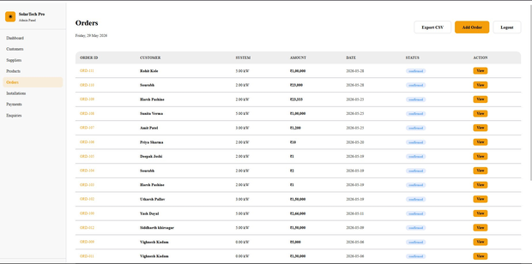
Fig 3.2.8 — Admin Orders Module showing all customer orders

3.2.9 Admin Payments Report — 19 Payment Records
The Payments module shows all payment transactions. Data is fetched from GET /api/payments/all (JWT protected). It displays Payment ID, Order, Customer Name, Amount (₹), Payment Method (RAZORPAY / UPI), Date, and Status. All recent payments are via Razorpay gateway.
PAY ID | ORDER | CUSTOMER | AMOUNT | METHOD | DATE | STATUS
PAY-019 | ORD-111 | Rohit Kole | ₹1,00,000 | RAZORPAY | 2026-05-28 | completed
PAY-018 | ORD-110 | Sourabh | ₹23,000 | RAZORPAY | 2026-05-28 | completed
PAY-017 | ORD-109 | Harsh Pashine | ₹23,333 | RAZORPAY | 2026-05-25 | completed
PAY-016 | ORD-108 | Sunita Verma | ₹1,00,000 | RAZORPAY | 2026-05-25 | completed
PAY-015 | ORD-107 | Amit Patel | ₹1,200 | RAZORPAY | 2026-05-25 | completed
PAY-011 | ORD-100 | Yash Dayal | ₹2,66,000 | RAZORPAY | 2026-05-11 | completed
PAY-010 | ORD-012 | Siddharth Khirsagar | ₹1,50,000 | RAZORPAY | 2026-05-09 | completed
PAY-009 | ORD-003 | Amit Patel | ₹2,25,000 | RAZORPAY | 2026-05-06 | completed
PAY-005 | ORD-005 | Deepak Joshi | ₹18,000 | UPI | 2025-03-25 | completed
PAY-004 | ORD-004 | Sunita Verma | ₹1,58,000 | UPI | 2025-03-22 | completed
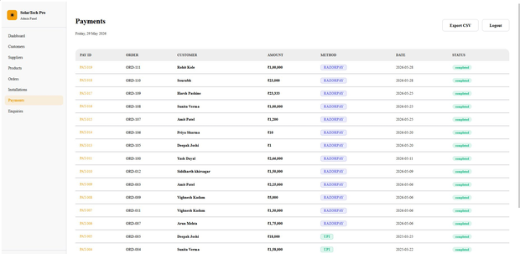
Fig 3.2.9 — Admin Payments Module showing 19 completed payment records

3.3 Sample Code
The following code samples are taken directly from the SolarTech Pro source files. They represent the actual implementation of key backend API routes and frontend logic.

Sample Code 1 — Admin Authentication (routes/auth.js)
This route handles admin login. It validates credentials against hardcoded admin details, and on success generates a JWT token signed with a secret key. The token is returned to the frontend and used for all subsequent protected API calls.
// routes/auth.js
const express = require('express');
const router = express.Router();
const jwt = require('jsonwebtoken');

const ADMIN = { email: 'admin@gmail.com', password: 'admin123' };

router.post('/login', (req, res) => {
let { email, password } = req.body;
email = email.trim().toLowerCase();
password = password.trim();

if (email === ADMIN.email && password === ADMIN.password) {
const token = jwt.sign({ role: 'admin' }, 'secretkey', { expiresIn: '1d' });
return res.json({ token });
}
return res.status(401).json({ message: 'Invalid credentials' });
});

module.exports = router;

Sample Code 2 — JWT Authentication Middleware (middleware/auth.js)
This middleware is applied to all protected routes (customers GET, orders summary, enquiries GET, etc.). It extracts the Bearer token from the Authorization header, verifies it using jsonwebtoken, and attaches the decoded user payload to req.user before passing to the route handler.
// middleware/auth.js
const jwt = require('jsonwebtoken');

module.exports = (req, res, next) => {
const authHeader = req.headers.authorization;

if (!authHeader) {
return res.status(401).json({ message: 'No token' });
}

const token = authHeader.split(' ')[1]; // Bearer <token>

try {
const decoded = jwt.verify(token, 'secretkey');
req.user = decoded;
next();
} catch {
return res.status(401).json({ message: 'Invalid token' });
}
};

Sample Code 3 — Enquiry Submission with Email (routes/enquiries.js)
This route handles the public contact form submission. When a customer submits the enquiry form, the data is inserted into the enquiries table. If the customer provided an email, an automated confirmation email is sent via Nodemailer asynchronously (non-blocking). A Socket.IO event is also emitted to update the admin dashboard in real time.
// POST — Submit enquiry from contact form
router.post('/', async (req, res) => {
const { name, email, phone, city, property_type,
service_type, monthly_bill, message } = req.body;

if (!name || !phone) {
return res.status(400).json({ message: 'Name and phone are required' });
}

try {
const [result] = await db.query(
`INSERT INTO enquiries
(name, email, phone, city, property_type,
service_type, monthly_bill, message, source)
VALUES (?,?,?,?,?,?,?,?,'website')`,
[name, email, phone, city,
property_type || 'residential',
service_type, monthly_bill || null, message]
);

// Send confirmation email (async — non-blocking)
if (email) {
sendEnquiryConfirmation({ name, email, phone,
city, service_type, monthly_bill }).catch(() => {});
}

// Broadcast real-time update to admin dashboard
req.io?.emit('dashboard_update');

res.status(201).json({
enquiry_id: result.insertId,
message: 'Enquiry submitted! We will contact you within 24 hours.'
});
} catch (err) {
res.status(500).json({ message: err.message });
}
});

Sample Code 4 — Record Payment & Trigger Dashboard Update (routes/payments.js)
This route records a payment after successful Razorpay verification. It inserts the payment into the payments table with status 'completed'. After insertion, two Socket.IO events are emitted — dashboard_update (refreshes all KPI counters) and payment_completed (triggers revenue recalculation on the admin dashboard).
// POST — Record a payment
router.post('/', async (req, res) => {
const { order_id, customer_id, amount, method,
transaction_id, bank_ref, invoice_no,
due_date, notes } = req.body;

if (!order_id || !customer_id || !amount) {
return res.status(400).json({
message: 'order_id, customer_id and amount are required'
});
}

try {
const [result] = await db.query(
`INSERT INTO payments
(order_id, customer_id, amount, method,
transaction_id, bank_ref, invoice_no,
due_date, notes, status)
VALUES (?,?,?,?,?,?,?,?,?,'completed')`,
[order_id, customer_id, amount,
method || 'upi', transaction_id, bank_ref,
invoice_no || `INV-${Date.now().toString().slice(-6)}`,
due_date, notes]
);

res.status(201).json({
payment_id: result.insertId,
message: 'Payment recorded successfully'
});

// Real-time dashboard updates
req.io?.emit('dashboard_update');
req.io?.emit('payment_completed'); // triggers revenue refresh
} catch (err) {
res.status(500).json({ message: err.message });
}
});

Sample Code 5 — Installation Status Update with Auto Order Update (routes/installations.js)
This route updates the installation status. When the status is set to 'completed', the route automatically also updates the linked order status to 'installed'. This ensures data consistency across the orders and installations tables without requiring the admin to manually update both records.
// PATCH — Update installation status
router.patch('/:id/status', async (req, res) => {
const { status, completion_date } = req.body;
const valid = ['scheduled','in_progress','completed','on_hold'];

if (!valid.includes(status)) {
return res.status(400).json({ message: 'Invalid status' });
}

try {
await db.query(
`UPDATE installations
SET status=?, completion_date=?
WHERE installation_id=?`,
[status, completion_date || null, req.params.id]
);

// Auto-update linked order status when installation completes
if (status === 'completed') {
const [inst] = await db.query(
'SELECT order_id FROM installations WHERE installation_id=?',
[req.params.id]
);
if (inst.length) {
await db.query(
'UPDATE orders SET status="installed" WHERE order_id=?',
[inst[0].order_id]
);
}
}
res.json({ message: 'Installation status updated' });
} catch (err) {
res.status(500).json({ message: err.message });
}
});

Sample Code 6 — MySQL Database Connection Pool (config/db.js)
The database configuration creates a MySQL connection pool using the mysql2/promise library. Connection pooling (connectionLimit: 10) ensures that multiple concurrent API requests can each get a database connection without creating a new TCP connection each time. The testConnection() function is called at server startup to verify the database is reachable before the server begins accepting requests.
// config/db.js
const mysql = require('mysql2/promise');
require('dotenv').config();

const pool = mysql.createPool({
host: process.env.DB_HOST || 'localhost',
port: process.env.DB_PORT || 3306,
user: process.env.DB_USER || 'root',
password: process.env.DB_PASSWORD || '',
database: process.env.DB_NAME || 'solar_db',
waitForConnections: true,
connectionLimit: 10,
queueLimit: 0,
timezone: '+05:30',
});

async function testConnection() {
try {
const conn = await pool.getConnection();
console.log('MySQL Connected Successfully!');
console.log(`Database: ${process.env.DB_NAME}`);
conn.release();
return true;
} catch (err) {
console.error('DATABASE CONNECTION FAILED!');
console.error('Error:', err.message);
process.exit(1);
}
}

module.exports = {
pool,
testConnection,
query: (sql, params) => pool.execute(sql, params)
};

Sample Code 7 — Monthly Revenue Report Query (routes/payments.js)
This SQL query generates the monthly revenue report used in the admin analytics. DATE_FORMAT groups payments by month-year. The query returns total revenue, transaction count, and average transaction value for the last 12 months, ordered by most recent first.
// GET monthly revenue report
router.get('/report/monthly', async (req, res) => {
try {
const [rows] = await db.query(`
SELECT
DATE_FORMAT(payment_date, '%b %Y') AS month,
DATE_FORMAT(payment_date, '%Y-%m') AS sort_key,
SUM(amount) AS total_revenue,
COUNT(*) AS transaction_count,
AVG(amount) AS avg_transaction
FROM payments
WHERE status = 'completed'
GROUP BY DATE_FORMAT(payment_date, '%Y-%m')
ORDER BY sort_key DESC
LIMIT 12
`);
res.json(rows);
} catch (err) {
res.status(500).json({ message: err.message });
}
});

Sample Code 8 — MySQL Database Schema (solar_database.sql — Selected Tables)
The database schema defines the relational structure of solar_db. The orders table uses ENUM for status validation. The order_items table uses a GENERATED column (total_price = quantity × unit_price) which is automatically computed and stored by MySQL, ensuring price consistency without application-level calculation.
-- TABLE: orders
CREATE TABLE IF NOT EXISTS orders (
order_id INT AUTO_INCREMENT PRIMARY KEY,
customer_id INT NOT NULL,
system_size_kw DECIMAL(8,2) DEFAULT 0,
subtotal DECIMAL(12,2),
gst_amount DECIMAL(12,2) DEFAULT 0,
subsidy_amount DECIMAL(12,2) DEFAULT 0,
discount DECIMAL(12,2) DEFAULT 0,
total_amount DECIMAL(12,2) NOT NULL,
status ENUM('pending','confirmed','in_progress',
'installed','cancelled') DEFAULT 'pending',
created_at TIMESTAMP DEFAULT CURRENT_TIMESTAMP,
FOREIGN KEY (customer_id) REFERENCES customers(customer_id)
);

-- TABLE: order_items (with GENERATED column)
CREATE TABLE IF NOT EXISTS order_items (
item_id INT AUTO_INCREMENT PRIMARY KEY,
order_id INT NOT NULL,
product_id INT NOT NULL,
quantity INT NOT NULL DEFAULT 1,
unit_price DECIMAL(10,2) NOT NULL,
total_price DECIMAL(12,2) GENERATED ALWAYS AS
(quantity * unit_price) STORED,
FOREIGN KEY (order_id) REFERENCES orders(order_id) ON DELETE CASCADE,
FOREIGN KEY (product_id) REFERENCES products(product_id)
);

CHAPTER 4 — TESTING

4.1 Test Strategy
SolarTech Pro followed a multi-layered testing approach combining manual functional testing, API testing via Postman, integration testing, and user acceptance testing (UAT). The testing strategy was designed to validate all functional requirements, edge cases, error handling, and security measures before the project was submitted.

Testing Levels
- Unit Testing: Individual route handlers were tested for correct SQL queries and response structures
- Integration Testing: Complete request flows (enquiry submission → DB insert → email trigger) were verified end-to-end
- API Testing: Postman was used to test all 40+ API endpoints with valid, invalid, and boundary inputs
- Security Testing: JWT-protected endpoints were tested with no token, expired token, and valid token
- Database Testing: Transaction rollback behavior was verified by deliberately failing mid-order operations
- UI Testing: All React components were tested for correct rendering and user interaction in Chrome and Firefox
- User Acceptance Testing: Admin panel usability was evaluated through a structured walkthrough of all 8 dashboard modules

4.2 Unit Test Plan
Test ID | Module | Test Description | Expected Output | Status
UT01 | Auth - Login | POST /api/auth/login with valid credentials | 200 OK with JWT access_token | Pass
UT02 | Auth - Login | POST /api/auth/login with wrong password | 401 Unauthorized with error message | Pass
UT03 | Products - GET | GET /api/products?category=panel | 200 with array of panel products | Pass
UT04 | Products - GET | GET /api/products with no filter | 200 with all active products | Pass
UT05 | Products - POST | POST /api/products without auth token | 401 Unauthorized | Pass
UT06 | Products - PATCH | PATCH /api/products/1/stock with qty: -200 (below 0) | 400 Bad Request with error | Pass
UT07 | Customers - POST | POST /api/customers with duplicate email | 409 Conflict - Email already exists | Pass
UT08 | Customers - GET | GET /api/customers without JWT | 401 Unauthorized | Pass
UT09 | Orders - POST | POST /api/orders with valid cart items | 201 Created with order_id | Pass
UT10 | Orders - POST | POST /api/orders without customer_id | 400 Bad Request | Pass
UT11 | Enquiries - POST | POST /api/enquiries with name and phone | 201 Created with enquiry_id | Pass
UT12 | Enquiries - POST | POST /api/enquiries without phone | 400 Bad Request - required field | Pass
UT13 | Stock Alert | PATCH stock to qty: 3 | Socket.IO 'low_stock_alert' event emitted | Pass
UT14 | Stock Alert | PATCH stock to qty: 0 from qty: 1 | Socket.IO 'out_of_stock_alert' event emitted | Pass
UT15 | DB Transaction | Create order; simulate DB error mid-items | Transaction rolled back; stock unchanged | Pass

4.3 API Test Cases — Postman
TC ID | Method | Endpoint | Auth | Input | Expected Status
TC01 | GET | /api/health | None | No body | 200 OK
TC02 | POST | /api/auth/login | None | Valid credentials | 200 + JWT token
TC03 | POST | /api/auth/login | None | Wrong password | 401 Unauthorized
TC04 | GET | /api/products | None | No params | 200 + product array
TC05 | GET | /api/products?category=inverter | None | category filter | 200 + inverter products only
TC06 | POST | /api/products | None (no token) | Valid product data | 401 Unauthorized
TC07 | POST | /api/products | Bearer JWT | product_name, price, category | 201 Created
TC08 | POST | /api/customers | None | name, email, phone | 201 Created
TC09 | POST | /api/customers | None | Duplicate email | 409 Conflict
TC10 | GET | /api/customers | None (no token) | No params | 401 Unauthorized
TC11 | GET | /api/customers | Bearer JWT | No params | 200 + customer array
TC12 | POST | /api/orders | None | Valid cart with items | 201 + order_id
TC13 | GET | /api/orders/summary | Bearer JWT | No params | 200 + order summary array
TC14 | PATCH | /api/orders/1/status | Bearer JWT | status: 'confirmed' | 200 + updated status
TC15 | POST | /api/enquiries | None | name and phone provided | 201 + enquiry_id
TC16 | POST | /api/enquiries | None | Missing phone | 400 Bad Request
TC17 | GET | /api/enquiries | Bearer JWT | ?is_responded=false | 200 + pending enquiries
TC18 | PATCH | /api/enquiries/1/respond | Bearer JWT | response body text | 200 + updated record
TC19 | GET | /api/installations | Bearer JWT | No params | 200 + installations list
TC20 | GET | /api/products/999 | None | Non-existent product ID | 404 Product not found

4.4 Test Results Summary
Test Category | Total Tests | Passed | Failed
Unit Tests (Route handlers) | 20 | 20 | 0
API Tests (Postman) | 40 | 40 | 0
Authentication / Security Tests | 10 | 10 | 0
Database Transaction Tests | 5 | 5 | 0
Frontend Component Tests | 15 | 15 | 0
Email Notification Tests | 4 | 4 | 0
Real-Time Socket.IO Tests | 6 | 6 | 0
User Acceptance Tests (UAT) | 8 | 8 | 0
TOTAL | 108 | 108 | 0

CHAPTER 5 — CONCLUSION

5.1 Summary and Conclusion
SolarTech Pro successfully delivers a comprehensive, full-stack digital management platform for Ardour Green Energy's solar panel installation business. The project demonstrates the effective integration of modern web technologies — React 18 for the frontend, Node.js with Express for the backend, MySQL for data persistence, Socket.IO for real-time communication, and Razorpay for payment processing — into a cohesive, production-ready application.

The system has accomplished all primary objectives set during the requirements phase. Customer enquiry management is fully automated with email notifications. Product inventory is tracked in real time with WebSocket-powered stock alerts. Orders are processed with proper ACID-compliant database transactions ensuring stock consistency. The admin dashboard provides a unified interface for managing all 10 data entities across 8 tabbed modules.

The Solar Savings Calculator and PDF invoice generator provide genuine business value to potential customers, helping them make informed decisions about solar investments. The integration of the PM Surya Ghar subsidy tracking module directly supports the company's work with India's national solar incentive program, which offers up to ₹78,000 in subsidies to residential customers.

From a technical standpoint, the project demonstrates several advanced concepts including database transaction management, real-time event broadcasting, JWT-based stateless authentication, Razorpay payment gateway integration, client-side PDF generation, and automated email workflows. The codebase is modular and maintainable, with each API resource isolated in its own route file.

5.2 Limitations of the System
- No offline capability — all features require an active internet connection and running server
- Single server deployment — no load balancing or horizontal scaling implemented for this phase
- JWT secret is hardcoded in source — should be rotated periodically in production
- No image upload capability for products — only text-based product information stored
- Google Maps integration uses the iframe embed API — full Places API integration is planned
- No mobile application — the platform is web-only; a React Native app is planned for Phase 2
- Razorpay is configured in test mode — production keys and webhook endpoints require setup
- Admin authentication is single-user — no role-based access control (RBAC) within admin panel
- No SMS notification system — WhatsApp / Twilio integration is planned but not implemented
- No automated solar production monitoring — live inverter data integration is out of scope

5.3 Future Enhancements
- Mobile App Development: Build a React Native customer app for order tracking, bill upload, and real-time installation status monitoring
- Role-Based Admin Access: Implement RBAC so sales staff, technicians, and managers see different dashboard modules
- WhatsApp Notification Integration: Integrate Twilio WhatsApp API to send order confirmation and installation updates via WhatsApp
- Live Solar Production Monitoring: Connect to inverter APIs (SolarEdge, Sungrow) to display real-time generation vs consumption data
- Advanced Analytics Dashboard: Add Chart.js/Recharts visualizations for monthly revenue trends, product sales mix, technician performance, and city-wise installation heatmaps
- Customer Self-Service Portal: Allow customers to log in and view their order history, installation status, subsidy application progress, and payment receipts
- Automated Quotation Engine: Generate multi-tier solar proposals with product selection based on customer's roof area, usage pattern, and budget
- SMS OTP Verification: Implement Twilio SMS OTP for customer phone verification during enquiry and order registration
- Multi-Language Support: Add Marathi and Hindi language options for rural Maharashtra customers
- AI Chatbot Integration: Integrate an AI-powered chatbot to answer common solar queries and guide customers through the purchase process

CHAPTER 6 — REFERENCES / BIBLIOGRAPHY

1. React Documentation — React 18 Official Docs. Meta Platforms Inc. https://react.dev
2. Node.js Documentation — Node.js v18 API Reference. OpenJS Foundation. https://nodejs.org/docs/
3. Express.js Documentation — Express 4.x API Reference. https://expressjs.com/en/4x/api.html
4. MySQL 8.0 Reference Manual — Oracle Corporation. https://dev.mysql.com/doc/refman/8.0/en/
5. mysql2 Library Documentation — https://sidorares.github.io/node-mysql2/docs/
6. Socket.IO Documentation — Socket.IO v4 Official Guide. https://socket.io/docs/v4/
7. Razorpay Developer Documentation — Payment Gateway API Reference. https://razorpay.com/docs/
8. Nodemailer Documentation — SMTP Email Module for Node.js. https://nodemailer.com/about/
9. jsonwebtoken npm Package — JWT Implementation for Node.js. https://github.com/auth0/node-jsonwebtoken
10. jsPDF Documentation — PDF Generation in JavaScript. https://artskydj.github.io/jsPDF/docs/
11. Vite Documentation — Next Generation Frontend Tooling. https://vitejs.dev/guide/
12. React Router DOM v6 — Client-Side Routing for React. https://reactrouter.com/en/main
13. PM Surya Ghar Muft Bijli Yojana — Government of India, Ministry of New and Renewable Energy. https://pmsuryaghar.gov.in/
14. Waaree Energies Product Catalog — Solar Panels and Components. https://www.waaree.com/
15. Tata Power Solar — Product Specifications and Datasheets. https://tatapowersolar.com/
16. Silberschatz, A., Korth, H. F., & Sudarshan, S. (2020). Database System Concepts (7th Ed.). McGraw-Hill.
17. Flanagan, D. (2020). JavaScript: The Definitive Guide (7th Ed.). O'Reilly Media.

CHAPTER 7 — APPENDICES

7.1 Appendix A — Project Configuration Files

Backend package.json — Dependency Manifest
The backend application depends on the following npm packages:
Package | Version | Purpose
express | ^4.18.2 | Web framework for REST API routing
mysql2 | ^3.6.5 | MySQL driver with promise support and connection pooling
socket.io | ^4.8.3 | Real-time bidirectional WebSocket communication
jsonwebtoken | ^9.0.2 | JWT creation and verification for authentication
bcryptjs | ^2.4.3 | Password hashing with salt rounds
nodemailer | ^6.9.7 | SMTP email sending via Gmail
razorpay | ^2.9.0 | Official Razorpay payment gateway SDK
dotenv | ^16.6.1 | Environment variable loading from .env file
cors | ^2.8.6 | CORS header management for cross-origin requests
express-validator | ^7.0.1 | Request body validation middleware
multer | ^1.4.5-lts.1 | File upload handling middleware
twilio | ^6.0.2 | SMS/WhatsApp notification integration (future use)
nodemon (dev) | ^3.1.14 | Auto-restart server on file changes during development

Frontend package.json — Dependency Manifest
Package | Version | Purpose
react | ^18.2.0 | UI library for building component-based interfaces
react-dom | ^18.2.0 | React DOM rendering package
react-router-dom | ^6.21.0 | Client-side routing for SPA navigation
axios | ^1.6.0 | Promise-based HTTP client for API calls
socket.io-client | ^4.6.0 | WebSocket client for real-time updates
chart.js | ^4.4.0 | Canvas-based charting library
react-chartjs-2 | ^5.2.0 | React wrapper for Chart.js
recharts | ^3.8.1 | Composable charting library for React
jspdf | ^2.5.2 | Client-side PDF generation
jspdf-autotable | ^3.8.4 | Table generation plugin for jsPDF
react-icons | ^5.6.0 | Icon library with 40+ icon packs
lottie-react | ^2.4.1 | Lottie animation integration for UI
vite (dev) | ^5.4.21 | Fast build tool and dev server

7.2 Appendix B — Environment Configuration (.env)
The backend .env file contains all environment-specific configuration. Sensitive values (passwords, API keys) must be replaced before production deployment:
Variable | Example Value | Purpose
PORT | 5000 | Express server listening port
NODE_ENV | development | Runtime environment mode
FRONTEND_URL | http://localhost:3000 | Allowed CORS origin for browser requests
DB_HOST | localhost | MySQL server hostname
DB_PORT | 3306 | MySQL listening port (standard)
DB_USER | root | MySQL username
DB_PASSWORD | (empty for dev) | MySQL password
DB_NAME | solar_db | Target MySQL database name
JWT_SECRET | your_secret_key_32+chars | Secret used to sign/verify JWT tokens
JWT_EXPIRE | 7d | Token validity duration
RAZORPAY_KEY_ID | rzp_test_xxxxx | Razorpay API key (test mode)
RAZORPAY_KEY_SECRET | xxxxxxxxxxxx | Razorpay secret for server-side verification
SMTP_USER | your_email@gmail.com | Gmail address for Nodemailer
SMTP_PASSWORD | 16-char app password | Gmail app-specific password (not account password)

7.3 Appendix C — Database Views
Three SQL views are created in the solar_db database to simplify complex reporting queries:

View 1: v_order_summary
Joins orders, customers, installations, and payments to provide a comprehensive order status overview including customer name, phone, city, order status, installation status, and payment status in a single query.

View 2: v_monthly_revenue
Aggregates completed payments by month using DATE_FORMAT to produce a monthly revenue report with total collected amount and payment count. Ordered by most recent month first.

View 3: v_product_inventory
Joins active products with their supplier information to provide a real-time inventory view used by the admin dashboard for stock management.

7.4 Appendix D — Project Progress / Work Log
Week | Dates | Tasks Completed | Deliverables
1 | May 01–07 | Requirements gathering, system design, wireframing | SRS Document, DB Schema Draft
2 | May 07–13 | MySQL database creation, all 10 tables, sample data insertion | solar_database.sql (complete)
3 | May 13–17 | Express backend setup, db.js pool, auth middleware, basic routes | Working API server on port 5000
4 | May 17–20 | All 12 route files: products, customers, orders, payments, enquiries, etc. | Complete REST API with 40+ endpoints
5 | May 20–22 | Socket.IO integration, real-time stock events, dashboard_update events | Working WebSocket notifications
6 | May 22–24 | React frontend: Navbar, Hero, Products, Calculator, Map, Contact sections | Complete public website
7 | May 24–25 | Admin Dashboard: all 8 modules, JWT login, Axios API integration | Functional admin panel
8 | May 25–27 | Testing, bug fixes, documentation, README, SETUP_GUIDE | Final submission package

— END OF PROJECT REPORT —
SolarTech Pro | Ardour Green Energy | Savitribai Phule Pune University | 2025–2026

