**This document describes the steps involved in deploying a Flask application on AWS Elastic Beanstalk using CodePipeline for continuous delivery.**

1. Created an Elastic Beanstalk environment.

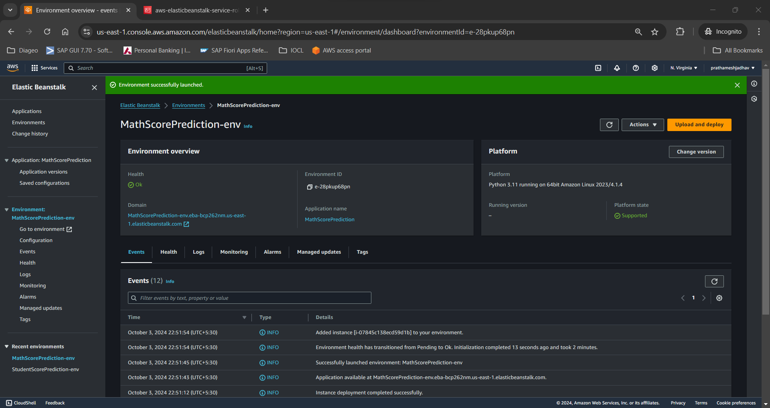

1. Created a CodePipeline to continuously deliver any code changes in the application hosted on GitHub repository to AWS Elastic Beanstalk.

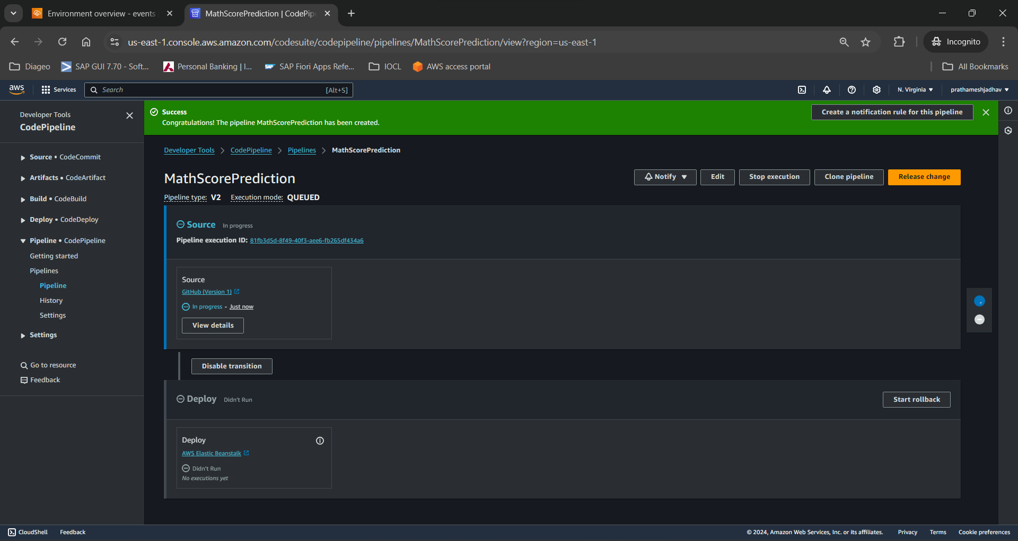

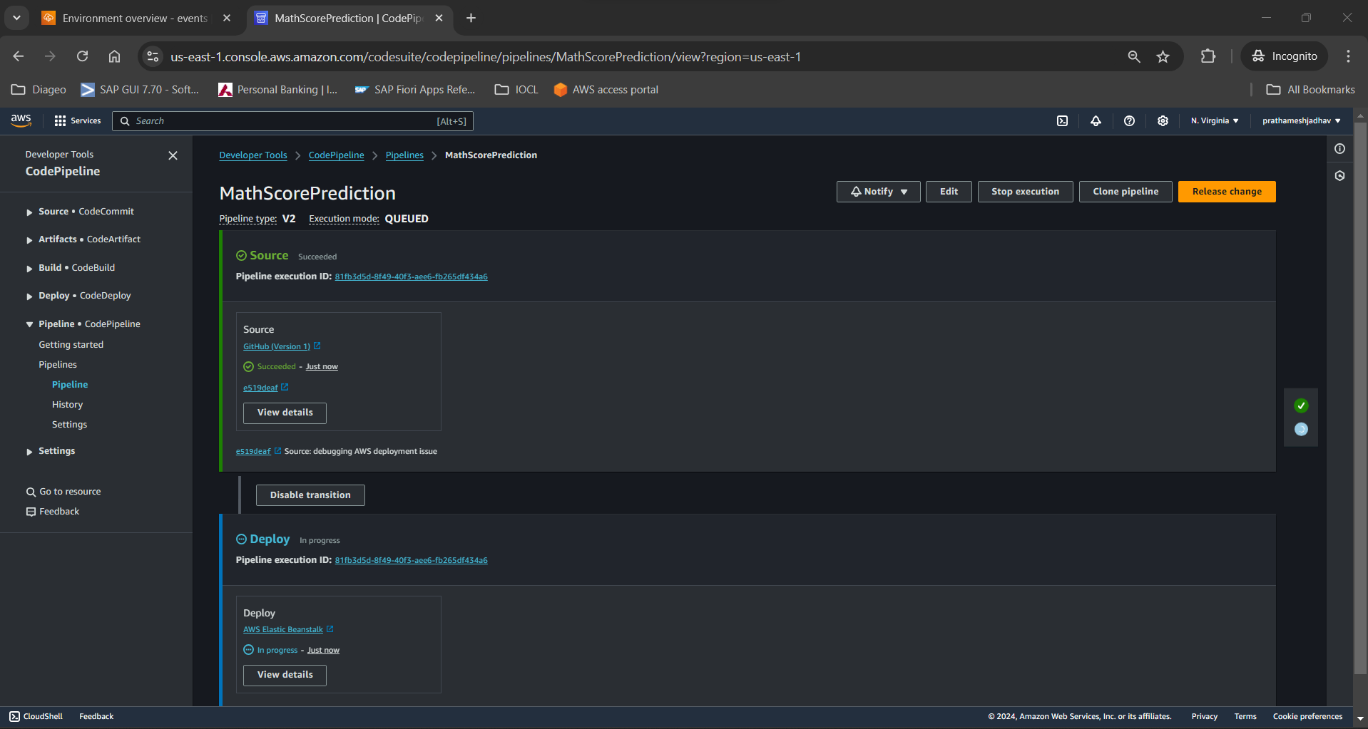

CodePipeline deployed successfully.

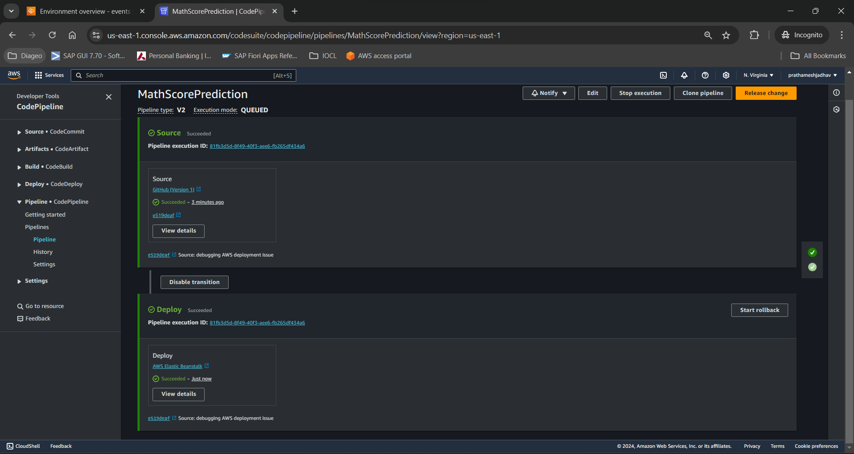

1. Back to the Beanstalk environment dashboard, note that the Running version under Platform is now our application version in the latest commit to the GitHub repository we configured in step 2.

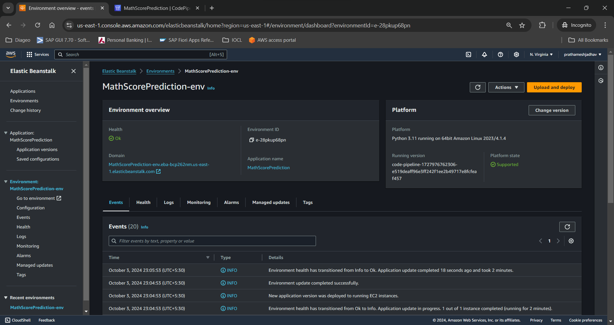

1. Click on the domain URL under Environment overview section to launch the home page of our web application displaying a Welcome message.

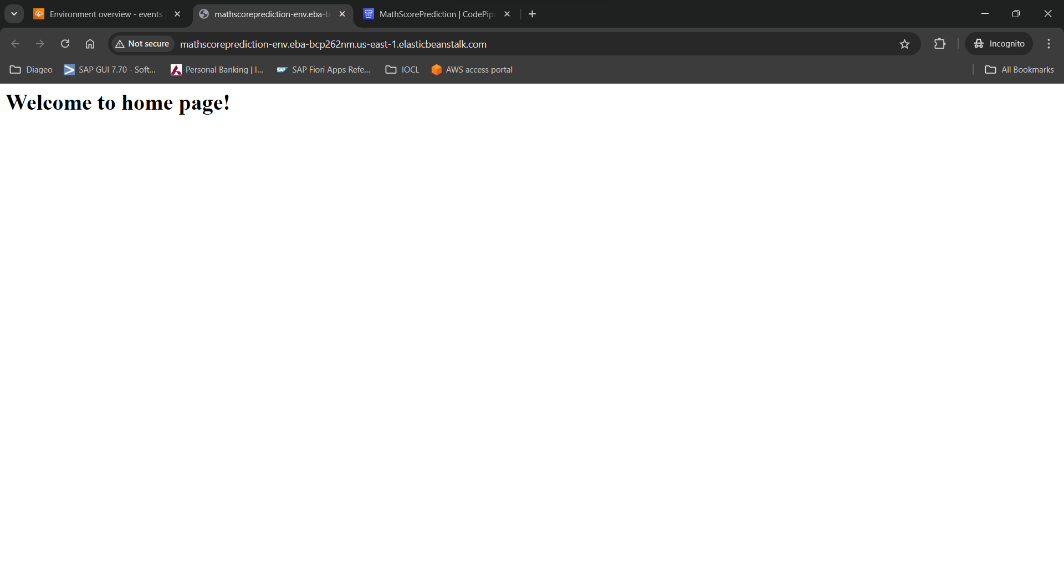

1. Hit the /predictdata endpoint to open a form with all the input features.

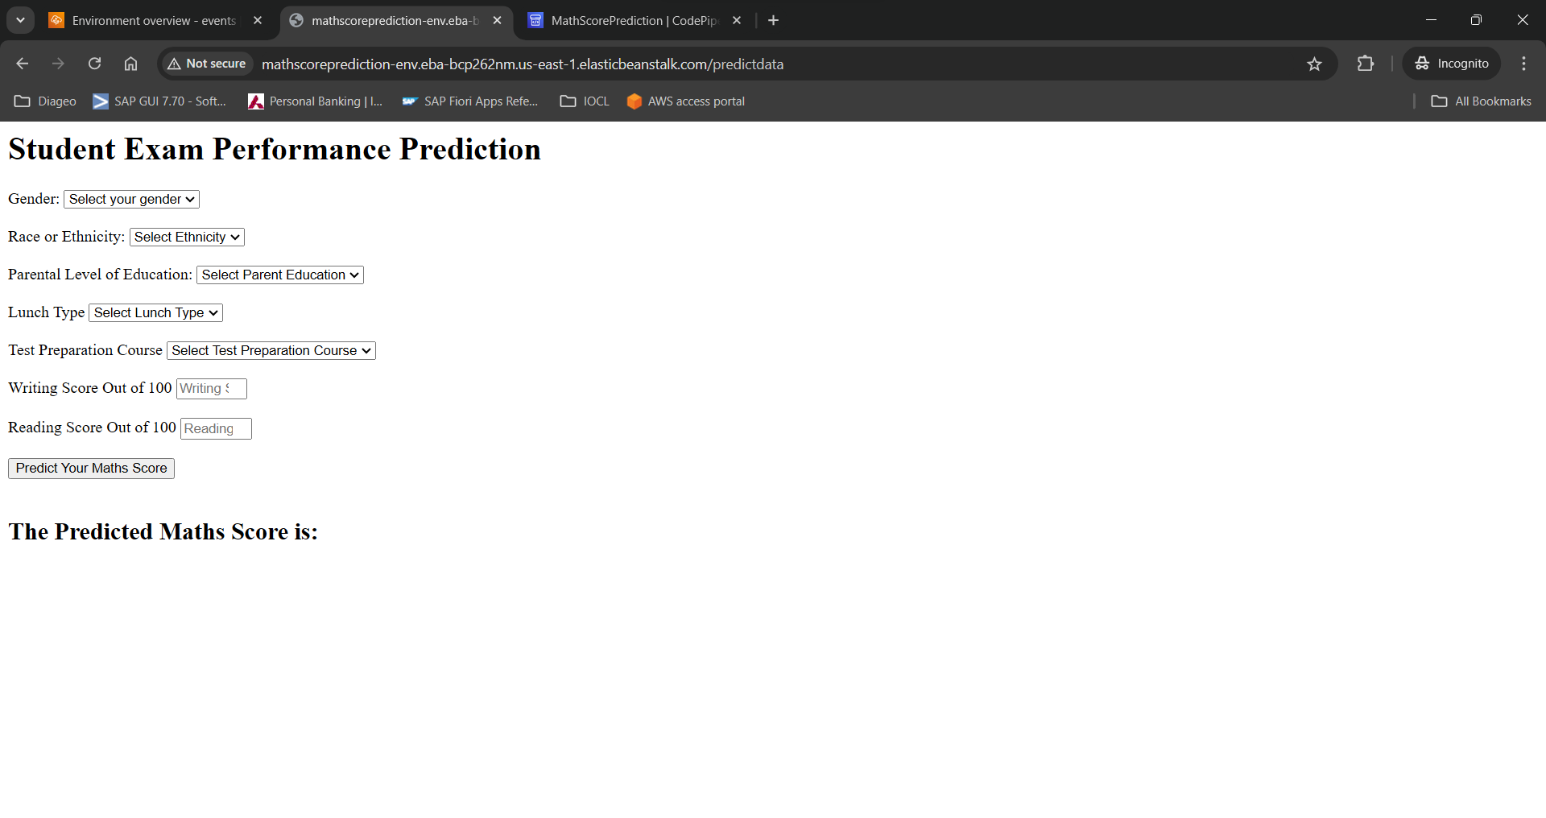

1. Fill all the fields and click on ‘Predict Your Maths Score’ button

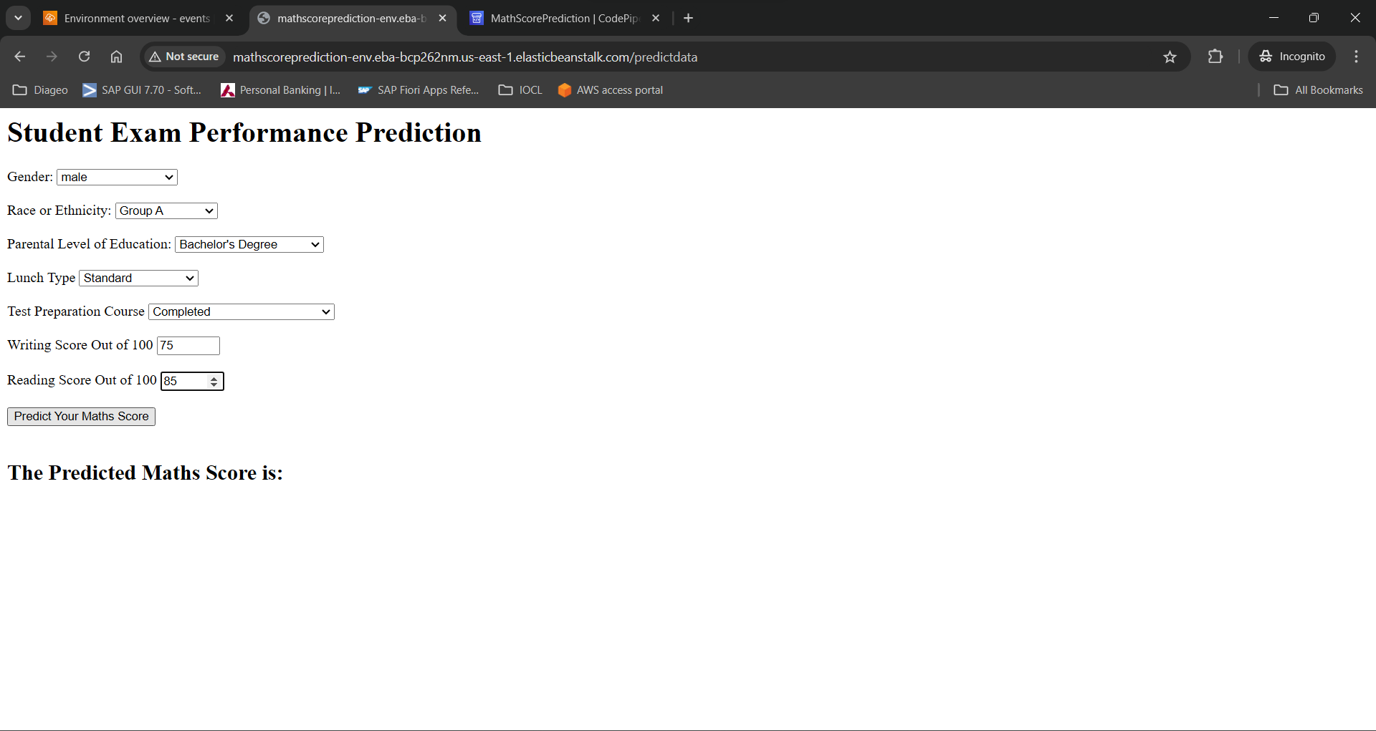

1. Predicted Maths score is displayed as an output feature based on the Machine Learning model selected in our application.

