**Assignment 2 Part 2**

**Implementing Naive Bayes Classifier using Spark MapReduce**

Naïve-Bayes Algorithm Description:

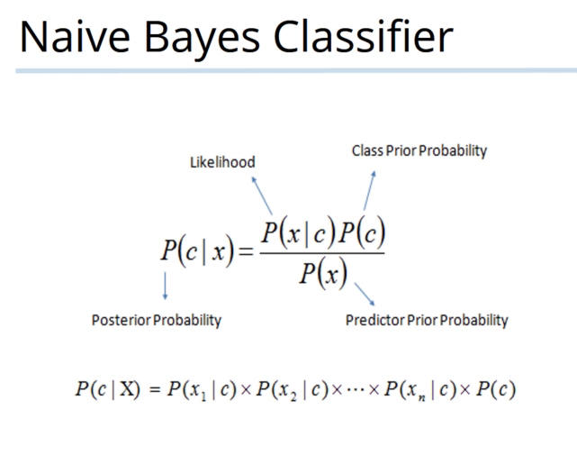

Prior Probabilities:

|  |  |
| --- | --- |
| Prior Positive Probability | 0.4988999057062034 |
| Prior Negative Probability | 0.5010715204160356 |

Metrics:

|  |  |
| --- | --- |
| Accuracy | 0.85 |
| Precision | 0.87 |
| Recall | 0.83 |
| F-measure | 0.85 |