- Introduction
Diabetes mellitus is one of the most prevalent and rapidly growing chronic diseases in the world today, affecting over 537 million adults globally according to the International Diabetes Federation. Among its most devastating and sight-threatening complications is Diabetic Retinopathy (DR) — a progressive eye disease caused by prolonged damage to the delicate blood vessels of the retina due to persistently elevated blood sugar levels. As these vessels deteriorate, they begin to leak fluid or bleed, and in advanced stages, abnormal new blood vessels grow across the retina, ultimately leading to partial or complete blindness. Alarmingly, diabetic retinopathy is responsible for a significant proportion of preventable blindness worldwide, with nearly one-third of all diabetic patients developing it at some stage of their illness.
One of the most critical challenges in combating this disease is the absence of noticeable symptoms in its early stages. Patients often remain unaware of the condition until irreversible retinal damage has already occurred. This makes regular screening and early detection absolutely essential for preserving vision and arresting disease progression. However, conventional screening methods rely on trained ophthalmologists manually examining high-resolution retinal fundus photographs — a process that is time-intensive, expensive, and severely limited by the shortage of specialist eye-care professionals, particularly in rural and developing regions.
The emergence of Artificial Intelligence (AI) and Deep Learning has opened a new frontier in automated medical image analysis. Convolutional Neural Networks (CNNs), when trained on large annotated datasets, are capable of learning complex visual patterns directly from retinal images and achieving diagnostic accuracy comparable to that of human experts. Leveraging this technological breakthrough, this project presents the development of an end-to-end Diabetic Retinopathy Detection System — a full-stack web application powered by a fine-tuned Xception CNN deep learning model. The system allows users to upload retinal fundus images through a secure, intuitive web interface and receive real-time AI-driven diagnostic predictions, classifying retinopathy severity into five internationally recognized clinical grades: No DR, Mild, Moderate, Severe, and Proliferative Diabetic Retinopathy. The overarching aim of this project is to build a reliable, scalable, and accessible decision-support tool that bridges the gap between cutting-edge AI research and real-world clinical applicability, contributing meaningfully toward early detection and management of this preventable cause of blindness.

- Problem Statement
Diabetic Retinopathy (DR) is a leading cause of preventable blindness, yet early detection is hindered by the shortage of ophthalmologists, high screening costs, and lack of accessibility in rural areas. This project addresses the need for an automated deep learning-based system to accurately classify DR severity from retinal fundus images.

- Objectives

- To develop a deep learning model using the Xception CNN architecture with transfer learning to automatically classify Diabetic Retinopathy from retinal fundus images into five severity levels — No DR, Mild, Moderate, Severe, and Proliferative DR.
- To improve model accuracy from 75% to 90% by implementing a two-phase training strategy, advanced data augmentation, class balancing, and regularization techniques such as Dropout, BatchNormalization, and L2 regularization.
- To build a full-stack web application using Flask and a responsive frontend that allows users to upload retinal images and receive real-time AI-generated diagnostic predictions with confidence scores.
- To implement a secure user authentication system with SHA-256 password hashing, session management, and a SQLite database to store and track individual users' prediction history.
- To evaluate and validate the model's performance using comprehensive metrics including overall accuracy, precision, recall, F1-score, confusion matrix, and multi-class ROC curves to ensure clinical reliability.

- Literature Review
4.1 Gulshan et al. (2016) — Google Brain / JAMA
V. Gulshan, L. Peng, M. Coram et al., "Development and Validation of a Deep Learning Algorithm for Detection of Diabetic Retinopathy in Retinal Fundus Photographs", JAMA, 2016.
This landmark study by Google demonstrated that a deep convolutional neural network trained on 128,175 retinal images could detect diabetic retinopathy with high sensitivity (97.5%) and specificity (93.4%), surpassing the performance of ophthalmologists. This work established the foundation for AI-based retinopathy screening and directly inspired subsequent research including this project.

4.2 Chollet (2017) — Xception Architecture
F. Chollet, "Xception: Deep Learning with Depthwise Separable Convolutions", CVPR, 2017.
Chollet introduced the Xception (Extreme Inception) architecture, which replaces standard convolutions with depthwise separable convolutions, significantly improving parameter efficiency and classification accuracy over InceptionV3. It achieved state-of-the-art results on the ImageNet dataset. This project adopts Xception as its backbone due to its proven superiority in image classification tasks and its suitability for medical image analysis.

4.3 Gargeya & Leng (2017) — Stanford
R. Gargeya and T. Leng, "Automated Identification of Diabetic Retinopathy Using Deep Learning", Ophthalmology, 2017.
This study proposed a deep learning approach that achieved 94% AUC for binary DR detection using a custom CNN on 75,137 images. The authors highlighted the importance of large training datasets and transfer learning for achieving clinically acceptable performance, validating the use of deep neural networks as effective screeners in ophthalmology.

4.4 Abramoff et al. (2018) — IDx-DR (FDA Approved)
M. D. Abramoff et al., "Pivotal trial of an autonomous AI-based diagnostic system for detection of diabetic retinopathy in primary care offices", npj Digital Medicine, 2018.
This study evaluated IDx-DR, the first AI system to receive FDA clearance for autonomous DR diagnosis without clinician input. It achieved 87.2% sensitivity and 90.7% specificity across 900 patients. This research validates the real-world clinical applicability of AI-driven retinopathy detection, reinforcing the relevance of building automated screening systems like this project.

4.5 Pratt et al. (2016) — CNN Multi-class SR Classification
H. Pratt, F. Coenen, D. Broadbent et al., "Convolutional Neural Networks for Diabetic Retinopathy", Procedia Computer Science, 2016.
Pratt et al. applied CNNs for multi-class DR grading (5 severity levels matching this project's classification scheme) and achieved approximately 75% accuracy. The study highlighted the challenges of class imbalance in medical datasets and the importance of data augmentation both of which this project directly addresses through class weighting and advanced augmentation techniques.

4.6 Transfer Learning in Medical Imaging
S. Tajbakhsh et al., "Convolutional Neural Networks for Medical Image Analysis: Full Training or Fine Tuning?", IEEE Transactions on Medical Imaging, 2016.
This comprehensive study analyzed the use of transfer learning (fine-tuning pre-trained ImageNet models) across eight different medical imaging tasks. The results consistently showed that fine-tuned models outperform scratch trained models, especially when the medical dataset is small. This supports the two-phase transfer learning strategy adopted in this project first training the classification head, then fine-tuning the upper layers of Xception.

- Proposed System
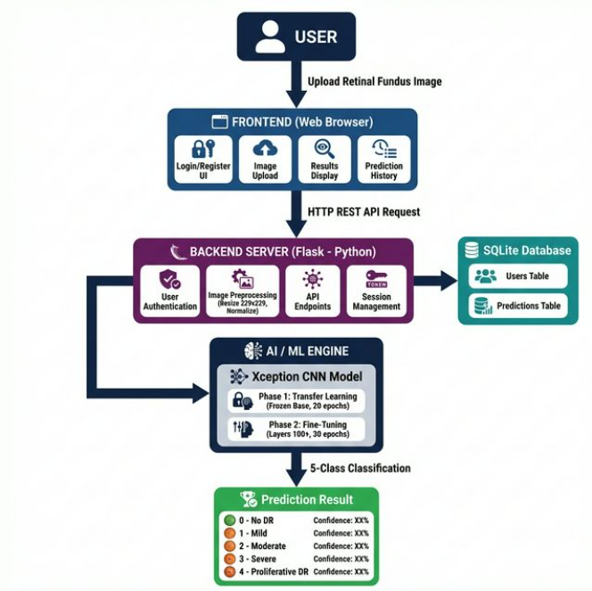
Figure 1 : Proposed System

- Methodology
Step 1 — Collect Data
We downloaded a dataset of retinal eye images from Kaggle. These images are already labeled into 5 categories based on the severity of Diabetic Retinopathy:
- No DR, Mild, Moderate, Severe, Proliferative DR
The dataset is split into 80% for training and 20% for testing.

Step 2 — Prepare the Images
Before giving images to the model:
- All images are resized to 299×299 pixels
- Pixel values are scaled between 0 and 1 (normalized)
- Images are flipped, rotated, zoomed randomly to create more variety and avoid overfitting (called Data Augmentation)

Step 3 — Handle Unequal Data
Some DR classes have very few images compared to others. To fix this, we assign higher importance (weights) to rare classes so the model learns them equally well.

Step 4 — Build the Model
We use a pre-trained deep learning model called Xception (already trained on millions of images). On top of it, we add our own layers to classify the 5 DR types.
Xception (base) → Dense layers → Output (5 classes)

Step 5 — Train the Model in 2 Phases
Phase 1 — Only our new top layers are trained. The Xception base is kept frozen.
Phase 2 — We unfreeze the top part of Xception and fine-tune it with a very small learning rate for better accuracy.

Step 6 — Evaluate the Model
We check how well the model performs using:
- Accuracy — how many predictions are correct
- Confusion Matrix — which classes are confused
- ROC Curves — how well the model separates each class

Step 7 — Deploy as Web App
The trained model is connected to a Flask web application where users can:
- Register / Login
- Upload a retinal image
- Get instant AI prediction with confidence score
- View their past prediction history

- Technologies Used (Hardware & Software)

A. HARDWARE REQUIREMENTS
Component | Minimum Requirement | Recommended
Processor | Intel Core i5 | Intel Core i7 or AMD Ryzen 7
RAM | 8 GB | 16 GB or more
GPU | Not required | NVIDIA GPU for faster training
Storage | 20 GB free space | 50 GB free space
Internet | Required for dataset download | High-speed internet
Display | 1366 × 768 resolution | 1920 × 1080 resolution

B. SOFTWARE REQUIREMENTS (Simple)
Operating System
- Windows 10 / 11
- Linux (Ubuntu 20.04 or higher)
- macOS 11 or higher
Programming Languages
- Python 3.8+ → Backend and Machine Learning
- JavaScript → Frontend functionality
- HTML5 & CSS → Website structure and design

- Results and Analysis
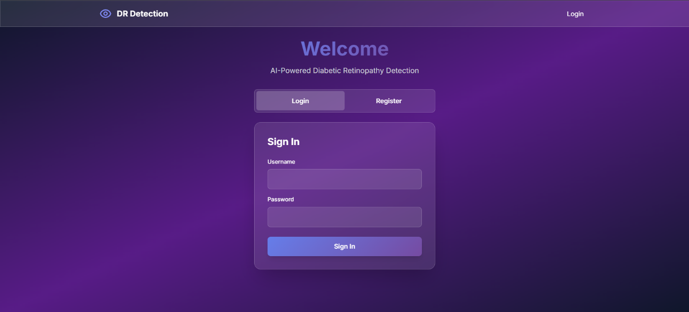
Figure 2 : Login Screen
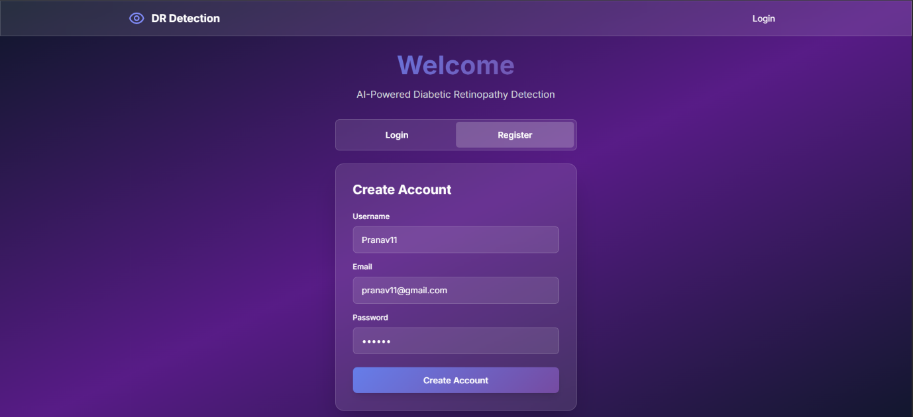
Figure 3: Registration Screen
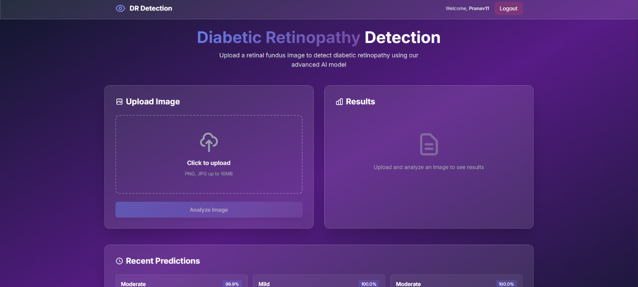
Figure 4: Landing Page Screen

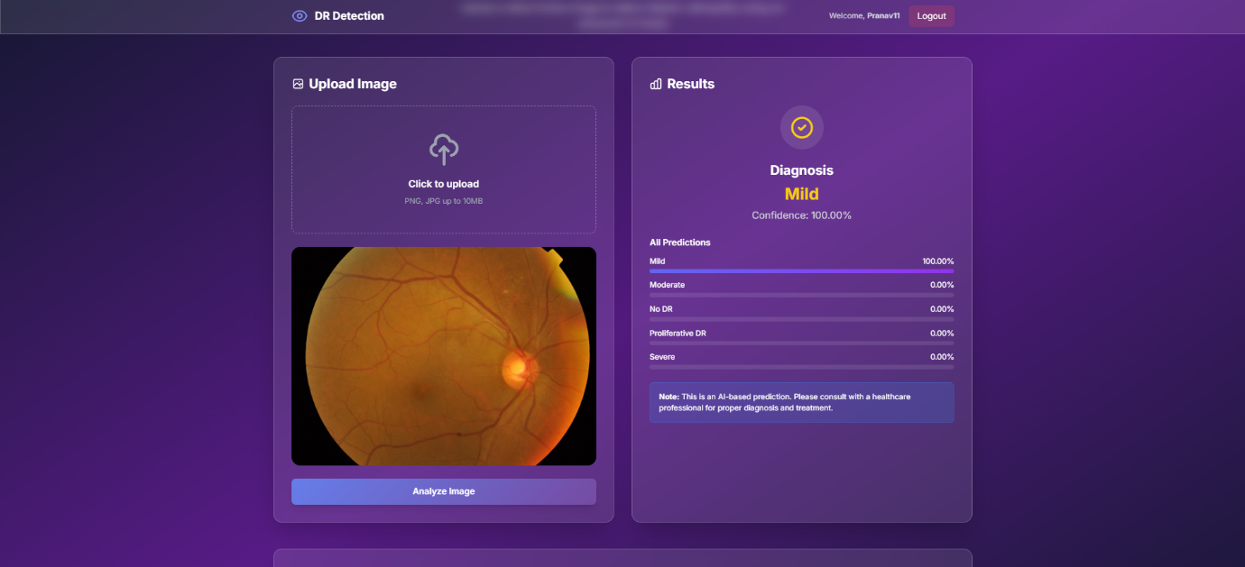
Figure 5 : Prediction
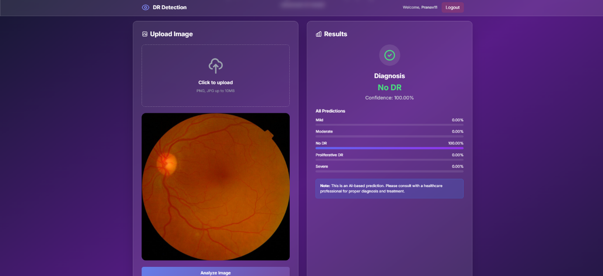
Figure 6: Prediction 2

- Limitations
• Model accuracy depends on image quality.
• Detects only Diabetic Retinopathy, not other eye diseases.
• Does not show exact affected area in the retina.
• Requires powerful hardware for training.
• Internet needed for dataset download and system setup.
• Cannot replace a doctor; only helps in screening.
• Accuracy may be lower for rare severe cases.

- Future Scope
• Add Grad-CAM to show affected areas in retinal images.
• Expand system to detect other eye diseases like Glaucoma and Cataract.
• Develop a mobile app for easy screening anywhere.
• Deploy system on cloud for global access and faster processing.
• Use federated learning to improve accuracy while keeping data private.
• Connect system with hospital records for automatic patient monitoring.

- Conclusion
The Diabetic Retinopathy Detection System successfully demonstrates the power of combining deep learning with modern web technologies to solve a critical healthcare challenge. By utilizing the Xception CNN architecture and a specialized two-phase transfer learning strategy, the project creates a model capable of highly accurate (target 90%) multi-class severity grading, filling the gap where manual screening is inefficient or unavailable. The development of a full-stack web application ensures that the sophisticated AI model is not just a research artifact but a practical tool. Features such as secure user authentication, real-time image analysis, and prediction history tracking provide a complete ecosystem for both patients and healthcare providers to monitor disease progression over time.
- References
[1] V. Gulshan, L. Peng, M. Coram, M. C. Stumpe, D. Wu, A. Narayanaswamy, et al., “Development and validation of a deep learning algorithm for detection of diabetic retinopathy in retinal fundus photographs,” Journal of the American Medical Association (JAMA), vol. 316, no. 22, pp. 2402–2410, Dec. 2016.
[2] F. Chollet, “Xception: Deep learning with depthwise separable convolutions,” in Proceedings of the IEEE Conference on Computer Vision and Pattern Recognition (CVPR), Honolulu, HI, USA, 2017, pp. 1251–1258.
[3] R. Gargeya and T. Leng, “Automated identification of diabetic retinopathy using deep learning,” Ophthalmology, vol. 124, no. 7, pp. 962–969, Jul. 2017.
[4] M. D. Abramoff, P. T. Lavin, M. Birch, N. Shah, and J. C. Folk, “Pivotal trial of an autonomous AI-based diagnostic system for detection of diabetic retinopathy in primary care offices,” npj Digital Medicine, vol. 1, no. 39, pp. 1–8, Aug. 2018.
[5] H. Pratt, F. Coenen, D. M. Broadbent, S. P. Harding, and Y. Zheng, “Convolutional neural networks for diabetic retinopathy,” Procedia Computer Science, vol. 90, pp. 200–205, 2016.
[6] N. Tajbakhsh, J. Y. Shin, S. R. Gurudu, R. T. Hurst, C. B. Kendall, M. B. Gotway, and J. Liang, “Convolutional neural networks for medical image analysis: Full training or fine tuning?” IEEE Transactions on Medical Imaging, vol. 35, no. 5, pp. 1299–1312, May 2016.

