Bank Loan Analysis Project Report
Prepared by: Prathamesh Kadam
Tools: SQL Server, SSMS, Power BI, Power Query, DAX

Project Overview
This report documents the end-to-end Bank Loan Analysis project. The project involved SQL-based KPI generation, business analysis, and interactive Power BI dashboard development for monitoring loan performance, risk, and customer behavior.

PROBLEM STATEMENT
Key Performance Indicators (KPIs) Requirements:
- Total Loan Applications: We need to calculate the total number of loan applications received during a specified period. Additionally, it is essential to monitor the Month-to-Date (MTD) Loan Applications and track changes Month-over-Month (MoM).
- Total Funded Amount: Understanding the total amount of funds disbursed as loans is crucial. We also want to keep an eye on the MTD Total Funded Amount and analyse the Month-over-Month (MoM) changes in this metric.
- Total Amount Received: Tracking the total amount received from borrowers is essential for assessing the bank's cash flow and loan repayment. We should analyse the Month-to-Date (MTD) Total Amount Received and observe the Month-over-Month (MoM) changes.
- Average Interest Rate: Calculating the average interest rate across all loans, MTD, and monitoring the Month-over-Month (MoM) variations in interest rates will provide insights into our lending portfolio's overall cost.
- Average Debt-to-Income Ratio (DTI): Evaluating the average DTI for our borrowers helps us gauge their financial health. We need to compute the average DTI for all loans, MTD, and track Month-over-Month (MoM) fluctuations.
Good Loan v Bad Loan KPI’s
Good Loan:
- Good Loan Application Percentage
- Good Loan Applications
- Good Loan Funded Amount
- Good Loan Total Received Amount
Bad Loan
- Bad Loan Application Percentage
- Bad Loan Applications
- Bad Loan Funded Amount
- Bad Loan Total Received Amount
CHARTS
- Monthly Trends by Issue Date (Line Chart): To identify seasonality and long-term trends in lending activities
- Regional Analysis by State (Filled Map): To identify regions with significant lending activity and assess regional disparities
- Loan Term Analysis (Donut Chart): To allow the client to understand the distribution of loans across various term lengths.
- Employee Length Analysis (Bar Chart): How lending metrics are distributed among borrowers with different employment lengths, helping us assess the impact of employment history on loan applications.
- Loan Purpose Breakdown (Bar Chart): Will provide a visual breakdown of loan metrics based on the stated purposes of loans, aiding in the understanding of the primary reasons borrowers seek financing.
- Home Ownership Analysis (Tree Map): For a hierarchical view of how home ownership impacts loan applications and disbursements.
GRID
Need for a comprehensive 'Details Dashboard' that provides a consolidated view of all the essential information within our loan data. This Details Dashboard aims to offer a holistic snapshot of key loan-related metrics and data points, enabling users to access critical information efficiently.

Dashboard Screenshots

Dashboard 1 - Summary
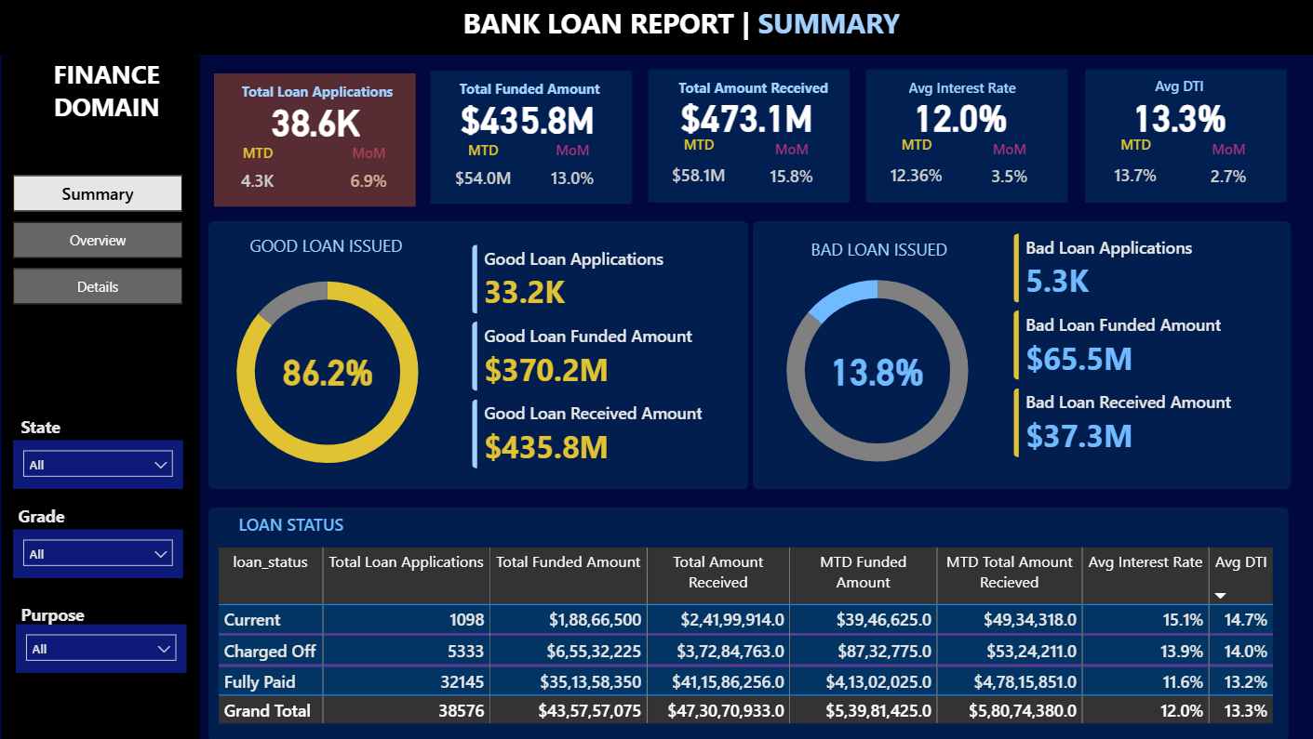

Dashboard 2 - Overview
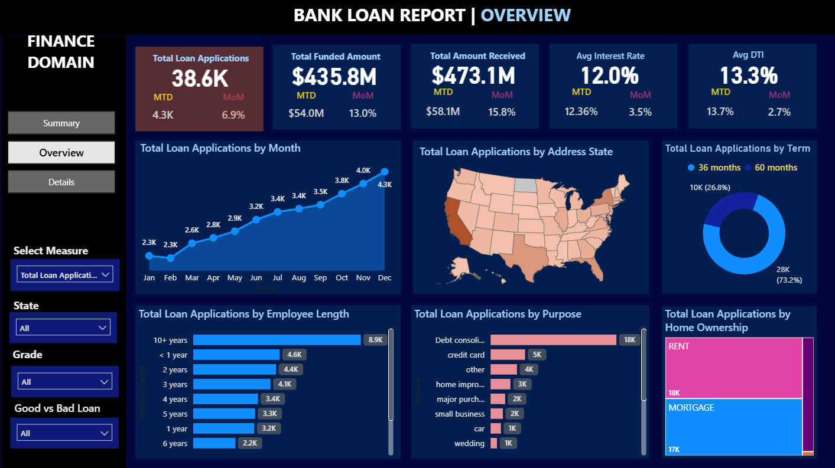

Dashboard 3 - Details
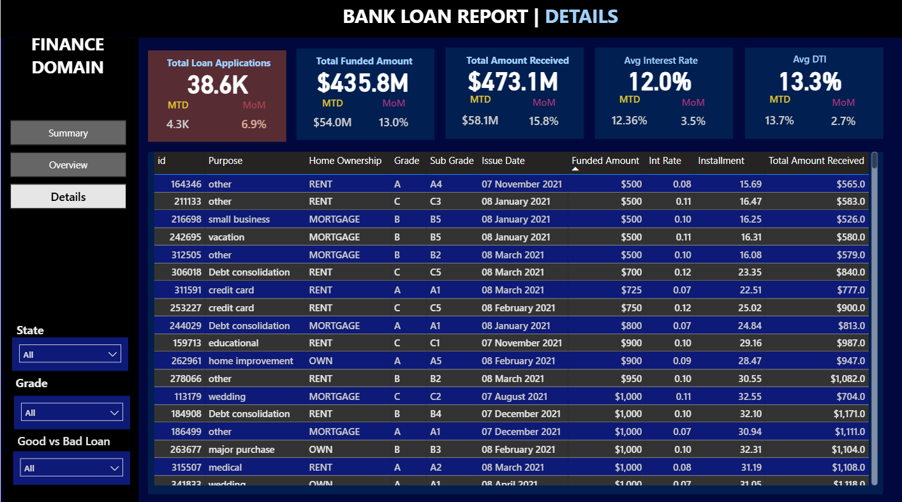
Key Business Results
• Total Loan Applications: 38.6K
• Total Funded Amount: $435.8M
• Total Amount Received: $473.1M
• Good Loan Percentage: 86.2%
• Bad Loan Percentage: 13.8%
• Average Interest Rate: 12.0%
• Average DTI: 13.3%

SQL Queries and Results
The accompanying SQL Query Document contains all KPI calculations, Good vs Bad Loan analysis, monthly trend analysis, state analysis, loan purpose analysis, term analysis, employment length analysis, and home ownership analysis with their query outputs.
Attach the original SQL Query Document together with this report when sharing with recruiters or uploading to GitHub.

