**Modern Education Society’s**

**Wadia College of Engineering, Pune-01**

|  |
| --- |
| **NAME OF STUDENT: CLASS:** |
| **SEMESTER/YEAR: ROLL NO:** |
| **DATE OF PERFORMANCE: DATE OF SUBMISSION:** |
| **EXAMINED BY: EXPERIMENT NO:** |

# TITLE: ASSIGNMENT ON K-MEANS CLUSTERING.

.

**Problem Statement**:

Implement K-Means clustering/ hierarchical clustering on sales\_data\_sample.csv dataset.

Determine the number of clusters using the elbow method.

Dataset link : https://www.kaggle.com/datasets/kyanyoga/sample-sales-data

**Objectives:**

* Understand the elbow method.
* Understand the K-Means clustering algorithm.

**Pre-requisites:**

1. Knowledge of python programming.
2. Knowledge of Data Pre-processing.
3. Knowledge of unsupervised learning.

**Description: The elbow method**

The elbow method is used to determine the optimal number of clusters in k-means clustering. The elbow method plots the value of the cost function produced by different values of k. As you know, if k increases, average distortion will decrease, each cluster will have fewer constituent instances, and the instances will be closer to their respective centroids. However, the improvements in average distortion will decline as k increases. The value of k at which improvement in distortion declines the most is called the elbow, at which we should stop dividing the data into further clusters.

**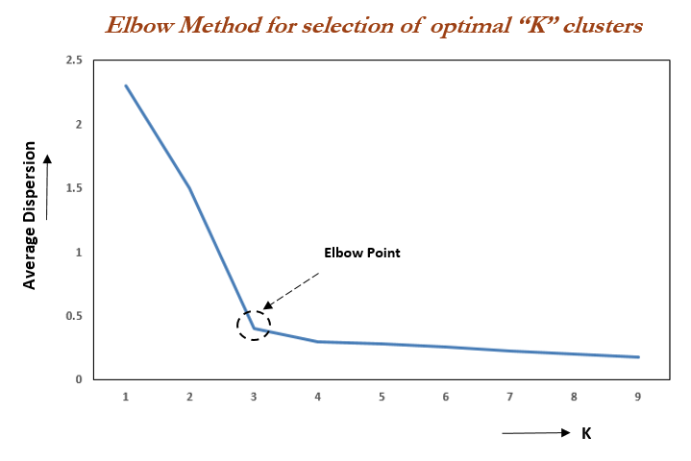**

**K-means **C**lustering is an unsupervised learning algorithm which aims to partition n observations into k clusters in which each observation belongs to the cluster with the nearest centroid. The algorithm aims to minimize the squared Euclidean distances between the observation and the centroid of cluster to which it belongs. K-means clustering is an unsupervised learning algorithm which aims to partition n observations into k clusters in which each observation belongs to the cluster with the nearest centroid. The algorithm aims to minimize the squared Euclidean distances between the observation and the centroid of cluster to which it belongs.**

**Let us define cost function of K-means clustering as ‘Epsilon’ which is sum of squares of distance between data points and respective centroid of cluster to which the data point belongs. We expect the cost function to decrease with number of iterations.**

**Now let us fit the model with a range of values of ‘k’ starting from 2 to 5. For each value of ‘k’ the algorithm runs for 15 iterations and cost function ‘Epsilon’ at the end of 15th iteration is calculated. When we plot the graph of ‘value of k’ on x-axis and ‘value of Epsilon’ on y-axis, there is an elbow formation at the optimum value of ‘k’.Let us check this by plotting the graph of ‘value of k’ vs ‘value of Epsilon’.**

**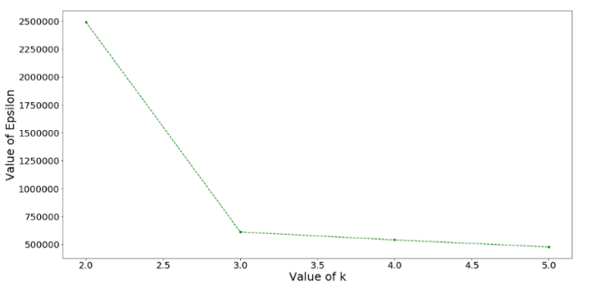**

**From the above graph we observe that there is an elbow formation at k = 3. Hence the optimum value of k is 3. Therefor we cluster the data set into 3 clusters.**

## K-Means Clustering-

1. K-Means clustering is an unsupervised iterative clustering technique.
2. It partitions the given data set into k predefined distinct clusters.
3. A cluster is defined as a collection of data points exhibiting certain similarities.

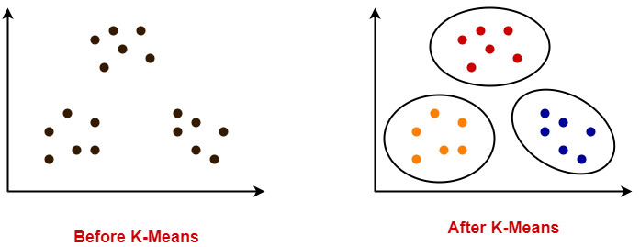

The objective of K-Means clustering is to minimize total intra-cluster variance, or, the squared error function:

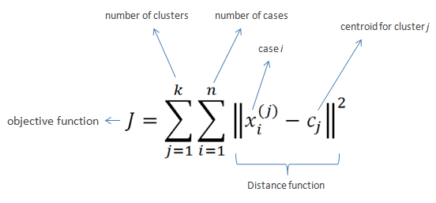

K-Means Clustering Algorithm involves the following steps-

### Step-01:

Choose the number of clusters K.

Step-02:

* Randomly select any K data points as cluster centers.
* Select cluster centers in such a way that they are as farther as possible from each other.

### Step-03:

* Calculate the distance between each data point and each cluster center.
* The distance may be calculated either by using given distance function or by using euclidean distance formula.

### Step-04:

* Assign each data point to some cluster.
* A data point is assigned to that cluster whose center is nearest to that data point.

### Step-05:

* Re-compute the center of newly formed clusters.
* The center of a cluster is computed by taking mean of all the data points contained in that cluster.

### Step-06:

Keep repeating the procedure from Step-03 to Step-05 until any of the following stopping criteria is met-

* Center of newly formed clusters do not change
* Data points remain present in the same cluster
* Maximum number of iterations are reached

## Advantages-

K-Means Clustering Algorithm offers the following advantages-

### 1. It is relatively efficient with time complexity O(nkt) where-

* n = number of instances
* k = number of clusters
* t = number of iterations

### 2. It often terminates at local optimum.

* Techniques such as Simulated Annealing or [Genetic Algorithms](https://www.gatevidyalay.com/genetic-algorithm-in-ai-operators-working/" \t "_blank) may be used to find the global optimum.

## Disadvantages-

K-Means Clustering Algorithm has the following disadvantages-

1. It requires to specify the number of clusters (k) in advance.
2. It can not handle noisy data and outliers.
3. It is not suitable to identify clusters with non-convex shapes.

## PRACTICE PROBLEMS BASED ON K-MEANS CLUSTERING:-

## Problem-01:

Cluster the following eight points (with (x, y) representing locations) into three clusters:

A1(2, 10), A2(2, 5), A3(8, 4), A4(5, 8), A5(7, 5), A6(6, 4), A7(1, 2), A8(4, 9)

Initial cluster centers are: A1(2, 10), A4(5, 8) and A7(1, 2).

The distance function between two points a = (x1, y1) and b = (x2, y2) is defined as-

Ρ(a, b) = |x2 – x1| + |y2 – y1|

Use K-Means Algorithm to find the three cluster centers after the second iteration.

## Solution-

We follow the above discussed K-Means Clustering Algorithm-

### Iteration-01:

We calculate the distance of each point from each of the center of the three clusters.

The distance is calculated by using the given distance function.

The following illustration shows the calculation of distance between point A1(2, 10) and each of the center of the three clusters-

### Calculating Distance Between A1(2, 10) and C1(2, 10)-

Ρ(A1, C1)

= |x2 – x1| + |y2 – y1|

= |2 – 2| + |10 – 10|

= 0

### Calculating Distance Between A1(2, 10) and C2(5, 8)-

Ρ(A1, C2)

= |x2 – x1| + |y2 – y1|

= |5 – 2| + |8 – 10|

= 3 + 2

= 5

### Calculating Distance Between A1(2, 10) and C3(1, 2)-

Ρ(A1, C3)

= |x2 – x1| + |y2 – y1|

= |1 – 2| + |2 – 10|

= 1 + 8

= 9

In the similar manner, we calculate the distance of other points from each of the center of the three clusters.

Next,

* We draw a table showing all the results.
* Using the table, we decide which point belongs to which cluster.
* The given point belongs to that cluster whose center is nearest to it.

|  |  |  |  |  |
| --- | --- | --- | --- | --- |
| Given Points | Distance from center (2, 10) of Cluster-01 | Distance from center (5, 8) of Cluster-02 | Distance from center (1, 2) of Cluster-03 | Point belongs to Cluster |
| A1(2, 10) | 0 | 5 | 9 | C1 |
| A2(2, 5) | 5 | 6 | 4 | C3 |
| A3(8, 4) | 12 | 7 | 9 | C2 |
| A4(5, 8) | 5 | 0 | 10 | C2 |
| A5(7, 5) | 10 | 5 | 9 | C2 |
| A6(6, 4) | 10 | 5 | 7 | C2 |
| A7(1, 2) | 9 | 10 | 0 | C3 |
| A8(4, 9) | 3 | 2 | 10 | C2 |

From here, New clusters are-

#### Cluster-01:

First cluster contains points-

* A1(2, 10)

#### Cluster-02:

Second cluster contains points-

* A3(8, 4)
* A4(5, 8)
* A5(7, 5)
* A6(6, 4)
* A8(4, 9)

#### Cluster-03:

Third cluster contains points-

* A2(2, 5)
* A7(1, 2)

Now, We re-compute the new cluster clusters.

The new cluster center is computed by taking mean of all the points contained in that cluster.

#### For Cluster-01:

We have only one point A1(2, 10) in Cluster-01.

So, cluster center remains the same.

#### For Cluster-02:

Center of Cluster-02

= ((8 + 5 + 7 + 6 + 4)/5, (4 + 8 + 5 + 4 + 9)/5)

= (6, 6)

#### For Cluster-03:

Center of Cluster-03

= ((2 + 1)/2, (5 + 2)/2)

= (1.5, 3.5)

This is completion of Iteration-01.

### Iteration-02:

We calculate the distance of each point from each of the center of the three clusters.

The distance is calculated by using the given distance function.

The following illustration shows the calculation of distance between point A1(2, 10) and each of the center of the three clusters-

### Calculating Distance Between A1(2, 10) and C1(2, 10)-

Ρ(A1, C1)

= |x2 – x1| + |y2 – y1|

= |2 – 2| + |10 – 10|

= 0

### Calculating Distance Between A1(2, 10) and C2(6, 6)-

Ρ(A1, C2)

= |x2 – x1| + |y2 – y1|

= |6 – 2| + |6 – 10|

= 4 + 4

= 8

### Calculating Distance Between A1(2, 10) and C3(1.5, 3.5)-

Ρ(A1, C3)

= |x2 – x1| + |y2 – y1|

= |1.5 – 2| + |3.5 – 10|

= 0.5 + 6.5

= 7

In the similar manner, we calculate the distance of other points from each of the center of the three clusters.Next,

* We draw a table showing all the results.
* Using the table, we decide which point belongs to which cluster.
* The given point belongs to that cluster whose center is nearest to it.

|  |  |  |  |  |
| --- | --- | --- | --- | --- |
| Given Points | Distance from center (2, 10) of Cluster-01 | Distance from center (6, 6) of Cluster-02 | Distance from center (1.5, 3.5) of Cluster-03 | Point belongs to Cluster |
| A1(2, 10) | 0 | 8 | 7 | C1 |
| A2(2, 5) | 5 | 5 | 2 | C3 |
| A3(8, 4) | 12 | 4 | 7 | C2 |
| A4(5, 8) | 5 | 3 | 8 | C2 |
| A5(7, 5) | 10 | 2 | 7 | C2 |
| A6(6, 4) | 10 | 2 | 5 | C2 |
| A7(1, 2) | 9 | 9 | 2 | C3 |
| A8(4, 9) | 3 | 5 | 8 | C1 |

From here, New clusters are-

#### Cluster-01:

First cluster contains points-

* A1(2, 10)
* A8(4, 9)

#### Cluster-02:

Second cluster contains points-

* A3(8, 4)
* A4(5, 8)
* A5(7, 5)
* A6(6, 4)

#### Cluster-03:

Third cluster contains points-

* A2(2, 5)
* A7(1, 2)

Now, We re-compute the new cluster clusters.

The new cluster center is computed by taking mean of all the points contained in that cluster.

#### For Cluster-01:

Center of Cluster-01

= ((2 + 4)/2, (10 + 9)/2)

= (3, 9.5)

#### For Cluster-02:

Center of Cluster-02

= ((8 + 5 + 7 + 6)/4, (4 + 8 + 5 + 4)/4)

= (6.5, 5.25)

#### For Cluster-03:

Center of Cluster-03

= ((2 + 1)/2, (5 + 2)/2)

= (1.5, 3.5)

This is completion of Iteration-02.

After second iteration, the center of the three clusters are-

C1(3, 9.5)

C2(6.5, 5.25)

C3(1.5, 3.5)

## Problem-02: Use K-Means Algorithm to create two clusters-

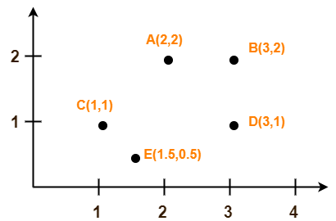

Solution- We follow the above discussed K-Means Clustering Algorithm.

Assume A(2, 2) and C(1, 1) are centers of the two clusters.

### Iteration-01:

We calculate the distance of each point from each of the center of the two clusters.

The distance is calculated by using the euclidean distance formula.

The following illustration shows the calculation of distance between point A(2, 2) and each of the center of the two clusters-

### Calculating Distance Between A(2, 2) and C1(2, 2)-

Ρ(A, C1)

= sqrt [ (x2 – x1)2 + (y2 – y1)2 ]

= sqrt [ (2 – 2)2 + (2 – 2)2 ]

= sqrt [ 0 + 0 ]

= 0

### Calculating Distance Between A(2, 2) and C2(1, 1)-

Ρ(A, C2)

= sqrt [ (x2 – x1)2 + (y2 – y1)2 ]

= sqrt [ (1 – 2)2 + (1 – 2)2 ]

= sqrt [ 1 + 1 ]

= sqrt [ 2 ]

= 1.41

In the similar manner, we calculate the distance of other points from each of the center of the two clusters.Next,

* We draw a table showing all the results.
* Using the table, we decide which point belongs to which cluster.
* The given point belongs to that cluster whose center is nearest to it.

|  |  |  |  |
| --- | --- | --- | --- |
| Given Points | Distance from center (2, 2) of Cluster-01 | Distance from center (1, 1) of Cluster-02 | Point belongs to Cluster |
| A(2, 2) | 0 | 1.41 | C1 |
| B(3, 2) | 1 | 2.24 | C1 |
| C(1, 1) | 1.41 | 0 | C2 |
| D(3, 1) | 1.41 | 2 | C1 |
| E(1.5, 0.5) | 1.58 | 0.71 | C2 |

From here, New clusters are-

#### Cluster-01:

First cluster contains points-

* A(2, 2)
* B(3, 2)
* E(1.5, 0.5)
* D(3, 1)

#### Cluster-02:

Second cluster contains points-

* C(1, 1)
* E(1.5, 0.5)

Now, We re-compute the new cluster clusters.

The new cluster center is computed by taking mean of all the points contained in that cluster.

#### For Cluster-01: Center of Cluster-01

= ((2 + 3 + 3)/3, (2 + 2 + 1)/3)

= (2.67, 1.67)

#### For Cluster-02: Center of Cluster-02

= ((1 + 1.5)/2, (1 + 0.5)/2)

= (1.25, 0.75)

This is completion of Iteration-01. **Next, we go to iteration-02, iteration-03 and so on until the centers do not change anymore.**

**Questions:**

## 1. Compare Hierarchical Clustering and k-Means Clustering.

2. What are some Stopping Criteria for k-Means Clustering?

3. How would you Pre-Process the data for k-Means?