1. 01_ .jpg
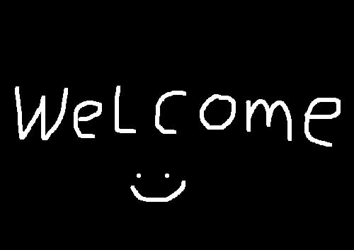

2. 02_Law meme.jpg
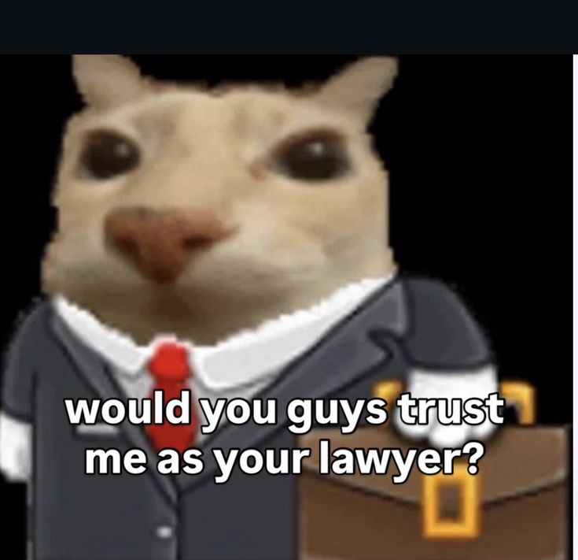

3. 03_i believe in psyduck supremacy .jpg
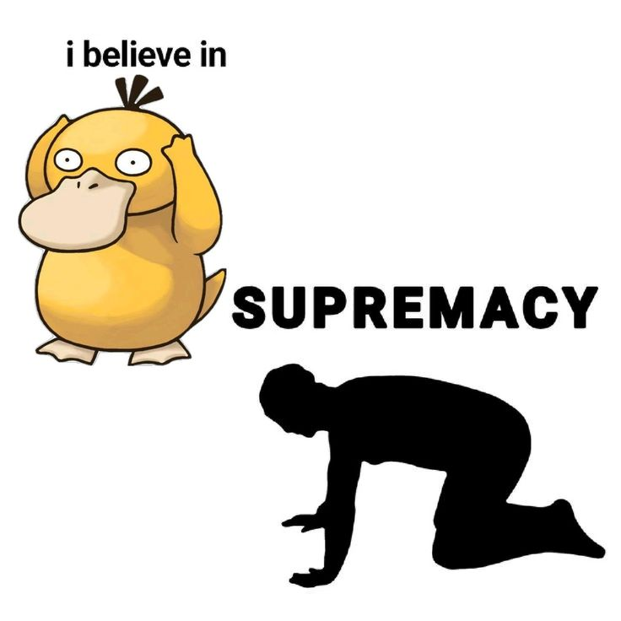

4. 04_Memes That Hopefully Inspire Confidence.jpg
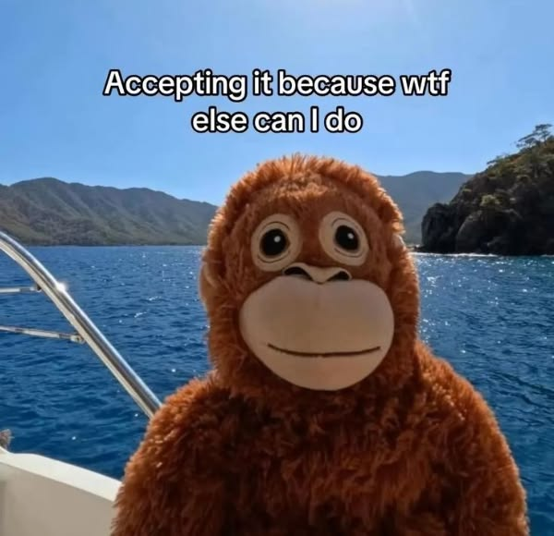

5. 05_678706606388592054.jpg
