**Hive Complex Data Types with Examples**

**There are three complex types in hive,**  
  
**arrays:** It is an ordered collection of elements.The elements in the array must be of the same type.  
  
**map:** It is an unordered collection of key-value pairs.Keys must be of primitive types.Values can be of any type.  
  
**struct:** It is a collection of elements of different types.  
  
**Examples:**complex datatypes

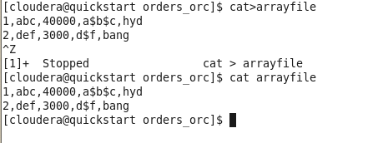

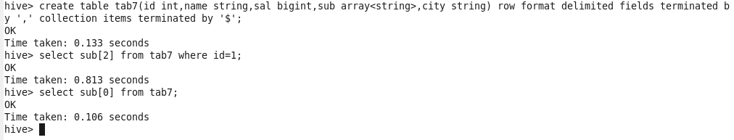

MAP

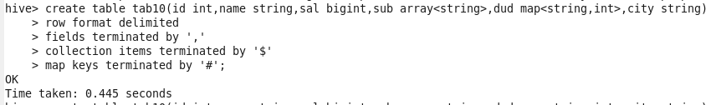

…

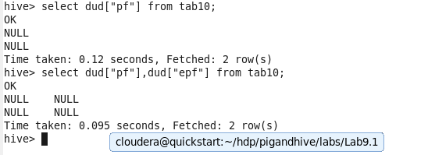

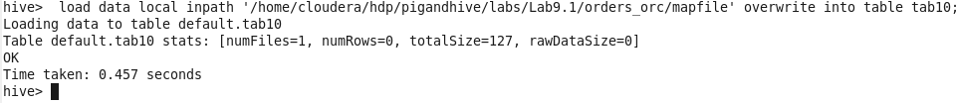

..

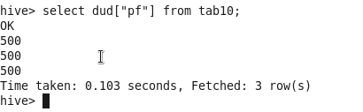

..

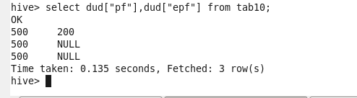

..

STRUCT

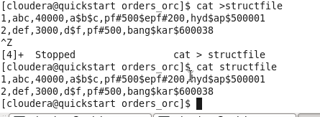

..

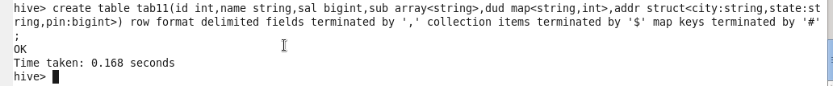

..

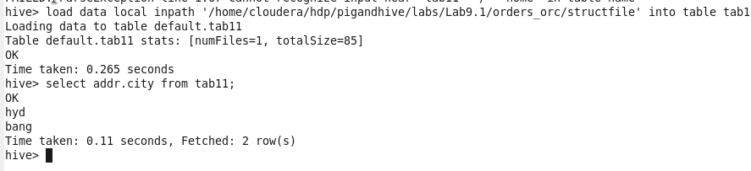

10] Skipping Headers

1. Download the attached file in LABS_HOME/demos
2. Wait for the instructions

* Code/Dataset

data/log2.txt

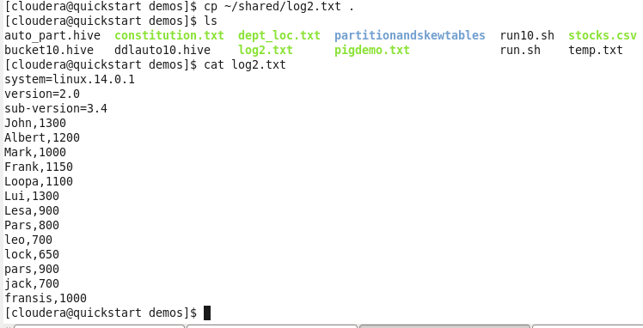

..

One of the features – removing header and footer from files

Here removing header from line which is not required

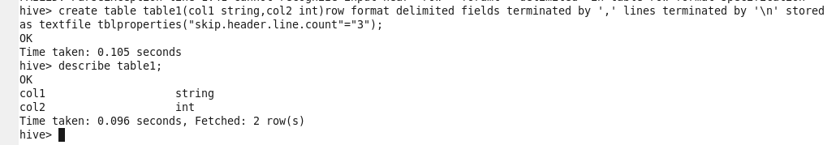

Also we can remove footer similarly by “skip.footer.line”

..

Don’t load data first

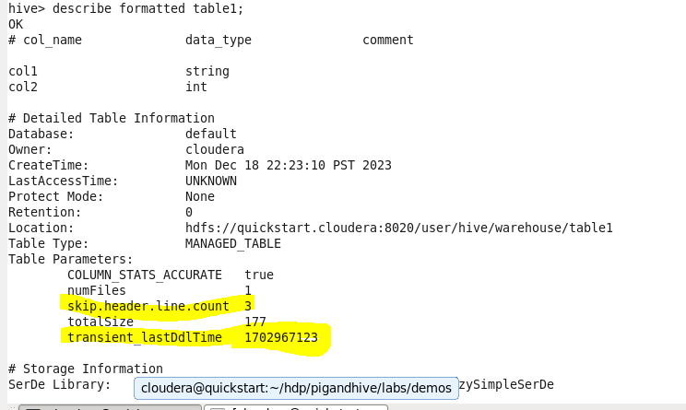

Now load data



