**HBASE**

**Jps**

**Sudo jps**

**No output**

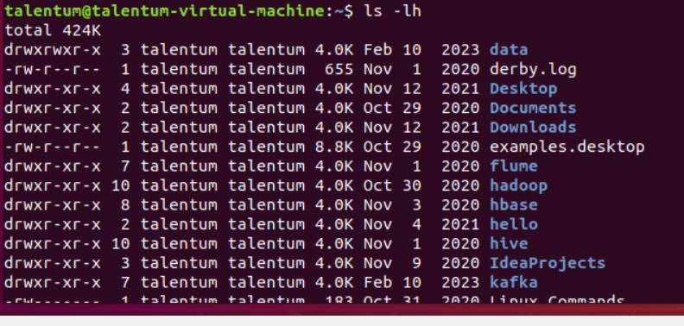

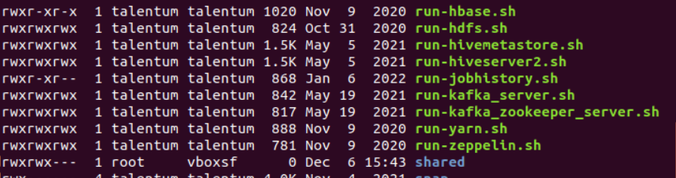

**Nano run-hdfs.sh**

**Hdfs namenode –format**

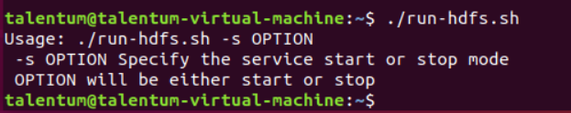

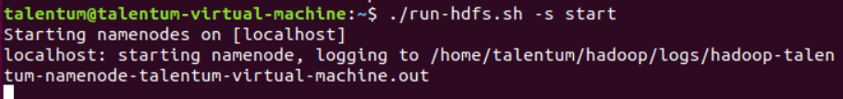

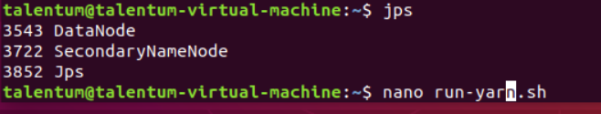

**Now for yarn**

**To start**

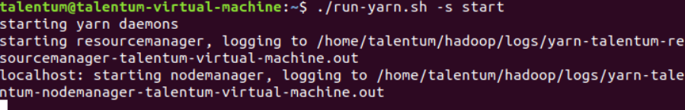

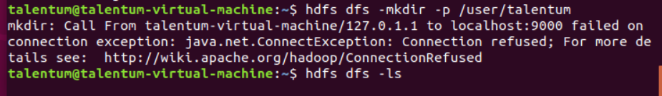

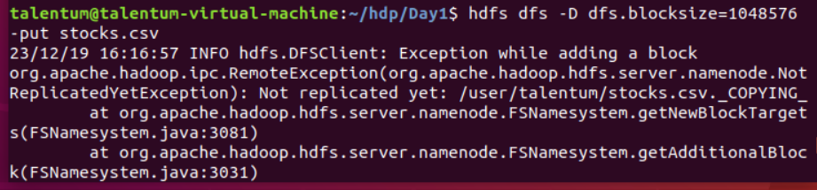

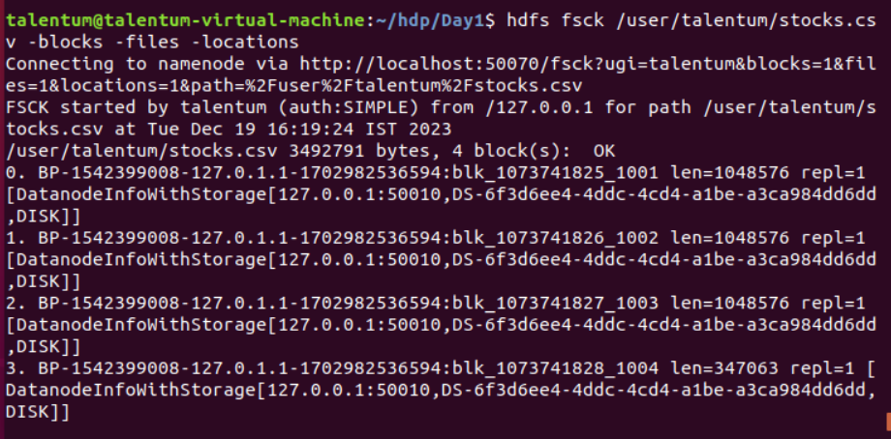

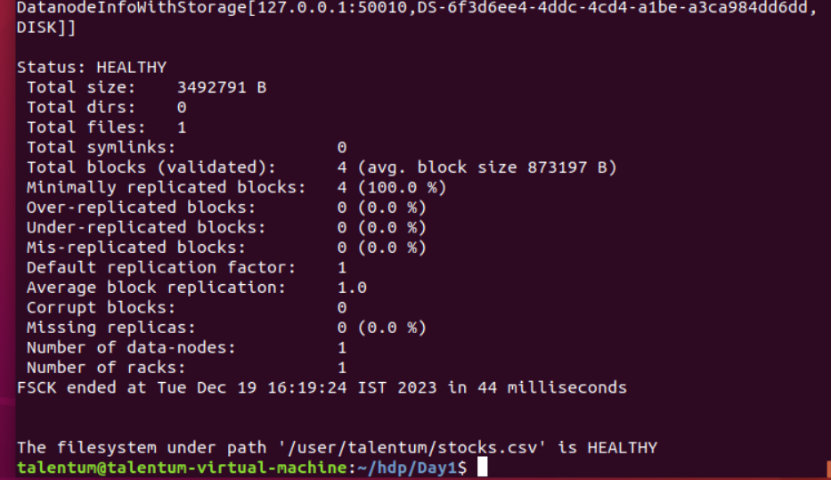

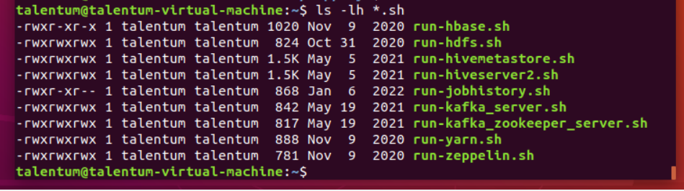





**Another terminal**

**Hive**

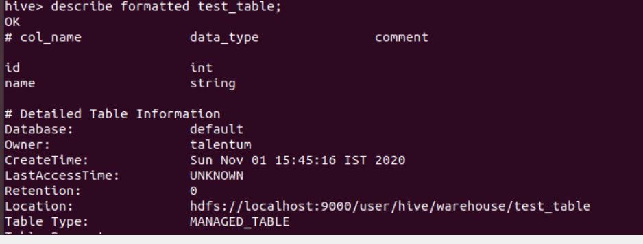

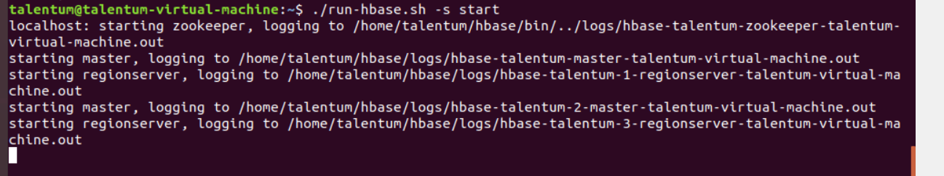



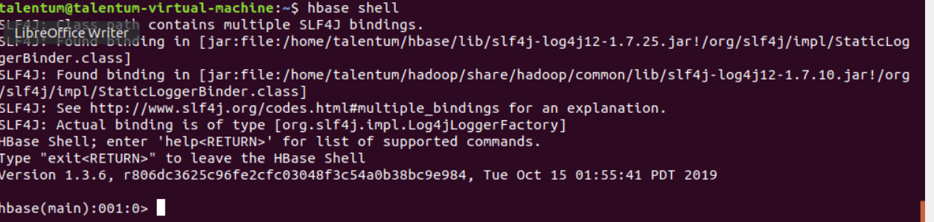

**To view tables**

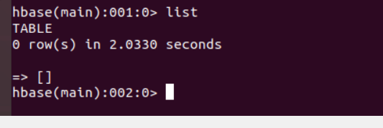

**Create table notifiactions**

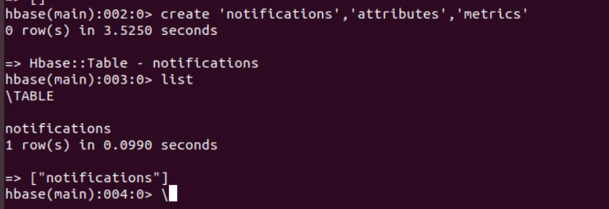

**Inserting data into a table using HBase Shell**

**put**

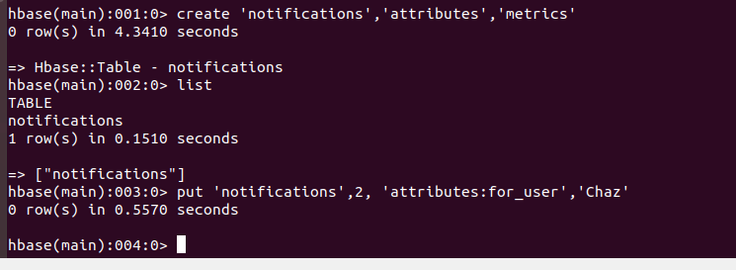

**Example 3: Updating data using the HBase Shell**

**Put(condtn)**

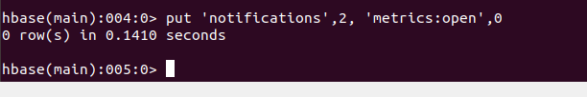

**To view table:**

**Use scan**

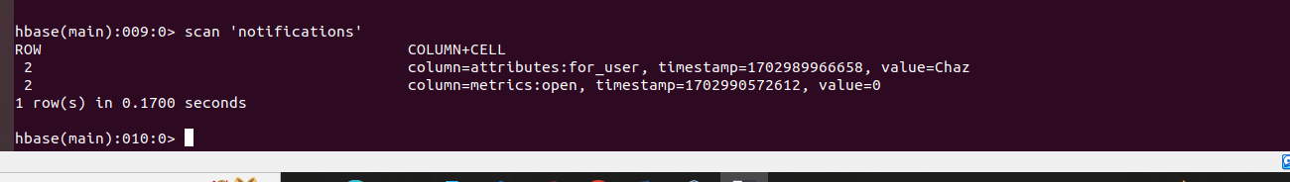

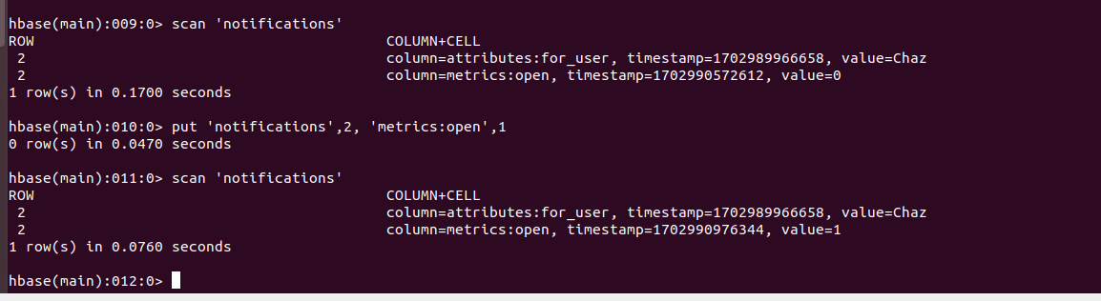

**Example 4:**

**Retrieving data using the HBase Shell**

**Get**

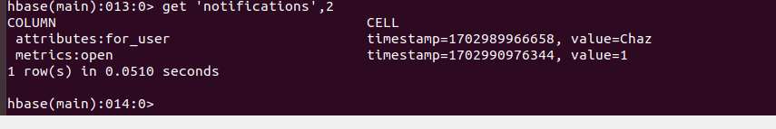

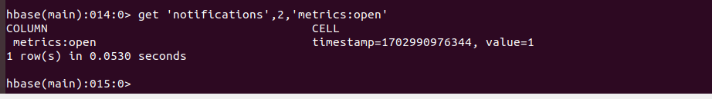

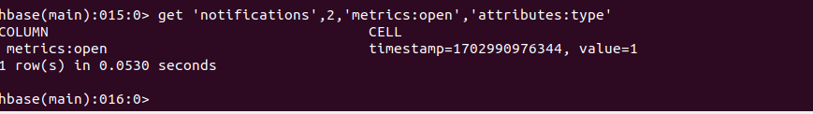

Example 5: Retrieving a range of row ids using the HBase Shell

Scan

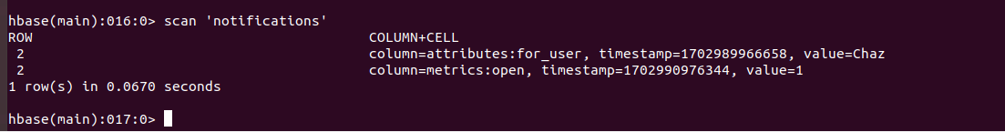

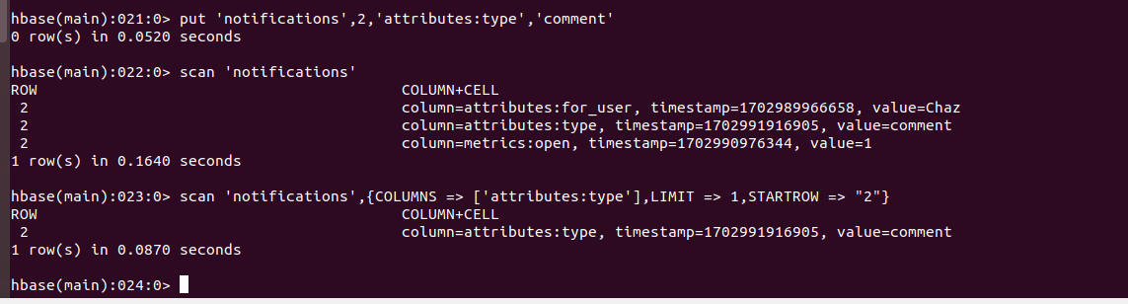

Example 6

Delete

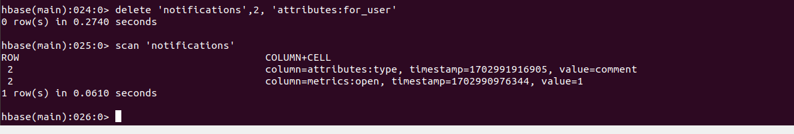

Drop table

