**1] HBase CRUD operations**

1. **Refer the attached Lab manual for the lab Lab 3: Using HBase**
2. **Follow the instructions in the lab and implement it**

* **TimeLine = 30 Mins**

* **Code/Dataset**

**data/HBaseEssentials-LabGuide**

**Lab 3 : Using HBase**

**Launch Hbase**

**Check version**





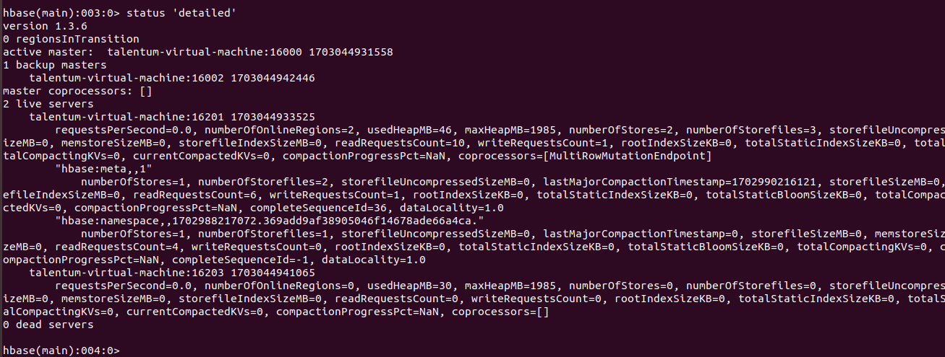

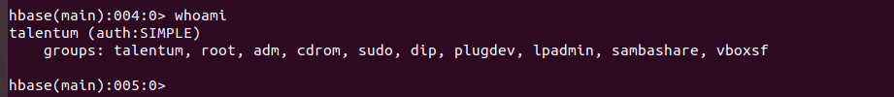

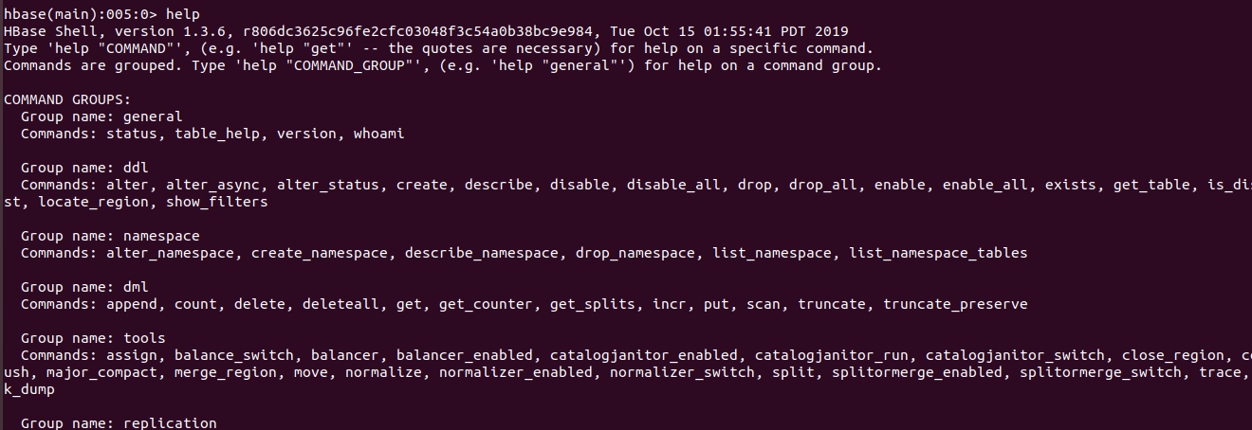

**Check these commands too**

**Help ‘ddl’**

**Help ‘get’**

**Help ‘put’**

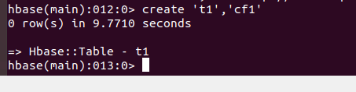

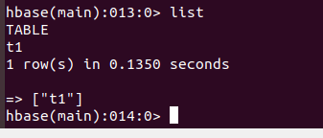



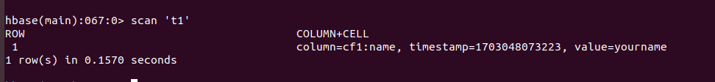

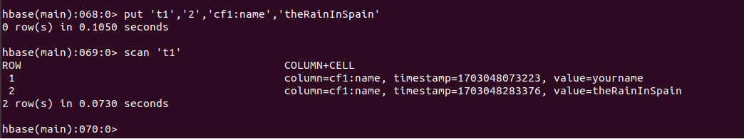

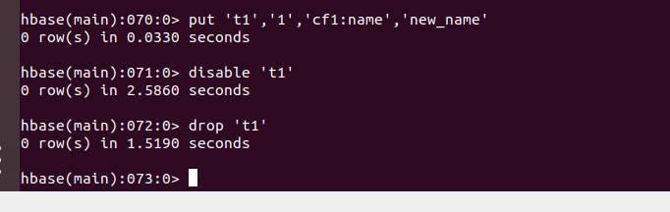

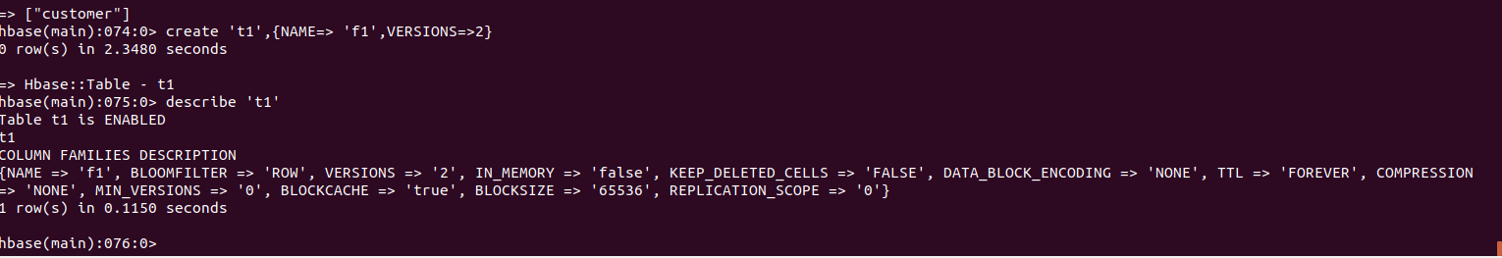

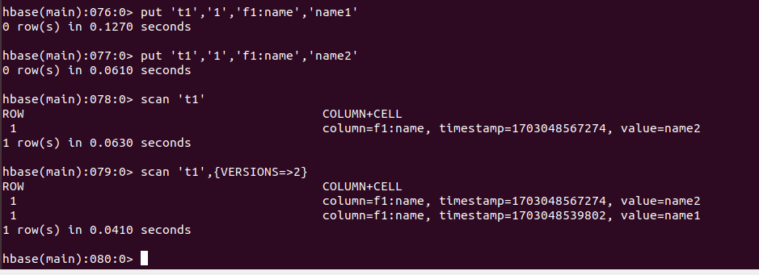

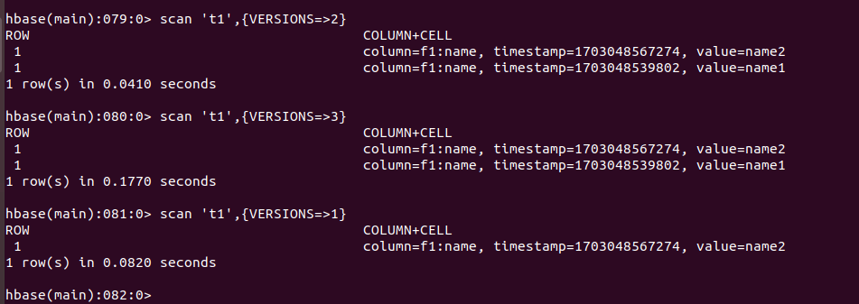

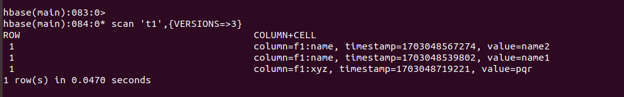

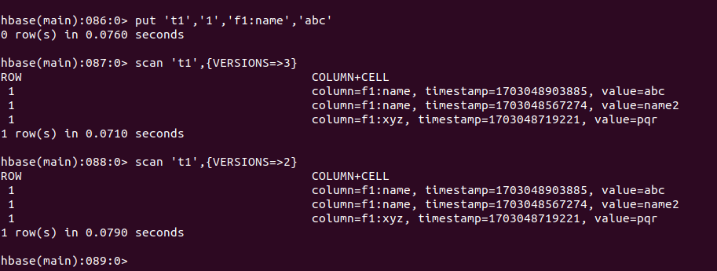

**exit**

**LAB**

**Exercise 1: Perform CRUD operations with HBase shell**

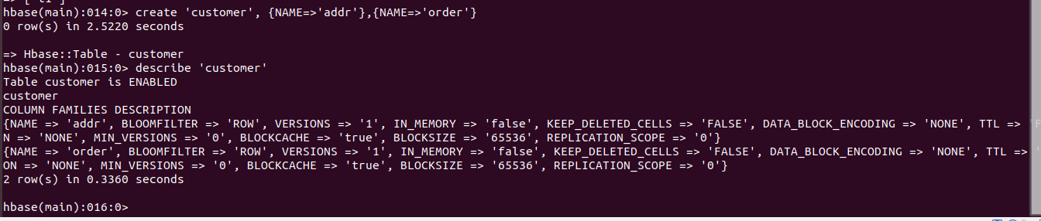

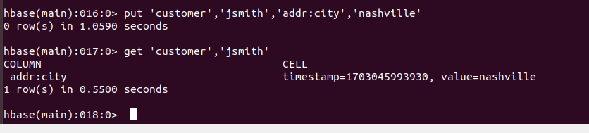

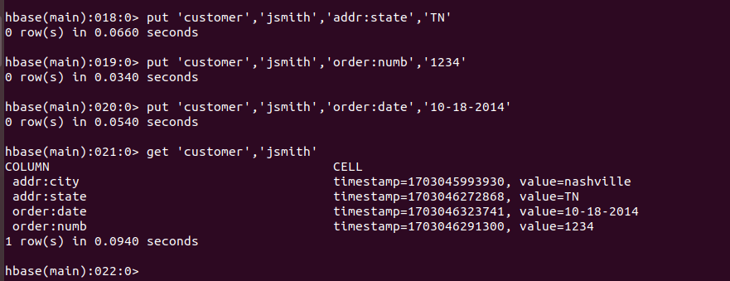

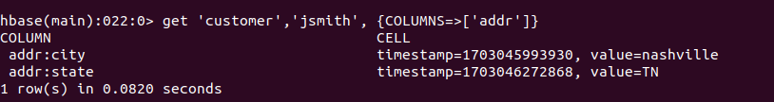

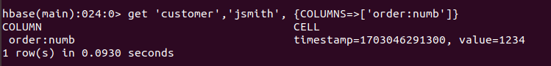

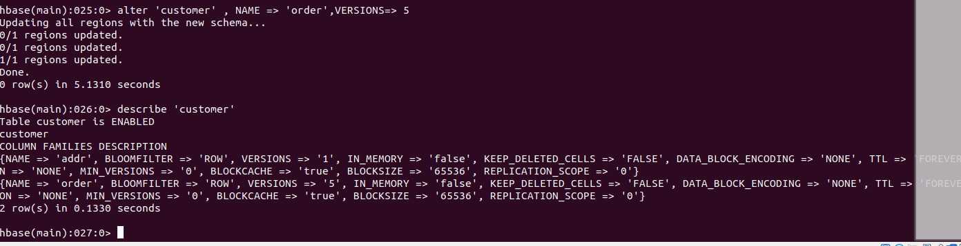

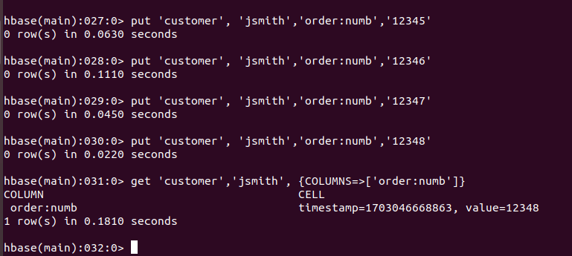

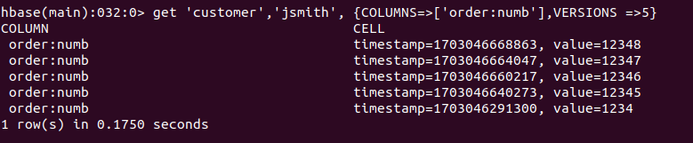

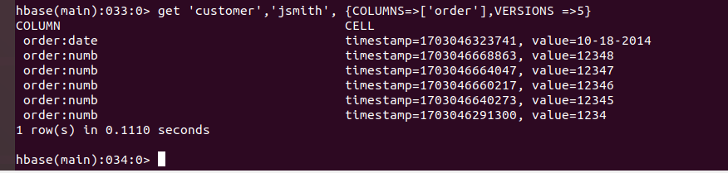

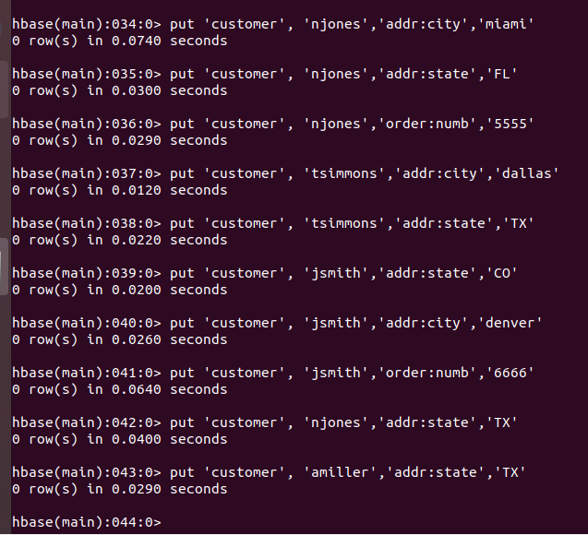

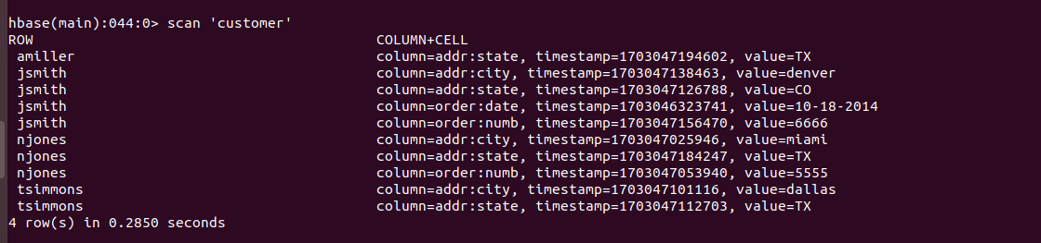

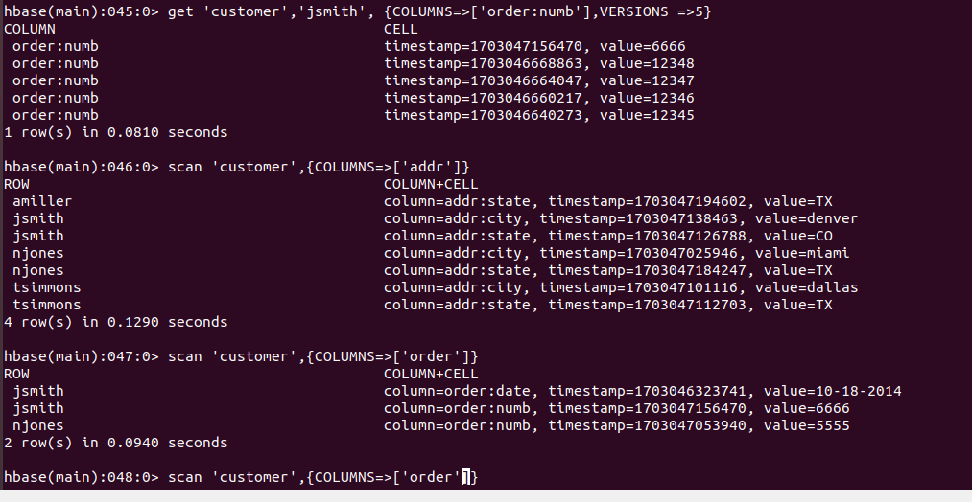

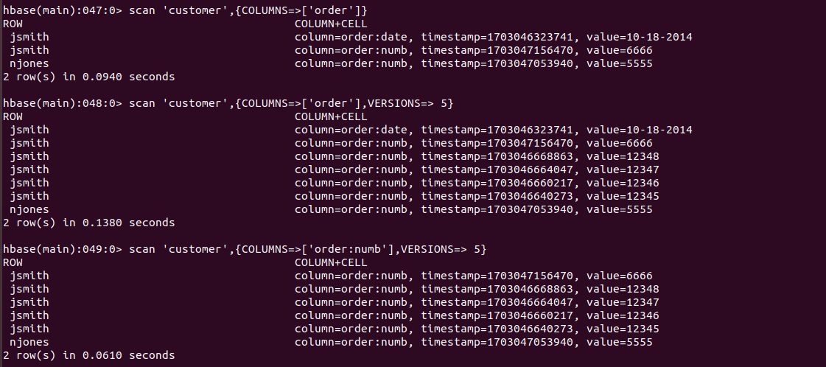

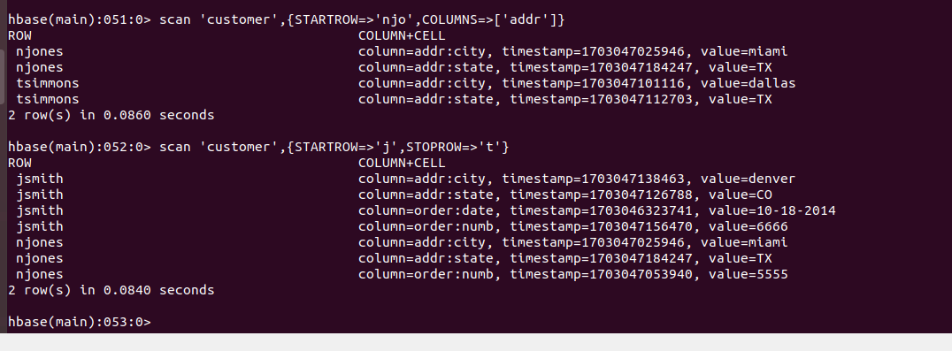

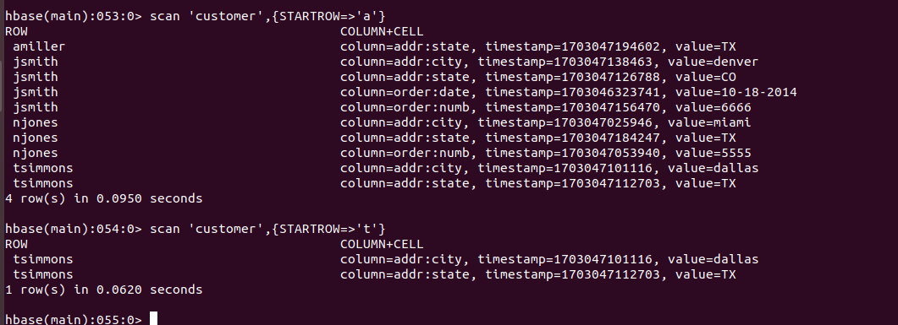

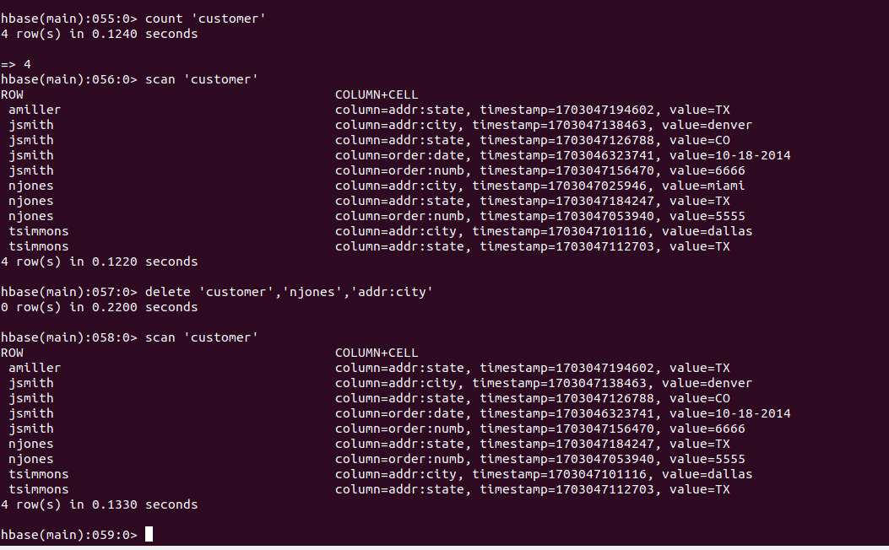

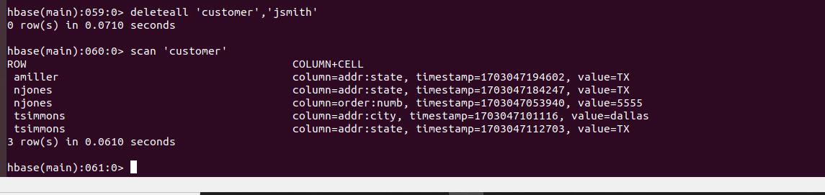

2]  Inserting data into a HBase table through a tool

1) Start Hbase shell

2) Create a Table 'driver_dangerous_event'  using following command on hbase shell

>>> create 'driver_dangerous_event','events'

3) From a linux command line put the data.csv in your home on hdfs

4) On a new linux command line give following command

>>> hbase org.apache.hadoop.hbase.mapreduce.ImportTsv -Dimporttsv.separator=,  -Dimporttsv.columns="HBASE_ROW_KEY,events:driverId,events:driverName,events:eventTime,events:eventType,events:latitude,events:longitude,events:routeId,events:routeName,events:truckId" driver_dangerous_event hdfs://localhost:9000/user/talentum/data.csv

5) Come to the hbase shell and scan the table

* Code/Dataset

data/data.csv

