4] Importing data using sqoop

1) Download the attached files in **STAGING_AREA**

2) Create a folder Lab3.1 in **LABS_HOME**

3) Copy the files in step 1 to step 2 location

4) Wait for the instructions from the trainer.

**Dataset -**

* data/salaries.txt

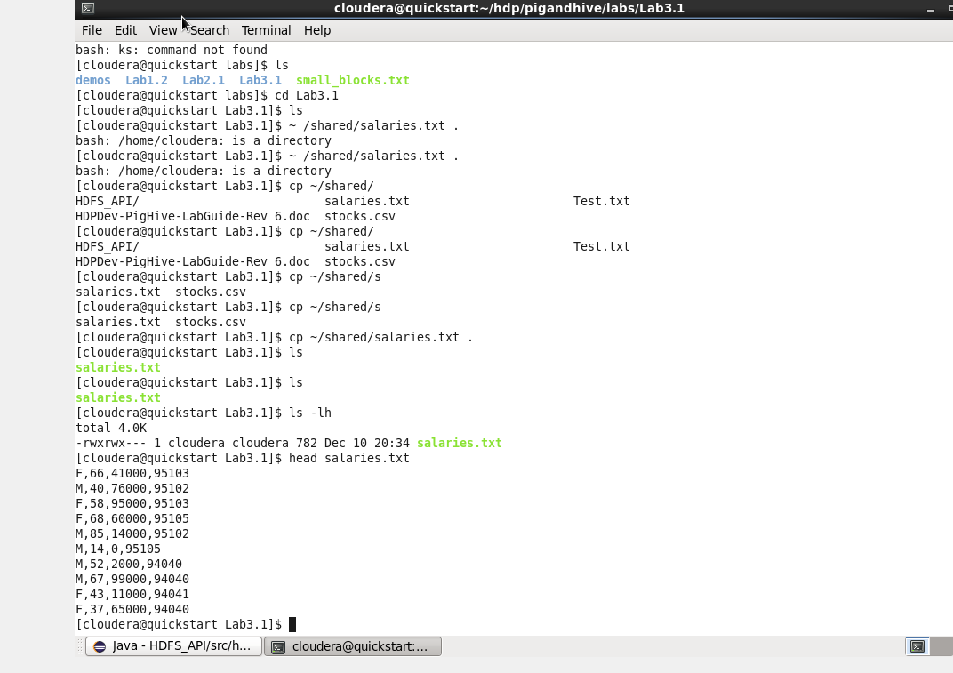

Cccc

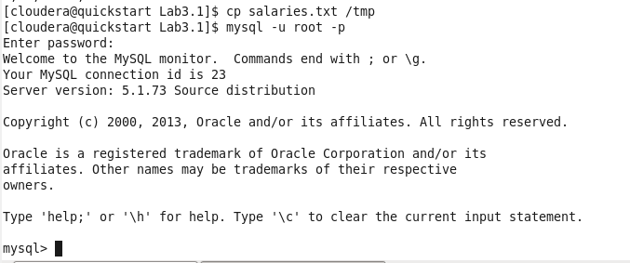

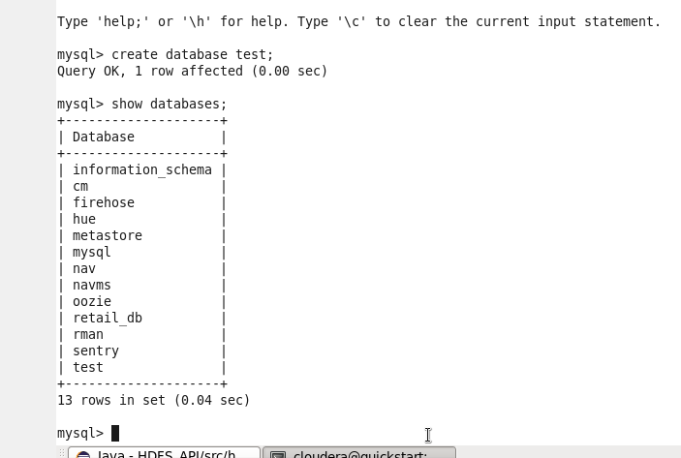

Cccc

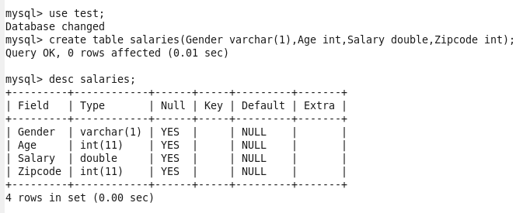

Cccc

We have salaries.txt loaded in hdfs, so by giving below command we are loading data from salaries.txt to our table

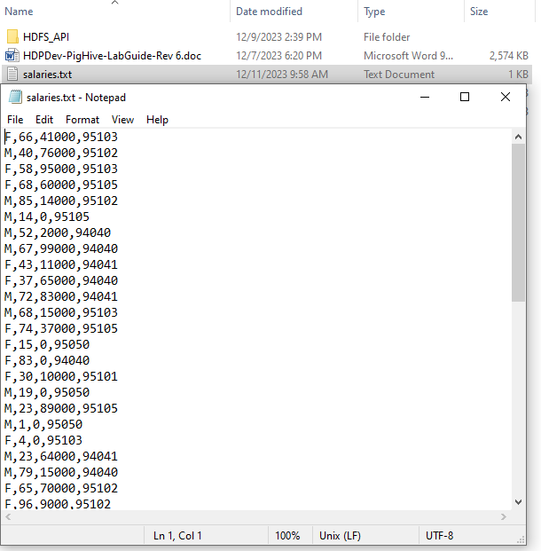

Cccc



Cccc

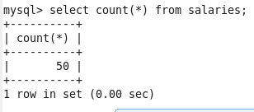

Cccc

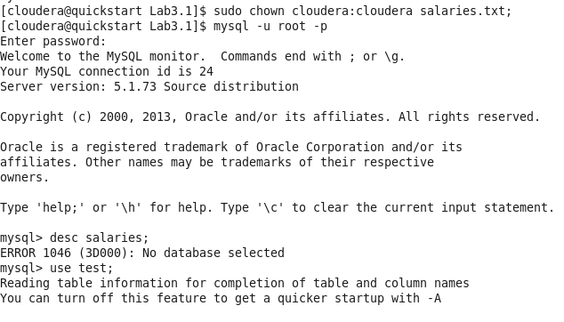

Cccc

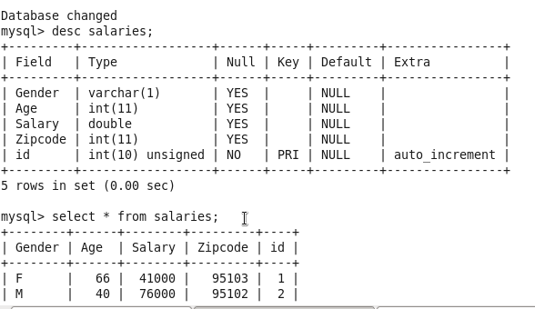

Cccc

Sqoop commands

1) Import the Table into HDFS

sqoop import --connect jdbc:mysql://quickstart.cloudera:3306/test --driver com.mysql.jdbc.Driver --username root -password cloudera --table salaries

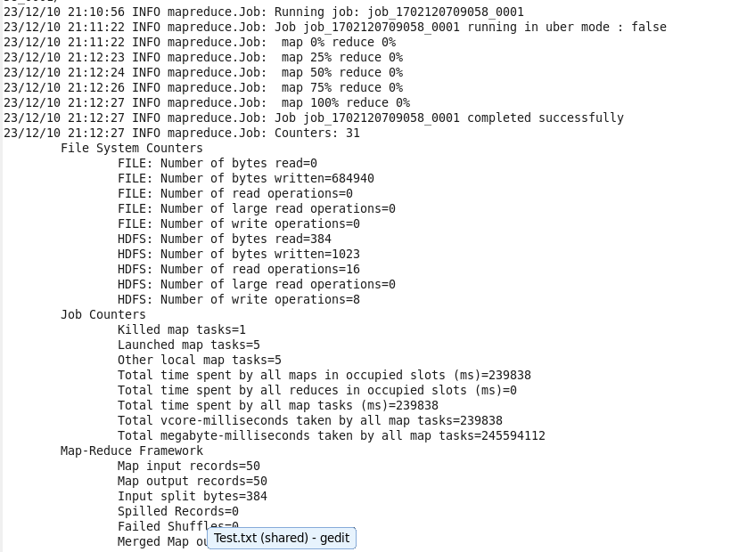

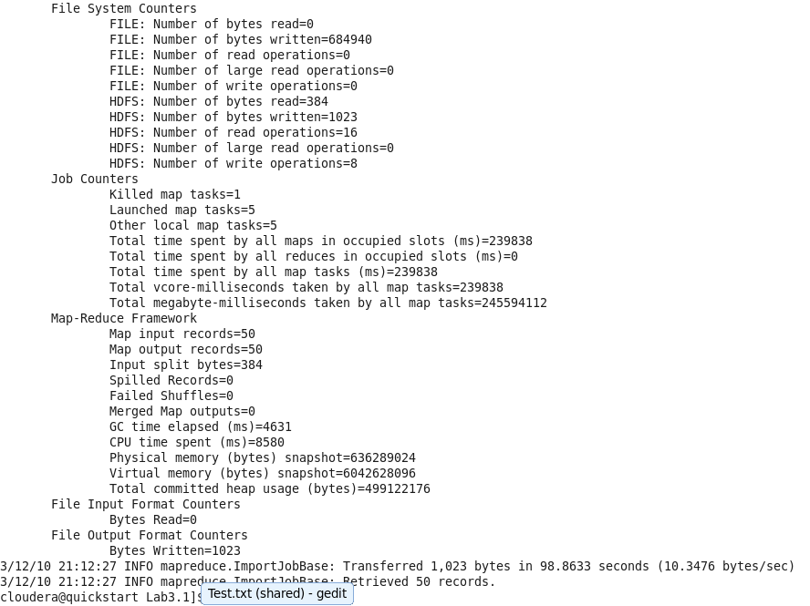

Cccc

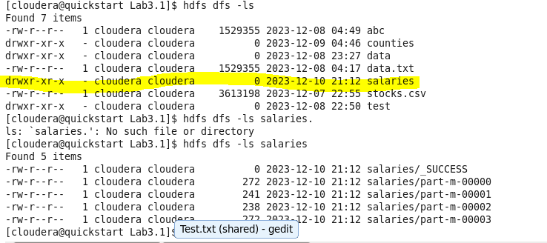

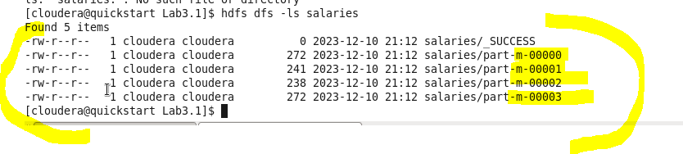

Here mappers are generated as shown above- 4 mappers are created and the records are distributed accordingly.

Look at the sizes, you will see almost equal distribution of record

1st mapper- 272 byte of data, 2nd mapper- 241, etc

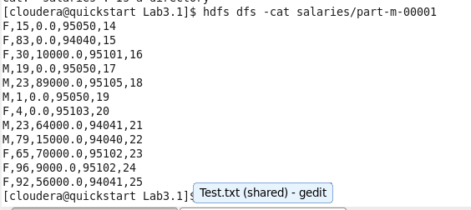

The 12 entries from 2nd mapper as we can see (i.e. 00001)

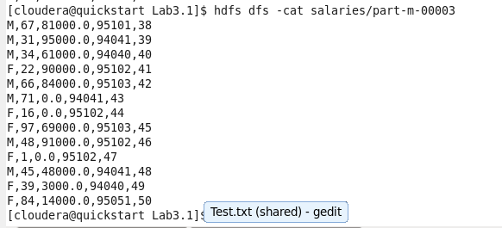

-m-00003

We cannot get the schemas means table (column name, etc) here because it is Metadata, Can get by using HIVE.

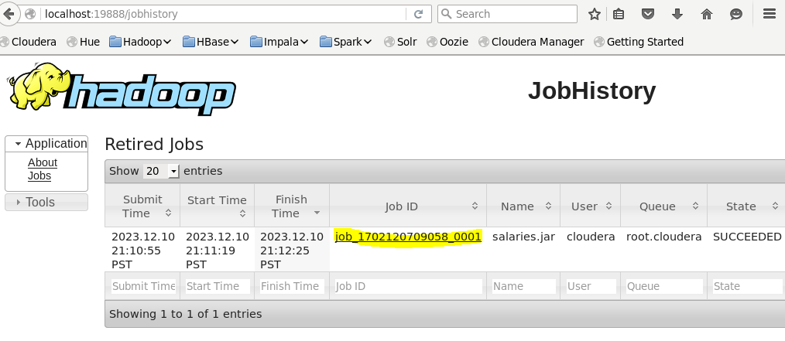

Job ID : same for both.



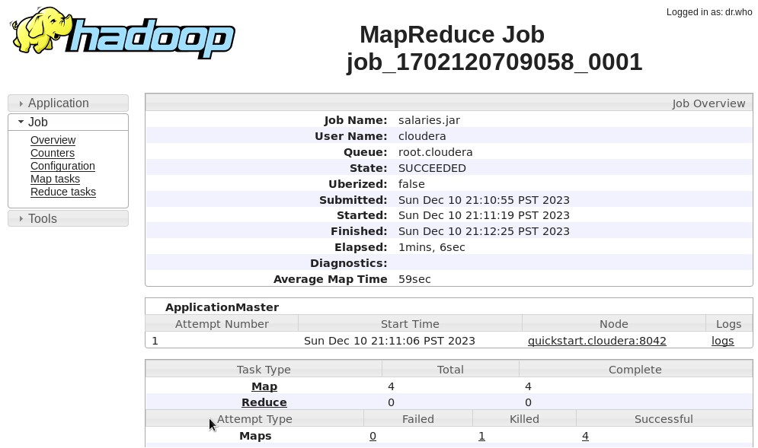

Click on Map:

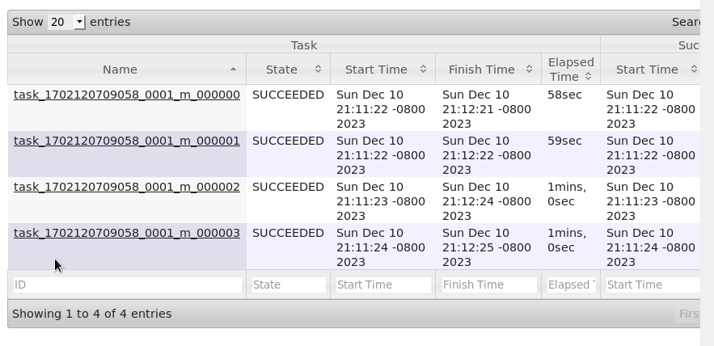

Cccc

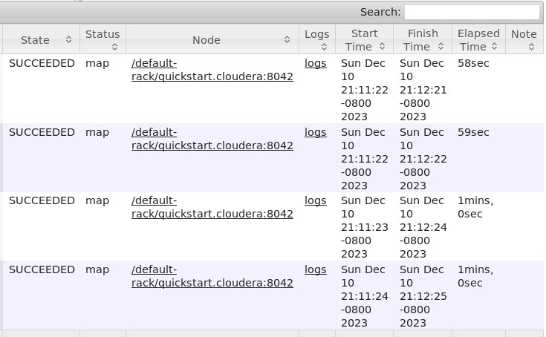

Click on Logs:

Shared data across 4 map process accessing same data

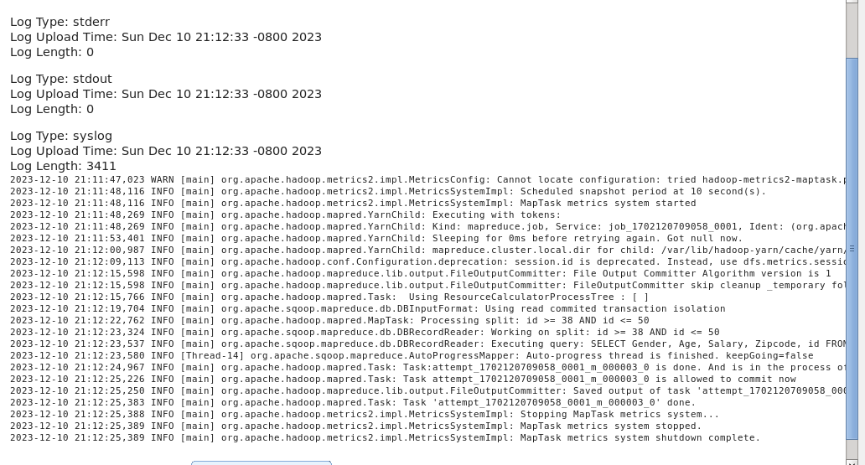

Cccc

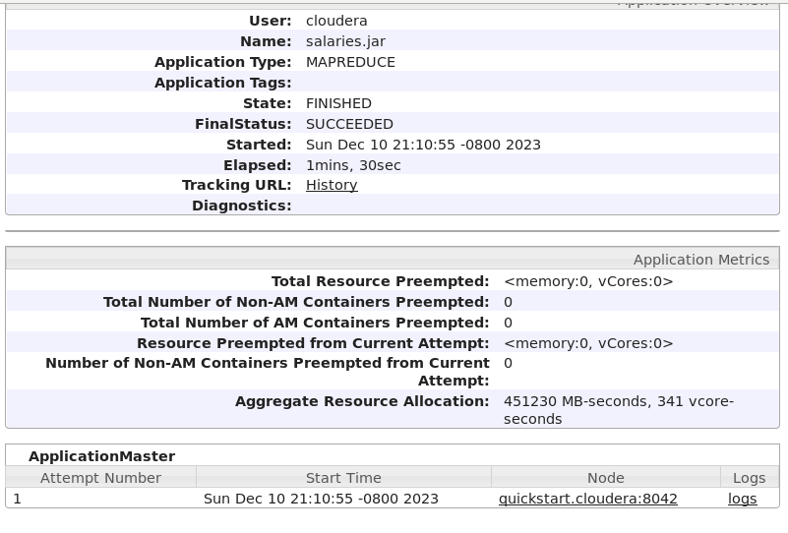

Yarn

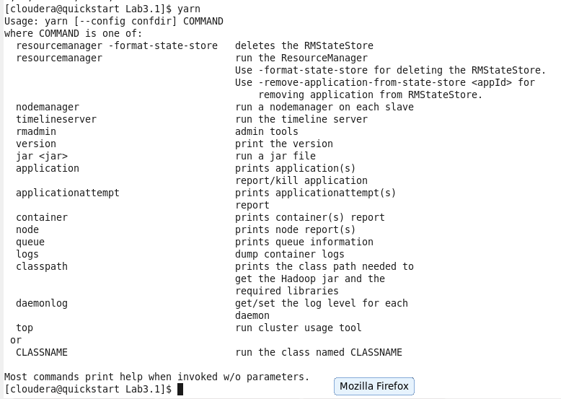

Logs : container

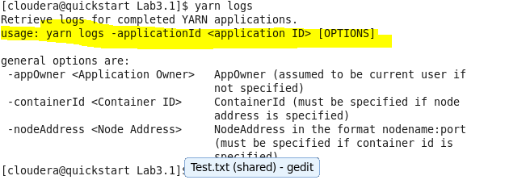

Cccc

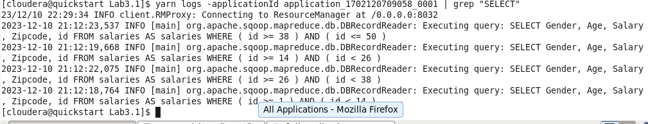

2) sqoop import --connect jdbc:mysql://quickstart.cloudera:3306/test --driver com.mysql.jdbc.Driver --username root -password cloudera --table salaries --columns salary,age -m 1 --target-dir salaries2

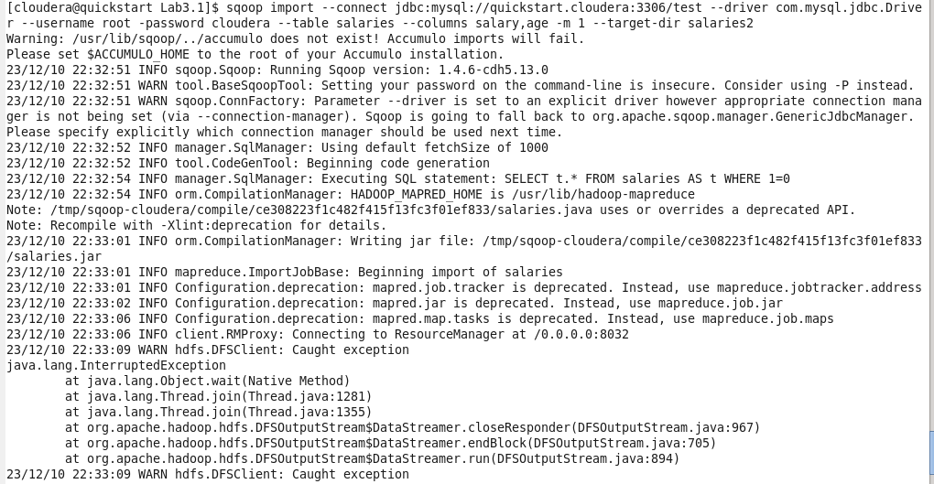

Cccc

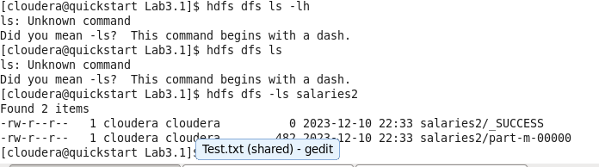

Ap id :02

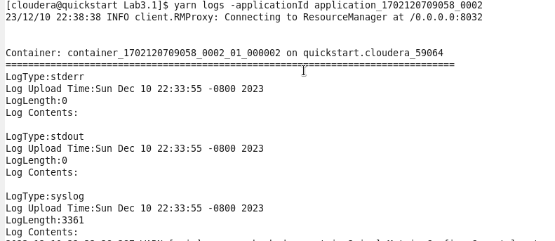

Cccc

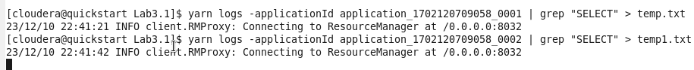

Cccc

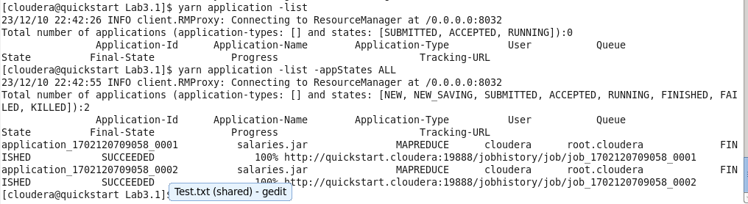

To see the ApplicationID

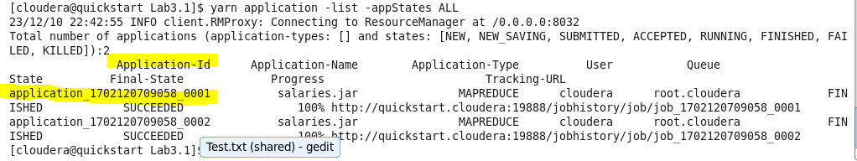

Cccc

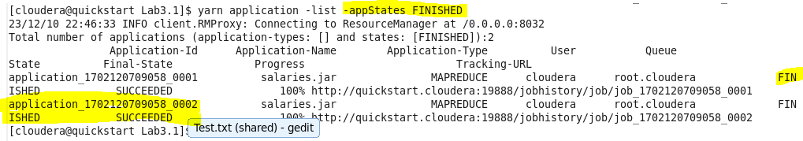

3) Importing from a Query

sqoop import --connect jdbc:mysql://quickstart.cloudera:3306/test --driver com.mysql.jdbc.Driver --username root --password cloudera --query "select * from salaries s where s.salary > 90000.00 and \$CONDITIONS" --split-by gender -m 2 --target-dir salaries3

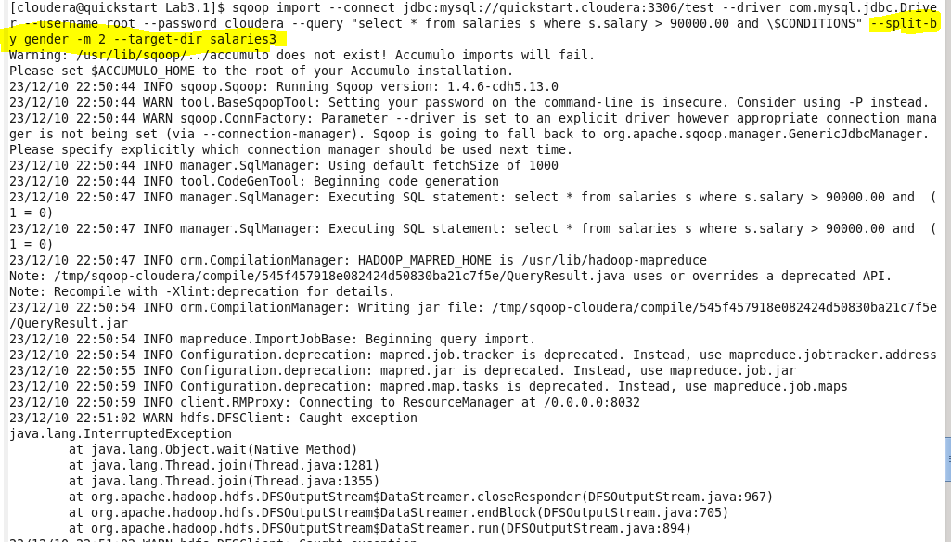

Cccc

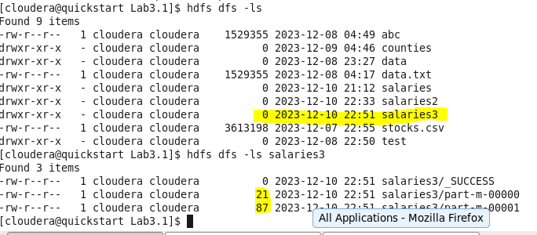

Cccc

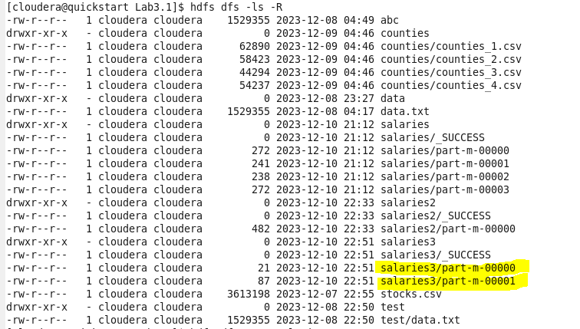

Cccc

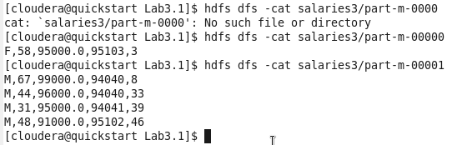

Cccc

If we remove and \$CONDITIONS so our query will fail similarly –splitby condition is also necessary.

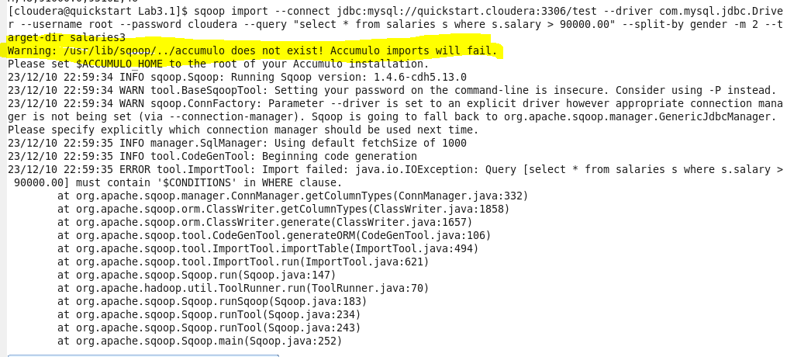

Here we removed split by condition, so it will fail again

