Without Combiner

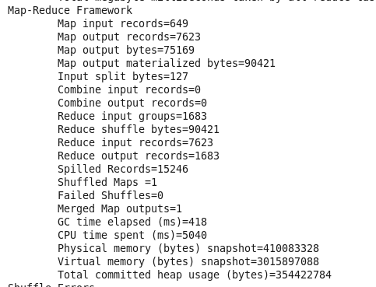

With combiner

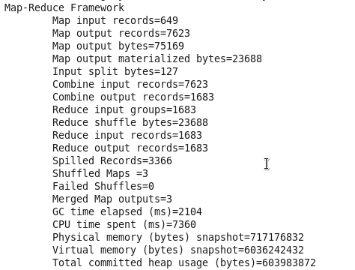

.

Using Partitioner

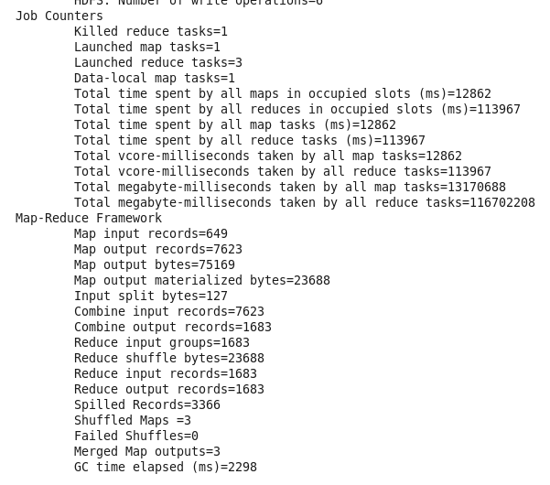

5] Implementing Counter

1) Download an attachment in **STAGING_AREA** location

2) Extract it

3) Pull it to **LABS_AREA**/counter

4) Study the code

5) Create **counties** folder in your home on HDFS

6) Put all **counties_*.csv** files from local linux file system to **counties** folder on HDFS

7) Run the application with command as **yarn jar average.jar <Main Class>**

8) See the output of the job on terminal window and confirm whether counters you created are working or not

Code/Dataset:- data/Average.rar

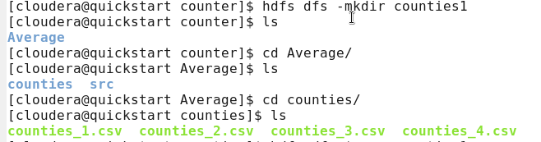

…

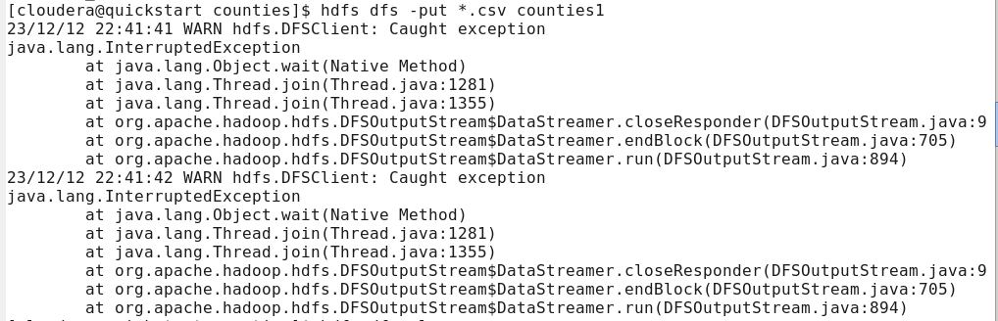

…

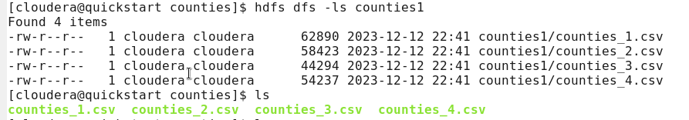

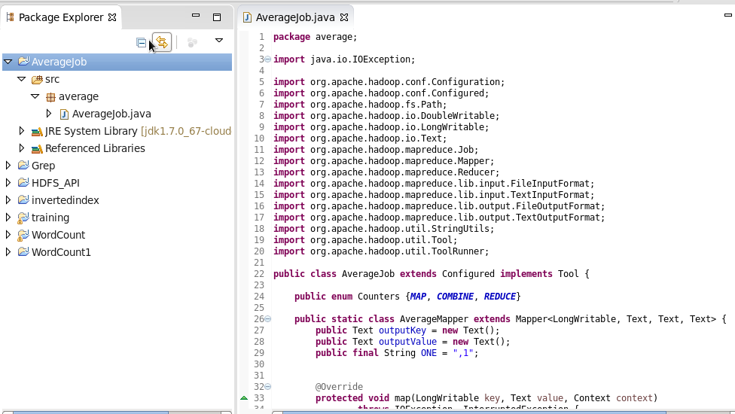

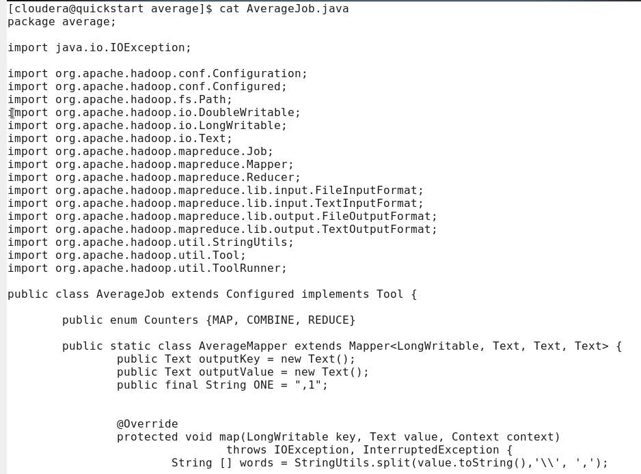

Make the normal .jar file

Run it using : yarn jar average.jar average.AverageJob

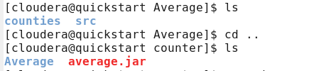

…

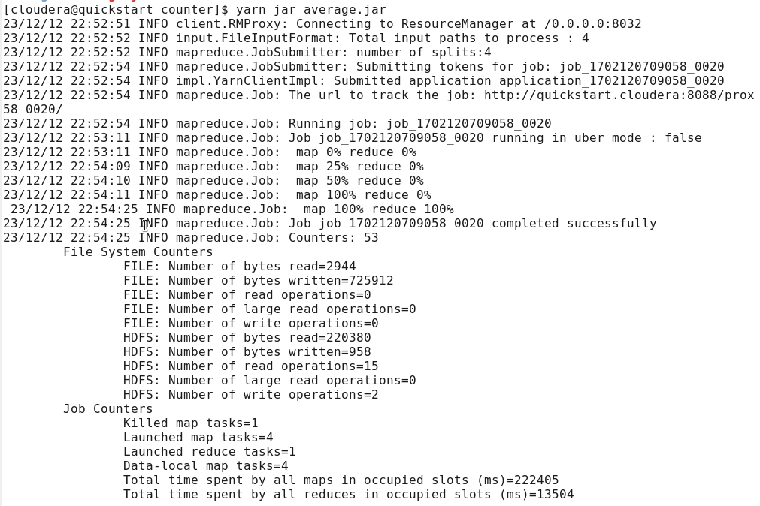

…

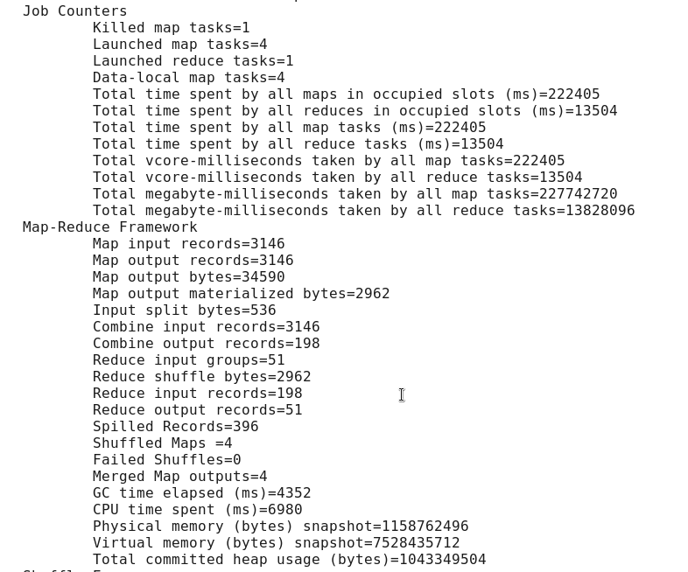

…

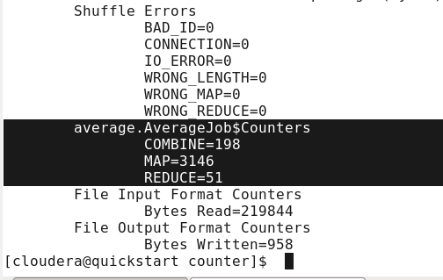

7] Compression

1) Download the rar file in **STAGING_AREA**

2) Extract it

3) Pull the extracted folder in **LABS_AREA**

4) Create a **logfiles** folder on HDFS and put the log files from project folder into it

5) Create an eclipse project **compression**

6) Import the java files from project folder in **STAGING_AREA**   in to this project

7) Remove the compilation errors by adding hadoop client side libraries

8) Create a jar **compression.jar**

9) Have a first Run using **yarn jar compression.jar INFO** command

10) Wait for the in

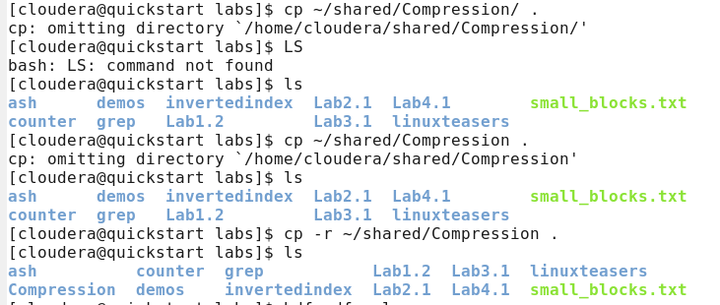

…

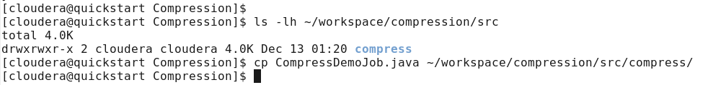

…

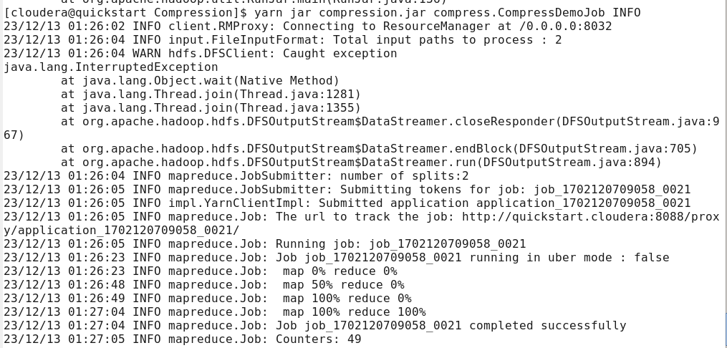

…

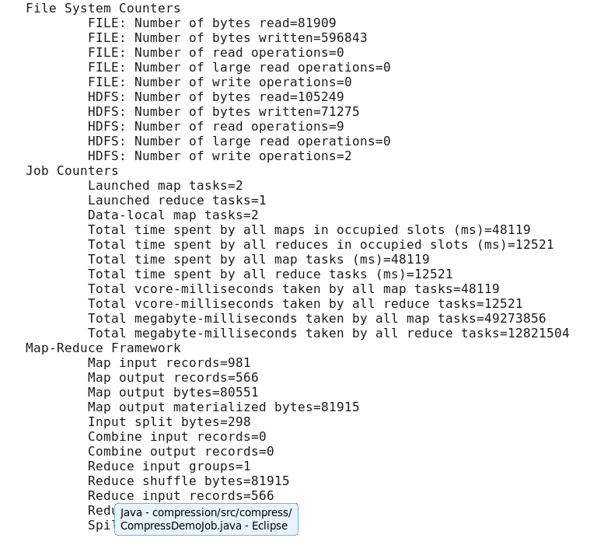

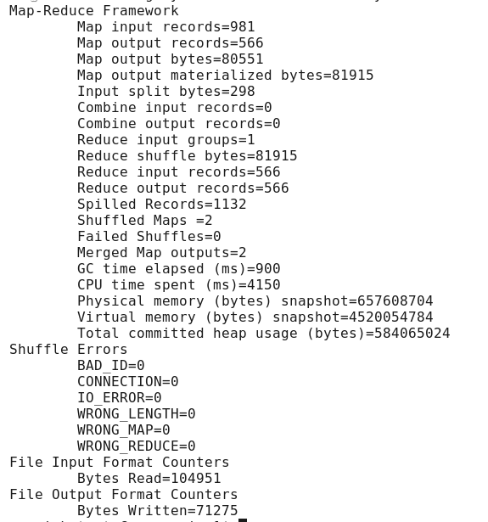



Now uncomment these lines from code

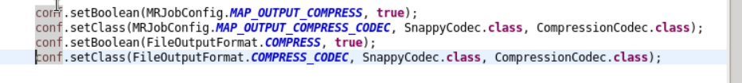

…

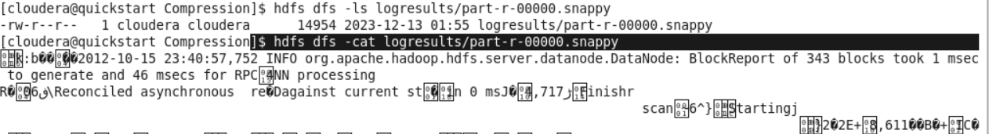

…

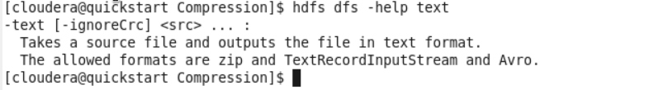

…

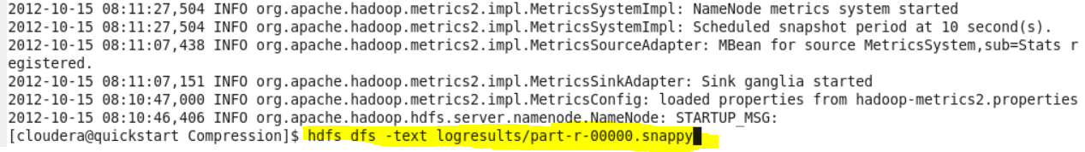

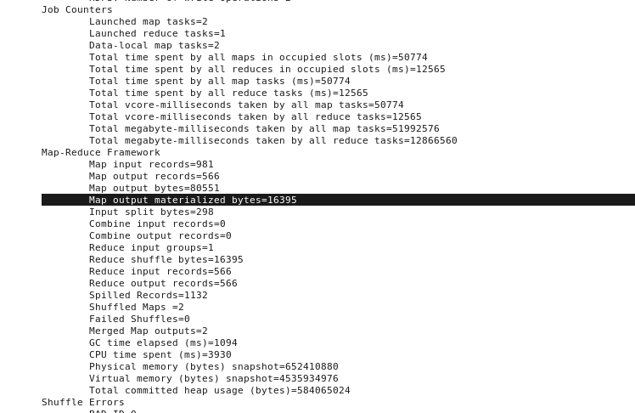

Compare same with the without compression output

LAB-> MRStreaming

Python

Put MRStreaming folder in LABS_AREA in our staging area, it contains mapper.py and reducer.py

Run the following command as it is



Then

hdfs dfs –ls

dhfs dfs –ls dft-output

dhfs dfs –cat dft-output/……00000