LAB: UNDERSTANDING HIVE TABLES

1] Understanding Hive tables

1) Download the attached file in **STAGING_AREA**

2) Extract it

3) Create a folder **LABS_AREA**/lab7.1

4) Put the extracted contents in above location

5) Wait for the instructions.

* Code/Dataset

data/Lab7.1.rar

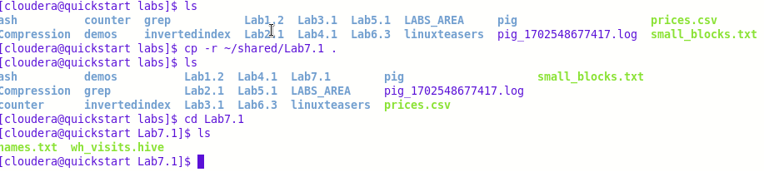

…

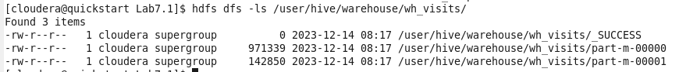

…

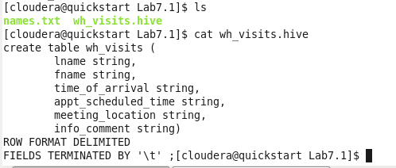

…

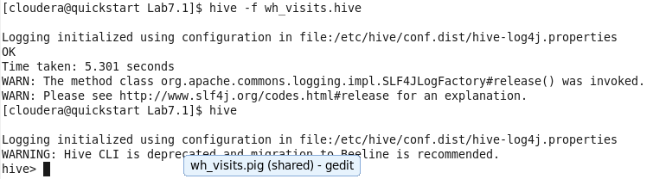

…

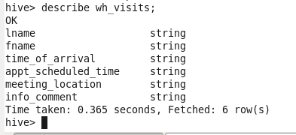

..

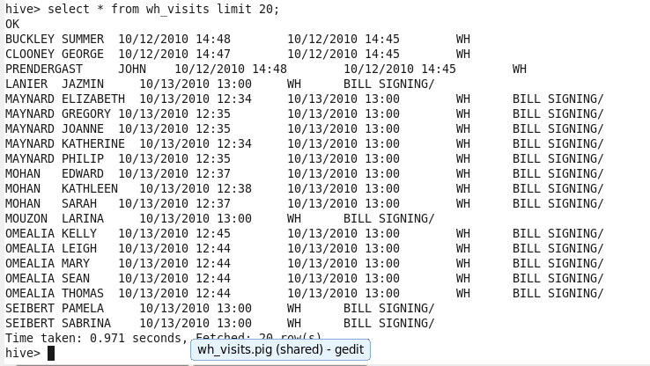

…

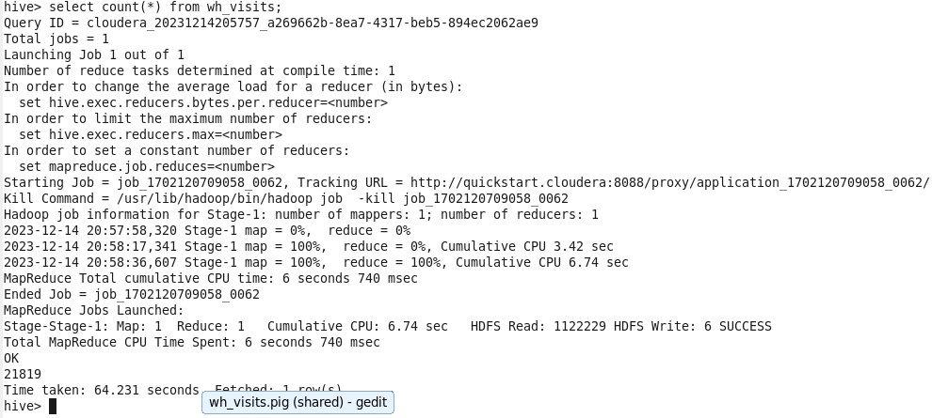

…

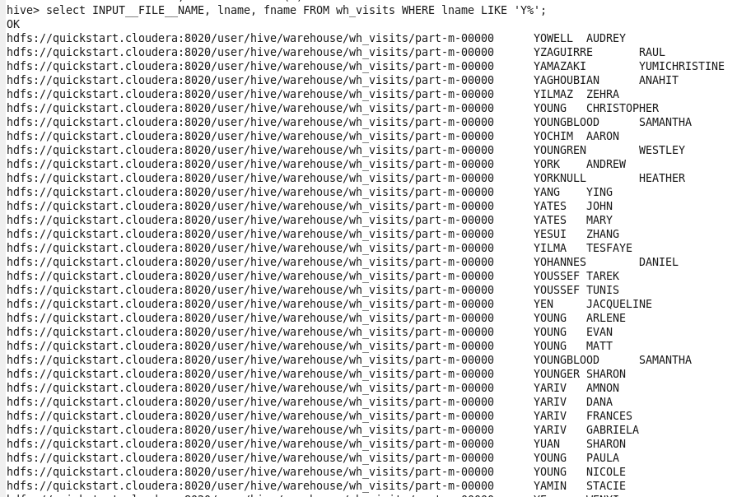

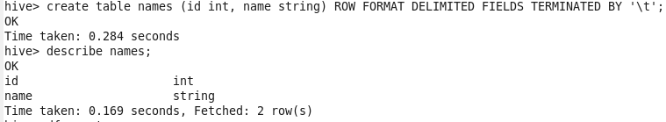

…

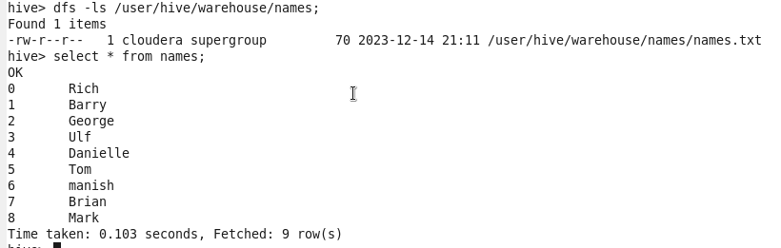

…

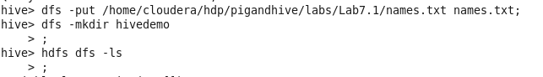

…

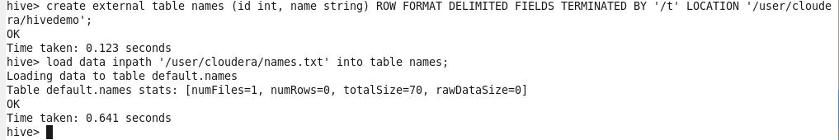

…

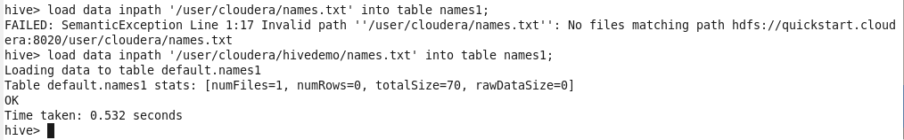

…

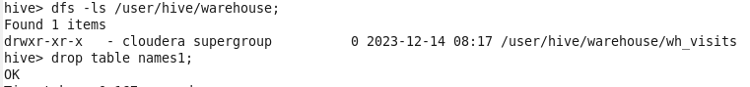

…

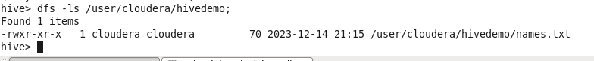

-------------------------------------------------------------------------------------------------------------Understanding Metastore

Find file

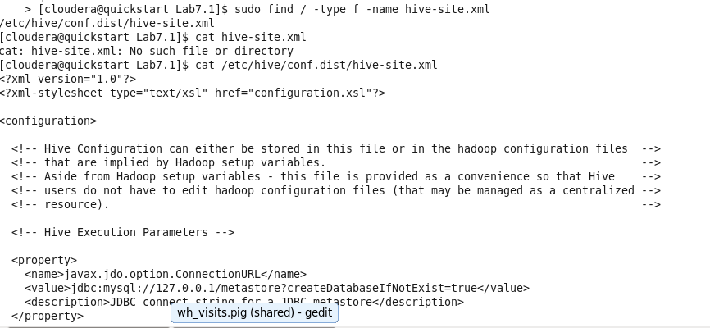

In new terminal

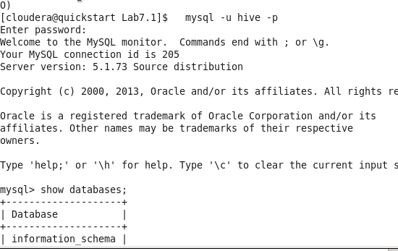

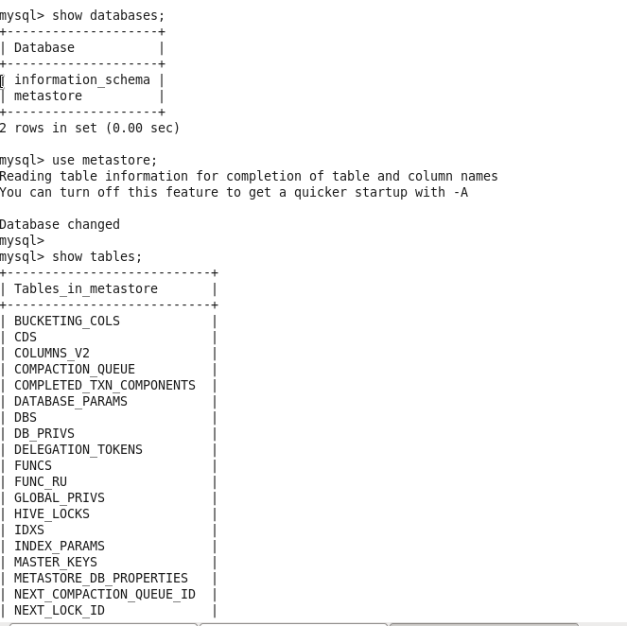

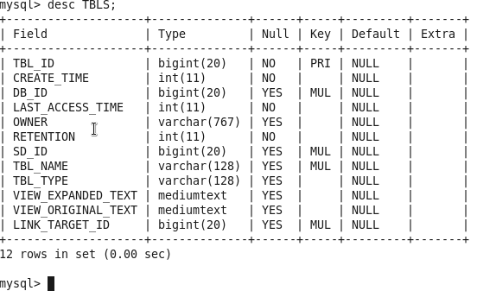

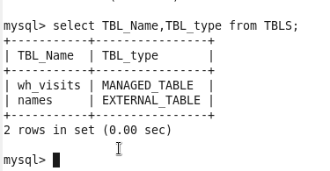

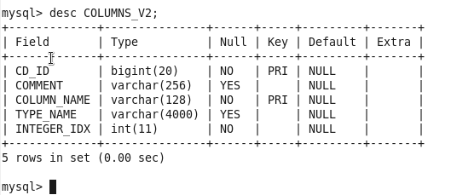

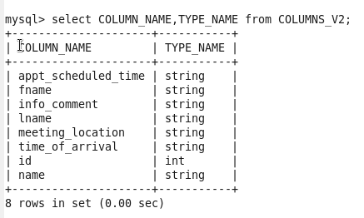

In hive

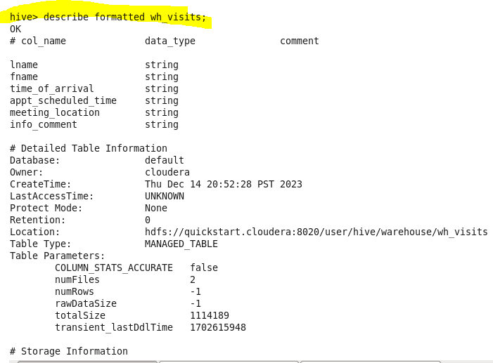

**LAB: UNDERSTANDING PARTITIONS AND SKEW**

2] Understanding partitions

1) Download the RAR in **STAGING_AREA.**

2) Extract the contents

3) Pull the contents in **LABS_HOME**/demos

4) Refer the lab manual

5) Wait for the instructions

* Code/Dataset

data/partitionandskewtables.rar

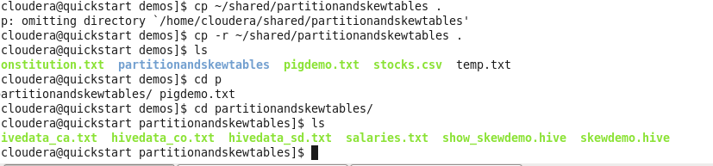

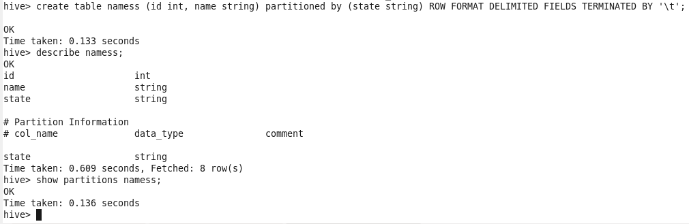

…

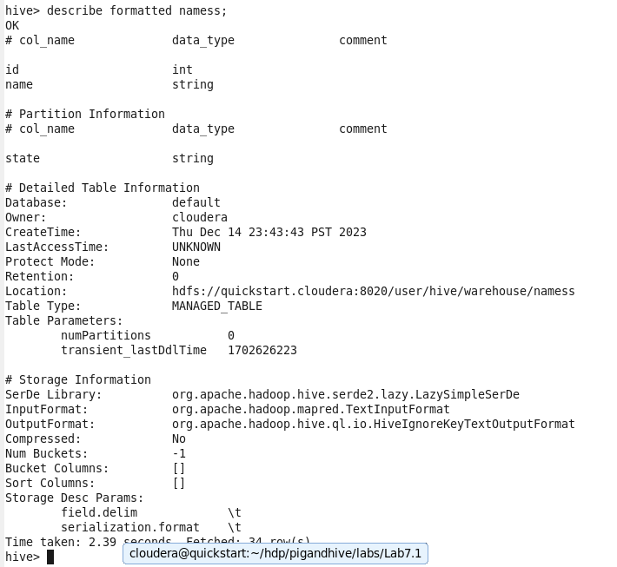

…

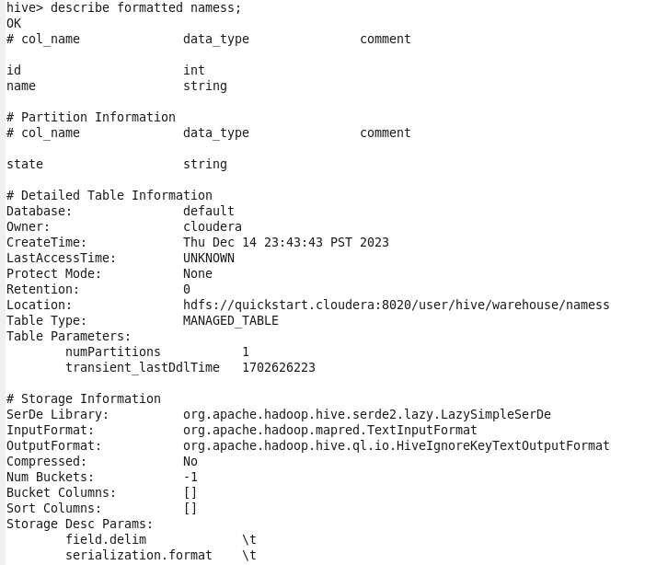

…

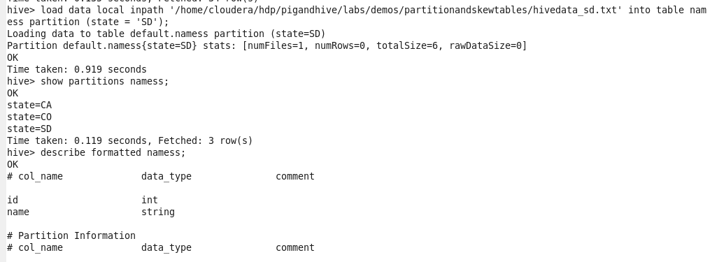

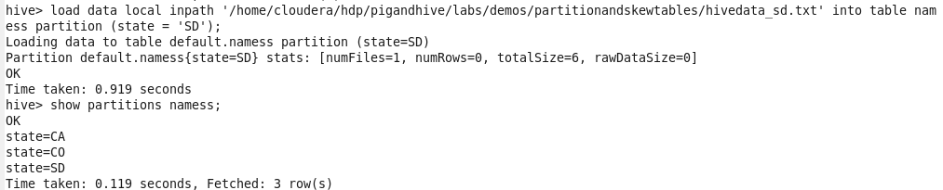

…

Describe formatted namess;

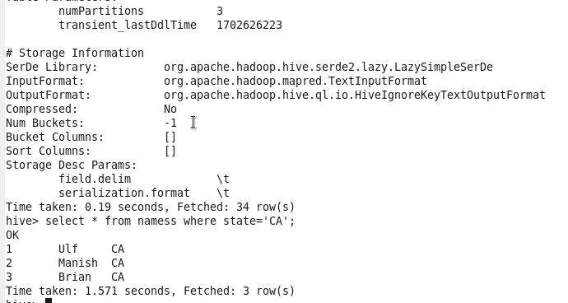

…

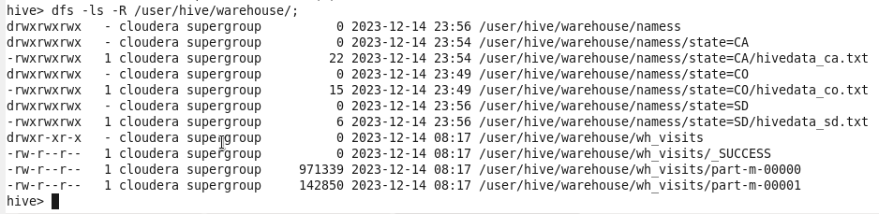

AUTOMATE ABOVE PROGRAM

Create 3 different files

DDL.hive

Load.hive

Run.sh(script file)

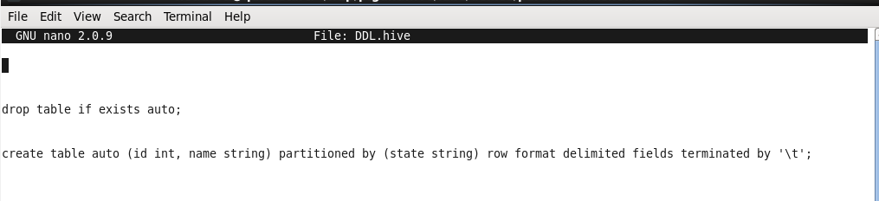

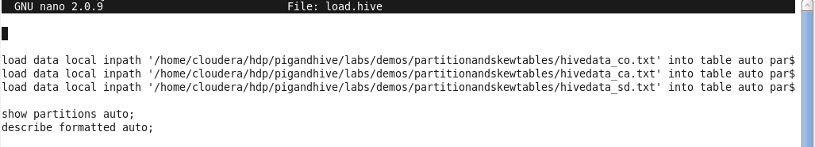

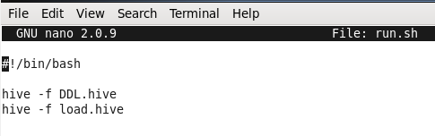



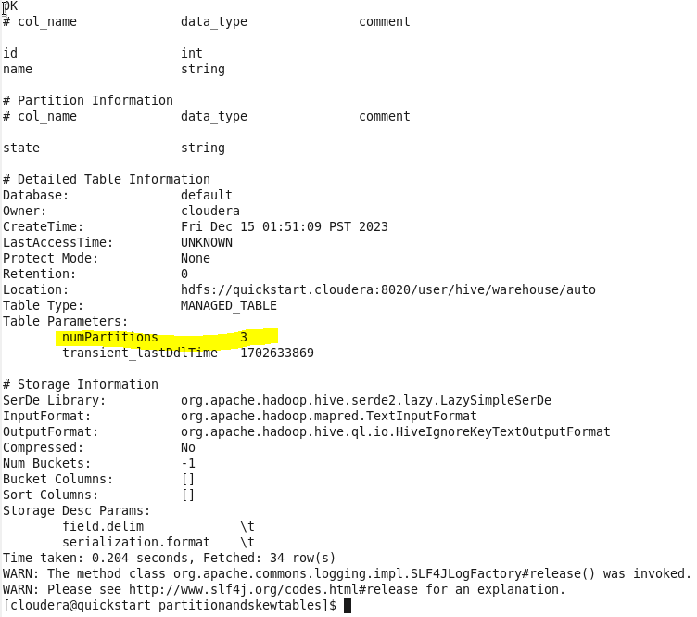

Dynamic Partitioning

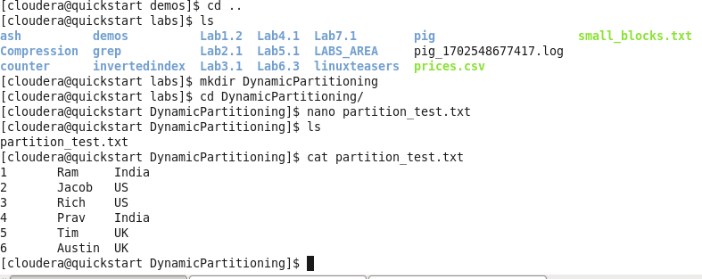



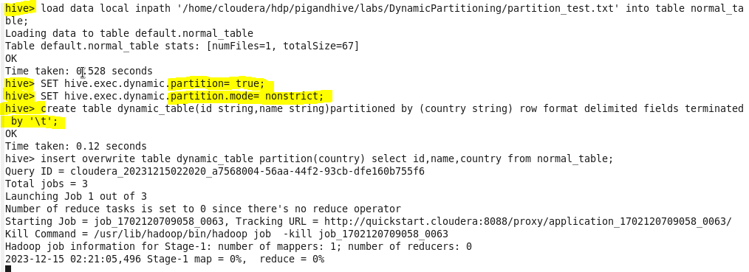

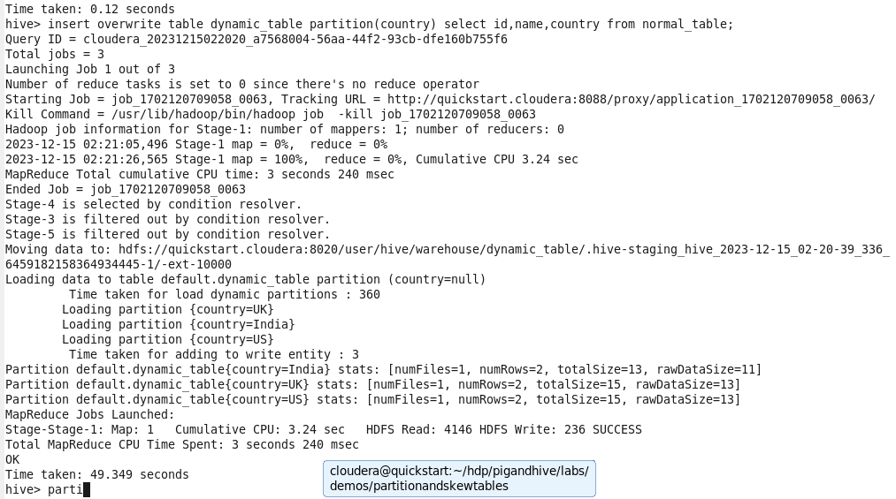

…

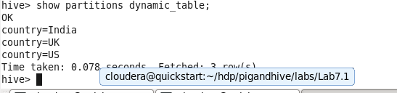

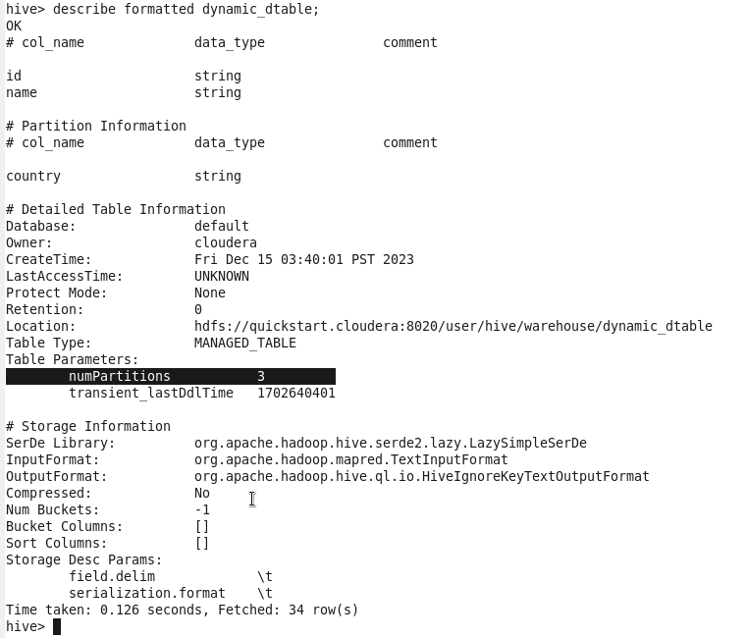

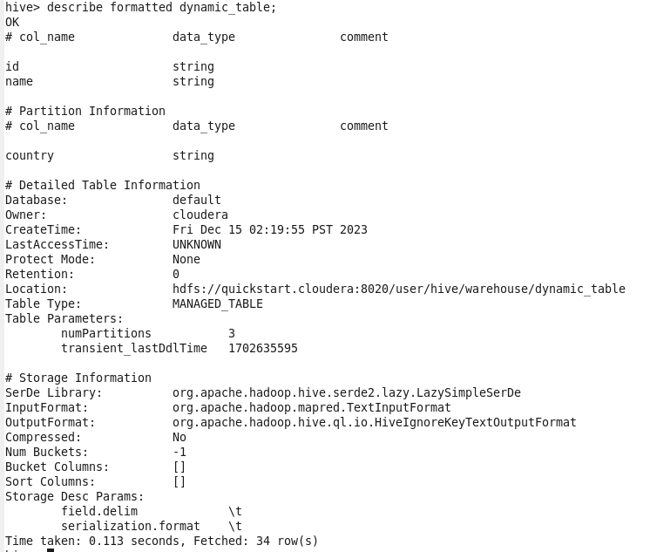

Automation for above dynamic table

Create auto.hive file





