Day 2)

1)

a.



b.

c.

d.

e.

2) To view no of blocks

a.

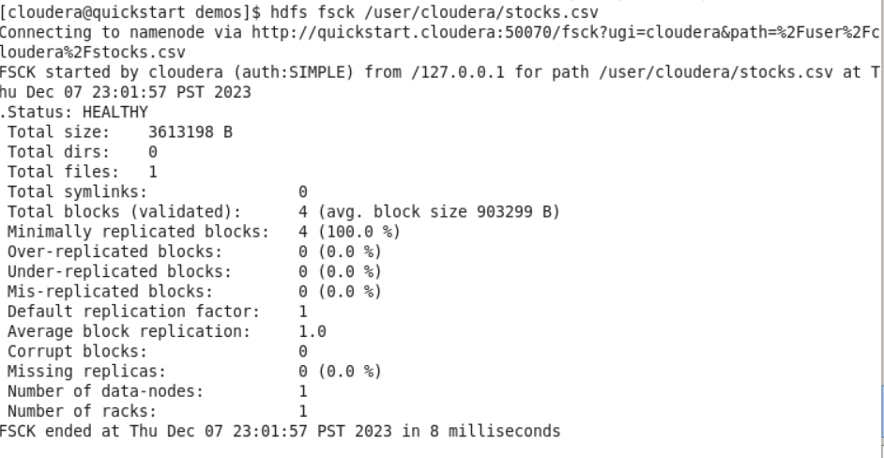

b.

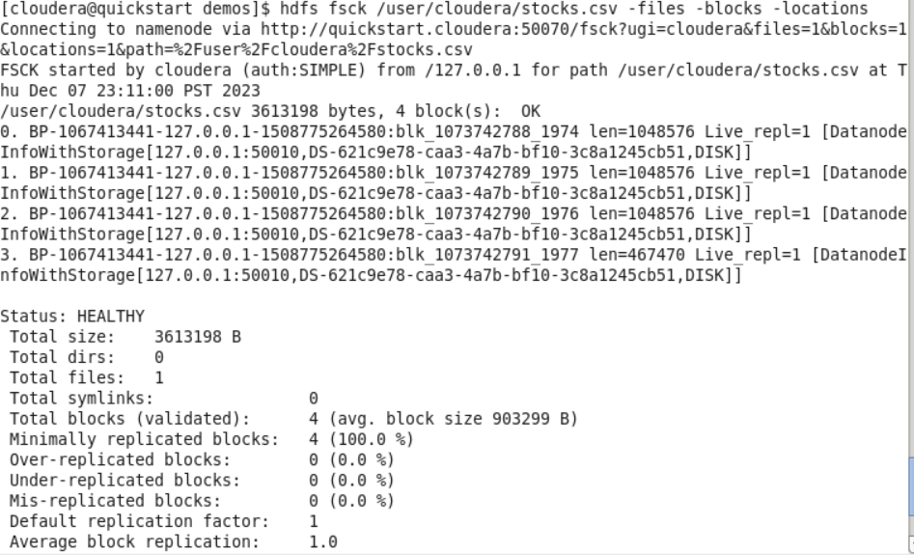

Created 4 blocks Block 1-Block 4

Size of Block 1,2,3 are equal but size of block 4 is less.(As our file size is 3.5 mb)

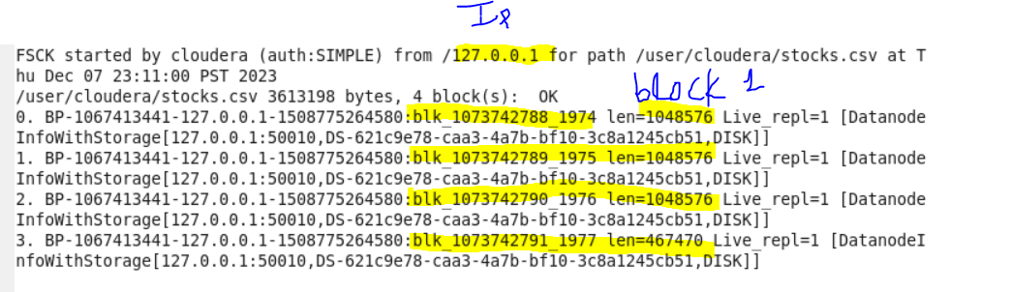

Local file system path to view block-



Find file named hdfs-site.xml

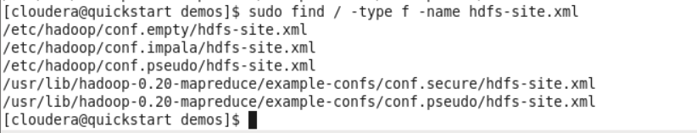

Now Cat

Conf.pseudo/hdfs-site.xml

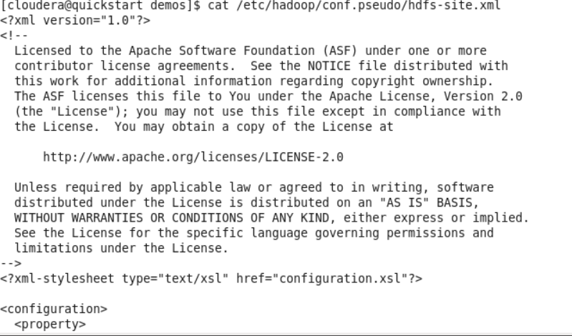

Store output in another file -> temp.txt



Open in gedit

Find name.dir

Copy path as highlighted

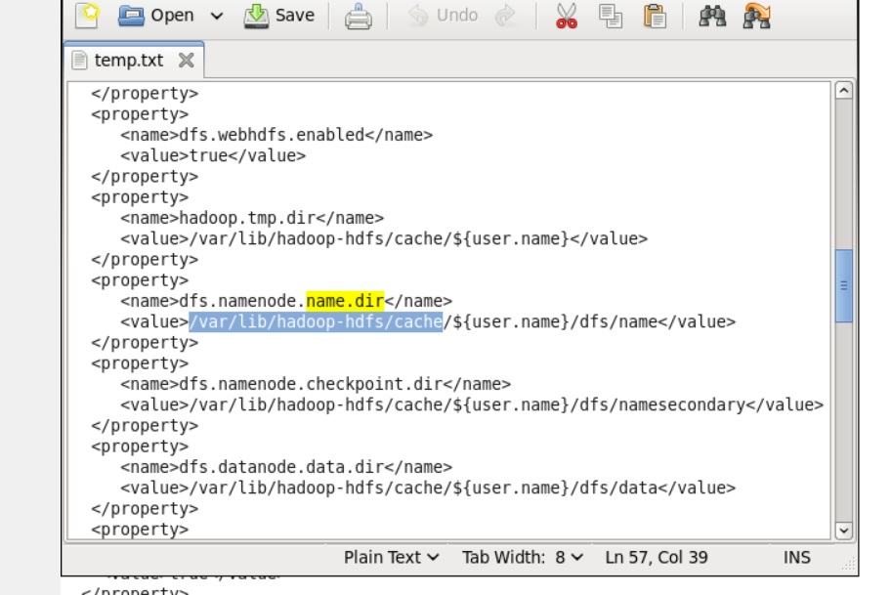

(Ek kaam karo)

Practicing linux commands



From man grep

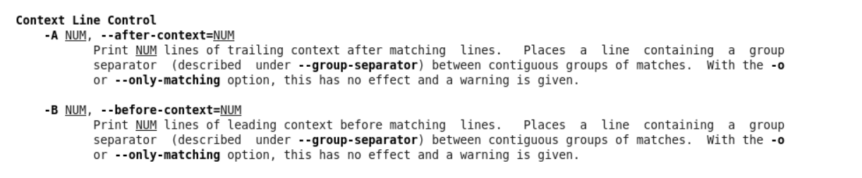

It will search for name ‘name.dir’ and –A 2 will show next 2 lines after the searched content



Using grep command is right way

As the process is happening in memory,consuming less time

But using append command the process is happening physically,thus consuming more time for geting output.