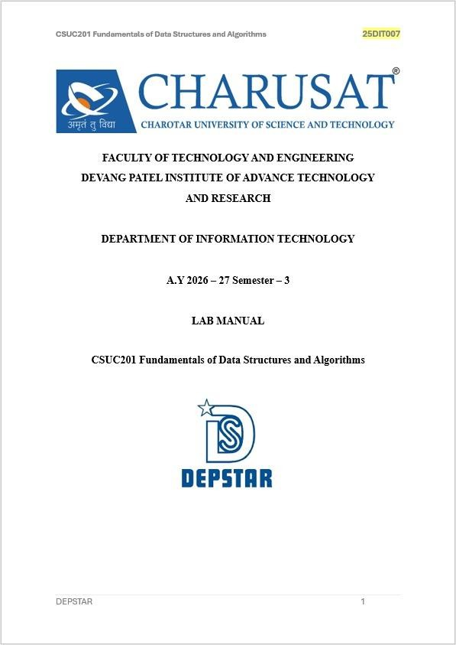

Practical 1: Array Operations: Traversal, Rotation, and Frequency Analysis

Practical Aim
To implement fundamental array operations.

Problem 1
A bakery prepares n items every morning and places them in a display row. At the end of each hour, the leftmost item is moved to the rightmost position to make room for fresh stock at the front. Given the initial row and the number of hours h, print the final display order.
Describe the approach you used. How does it behave when h is very large, say 10 million? Is there a way to get the correct result without performing the operation h times?
SOLUTION:

Practical 1.1

OUTPUT:

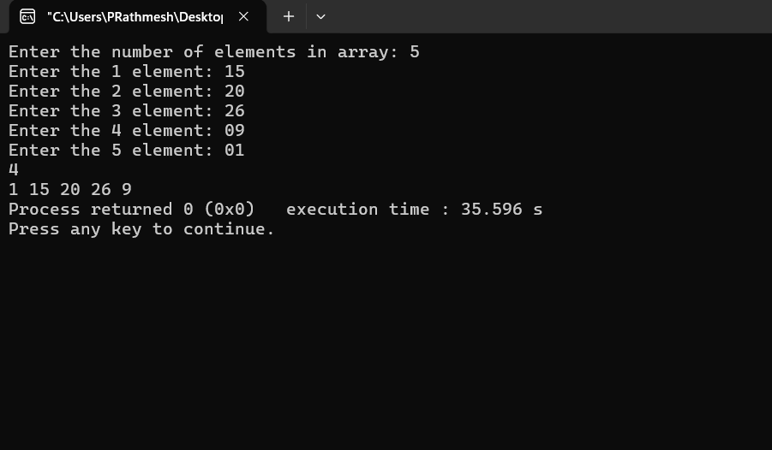
PROBLEM FACED:
While roatating I cannot understand the algorithm.
CONCLUSION:
Get to know about how to perform array rotation efficiently and understood how to avoid unnecessary repeated rotations.

Problem 2
A library issues books to students and records each book's ID every time it is borrowed. At the end of the month, the librarian wants to find all books that were borrowed more than once, as those need priority restocking. Given the borrowing log, print all such book IDs. Describe the approach you used. How many times does your solution scan the data? If the library had 100,000 borrow records, would your approach still be practical? Can you think of a way that requires fewer passes?

SOLUTION:
Practical 1.2

OUTPUT:
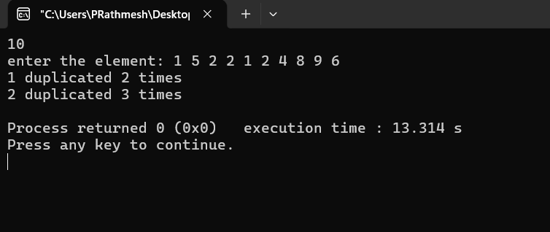

PROBLEM FACED:
I faced difficulty in preventing the same duplicate element from being printed multiple times.

CONCLUSION:
Get to know about how to find repeated elements in an array and understood the importance of reducing the number of passes for better performance.

Problem 3
A school newspaper editor wants to highlight the most impressive word from a submitted article on the front page. The word is chosen simply by length — the longest one wins. Given a sentence, print the winning word and how many letters it has. Describe the approach you used.
What does your solution do when two words have the same length? Is that behavior intentional, and can you think of a way to handle it explicitly?
SOLUTION:
Practical 1.3
OUTPUT:
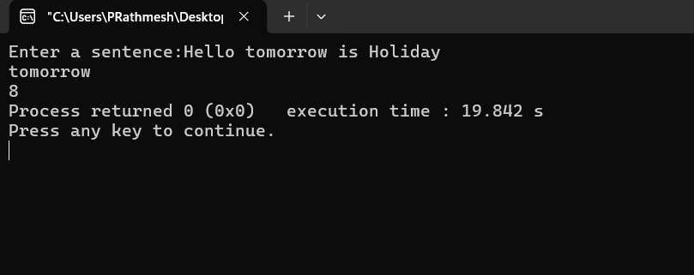

PROBLEM FACED:

while solving pb 3 in this practical, only one word was sub string and rest of was as it is. To solve this issue, I got a logical error that while finding of white space between two word I only choose ‘ ’ as space between two words and completely ignored “\t” that is used for space between two words.

CONCLUSION:
Get to know about how to process a sentence and find the longest word while comparing word lengths and handling ties appropriately.

Key questions:
- Problem 1 – Array Rotation
The display order repeats because there are only n possible rotation positions. After n left rotations, the array returns to its original order. Therefore, the repetition occurs after n hours, regardless of how large h is.
- Problem 2 – Duplicate Book IDs
If a book ID appears three times, it should appear only once in the output because we are finding IDs that occur more than once, not printing every occurrence. We can verify this by testing an input containing the same ID three times and checking that it appears only once in the output.
- Problem 3 – Longest Word
The punctuation should be removed or ignored before calculating the word length. For example, hello, should be treated as hello, so punctuation does not affect the comparison of word lengths.

