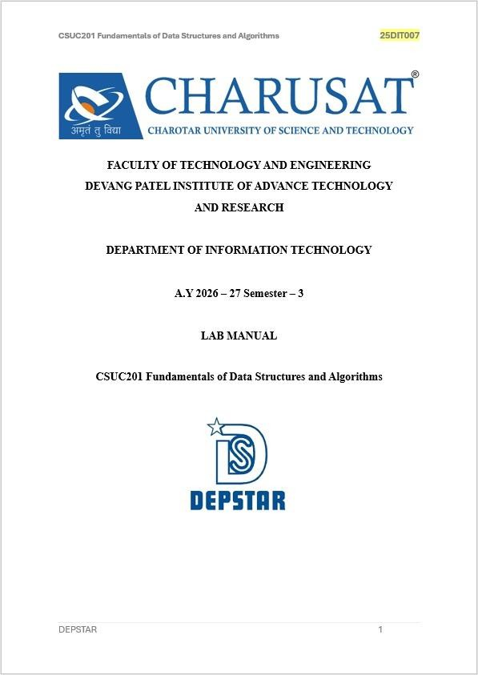

Practical 2: Linear and Binary Search: Iterative and Recursive Approaches

Practical Aim
To implement linear and binary search using both iterative and recursive approaches.

Problem 1
A security guard at a parking lot checks vehicles one by one from the entrance to find a car with a specific license plate. Sometimes he starts from the entrance, sometimes he calls a helper who starts from where the guard left off. Given a list of license plates and a target plate, implement both approaches — one that checks plates one by one from the start, and one where the function calls itself to continue checking — and report the position of the target plate if found. Describe the approach you used.
What happens in your solution if the target plate appears more than once in the list? Does it find the first occurrence, the last, or just any one?
SOLUTION:

Practical 2.1

OUTPUT:

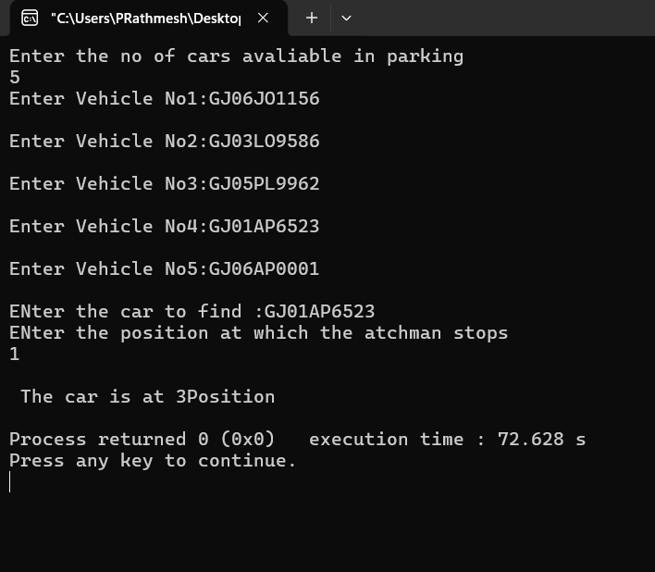

PROBLEM FACED:
Handling the recursive approaches correctly and determining the position when the target plate is found.
CONCLUSION:
Get to know about implementing linear search using both iterative and recursive methods and find the target element's position

Problem 2
A librarian maintains a sorted catalog of book codes and needs to locate a specific code quickly. Instead of going through every book, she opens the catalog to the middle, checks whether the target is to the left or right, and repeats. Given a sorted list of book codes and a target code, implement both approaches — one using a loop and one where the function calls itself — and report the position of the target code.
Describe the approach you used. What is the one condition your input

must satisfy for this approach to work correctly? What would go wrong if that condition was not met?

SOLUTION:

Practical 2.2

OUTPUT:
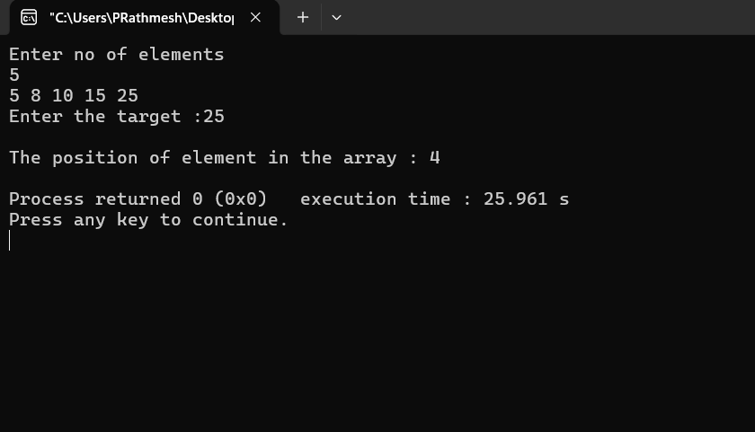

PROBLEM FACED:
while solving pb 2 in this practical, I identified a issue in my algorithm that,if the target element is not there, it goes into infinite loop which makes my solution fails.so to solve this problem I just return -1 at the end of function which indicates that the element is not there and it will break the infinite loop formed due to absence of that element.
CONCLUSION:

Get to know about implementing binary search using iterative and recursive approaches and understood that a sorted list is necessary for correct searching.
Key questions
- Problem 1 – Linear Search
Linear search may need to check every element when the target is near the end. To skip elements, the input needs to have an ordered/sorted property, which allows us to use binary search and reduce the number of comparisons.
- Problem 2 – Binary Search
Binary search requires the list to be sorted. If the list is not sorted, the left/right decision may be incorrect, so the algorithm can miss the target; it may sometimes give the correct answer by chance, but it is not guaranteed.

