Practical 3: Sorting Algorithms: Comparison-Based,Counting-Based, and Digit-Based Strategies

Practical Aim
To implement and compare multiple sorting algorithms and develop the ability to reason about which sorting strategy suits a given situation.

Problem 1
A teacher has a stack of student answer sheets with marks written on them and needs to arrange them in order before entering grades. She tries three different methods: in the first, she repeatedly compares adjacent sheets and swaps them if they are out of order; in the second, she finds the lowest-marked sheet each time and places it at the front; in the third, she picks each sheet one by one and inserts it into its correct position among the already-arranged sheets. Implement all three methods and for each one, print the sorted order of marks.
Describe how each of the three methods works in your own words. If the sheets were already in order before the teacher started, which method would finish the fastest and why?
SOLUTION:

Practical 3.1

OUTPUT:

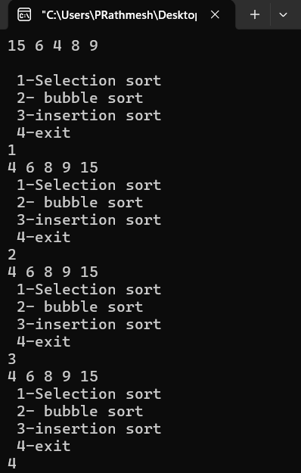

PROBLEM FACED:
while solving pb 1 in this practical, I got stuck in the insertion sorting method. I was confused when the element is greater than some element on left sorted side and smaller than on the end of left sorted side of array. Firstly, I implemented using for loop, but the issue was that I was inserting the value on the wrong position of sorted array.so to overcome this issue I switch to while loop and given the condition that j>=0 && arr[j]>temp then it will move the array and at the end of this loop, it will return the position before where we have to insert our temp element.so simply j+1 will give us the position to insert that chosen element.
CONCLUSION:
Get to know about implementing and compare three comparison-based sorting techniques and understand their behavior on different input arrangements.

Problem 2
A paint shop has buckets labeled with one of three colour codes — 0, 1, or 2 — but they are stored in a random order. The shop owner wants all 0s together, then all 1s, then all 2s, without using any extra storage.
Given the list of colour codes, rearrange them in place and print the result. Describe the approach you used. Does your solution make more than one pass through the list? Can you think of a way to do it in exactly one pass?

SOLUTION:

Practical 3.2

OUTPUT:
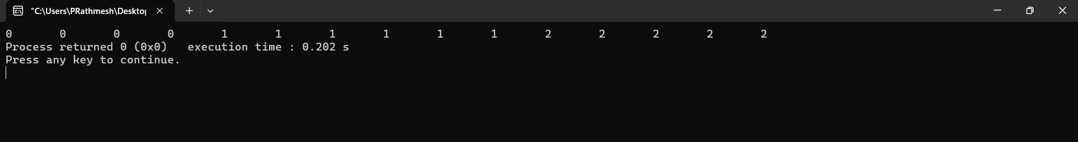

PROBLEM FACED:
Understanding sorting of distinct elements without using comparison
CONCLUSION:
Get to know about How to sort an array containing three distinct values efficiently and understood how the number of passes can be reduced.
Key questions
- Problem 1 – Sorting Algorithms
Answer: Bubble Sort can detect if the list is already sorted by using a swapped flag. If no swaps occur during a complete pass, the algorithm stops early. Selection Sort still searches for the minimum each time, while Insertion Sort naturally processes elements even when no swaps are needed.
- Problem 2 – Sorting 0s, 1s, and 2s
Answer: The second pass is usually forced when the solution first counts the number of 0s, 1s, and 2s and then goes through the array again to place them. It

can be eliminated by using a single-pass three-pointer approach, rearranging elements directly while scanning the array.

