SE LAB ASSIGNMENT
18MCMB13
A JAGADEESH

Problem Statement :
A new building with four storey has provision to install two lifts. Write req, and do arch. Plus HLD including sequence diagram for a single lift in a 4 storey building. Assume suitable data as required . Keep the design open to allow a second lift to be installed in a near future.

Software Requirements :

Functional Requirements :

-> Cab responds to Floor Request
-> Doors must open at requested floor
-> Doors must close automatically
-> Lift should move right after doors close
-> Emergency button must stop the lift
-> Emergency button must ring alarm
-> Floor request buttons lights on
-> Power backup must be provided in case of power loss
-> Direction of the cab moving should be displayed

Non-Functional Requirements :

-> Cab acceleration
-> Floor request order
-> Cabs stop at correct position
-> Cab selection

Sequence Diagram :

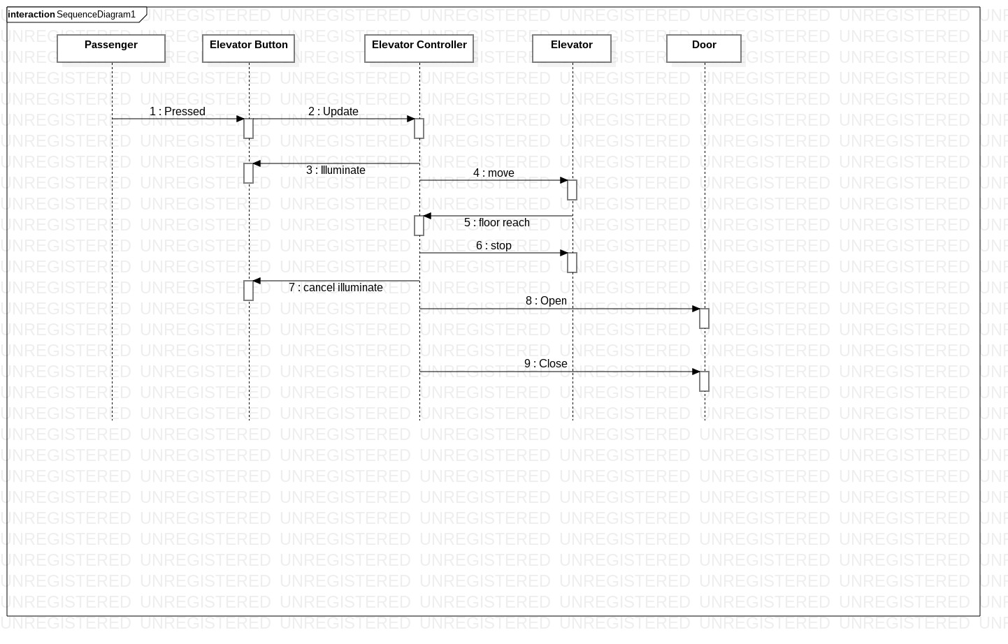

Use Case diagram :

