a

MINI PORJECt REPORT

ON

“DENSITY BASED TRAFFIC CONTROL SYSTEM”
FOR PARTIAL FULFILLMENT
OF THE REQUIREMENTS FOR THE
eMPLOYABILITY SKILLS ANS Mini PROJECT SUBJECT
oF T.E. E&TC – 2015 Course, SPPU, Pune

By
SONAWANE ANIKET PRADIP Exam No.-T150053284
VASEKAR PRATHAMESH R. Exam No.-T150053219

GUIDE:
Prof. L.P.PATIL

Department Of
Electronics and TELECommunication ENGINEERING
PUNE INSTITUTE OF COMPUTER TECHNOLOGY
PUNE – 43

ACADEMIC YEAR: 2020 - 2021

ABSTRACT
Traffic is the major problem which every country faces because of the increase in number of vehicles throughout the world, particularly in large urban areas. As the problem of urban traffic congestion spreads & occurrence of road accidents increase, there is a pressing need for the introduction of advanced technology and equipment to improve the traffic control algorithms to better accommodate this increasing demand. The simplest way for controlling a traffic light is using timer for each phase. Another way is to use electronic sensors in order to detect vehicles and produce signal that cycles. In this paper we propose a system for controlling the traffic light by image processing. The system will detect vehicles through images instead of using electronic sensors embedded in the pavement. A camera will be installed alongside the traffic light. It will capture image sequences. The image sequence will then be analyzed using digital image processing for vehicle detection, and according to traffic conditions on the road, traffic light can be controlled.
Sonawane Aniket Pradip
Vasekar Prathamesh R.

List of figures:

Figure number | Figure caption | Page no.
2.2.1 | Block Diagram of System | 15
2.3.1 | Flow Chart | 16
3.1.1 | MATLAB Circuit | 19
3.1.2 | Proteus Circuit | 20
4.1.1 | GUI of System | 24

Abbreviations

Symbol/word | meaning | Remark
%match Calculate Percentage match of test
Image and reference image.

CONTENTS

 | Abstract |  |  |  |  | 1
 | List of Figures |  |  |  |  | 2
 | List of Tables |  |  |  |  | 3
 | Abbreviations |  |  |  |  | 4
1 | Introduction
 | 1.1 | Background and Context |  |  |  | 6
 | 1.2 | Relevance |  |  |  | 7
 | 1.3 | Literature Survey |  |  |  | 9
 | 1.4 | Motivation |  |  |  | 12
 | 1.5 | Aim of the Project |  |  |  | 13
 | 1.6 | Scope and Objectives |  |  |  | 13
2 | Block Diagram
 | 2.1 | Technical Approach |  |  |  | 14
 | 2.2 | Block diagram |  |  |  | 15
 | 2.3 | Flow chart |  |  |  | 16
 | 2.4 | Hardware / software resources |  |  |  | 18
3 | System Design
 | 3.1 |  | Circuit Diagram |  |  | 19
 | 3.2 |  | Design Calculation |  |  | 22
4 | Implementation, Testing
 | 4.1 |  |  | Implementation |  | 24
 | 4.2 |  |  | Testing and debugging |  | 25
5 | Results and conclusion
 | 5.1 |  |  |  | Results | 27
 | 5.2 |  |  |  | Conclusion | 27
 | 5.3 |  |  |  | Future scope | 28
 | References |  |  |  |  | 29

CHAPTER 1

Introduction

  - Background: -
Nowadays traffic jams and congestion are a common issue because of the day-by-day increment of numerous vehicles. A smart traffic control system can be one of the solutions to the above problem. This can be done by measuring the vehicular density on that road wherein real time image and video processing techniques will be used. The main aim is to coordinate the traffic by keeping a check of its density from all the sides and thereby controlling the traffic signal intelligently. This paper will present an algorithm so as to determine the number of vehicles on that road. This density counting algorithm will work by the comparison between one frame of the live video (real time) and the reference image followed by looking for the vehicles in the desired region. The 0traffic signal will be controlled smartly by comparing the vehicle density and the direction of the traffic.

  - Relevance: -
Many types of traffic control systems have been introduced in order to find the density of vehicles on road. A system in which the total size of the traffic can be calculated using image processing methods is discussed in.
Another similar system proposed controls traffic lights using image processing techniques which can be implemented in real time.
A web camera is used at each stage of the traffic light to record images of the traffic lane we have selected. These captured images are then compared to a reference image of the empty road by image matching process. Canny edge detection method is used to determine the boundaries of the images. Here, the traffic is controlled depending on the percentage of match between the images. There are many papers based on edge detection methods.
Another system uses a video camera to capture images of the road and make use of that data to control traffic signals.
Instead of finding the total number of vehicles, they determine the traffic density corresponding to the total area occupied by vehicles on the road with respect to the total amount of pixels in one video frame.
In , a similar approach for traffic control system is also proposed. Manual controlling refers to controlling traffic with the help of manpower. Traffic police are allotted to a specified area to control traffic. Controlling traffic signals using timers and electrical sensors is known as automatic controlling. In this method, a constant numerical value is uploaded into the timer at each phase of the traffic light. According to the changes in the timer value, the traffic lights automatically become ON or OFF. The electrical sensors check for the presence of vehicles on the road and provide appropriate signals at each phase, which controls the automatic switching off lights. The manual controlling system requires tremendous manpower for implementation. Since the number of traffic police is limited and making them do this sort of work in the hot tropical areas is cruel. We need to find a better method to control traffic in the cities. In automatic traffic controlling system, the traffic light is controlled by timers at every stage or by using electronic sensors to detect the presence of vehicles. But in these methods, time could be wasted in showing a green signal when there are no vehicles at all. We can get over these limitations by controlling traffic lights with the help of image processing techniques. Our proposed system controls traffic lights using image processing techniques. Here, the vehicles are detected by considering the captured images instead of using timers or electronic sensors which are placed on the pavement. A web camera is placed at the traffic light which captures images of the road through which the vehicle count is estimated and traffic is controlled. Using image processing in traffic control is found to be a better technique than the existing methods. It helps decrease traffic congestion without any wastage of time caused by showing green signal on an empty road without any vehicles. It is a better way to determine the presence of vehicles since it makes use of real-time images which makes it better than systems depending on the vehicle’s metal content only.

  - Literature Survey: -
TRAFFIC LIGHT SYSTEMS: -
A traffic light system is an electronic device that assigns right of way at an intersection or crossing or street crossing by means of displaying the standard red, yellow and green colored indications. A traffic light, also known as traffic signal, stop light, stop-and-go lights, is a signaling device positioned at a road intersection, pedestrian crossing, or other location in order to indicate when it is safe to drive, ride, or walk using a universal color code (and a precise sequence, for that are colors blind).
Nowadays, a red light meant traffic in all directions had to stop. A yellow light meant cross-town traffic would have to slow and a green light would to go or proceed. The development of an intelligent control structure ensures an optimal solution for all participants in the transportation and road traffic system. There are different ways controlling road intersections. In the simplest cases the right-hand rule or if the traffic is higher, a roundabout or the signal of a policeman can help steer the traffic. However, especially in big cities, in the complicated cases when the roads in the intersection have several lanes, the use of traffic lights cannot be avoided. An additional issue arises when in the intersection not only roads but also railroad tracks take part, what often occurs in suburban traffic situations. The most common way to handle this type of intersection is the conventional cyclic lights control. In more enhanced control, the traffic in different directions is monitored by sensors and the signals thus obtained control the traffic lights. In this method the control is adapting to the traffic. The general problem is the huge number of variables and the need for large computing efforts. To simplify this problem a possible way is the use of fuzzy techniques. In the last couple of years, a lot of simulations were done, and also practical control systems were built based on simple fuzzy rules. However, in the most complicated cases where the numbers of lanes are large and maybe not only one but more road intersections and railroad take part, it does make sense to use fuzzy methods containing hierarchy and apply interpolation to decrease the complexity.
Benefit of Traffic Light Controller:
I. Provide orderly movement of traffic.
II. Minimize completing movement.
III. Coordinated for continuous movement.
This belief has led to traffic control signals being installed at many locations where they are not needed, adversely affecting the safety and efficiency of vehicular, bicycle, and pedestrian traffic. Traffic control signals, even when justified by traffic and roadway conditions, can be ill-designed, ineffectively placed, improperly operated, or poorly maintained. While traffic signals can help in locations where they are justified and installed properly, they also have disadvantages. There will always be some disadvantages even if the signal is justified.
Types of Traffic Signals Components and Operations:
Nowadays most traffic signals will have the following components or part:
- Main display with red, yellow and green lights.
- Traffic signal cabinet containing the traffic signal controller and Vehicle Detection Systems
- Inductive loops or sensors in the many cities, traffic signals mainly operate in three modes:
- Fixed-time mode: Under this mode, there are no detections for any approach. The signal continuously cycles regardless of actual traffic demand. Pedestrians walk signals are automatic and will cycle concurrently with the vehicular signal indication.
- Semi-Actuated mode: Under this mode, the detection system is present only on a minor cross-street. When detection is activated, the green light on a major street is interrupted to allow the minor street traffic and pedestrians to safely enter the intersection. Pedestrians walk signals for crossing a minor street are automatic, while those for crossing a major street are not. Pedestrians crossing a major street must push the “pedestrian push button” to get the walk signal.
- Actuated mode: Under this mode, there are detections for all approaches. The traffic signal is set to provide the green light “on demand” or only in the presence of vehicles.

  - Motivation:
Traffic is the major problem which every country faces because of the increase in number of vehicles throughout the world, particularly in large urban areas. As the problem of urban traffic congestion spreads & occurrence of road accidents increase, there is a pressing need for the introduction of advanced technology and equipment to improve the traffic control algorithms to better accommodate this increasing demand. The simplest way for controlling a traffic light is using timer for each phase. Another way is to use electronic sensors in order to detect vehicles, and produce signal that cycles. In this paper we propose a system for controlling the traffic light by image processing. The system will detect vehicles through images instead of using electronic sensors embedded in the pavement. A camera will be installed alongside the traffic light. It will capture image sequences. The image sequence will then be analyzed using digital image processing for vehicle detection, and according to traffic conditions on the road, traffic light can be controlled.

  - Aim of the Project:
To overcome from the major traffic issues that we are facing in our day-to-day life. To reduce the manpower in traffic scenarios.

  - Scope and Objectives:
General Objectives:
The general objectives of this project are:
To develop an integrated traffic light control system based on image processing to calculate the density of vehicle on the road and set the timer.
Specific Objectives:
i. To select the appropriate image enhancement and edge detection techniques useful for the vehicle detection & density computation
ii. To implement the image processing techniques & simulate the result
iii. To integrate the image processing part with the traffic light system

CHAPTER 2
Description of Project
2.1 Technical Approach: -
1)We went to find the best tools to detect images and process them so we preferred Matlab environment.
2) Among the key features of an image i.e., edges, lines, and points. We have used edge in our present work which can be detected from the abrupt change in the gray level. An edge essentially demarcates between two distinctly different regions, which means that an edge is the border between two different regions i.e., the edge of the cars in our case. Edge detection methods locate the pixels in the image that correspond to the edges of the objects (cars) seen in the image.
The result is a binary image with the detected edge pixels. Common algorithms used are Sobel Edge Detection Technique, Perwitt Edge Detection, Roberts Edge Detection Technique, Zero cross Threshold Edge Detection Technique and Canny Edge Detection Technique.
In our project we used Canny Edge Detection Technique because of its various advantages over other edge detection techniques. Canny edge detection gives better result as compared to others with some positive points. It is less sensitive to noise, adaptive in nature, resolved the problem of streaking, provides good localization, and detects sharper edges as compared to others. It is considered as optimal edge detection technique hence lot of work and improvement on
this algorithm has been done and also further improvements are possible.
3) Edge based matching is the process in which two representatives (edge) of the same objects are paired together. Any edge or its representation on one image is compared.
and evaluated against all the edges on the other image. Edge detection of reference and the real time images has been done using canny edge detection technique. Then this edge detected images are matched and accordingly the traffic light durations can be set.
We have used an approach of comparing a reference image with the real time image pixel by pixel. Though there are some disadvantages related to pixel-based matching but it is one of the best techniques for the algorithm which is used in the project for decision making. Real image is stored in matric in memory and the real time image is also converted in the desired matric. For images to be same their pixel values in matrix must be same. This is the simplest fact used in pixel matching. If there is any mismatch in pixel value it adds on to the counter used to calculate number of pixel mismatches. Finally, percentage of matching is expressed as
% match=No. of pixels matched successfully/ total no. of pixels

4)Next thing was to design the interface to display vehicle density on different lanes and its calculated match with respective timing for which we had options of choosing between graphical user interface and circuit simulation as hardware implementation of this was not possible due to covid, and serial communication between hardware circuit and Matlab was not so efficient we made graphical user interface for our project.
2.2 Block diagram:-
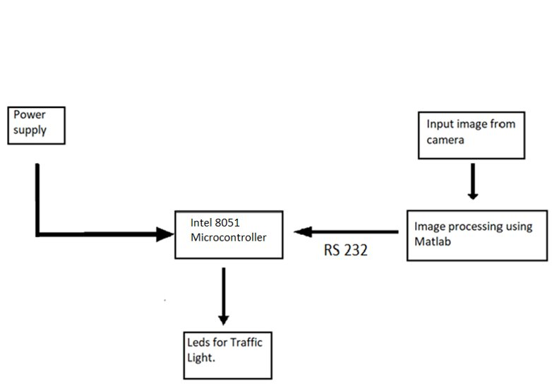
Fig. 2.2.1. Block Diagram

1) 8051 is processor used to input from Matlab as well as output the results to traffic lights by controlling the lights as required.
2) Power supply drives the microcontroller.
3) Matlab is main software used to detect and process images as well as used for decision making it inputs camera images and processes for every lane and determines which lane has highest traffic and determines its signal duration which then is given to 8051 which uses Matlab result to drive the traffic lights accordingly.
2.3 Flow chart: -
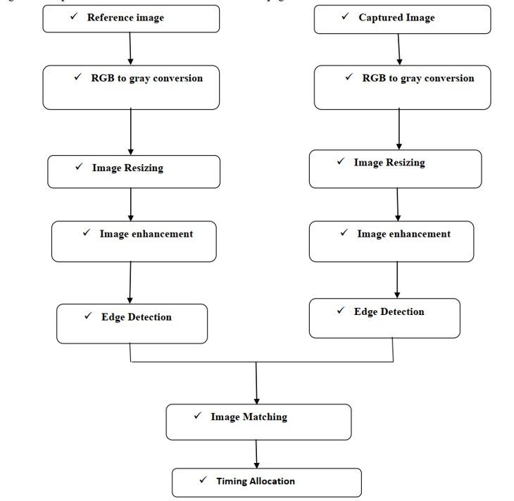
Fig. 2.3.1Flow Chart

Following are the generalized main steps involved in the image processing: -
1] Image acquisition
2] RGB to gray conversion
3] Image enhancement
4] Image matching using edge detection
Explanation: -
1) Lane without any car is taken as reference image.
2) Live image is captured/provided to the software.
3) Reference image and captured image are process in sequence first converted into gray image then image enhanced and edge detection is performed on each image from that both images are compared.
4) Compared images percentage calculated and accordingly signal timing is allocated.
5) Above process is done for all the four lanes/or any other numbers of lanes. And lane with most traffic is given preference for clearance.

2.4 Hardware / software resources
Software: -
- Matlab.
- Proteus 8.
- Keil M vision 5.
Libraries: -
- Canny algorithm.
- Image Processing toolbox.
- Graphical user interface (Guide)
Hardware: -

1. INTEL 8051 MICROCONTROLLER.

2. 7-SEGMENT DISPLAY

3. TRAFFIC LIGHTS

4. PULL UP RESISTORS

CHAPTER 3
System Design
3.1 Circuit diagram: -
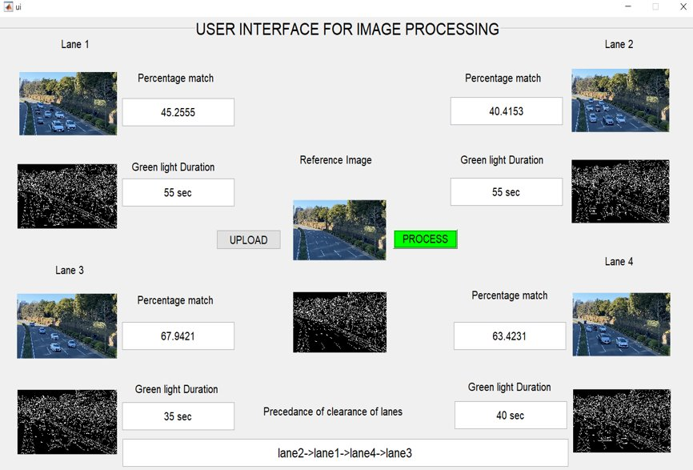
Fig. 3.1.1 (Matlab circuit)

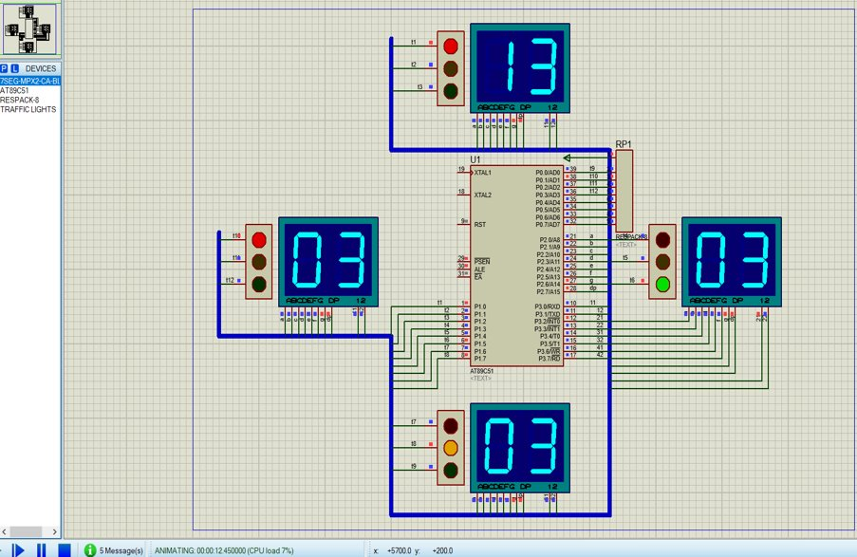
Fig. 3.1.2 (proteus circuit)
1)Image Acquisition: -
The first stage of any image processing operation is the image acquisition stage. After the image has been obtained, various methods of processing can be applied to the image to perform the many different tasks required today. However, if the image has not been acquired satisfactorily then the intended tasks may not be achievable, even with the aid of some form of image enhancement. Digital image acquisition is the creation of digital images, typically from a physical scene. The term is often assumed to imply or include the processing, compression, storage, printing, and display of such images. The most usual method is by digital photography with a digital camera but
other methods are also employed.
2)RGB to Gray Conversion: -
In photography and computing, a grayscale or grayscale digital image is an image in which the value of each pixel is a single sample, that is, it carries only intensity information. Images of this sort, also known as black-and-white, are composed exclusively of shades of gray, varying from black at the weakest intensity to white at the strongest. Grayscale images are distinct from one-bit bi-tonal black and-white images, which in the context of computer imaging are images with only the two colors, black, and white (also called bi-level or binary images). Grayscale images have many shades of gray in between. Grayscale images are
also called monochromatic, denoting the presence of only one (mono) color (chrome).
3)Edge Detection: -
Edge detection is a fundamental tool in image processing and computer vision, particularly in the areas of feature detection and feature extraction, which aim at identifying points in a digital image at which the image brightness changes sharply or, more formally, has discontinuities. The same problem of finding discontinuities in 1D signal is known as step detection. The purpose of detecting sharp changes in image brightness is to capture important events and changes in properties of the world. It can be shown that under rather general assumptions for an image formation model, discontinuities in image brightness are likely to correspond to, Discontinuities in depth, Discontinuities in surface orientation, Changes in material properties and Variations in scene illumination.
In the ideal case, the result of applying an edge detector to an image may lead to a set of connected curves that indicate the boundaries of objects, the boundaries of surface markings as well as curves that correspond to discontinuities in surface orientation. Thus, applying an edge detection algorithm to an image may significantly reduce the amount of data to be
processed and may therefore filter out information that may be regarded as less relevant, while preserving the important structural properties of an image. If the edge detection step is successful, the subsequent task of interpreting the information contents in the original image may therefore be substantially simplified. However, it is not always possible to obtain such ideal edges from real life images of moderate complexity. Edges extracted from non-trivial images are often hampered by fragmentation, meaning that the edge curves are not connected, missing edge segments as well as false edges not corresponding to interesting phenomena in the image
– thus, complicating the subsequent task of interpreting the image data.

4)Image Matching: -
Edge based matching is the process in which two representatives of the same objects are paired together. Any edge or its representation on one image is compared and evaluated against all the edges on the other image. Edge detection of reference and the real time images has been done using Prewitt operator. Then this edge detected images are matched and
accordingly, the traffic light durations can be set.

3.2 Design calculation:
Image matching:
Edge based matching is the process in which two representatives (edge) of the same objects are paired together. Any edge or its representation on one image is compared 14 and evaluated against all the edges on the other image. Edge detection of reference and the real time images has been done using canny edge detection technique. Then this edge detected images are matched and accordingly the traffic light durations can be set. We have used an approach of comparing a reference image with the real time image pixel by pixel. Though there are some disadvantages related to pixel-based matching but it is one of the best techniques for the algorithm which is used in the project for decision making. Real image is stored in matric in memory and the real time image is also converted in the desired matric. For images to be same their pixel values in matrix must be same. This is the simplest fact used in pixel matching. If there is any mismatch in pixel value it adds on to the counter used to calculate number of pixel mismatches. Finally, percentage of matching is expressed as

%match = No. of pixels matched successfully
total no. of pixels

After edge detection procedure both reference and real time images are matched and traffic lights can be controlled based on percentage of matching.: -
  - If the matching is between 0 to 5% - green light is on for 100 seconds.
  - If the matching is between 5 to 10% - green light is on for 95 seconds.
  - If the matching is between 10 to 15% - green light is on for 90 seconds.
  - If the matching is between 15 to 20% - green light is on for 85 seconds.
  - If the matching is between 20 to 25% - green light is on for 80 seconds.
  - If the matching is between 25 to 30% - green light is on for 75 seconds.
  - If the matching is between 30 to 35% - green light is on for 70 seconds.
  - If the matching is between 35 to 40% - green light is on for 65 seconds.
  - If the matching is between 40 to 45% - green light is on for 60 seconds.
  - If the matching is between 45 to 50% - green light is on for 55 seconds.
  - If the matching is between 50 to 55% - green light is on for 50 seconds.
  - If the matching is between 55 to 60% - green light is on for 45 seconds.
  - If the matching is between 60 to 65% - green light is on for 40 seconds.
  - If the matching is between 65 to 70% - green light is on for 35 seconds.
  - If the matching is between 70 to 75% - green light is on for 30 seconds.
  - If the matching is between 75 to 80% - green light is on for 25 seconds.
  - If the matching is between 80 to 85% - green light is on for 20 seconds.
  - If the matching is between 85 to 90% - green light is on for 15 seconds.
  - If the matching is between 90 to 95% - green light is on for 10 seconds.
  - If the matching is between 95 to 100% - green light is on for 5 seconds.

CHAPTER 4
Implementation and Testing
4.1 Implementation:
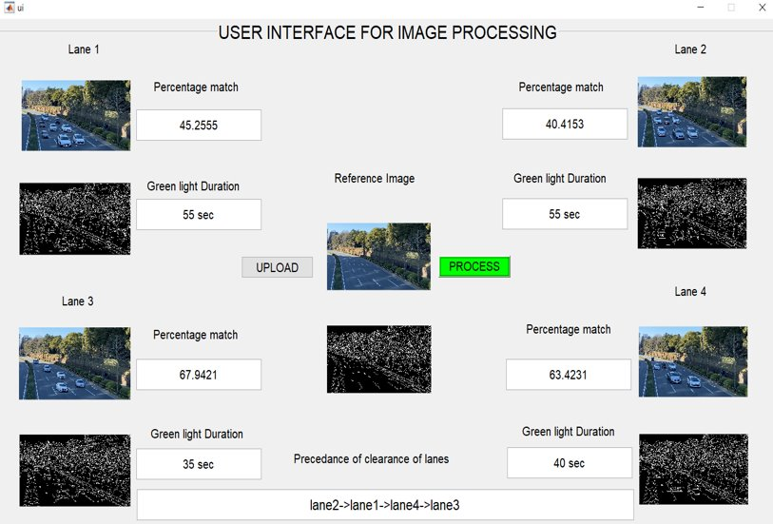Fig.4.1.1 UI for Image Processing

Above is a user interface for image Processing in which each image is compared with the reference image and we get the percentage match. It also shows the green light duration for each lane required. It also displays the precedence of clearance of road means which lane would go first.

4.2 Testing and debugging
Problems:
1) While giving inputs of images through gui it did not accept the images from 9 onwards it did not accepted those images and some other random images from 0-9 were uploaded.
Solution-By changing names of images which was not excepted by Matlab
Eg : traffic10.jpg was not accepted which was later changed to traffica.jpg
2) Unable to use global variables for inside different call back functions.
Solution- use global a; inside every function and that variable will be accessible inside that function.

CHAPTER 5
Results and conclusion
5.1 Results: -
As we can see the output of GUI given above clearly indicates the implemented results of the algorithm designed. The matching gives a good result in every cases. It displays the timing for the
4 junctions accordingly. It showed matching depending on the percentage of the edge detected.
1) Matched percentage of each detected images is displayed
2) From this percentage we can determine that the lane having least matched percentage with reference image (clear lane) have the highest traffic density.
3) From the matched percentage further, green light time is allocated for each lane according to percentage match.
4) And accordingly, all lanes are cleared without much time wasted.

5.2 Conclusion: -
Traffic control using image processing” technique that we propose overcomes the limitations of the earlier (in use) techniques used for controlling the traffic. Earlier in automatic traffic control use of timer had a drawback that the time is being wasted by green light on the empty. The technique we proposed avoids this problem. Upon comparison of various edge detection algorithms, it was inferred that Canny Edge Detector technique is the most efficient one. The project demonstrates that image processing is a far more efficient method of traffic control as compared to traditional techniques. Also, it is more effective than the density-based system based on since it is cost effective and less prone to error. The use of our technique removes the need for extra hardware such as sound sensors & magnetic loop embedded in pavements. The major advantage is the variation in signal time which control appropriate traffic density using Image matching. The accuracy in calculation of time due to single moving camera depends on the registration position while facing road every time. Output of GUI clearly indicated some expected results. It showed matching in almost every interval that were decided as boundaries like 10%, 35%, 68% etc. The study showed that image processing is a better technique to control the state change of the traffic light. It shows that it can reduce the traffic congestion and avoids the time being wasted by a green light on an empty road. It is also more consistent in detecting vehicle presence because it uses actual traffic images. It visualizes the reality so it functions much better than those systems that rely on the detection of the vehicles’ metal content. Overall, the system is good but it still needs improvement to achieve a hundred percent accuracy. The hardware implementation would enable the project to be used in real-time practical conditions. In addition, we propose a system to identify the vehicles as they pass by, giving preference to emergency vehicles and assisting in surveillance on a large scale. The handling of emergency with the help of assigning priority has an advantage since safety human is maintained.

5.2.1 Future Scope:
- Now as we are only monitoring the number of vehicles present at the signal, we can also use this method to monitor the number plate of the vehicle to detect the vehicles which disobey the traffic laws.
- We can also monitor the traffic at night since no patrol team would be required and the vehicles can run smoothly.

References

- Kastrinaki, M. Zervakis, and K. Kalaitzakis, "A survey of video processing techniques for traffic applications, “Image and Vision Computing, vol. 21, pp. 359-381, Apr 1 2003.
- Choudekar P, Banerjee S, Muju M.K, “Implementation of image processing in real time traffic light control” International Conference on Electronics Computer Technology, vol.2, pp.94 -98, 2011.
- Digital image processing by Rafael C. Gonzalez and Richard E. Wo
- Ms.PromilaSinhmar, “Intelligent Traffic Light and Density Control using IR Sensors and Microcontroller”, International Journal of Advanced Technology & Engineering Research (IJATER) ISSN NO: 2250-3536 VOLUME 2, ISSUE 2, March 2012.
- Ahmed S. Salama, Bahaa K. Saleh, Mohamad M. Eassa, “Intelligent Cross Road Traffic Management System (ICRTMS),” 2nd Int. Conf. on Computer Technology and Development, Cairo, Nov 2010, pp. 27-31
- N. J. Ferrier, S. M. Rowe, A. Blake, “Real-time traffic monitoring,” Proceedings of the Second IEEE Workshop on Applications of Computer Vision, pp.81 -88, 1994.

