To submit TMA01, you need to convert your final notebooks into Word format, and create a zip file containing the Word document and the notebooks.

As described in the section “Submitting your completed TMA” in the TMA01 guidance, you will need to run the notebook makeDocx.ipynb.

In order for this notebook to run successfully, you will need a couple of extra steps. You **must** carry out the following before attempting to create your final zip file for submission.

1. Install pandoc.

pandoc is document conversion module which is used to convert the notebooks to Word format. To install it on your virtual machine, you must execute:

!sudo apt-get –y install pandoc

in a notebook cell. For example:

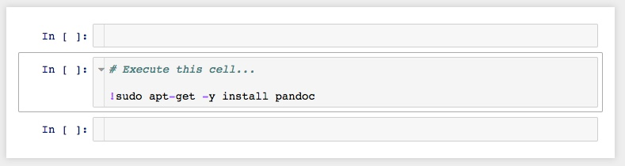

You only need to do this once, but until you do, your final notebook will not run.

1. In each notebook in which you intend to write some python code (which will be questions 2 and 3), you will need to enter an additional cell which alters the way the pandas dataframes are displayed.

In notebook 2016J_TMA01_q2.ipynb and 2016J_TMA01_q3.ipynb, you should add the following cell before any other cells containing python code:

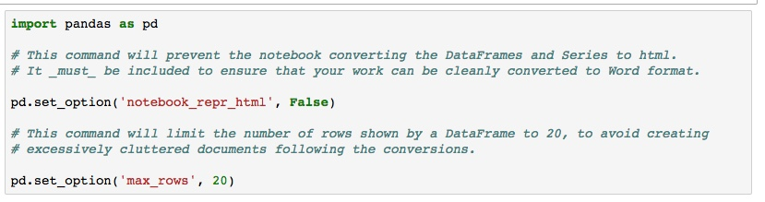

(of course, you do not need to enter the comments; just the pandas import and the two calls to pd.set_option)

This has the unfortunate effect of making the dataframes much less attractive, but the normal dataframe display doesn’t appear to render correctly when converted to Word.

1. Finally, you need to replace the file makeDocx.ipynb with the file:

makeDocx_UPDATE.ipynb

which is available on the Assessment Resources website.

Thank you for taking these extra steps, which we are doing to make the module go as smoothly as possible for you and your tutors.

Alistair Willis

(on behalf of the TM351 module team).