Ecommerce Sales Dashboard
Excel Dashboard Project | Sales, Quantity & Profit Analysis (2022-2024)

1. Key Business Questions (KPIs)
Before building the dashboard, the following business questions were defined to guide the analysis:
- Which products generate the highest total sales and total quantity sold?
- How do sales trends change month-by-month across the year?
- Which region contributes the highest profit, and how is profit distributed across regions?
- How does performance differ across product categories - Accessories, Electronics, and Office?
- How have sales, quantity, and profit changed year-over-year from 2022 to 2024?
- Which months consistently show low or high sales, indicating seasonal patterns?

2. Process & Methodology
Step 1: Data Collection
Raw transactional data was used, containing Order Date, Product Name, Category, Region, Quantity, Sales, and Profit across 3,500 records spanning January 2022 to December 2024.
Step 2: Data Cleaning & Preparation
The data was checked for consistency in date formats, category labels, and numeric fields before analysis.
Step 3: Pivot Table Analysis
Multiple PivotTables were created to summarize Sales, Quantity, and Profit by Product, Month, and Region.
Step 4: Dashboard Design
PivotCharts (Column, Bar, Line, Doughnut) were built from the PivotTables, and an Order Date Timeline and Category Slicer were added for interactive filtering.
Step 5: Insight Generation
Each year (2022, 2023, 2024) was filtered individually across each category to identify top-performing products, seasonal trends, and top-profit regions.

3. Dashboard Overview
The dashboard provides a single-page interactive view of overall e-commerce performance, filterable by Order Date (Year) and Category.
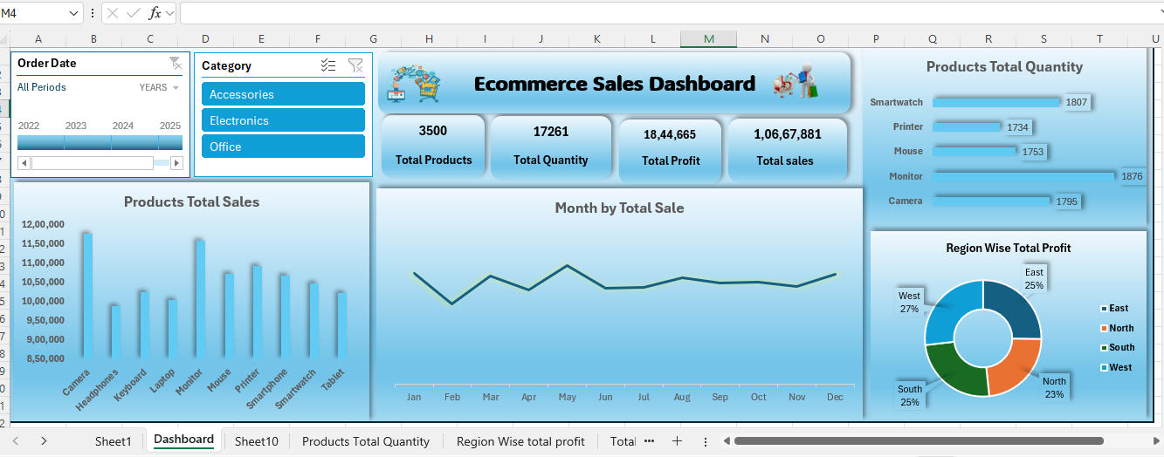
Fig 1: Overview Dashboard - All Years, All Categories
3,500  Total Products | 17,261  Total Quantity | 18,44,665  Total Profit | 1,06,67,881  Total Sales

4. Insights
2022
Accessories: Keyboard led total sales, while Mouse had the highest quantity sold. July recorded the lowest sales, picking up in August, with another peak in May. East Zone earned the highest profit share (27%).
Electronics: Camera led total sales and Tablet led total quantity. Sales dipped in February and peaked in October. East Zone had the highest profit.
Office: Printer (the only product) saw strong sales in May, with East Zone generating the highest profit.
2023
Accessories: Monitor led total sales, with a peak season across July-September. Mouse and Monitor recorded nearly equal quantity sold. West Zone had the highest profit.
Electronics: Camera led both total sales and total quantity. Sales peaked in August and dropped to the lowest in October. West and East Zones tied for the highest profit.
Office: Printer sales were lowest in April and highest in November, with South Zone leading in profit.
2024
Accessories: Monitor led total sales and quantity (666 units), with a May sales peak. West and East Zones tied for the highest profit.
Electronics: Camera and Smartphone led sales, with a strong March-May stretch. Smartwatch led total quantity, and West Zone had the highest profit.
Office: Printer sales rose in March, dipped in April-May, then recovered strongly from July through October, with East Zone leading in profit.
Overall Takeaway
Across all three years, Camera and Monitor consistently emerged as top-performing products in Electronics and Accessories respectively, while East and West Zones alternated as the leading profit-generating regions. Sales showed a recurring seasonal dip mid-year (July/October) across categories, useful for planning inventory and promotions.

5. Conclusion
This dashboard turned three years of raw transactional data (2022-2024) into a single, interactive view of e-commerce performance. Filtering by year and category consistently highlighted Camera and Monitor as the strongest products in Electronics and Accessories, while Printer remained the steady performer in Office. Profit leadership shifted over time - from East Zone in 2022, to West Zone in 2023-2024 - suggesting changing regional demand that could guide future stock allocation and marketing focus.
The recurring mid-year sales dip (July/October depending on category) points to a seasonal pattern worth planning around, whether through targeted promotions or inventory adjustments ahead of those months.
Overall, the project demonstrates how PivotTables, PivotCharts, and slicers/timelines in Excel can be combined to build a decision-ready dashboard - allowing quick, filtered insights without needing to touch the raw data directly. As more data becomes available (including 2025), the same structure can be extended without redesigning the dashboard.
Prepared as part of an Excel Data Analytics portfolio project.

