Q21. Write a VB.NET program to create a table Patient (Pid, PName, Contact_No, Disease). Insert records into table and display appropriate message in message box. (Use MS Access to create db)

Imports System.Data.OleDb

Public Class Patient

Dim con As OleDbConnection

Dim da As New OleDb.OleDbDataAdapter

Dim ds As New DataSet

Dim DbProvider As String

Dim DbSource As String

Dim query As String

Dim cmd As New OleDb.OleDbCommand

Private Sub Form1_Load(ByVal sender As System.Object, ByVal e As System.EventArgs) Handles MyBase.Load

con = New OleDbConnection("Provider=Microsoft.Jet.OLEDB.4.0;Data Source=C:\Users\Dell\OneDrive\Documents\Database4.mdb")

con.Open()

query = "Select * from Patient"

da = New OleDb.OleDbDataAdapter(query, con)

da.Fill(ds, "pat")

DataGridView1.DataSource = ds.Tables("pat")

End Sub

Private Sub Button1_Click(sender As Object, e As EventArgs) Handles Button1.Click

Dim x As Integer

Try

query = "insert into Patient values(" & CInt(TextBox1.Text) & ",'" & TextBox2.Text & "',' " & TextBox3.Text & " ', ' " & TextBox4.Text & " ')"

cmd = New OleDb.OleDbCommand(query, con)

x = cmd.ExecuteNonQuery()

If (x) Then

MsgBox("Data Inserted")

Else

MsgBox("data Not inserted")

End If

Catch ex As Exception

MsgBox(ex)

End Try

ds.Tables.Clear()

query = "Select * from Patient"

da = New OleDb.OleDbDataAdapter(query, con)

da.Fill(ds, "Patient")

DataGridView1.DataSource = ds.Tables("Patient")

End Sub

End Class

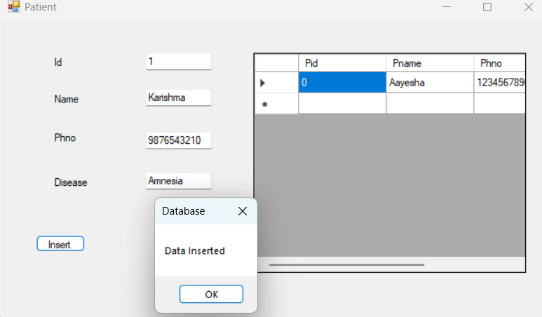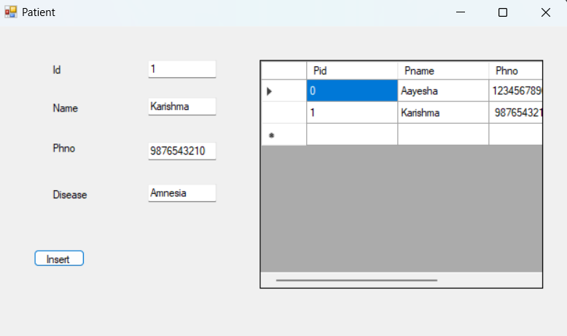

Q22. Write a VB.NET program to create a table Employee (Eid, EName, Designation, doj). Insert records into table and display it in GridView. (Use SQLServer to create db)

Imports System.Data.SqlClient

Public Class Emp

Dim cn As SqlConnection

Dim cmd As SqlCommand

Dim str As String

Dim ad As SqlDataAdapter

Dim ds As New DataSet

Private Sub Button1_Click(sender As Object, e As EventArgs) Handles Button1.Click

cn = New SqlConnection("Data Source=(LocalDB)\MSSQLLocalDB;AttachDbFilename=C:\Users\Dell\source\repos\Database\Database\Database2.mdf;Integrated Security=True")

cn.Open()

str = New String("Insert into Emp values(" & CInt(TextBox1.Text) & ", '" & TextBox2.Text & "', '" & TextBox3.Text & "', '" & TextBox1.Text & "')")

cmd = New SqlCommand(str, cn)

cmd.ExecuteNonQuery()

MsgBox("Record inserted!")

cn.Close()

End Sub

Private Sub Button2_Click(sender As Object, e As EventArgs) Handles Button2.Click

cn = New SqlConnection("Data Source=(LocalDB)\MSSQLLocalDB;AttachDbFilename=C:\Users\Dell\source\repos\Database\Database\Database2.mdf;Integrated Security=True")

cn.Open()

str = "Select * from Emp"

ad = New SqlDataAdapter(str, cn)

ad.Fill(ds, "Emp")

DataGridView1.DataSource = ds

DataGridView1.DataMember = "Emp"

cn.Close()

End Sub

End Class

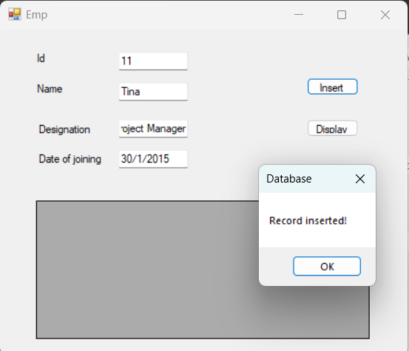

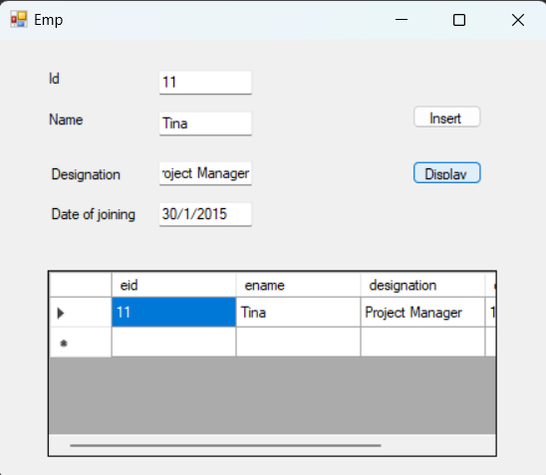

Q23. Write a VB.NET program to create a table student (RollNo ,SName, Class). Insert the records (Max: 5). Update class of students to ‘TYBCA’ whose class is ‘SYBCA’ and display updated records in GridView. (Use MS Access to create db)

Imports System.Data.OleDb

Public Class Tybca

Dim cn As OleDbConnection

Dim cmd As OleDbCommand

Dim str As String

Dim da As OleDbDataAdapter

Dim ds As New DataSet

Private Sub Button1_Click(sender As Object, e As EventArgs) Handles Button1.Click

cn = New OleDbConnection("Provider=Microsoft.Jet.OLEDB.4.0;Data Source=C:\Users\Dell\OneDrive\Documents\Database4.mdb")

cn.Open()

str = New String("insert into Student values(" & CInt(TextBox1.Text) & ",'" & TextBox2.Text & "','" & TextBox3.Text & "')")

cmd = New OleDbCommand(str, cn)

cmd.ExecuteNonQuery()

MessageBox.Show("Record inserted successfully")

End Sub

Private Sub Button2_Click(sender As Object, e As EventArgs) Handles Button2.Click

cn = New OleDbConnection("Provider=Microsoft.Jet.OLEDB.4.0;Data Source=C:\Users\Dell\OneDrive\Documents\Database4.mdb")

cn.Open()

str = "Update Student set Class1='TYBCA' where Class1='SYBCA'"

cmd = New OleDbCommand(str, cn)

cmd.ExecuteNonQuery()

MessageBox.Show("record updated")

End Sub

Private Sub Button3_Click(sender As Object, e As EventArgs) Handles Button3.Click

cn = New OleDbConnection("Provider=Microsoft.Jet.OLEDB.4.0;Data Source=C:\Users\Dell\OneDrive\Documents\Database4.mdb")

cn.Open()

str = "select * from Student where Class1='TYBCA'"

da = New OleDbDataAdapter(str, cn)

da.Fill(ds, "Student")

DataGridView1.DataSource = ds

DataGridView1.DataMember = "Student"

End Sub

End Class

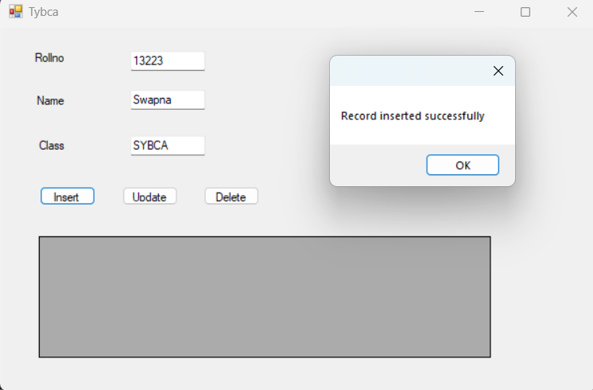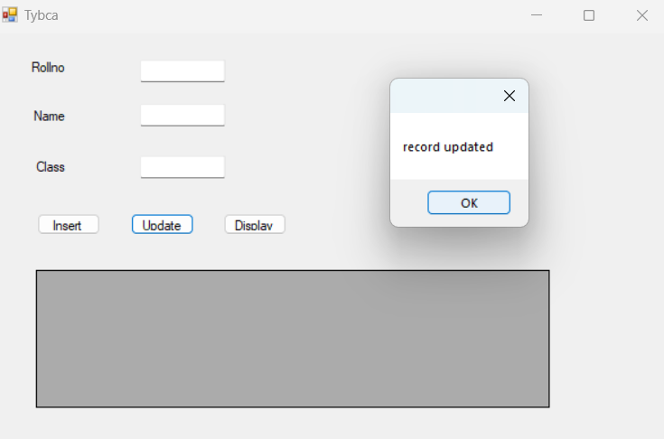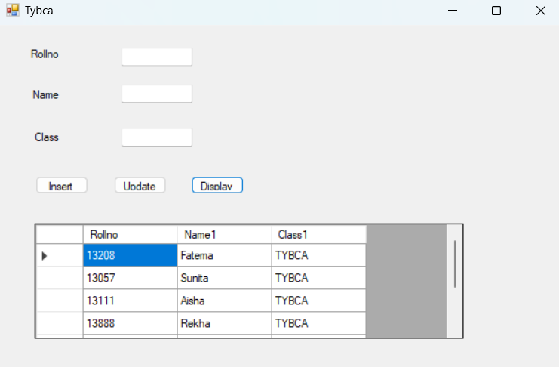

Q24. Write a VB.NET program to create teacher table (Tid , TName, subject). Insert the records (Max : 5). Search record of a teacher who teaches “VB.NET” subject and display result in GridView. (Use SQL to create db).

Imports System.Data.SqlClient

Public Class Teacherdb

Dim cn As SqlConnection

Dim cmd As SqlCommand

Dim str As String

Dim ad As SqlDataAdapter

Dim ds As New DataSet

Private Sub Button1_Click(sender As Object, e As EventArgs) Handles Button1.Click

cn = New SqlConnection("Data Source=(LocalDB)\MSSQLLocalDB;AttachDbFilename=C:\Users\Dell\source\repos\Database\Database\Database2.mdf;Integrated Security=True")

cn.Open()

str = New String("Insert into Teacher values(" & CInt(TextBox1.Text) & ", '" & TextBox3.Text & "', '" & TextBox2.Text & "')")

cmd = New SqlCommand(str, cn)

cmd.ExecuteNonQuery()

MsgBox("Record inserted!")

cn.Close()

End Sub

Private Sub Button2_Click(sender As Object, e As EventArgs) Handles Button2.Click

cn = New SqlConnection("Data Source=(LocalDB)\MSSQLLocalDB;AttachDbFilename=C:\Users\Dell\source\repos\Database\Database\Database2.mdf;Integrated Security=True")

cn.Open()

str = "Select * from Teacher where Subject='VB.NET'"

ad = New SqlDataAdapter(str, cn)

ad.Fill(ds, "Teacher")

DataGridView1.DataSource = ds

DataGridView1.DataMember = "Teacher"

cn.Close()

End Sub

End Class

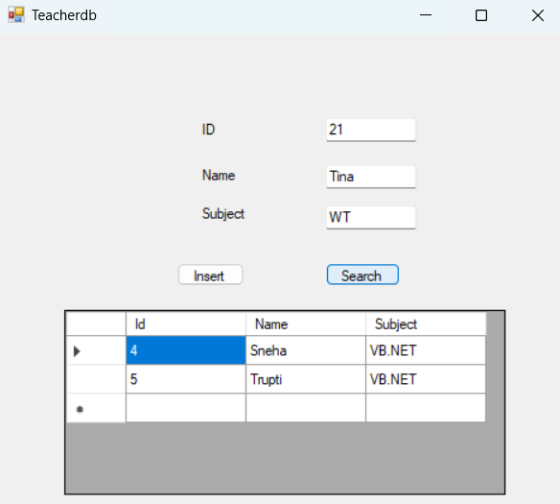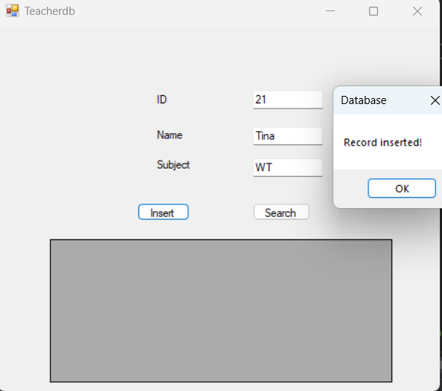

Q25. Write a VB.NET program to create movie table (Mv_Name, Release_year, Director). Insert the records(Max: 5). Delete the records of movies whose release year is 2015 and display appropriate message in messagebox.(Use MS Access to create db)

Public Class Movies

Dim con As New OleDb.OleDbConnection

Dim ds As New DataSet

Dim str As String

Dim da As New OleDb.OleDbDataAdapter

Dim cmd As New OleDb.OleDbCommand

Private Sub Button1_Click(sender As Object, e As EventArgs) Handles Button1.Click

Dim q As String

Dim x As Integer

q = "DELETE FROM movies WHERE release_year = 2015"

cmd = New OleDb.OleDbCommand(q, con)

Try

x = cmd.ExecuteNonQuery()

If (x) Then

MsgBox("Data Deleted")

Else

MsgBox("Data not deleted")

End If

ds.Tables.Clear()

da = New OleDb.OleDbDataAdapter("select * from movies", con)

da.Fill(ds, "movies")

DataGridView1.DataSource = ds.Tables("movies")

Catch ex As Exception

MsgBox("Exception Occured")

End Try

End Sub

Private Sub Button2_Click(sender As Object, e As EventArgs) Handles Button2.Click

con = New OleDb.OleDbConnection("Provider=Microsoft.Jet.OLEDB.4.0;Data Source=C:\Users\Dell\OneDrive\Documents\Database4.mdb")

con.Open()

str = New String("insert into movies values('" & TextBox1.Text & "','" & CInt(TextBox2.Text) & "','" & TextBox3.Text & "')")

cmd = New OleDb.OleDbCommand(str, con)

cmd.ExecuteNonQuery()

MessageBox.Show("Record inserted successfully")

'ds.Tables.Clear()

'da = New OleDb.OleDbDataAdapter("select * from movies", con)

'da.Fill(ds, "movies")

'DataGridView1.DataSource = ds.Tables("movies")

End Sub

End Class

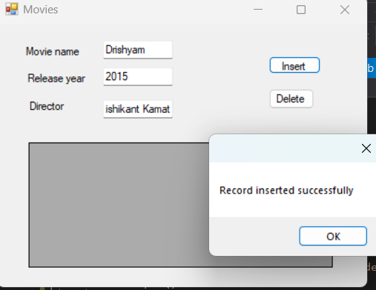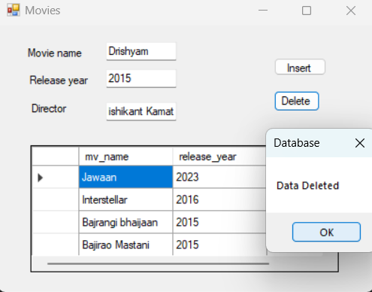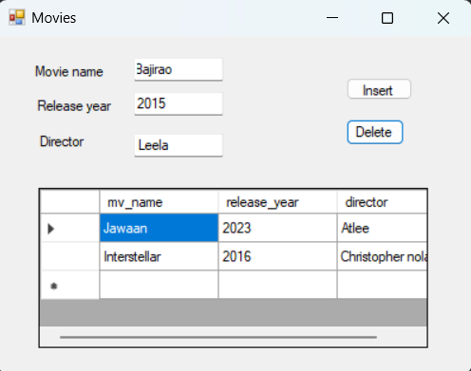

Q26. Write a VB.NET program to accept the details of customer (CName, Contact_No, Email_id). Store it into the database with proper validation and display appropriate message by using Messagebox.(Use MS Access )

Q27. . Write a VB.NET program to accept the details of product (pid, pname, expiry_date, price). Store it into the database and display it on the Crystal Report.(Use SQL Server)]

Imports System.Data.SqlClient

Public Class Product

Dim cn As SqlConnection

Dim cmd As SqlCommand

Dim str As String

Dim ad As SqlDataAdapter

Dim ds As New DataSet

Private Sub Button1_Click(sender As Object, e As EventArgs) Handles Button1.Click

cn = New SqlConnection("Data Source=(LocalDB)\MSSQLLocalDB;AttachDbFilename=C:\Users\Dell\source\repos\Database\Database\Database2.mdf;Integrated Security=True")

cn.Open()

str = New String("Insert into Product values(" & CInt(TextBox1.Text) & ", '" & TextBox2.Text & "', '" & TextBox3.Text & "', '" & TextBox1.Text & "')")

cmd = New SqlCommand(str, cn)

cmd.ExecuteNonQuery()

MsgBox("Record inserted!")

cn.Close()

End Sub

Private Sub Button2_Click(sender As Object, e As EventArgs) Handles Button2.Click

cn = New SqlConnection("Data Source=(LocalDB)\MSSQLLocalDB;AttachDbFilename=C:\Users\Dell\source\repos\Database\Database\Database2.mdf;Integrated Security=True")

cn.Open()

str = "Select * from Product"

ad = New SqlDataAdapter(str, cn)

ad.Fill(ds, "Product")

DataGridView1.DataSource = ds

DataGridView1.DataMember = "Product"

cn.Close()

End Sub

End Class

Q28. Write a VB.NET program to accept the details Supplier (SupId, SupName, Phone_No, Address ) store it into the database and display it. (Use Crystal Report)

Imports System.Data.SqlClient

Public Class Supplier

Dim cn As SqlConnection

Dim cmd As SqlCommand

Dim str As String

Dim ad As SqlDataAdapter

Dim ds As New DataSet

Private Sub Button1_Click(sender As Object, e As EventArgs) Handles Button1.Click

cn = New SqlConnection("Data Source=(LocalDB)\MSSQLLocalDB;AttachDbFilename=C:\Users\Dell\source\repos\Database\Database\Database2.mdf;Integrated Security=True")

cn.Open()

str = New String("Insert into Supplier values(" & CInt(TextBox1.Text) & ", '" & TextBox2.Text & "', '" & TextBox3.Text & "', '" & TextBox1.Text & "')")

cmd = New SqlCommand(str, cn)

cmd.ExecuteNonQuery()

MsgBox("Record inserted!")

cn.Close()

End Sub

Private Sub Button2_Click(sender As Object, e As EventArgs) Handles Button2.Click

cn = New SqlConnection("Data Source=(LocalDB)\MSSQLLocalDB;AttachDbFilename=C:\Users\Dell\source\repos\Database\Database\Database2.mdf;Integrated Security=True")

cn.Open()

str = "Select * from Supplier"

ad = New SqlDataAdapter(str, cn)

ad.Fill(ds, "Supplier")

DataGridView1.DataSource = ds

DataGridView1.DataMember = "Supplier"

cn.Close()

End Sub

End Class

Q29. Write a VB.NET program to create Author table (aid , aname , book_name). Insert the records (Max 5). Delete a record of author who has written “VB.NET book” and display remaining records on the Crystal Report.(Use MS Access to create db)

Public Class Author

Dim con As New OleDb.OleDbConnection

Dim ds As New DataSet

Dim str As String

Dim da As New OleDb.OleDbDataAdapter

Dim cmd As New OleDb.OleDbCommand

Private Sub Form1_Load(ByVal sender As System.Object, ByVal e As System.EventArgs) Handles MyBase.Load

con.ConnectionString = "Provider=Microsoft.Jet.OLEDB.4.0;Data Source=C:\Users\Dell\OneDrive\Documents\Database4.mdb"

con.Open()

da = New OleDb.OleDbDataAdapter("select * from Author", con)

da.Fill(ds, "ath")

DataGridView1.DataSource = ds.Tables("ath")

End Sub

Private Sub Button2_Click(ByVal sender As System.Object, ByVal e As System.EventArgs) Handles Button2.Click

Dim q As String

Dim x As Integer

q = "delete from Author where bname='VB.NET'"

cmd = New OleDb.OleDbCommand(q, con)

Try

x = cmd.ExecuteNonQuery()

If (x) Then

MsgBox("Data Deleted")

Else

MsgBox("Data not deleted")

End If

ds.Tables.Clear()

da = New OleDb.OleDbDataAdapter("select * from Author", con)

da.Fill(ds, "ath")

DataGridView1.DataSource = ds.Tables("ath")

Catch ex As Exception

MsgBox("Exception Occured")

End Try

End Sub

'Private Sub Button1_Click(ByVal sender As System.Object, ByVal e As System.EventArgs) Handles Button1.Click

' Form2.Show()

'End Sub

Private Sub Button3_Click(sender As Object, e As EventArgs)

con = New OleDb.OleDbConnection("Provider=Microsoft.Jet.OLEDB.4.0;Data Source=C:\Users\Dell\OneDrive\Documents\Database4.mdb")

con.Open()

Str = New String("insert into Student values(" & CInt(TextBox1.Text) & ",'" & TextBox2.Text & "','" & TextBox3.Text & "')")

cmd = New OleDb.OleDbCommand(str, con)

cmd.ExecuteNonQuery()

MessageBox.Show("Record inserted successfully")

End Sub

End Class

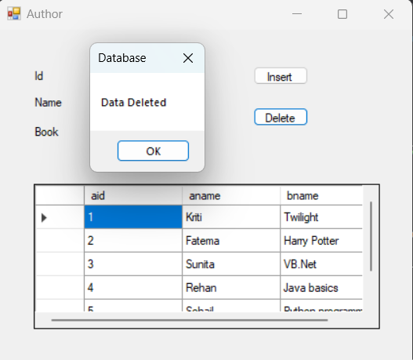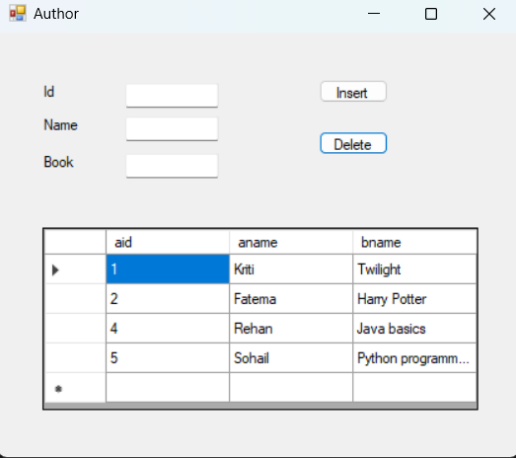

Q30. Write a VB.NET program to create player table (Pid,PName,Game, no_of_matches). Insert records and update number of matches of ‘Sachin Tendulkar’ and display result in Crystal Report.(Use SQL to create db)

Imports System.Data.SqlClient

Public Class Player

Dim cn As SqlConnection

Dim cmd As SqlCommand

Dim str As String

Dim ad As SqlDataAdapter

Dim ds As New DataSet

Dim n As Integer

Private Sub Button1_Click(sender As Object, e As EventArgs) Handles Button1.Click

cn = New SqlConnection("Data Source=(LocalDB)\MSSQLLocalDB;AttachDbFilename=C:\Users\Dell\source\repos\Database\Database\Database2.mdf;Integrated Security=True")

cn.Open()

str = New String("Insert into Player values(" & CInt(TextBox1.Text) & ", '" & TextBox2.Text & "', '" & TextBox3.Text & "', " & CInt(TextBox4.Text) & ")")

cmd = New SqlCommand(str, cn)

cmd.ExecuteNonQuery()

MsgBox("Record inserted!")

cn.Close()

End Sub

Private Sub Button2_Click(sender As Object, e As EventArgs) Handles Button2.Click

cn = New SqlConnection("Data Source=(LocalDB)\MSSQLLocalDB;AttachDbFilename=C:\Users\Dell\source\repos\Database\Database\Database2.mdf;Integrated Security=True")

cn.Open()

Dim a As Integer

a = InputBox("Enter No. of Matches you want to update:")

str = "update player set no_of_matches=" & CInt(a) & " where pname='Sachin Tendulkar' "

cmd = New SqlCommand(str, cn)

n = cmd.ExecuteNonQuery

If (n > 0) Then

MsgBox("Record Updated Successfully")

cmd = New SqlCommand(str, cn)

End If

cn.Close()

End Sub

End Class