

**Cloud Deployment Models**

**Name:** Pratham Kandari

**Sap Id:** 500097663

**Batch:** 7

**LAB- 10**

Step1 : search elastic beanstalk => open it => and click on create application.

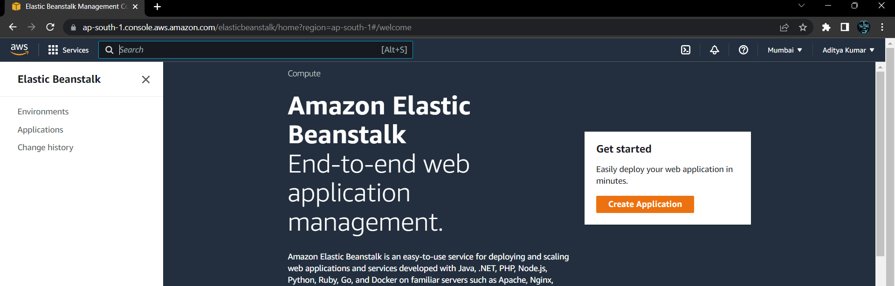

Step 2: name your application and leave tags.

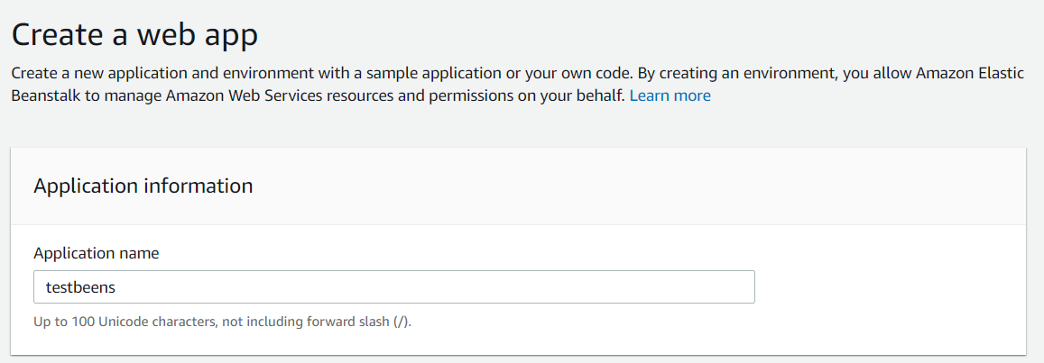

Step 3:select the platform on which we want to run our application.

* We will select tomcat because we will run our jsp code So, the tomcat platform is good for that

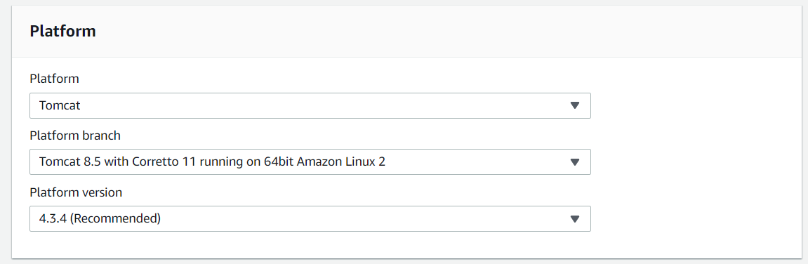

Step 4: Click on ‘upload your code’ to create our desired application otherwise you can select the ‘sample application’ it will automatically deploy a sample application

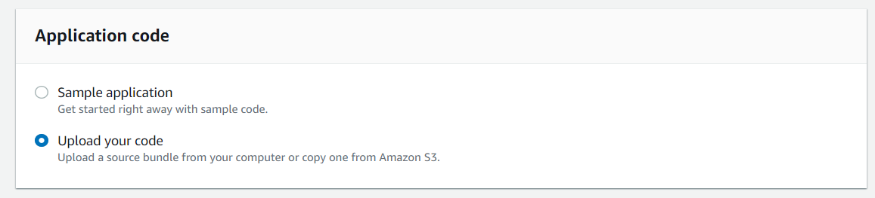

Step 5: if you want to change the version label you can.

* Click on ‘choose file’ => then select your file the file format will (.war)

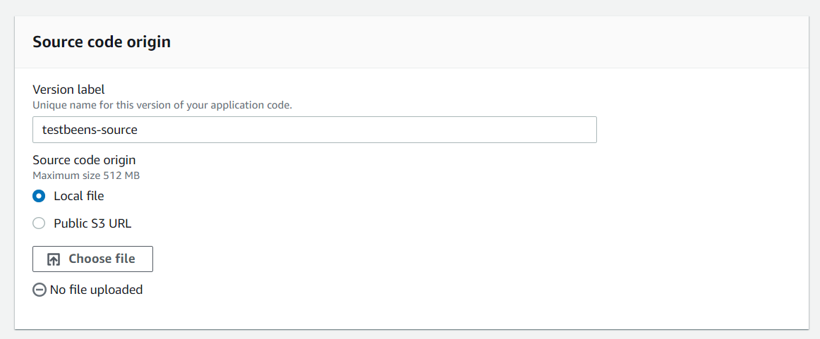

Step 6: select our file .

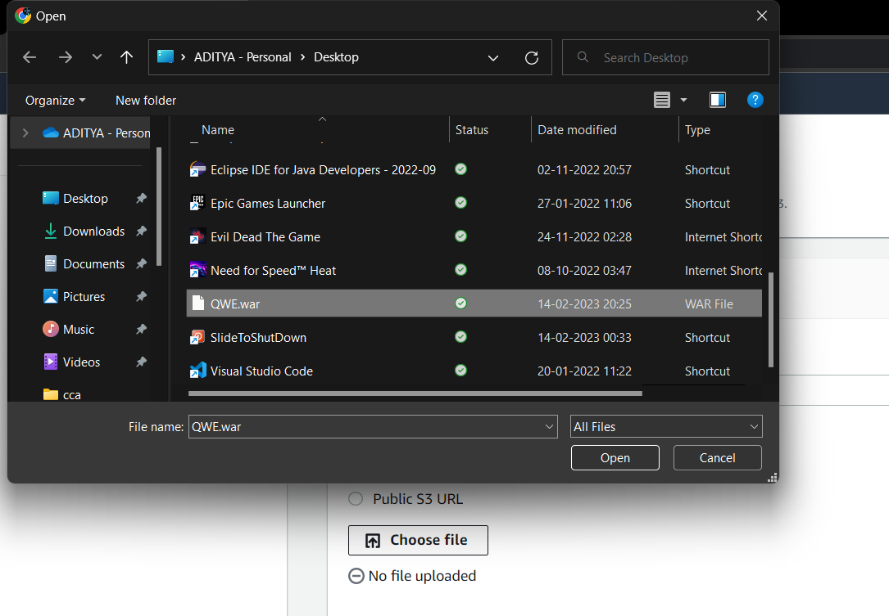

Step 7: Click on create application.

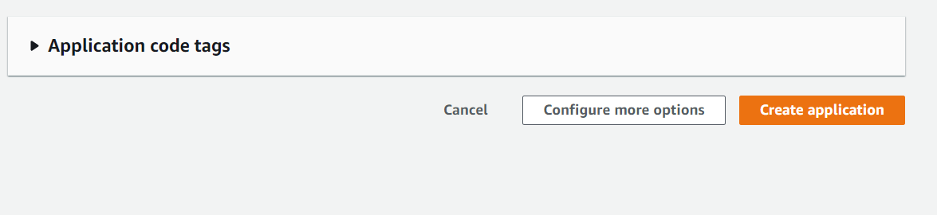

Step 8: our application environment is creating, it will take time.it will take time …

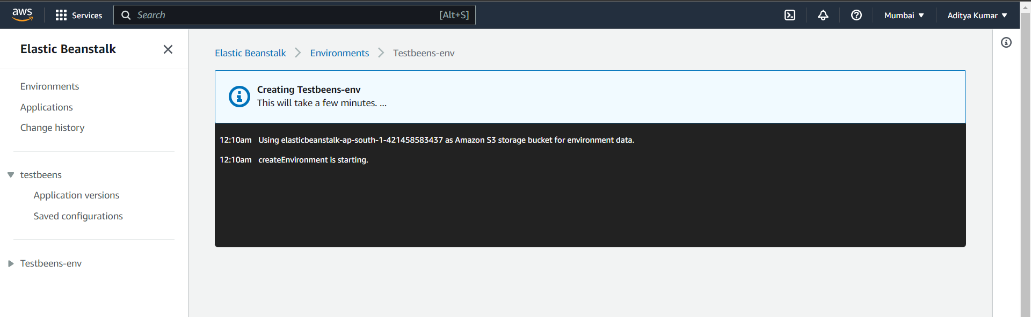

Step 9: our environment is created successfully deployed

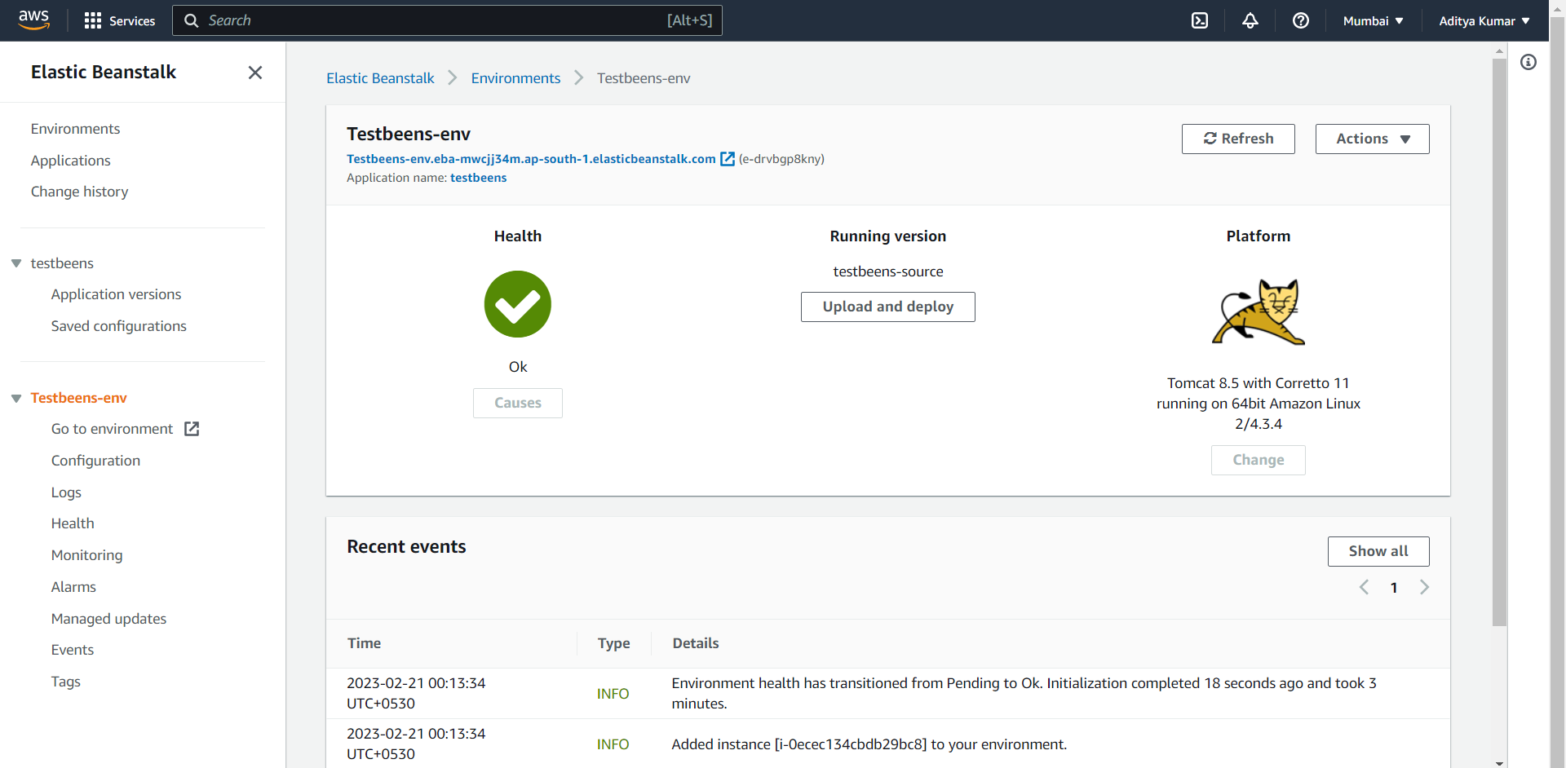

Step 10: Click on “go to the environment” which is on the left, it will take us to our web page.

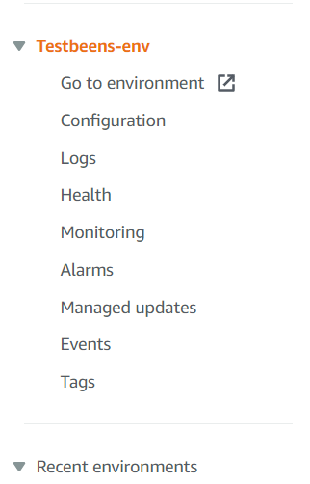

Step 11: This is our webpage ,click on login here it will redirect us to register page

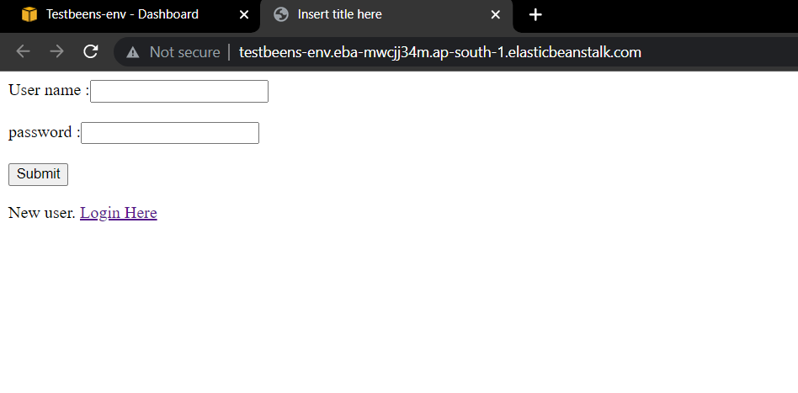

Step 12: here is our register page .

