THEME • RENEWABLE ENERGY INTELLIGENCE
Problem Statement No. 6
Renewable Energy Certificate (REC)
Fraud Detection System
A multi-signal, tamper-evident platform that detects statistical, network, and physically implausible REC fraud — and explains every flag in plain language for regulators and auditors.
Prepared for
Hackout-2026
Hackathon Submission — Renewable Energy Intelligence Track
Team: bhole chature
Team Members:
Pratham Kariya
Shreyansh Soni
Shaambhavi Dubey
Jeet Samani

Contents

1. Problem Statement

2. Our Solution — The Idea

3. How It Works — End-to-End Workflow

4. Technical Architecture

5. Detection Approach — Three Independent Signals

6. Technology Stack

7. Feasibility Analysis

8. Viability & Real-World Value

1. Problem Statement
Renewable Energy Certificates (RECs) are the instruments that prove a unit of electricity was generated from a renewable source. Because issuance and tracking are still largely manual, the system is vulnerable to duplication and fraudulent claims. This project builds a system that uses anomaly detection and ledger-based tracking to flag suspicious REC issuance patterns, duplicate certificates, and mismatches between claimed and actual generation data.

Target Users
Renewable energy regulators, certificate issuing bodies, corporate REC buyers, and independent auditors — anyone who must trust that a certificate represents real, one-time renewable generation.

The three ways REC fraud happens
- • Double counting — the same generation is claimed twice through duplicate serials or timestamp collisions.
- • Physically impossible claims — certificates issued for generation that could not have occurred, e.g. solar output claimed at night or output exceeding a plant's rated capacity.
- • Coordinated fraud rings — issuers and buyers gaming the market together through circular or wash-style trading that is invisible at the single-certificate level.

Impact
- • Strengthens integrity and trust in renewable energy markets.
- • Reduces regulatory and reputational risk for genuine producers.
- • Improves auditability of national and regional renewable energy claims.

2. Our Solution — The Idea
We propose a system that evaluates every REC from three independent angles at once: does the certificate's numbers look statistically off, does it fit a suspicious pattern of who is trading with whom, and does it match physical reality (the weather at the plant when generation supposedly happened). Every flag is stored in a tamper-evident record and explained in plain English for an auditor — not just returned as a bare risk number.
Where existing systems fall short — our opening
Real-world REC platforms and academic blockchain-REC work mostly solve double-counting with tokenization and immutable ledgers, but none proactively run ML anomaly detection or cross-reference claimed generation against independent physical data. Electricity-theft detection projects use tabular ML but never combine it with weather cross-validation or graph-based fraud-ring detection for RECs. That combination is our innovation.

What makes it eye-catching
- • Physical cross-validation. We pull solar irradiance and wind speed from a free API (Open-Meteo / NASA POWER) for the plant's location and timestamp, then flag RECs whose claimed generation contradicts the weather. Grounding fraud detection against real physical data is the single most compelling feature.
- • Fraud-ring graph detection. Issuers and buyers are modelled as a graph; circular loops and dense clusters expose the REC equivalent of wash trading.
- • LLM explainability. The Claude API converts a raw anomaly score into a plain-English audit explanation a regulator could act on — turning a black-box model into something usable.
- • Public verification portal. A QR-style “verify this REC” page shows a certificate's ledger provenance, making the abstract concept tangible.

3. How It Works — End-to-End Workflow
A certificate travels through the system in a fixed sequence. It is written to a tamper-evident ledger, scored independently by three detectors, the signals are fused, the result is explained, and everything is served to the dashboard and public portal.
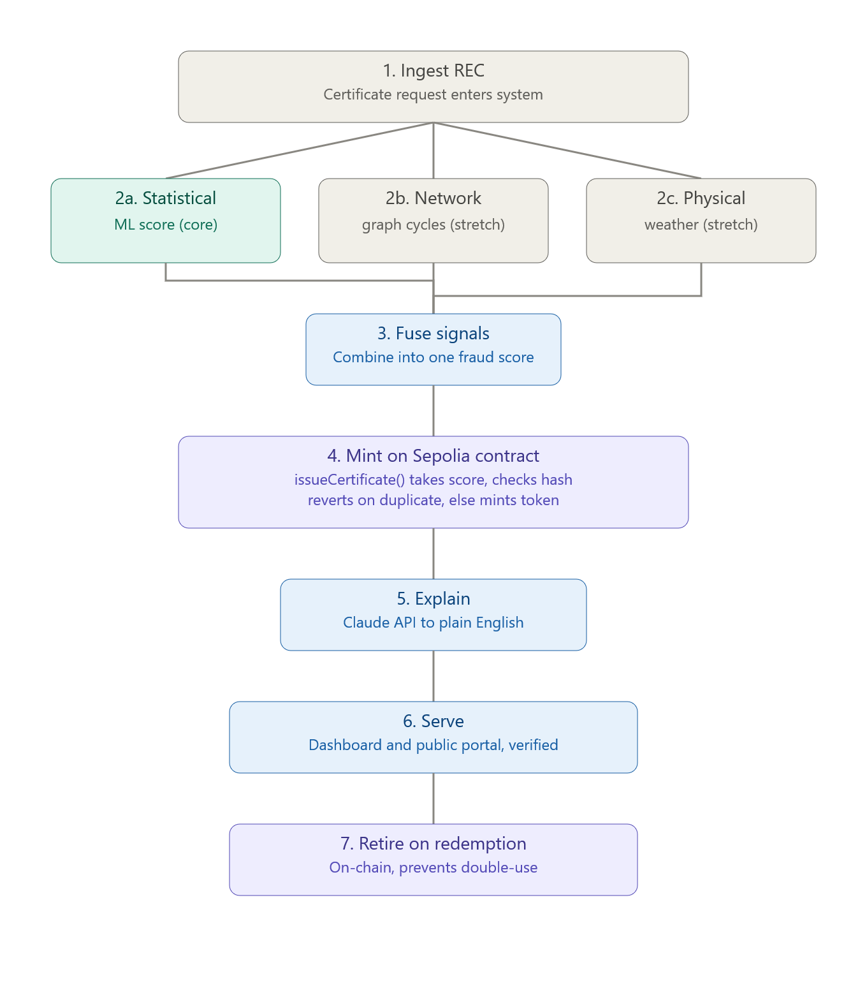
Figure 1 — End-to-end flow from ingestion to auditor-facing output.
- Ingest. A REC certificate request (plant metadata, claimed MWh, timestamp, and location) enters the system.
- Three-signal detection. An Isolation Forest scores statistical anomalies; a graph module hunts trading cycles and clusters; a weather check tests physical plausibility.
- Fuse. The three signals combine into one unified risk score per certificate.
- Ledger write. The certificate, with its risk score attached, is minted on-chain via a Sepolia smart contract. The contract hashes the plant ID, claimed MWh, and timestamp and checks it against every certificate it has ever issued if that generation record has been claimed before, the transaction reverts and nothing is minted; otherwise it mints a new token, making the record tamper-evident and permanently public.
- Explain. Claude turns the combined evidence into a short, plain English explanation an auditor can act on.
- Serve. Flags, scores, the fraud-ring graph, and the explanation are exposed through the dashboard and the public verify portal, merging the on-chain record (proof of existence and uniqueness) with the off-chain detail (score, reasoning, raw data).

4. Technical Architecture
The system is organised into five layers. Data flows top-down; the detection layer runs three independent signals in parallel that fuse into a single risk profile before being stored, explained, and served.
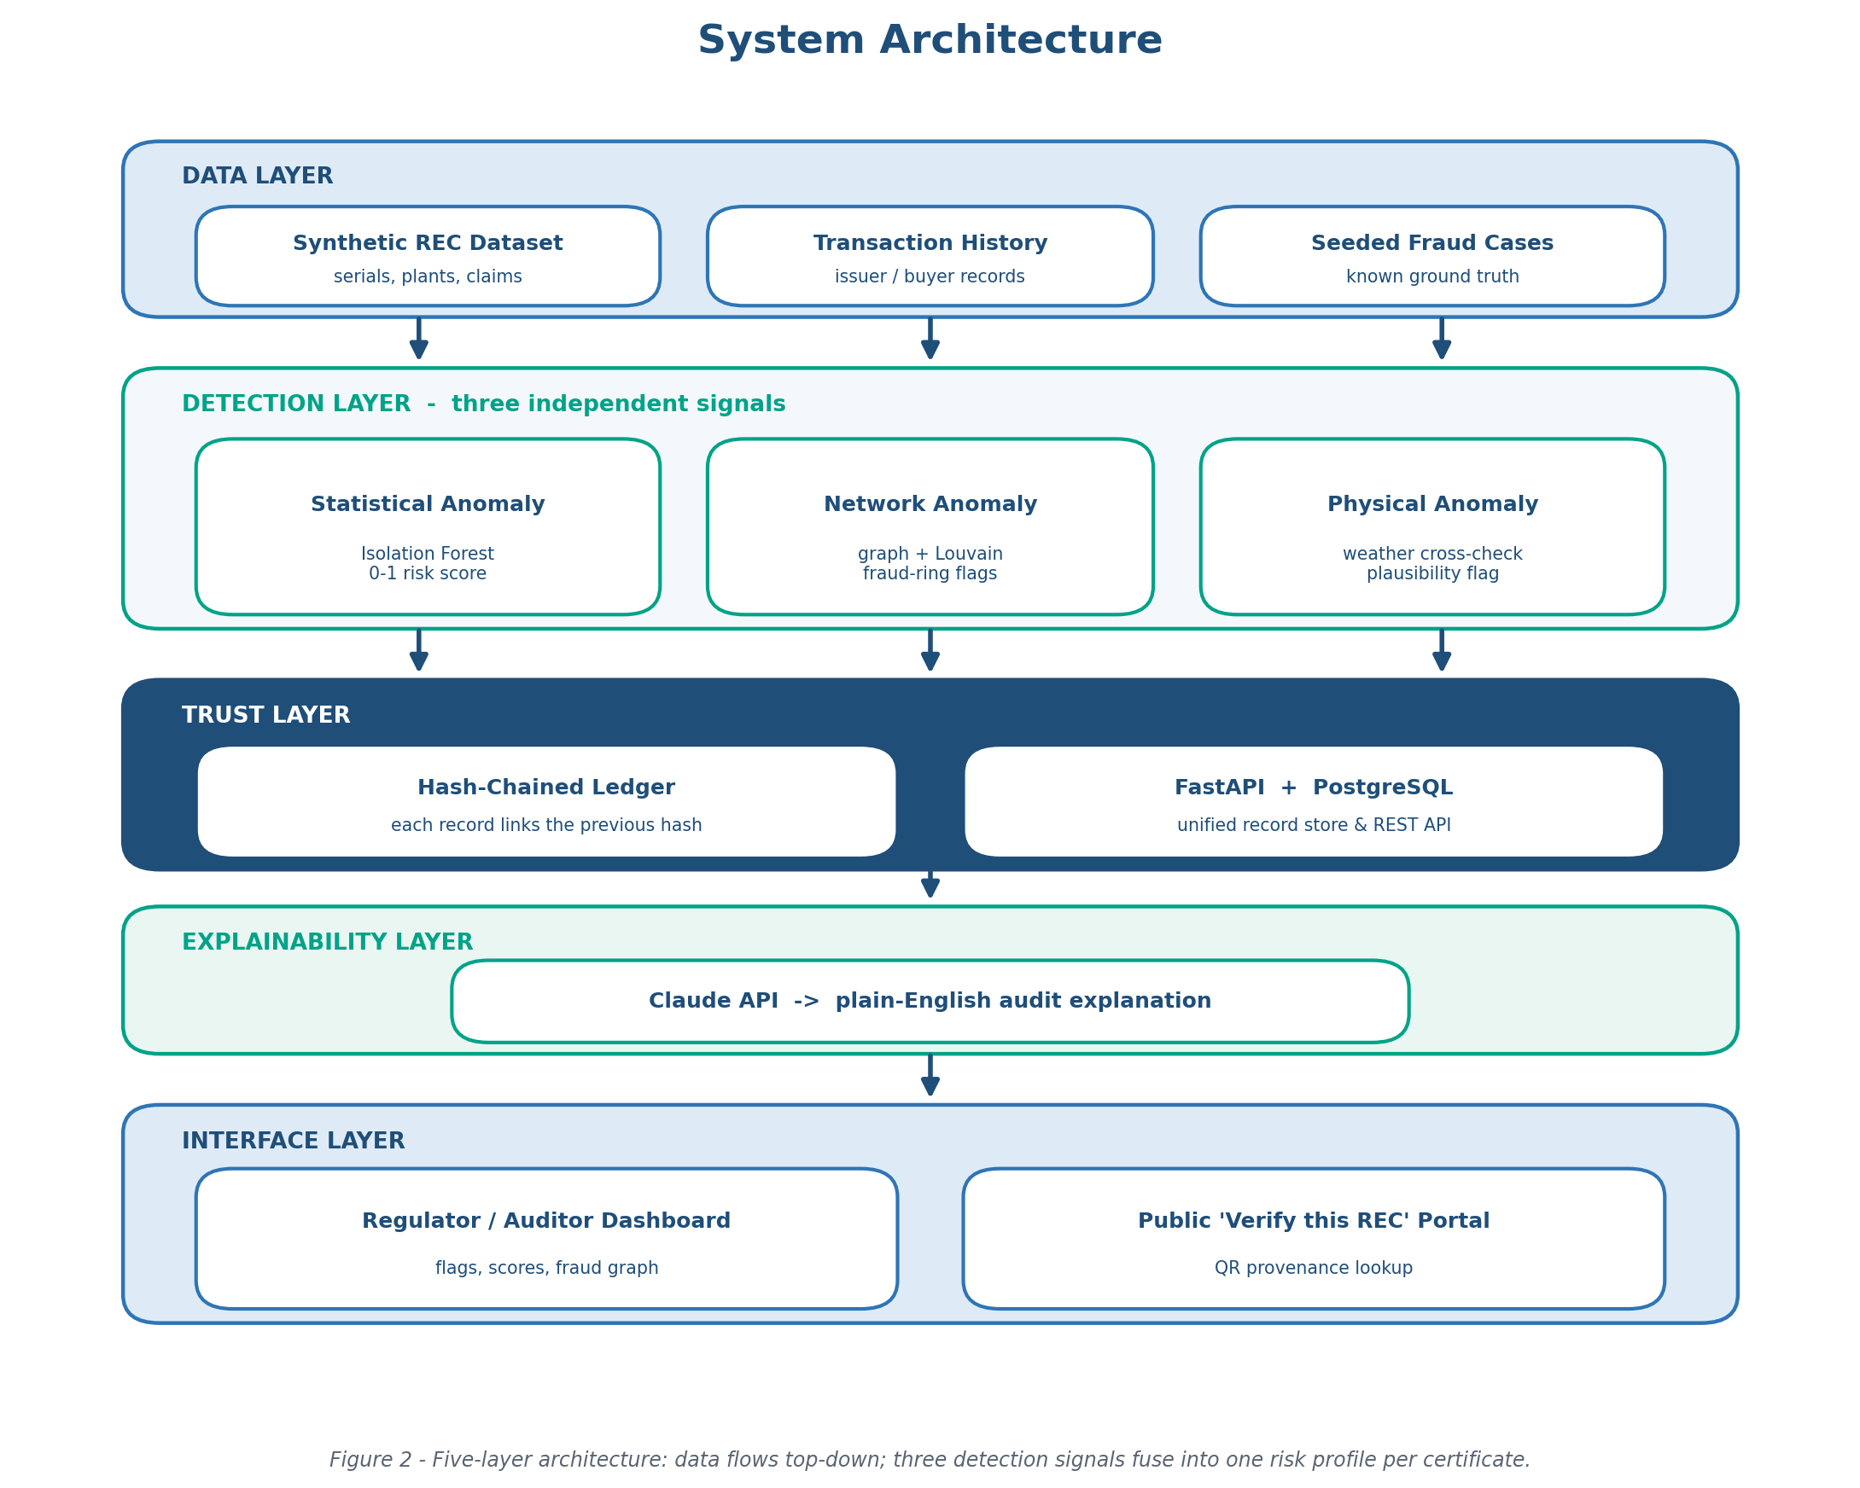
Figure 2 — Five-layer architecture.

Layer by layer
- Data layer. A synthetic dataset of REC certificates with deliberately seeded fraud cases (duplicate serials, over-capacity claims, implausible timing, circular trading) so every detector can be tested against known ground truth.
- Detection layer. Three parallel signals: statistical (Isolation Forest on engineered features), network (networkx graph with cycle and Louvain community checks), and physical (weather cross-check).
- Trust layer. Each record's hash includes the previous record's hash (Merkle-style chaining), so any retroactive edit is detectable. Backed by FastAPI and PostgreSQL.
- Explainability layer. The Claude API converts the fused signals into an auditor-readable explanation.
- Interface layer. A dashboard for regulators and auditors plus a public “verify this REC” portal.

5. Detection Approach — Three Independent Signals
No single signal is decisive. Combining statistical, network, and physical evidence makes evasion far harder: a fraudster would have to produce numbers that look normal, trade in a non-suspicious pattern, and match the actual weather — all at once.
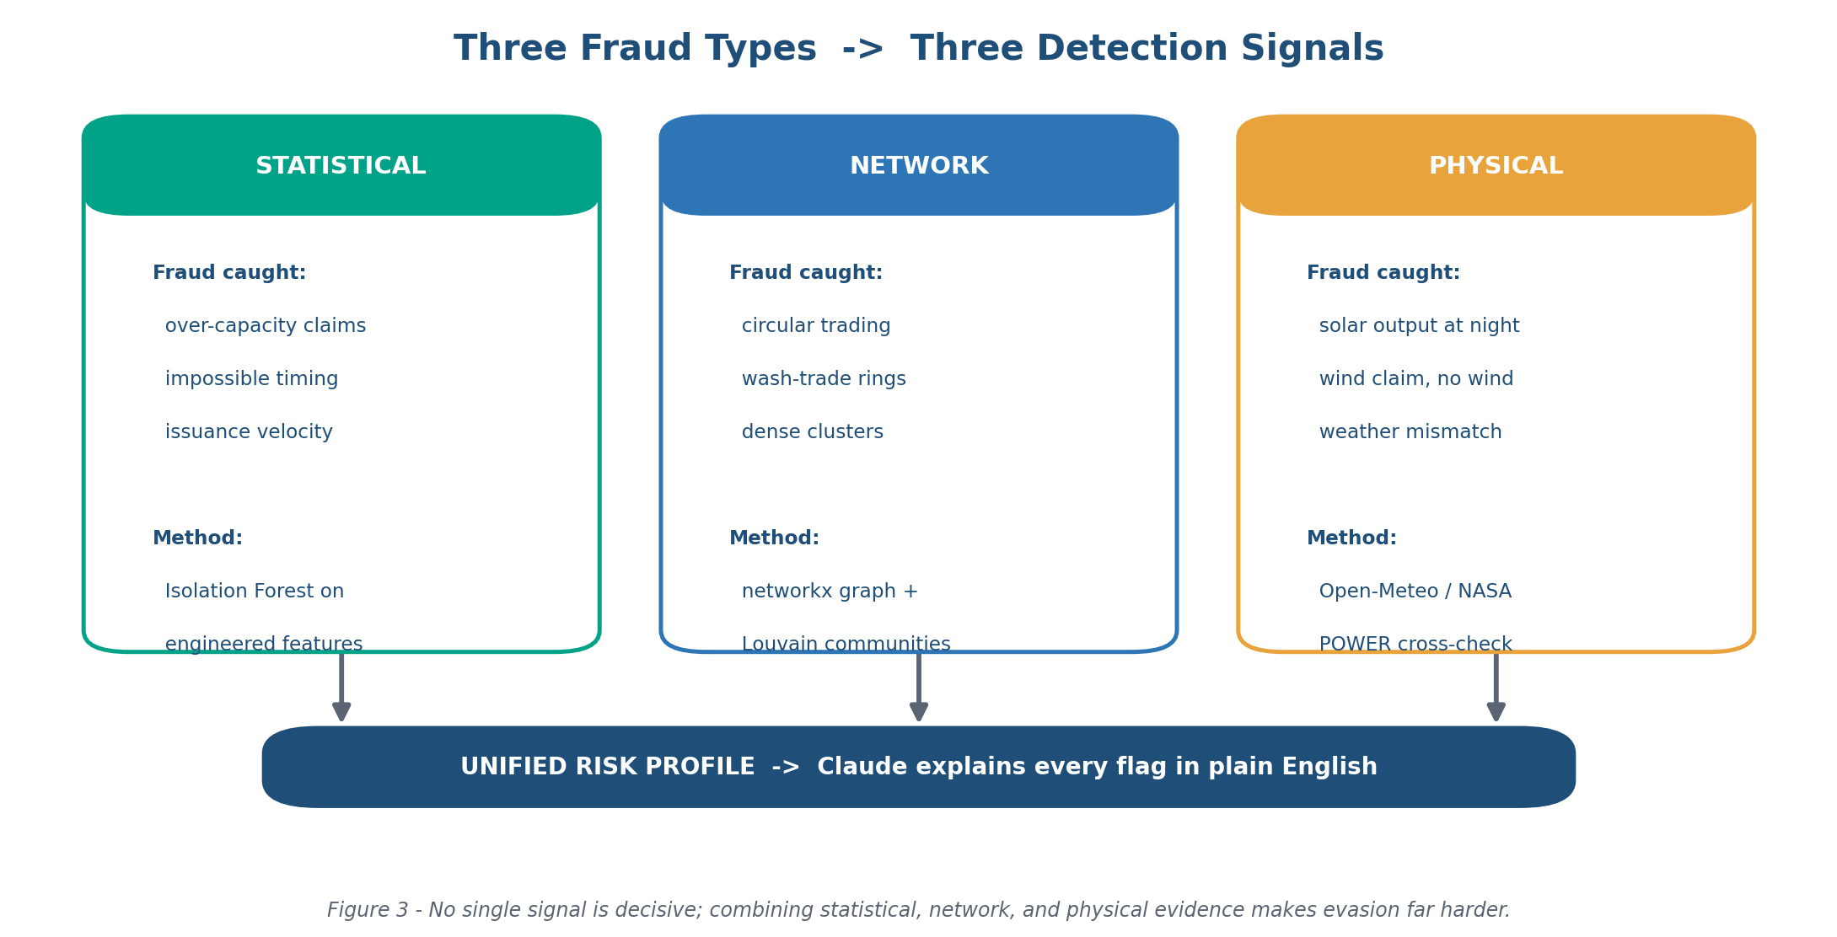
Figure 3 — Each fraud type is covered by a matching detection signal, fused into one risk profile.

Feature engineering (statistical signal)
The Isolation Forest scores each certificate on engineered features such as capacity-utilisation ratio, time-of-day plausibility, issuance velocity, and buyer concentration, producing a 0–1 risk score.

Graph analysis (network signal)
Issuer and buyer transactions form a directed graph. Trading cycles and dense communities (via the Louvain method) surface coordinated fraud that is invisible when certificates are viewed one at a time.

Physical plausibility (physical signal)
For each flagged certificate we fetch weather data at the plant's coordinates and claimed generation time, then check it against what the plant type physically requires — for example, a solar certificate claiming 4.2 MWh at 2 AM local time is physically impossible and is flagged.

6. Technology Stack
The stack is deliberately chosen to keep the team in one language (Python) for the data and backend work, minimise integration friction, and stay deployable within a hackathon timeframe.
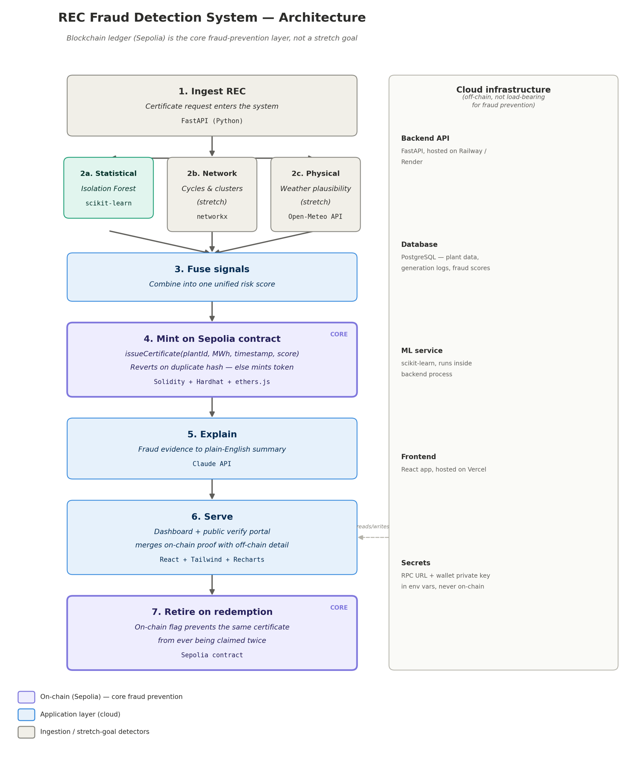

7. Feasibility Analysis

Technical feasibility
Every core component uses mature, well-documented libraries the team already knows. Isolation Forest, hash chaining, and networkx are all standard techniques; the weather APIs are free and keyless. The hardest integration — combining three signals — is de-risked by a shared data schema agreed before any code is written.

Resource feasibility
All data is synthetic, so there is no dependency on proprietary datasets or partner access. External services (weather APIs) are free; hosting fits free or low-cost demo tiers.
Risk & mitigation
Biggest risk: integration collisions between four parallel workstreams. Mitigation: lock a shared JSON / OpenAPI schema for the REC record in the first hour, build against mocks, and merge only at scheduled checkpoints — never continuously.

8. Viability & Real-World Value
The approach is viable because it closes a genuine gap rather than re-implementing what existing ledgers already do. Tokenization solves double-counting but says nothing about whether a claim is physically real or whether a trading pattern is coordinated. By grounding detection in physical data and network structure, the system produces evidence a regulator can act on.
- • Market relevance. Regulators, issuing bodies, and corporate buyers all need assurance that certificates represent real, one-time generation — a growing concern as renewable markets scale.
- • Actionable output. Plain-English explanations plus tamper-evident provenance mean flags can be investigated and defended, not just recorded.
- • Extensible. The synthetic-data foundation lets the same detectors be retrained on real issuance data, and the ledger can later be anchored to a public chain.
REC markets depend on a simple promise: one certificate equals one unit of real renewable generation. This project defends that promise from three sides at once — statistical, structural, and physical — and records every judgement in a tamper-evident ledger with a plain-English explanation attached. It is buildable in the available time, uses only free and familiar tools, and targets a gap that existing ledger-only solutions leave wide open.

