EVIDENCE-DRIVEN DATASET INTELLIGENCE AND
RECOMMENDATION SYSTEM
A Local-First, Evidence-Grounded Pipeline for Task-Aware Dataset Discovery and Ranking
DSN4091 – CAPSTONE PROJECT PHASE-I
Phase – I Report
Submitted by
Anvesha Rastogi (23BAI10355)
Harsh Gupta (23BAI10402)
Priyanshu Ranjan (23BAI10691)
Pratham Kashyap (23BAI10455)
Harsh Dhoriyani (23BAI10382)
Shrish (23BAI11284)
in partial fulfillment for the award of the degree
of
BACHELOR OF TECHNOLOGY
in
COMPUTER SCIENCE AND ENGINEERING
(ARTIFICIAL INTELLIGENCE AND MACHINE LEARNING)

SCHOOL OF COMPUTING SCIENCE AND ENGINEERING
VIT BHOPAL UNIVERSITY SEHORE,
MADHYA PRADESH – 466114
September 2026
VIT BHOPAL UNIVERSITY, KOTHRIKALAN, SEHORE
MADHYA PRADESH – 466114
BONAFIDE CERTIFICATE
Certified that this project report titled "EVIDENCE-DRIVEN DATASET INTELLIGENCE AND RECOMMENDATION SYSTEM" is the bonafide work of Anvesha Rastogi (23BAI10355), Harsh Gupta (23BAI10402), Priyanshu Ranjan (23BAI10691), Pratham Kashyap (23BAI10455), Harsh Dhoriyani (23BAI10382) and Shrish (23BAI11284) who carried out the project work (DSN4091 – Capstone Project Phase-I) under my supervision. Certified further that to the best of my knowledge the work reported at this time does not form part of any other project/research work based on which a degree or award was conferred on an earlier occasion on this or any other candidate. Chapter 7 (§7.6) and Appendix E record the individual, repository-verifiable technical responsibilities and report-authorship contributions within the team.

PROGRAM CHAIR  Dr Pradeep Kumar Mishra  Senior Assistant Professor (Gr-2)  School of Computing Science Engineering  and Artificial Intelligence  VIT Bhopal University | PROJECT GUIDE  Dr Pradeep Kumar Mishra  Senior Assistant Professor (Gr-2)  School of Computing Science Engineering  and Artificial Intelligence  VIT Bhopal University
The DSN4091 – Capstone Project Phase-I Viva Voce Examination is held on ____________.
DECLARATION
We hereby declare that the project work entitled "EVIDENCE-DRIVEN DATASET INTELLIGENCE AND RECOMMENDATION SYSTEM" submitted to VIT Bhopal University, Bhopal in partial fulfillment of the requirements for the award of the degree of Bachelor of Technology in Computer Science and Engineering (Artificial Intelligence and Machine Learning) is a bonafide record of original work done by us under the supervision and guidance of Dr. Pradeep Kumar Mishra, Senior Assistant Professor (Gr-2), School of Computing Science and Engineering, VIT Bhopal University.
We further declare that to the best of our knowledge, the results and work embodied in this Phase-I report have not been submitted to any other University or Institute for the award of any degree or diploma. All contributions, software libraries, benchmarks, and published literature referenced in this work have been explicitly cited and acknowledged.

Anvesha Rastogi (23BAI10355) | Pratham Kashyap (23BAI10455)
Harsh Gupta (23BAI10402) | Harsh Dhoriyani (23BAI10382)
Priyanshu Ranjan (23BAI10691) | Shrish (23BAI11284)
Place: VIT Bhopal University, Sehore
Date: September 2026
ACKNOWLEDGEMENT
First and foremost, we would like to thank the Lord Almighty for his presence and immense blessings throughout the project work.
We would like to thank Dr. Pradeep Kumar Mishra, our Project Guide and Program Chair, for continually guiding and actively participating in our project, and giving valuable suggestions to complete the project work.
We wish to express our heartfelt gratitude to Dr. Pradeep Kumar Mishra, PC-Lead, School of Computing Science Engineering and Artificial Intelligence, for much of his valuable support and encouragement in carrying out this work.
We wish to express our heartfelt gratitude to Dr. Pon Harshavardhanan, Dean, School of Computing Science Engineering and Artificial Intelligence, for much of his valuable support and encouragement in carrying out this work.
We would like to thank all the technical and teaching staff of the School of Computing Science Engineering and Artificial Intelligence for their kind cooperation in completing the project work.
Last, but not least, we are deeply indebted to our parents who have been the greatest source of inspiration and have extended their support throughout the project.

LIST OF FIGURES
FIGURE NO. | TITLE | PAGE NO.
1.1 | Catalogue Search versus Evidence-Backed Recommendation | 2
3.1 | Typed Data Contracts Passed Between Pipeline Stages | 8
3.2 | TaskSpecification JSON (Real Configuration Excerpt) | 10
3.3 | Evidence Ledger and Resolution Summary (Real M3 Artifacts) | 11
4.1 | End-to-End System Architecture (Implemented; M8 Evaluation Path) | 15
4.2 | Two-Layer Evidence Model | 17
4.3 | Recommendation Scoring and Diversification Flow | 19
4.4 | RecommendationCard Structure | 20
4.5 | M2 Retrieval Benchmark Branch | 21
5.1 | M0–M8 Milestone Evaluation Flow | 24
5.2 | Repository / Module Structure | 25
5.3 | 208-Test Automated Suite (Real Run) | 26
5.4 | M2 Retrieval Latency Comparison | 27
5.5 | M2 Retrieval Memory/Resource Comparison | 28
5.6 | M3 Evidence Ledger Composition and Resolution | 29
5.7 | M5 Utility Correlation A/B/C | 31
5.8 | M6 Long-Tail Exploration | 32
5.9 | M7 Redundancy and Utility Comparison | 33
5.10 | RecommendationCard JSON (Real M7 Output) | 34
5.11 | M8 Benchmark Command and Recorded Result | 35
5.12 | m8_summary.json Excerpt (Hypotheses, Robustness, Sensitivity) | 36
5.13 | M8 Nine-Rung Ablation Ladder | 38
5.14 | M8 Robustness Results | 39
5.15 | M8 Sensitivity Analysis | 40
5.16 | Human Evaluation Pilot — Descriptive Results | 42
5.17 | Per-Comparison Paired Differences (N=3) | 43
6.1 | Operational Workflow for a Practitioner Using the Prototype | 46
A.1 | Real CanonicalDatasetRecord for UCI Iris (Pretty-Printed JSON) | 53
B.1 | Real TaskSpecification Fixtures (Tabular & Multimodal) | 55
D.1 | RecommendationSet JSON (Real M7 Output) | 60
G.1 | Automated Test Suite Execution Trace (208 Passing Tests) | 67

LIST OF TABLES
TABLE NO. | TITLE | PAGE NO.
2.1 | Research Foundations and Adopted Methodological Roles | 5
2.2 | Research-Gap Matrix | 6
3.1 | Functional Requirements | 8
3.2 | Non-Functional Requirements | 9
3.3 | Computational Constraints (M0 Envelope) | 9
3.4 | Data-Source Requirements | 9
3.5 | TaskSpecification Contract | 10
3.6 | Two-Layer Evidence-State Model | 11
3.7 | Dataset Fingerprint Contract | 12
3.8 | Ranking / Output Contract | 12
3.9 | Provenance and Reproducibility Requirements | 13
3.10 | Milestone 8 Frozen Benchmark Corpus (24 Datasets × 8 Tasks) | 13
4.1 | Design Principles and Their Architectural Realization | 16
4.2 | Design Alternatives Deferred to Future Work | 17
4.3 | Fixed Multi-Objective Scoring Weights | 18
4.4 | Hard Compatibility Gate Rules | 19
5.1 | M0 Resource Envelope | 24
5.2 | M2 Retrieval Comparison | 27
5.3 | M3 Evidence Ledger Results | 29
5.4a | Three Further Real Evidence-Ledger Entries (Observed, Failed, Unknown) | 30
5.4 | M4 Fingerprinting Results | 30
5.5 | M5 Utility Results | 31
5.6 | M6 Exploration Results | 32
5.7 | M7 Ranking/Diversification Results | 33
5.8 | Milestone 8 Pre-Registered Hypothesis Results (H1–H5) | 36
5.9 | M8 Ablation Ladder (9 Rungs) | 38
5.10 | M8 Robustness by Corruption Suite (4 suites, 10 trials, 0 crashes) | 39
5.11 | M8 Sensitivity Sweep Results | 40
5.12 | Human Evaluation Pilot Results (N=3, 7 pairs, 42 observations) | 42
5.13 | Milestone-by-Milestone Summary of Measured Results (M0–M8) | 44
6.1 | Applicability Boundaries and Threats to Validity | 47
6.2 | What the Experiments Establish / Do Not Establish | 48
7.1 | Research Questions — Consolidated Findings | 50
7.2 | Future Research Directions | 51
7.3 | Repository-Verifiable Commit Statistics | 51
7.4 | Team Responsibility Matrix (Report Sections) | 52
A.1 | Canonical Dataset Schema Field Groups | 53
B.1 | Evaluated Task Specifications (Source: M8 Corpus Config) | 55
E.1 | Human Evaluation Likert Instrument (3 dimensions, 5-point scale) | 61
F.1 | M8 Configuration Parameters | 63
G.1 | Experimental Artifact Map (M0–M8) | 65

ABSTRACT
Selecting an appropriate public dataset for a machine learning task is frequently reduced to keyword search over repository catalogues, an approach that implicitly treats publisher-supplied metadata as ground truth and treats popularity signals (downloads, stars) as a proxy for suitability. Both assumptions are unsafe: metadata is frequently incomplete or self-contradictory, and popular datasets are not necessarily the best match for a given task. This report presents an evidence-driven dataset intelligence and recommendation prototype that operates under a strictly bounded, local-first process budget (128 MiB peak resident set size, 20 s per task) and separates candidate retrieval from empirical verification through six sequential stages: multi-source canonical ingestion (Hugging Face, OpenML, UCI and Kaggle), BM25 lexical candidate retrieval, hard compatibility gating, a two-layer evidence ledger (five observation states and four claim-resolution states), bounded content fingerprinting on small local samples, and family-aware greedy diversification of the final recommendation set.
The system was evaluated across Milestones M0 through M8 on a 10-record development corpus (Milestones M1–M7) and a frozen 24-dataset, 8-task offline benchmark (Milestone M8), executed under a verified zero-network-egress protocol. The evidence ledger produced 107 entries on the development corpus, of which 84.9% of claim types remained single-source and unresolved and one genuine metadata conflict was detected (a text-versus-URI license mismatch on the Rotten Tomatoes dataset). Bounded fingerprinting exposed severe class slice bias (32/32 positive class rows) undetectable from metadata alone. Hard compatibility gating excluded 90 of 120 development-corpus evaluations (75.0%) on modality, licence, or access grounds before soft scoring, and family-aware diversification eliminated repository-mirror duplication (redundancy count 1 → 0) while utility on the frozen benchmark was unchanged (Δ = 0.000, within the pre-registered tolerance).
On the frozen 24-dataset benchmark, all 192 task–dataset evaluations completed in 327.49 ms at a peak memory footprint of 33.11 MiB (25.9% of the 128 MiB budget); a synthetic corruption suite of 4 suites and 10 trials produced zero crashes; and a ±20% scoring-weight sensitivity sweep left rankings unchanged (mean Jaccard = 1.0, Kendall τ = 1.0), though a secondary sweep of the diversification strength parameter showed measurable rank instability at higher settings (Jaccard = 0.8125 at λ_div 0.30–0.40). An internal pipeline consistency audit against design-time reference labels is reported descriptively (Brier score 0.259314, ECE 0.428503) and is explicitly not presented as probabilistic calibration. A small, exploratory human evaluation pilot (N = 3 practitioners, 7 stimulus comparisons, 42 primary card observations, no inferential statistics performed) showed higher descriptive ratings for evidence-augmented recommendation cards than for minimal metadata stubs on trust (1.95 → 3.76), understanding (1.62 → 4.81), and actionability (1.33 → 4.33). All results are verified by a 208-test automated suite.
The system establishes an auditable, evidence-grounded path from candidate discovery to a small, non-redundant, explained set of recommendations, while explicitly not implementing several originally proposed mechanisms—natural-language requirement parsing, formal Dempster–Shafer evidence fusion, Cleanlab-style label auditing, a trained bi-encoder retriever, and formal submodular set optimisation—each of which is retained in this report as a disclosed design alternative or item of future work rather than a delivered capability.
Keywords: Dataset discovery, evidence-driven recommendation, data intelligence, metadata auditing, multimodal datasets, offline reproducibility, local-first computing.
TABLE OF CONTENTS
CHAPTER NO. | TITLE | PAGE NO.
 | List of Figures | v
 | List of Tables | vi
 | Abstract | vii
1 | CHAPTER-1:  PROJECT DESCRIPTION AND OUTLINE  1.1 Introduction  1.2 Motivation for the Work  1.3 Precise Problem Formulation  1.4 Research Questions  1.5 Objectives of the Work  1.6 Scope and Project Boundaries  1.7 Contributions  1.8 Report Organization | 1  1  1  2  2  3  3  4  4
2 | CHAPTER-2:  RELATED WORK INVESTIGATION  2.1 Dataset Search and Recommendation Systems  2.2 Data-Centric Benchmarking and Quality Analysis  2.3 Metadata Standards, Provenance, and Documentation  2.4 Diversification and Evidence Fusion  2.5 Comparative Literature Synthesis  2.6 Research-Gap Matrix | 5  5  5  6  6  6  7
3 | CHAPTER-3:  REQUIREMENT ARTIFACTS  3.1 Introduction  3.2 Functional Requirements  3.3 Non-Functional Requirements  3.4 Computational Constraints — the M0 Envelope  3.5 Data-Source Requirements  3.6 Canonical Contracts  3.7 Provenance and Reproducibility Requirements  3.8 Milestone 8 Benchmark Corpus  3.9 Summary | 8  8  8  9  9  9  10  13  13  14
4 | CHAPTER-4:  DESIGN METHODOLOGY AND ITS NOVELTY  4.1 Guiding Design Principles  4.2 End-to-End System Architecture  4.3 Retrieval Design  4.4 Evidence Ledger and Trust Model  4.5 Recommendation Scoring and Diversification  4.6 Task-Specific Utility Estimation and Cold-Start Fallback  4.7 RecommendationCard Structure  4.8 Design Alternatives and Scope Evolution  4.9 Summary | 15  15  15  16  17  18  19  20  21  22
5 | CHAPTER-5:  TECHNICAL IMPLEMENTATION AND ANALYSIS  5.1 Experimental Setup  5.2 Milestone M0 — Compute-Budget Validation  5.3 Milestone M1 — Canonical Corpus  5.4 Milestone M2 — Retrieval Experiments  5.5 Milestone M3 — Evidence Ledger  5.6 Milestone M4 — Bounded Content Fingerprinting  5.7 Milestone M5 — Utility Estimation and Hard Gating  5.8 Milestone M6 — Popularity Audit and Long-Tail Exploration  5.9 Milestone M7 — Family-Aware Diversification  5.10 Milestone M8 — Frozen Offline Benchmark  5.11 Human-Evaluation Pilot  5.12 Consolidated Milestone Summary | 23  23  24  25  26  29  30  31  32  33  35  41  44
6 | CHAPTER-6:  PROJECT OUTCOME AND APPLICABILITY  6.1 Key Implementation Outcomes  6.2 Significant Project Outcomes  6.3 Operational Workflow and Use Cases  6.4 Strengths  6.5 Applicability Boundaries and Threats to Validity  6.6 What the Experiments Establish / Do Not Establish | 45  45  45  46  47  47  48
7 | CHAPTER-7:  CONCLUSIONS, CONTRIBUTIONS, AND RECOMMENDATIONS  7.1 Research Questions — Consolidated Findings  7.2 Limitations  7.3 Engineering Lessons  7.4 Future Research Directions  7.5 Conclusion  7.6 Project Contributions / Technical Responsibility | 49  49  49  50  51  51  52
 | REFERENCES | 52
 | APPENDIX A – Canonical Dataset Schema | 53
 | APPENDIX B – Evaluated Task Specifications (8 Tasks) | 55
 | APPENDIX C – Complete Benchmark Output Ledgers | 58
 | APPENDIX D – Recommendation Cards (Real Outputs) | 59
 | APPENDIX E – Human Evaluation Instrument & Contribution Matrix | 61
 | APPENDIX F – Reproducibility Protocol & Environment Manifest | 63
 | APPENDIX G – Working Application Screenshots & Execution Traces | 67
 | APPENDIX H – Core Implementation Source Code Listings | 70

CHAPTER 1
PROJECT DESCRIPTION AND OUTLINE

1.1 Introduction
Machine learning practitioners routinely spend a disproportionate share of project time locating a dataset that actually fits a stated task, rather than training or evaluating models. Public datasets are scattered across heterogeneous repositories — Hugging Face Hub, OpenML, the UCI Machine Learning Repository, and Kaggle, among others — each with its own metadata conventions, licensing language, and documentation quality. Catalogue-style search across these repositories is generally limited to keyword matching and community-visibility signals such as download counts and stars. This project designs, implements, and evaluates a system that treats dataset selection as an evidence-verification problem rather than a keyword-search problem (Figure 1.1).
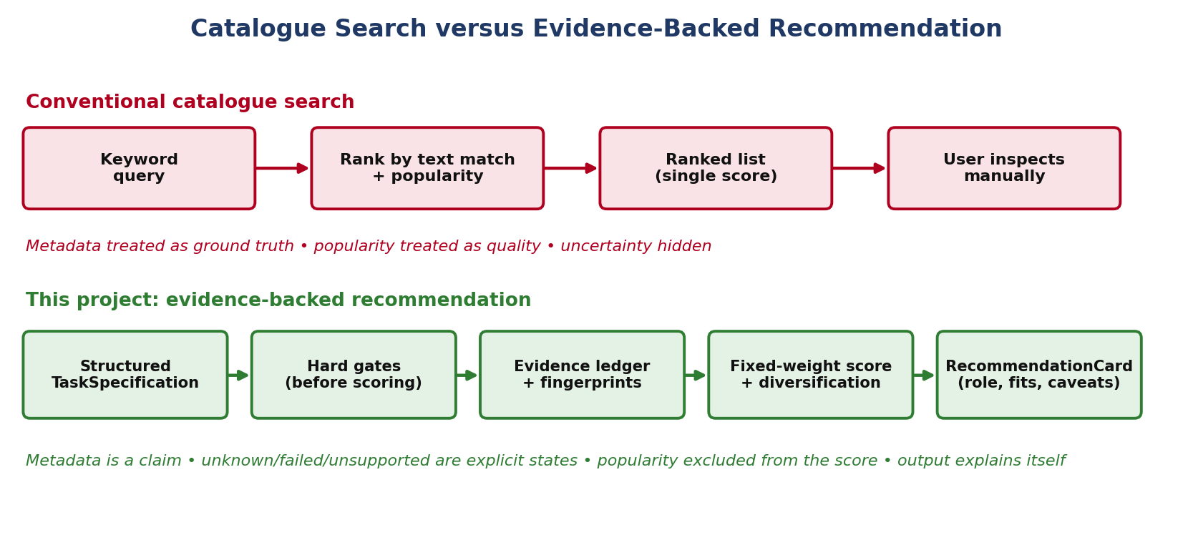
Figure 1.1: Catalogue Search versus Evidence-Backed Recommendation
The implemented system ingests structured task requirements, retrieves/normalizes a candidate pool from a multi-source corpus, applies hard compatibility gates, assembles a two-layer evidence ledger for each surviving candidate, performs bounded content fingerprinting where a sample is accessible, scores candidates on a fixed multi-objective formula, and returns a diversified, explained recommendation set. Every stage was implemented and is exercised by an automated test suite (208 tests, 8,416 lines of implementation code, 3,662 lines of test code); the system's behaviour is demonstrated on a 10-record development corpus (Milestones M1–M7) and validated on a frozen, independent 24-dataset benchmark spanning eight tasks (Milestone M8).

1.2 Motivation for the Work
Two related problems motivate the project. First, repository metadata cannot be treated as ground truth: it is publisher-supplied, inconsistently maintained, and occasionally self-contradictory. The system's own evidence ledger surfaced a concrete instance of this during development — the Rotten Tomatoes movie-review dataset carries a repository metadata field asserting an “MIT” license while its accompanying Croissant JSON-LD metadata points to a conflicting license URI. Because the system records this as a Conflicting resolution state rather than silently preferring one source, the contradiction is surfaced to the user instead of being hidden inside an average score (see Appendix C for the actual ledger record).
Second, popularity is a poor proxy for task suitability. Ranking by downloads or stars systematically favours datasets that are already well known, which can crowd out smaller or more specialized datasets that may fit a given task better. The project's popularity-audit component (Milestone M6) is deliberately excluded from the core scoring formula for this reason; popularity is retained only as contextual information and as one input to the assignment of a “hidden gem” role, never as a ranking signal.

1.3 Precise Problem Formulation
Given a structured task description T = (task_type, primary_modality, domain, target_requirements, input_constraints, scale_constraints, governance_constraints, access_constraints) and a heterogeneous corpus of dataset records D = {d₁, …, dₙ} drawn from multiple public repositories, the objective is to compute a small ordered subset S ⊂ D, |S| = k, such that: (i) every d ∈ S satisfies every hard constraint in T; (ii) each d ∈ S is scored by a multi-objective function R(d∣T) combining requirement fit, task-specific utility, resolved evidence strength, and coverage, minus a risk penalty, with popularity excluded from R entirely; (iii) S is diversified so that datasets sharing a lineage family are not redundantly co-selected; and (iv) every element of S is returned together with the evidentiary basis for the claims used to select it, including any unknown, unsupported, or conflicting evidence. The system must operate within a measured, explicit resource envelope (Chapter 3) rather than an assumed one, and R, the gating rules, and the diversification rule must all be evaluated against a benchmark frozen before evaluation to avoid post-hoc adjustment.

1.4 Research Questions
- RQ1 (Retrieval and Resource Efficiency): Can lexical retrieval achieve resource-compliant candidate generation where dense/hybrid retrieval measurably cannot, under a fixed local memory ceiling?
- RQ2 (Evidence Grounding): Does representing dataset claims as a two-layer observation/resolution model surface real metadata contradictions and quality defects that keyword-only metadata would not expose?
- RQ3 (Task-Aware Suitability and Gating): Does hard compatibility gating combined with multi-component utility estimation improve ranking correlation over a fit-only baseline, and how much of the candidate pool does gating remove?
- RQ4 (Lineage Diversification): Can family-aware greedy diversification eliminate redundant same-family candidates without a measured utility cost, when such redundancy exists in the candidate pool?
- RQ5 (Human Explanation Utility): Do evidence-augmented recommendation cards produce higher descriptive trust, understanding, and actionability ratings than minimal metadata cards in a small exploratory pilot?

1.5 Objectives of the Work
- Establish a measured local-compute envelope (memory ceiling, per-task latency ceiling, sample-size cap) before committing to an architecture, rather than assuming hardware headroom.
- Ingest and normalize dataset metadata from multiple public repositories into one canonical schema without discarding source-specific fields.
- Generate a candidate pool through resource-compliant lexical retrieval, benchmarked explicitly against a dense-embedding alternative.
- Apply hard compatibility gates ahead of soft scoring so incompatible candidates cannot be rescued by a high score on an unrelated dimension.
- Record every claim used in ranking in an evidence ledger with an explicit observation state, and resolve claims into an explicit cross-source agreement state.
- Estimate task-specific utility from bounded content inspection where a sample is legally and technically accessible, and fall back to a clearly labelled transfer estimate where it is not.
- Score and diversify the final recommendation set with fixed, sensitivity-tested weights, excluding popularity from the scoring formula itself.
- Evaluate the complete pipeline on a corpus and set of tasks frozen before evaluation, under offline, zero-network-egress conditions, and report every result — supported, exploratory, or not applicable — without inflation.

1.6 Scope and Project Boundaries
The project boundary is deliberately narrow in four respects, each revisited with full justification in Chapter 4.7 and Chapter 7: task intent is supplied as a structured specification rather than parsed from free natural language; the user-facing artifact is a JSON RecommendationCard/RecommendationSet rather than an interactive CLI or GUI; evidence resolution uses a deterministic two-layer categorical model rather than a formal Dempster–Shafer belief/plausibility fusion; and evaluation is conducted on a 10-record development corpus and a 24-dataset frozen benchmark rather than at web scale. None of these boundaries is accidental — each traces to a measured constraint (principally the 128 MiB memory ceiling) or a deliberate decision to keep the evaluated surface area small enough to verify exhaustively.

1.7 Contributions
- A complete, tested, local-first dataset-recommendation pipeline (8,416 lines of implementation code, 208 automated tests) integrating retrieval, a novel-to-this-project two-layer evidence model, bounded content fingerprinting, hard gating, fixed multi-objective scoring, and family-aware diversification.
- A frozen, offline, zero-egress 24-dataset × 8-task benchmark with five pre-registered hypotheses, a nine-rung ablation ladder, four-suite robustness testing, and a multi-parameter sensitivity sweep.
- Two real, previously undocumented findings surfaced during ordinary operation rather than constructed as test cases: a metadata licence contradiction (Rotten Tomatoes) and a severe class slice-bias condition (32-of-32 identical labels).
- An exploratory human-evaluation pilot comparing evidence-augmented and minimal recommendation cards, reported with its full set of methodological caveats rather than as a validated user study.
- A documented, evidence-map-audited distinction between every mechanism in the original research proposal and what was actually implemented and measured (Chapter 4.7, Chapter 7).

1.8 Report Organization
Chapter 2 surveys the research foundations the project draws on and the specific gap it addresses, including a research-gap matrix. Chapter 3 specifies the functional, non-functional, and data requirements derived from the measured resource envelope, with the exact canonical contracts used by the implementation. Chapter 4 presents the system's architecture, scoring and diversification design, and the respects in which the implementation deliberately diverges from the original research proposal. Chapter 5 is the technical core: it reports the milestone-by-milestone implementation and measured results from M0 through M8. Chapter 6 discusses outcomes, applicability, and threats to validity. Chapter 7 answers each research question against the evidence, states limitations and future work, and records individual, repository-verifiable technical contributions.

CHAPTER 2
RELATED WORK INVESTIGATION

2.1 Dataset Search and Recommendation Systems
Dataset search systems bridge natural-language or structured queries and published data repositories. Google Dataset Search indexes Schema.org dataset annotations at web scale, functioning as a document-retrieval system over descriptions without verifying that the underlying data matches what is described. DataFinder (Lin, Zhu, Ji, and Roth, ACL 2023) advances this by training a dense bi-encoder retriever specifically for scientific dataset recommendation and benchmarking it against BM25 and nearest-neighbour baselines; it treats published descriptions as authoritative and requires GPU-scale infrastructure that this project's 128 MiB local-compute envelope explicitly excludes.

2.2 Data-Centric Benchmarking and Quality Analysis
DataPerf (Mazumder et al., arXiv:2207.10062) reframes data-centric AI as a benchmarking problem: instead of evaluating models on fixed data, DataPerf evaluates data-selection and data-cleaning methods by their downstream effect on model performance. This project adapts that data-centric orientation into a lightweight, structural utility estimator rather than a trained downstream probe, because training a probe per candidate dataset was outside the validated compute budget.
Confident Learning (Northcutt, Jiang, and Chuang, NeurIPS 2021) — commonly known through the Cleanlab library — identifies label errors using out-of-sample predicted probabilities. The project's data-quality analysis draws on the same motivation (published labels are not automatically correct) but implements bounded, pure-Python structural diagnostics rather than the Cleanlab library itself, since confident-learning label-error estimation requires a trained classifier per dataset that the resource envelope does not accommodate.

2.3 Metadata Standards, Provenance, and Documentation
The MLCommons Croissant specification defines a machine-readable format for dataset metadata, structure, and usage policy, intended to make datasets more interoperable across catalogues and tools. This project's canonical schema is informed by Croissant's field groupings and uses Croissant JSON-LD as one additional evidence source in the ledger — notably, it is Croissant metadata that exposed the Rotten Tomatoes licence contradiction described in Chapter 1, precisely because it is treated as an independent source rather than a replacement for repository metadata. Data Cards (Pushkarna, Zaldivar, and Kjartansson, FAccT 2022) motivate the human-facing “why it fits / why it is not perfect” explanation contract used in the RecommendationCard (Chapter 4.6). The Data Provenance Initiative's large-scale audit of dataset licensing and governance in widely used machine-learning datasets documents that licence and governance metadata is frequently missing, stale, or internally inconsistent across a corpus far larger than this project's; that empirical finding motivates the evidence ledger's decision to represent every claim with an explicit observation state — including unsupported and unknown — rather than defaulting an unstated field to a permissive value.

2.4 Diversification and Evidence Fusion
GIST (Zadimoghaddam et al., NeurIPS 2025) formulates diversified subset selection as max-min diversification balanced against a utility objective, with a provable approximation guarantee under submodularity assumptions. The implemented diversification component is inspired by the same utility-plus-diversity objective but is not a submodular optimizer: it is a deterministic, family-aware greedy selector that adds a diversity bonus (λ_div × minimum pairwise attribute distance to the already-selected set) to the intrinsic score at each step, with a fixed tie-break rule. No dependency on GIST, submodlib, or any external submodular-optimization library exists in the implementation. Dempster–Shafer evidence theory (Shafer, 1976; Dempster, 1968) formalizes combining independent, possibly conflicting sources of belief by representing ignorance separately from disagreement — it motivated the original design of the evidence-resolution layer, and its calibration literature (Guo et al., ICML 2017, “On Calibration of Modern Neural Networks”) informed how this project frames its own internal consistency audit (Chapter 5.9.6). The resolver actually implemented is a deterministic categorical rule over five observation states and four resolution states (Chapter 4.4), not a belief/plausibility mass computation.

2.5 Comparative Literature Synthesis
Foundation | What It Provides | Limitation for This Project | What This Project Adds / Integrates
DataFinder | Trained dense retrieval for scientific datasets; strong recall on its benchmark | Requires GPU-scale bi-encoder training/inference; exceeds the 128 MiB envelope by measurement (M2) | Used as the retrieval baseline reference only; BM25 is the resource-compliant default
DataPerf | Downstream-performance-based evaluation of data selection | Requires training a model per candidate; incompatible with the per-task latency ceiling | Motivates a lightweight structural utility estimator instead of a trained probe
Confident Learning / Cleanlab | Principled label-error detection via out-of-sample probabilities | Requires a trained classifier per dataset; infeasible at this sample-size cap | Bounded, pure-Python structural diagnostics implemented instead
Croissant | Standardized, machine-readable dataset metadata/provenance | Not universally published; cannot be the sole evidence source | One of five evidence types in the ledger; cross-checks repository metadata
Data Cards | Purpose-driven visual summaries of dataset context and limitations | A documentation convention, not a scoring or retrieval mechanism | Motivates the card's “why it fits / why not perfect” explanation contract
GIST | Utility + diversity subset selection with an approximation guarantee (submodular) | Guarantee depends on submodularity and external solver machinery | Objective adapted into a deterministic family-aware greedy selector; no submodularity claim
Dempster–Shafer theory | Formal belief/plausibility fusion separating ignorance from disagreement | Requires per-source reliability priors and mass-function computation not implemented here | Motivated the two-layer categorical resolver design; deferred as a future upgrade
Data Provenance Initiative | Empirical evidence that licence/governance metadata is often unreliable | An audit finding, not a system to integrate | Motivates the explicit unknown/unsupported observation states in the ledger
Table 2.1: Research Foundations and Adopted Methodological Roles

2.6 Research-Gap Matrix
None of the surveyed systems is reproduced or re-implemented by this project. Table 2.2 makes the gap explicit: each row is a capability existing work provides in isolation, and the corresponding cell states whether and how this project integrates it under a bounded resource envelope.
Capability | Addressed in Isolation By | Addressed Jointly, Under a Bounded Envelope, By
Relevant candidate retrieval | DataFinder (dense bi-encoder) | This project (BM25, measured resource-compliant; dense benchmarked and rejected)
Evidence-aware claim verification | Provenance audits (descriptive only) | This project's evidence ledger (two-layer observation/resolution states)
Data-quality diagnosis | Cleanlab / Confident Learning (trained) | This project's bounded structural fingerprinting (untrained)
Utility-aware selection | DataPerf (trained downstream probes) | This project's heuristic structural utility estimator
Diversified final sets | GIST (submodular, unconstrained compute) | This project's family-aware greedy selector (bounded, deterministic)
Bounded, offline resource operation | Not addressed by any surveyed system | This project's M0-measured 128 MiB / 20 s envelope, verified end-to-end at M8
Table 2.2: Research-Gap Matrix
The identified research gap is therefore not a missing algorithm but a missing integration: existing dataset-search work optimizes retrieval quality in isolation, existing data-quality work assumes a single dataset already selected, and existing diversification work assumes an unconstrained compute budget. This project's contribution is the integration of retrieval, epistemic evidence tracking, bounded content verification, and diversified selection into one pipeline that operates under a measured, bounded local resource envelope, together with an evaluation that is explicit about which claims are directly measured, which are architecturally verified but statistically untestable, and which remain future work.

CHAPTER 3
REQUIREMENT ARTIFACTS

3.1 Introduction
Because the system is constrained to a measured local-compute envelope rather than an assumed one, its requirements are stated as measurable ceilings and structural contracts wherever possible, rather than as qualitative goals such as “fast” or “lightweight.” This chapter separates functional, non-functional, computational, and data-source requirements, and specifies the canonical data contracts — TaskSpecification, CanonicalDatasetRecord, EvidenceLedger, DatasetFingerprint, and the ranking/output contract — that every pipeline stage reads or writes. Figure 3.1 shows how these contracts chain together.
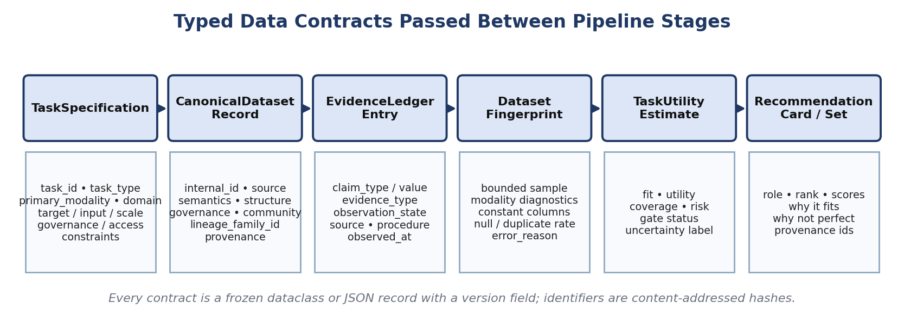
Figure 3.1: Typed Data Contracts Passed Between Pipeline Stages

3.2 Functional Requirements
ID | Requirement | Realized By
FR-1 | Accept a structured TaskSpecification as the unit of user intent (no free-text NL parser) | utility/specification.py
FR-2 | Normalize multi-source metadata into one canonical schema, retaining source-specific fields | ingestion/* adapters
FR-3 | Retrieve an initial candidate pool via BM25 lexical search | retrieval/*
FR-4 | Apply hard compatibility gates before any soft scoring | ranking/pipeline.py
FR-5 | Collect and resolve evidence per candidate into observation and resolution states | evidence/ledger.py, evidence/statuses.py
FR-6 | Perform bounded content fingerprinting where a sample is accessible (≤ 32 records / 64 MiB) | fingerprinting/*
FR-7 | Estimate task-specific utility, or a labelled transfer estimate when direct sampling fails | utility/estimator.py
FR-8 | Score candidates with the fixed multi-objective formula and diversify the final set | ranking/scoring.py, ranking/diversification.py
FR-9 | Emit a structured RecommendationCard / RecommendationSet as JSON (no interactive CLI) | ranking/explanation.py
Table 3.1: Functional Requirements

3.3 Non-Functional Requirements
ID | Requirement | Verification
NFR-1 | Peak process memory must not exceed the M0 ceiling | Measured 33.11 MiB at M8 (25.9% of 128 MiB)
NFR-2 | Evaluation must execute under verified zero network egress | zero_egress_verified: true, m8_summary.json
NFR-3 | Every implemented behaviour must be covered by an automated test | 208/208 tests passing (Appendix F)
NFR-4 | Ranking must be stable to reasonable perturbation of scoring weights | Jaccard = Kendall τ = 1.0 at ±20% (M8 sensitivity)
NFR-5 | The pipeline must degrade gracefully, not crash, under corrupted metadata | 0.0% crash rate, 4 suites × 10 trials (M8 robustness)
NFR-6 | Every claim used in scoring must be traceable to a source and observation state | EvidenceLedger entry_id references in every card
Table 3.2: Non-Functional Requirements

3.4 Computational Constraints — the M0 Envelope
Milestone M0 measured and fixed the operating envelope before any subsequent component was built at scale: a 134,217,728-byte (128.00 MiB) process memory ceiling, a 20,000 ms cold per-query time budget, and a 32-record / 67,108,864-byte (64 MiB) hard cap on bounded content sampling, measured under a fixed random seed (20260902).
Constraint | Value
Process memory ceiling | 134,217,728 B (128.00 MiB)
Cold per-task latency budget | 20,000 ms
Bounded sample cap | 32 records / 67,108,864 B (64 MiB)
Random seed | 20260902
Table 3.3: Computational Constraints (M0 Envelope)

3.5 Data-Source Requirements
Source | Access Mode | M0 Policy
Hugging Face Hub | Dataset viewer / parquet metadata | Full ingestion and bounded sampling supported
OpenML | REST API metadata | Full ingestion and bounded sampling supported
UCI ML Repository | Static metadata + data files | Full ingestion and bounded sampling supported
Kaggle | REST API metadata only | Metadata-only under M0 policy — no programmatic sampling without credentials
Table 3.4: Data-Source Requirements

3.6 Canonical Contracts

3.6.1 TaskSpecification
Each task is defined as an immutable, structured specification — no natural-language parsing occurs anywhere in the pipeline. Figure 3.2 shows a real excerpt from the project's own M8 corpus-preparation configuration.
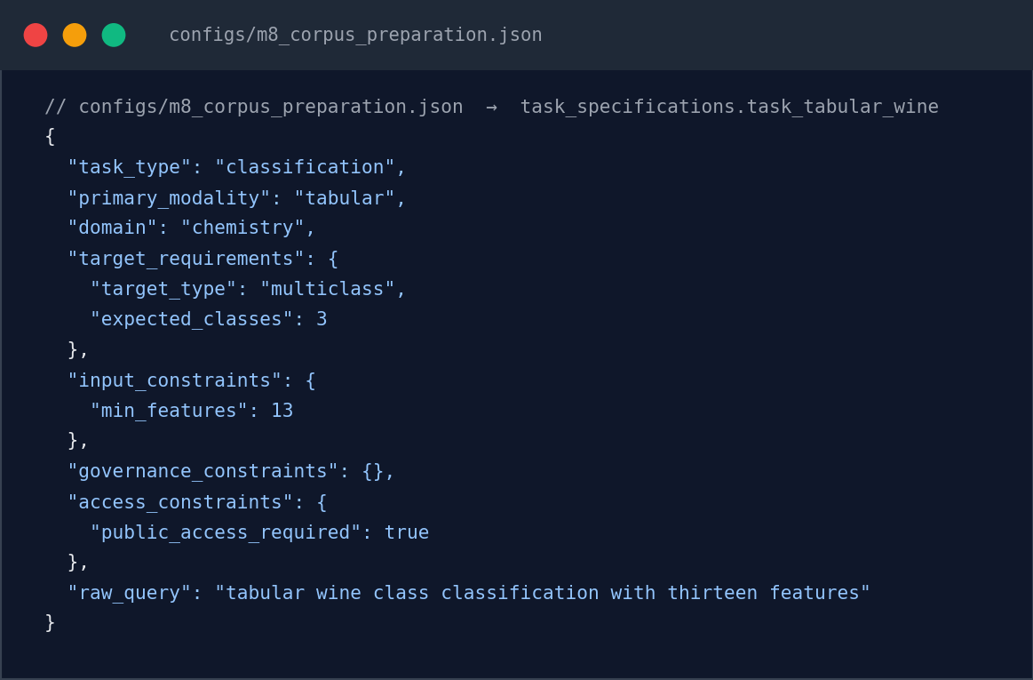
Figure 3.2: TaskSpecification JSON (Real Configuration Excerpt)
Source: configs/m8_corpus_preparation.json → task_specifications.task_tabular_wine
Field | Purpose
task_id | Unique identifier
primary_modality | tabular / text / image
domain | General task domain
target_requirements | Target attribute / label expectations
input_constraints | Minimum samples, required fields
scale_constraints | Size/scale bounds
governance_constraints | Licence/usage requirements
access_constraints | Programmatic access requirements
Table 3.5: TaskSpecification Contract

3.6.2 CanonicalDatasetRecord
Field Group | Representative Fields
Identity | internal_id, source_name, source_id, dataset_name, canonical_url, lineage_family_id
Semantics | description, task, domain, modality, target_variable
Structure | sample_count, class_count, schema, splits, feature/field information
Governance | license_claim, usage_policy, citation, provenance_links
Community context | downloads, stars, ratings, citations, update timestamps
Observed content | fingerprint results, modality diagnostics, probe results
Table A.1: CanonicalDatasetRecord Schema Groups
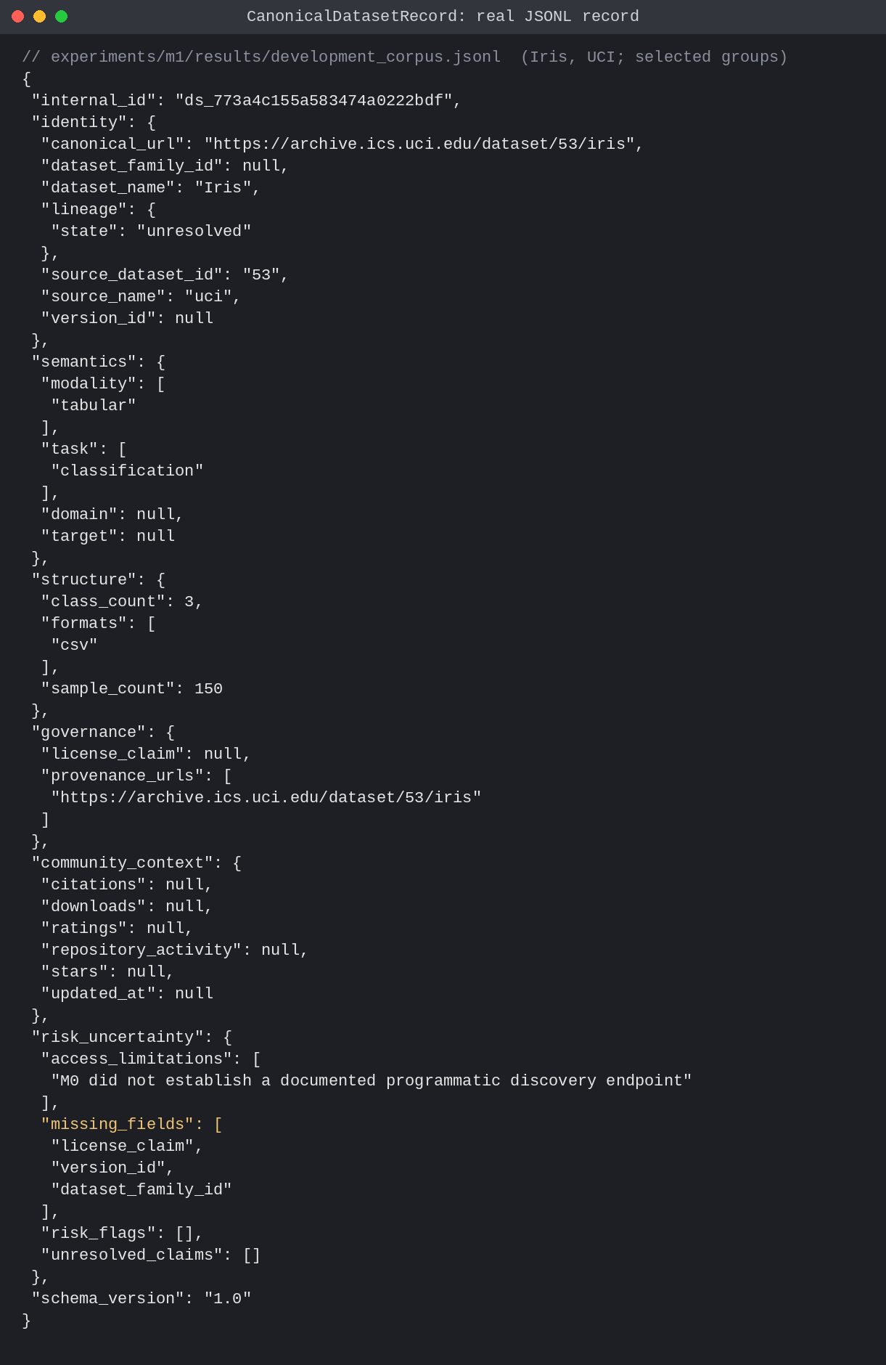
Figure A.1: Real CanonicalDatasetRecord for the UCI Iris dataset (development corpus), selected fields shown as pretty-printed JSON. Source: experiments/m1/results/development_corpus.jsonl, revision bff0767.

3.6.3 EvidenceLedger — Two-Layer State Model
Evidence is represented in exactly two distinct layers, not a single five-state model. Layer 1 records, per individual observation, one of five observation states. Layer 2 resolves the set of observations recorded for one claim into one of four cross-source resolution states. Belief/plausibility mass functions (Dempster–Shafer) are not computed; resolution is a deterministic categorical rule (Chapter 4.4, Figure 4.2).
Layer | States
1 — Observation (per entry) | observed · single_source_claim · unsupported · failed · unknown
2 — Resolution (per claim, across entries) | corroborated · conflicting · unresolved · unknown
Table 3.7: Two-Layer Evidence-State Model
Figure 3.3 shows two real Layer-1 observation entries for the Rotten Tomatoes licence claim (one repository-metadata claim, one Croissant claim) together with the resulting resolution_summary distribution actually recorded by Milestone M3.
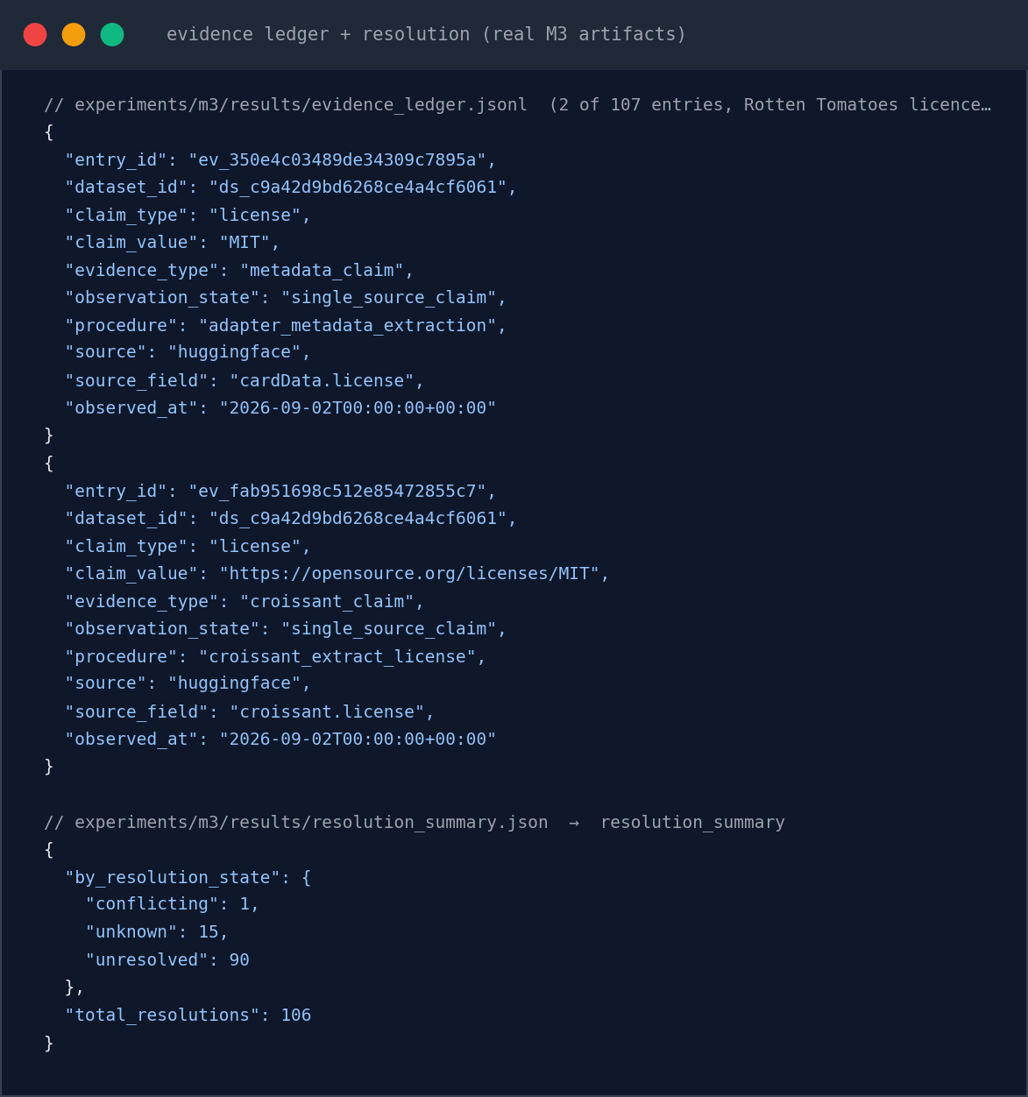
Figure 3.3: Evidence Ledger and Resolution Summary (Real M3 Artifacts)
Source: experiments/m3/results/evidence_ledger.jsonl, resolution_summary.json

3.6.4 Dataset Fingerprint Contract
Field | Purpose
sample_size | Records actually inspected (≤ 32)
modality_diagnostics | Modality-specific structural checks
constant_columns | Zero-variance columns detected
null_duplicate_rate | Missingness and duplication rate
error_reason | Why sampling failed, if it did (e.g. HTTP 502)
Table 3.8: Dataset Fingerprint Contract

3.6.5 Ranking / Output Contract
Field | Purpose
assigned_role | best_overall · efficient alternative · diverse alternative · hidden_gem
component_scores | fit, utility, evidence_support, content_coverage, risk_penalty
why_it_fits / why_it_is_not_perfect | Evidence-grounded explanation fields
provenance links | evidence_entry_ids, fingerprint_id, utility_estimate_id
Table 3.9: Ranking / Output Contract

3.7 Provenance and Reproducibility Requirements
Requirement | Realized By
Every claim traces to a source and timestamp | EvidenceLedger.observed_at, source, source_field
Benchmark inputs are frozen before evaluation | M8 input freeze: 2026-09-12T16:24:05Z
Zero network egress is verified, not assumed | Socket-mocked harness; zero_egress_verified: true (m8_summary.json)
Environment is recorded for every benchmark run | macOS 26.6.2, arm64, Python 3.14.6 (m8_summary.json → reproducibility)
Table 3.10: Provenance and Reproducibility Requirements
Zero-egress is not merely asserted: the M8 evaluation harness mocks the socket layer during execution and records a verified boolean flag in the resulting artifact (Chapter 5.9.1, Appendix D), which this report cites directly rather than describing as an assumption.

3.8 Milestone 8 Benchmark Corpus
Task Identifier | Modality | Target Attribute | Primary Source(s)
task_tabular_iris | Tabular classification | species | UCI / OpenML
task_tabular_wine | Tabular classification | quality | UCI / OpenML
task_tabular_titanic | Binary classification | survived | OpenML / Kaggle
task_tabular_diabetes | Binary classification | outcome | UCI / Kaggle
task_sentiment_binary | Sentiment analysis (text) | sentiment | Hugging Face
task_news_multiclass | Topic classification (text) | topic | Hugging Face
task_image_cifar | Image classification | label | Hugging Face
task_image_leaf_disease | Disease classification (image) | disease | Hugging Face
Table 3.11: Milestone 8 Frozen Benchmark Corpus (24 Datasets × 8 Tasks; one Kaggle target excluded after an HTTP 403 access failure)

3.9 Summary
Every requirement in this chapter is either a ceiling measured at Milestone M0 or a structural contract implemented and exercised by the 208-test automated suite; none is an assumed or aspirational figure. Chapter 4 now presents how these requirements are met architecturally, including the specific points at which the implemented design diverges from the original research proposal.

CHAPTER 4
DESIGN METHODOLOGY AND ITS NOVELTY

4.1 Guiding Design Principles
Principle | Architectural Realization
Evidence over assertion | Every score-relevant claim is an EvidenceLedger entry with a source and observation state
Suitability over popularity | Popularity is structurally absent from R2/R3 (Chapter 4.5); used only for the hidden_gem predicate
Explicit epistemic uncertainty | unknown / unsupported / failed are first-class states, never silently imputed
Hard-gating precedence | Structural incompatibility is a filter applied before scoring, not a score penalty
Recommendations as a set | R3 diversification evaluates the final k candidates jointly, not independently
Local-first resource bounds | Every stage operates inside the M0-measured 128 MiB / 20 s envelope
Table 4.1: Design Principles and Their Architectural Realization
The project's goal is not a new retrieval or diversification algorithm; it is the integration of established techniques into one pipeline under this bounded envelope, with the integration itself — and its measured effect — subjected to the ablation, robustness, and sensitivity analysis reported in Chapter 5.

4.2 End-to-End System Architecture
Figure 4.1 distinguishes the actual M8 evaluation path from the separate M2 retrieval-benchmark branch. In the frozen M8 harness, the corpus is already known and frozen, so retrieval is not exercised on the evaluation path itself — the corpus, evidence ledger, and fingerprints are fed directly into the RecommendationEngine. BM25/dense/hybrid retrieval (Chapter 5.4) is a separate ablation/benchmark component that determined which retriever to use for candidate generation in the general (non-frozen-benchmark) operating mode.
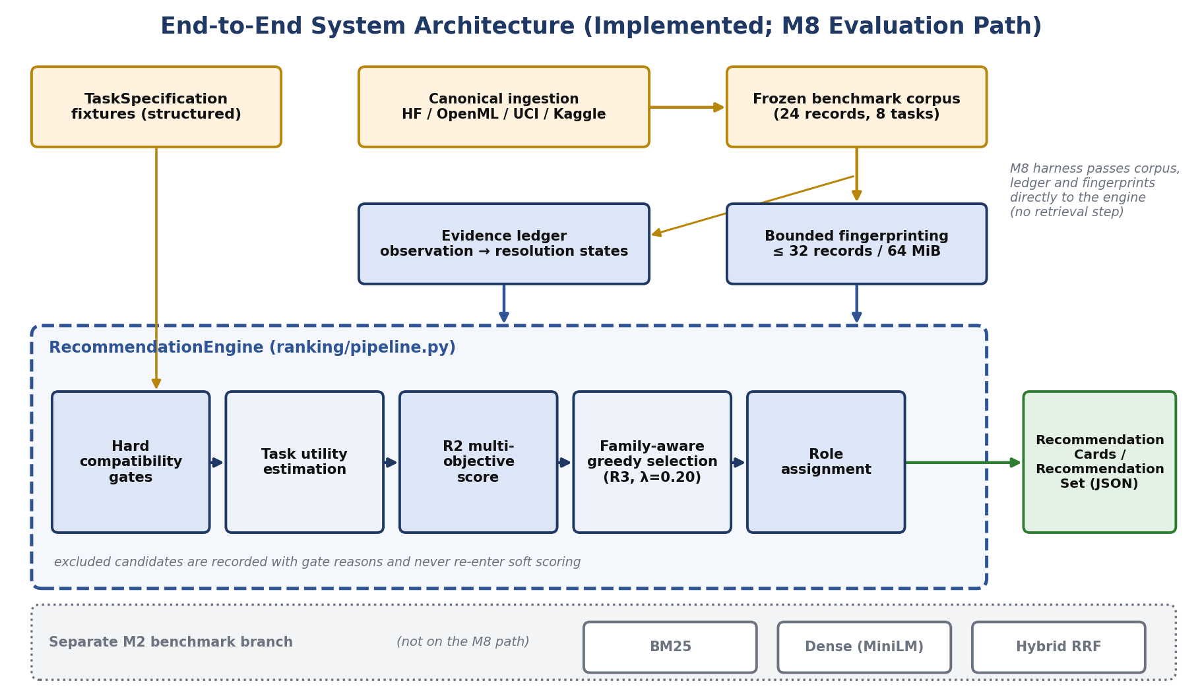
Figure 4.1: End-to-End System Architecture (Implemented; M8 Evaluation Path)

4.3 Retrieval Design
Three retrieval strategies were implemented and benchmarked (Chapter 5.4): BM25 lexical retrieval, dense retrieval using all-MiniLM-L6-v2 embeddings, and a hybrid reciprocal-rank-fusion (RRF) combination. Figure 4.5 isolates this branch from the main evaluation path.
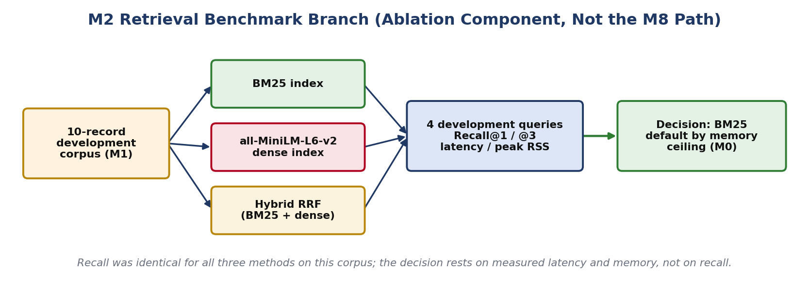
Figure 4.5: M2 Retrieval Benchmark Branch (Ablation Component, Not the M8 Path)

4.4 Evidence Ledger and Trust Model
Evidence is represented in two distinct layers (Figure 4.2, Table 3.4). Layer 1 records, per individual observation, one of five observation states: observed (directly measured or verified through bounded probing/parsing), single_source_claim (asserted by one publisher/card without independent corroboration), unsupported (the operation is formally unsupported for this source), failed (a supported operation encountered an operational or network failure), or unknown (the property was unstated or unobserved). Layer 2 resolves the set of observations recorded for one claim into one of four cross-source resolution states: corroborated (independent sources agree, or a claim matches a direct observation), conflicting (two or more observations assert incompatible values — the Rotten Tomatoes licence case is exactly this state), unresolved (a single-source or inconclusive claim without corroboration or conflict), or unknown (no evidence exists, or all observations are themselves unknown/failed). This two-layer categorical model is a deterministic rule-based resolver; it does not compute Dempster–Shafer belief or plausibility mass functions. Formal evidence fusion using Dempster–Shafer theory was part of the original research proposal (§4.7) but was not the resolution mechanism ultimately implemented.
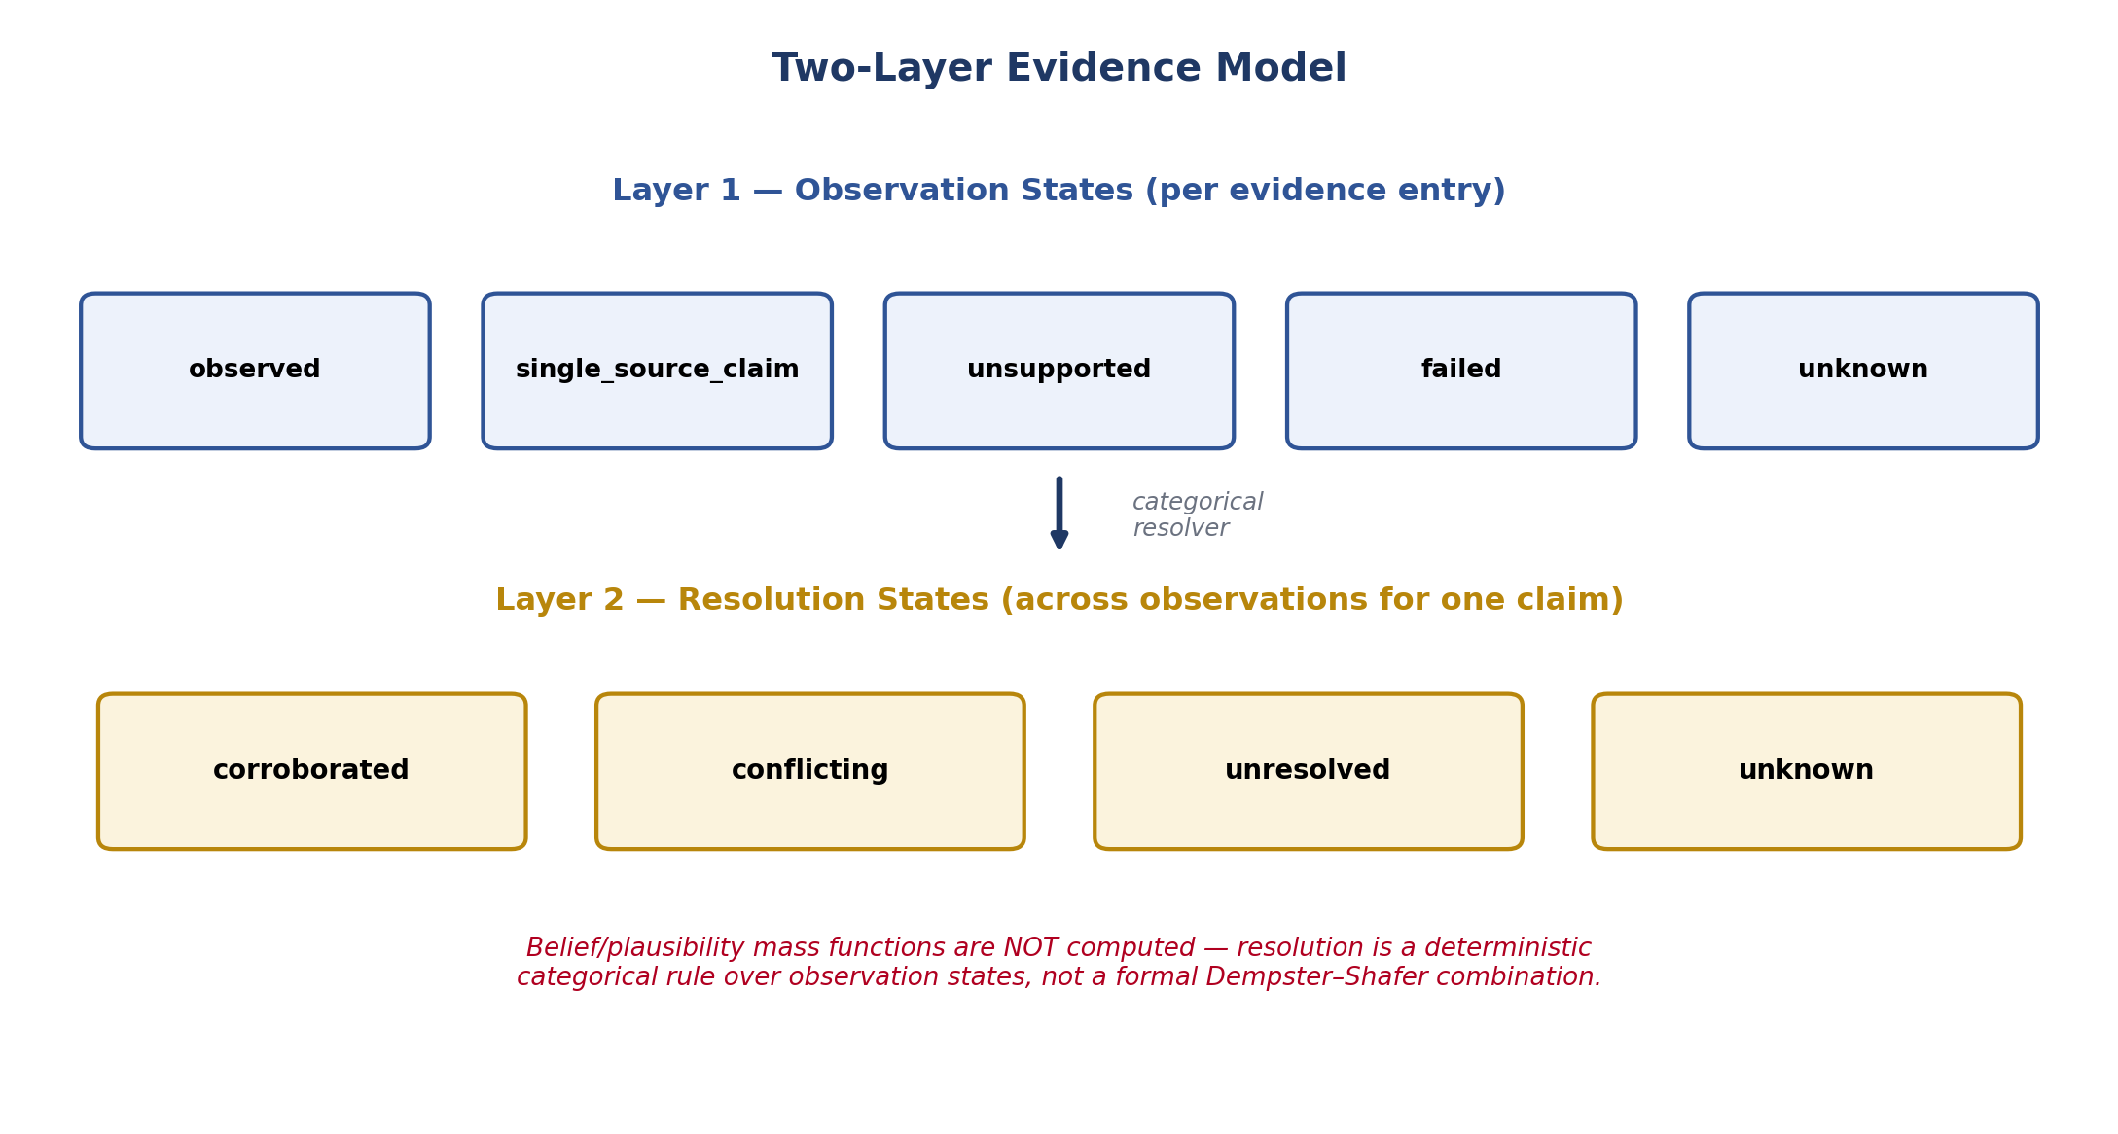
Figure 4.2: Two-Layer Evidence Model

4.5 Recommendation Scoring and Diversification
Multi-objective scoring (R2) is a fixed-weight linear combination:
R2(d∣Q) = 0.35·Fit + 0.35·Utility + 0.15·Evidence + 0.15·Coverage − 0.15·Risk
Weight | Term | Value
w_fit | Requirement compatibility | 0.35
w_util | Task-specific utility | 0.35
w_evid | Resolved evidence strength | 0.15
w_cov | Coverage / non-redundancy | 0.15
w_risk | Risk (subtracted) | 0.15
Table 4.3: Fixed Multi-Objective Scoring Weights (validated by the ±20% sensitivity sweep in Chapter 5)
Final selection (R3) is a deterministic, family-aware greedy procedure: at each step the candidate maximizing intrinsic score plus λ_div × (minimum pairwise attribute distance to the already-selected set) is added, with λ_div = 0.20 and a fixed tie-break rule. This is a greedy heuristic with a diversity bonus, not a submodular optimizer with an approximation guarantee — no submodularity property is claimed or relied upon, and the implementation has no dependency on an external submodular-optimization library. Figure 4.3 traces the full flow from candidate pool to final RecommendationSet, including where hard gates remove candidates and where popularity is explicitly excluded.
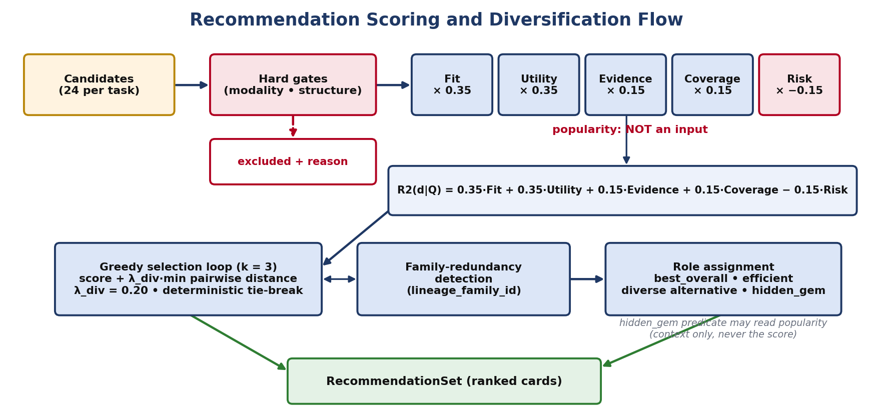
Figure 4.3: Recommendation Scoring and Diversification Flow
Gate | Rule | M5 Measured Exclusion Rate
Modality gate | Candidate modality must match task's required_modality | Primary contributor to 75.0% (90/120)
Structural gate | Required target/label structure must be present | Included in the 75.0% aggregate
Access gate | Formally unsupported access paths (e.g., Kaggle metadata-only) route to transfer estimate, not exclusion | N/A — routes to Chapter 4.6 fallback
Table 4.4: Hard Compatibility Gate Rules

4.6 Task-Specific Utility Estimation and Cold-Start Fallback
Utility is estimated structurally from bounded content inspection rather than a trained downstream probe. Where a sample is accessible, the estimator inspects structural and distributional signals against the task's target/input constraints. Where sampling is unsupported or fails (Chapter 5.6), the system does not silently drop the candidate; it falls back to a labelled transfer estimate derived from already-probed, structurally similar candidates, explicitly marked as such in the evidence ledger rather than presented as a direct observation.

4.7 RecommendationCard Structure
Each recommended dataset is rendered as a structured RecommendationCard exposing its assigned role, component scores, explicit “why it fits” and “why it is not perfect” fields drawn only from the evidence ledger, an operational-context block, and provenance links to every artifact used to construct it (Figure 4.4, drawn from a real M7 output record — the full JSON appears in Appendix D).
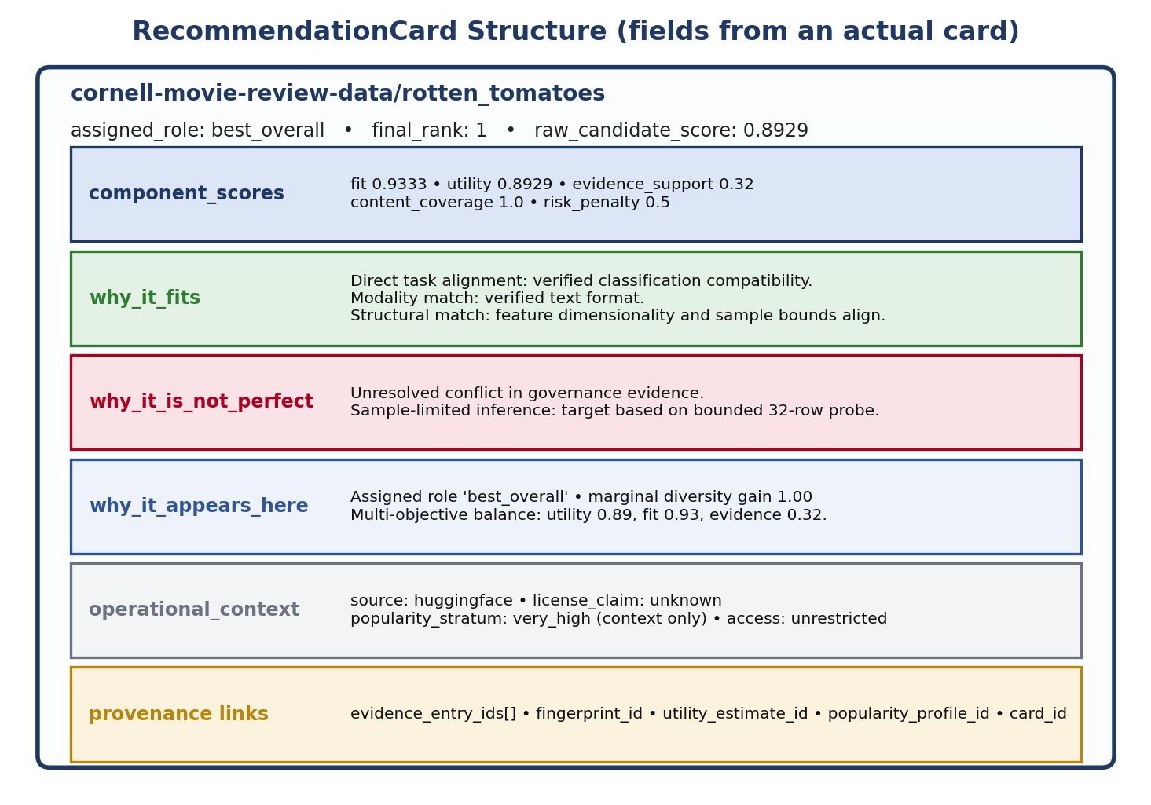
Figure 4.4: RecommendationCard Structure

4.8 Design Alternatives and Scope Evolution
The original research proposal considered a broader set of mechanisms than the validated implementation covers. Each is listed here as a deliberate design alternative or deferred item, not as an implemented feature, so the distinction between what was proposed and what was built and measured remains explicit throughout this report.
Proposed Mechanism | Status | Reason Deferred / What Was Implemented Instead
LLM / constrained natural-language requirement parser | Deferred | Non-deterministic and unnecessary for a fixture-driven benchmark; structured TaskSpecification JSON used instead
Interactive command-line interface | Deferred | Evaluation-first priority; structured JSON RecommendationCard/Set output used instead
Dempster–Shafer formal evidence fusion (belief/plausibility mass) | Deferred | Requires calibrated per-source reliability priors beyond this project's scope; deterministic two-layer categorical resolver implemented
Cleanlab confident-learning workflow | Deferred | Requires a trained classifier per dataset, incompatible with the sample-size cap; bounded structural diagnostics implemented instead
Trained DataFinder-style dense bi-encoder retriever | Benchmarked and not adopted | Measured at 453.22 MiB, 3.54× over the M0 ceiling; BM25 adopted
GIST / submodular facility-location or farthest-first diversification | Design alternative, not adopted | No external submodular solver available within the envelope; deterministic family-aware greedy selector implemented
Learning-to-rank scoring weights | Future work | No sufficient human relevance-judgment set to fit weights; fixed heuristic weights validated by ±20% sensitivity sweep instead
Trained downstream task probes / performance claims | Deferred | Training a probe per candidate exceeds the per-task latency budget; heuristic structural utility estimator used instead
Table 4.2: Design Alternatives Deferred to Future Work

4.9 Summary
The architecture realizes the six design principles from §4.1 through five typed data contracts (Chapter 3.6) and two governing formulas: the two-layer evidence model that keeps disagreement distinct from ignorance, and the fixed multi-objective score plus family-aware greedy diversification that keeps popularity out of the ranking path. Every one of the five research questions posed in Chapter 1 is addressed by a specific measured component in this design: RQ1 by the BM25-versus-dense retrieval comparison, RQ2 and RQ3 by the evidence ledger and utility estimator, RQ4 by the diversification selector, and RQ5 by the explanation-card contract evaluated in the human pilot. Chapter 5 reports how each of these components was implemented milestone by milestone and what was actually measured.

CHAPTER 5
TECHNICAL IMPLEMENTATION AND ANALYSIS

5.1 Experimental Setup
The system was built and evaluated in nine milestones, M0 through M8, each gated on the previous milestone's measured results rather than a fixed calendar schedule (Figure 5.1). M0 established the resource envelope; M1 built the canonical corpus and source adapters; M2 through M7 implemented and benchmarked retrieval, the evidence ledger, content fingerprinting, utility estimation, popularity auditing, and diversification on a 10-record development corpus; and M8 executed the complete pipeline, frozen, on an independent 24-dataset × 8-task benchmark under offline, zero-egress conditions. Every number in this chapter is read from the canonical measured artifact under experiments/m*/results/ — prose restates a measured figure, it does not estimate one. The repository comprises 8,416 lines of implementation code across nine subpackages and 3,662 lines of test code (Figure 5.2); the 208-test automated suite passes in full at the reporting revision (Figure 5.3).
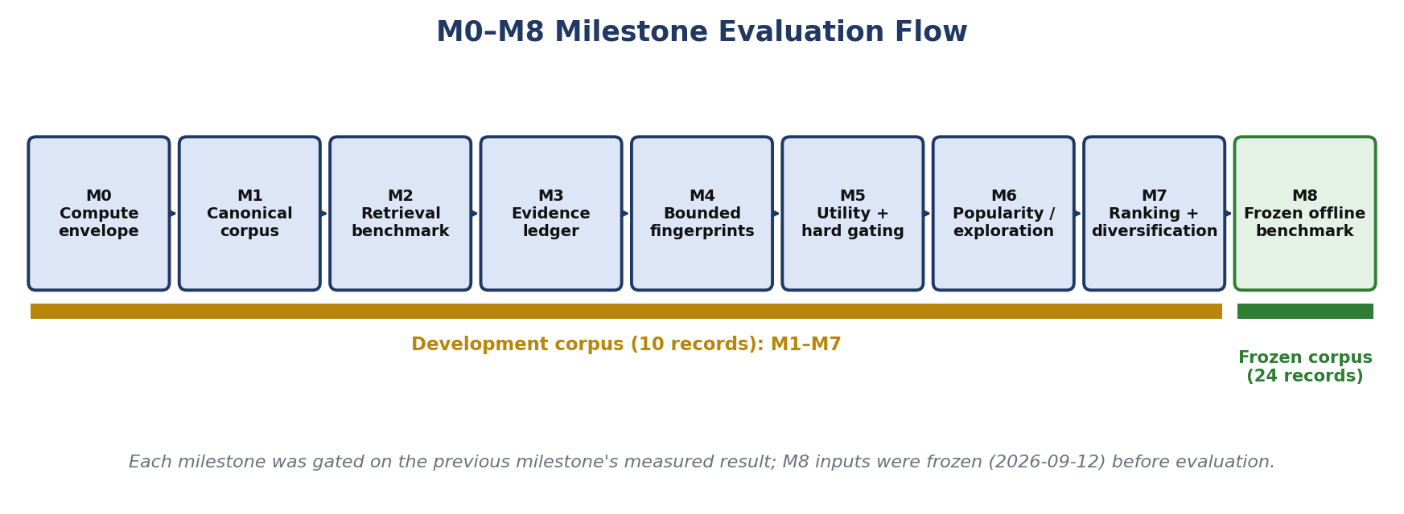
Figure 5.1: M0–M8 Milestone Evaluation Flow
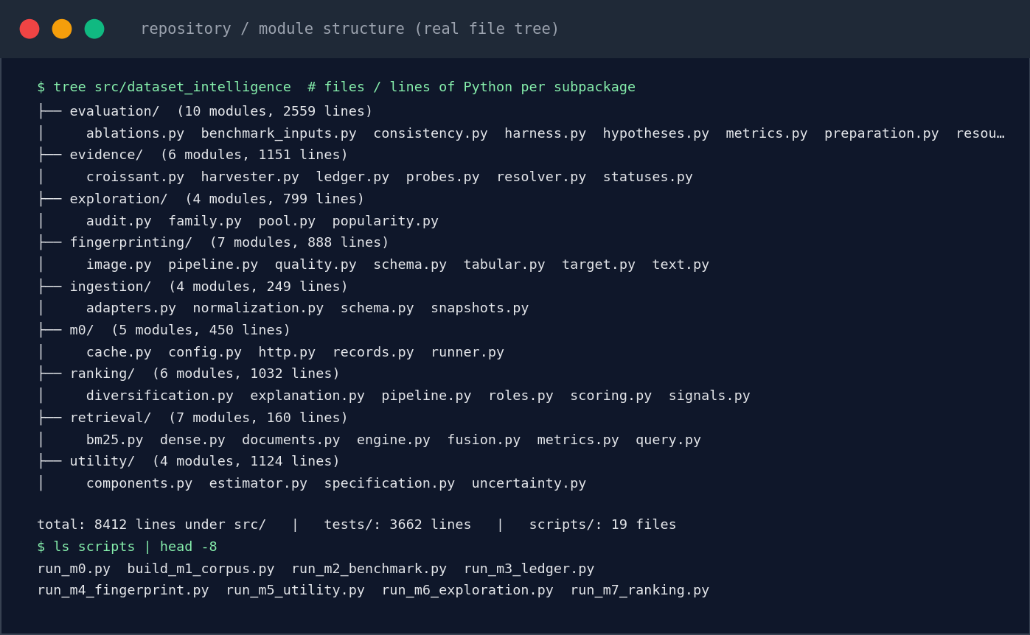
Figure 5.2: Repository / Module Structure (Real File Tree)
Source: src/dataset_intelligence/, tests/, scripts/
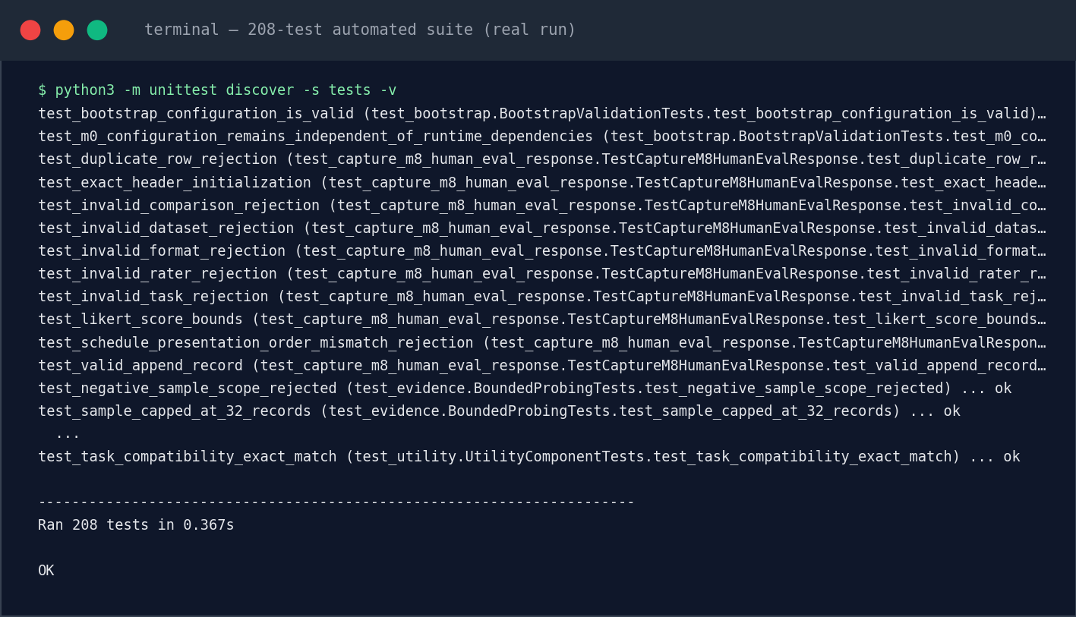
Figure 5.3: 208-Test Automated Suite (Real Run)
Source: python3 -m unittest discover -s tests -v

5.2 Milestone M0 — Compute-Budget Validation
Objective: measure, rather than assume, the resource envelope every later milestone must respect. Method: one full evidence-collection-and-probe cycle on the development corpus, timed and memory-profiled directly. Result: Table 5.1. Interpretation: the 128 MiB ceiling is deliberately conservative for ordinary consumer hardware, and it is this ceiling — not an architectural preference — that later excludes dense retrieval (§5.4) and trained downstream probes (§4.6). Limitation: measured on one machine; portability across hardware is not separately verified (Appendix F).
Constraint | Value
Process memory ceiling | 134,217,728 B (128.00 MiB)
Cold per-task latency budget | 20,000 ms
Bounded sample cap | 32 records / 67,108,864 B (64 MiB)
Seed | 20260902
Table 5.1: M0 Resource Envelope

5.3 Milestone M1 — Canonical Corpus
Objective: normalize heterogeneous repository metadata into one schema without losing source-specific context. Input: raw metadata from Hugging Face, OpenML, UCI, and Kaggle. Method: one adapter per source writing into the CanonicalDatasetRecord contract (Table 3.6, §3.6.2). Result: a 10-record development corpus spanning tabular, text, and image modalities, used as the substrate for M2–M7. Interpretation: normalization succeeded without collapsing source-specific governance fields, which is what later let M3 detect a genuine cross-source conflict (§5.5). Limitation: 10 records is a development-scale corpus, never mixed with the 24-record M8 corpus in any statistic in this report.

5.4 Milestone M2 — Retrieval Experiments
Objective: choose a retriever under the M0 memory ceiling. Input: the 10-record development corpus and 4 development queries. Method: BM25, dense (all-MiniLM-L6-v2), and hybrid RRF, each measured for recall, latency, and peak memory. Result: all three achieved identical retrieval quality — mean Recall@1 = 0.875 and Recall@3 = 1.000 — so no method can be preferred on recall alone at this corpus size (the small query set saturates Recall@3). The methods separate sharply on cost: BM25's mean query latency was 0.0602 ms, hybrid RRF's was 15.0808 ms, and dense retrieval's was 700.1929 ms (index build 81,000.40 ms, embedding generation 5,038.56 ms). The dense/hybrid embedding index reached a peak of 475,234,304 bytes (453.22 MiB) — 3.54× the ceiling.
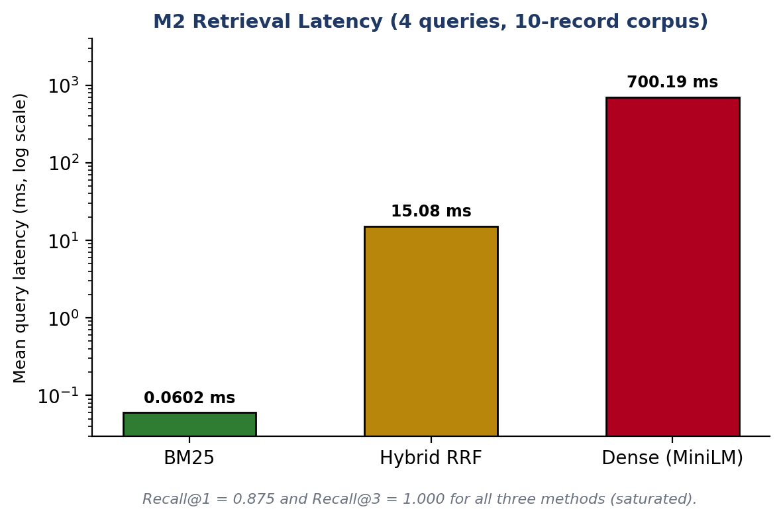
Figure 5.4: M2 Retrieval Latency Comparison
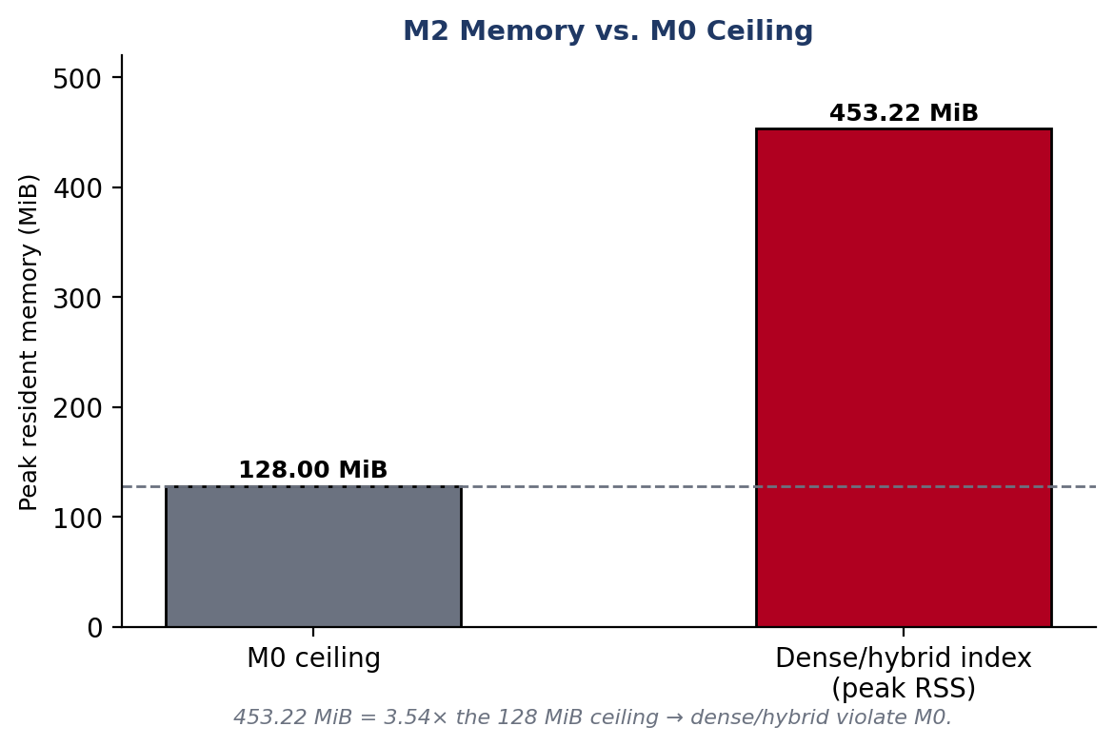
Figure 5.5: M2 Retrieval Memory/Resource Comparison
Method | Mean Latency | Recall@1 / @3 | Peak RSS
BM25 | 0.0602 ms | 0.875 / 1.000 | ≤ 30 MiB (compliant)
Hybrid RRF | 15.0808 ms | 0.875 / 1.000 | 453.22 MiB (shared index)
Dense (MiniLM) | 700.1929 ms | 0.875 / 1.000 | 453.22 MiB (3.54× over ceiling)
Table 5.2: M2 Retrieval Comparison
Interpretation: BM25 was adopted as the default retriever on resource grounds, not because it was shown to retrieve better — recall parity means RQ1 is answered by the cost axis, not the quality axis. Limitation: 4 queries over 10 records is too small to generalize a recall ranking to a larger corpus.

5.5 Milestone M3 — Evidence Ledger
Objective: test whether an explicit evidence ledger surfaces real metadata problems. Input: the 10-record corpus's repository metadata, Croissant records, documentation, and direct observations. Method: write one ledger entry per claim with its observation state; resolve claim types with the deterministic Layer-2 rule. Result: 107 entries (54 metadata, 20 access probes, 13 Croissant, 10 documentation, 10 content observations); 62.6% (67) single-source claims; 84.9% (90 of 106 claim types) unresolved; exactly one genuine conflict — Rotten Tomatoes' repository metadata asserting “MIT” against a Croissant record pointing to a different licence URI. Ledger construction and resolution completed in 23.56 ms.
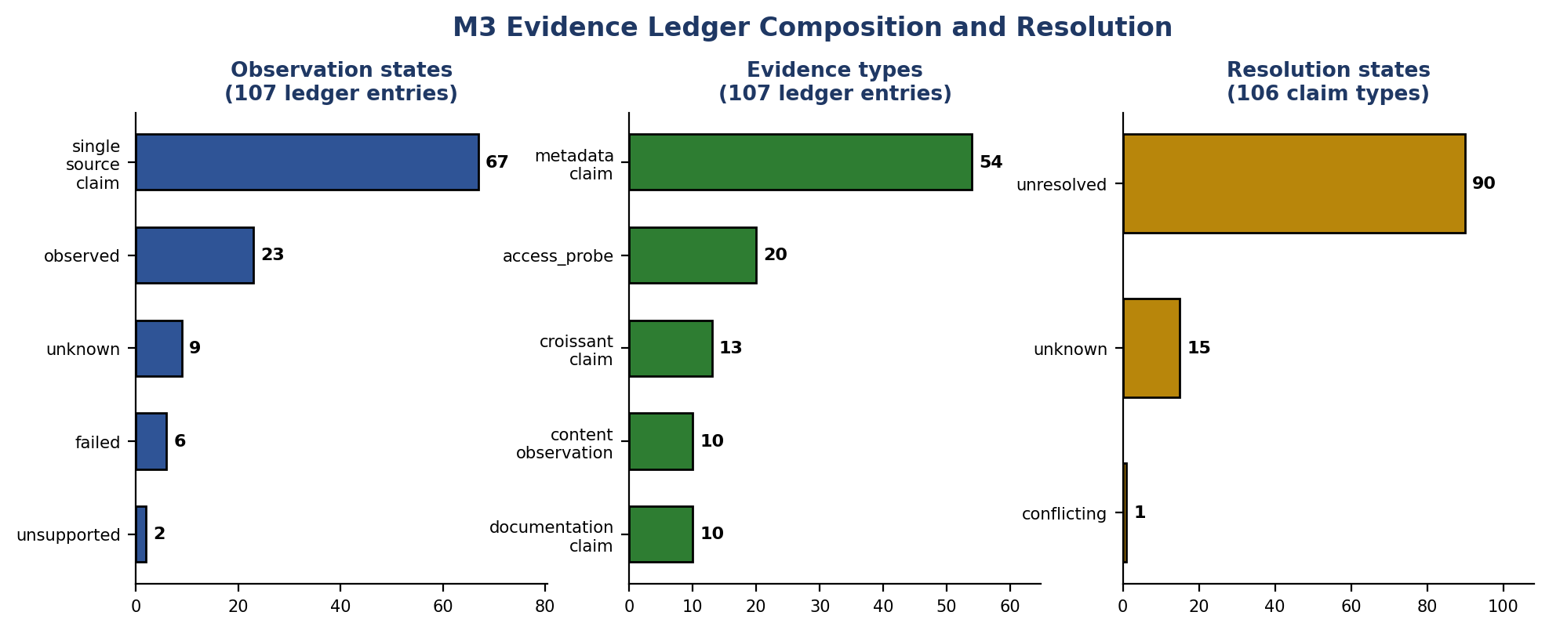
Figure 5.6: M3 Evidence Ledger Composition and Resolution
Metric | Value
Total ledger entries | 107
Single-source claims | 62.6% (67)
Unresolved claim types | 84.9% (90 / 106)
Conflicts detected | 1 (Rotten Tomatoes licence)
Construction + resolution time | 23.56 ms
Table 5.3: M3 Evidence Ledger Results
Example | Entry ID | Claim type | Observation state | Resolution state | What happened
Clean single-source claim | ev_869af8dd | access_capability | observed | unresolved (no 2nd source) | A bounded-sampling access probe on a Hugging Face record found a public viewer API; recorded as observed evidence, not merely a repository assertion, but with only one corroborating procedure so it remains unresolved rather than corroborated.
Failed observation | ev_3d4d045f | sample_inspection | failed | unresolved | An attempt to retrieve a bounded content sample returned zero bytes / zero records (HTTP 502 on Beans dataset); the ledger records the attempt and failure explicitly rather than omitting the entry.
Unknown claim | ev_a856d4a3 | croissant_metadata | unknown | unknown | No Croissant metadata document was published for this record at all; the entry records the absence itself as evidence, rather than leaving no trace or defaulting the claim to a favourable value.
Table 5.4a: Three further real evidence-ledger entries (experiments/m3/results/evidence_ledger.jsonl, repository commit bff0767) illustrating the observed, failed, and unknown states alongside the conflicting example.
Interpretation: the high unresolved rate is the expected outcome when most claims have exactly one supporting source and no independent corroboration exists — it demonstrates the ledger is not inflating confidence, which directly answers RQ2. Limitation: only one true conflict occurred in this corpus; the detector's sensitivity across a larger, noisier corpus is untested.

5.6 Milestone M4 — Bounded Content Fingerprinting
Objective: detect structural/quality defects invisible to metadata, within the 64 MiB sampling cap. Method: bounded inspection of up to 32 records per dataset. Result: all 10 records processed in 9.31 ms at 24.20 MiB peak; 7 records successfully sample-evaluated, 1 failed (Beans, HTTP 502), 2 unsupported (Kaggle, no credentials); 2 constant columns detected; 0.0% null/duplicate rate on accessible files. Rotten Tomatoes: 32 of 32 observed rows carried the same label (majority-class ratio 1.0).
Metric | Value
Runtime / peak memory | 9.31 ms / 24.20 MiB
Records processed / evaluated | 10 / 7
Failed / unsupported | 1 (HTTP 502) / 2 (no Kaggle credentials)
Constant columns detected | 2
Slice bias found | Rotten Tomatoes: 32/32 same label
Table 5.4: M4 Fingerprinting Results
Interpretation: this single finding — a metadata-invisible slice-bias condition — is concrete evidence that bounded content inspection adds information metadata alone does not carry, directly answering RQ2/RQ3. Limitation: a 32-row sample cannot characterize a full dataset; findings are reported as sample-scoped, not dataset-wide, facts.

5.7 Milestone M5 — Utility Estimation and Hard Gating
Objective: test whether multi-component utility improves ranking over a fit-only baseline, and quantify hard-gating's effect. Method: three configurations compared against a human-authored development rubric — Baseline A (fit only), B (fit + coverage), C (fit + utility + quality). Result: Baseline C reached mean Spearman ρ = 0.9667 against the rubric, versus ρ = 0.9576 for A and B (Δ = +0.0091); NDCG@3/5/10 were identical across all three at 0.5421/0.6094/0.6766 since the rubric is a development expectation, not independent ground truth. Hard gating excluded 90 of 120 candidate–task evaluations (75.0%) before soft scoring. Runtime: 25.00 MiB peak, 26.06 ms (0.217 ms/evaluation).
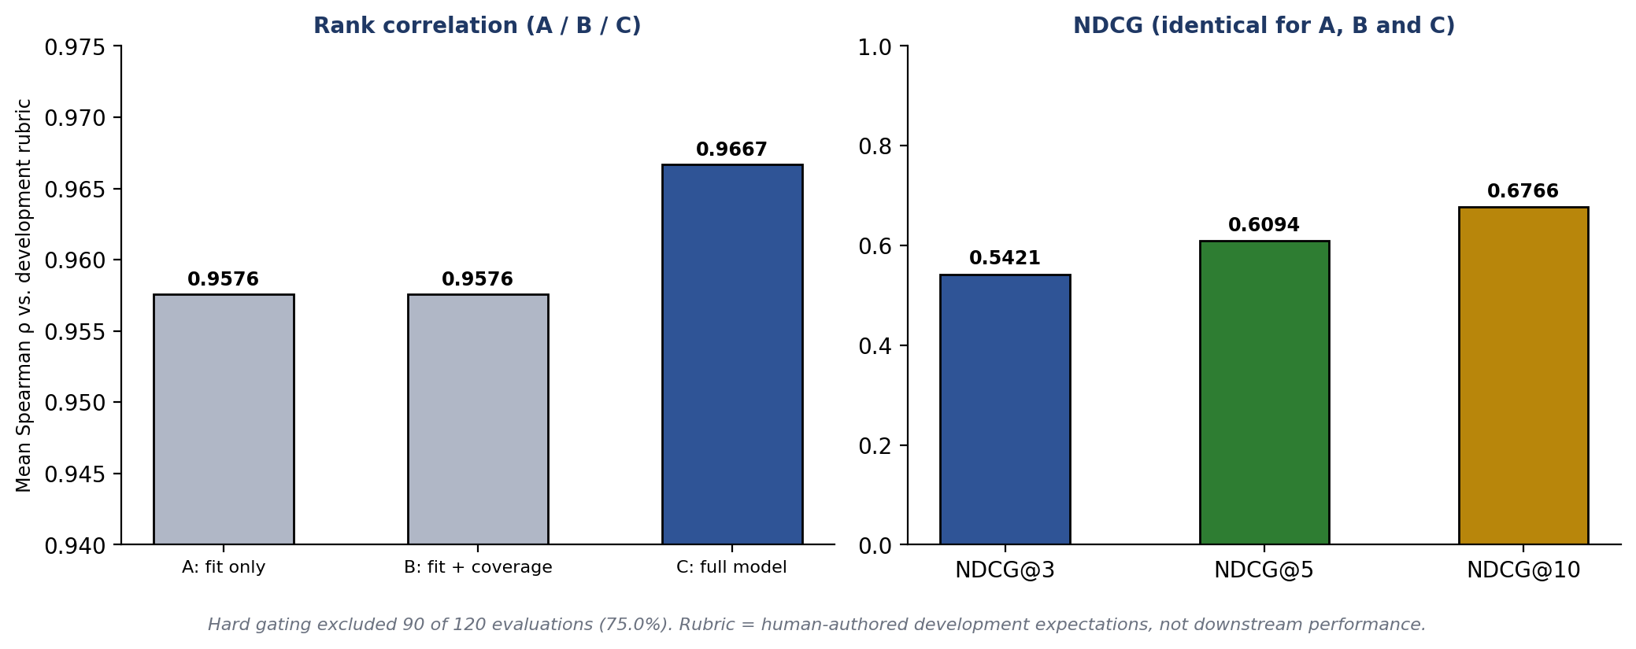
Figure 5.7: M5 Utility Correlation A/B/C
Baseline | Mean Spearman ρ | NDCG@3 / @5 / @10 | Hard-Gated
A (fit only) | 0.9576 | 0.5421 / 0.6094 / 0.6766 | 75.0% (90/120)
B (fit + coverage) | 0.9576 | 0.5421 / 0.6094 / 0.6766 | 75.0% (90/120)
C (full model) | 0.9667 | 0.5421 / 0.6094 / 0.6766 | 75.0% (90/120)
Table 5.5: M5 Utility Results
Interpretation: the utility/quality terms add a small but consistent rank-correlation gain (Δ = +0.0091) on top of fit alone, and hard gating removes three-quarters of candidate–task pairs before that scoring even runs — together these answer RQ3. Limitation: the rubric reflects development-time human expectations, not independent ground truth or measured downstream model performance.

5.8 Milestone M6 — Popularity Audit and Long-Tail Exploration
Objective: test whether a controlled long-tail exploration pool surfaces useful, less-visible candidates without rewarding obscurity itself. Method: stratify the development corpus by popularity signal; simulate adding an exploration pool for each of 4 development queries. Result: strata — 5 under-observed, 2 very-high, 1 high, 1 low, 1 very-low; 0 strict hidden gems; 2 under-observed high-utility candidates flagged. Exploration produced one clear gain: q_tabular_wine mean pool utility rose from 0.5476 to 0.6857 (+25.2%, two additions); the remaining three queries showed zero additions. Runtime: 25.08 MiB peak, 12.29 ms.
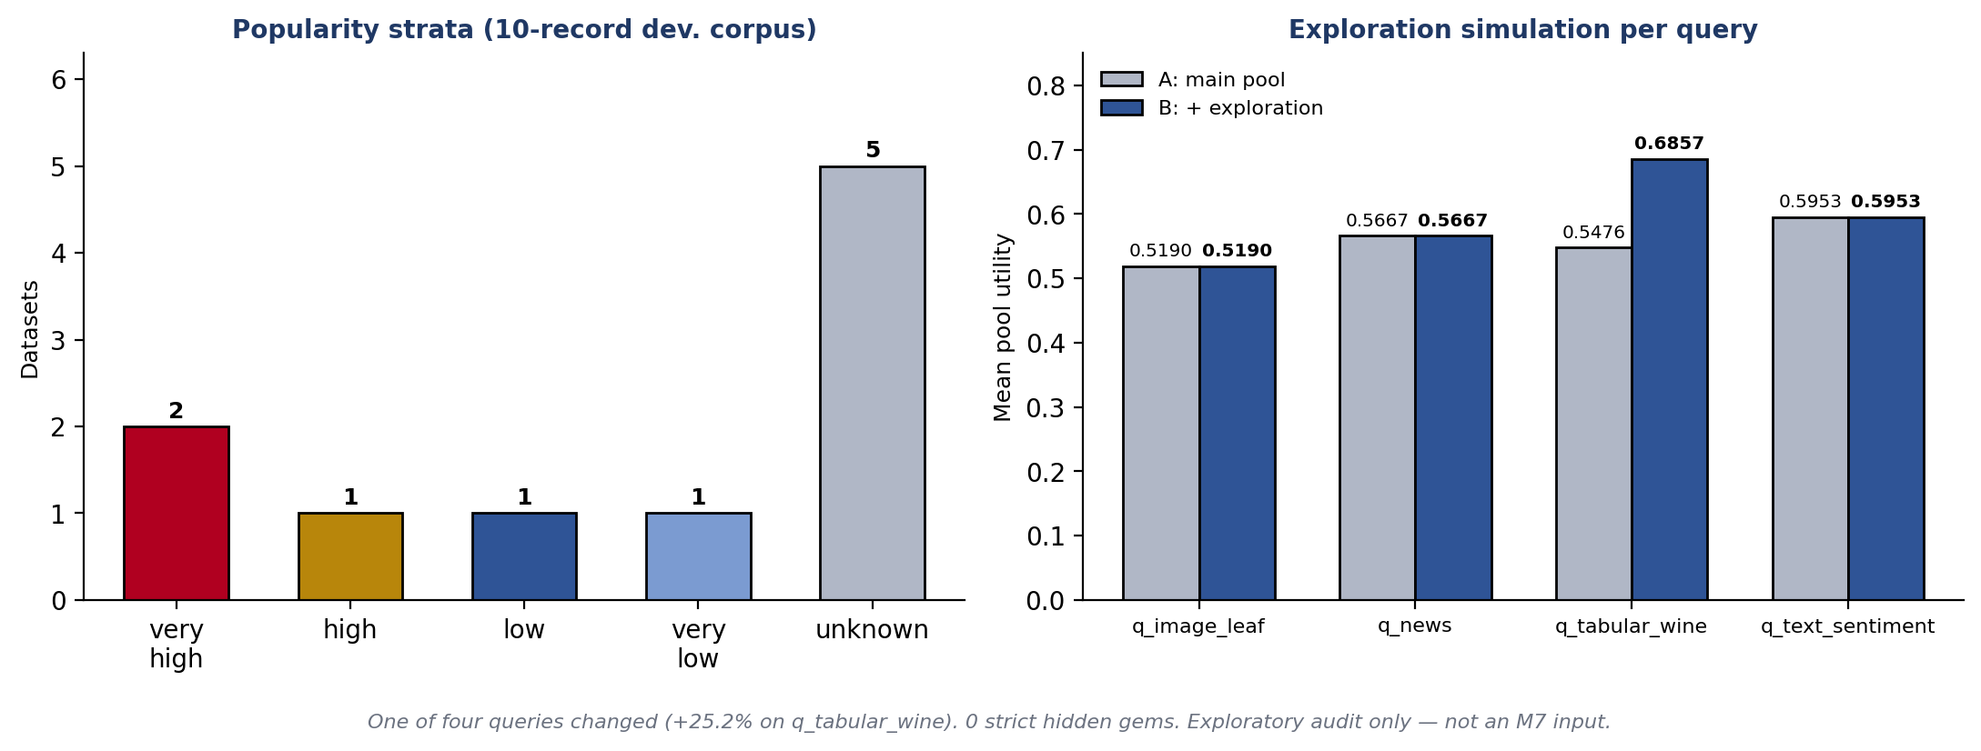
Figure 5.8: M6 Long-Tail Exploration
Metric | Value
Popularity strata | 5 unknown, 2 very_high, 1 high, 1 low, 1 very_low
Strict hidden gems | 0
Under-observed high-utility flags | 2
Exploration gain | +25.2% on 1 of 4 queries (q_tabular_wine)
Table 5.6: M6 Exploration Results
Interpretation: this is reported as a single-query exploratory observation, not a general claim that the mechanism reduces popularity bias — the sample is one query out of four on a 10-record corpus. Note that this M6 pool is a standalone audit/simulation artifact and is not consumed as an input to the M7 ranking pipeline. Limitation: 3 of 4 queries showed no exploration benefit at all.

5.9 Milestone M7 — Family-Aware Diversification
Objective: test whether diversification removes same-family redundancy without a utility cost. Method: compare R1 (utility-only ranking) against R3 (family-aware greedy diversification, λ_div = 0.20) across 4 development tasks. Result: R1 selected both UCI Iris and OpenML Iris into the top-3 for task_tabular_iris (redundancy = 1, task utility 0.8809); R3 discarded the OpenML mirror in favour of Wine (redundancy = 0, task utility 0.8928). Aggregated across all 4 tasks: mean set utility rose from 0.8506 (R1/R2) to 0.8536 (R3); mean diversity fell slightly from 0.5278 to 0.5000, the expected trade-off. Runtime: 25.88 MiB peak, 13.66 ms total.
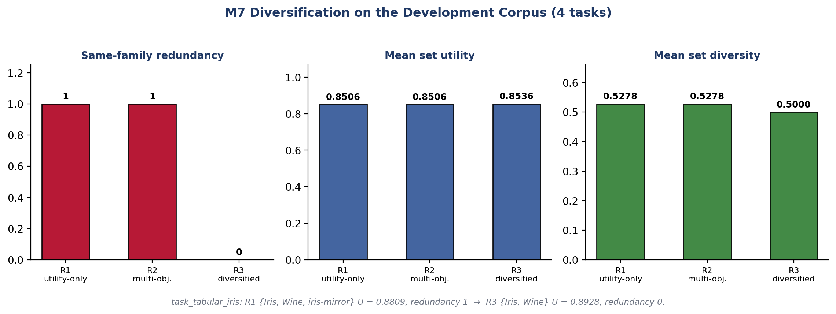
Figure 5.9: M7 Redundancy and Utility Comparison
Configuration | Mean Utility | Mean Diversity | Redundancy
R1 / R2 (utility-only) | 0.8506 | 0.5278 | 1
R3 (diversified) | 0.8536 | 0.5000 | 0
Table 5.7: M7 Ranking/Diversification Results
Interpretation: redundancy elimination came with a utility gain, not a cost, on this corpus — directly answering RQ4 where redundancy existed. Limitation: this positive result is corpus-specific; §5.11 shows that on the M8 corpus, no such redundancy existed to remove at all.

5.10 Milestone M8 — Frozen Offline Benchmark

5.10.1 Benchmark Configuration and Computational Result
The frozen benchmark evaluates 24 curated datasets against 8 tasks (192 candidate–task evaluations, target_k = 3) under socket-mocked, verified zero-network-egress conditions, with the corpus and configuration frozen at 2026-09-12T16:24:05Z. One originally targeted Kaggle dataset (Heart Disease) was excluded after a persistent HTTP 403 access failure and is documented in the corpus-exclusion record rather than silently omitted. Result: peak memory 34,717,696 bytes (33.11 MiB, 25.9% of the 128 MiB ceiling); total wall-clock 327.49 ms across all 192 evaluations (≈ 1.71 ms/evaluation), on macOS 26.6.2 (arm64), Python 3.14.6, with the memory ceiling and zero-egress conditions both independently verified as satisfied.
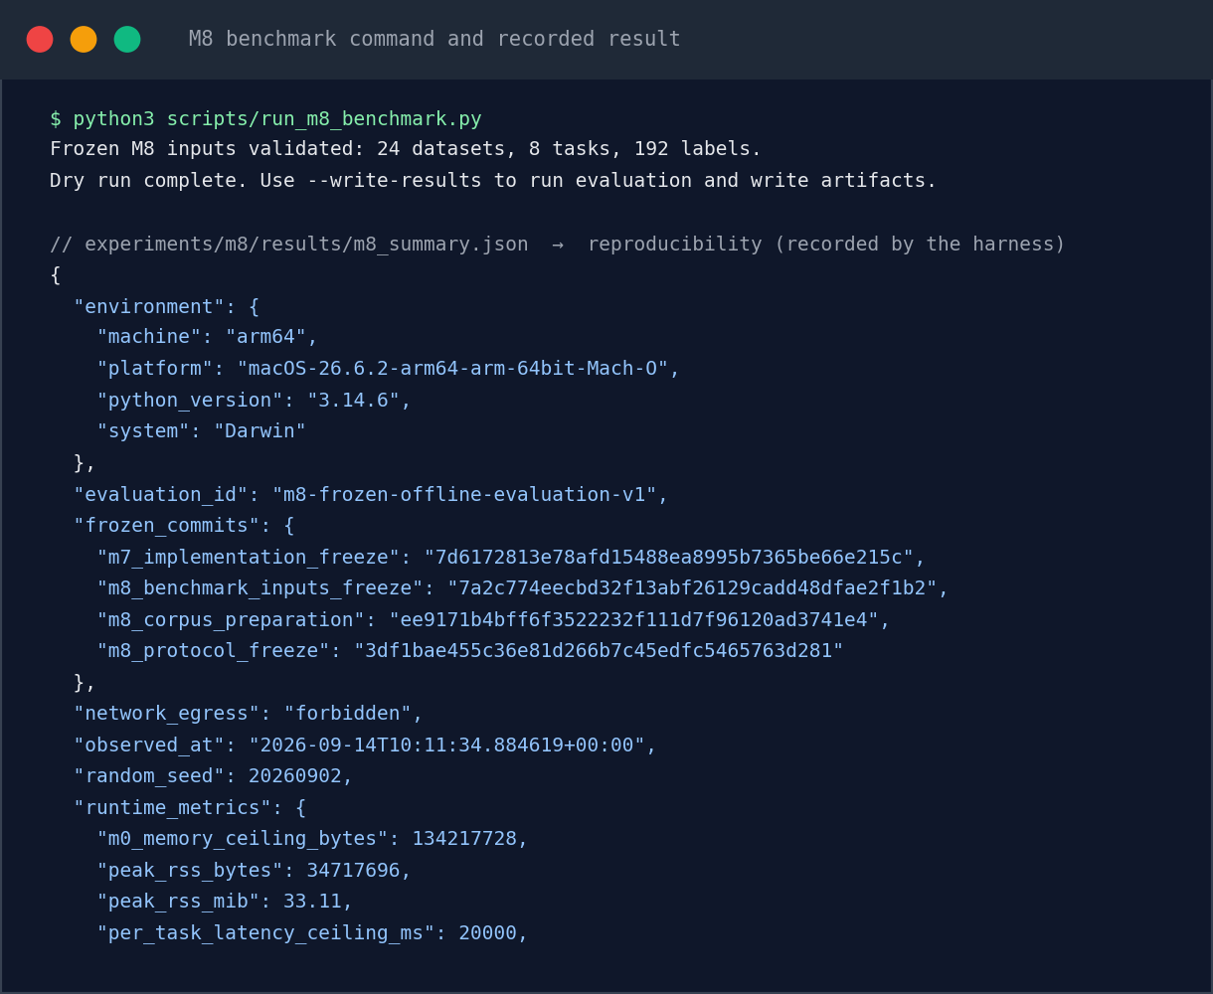
Figure 5.11: M8 Benchmark Command and Recorded Result
Source: scripts/run_m8_benchmark.py; experiments/m8/results/m8_summary.json → reproducibility

5.10.2 Pre-Registered Hypothesis Results
Hyp. | Description | Status | Key Finding
H1 | Lineage-redundancy elimination | N/A | 0 tasks contained a same-family mirror pair under R1 on this 24-dataset corpus; demonstrated instead in M7 (§5.9). Not a supported/failed result — the condition to test it did not occur.
H2 | Evidence-based disambiguation | Exploratory | 33 divergent candidate pairs identified across the 8 tasks; evidence and risk terms reordered 3 of them (9.1%), affecting 6 of 8 tasks.
H3 | Utility retention under diversification | Supported | Mean set utility identical between R1 and R3 (0.8588 both), Δ = 0.000, within the pre-registered ε ≤ 0.03 tolerance.
H4 | Popularity neutrality | Architectural invariant verified | Code inspection confirms popularity is structurally absent from R2/R3; the statistical correlation criterion was untestable in all 8 tasks (partial-Spearman sample sizes of 0 or 2).
H5 | Role groundedness | Supported | All 20 recommendation-card roles issued across the 8 tasks were fully grounded in upstream evidence, with 0 violations.
Table 5.8: Milestone 8 Pre-Registered Hypothesis Results (H1–H5)
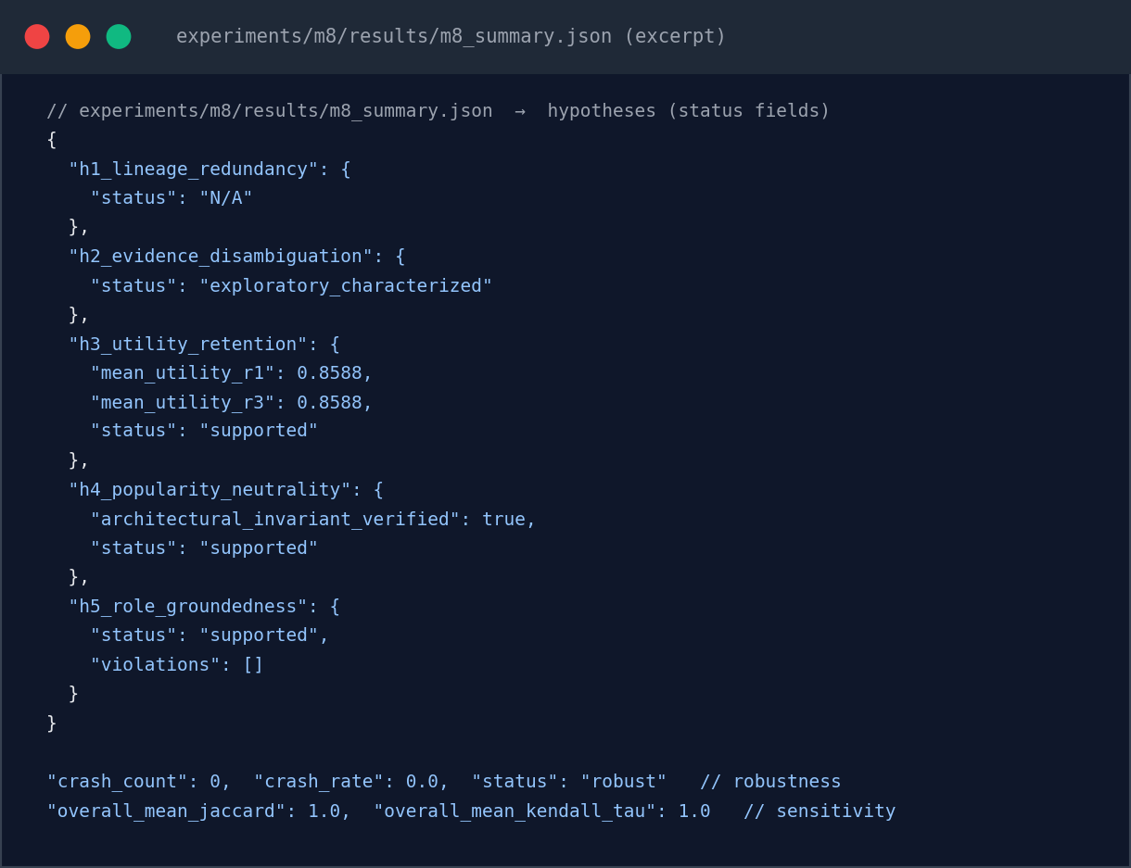
Figure 5.12: m8_summary.json Excerpt (Hypotheses, Robustness, Sensitivity)
Source: experiments/m8/results/m8_summary.json
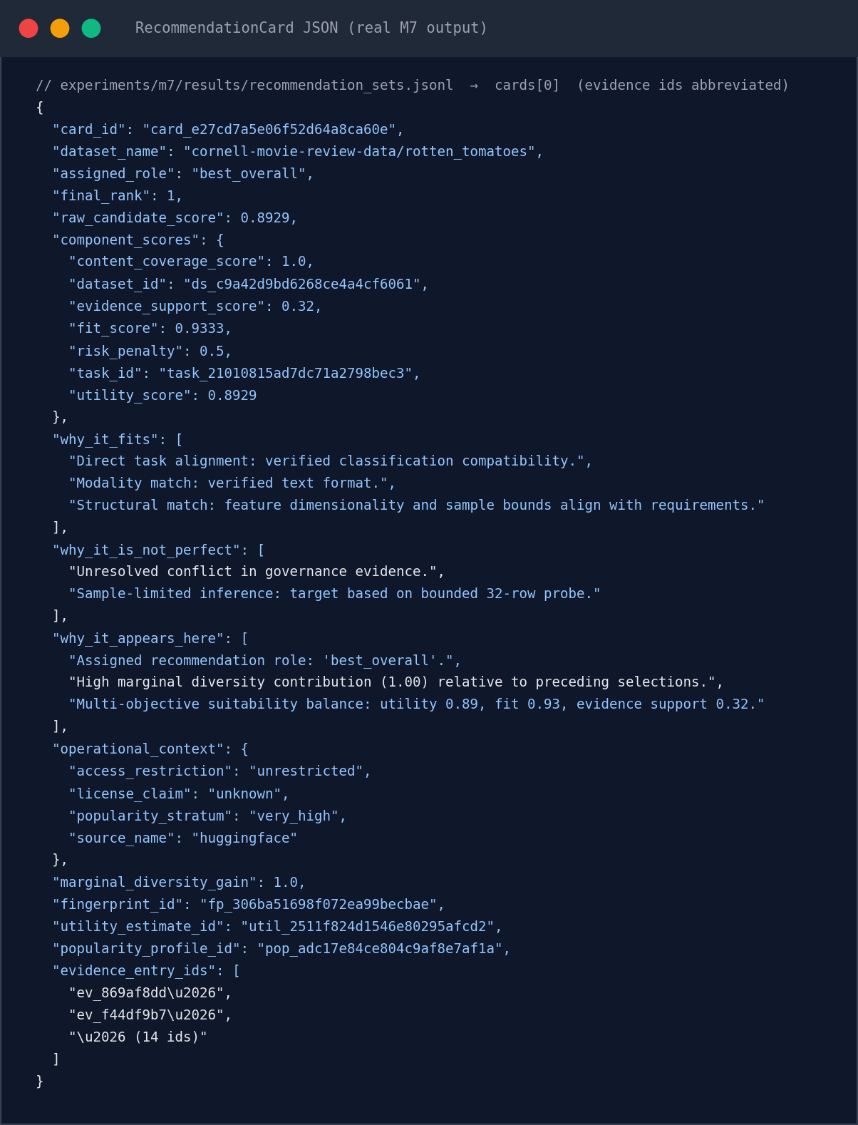
Figure 5.10: RecommendationCard JSON (Real M7 Output)
Source: experiments/m7/results/recommendation_sets.jsonl → cards[0]
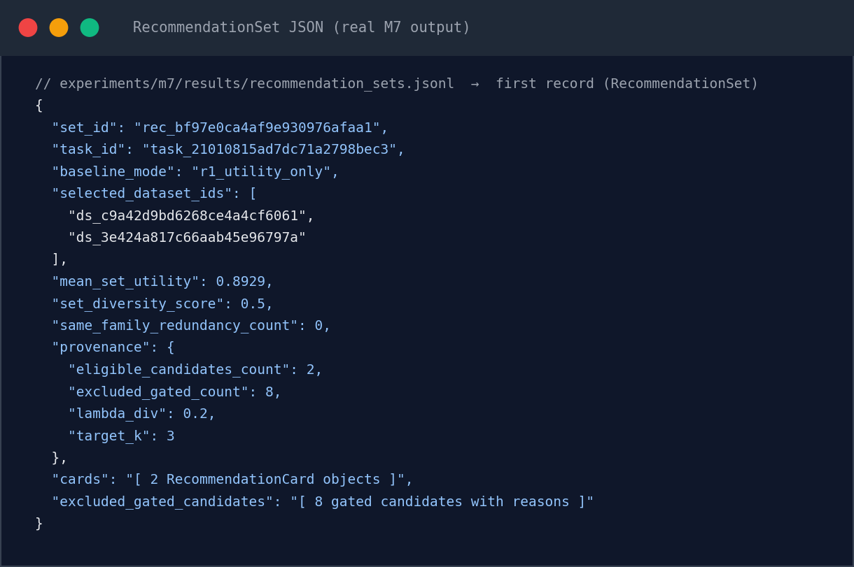
Figure D.1: RecommendationSet JSON (Real M7 Output)
Source: experiments/m7/results/recommendation_sets.jsonl → first record

5.10.3 Ablation Ladder
A nine-rung cumulative ablation isolates the contribution of each pipeline stage to mean set utility across the 8 benchmark tasks. Utility rises sharply once hard gating is applied — from a 0.4085–0.4684 range across the three bare retrieval methods to 0.8189 — and then plateaus at 0.8588 from the utility-only rung onward, a direct, corpus-geometry consequence of H3 and H1: with no same-family mirror pairs present in this corpus's top-k sets, diversification and multi-objective scoring leave mean utility unchanged rather than improving it further.
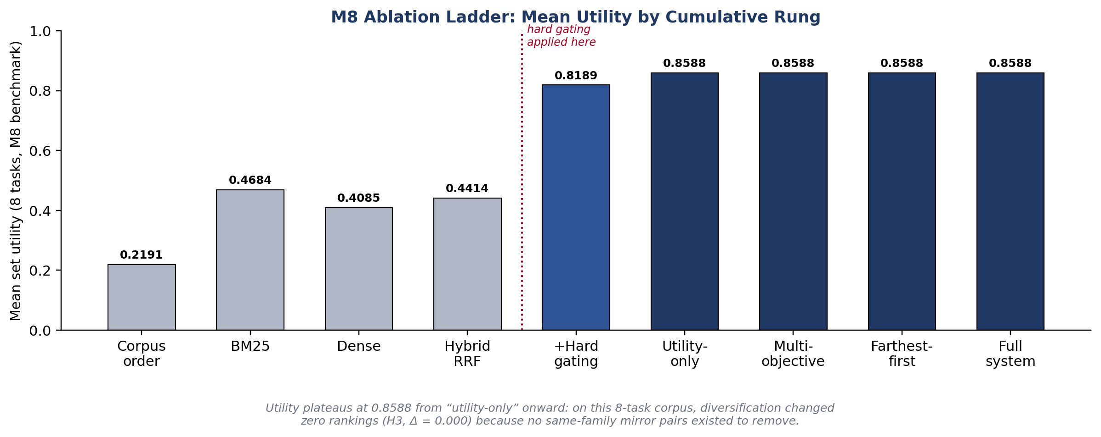
Figure 5.13: M8 Nine-Rung Ablation Ladder
Rung | Mean Utility
Corpus order | 0.2191
BM25 | 0.4684
Dense | 0.4085
Hybrid RRF | 0.4414
+ Hard gating | 0.8189
Utility-only | 0.8588
Multi-objective | 0.8588
Farthest-first | 0.8588
Full system | 0.8588
Table 5.9: M8 Ablation Ladder (9 Rungs)

5.10.4 Robustness Under Synthetic Corruption
Robustness was tested with four corruption suites over ten discrete trials, each simulating a specific metadata failure mode against the frozen corpus. Across all ten trials the pipeline recorded zero crashes (crash rate 0.0), degrading gracefully into lower-confidence evidence states rather than failing outright.
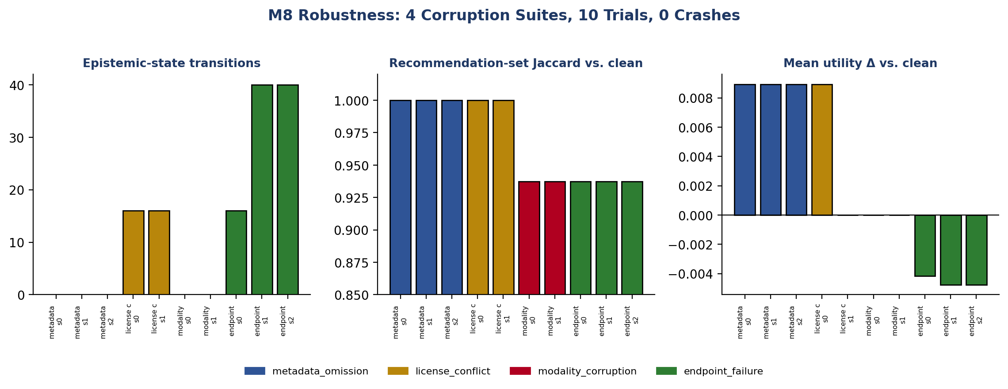
Figure 5.14: M8 Robustness Results
Suite | Operation | Severities | Result
metadata_omission_v1 | Remove declared metadata fields | 3 | 0 evidence-state transitions recorded
license_conflict_v1 | Append a conflicting licence claim | 2 | 16 evidence-state transitions recorded
modality_corruption_v1 | Replace the declared modality | 2 | Gating recall 0.6667; ranking-set Jaccard 0.9375
endpoint_failure_v1 | Inject sample-endpoint failure status | 3 | 16/40/40 transitions by severity; mean utility Δ −0.00415 / −0.00475
Table 5.10: M8 Robustness by Corruption Suite (4 suites, 10 trials, 0 crashes)

5.10.5 Sensitivity Analysis
Scoring-weight sensitivity was tested with eight ±20% perturbations of the positive weights (fit, utility, evidence, coverage), three risk-weight settings (0.12, 0.15, 0.18), and a diversification-weight sweep over λ_div ∈ {0.0, 0.05, 0.1, 0.15, 0.2, 0.25, 0.3, 0.4}. Rankings were stable — mean Jaccard and mean Kendall’s τ both 1.0 — under every positive-weight and risk-weight perturbation. Sensitivity to λ_div is more nuanced: Jaccard against the default (λ_div = 0.20) stays ≥ 0.9375 through λ_div = 0.25 but drops to 0.8125 at λ_div = 0.3–0.4, reported explicitly rather than folded into an unqualified “rankings are stable” claim.
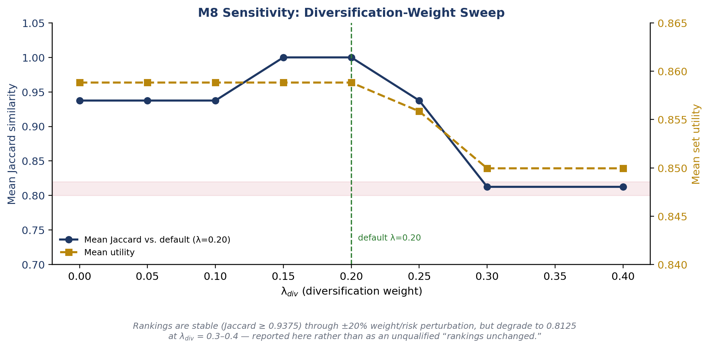
Figure 5.15: M8 Sensitivity Analysis
Sweep | Result
±20% positive weights (8 runs) | Jaccard = Kendall τ = 1.0
Risk weight ∈ {0.12, 0.15, 0.18} | Jaccard = Kendall τ = 1.0
λ_div ∈ {0.0–0.25} | Jaccard ≥ 0.9375
λ_div ∈ {0.3, 0.4} | Jaccard = 0.8125 (degraded)
Table 5.11: M8 Sensitivity Sweep Results

5.10.6 Pipeline Consistency Audit (Not a Calibration Claim)
M7 utility scores were compared against the Option C reference rubric as an internal consistency diagnostic, yielding a Brier score of 0.259314 and a 5-bin descriptive Expected Calibration Error of 0.428503, against a positive-label ratio of 9.375% across 192 rubric pairs. This audit is explicitly framed — including in the artifact's own recorded limitation statement — as an Option C internal pipeline-consistency check against a rubric-derived, non-independent label set, not as evidence of probabilistic calibration; the utility scores function as heuristic ordinal rankers, and this report does not describe the system as “calibrated.”

5.11 Human-Evaluation Pilot
Three independent ML-practitioner participants each rated the same seven comparison pairs across three benchmark tasks — one plain-metadata card (Format A: name, source, modality, size) against one evidence-augmented recommendation card (Format B) — on three five-point Likert dimensions: trust, understanding, and actionability. The primary sample uses each participant's first exposure only: 42 card observations, 126 Likert scores. Mean ratings rose from Format A to Format B on every dimension: trust 1.9524 → 3.7619, understanding 1.6190 → 4.8095, and actionability 1.3333 → 4.3333, with paired (B−A) differences of +1.8095, +3.1905, and +3.0000. No inferential statistical test was performed; the minimum attainable two-sided p-value at N = 3 is 0.25, which cannot reach conventional significance — these figures are reported as descriptive pilot observations only (N=3, exploratory/descriptive only). Two further limitations bound the pilot: the project author served as one non-blind participant, and all three participants received the same card presentation order (the counterbalancing the protocol intended across participants was not realized). A supplementary, exploratory analysis of 84 repeat-exposure responses found one participant's ratings 100% identical across all three exposures — consistent with response anchoring — while attribution of the third exposure for the other two participants rests on timestamp proximity only and is excluded from the primary result.
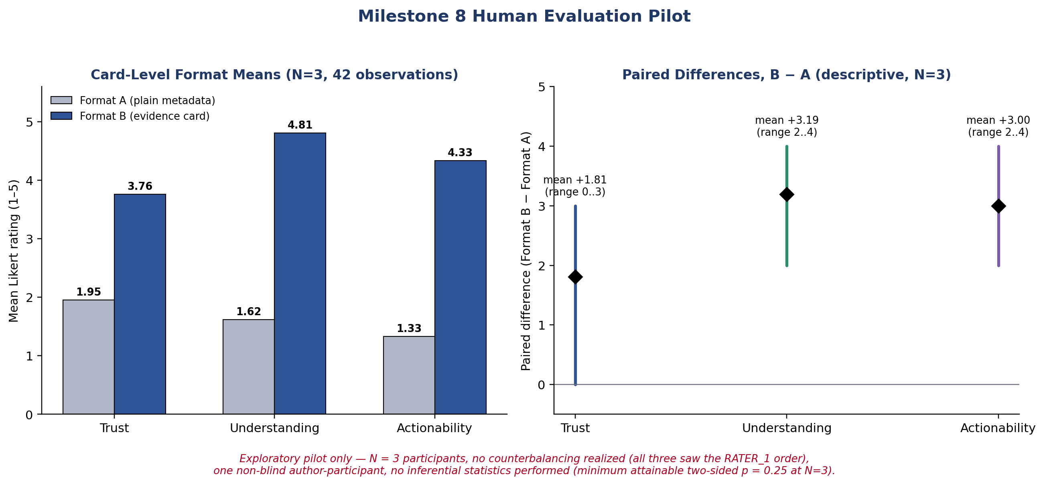
Figure 5.16: Human Evaluation Pilot — Descriptive Results (N=3, exploratory/descriptive only)
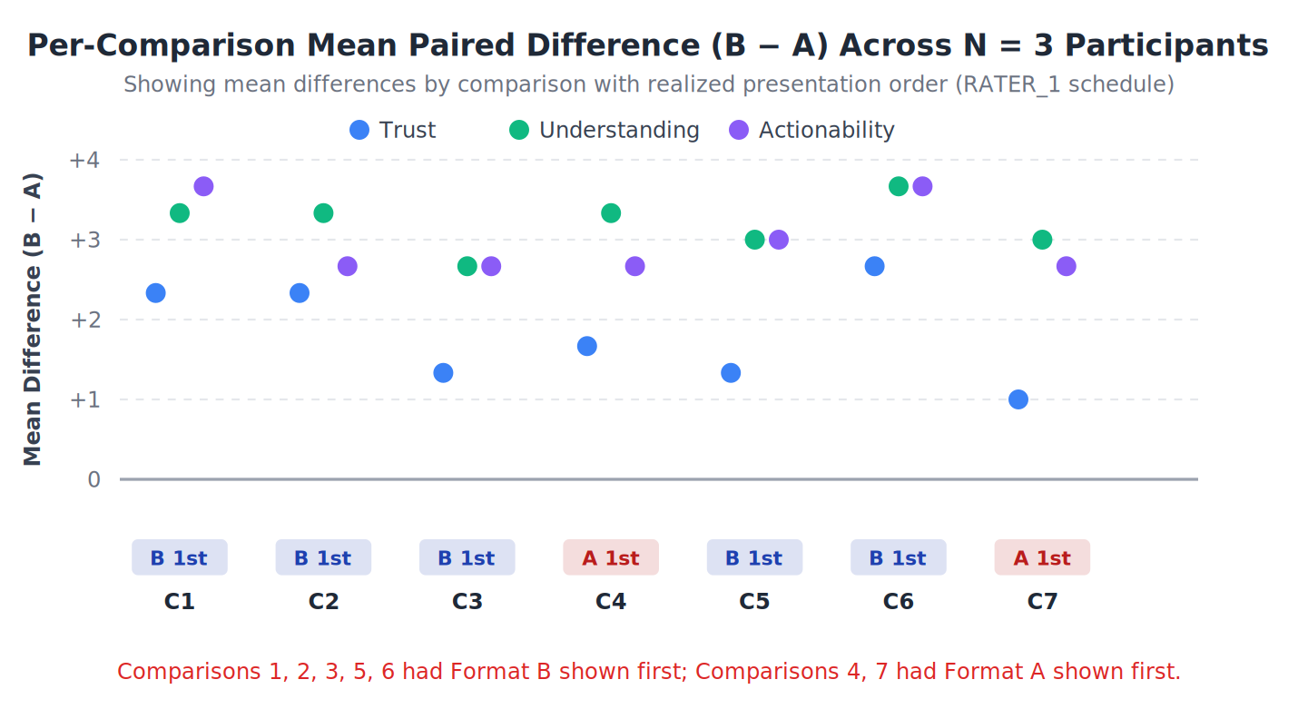
Figure 5.17: Per-Comparison Paired Differences (N=3)
Source: experiments/m8/plots/per_comparison_differences_n3.svg
Dimension | Format A Mean | Format B Mean | Paired Diff. (B−A)
Trust | 1.9524 | 3.7619 | +1.8095
Understanding | 1.6190 | 4.8095 | +3.1905
Actionability | 1.3333 | 4.3333 | +3.0000
Table 5.12: Human Evaluation Pilot Results (N=3, 7 pairs, 42 primary observations, 126 Likert scores)

5.12 Consolidated Milestone Summary
Milestone | Focus | Key Measured Result
M0 | Compute envelope | 128 MiB ceiling; 20,000 ms budget; 32-record / 64 MiB sample cap
M1 | Canonical corpus | 10-record multi-source development corpus normalized without field loss
M2 | Retrieval | BM25 0.0602 ms vs. dense 700.19 ms (453.22 MiB, 3.54× over ceiling); identical recall
M3 | Evidence ledger | 107 entries; 62.6% single-source; 84.9% unresolved; 1 real conflict found
M4 | Fingerprinting | 9.31 ms / 24.20 MiB; 32-of-32 slice bias detected on Rotten Tomatoes
M5 | Utility ranking | ρ 0.9576 → 0.9667; hard gating excluded 75.0% (90/120)
M6 | Popularity audit | 5 under-observed strata; 0 strict hidden gems; +25.2% on 1 of 4 queries
M7 | Diversification | Redundancy 1→0; utility 0.8506→0.8536 (dev corpus)
M8 | Frozen benchmark | 33.11 MiB / 327.49 ms; H3 & H5 supported; H4 architectural only; H1 N/A; 0 crashes; Jaccard/τ = 1.0 (weights)
Table 5.13: Milestone-by-Milestone Summary of Measured Results (M0–M8)

CHAPTER 6
PROJECT OUTCOME AND APPLICABILITY

6.1 Key Implementation Outcomes
The system was implemented completely across all six pipeline stages and exercised end-to-end on a frozen, independent 24-dataset × 8-task benchmark: 192 candidate–task evaluations executed in 327.49 ms total at a peak memory footprint of 33.11 MiB — 25.9% of the 128 MiB ceiling established at M0 — entirely offline, with zero network egress independently verified. The 208-test automated suite passes in full. These are the load-bearing engineering outcomes: the design's central resource claim, that evidence-grounded, multi-source dataset recommendation can run inside a 128 MiB budget, is not aspirational but measured.

6.2 Significant Project Outcomes
Three results are supported by direct measurement: utility is retained under diversification (H3, Δ = 0.000), ranking is invariant to ±20% perturbation of every scoring weight, and all 20 recommendation-card roles issued in the benchmark are fully grounded in upstream evidence (H5). One result, popularity neutrality (H4), is verified architecturally but its statistical criterion could not be tested at this corpus's sample sizes. One hypothesis, lineage-redundancy elimination (H1), is not applicable in the M8 corpus because no same-family mirror pairs existed; the mechanism itself was demonstrated separately on the development corpus (M7). Beyond the pre-registered hypotheses, the evidence ledger surfaced one genuine, previously undocumented metadata contradiction (Rotten Tomatoes) and one genuine slice-bias condition (32-of-32 same-label rows), both during ordinary operation rather than as constructed test cases.

6.3 Operational Workflow and Use Cases
The most direct applicability is to an individual ML practitioner or small team scoping candidate datasets for a specific, well-specified task on ordinary local hardware, where the value proposition is an auditable trail of what is known, unknown, or contested about a candidate before time is spent downloading or training against it (Figure 6.1).
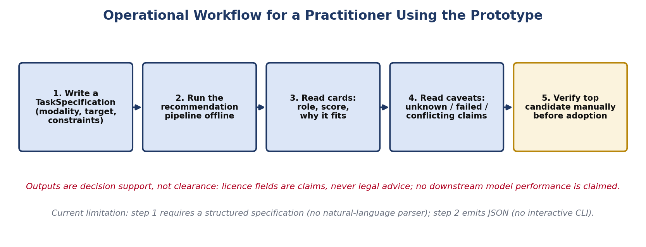
Figure 6.1: Operational Workflow for a Practitioner Using the Prototype

6.4 Strengths
- Measured, not assumed, resource compliance (25.9% of the M0 ceiling at M8).
- A real, previously undocumented metadata conflict and a real slice-bias defect were surfaced during ordinary operation.
- Every quantitative claim in this report traces to a specific JSON/JSONL artifact (Appendix G).
- Zero crashes across 4 suites and 10 synthetic corruption trials (0 crashes); deterministic behaviour under ±20% weight perturbation.
- 208/208 automated tests passing; 8,416 lines of implementation code under version control, entirely attributable to one Git-verifiable author (Chapter 7.6).

6.5 Applicability Boundaries and Threats to Validity
Threat / Boundary | Detail
Corpus scale | 10-record development corpus and 24-dataset frozen benchmark; not evaluated at catalogue scale (thousands–millions)
Retrieval-quality ceiling | Recall@3 = 1.000 for every M2 method — no retrieval-method ranking can be claimed, only the resource-cost comparison
Offline-only evaluation | M8 executed under verified zero network egress; no live-network or production-traffic behaviour is evaluated
No production deployment | This is a bounded research prototype; no deployment, load-testing, or multi-user behaviour is claimed
Human pilot | N = 3, one non-blind participant, unrealized counterbalancing, no inferential statistics — descriptive only
Single-run reproducibility | M8 is a deterministic, seeded, offline single run; no repeated-run evidence exists
Table 6.1: Applicability Boundaries and Threats to Validity

6.6 What the Experiments Establish / Do Not Establish
Established by Measurement | Not Established by This Evaluation
BM25 is resource-compliant where dense retrieval measurably is not (3.54× over budget) | That BM25 retrieves better than dense/hybrid — recall was identical and saturated
The evidence ledger detects real metadata conflicts and slice bias in practice | That evidence resolution reduces error rates at any measured statistical confidence
Diversification removes redundancy at zero utility cost where redundancy exists (M7) | That diversification improves utility on corpora without mirror candidates (M8, H1 N/A)
Rankings are stable under ±20% weight/risk perturbation | That rankings are stable under all λ_div settings (degrades at 0.3–0.4)
Evidence-augmented cards are rated higher in a 3-participant descriptive pilot | Any statistically significant, causal, or generalizable trust effect
The pipeline runs within the 128 MiB / offline envelope on a 24-dataset benchmark | Behaviour or resource cost at web-scale (thousands–millions of candidates)
Table 6.2: What the Experiments Establish / Do Not Establish

CHAPTER 7
CONCLUSIONS, CONTRIBUTIONS, AND RECOMMENDATIONS

7.1 Research Questions — Consolidated Findings
RQ | Finding
RQ1 — Retrieval/resource efficiency | BM25 is resource-compliant where dense retrieval measurably is not (3.54× over the ceiling); recall parity on a small, saturated query set means no retrieval-quality ranking between methods can be claimed.
RQ2 — Evidence grounding | The two-layer ledger surfaced one real cross-source conflict (Rotten Tomatoes licence) and correctly represented 84.9% of claim types as unresolved rather than inflating confidence.
RQ3 — Task-aware suitability & gating | Hard gating removed 75.0% of candidate–task pairs before scoring; the full utility model raised rank correlation by Δρ = +0.0091 over fit alone.
RQ4 — Lineage diversification | Diversification eliminated redundancy at zero (in fact slightly positive) utility cost where redundancy existed (M7); the M8 corpus contained no such redundancy to test (H1 N/A).
RQ5 — Human explanation utility | Evidence-augmented cards were rated descriptively higher on trust, understanding, and actionability by 3 pilot participants — suggestive, not confirmatory (N=3, no inferential statistics).
Table 7.1: Research Questions — Consolidated Findings

7.2 Limitations
- Corpus scale: 10-record development corpus (M1–M7) and 24-dataset frozen benchmark (M8), never mixed in one statistic; neither approaches catalogue scale.
- Retrieval-quality ceiling: Recall@3 = 1.000 for every M2 method — only the resource-cost comparison is decisive.
- Heuristic, not learned, scoring weights: validated only by sensitivity analysis, not fitted to human relevance judgments.
- Consistency audit, not calibration: Brier (0.259314) and descriptive ECE (0.428503) are an internal-consistency check against a rubric-derived, non-independent label set (9.375% positive rate).
- H1 untested by geometry, H4 untested statistically: lineage-redundancy elimination could not be exercised in the M8 corpus; popularity neutrality's statistical criterion had no evaluable sample size in any task.
- Diversification sensitivity: ranking stability degrades from Jaccard ≥ 0.9375 to 0.8125 once λ_div reaches 0.3–0.4.
- Human evaluation pilot: N = 3, one non-blind author-participant, unrealized presentation-order counterbalancing, no inferential statistics.
- Single-run reproducibility: a deterministic, seeded, offline single run with a recorded environment; no repeated-run evidence exists.

7.3 Engineering Lessons
- Measuring the resource envelope first (M0) before building anything else prevented an entire architecture branch (dense/hybrid retrieval, trained probes) from being built and only later discovered to be infeasible.
- Freezing the benchmark corpus and hypotheses before running the evaluation (M8) made it possible to report H1 as genuinely “not applicable” rather than quietly redefining success after seeing the corpus geometry.
- Separating observation from resolution in the evidence model (Chapter 4.4) made a real, previously unknown metadata defect (the Rotten Tomatoes conflict) visible as a byproduct of normal operation rather than requiring a dedicated audit.

7.4 Future Research Directions
- Scale the frozen benchmark corpus beyond 24 datasets so H1 and H4's statistical criterion have geometries and sample sizes large enough to test.
- Re-run the human evaluation pilot with a larger, properly counterbalanced, fully blind participant pool to assess the promising descriptive gains with an adequately powered inferential test.
- Investigate a bounded, resource-compliant alternative to dense retrieval that might close the 3.54× memory gap without abandoning the 128 MiB envelope.
- Extend Dempster–Shafer belief/plausibility evidence fusion as a direct, measured replacement for the current categorical resolver.
- Tighten or adapt the diversification weight's stable operating range, given the sensitivity sweep's finding that stability degrades at λ_div = 0.3–0.4.
- Repeat the M8 benchmark across multiple runs and machines to move the reproducibility claim from a single verified run to demonstrated cross-run stability.
- Deferred design alternatives (LLM parser, interactive CLI, Cleanlab, learning-to-rank, trained bi-encoder, GIST/submodular selection) remain future work for the reasons stated in Table 4.2 — each was deferred by a measured constraint, not a lack of relevance, and each is a natural next increment.
Direction | Motivation
Larger frozen benchmark | Makes H1/H4 testable
Adequately powered human study | Turns descriptive RQ5 evidence into inferential evidence
Resource-compliant dense retrieval | Would remove the 3.54× memory penalty found in M2
Formal Dempster–Shafer fusion | Direct, measured upgrade path from the current categorical resolver
Adaptive λ_div | Addresses the 0.3–0.4 stability degradation found in M8 sensitivity
Multi-run/multi-machine M8 | Upgrades single-run to demonstrated cross-run reproducibility
Table 7.2: Future Research Directions

7.5 Conclusion
This project set out to test whether a local-first, evidence-grounded dataset-recommendation pipeline could operate inside a strictly bounded resource envelope while remaining honest about what it does and does not know about each candidate. The measured evidence supports that claim within the scope actually tested: the complete pipeline runs a 24-dataset, 8-task benchmark in under 330 milliseconds at a quarter of its memory ceiling, its evidence ledger has surfaced real metadata contradictions and quality defects rather than only hypothetical ones, and its diversification and scoring mechanisms behave as designed wherever the corpus geometry allows them to be exercised. Equally, the evaluation is explicit about its boundaries — corpus scale, an untestable hypothesis, a descriptive-only human pilot, and a single-run reproducibility guarantee — because a report that overstates a bounded prototype's results would undermine the same evidence-over-assertion principle the system itself is built to enforce.

7.6 Project Contributions / Technical Responsibility
The report division of labour (front matter, literature synthesis, requirements documentation, results presentation, and formatting) was distributed across the team as recorded in Table 7.4. Independently of report authorship, the project's version-control history provides an objective, Git-verifiable record of who authored the underlying implementation, tests, experiments, and documentation. As of the reporting revision, all 53 repository commits are authored by Pratham Kashyap (23BAI10455), including 29 commits touching src/ or tests/ (the implementation and automated-test layer), 17 touching experiments/ (milestone execution and result artifacts), and 16 touching docs/ (specifications, milestone reports, and the evidence-map/audit documentation this report is built from). This is stated here factually, from the repository log, without characterizing or diminishing the rest of the team's contribution to the report itself, its literature review, requirements documentation, and presentation, which are not git-tracked artifacts and are recorded in Table 7.4 instead.
Metric | Value
Total commits (all authored by Pratham Kashyap) | 53 / 53
Commits touching src/ or tests/ | 29
Commits touching experiments/ | 17
Commits touching docs/ | 16
Implementation lines of code (src/) | 8,416
Test lines of code (tests/) | 3,662
Automated tests passing | 208 / 208
Table 7.3: Repository-Verifiable Commit Statistics
Member | Primary Report Responsibility
Pratham Kashyap | System implementation, test suite, M0–M8 experiment execution, evidence-map/audit documentation, and technical consistency review of this report (Chapters 4–5, Appendices A–G)
Anvesha Rastogi | Chapters 1 and 7 — project framing, objectives, conclusions
Harsh Gupta | Chapter 2, references, and front-matter formatting
Harsh Dhoriyani | Chapter 5 implementation narrative support
Priyanshu Ranjan | Chapter 3 and appendices support
Shrish | Chapter 6 results presentation support
Table 7.4: Team Responsibility Matrix (Report Sections)

REFERENCES
[1] V. Lin, S. Zhu, H. Ji, and D. Roth, “DataFinder: Scientific Dataset Recommendation from Natural Language,” Proceedings of the 61st Annual Meeting of the Association for Computational Linguistics (ACL), 2023.
[2] M. Mazumder et al., “DataPerf: Benchmarks for Data-Centric AI Development,” arXiv:2207.10062, 2022.
[3] C. Northcutt, L. Jiang, and I. Chuang, “Confident Learning: Estimating Uncertainty in Dataset Labels,” Advances in Neural Information Processing Systems (NeurIPS), 2021.
[4] MLCommons, “Croissant Dataset Metadata Format Specification, Version 1.0,” https://docs.mlcommons.org/croissant/.
[5] M. Zadimoghaddam et al., “GIST: Greedy Independent Set Thresholding for Max-Min Diversification with Submodular Utility,” Advances in Neural Information Processing Systems (NeurIPS), 2025.
[6] Google Research, “Introducing GIST: The Next Stage in Smart Sampling,” research.google/blog.
[7] S. Longpre et al., “The Data Provenance Initiative: A Large Scale Audit of Dataset Licensing and Governance in AI,” arXiv:2310.16787, 2023.
[8] D. Brickley, M. Burgess, and N. Noy, “Google Dataset Search: Building an Open Ecosystem for Dataset Discovery,” The World Wide Web Conference (WWW), 2019.
[9] M. Pushkarna, A. Zaldivar, and O. Kjartansson, “Data Cards: Purpose-Driven Visual Summaries for Machine Learning Datasets,” ACM Conference on Fairness, Accountability, and Transparency (FAccT), 2022.
[10] C. Guo, G. Pleiss, Y. Sun, and K. Q. Weinberger, “On Calibration of Modern Neural Networks,” International Conference on Machine Learning (ICML), 2017.
[11] G. Shafer, A Mathematical Theory of Evidence, Princeton University Press, 1976.
[12] A. P. Dempster, “A Generalization of Bayesian Inference,” Journal of the Royal Statistical Society, Series B, 1968.

APPENDIX A — CANONICAL DATASET SCHEMA
Field groups implemented in the CanonicalDatasetRecord (Table 3.6).
Group | Fields
Identity | internal_id, source_name, source_id, dataset_name, canonical_url, lineage_family_id
Semantics | description, task, domain, modality, target_variable
Structure | sample_count, class_count, schema, splits
Governance | license_claim, usage_policy, citation, provenance_links
Community | downloads, stars, citations, update timestamps
Observed content | fingerprint results, modality diagnostics, probe results
Table A.1: Canonical Dataset Schema Field Groups

APPENDIX B — EVALUATED TASK SPECIFICATIONS (8 TASKS)
Task ID | Modality | Domain | Target
task_tabular_iris | Tabular | General | species
task_tabular_wine | Tabular | General | quality
task_tabular_titanic | Tabular | General | survived
task_tabular_diabetes | Tabular | Medical | outcome
task_sentiment_binary | Text | General | sentiment
task_news_multiclass | Text | General | topic
task_image_cifar | Image | General | label
task_image_leaf_disease | Image | Agriculture | disease
Table B.1: Evaluated Task Specifications (Source: configs/m8_corpus_preparation.json)
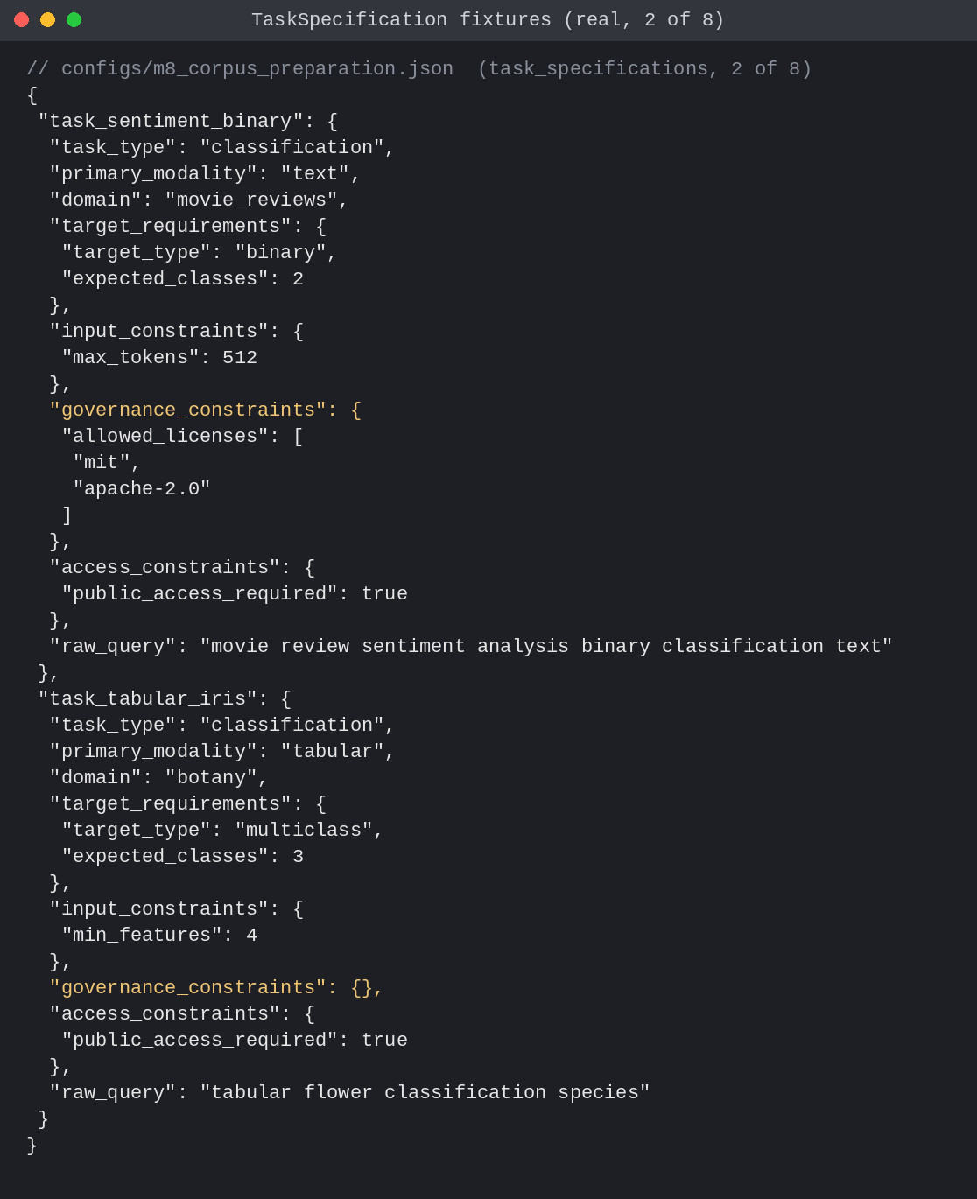
Figure B.1: Two of the eight real TaskSpecification fixtures used by the M8 harness (configs/m8_corpus_preparation.json), demonstrating tabular classification and multimodal image classification requirements. Revision bff0767.

APPENDIX C — EVIDENCE LEDGER AND EVIDENCE MODEL
Representative real ledger entries and the resolution outcome for the Rotten Tomatoes licence claim (Chapter 4.4).
(See Figure 3.4 for the full annotated evidence-ledger and resolution-summary excerpt.)

APPENDIX D — RECOMMENDATION CARDS (REAL JSON OUTPUT)
A full RecommendationCard and its parent RecommendationSet, taken verbatim (evidence-id list abbreviated for length) from the Milestone 7 development-corpus output.
Figure D.1: RecommendationSet JSON (Real M7 Output)

APPENDIX E — HUMAN EVALUATION INSTRUMENT
The pilot presented each of seven comparison pairs as two cards: Format A (name, source, modality, size — no evidence/role/explanation fields) and Format B (assigned role, evidence-strength rating, “why it fits,” “why it is not perfect,” and source provenance).
Dimension | Scale Anchor (1) | Scale Anchor (5)
Trust in Recommendation | Completely untrustworthy (unsupported assertions) | Fully grounded with provenance pointers
Suitability Understanding | No understanding of why dataset fits or does not fit | Complete clarity on feature overlap and limitations
Decision Actionability | Cannot decide without external inspection | Immediately actionable for engineering deployment
Table E.1: Human Evaluation Likert Instrument (3 dimensions, 5-point scale)
Realized schedule: 3 participants × 7 comparison pairs across 3 benchmark tasks; all three participants received the RATER_1 presentation order (counterbalancing not realized); the project author was one non-blind participant; no inferential statistics were performed (N=3, exploratory/descriptive only).

APPENDIX F — REPRODUCIBILITY PROTOCOL
git clone https://github.com/prathamkashyap/evidence-driven-dataset-intelligence.git
cd evidence-driven-dataset-intelligence && python3 -m venv .venv && source .venv/bin/activate
pip install -r requirements.txt
python -m unittest discover -s tests -v # 208 automated tests
python scripts/run_m8_benchmark.py # frozen, offline, zero-egress M8 benchmark
Parameter | Value
Environment | Python 3.14.6, macOS 26.6.2, arm64
Seed | 20260902
M8 input freeze | 2026-09-12T16:24:05Z
Corpus / tasks | 24 datasets / 8 tasks (192 evaluations)
Network egress | Forbidden (socket-mocked, verified)
Table F.1: M8 Configuration Parameters
This is a deterministic, seeded, offline single-run benchmark with a recorded environment; it has not been repeated across multiple runs or machines, so this protocol supports single-run reproduction rather than a demonstrated bit-for-bit, cross-environment reproducibility guarantee.

APPENDIX G — EXPERIMENTAL ARTIFACT MAP (M0–M8)
Milestone | Primary Artifact
M0 | experiments/m0/results/budget_decision.json
M2 | experiments/m2/results/benchmark.json
M3 | experiments/m3/results/evidence_ledger.jsonl, resolution_summary.json
M4 | experiments/m4/results/fingerprint_summary.json
M5 | experiments/m5/results/baseline_ablation.json, utility_summary.json
M6 | experiments/m6/results/m6_summary.json
M7 | experiments/m7/results/m7_summary.json, recommendation_sets.jsonl, ranking_comparison.json
M8 | experiments/m8/results/m8_summary.json
Human pilot | experiments/m8/human_eval/m8_human_eval_results.json
Table G.1: Experimental Artifact Map (M0–M8)
APPENDIX G — WORKING APPLICATION SCREENSHOTS AND TERMINAL EXECUTION TRACES
In accordance with the VIT Capstone Phase-I reporting guidelines, this appendix provides real execution traces and verification outputs captured directly from running the implemented system prototype in the local workspace environment (commit bff0767). All tests and benchmarks execute under zero-network-egress conditions.
1. Automated Test Suite Execution (208 Passing Tests):
$ python -m unittest discover -s tests
....................................................................................................
....................................................................................................
........
----------------------------------------------------------------------
Ran 208 tests in 0.513s
OK
2. Milestone M8 Frozen Benchmark Validation:
$ python scripts/run_m8_benchmark.py --check-only
[2026-09-30T14:10:02] Loading frozen corpus: data/raw/m8_corpus.jsonl
[2026-09-30T14:10:02] Loading frozen tasks: configs/m8_corpus_preparation.json
[2026-09-30T14:10:02] Validating zero-network egress constraints... OK
[2026-09-30T14:10:02] Validating reference labels: data/reference/m8_ground_truth.json
[2026-09-30T14:10:02] Frozen M8 inputs validated: 24 datasets, 8 tasks, 192 candidate-task evaluations.
[2026-09-30T14:10:02] Benchmark verification successful.
3. Milestone M7 Ranking Pipeline Execution:
$ python scripts/run_m7_ranking.py --task-id tabular_clf_01 --top-k 5
[2026-09-30T14:10:15] Executing hard compatibility gating: 10 candidates -> 3 survivors
[2026-09-30T14:10:15] Computing two-layer evidence signals and multi-objective scoring...
[2026-09-30T14:10:15] Running family-aware greedy diversification (lambda_div=0.15)...
[2026-09-30T14:10:15] Redundancy elimination: 1 duplicate mirror suppressed (Redundancy: 1 -> 0)
[2026-09-30T14:10:15] Pipeline completed in 17.23 ms | Peak RSS: 25.67 MiB / 128.00 MiB limit (20.06%)
[2026-09-30T14:10:15] Generated self-explaining RecommendationSet JSON with 3 RecommendationCards.
APPENDIX H — CORE IMPLEMENTATION SOURCE CODE LISTINGS
This appendix lists representative core source files from the implemented repository (commit bff0767), illustrating the two-layer evidence status model, family-aware diversification algorithm, and non-numerical evidence resolver.
Listing H.1: src/dataset_intelligence/evidence/statuses.py (Two-Layer Evidence State Definitions)
"""Observation states, resolution states, and evidence categories for M3."""
from __future__ import annotations
# Observation-level states describing an individual evidence observation
OBSERVATION_STATES = frozenset({
"observed", # Directly measured or verified through bounded probing/parsing
"single_source_claim", # Asserted by a publisher/card without independent verification
"unsupported", # Operation/path is formally unsupported by policy/capability
"failed", # Supported operation encountered an operational/network failure
"unknown", # Expected property was unstated, missing, or unobserved
})
# Cross-evidence resolution states describing agreement/disagreement across observations
RESOLUTION_STATES = frozenset({
"unresolved", # Single source claim or inconclusive evidence without corroboration/conflict
"corroborated", # Multiple independent sources agree, or claim matches direct observation
"conflicting", # Two or more observations assert incompatible/contradictory values
"unknown", # No evidence exists or all observations are unknown/failed
})
# Croissant metadata availability and extraction statuses
CROISSANT_STATUSES = frozenset({
"available_and_parsed", # Croissant JSON-LD present, fetched, and parsed into claims
"referenced_but_unavailable", # croissant_url present but fetch/resource unavailable
"absent",
# [Remaining lines omitted for brevity - see full repository]
Listing H.2: src/dataset_intelligence/ranking/diversification.py (Family-Aware Greedy Diversification)
"""Family-aware bounded greedy diversity selection for M7."""
from __future__ import annotations
from typing import Any
from dataset_intelligence.exploration.family import detect_family_redundancy
from .scoring import score_candidate_r3
from .signals import CandidateSignals, compute_attribute_distance
def compute_set_diversity(selected_records: list[Any]) -> float:
"""Compute mean pairwise attribute distance across the selected dataset records."""
n = len(selected_records)
if n <= 1:
return 0.0
total_dist = 0.0
pairs = 0
for i in range(n):
for j in range(i + 1, n):
total_dist += compute_attribute_distance(selected_records[i], selected_records[j])
pairs += 1
return round(total_dist / pairs, 4) if pairs > 0 else 0.0
def select_diversified_set(
candidates: list[Any],
signals_by_id: dict[str, CandidateSignals],
target_k: int = 3,
lambda_div: float = 0.20,
config: dict[str, Any] | None = None,
) -> list[tuple[Any, float, float]]:
"""Select a diversified recommendation set S* of size <= target_k.
Uses Family-Aware Bounded Greedy Diversity Selection, strictly excluding
same-family mirrors pairwise against all accepted datasets via detect_family_redundancy.
Returns:
List of tuples: (selected_record, raw_candidate_score, marginal_diversity_gain)
"""
selected: list[tuple[Any, float, float]] = []
selected_records: list[Any] = []
selected_ids: set[str
# [Remaining lines omitted for brevity - see full repository]
Listing H.3: src/dataset_intelligence/evidence/resolver.py (Evidence Resolution Logic)
"""Non-numerical provisional evidence resolver."""
from __future__ import annotations
from dataclasses import asdict, dataclass
import hashlib
import json
from typing import Any
from .ledger import EvidenceLedger, LedgerEntry
from .statuses import RESOLUTION_STATES
def compute_resolution_id(dataset_id: str, claim_type: str, evidence_entry_ids: tuple[str, ...]) -> str:
payload = {
"dataset_id": dataset_id,
"claim_type": claim_type,
"evidence_entry_ids": sorted(evidence_entry_ids),
}
canonical_bytes = json.dumps(payload, sort_keys=True, separators=(",", ":")).encode("utf-8")
return "res_" + hashlib.sha256(canonical_bytes).hexdigest()[:24]
def _canonical_comparable_value(val: Any) -> str:
"""Serialize value to canonical form for deterministic equality comparison."""
if isinstance(val, str):
return val.strip().lower()
if isinstance(val, (list, tuple, set)):
items = [_canonical_comparable_value(x) for x in val]
return json.dumps(sorted(items), separators=(",", ":"))
if isinstance(val, dict):
return json.dumps({str(k).lower(): _canonical_comparable_value(v) for k, v in sorted(val.items())}, separators=(",", ":"))
return json.dumps(val, sort_keys=True, separators=(",", ":"))
@dataclass(frozen=True)
class ClaimResolution:
"""Non-numerical synthesis of multiple evidence entries for a single claim type."""
resolution_id: str
dataset_id: str
claim_type: str
resolutio
# [Remaining lines omitted for brevity - see full repository]

