Objective 2 Global results and interpretation
Socio-cognitive traits and the Legatum Prosperity Index

Abstract
This study evaluates prediction in the global sample, including India for total early-stage entrepreneurial activity (TEA), opportunity-motivated entrepreneurship (OME), and necessity-motivated entrepreneurship (NME). Objective 2 combines socio-cognitive traits and the legatum prosperity index with ten machine-learning classifiers. Independent-variable-only and independent-variable-plus-control specifications are compared on identical held-out respondents. Tables and figures use completed saved outputs; no classifier was refitted for this manuscript. The evidence supports predictive interpretation, not causal attribution.

Study design
The analytical sample comprises 1,342,884 respondents surveyed across 8 years and 89 countries. Three binary outcomes were modeled separately. The ten candidate classifiers were logistic regression, lasso, ridge, elastic net, naïve Bayes, decision tree, XGBoost, CatBoost, random forest, and H2O gradient boosting. Predictive measures were calculated from the saved held-out test predictions, using thresholds selected on validation data.
The principal specification includes the independent variables and the pre-specified controls. Its comparison with the independent-variable-only specification uses exactly the same test records. Precision-recall area is interpreted against the outcome prevalence, particularly for less common positive cases. Receiver operating characteristic area, precision, recall, and the F1 score provide complementary views of discrimination and classification.

Sample composition
Table 1. Sample size, positive outcome prevalence, and data partition
Outcome | Respondents | Positive cases | Prevalence | Training | Validation | Test
TEA | 1,342,884 | 154,420 | 11.5% | 913,163 | 161,145 | 268,576
OME | 1,342,884 | 100,087 | 7.5% | 913,163 | 161,145 | 268,576
NME | 1,342,884 | 69,931 | 5.2% | 913,163 | 161,145 | 268,576

Note. The two predictor specifications use identical respondent partitions within each target.

Interpretation
The outcome prevalence is TEA: 11.5%; OME: 7.5%; NME: 5.2%. Although all three targets use the same respondent pool, their positive classes differ substantially. This matters because a model can achieve high overall accuracy by identifying the more common negative class.
The held-out sample contains 268,576 observations per outcome. Model comparisons within this document are therefore made on a consistent test partition; results should not be compared with the other geographic manuscript as if the samples were independent, because the global sample includes India.

Predictor distributions
Table 2. Descriptive statistics and missingness of model inputs
Variable | Role | Observed distribution | Missing
Entrepreneurial self-efficacy | Independent | 53.1% coded one | 7.9%
Opportunity perception | Independent | 45.9% coded one | 18.1%
Fear of failure | Independent | 43.7% coded one | 0.6%
Knowledge of an entrepreneur | Independent | 44.2% coded one | 2.3%
Entrepreneurial intention | Independent | 2 categories | 23.2%
Media coverage | Independent | 62.0% coded one | 20.9%
Discent | Independent | 4.6% coded one | 0.9%
Busang | Independent | 6.1% coded one | 0.8%
Established business owner | Independent | 7.8% coded one | 0.0%
Good career choice | Independent | 1.25 (0.93) | 14.3%
Ease start business | Independent | 43.7% coded one | 22.2%
High status | Independent | 69.8% coded one | 22.8%
Social enterprise | Independent | 39.4% coded one | 32.4%
Overall prosperity score | Independent | 67.92 (10.53) | 1.0%
Safety and security | Independent | 75.68 (15.11) | 1.0%
Personal freedom | Independent | 69.55 (20.07) | 1.0%
Governance | Independent | 63.51 (15.28) | 1.0%
Social capital | Independent | 58.35 (11.13) | 1.0%
Investment environment | Independent | 66.71 (12.63) | 1.0%
Enterprise conditions | Independent | 63.96 (10.82) | 1.0%
Market access and infrastructure | Independent | 65.78 (11.37) | 1.0%
Economic quality | Independent | 60.50 (10.43) | 1.0%
Living conditions | Independent | 83.52 (12.29) | 1.0%
Health | Independent | 75.44 (6.23) | 1.0%
Education | Independent | 71.78 (13.11) | 1.0%
Natural environment | Independent | 60.27 (9.08) | 1.0%
Yrsurv | Control | 8 categories | 0.0%
Age | Control | 41.50 (14.53) | 2.8%
Gender | Control | 2 categories | 0.0%
Education attainment | Control | 5 categories | 1.6%
Household income | Control | 3 categories | 18.9%
Hhsize | Control | 74.55 (81460.96) | 1.8%
Occupation status | Control | 7 categories | 1.8%
Gdp per capita ppp | Control | 35593.44 (21374.64) | 0.0%
Population totalthousands | Control | 96167409.78 (259900716.69) | 0.0%
Gdp growth | Control | 2.41 (4.02) | 0.0%

Note. Binary variables show the observed percentage coded one. Other numeric variables show mean and standard deviation. Categorical fields show the number of observed categories; missingness is calculated over all eligible respondents.

Interpretation
The table records the distribution of all independent variables and controls used in the principal specification. The largest missingness percentages occur for Social enterprise (32.4%), Entrepreneurial intention (23.2%), High status (22.8%). These fields can influence prediction through both their observed values and their recorded missing states.
Institutional values are shared by respondents within each country and year; respondent totals must not be interpreted as independent institutional observations. Descriptive differences do not establish adjusted or causal relationships with entrepreneurial outcomes.

Entrepreneurial intention response pattern
Table 3. Missing entrepreneurial intention by observed outcome
Outcome | Positive cases | Missing among positives | Negative cases | Missing among negatives
TEA | 154,420 | 100.0% | 1,188,464 | 13.2%
OME | 100,087 | 100.0% | 1,242,797 | 17.0%
NME | 69,931 | 100.0% | 1,272,953 | 18.9%

Note. The entrepreneurial-intention field remains a predictor, with its missing state retained under the agreed model specification.

Interpretation
Entrepreneurial intention is missing for every positive case across the three outcomes. The negative-case missingness rates differ by outcome, as shown in the final column. Missingness is therefore strongly associated with outcome status in the observed survey data.
The model can use this response pattern to distinguish positive and negative cases. Consequently, high predictive scores should be interpreted as the performance of the full observed-data pipeline, rather than as evidence that reported intention or institutional conditions alone accurately identify entrepreneurs.

Held-out model performance
Table 4. Leading classifier by precision-recall area for each outcome
Outcome | Classifier | ROC area | PR area | Precision | Recall | F1
TEA | XGBoost | 0.994 | 0.953 | 0.885 | 0.885 | 0.885
OME | Random Forest | 0.978 | 0.744 | 0.626 | 0.830 | 0.714
NME | Random Forest | 0.979 | 0.716 | 0.624 | 0.710 | 0.664

Note. The displayed classifier has the largest saved held-out precision-recall area within each target. All ten classifiers are reported in Supplementary Table S1. ROC denotes receiver operating characteristic; PR denotes precision-recall.

Interpretation
The leading observed models are TEA: XGBoost, precision-recall area 0.953; OME: Random Forest, precision-recall area 0.744; NME: Random Forest, precision-recall area 0.716. Precision-recall area is the principal ranking measure because the opportunity- and necessity-motivated outcomes have relatively few positive cases. The receiver operating characteristic values provide a complementary assessment of ranking across both classes.
These results were selected descriptively from the held-out metrics and are not evidence that the top classifier is statistically superior to a close competitor. The intention-missingness pattern in Table 3 is present in every fitted model and must be considered when interpreting apparently high discrimination.

Classification at selected thresholds
Table 5. Confusion counts for the leading classifiers
Outcome | Classifier | True positive | False positive | True negative | False negative
TEA | XGBoost | 27,329 | 3,540 | 234,152 | 3,555
OME | Random Forest | 16,621 | 9,919 | 238,640 | 3,396
NME | Random Forest | 9,925 | 5,975 | 248,615 | 4,061

Note. Counts use thresholds selected from validation observations and applied to the held-out test sample. All ten-model confusion results appear in Supplementary Table S2.

Interpretation
The selected classifiers produce TEA: 3,540 false positives and 3,555 false negatives; OME: 9,919 false positives and 3,396 false negatives; NME: 5,975 false positives and 4,061 false negatives. Unlike curve areas, these counts show the concrete false-alarm and missed-case trade-off at the chosen operating points.
The preferred balance of false positives and false negatives depends on the intended use of a classifier. Because no such decision cost was specified, these validation-selected thresholds are reproducible benchmarks rather than policy-optimal decision rules.

Additional information from controls
Table 6. Change in precision-recall area after adding controls
Outcome | Classifier | Predictors only | With controls | Change | Median change
TEA | XGBoost | 0.930 | 0.953 | +0.022 | +0.027
OME | Random Forest | 0.712 | 0.744 | +0.033 | +0.032
NME | Random Forest | 0.679 | 0.716 | +0.037 | +0.039

Note. Change equals the score with controls minus the score with independent variables only, on identical held-out respondents. Full matched comparisons appear in Supplementary Table S3.

Interpretation
The changes are TEA: selected-model change +0.022, ten-model median +0.027; OME: selected-model change +0.033, ten-model median +0.032; NME: selected-model change +0.037, ten-model median +0.039. The model-level median limits reliance on a single selected classifier and shows whether the control set tends to add predictive information across algorithms.
The comparison measures the predictive contribution of the control set as a whole on this test split. It does not identify the separate contribution or causal effect of any individual control.

Institutional predictor importance
Table 7. Leading institutional variables in random-forest importance
Outcome | Leading institutional variable | Share of all importance | All institutional fields
TEA | Education | 1.1% | 10.0%
OME | Safety and security | 1.5% | 15.3%
NME | Education | 2.0% | 17.6%

Note. Shares use all fitted random-forest features as the denominator. The ranking includes raw institutional fields and excludes their missingness indicators, although those indicators remain in the denominator.

Interpretation
The leading institutional fields are TEA: Education (1.1% of all importance); OME: Safety and security (1.5% of all importance); NME: Education (2.0% of all importance). The fourth column shows the combined share of all raw institutional variables, allowing the leading pillar to be read in the context of the wider institutional block.
Across countries, multiple institutional pillars are correlated and may substitute for one another in forest splits. Impurity importance describes model usage, not the direction or causal magnitude of an institutional effect.

Figure 1. Receiver operating characteristic curves
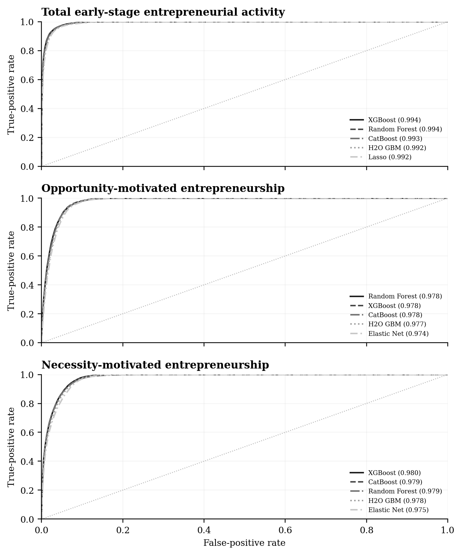
Note. Five strongest models in each panel by the area represented. Dotted line indicates chance discrimination or positive-case prevalence.

Interpretation
The largest displayed area values are TEA: XGBoost 0.994; OME: Random Forest 0.978; NME: XGBoost 0.980. The curves display ranking across all possible thresholds, complementing the single-threshold performance values in Table 4.
Several curves lie close together, so small visual differences should not be interpreted as established superiority. The outcome-linked intention missingness in Table 3 remains part of these observed predictive results.

Figure 2. Precision-recall curves
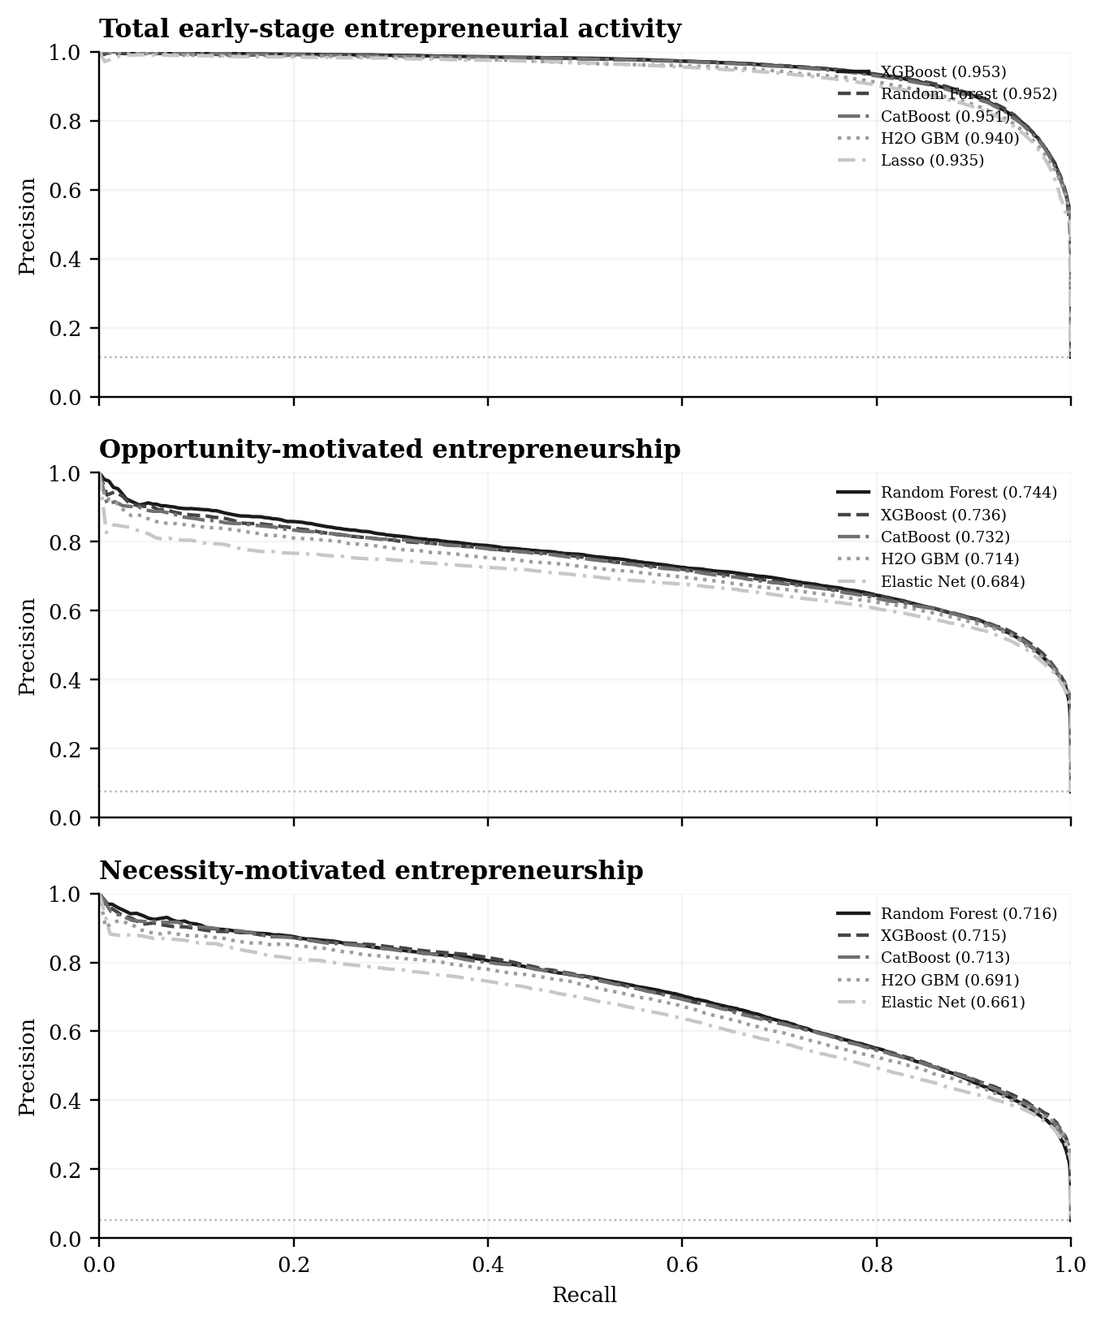
Note. Five strongest models in each panel by the area represented. Dotted line indicates chance discrimination or positive-case prevalence.

Interpretation
The largest displayed area values are TEA: XGBoost 0.953; OME: Random Forest 0.744; NME: Random Forest 0.716. The curves display ranking across all possible thresholds, complementing the single-threshold performance values in Table 4.
Several curves lie close together, so small visual differences should not be interpreted as established superiority. The outcome-linked intention missingness in Table 3 remains part of these observed predictive results.

Figure 3. Random-forest feature importance
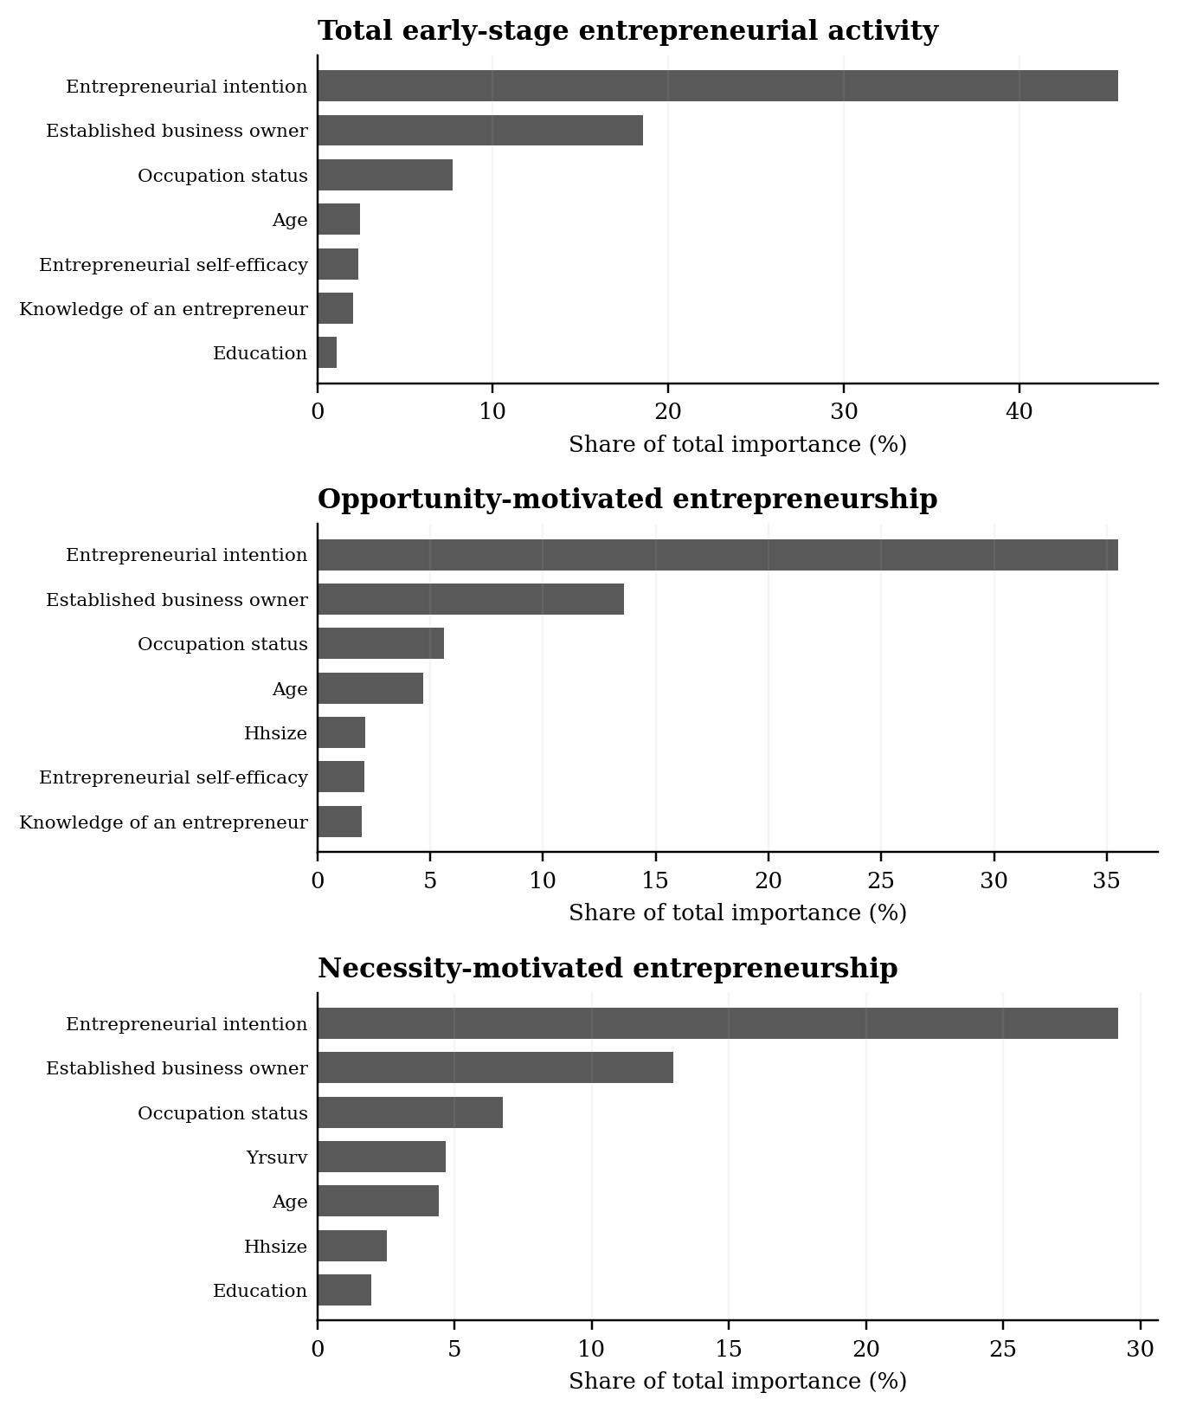
Note. The seven largest features in each full-specification random forest are shown as shares of total impurity importance.

Interpretation
The leading fitted features are TEA: Entrepreneurial intention (45.6%); OME: Entrepreneurial intention (35.5%); NME: Entrepreneurial intention (29.2%). Their order differs across outcome definitions, indicating that the forest uses different observed inputs when identifying the three entrepreneurial statuses.
Importance is a descriptive model diagnostic. It does not reveal the sign of an association or an intervention effect, and the missingness of entrepreneurial intention can contribute to its rank.

Figure 4. Change in precision-recall area after adding controls
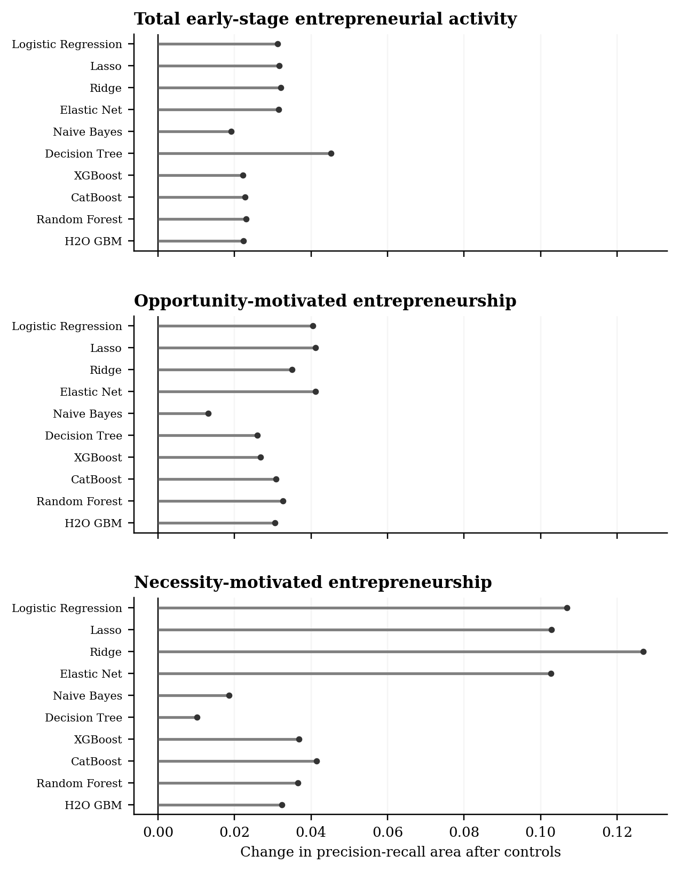
Note. Each dot is a ten-model paired comparison on exactly the same held-out respondents. Positive values favor the specification with controls.

Interpretation
Across model families the changes are TEA: median +0.027; OME: median +0.032; NME: median +0.039. The chart displays heterogeneity around these medians rather than reducing the comparison to the leading model in Table 6.
The plotted increment belongs to the full control set, including survey year in the controlled specification. It should not be attributed to any single variable or interpreted causally.

Figure 5. Institutional feature importance
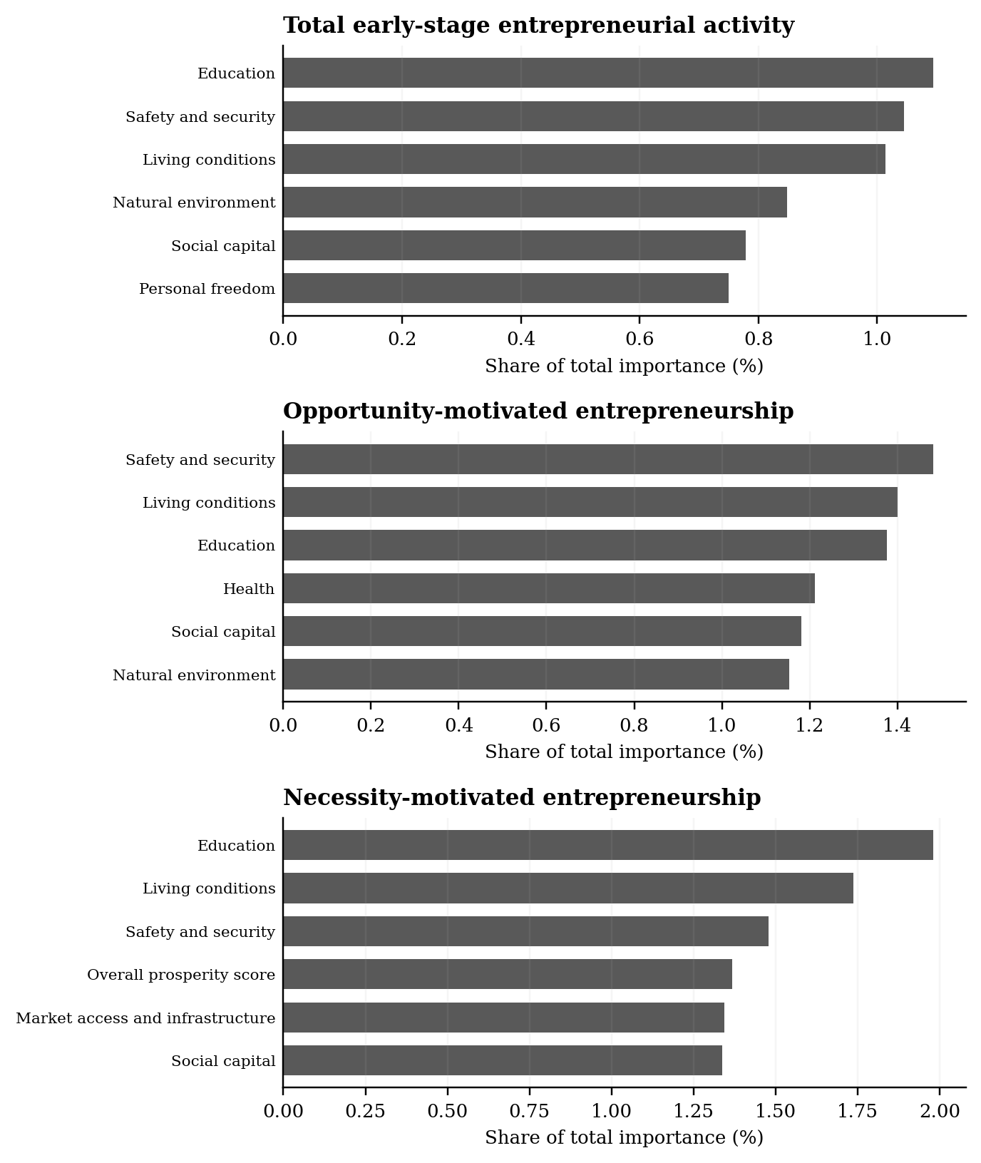
Note. The six leading raw institutional fields in each random forest are shown as shares of all fitted-feature importance.

Interpretation
The three outcome panels make clear whether the institutional ranking is stable across total, opportunity-motivated, and necessity-motivated entrepreneurship. The bar scale uses the whole model as its denominator, not the institutional block alone.
Across countries, index components can be strongly correlated. The bars describe model use of these fields rather than independent institutional effects.

Discussion
Across the three outcomes, the leading precision-recall areas are TEA: 0.953 for XGBoost; OME: 0.744 for Random Forest; NME: 0.716 for Random Forest. The pattern indicates that the saved observed-data specification separates entrepreneurial status from the negative class well on the held-out partition. Differences among model families are generally smaller than the separation from a prevalence-only benchmark, but no formal uncertainty interval was calculated.
The dominant qualification is the survey structure of entrepreneurial intention: the field is missing for every positive case. Retaining this variable followed the agreed specification, but the missing state itself offers target-linked information. These discrimination measures should not be interpreted as the performance of a prospective survey in which the intention question is asked of every respondent.
In the global sample, institutional measures vary by country and year, but related pillars are correlated and the model was fitted for prediction. Importance rankings do not identify a policy effect or support causal comparison between institutions.

Conclusion
The study documents outcome-specific predictive performance, the incremental value of the complete control set, and the variables used by random forests in this sample. The complete model results are retained in the supplementary tables to make the principal comparisons auditable. Substantive claims about socio-cognitive or institutional mechanisms would require analyses designed for identification rather than this predictive design.

Supplementary model results
The following tables show all ten candidate classifiers for every outcome. They retain the complete model-level evidence underlying the concise main tables.
Supplementary Table S1. Full held-out classifier performance
Outcome | Classifier | ROC area | PR area | Precision | Recall | F1
TEA | Logistic Regression | 0.991 | 0.934 | 0.852 | 0.886 | 0.868
TEA | Lasso | 0.992 | 0.935 | 0.851 | 0.888 | 0.869
TEA | Ridge | 0.991 | 0.931 | 0.849 | 0.883 | 0.865
TEA | Elastic Net | 0.992 | 0.935 | 0.851 | 0.888 | 0.869
TEA | Naive Bayes | 0.902 | 0.437 | 0.469 | 0.734 | 0.572
TEA | Decision Tree | 0.989 | 0.895 | 0.856 | 0.869 | 0.863
TEA | XGBoost | 0.994 | 0.953 | 0.885 | 0.885 | 0.885
TEA | CatBoost | 0.993 | 0.951 | 0.882 | 0.884 | 0.883
TEA | Random Forest | 0.994 | 0.952 | 0.867 | 0.908 | 0.887
TEA | H2O GBM | 0.992 | 0.940 | 0.856 | 0.890 | 0.873
OME | Logistic Regression | 0.974 | 0.683 | 0.582 | 0.848 | 0.690
OME | Lasso | 0.974 | 0.684 | 0.581 | 0.847 | 0.689
OME | Ridge | 0.974 | 0.675 | 0.583 | 0.849 | 0.691
OME | Elastic Net | 0.974 | 0.684 | 0.581 | 0.847 | 0.689
OME | Naive Bayes | 0.879 | 0.290 | 0.314 | 0.670 | 0.428
OME | Decision Tree | 0.971 | 0.626 | 0.565 | 0.842 | 0.676
OME | XGBoost | 0.978 | 0.736 | 0.626 | 0.828 | 0.713
OME | CatBoost | 0.978 | 0.732 | 0.623 | 0.825 | 0.710
OME | Random Forest | 0.978 | 0.744 | 0.626 | 0.830 | 0.714
OME | H2O GBM | 0.977 | 0.714 | 0.592 | 0.861 | 0.702
NME | Logistic Regression | 0.975 | 0.659 | 0.584 | 0.671 | 0.625
NME | Lasso | 0.975 | 0.661 | 0.585 | 0.673 | 0.626
NME | Ridge | 0.974 | 0.642 | 0.542 | 0.723 | 0.619
NME | Elastic Net | 0.975 | 0.661 | 0.585 | 0.673 | 0.626
NME | Naive Bayes | 0.885 | 0.227 | 0.257 | 0.583 | 0.357
NME | Decision Tree | 0.969 | 0.588 | 0.629 | 0.604 | 0.616
NME | XGBoost | 0.980 | 0.715 | 0.620 | 0.708 | 0.661
NME | CatBoost | 0.979 | 0.713 | 0.618 | 0.709 | 0.660
NME | Random Forest | 0.979 | 0.716 | 0.624 | 0.710 | 0.664
NME | H2O GBM | 0.978 | 0.691 | 0.603 | 0.690 | 0.644

Note. All values are from held-out test data for the full independent-variable-plus-control specification.
Supplementary Table S2. Full held-out confusion matrices
Outcome | Classifier | True positive | False positive | True negative | False negative
TEA | Logistic Regression | 27,366 | 4,772 | 232,920 | 3,518
TEA | Lasso | 27,417 | 4,782 | 232,910 | 3,467
TEA | Ridge | 27,270 | 4,862 | 232,830 | 3,614
TEA | Elastic Net | 27,418 | 4,788 | 232,904 | 3,466
TEA | Naive Bayes | 22,673 | 25,655 | 212,037 | 8,211
TEA | Decision Tree | 26,837 | 4,503 | 233,189 | 4,047
TEA | XGBoost | 27,329 | 3,540 | 234,152 | 3,555
TEA | CatBoost | 27,298 | 3,666 | 234,026 | 3,586
TEA | Random Forest | 28,054 | 4,293 | 233,399 | 2,830
TEA | H2O GBM | 27,496 | 4,623 | 233,069 | 3,388
OME | Logistic Regression | 16,974 | 12,200 | 236,359 | 3,043
OME | Lasso | 16,953 | 12,205 | 236,354 | 3,064
OME | Ridge | 16,988 | 12,143 | 236,416 | 3,029
OME | Elastic Net | 16,952 | 12,207 | 236,352 | 3,065
OME | Naive Bayes | 13,412 | 29,279 | 219,280 | 6,605
OME | Decision Tree | 16,863 | 12,980 | 235,579 | 3,154
OME | XGBoost | 16,576 | 9,907 | 238,652 | 3,441
OME | CatBoost | 16,523 | 10,014 | 238,545 | 3,494
OME | Random Forest | 16,621 | 9,919 | 238,640 | 3,396
OME | H2O GBM | 17,227 | 11,858 | 236,701 | 2,790
NME | Logistic Regression | 9,391 | 6,683 | 247,907 | 4,595
NME | Lasso | 9,410 | 6,670 | 247,920 | 4,576
NME | Ridge | 10,112 | 8,561 | 246,029 | 3,874
NME | Elastic Net | 9,414 | 6,677 | 247,913 | 4,572
NME | Naive Bayes | 8,156 | 23,559 | 231,031 | 5,830
NME | Decision Tree | 8,449 | 4,977 | 249,613 | 5,537
NME | XGBoost | 9,896 | 6,058 | 248,532 | 4,090
NME | CatBoost | 9,918 | 6,130 | 248,460 | 4,068
NME | Random Forest | 9,925 | 5,975 | 248,615 | 4,061
NME | H2O GBM | 9,655 | 6,352 | 248,238 | 4,331

Note. Every row sums to the test sample size for its outcome; thresholds were selected on validation data.
Supplementary Table S3. Full matched comparison of predictor specifications
Outcome | Classifier | Predictors only | With controls | Change
TEA | Logistic Regression | 0.903 | 0.934 | +0.031
TEA | Lasso | 0.903 | 0.935 | +0.032
TEA | Ridge | 0.899 | 0.931 | +0.032
TEA | Elastic Net | 0.903 | 0.935 | +0.031
TEA | Naive Bayes | 0.418 | 0.437 | +0.019
TEA | Decision Tree | 0.849 | 0.895 | +0.045
TEA | XGBoost | 0.930 | 0.953 | +0.022
TEA | CatBoost | 0.928 | 0.951 | +0.023
TEA | Random Forest | 0.929 | 0.952 | +0.023
TEA | H2O GBM | 0.918 | 0.940 | +0.022
OME | Logistic Regression | 0.643 | 0.683 | +0.040
OME | Lasso | 0.643 | 0.684 | +0.041
OME | Ridge | 0.640 | 0.675 | +0.035
OME | Elastic Net | 0.643 | 0.684 | +0.041
OME | Naive Bayes | 0.277 | 0.290 | +0.013
OME | Decision Tree | 0.600 | 0.626 | +0.026
OME | XGBoost | 0.709 | 0.736 | +0.027
OME | CatBoost | 0.701 | 0.732 | +0.031
OME | Random Forest | 0.712 | 0.744 | +0.033
OME | H2O GBM | 0.683 | 0.714 | +0.031
NME | Logistic Regression | 0.552 | 0.659 | +0.107
NME | Lasso | 0.558 | 0.661 | +0.103
NME | Ridge | 0.515 | 0.642 | +0.127
NME | Elastic Net | 0.558 | 0.661 | +0.103
NME | Naive Bayes | 0.209 | 0.227 | +0.019
NME | Decision Tree | 0.578 | 0.588 | +0.010
NME | XGBoost | 0.679 | 0.715 | +0.037
NME | CatBoost | 0.671 | 0.713 | +0.041
NME | Random Forest | 0.679 | 0.716 | +0.037
NME | H2O GBM | 0.659 | 0.691 | +0.032

Note. Each pair was evaluated on identical held-out row identifiers. Positive change favors the specification with controls.

