Objective 2 results and interpretation
Socio-cognitive traits and the Legatum Prosperity Index

Results and analytical scope
This manuscript reports predictive analyses for total early-stage entrepreneurial activity (TEA), opportunity-motivated entrepreneurship (OME), and necessity-motivated entrepreneurship (NME). Each outcome was modeled separately for the global sample, which includes India, and for India alone. The principal specification contains socio-cognitive and institutional predictors together with the pre-specified control variables. Independent-variable-only results are retained for matched comparisons.
All estimates, figures, and tables were reconstructed from the completed saved model outputs. The ten classifiers were not refitted. Precision-recall (PR) area and receiver operating characteristic (ROC) area summarize discrimination; precision, recall, the F1 score, and confusion counts use thresholds selected on validation data and evaluated on held-out test cases. The reported comparisons describe predictive associations and do not identify causal effects.

Sample composition
Table 1. Sample size, outcome prevalence, and analysis splits
Sample | Outcome | Respondents | Positive cases | Prevalence | Test cases
Global | TEA | 1,342,884 | 154,420 | 11.5% | 268,576
Global | OME | 1,342,884 | 100,087 | 7.5% | 268,576
Global | NME | 1,342,884 | 69,931 | 5.2% | 268,576
India | TEA | 27,555 | 3,188 | 11.6% | 5,510
India | OME | 27,555 | 2,167 | 7.9% | 5,510
India | NME | 27,555 | 1,849 | 6.7% | 5,510

Note. Global estimates include India. Training and validation counts are available in the accompanying table file; the same respondents enter paired predictor-set comparisons.

Interpretation
Global sample. The global analytical sample contains 1,342,884 respondents, with 268,576 reserved for testing in each outcome analysis. Positive-case prevalence is TEA 11.5%, OME 7.5%, NME 5.2%. The lower prevalence of opportunity- and necessity-motivated entrepreneurship means that accuracy alone would provide an incomplete assessment of classification performance.
India sample. The India sample contains 27,555 respondents and 5,510 held-out observations per outcome. Its observed prevalence is TEA 11.6%, OME 7.9%, NME 6.7%. The separate India models assess within-country prediction rather than the performance of a global model transported to India.
Interpretive implication. Because the global sample includes India, the two samples are not independent. Differences in performance should therefore be interpreted as descriptive differences between fitted populations, with attention to the much smaller India test set.

Predictor distributions
Table 2. Descriptive statistics and missingness of model predictors
Predictor | Role | Global value | Missing | India value | Missing
Entrepreneurial self-efficacy | Predictor | 53.1% | 7.9% | 61.4% | 9.3%
Opportunity perception | Predictor | 45.9% | 18.1% | 60.4% | 10.4%
Fear of failure | Predictor | 43.7% | 0.6% | 44.0% | 1.0%
Knowledge of an entrepreneur | Predictor | 44.2% | 2.3% | 44.8% | 13.1%
Entrepreneurial intention | Predictor | 2 categories | 23.2% | 2 categories | 20.0%
Media coverage | Predictor | 62.0% | 20.9% | 63.3% | 11.6%
Discent | Predictor | 4.6% | 0.9% | 5.2% | 1.6%
Busang | Predictor | 6.1% | 0.8% | 4.3% | 2.1%
Established business owner | Predictor | 7.8% | 0.0% | 6.6% | 0.0%
Good career choice | Predictor | 1.25 (0.93) | 14.3% | 1.32 (0.91) | 6.5%
Ease start business | Predictor | 43.7% | 22.2% | 59.2% | 11.8%
High status | Predictor | 69.8% | 22.8% | 70.6% | 11.6%
Social enterprise | Predictor | 39.4% | 32.4% | 58.0% | 13.2%
Overall prosperity score | Predictor | 67.92 (10.53) | 1.0% | 52.27 (1.44) | 0.0%
Safety and security | Predictor | 75.68 (15.11) | 1.0% | 46.96 (3.94) | 0.0%
Personal freedom | Predictor | 69.55 (20.07) | 1.0% | 54.00 (3.50) | 0.0%
Governance | Predictor | 63.51 (15.28) | 1.0% | 58.39 (1.62) | 0.0%
Social capital | Predictor | 58.35 (11.13) | 1.0% | 43.70 (3.69) | 0.0%
Investment environment | Predictor | 66.71 (12.63) | 1.0% | 54.87 (2.04) | 0.0%
Enterprise conditions | Predictor | 63.96 (10.82) | 1.0% | 62.12 (1.90) | 0.0%
Market access and infrastructure | Predictor | 65.78 (11.37) | 1.0% | 51.05 (3.02) | 0.0%
Economic quality | Predictor | 60.50 (10.43) | 1.0% | 48.96 (0.69) | 0.0%
Living conditions | Predictor | 83.52 (12.29) | 1.0% | 53.02 (2.69) | 0.0%
Health | Predictor | 75.44 (6.23) | 1.0% | 62.84 (2.23) | 0.0%
Education | Predictor | 71.78 (13.11) | 1.0% | 49.98 (0.81) | 0.0%
Natural environment | Predictor | 60.27 (9.08) | 1.0% | 41.35 (0.44) | 0.0%
Yrsurv | Control | 8 categories | 0.0% | 8 categories | 0.0%
Age | Control | 41.50 (14.53) | 2.8% | 35.71 (12.20) | 0.0%
Gender | Control | 2 categories | 0.0% | 2 categories | 0.0%
Education attainment | Control | 5 categories | 1.6% | 5 categories | 0.5%
Household income | Control | 3 categories | 18.9% | 3 categories | 6.1%
Hhsize | Control | 74.55 (81460.96) | 1.8% | 3.97 (1.66) | 1.1%
Occupation status | Control | 7 categories | 1.8% | 7 categories | 4.5%
Gdp per capita ppp | Control | 35593.44 (21374.64) | 0.0% | 6356.76 (856.84) | 0.0%
Population totalthousands | Control | 96167409.78 (259900716.69) | 0.0% | 1363227202.26 (32494678.65) | 0.0%
Gdp growth | Control | 2.41 (4.02) | 0.0% | 5.63 (4.43) | 0.0%

Note. Binary values are proportions coded one; other numerical values are means with standard deviations in parentheses. Missing percentages refer to the eligible sample. Institutional scores repeat for respondents in the same country and survey year.

Interpretation
Global sample. The global distribution combines respondent-level socio-cognitive variables with country-year institutional measures. The overall prosperity score has a global summary of 67.92 (10.53) and 1.0% missingness. Several socio-cognitive fields have substantially more missing values than the institutional index, so the handling of missing categories is consequential for the fitted models.
India sample. In India, the same institutional measure has a summary of 52.27 (1.44) and 0.0% missingness. Within India, each respondent surveyed in a given year receives the same national institutional score. The respondent count should therefore not be interpreted as the number of independent observations of institutional conditions.
Interpretive implication. The table describes observed predictor distributions, not adjusted relationships with entrepreneurship. Institutional score differences between India and the global sample may reflect country composition and survey-year coverage as well as substantive differences in the measured conditions.

Survey response pattern
Table 3. Missing entrepreneurial intention by observed outcome
Sample | Outcome | Positive cases missing | Negative cases missing
Global | TEA | 100.0% | 13.2%
Global | OME | 100.0% | 17.0%
Global | NME | 100.0% | 18.9%
India | TEA | 100.0% | 9.5%
India | OME | 100.0% | 13.2%
India | NME | 100.0% | 14.2%

Note. Entrepreneurial intention was retained as a predictor as specified in the analysis plan; its missing state was preserved rather than removed.

Interpretation
Global sample. Entrepreneurial intention is missing for every positive case in all three global outcomes. Among negative cases, the corresponding missingness rates are TEA 13.2%, OME 17.0%, NME 18.9%. Missingness therefore carries substantial information about the observed outcome, independently of the respondent's stated intention value.
India sample. The India analysis exhibits the same complete missingness among positive cases. The negative-case rates are TEA 9.5%, OME 13.2%, NME 14.2%. This pattern applies to all India outcomes and is present in the predictor data used by the classifiers.
Interpretive implication. The survey response pattern is essential to interpreting subsequent discrimination measures. High held-out performance reflects the entire observed-data process, including outcome-linked missingness, and should not be presented as evidence that institutional measures alone predict entrepreneurship with the reported accuracy.

Classifier discrimination
Table 4. Highest precision-recall area model for each outcome and sample
Sample | Outcome | Selected model | ROC area | PR area | Precision | Recall | F1
Global | TEA | XGBoost | 0.994 | 0.953 | 0.885 | 0.885 | 0.885
Global | OME | Random Forest | 0.978 | 0.744 | 0.626 | 0.830 | 0.714
Global | NME | Random Forest | 0.979 | 0.716 | 0.624 | 0.710 | 0.664
India | TEA | XGBoost | 0.998 | 0.981 | 0.924 | 0.953 | 0.938
India | OME | Random Forest | 0.988 | 0.858 | 0.751 | 0.813 | 0.780
India | NME | H2O GBM | 0.988 | 0.830 | 0.696 | 0.837 | 0.760

Note. The selected model has the largest held-out precision-recall area within each sample and outcome. All ten model results appear in Supplementary Table S1. Selection here is descriptive and does not imply a statistically significant advantage.

Interpretation
Global sample. The best observed precision-recall area in the global sample is TEA: XGBoost (precision-recall area 0.953); OME: Random Forest (precision-recall area 0.744); NME: Random Forest (precision-recall area 0.716). Discrimination is strongest for total early-stage entrepreneurial activity, while the two motive-specific outcomes are more difficult to identify because they have fewer positive cases and differ in their outcome composition.
India sample. For India, the corresponding selected classifiers are TEA: XGBoost (precision-recall area 0.981); OME: Random Forest (precision-recall area 0.858); NME: H2O GBM (precision-recall area 0.830). The leading algorithm differs across outcomes, indicating that the relative performance of model families depends on the target. Estimates are based on the smaller India test sample and should be read with this sampling difference in mind.
Interpretive implication. The near-ceiling receiver operating characteristic areas must be interpreted alongside Table 3. They measure ranking on the saved held-out split under the observed survey missingness structure, not the predictive contribution of any one socio-cognitive or institutional variable.

Classification at selected thresholds
Table 5. Confusion counts for the selected classifiers
Sample | Outcome | Selected model | True positive | False positive | True negative | False negative
Global | TEA | XGBoost | 27,329 | 3,540 | 234,152 | 3,555
Global | OME | Random Forest | 16,621 | 9,919 | 238,640 | 3,396
Global | NME | Random Forest | 9,925 | 5,975 | 248,615 | 4,061
India | TEA | XGBoost | 607 | 50 | 4,823 | 30
India | OME | Random Forest | 352 | 117 | 4,960 | 81
India | NME | H2O GBM | 309 | 135 | 5,006 | 60

Note. Each model's threshold was chosen using validation observations. Complete confusion matrices for all ten classifiers are provided in Supplementary Table S2.

Interpretation
Global sample. At their validation-selected thresholds, the selected global classifiers produce TEA: 3,540 false positives and 3,555 false negatives; OME: 9,919 false positives and 3,396 false negatives; NME: 5,975 false positives and 4,061 false negatives. These counts show the operating-point trade-off that is hidden by a single curve-area statistic. In particular, the smaller positive classes make false positive classifications consequential for precision.
India sample. For India, the selected models produce TEA: 50 false positives and 30 false negatives; OME: 117 false positives and 81 false negatives; NME: 135 false positives and 60 false negatives. The absolute counts are lower because the India test set is smaller. Model comparisons should use both these counts and the corresponding precision and recall values rather than the raw number of errors alone.
Interpretive implication. No application-specific cost of a false positive or false negative was specified. Consequently, the reported validation-selected thresholds provide reproducible operating points but do not establish an optimal threshold for a policy or screening decision.

Incremental information from controls
Table 6. Change in precision-recall area after including control variables
Sample | Outcome | Selected model | Predictors only | With controls | Change | Median change all models
Global | TEA | XGBoost | 0.930 | 0.953 | +0.022 | +0.027
Global | OME | Random Forest | 0.712 | 0.744 | +0.033 | +0.032
Global | NME | Random Forest | 0.679 | 0.716 | +0.037 | +0.039
India | TEA | XGBoost | 0.975 | 0.981 | +0.006 | +0.005
India | OME | Random Forest | 0.854 | 0.858 | +0.004 | +0.006
India | NME | H2O GBM | 0.823 | 0.830 | +0.007 | +0.004

Note. Change is the score with controls minus the predictor-only score on exactly the same held-out respondents. Full paired results are shown in Supplementary Table S3.

Interpretation
Global sample. For the selected global model in each outcome, the precision-recall area changes are TEA +0.022; OME +0.033; NME +0.037. The final column summarizes the corresponding change across all ten model families, guarding against an interpretation based only on the selected classifier.
India sample. The selected India model changes are TEA +0.006; OME +0.004; NME +0.007. Survey year is included in the control specification. Since India's institutional scores are annual country-level values, year and the institutional indices capture overlapping temporal variation.
Interpretive implication. These matched test-split differences describe incremental predictive information from the full control set. They do not estimate the independent effect of age, survey year, macroeconomic conditions, or any single institutional pillar.

Institutional predictors
Table 7. Leading institutional predictors in the random forest
Sample | Outcome | Leading institutional variable | Share of all importance | Institutional total
Global | TEA | Education | 1.1% | 10.0%
Global | OME | Safety and security | 1.5% | 15.3%
Global | NME | Education | 2.0% | 17.6%
India | TEA | Safety and security | 0.4% | 4.0%
India | OME | Living conditions | 0.7% | 6.3%
India | NME | Market access and infrastructure | 0.6% | 6.4%

Note. Importance is the random forest's impurity-based allocation across fitted inputs. The institutional total sums all raw institutional fields, while the leading-variable column reports the largest one. Missingness indicators enter the denominator but are excluded from the institutional ranking.

Interpretation
Global sample. The most prominent institutional dimensions in the global fits are TEA: Education (1.1% of all importance); OME: Safety and security (1.5% of all importance); NME: Education (2.0% of all importance). The reported shares indicate how often the model used these fields in impurity-reducing splits relative to all predictors, including socio-cognitive variables and controls.
India sample. In the India fits, the leading institutional fields are TEA: Safety and security (0.4% of all importance); OME: Living conditions (0.7% of all importance); NME: Market access and infrastructure (0.6% of all importance). These scores vary at the national annual level, yielding only eight distinct survey-year profiles. A large or small importance share is therefore sensitive to the particular temporal pattern and to competition with the year control.
Interpretive implication. Random-forest impurity importance is not an effect estimate and may redistribute importance among correlated institutional pillars. The table supports a descriptive account of model reliance, not a ranking of which policy reform would change entrepreneurship rates.

Figures

Figure 1. Receiver operating characteristic curves
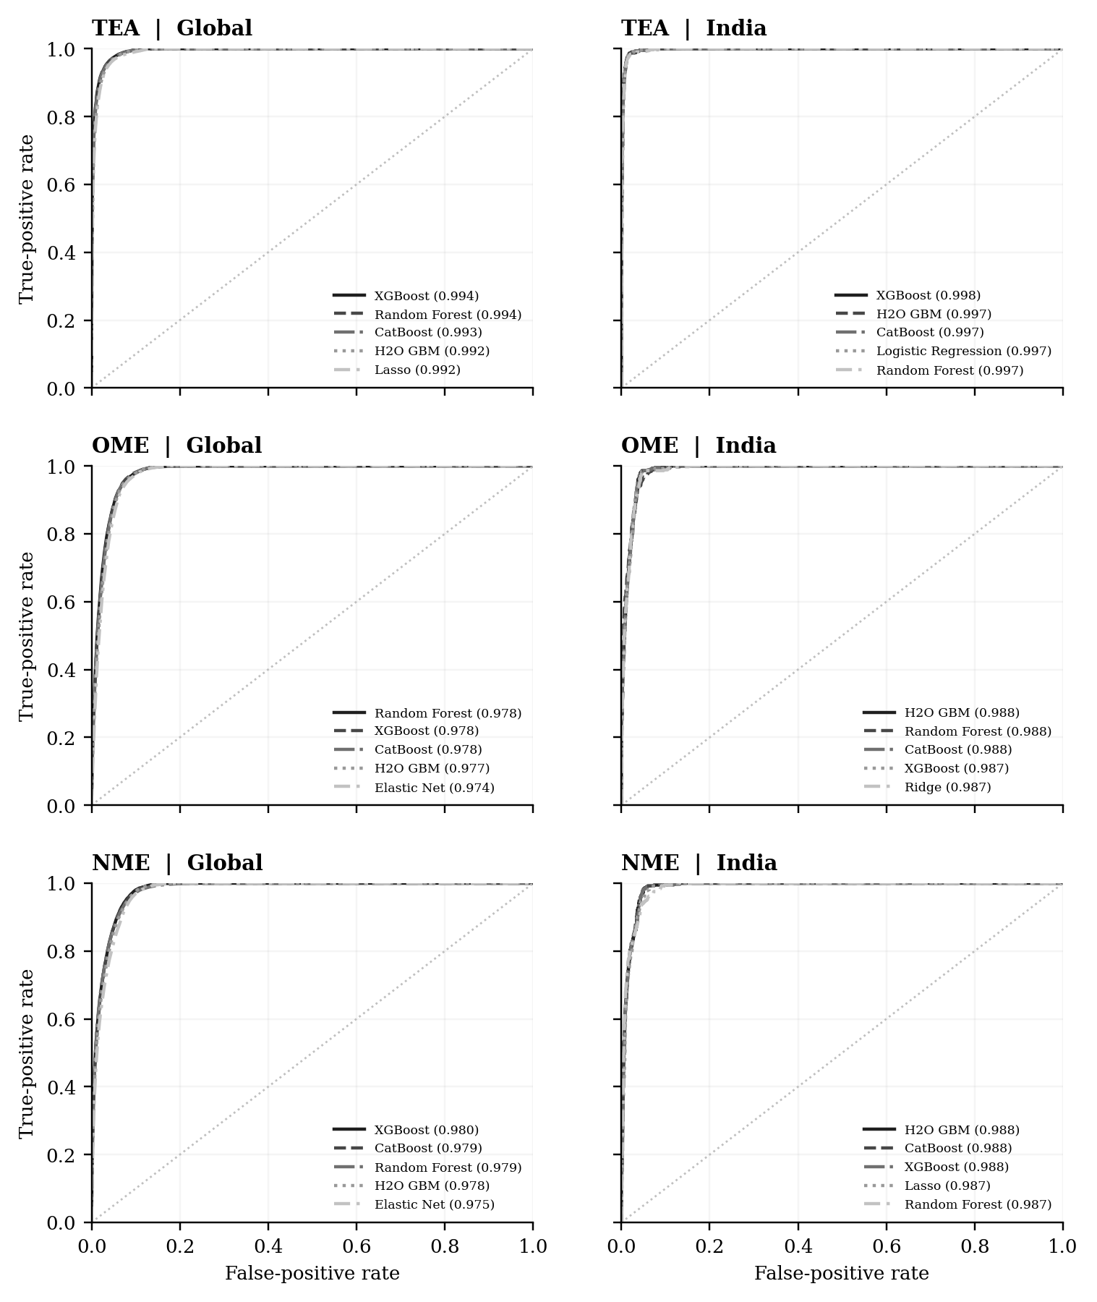
Note. The five largest receiver operating characteristic areas are plotted within each sample and outcome panel. The dotted diagonal represents chance ranking.

Interpretation
Global sample. The global panels show consistently strong ranking across the three outcomes. For the models selected by precision-recall area, the corresponding receiver operating characteristic area values are TEA XGBoost (0.994); OME Random Forest (0.978); NME Random Forest (0.979). The spread between curves is much smaller than the separation from the reference line, indicating that several model families perform similarly on the saved test split.
India sample. The India panels show receiver operating characteristic area values of TEA XGBoost (0.998); OME Random Forest (0.988); NME H2O GBM (0.988) for the selected classifiers. Differences in curve shape should be read against the smaller India test sample and the prevalence of each positive outcome. The India curves describe separately trained country-specific fits.

Figure 2. Precision recall curves
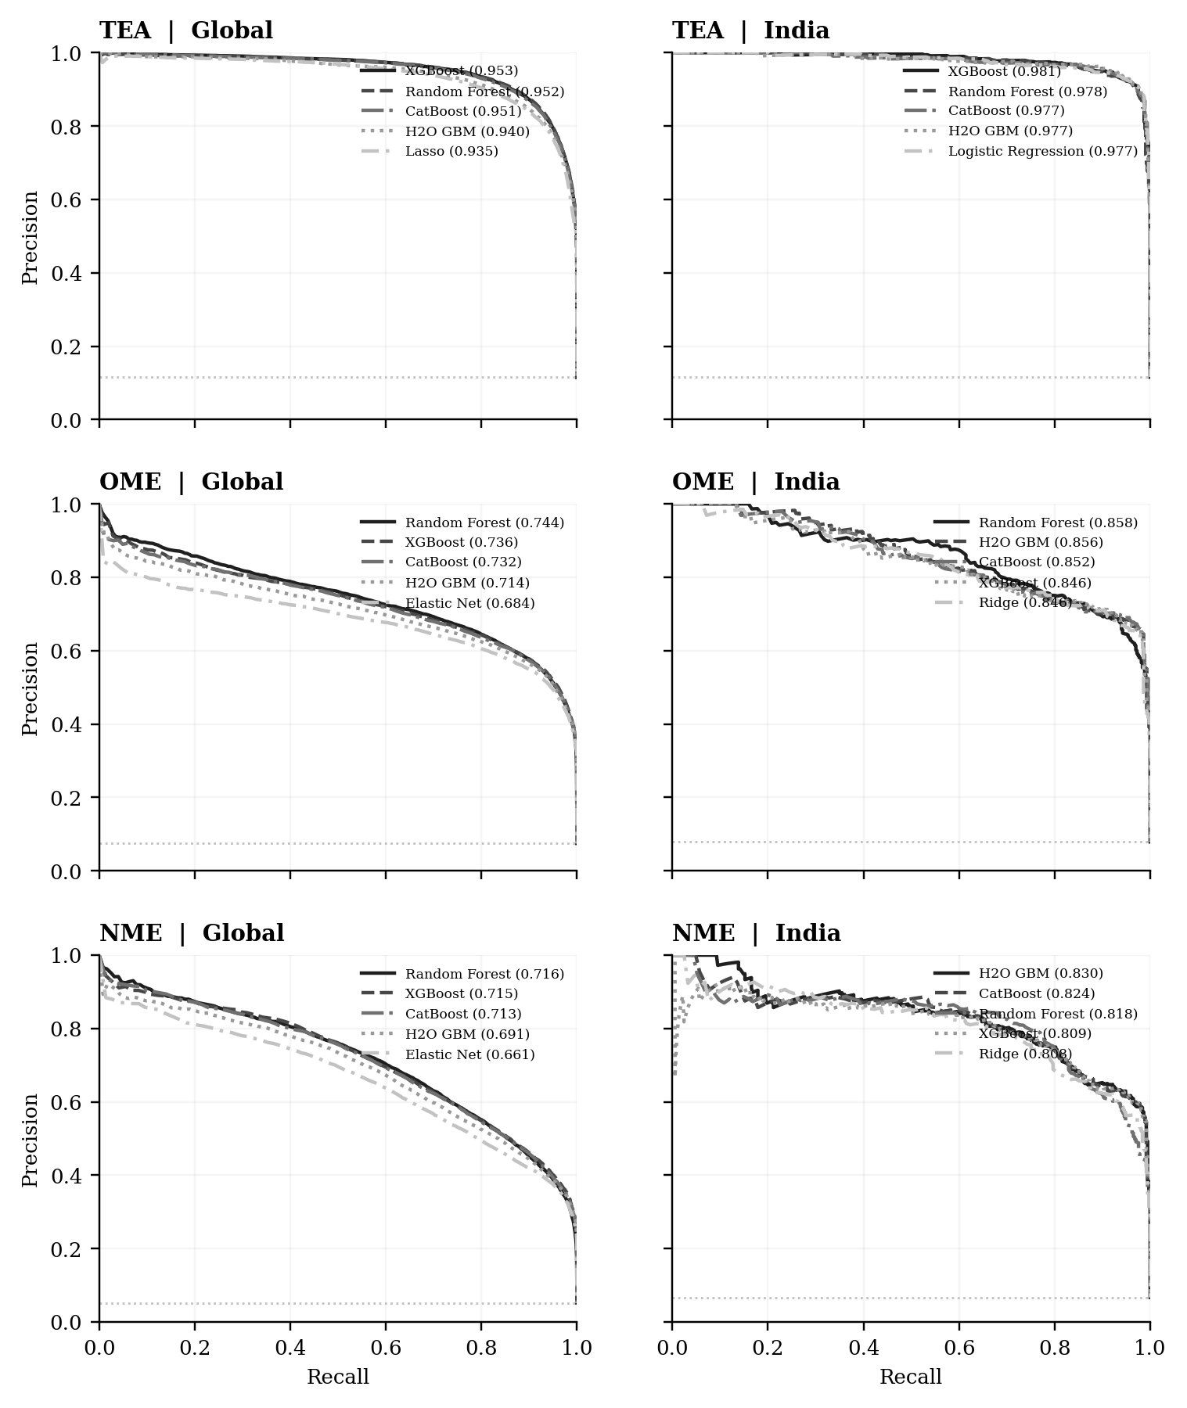
Note. The five largest precision-recall areas are plotted within each panel. The dotted horizontal line marks outcome prevalence.

Interpretation
Global sample. The global panels show consistently strong ranking across the three outcomes. For the models selected by precision-recall area, the corresponding precision-recall area values are TEA XGBoost (0.953); OME Random Forest (0.744); NME Random Forest (0.716). The spread between curves is much smaller than the separation from the reference line, indicating that several model families perform similarly on the saved test split.
India sample. The India panels show precision-recall area values of TEA XGBoost (0.981); OME Random Forest (0.858); NME H2O GBM (0.830) for the selected classifiers. Differences in curve shape should be read against the smaller India test sample and the prevalence of each positive outcome. The India curves describe separately trained country-specific fits.

Figure 3. Random forest feature importance
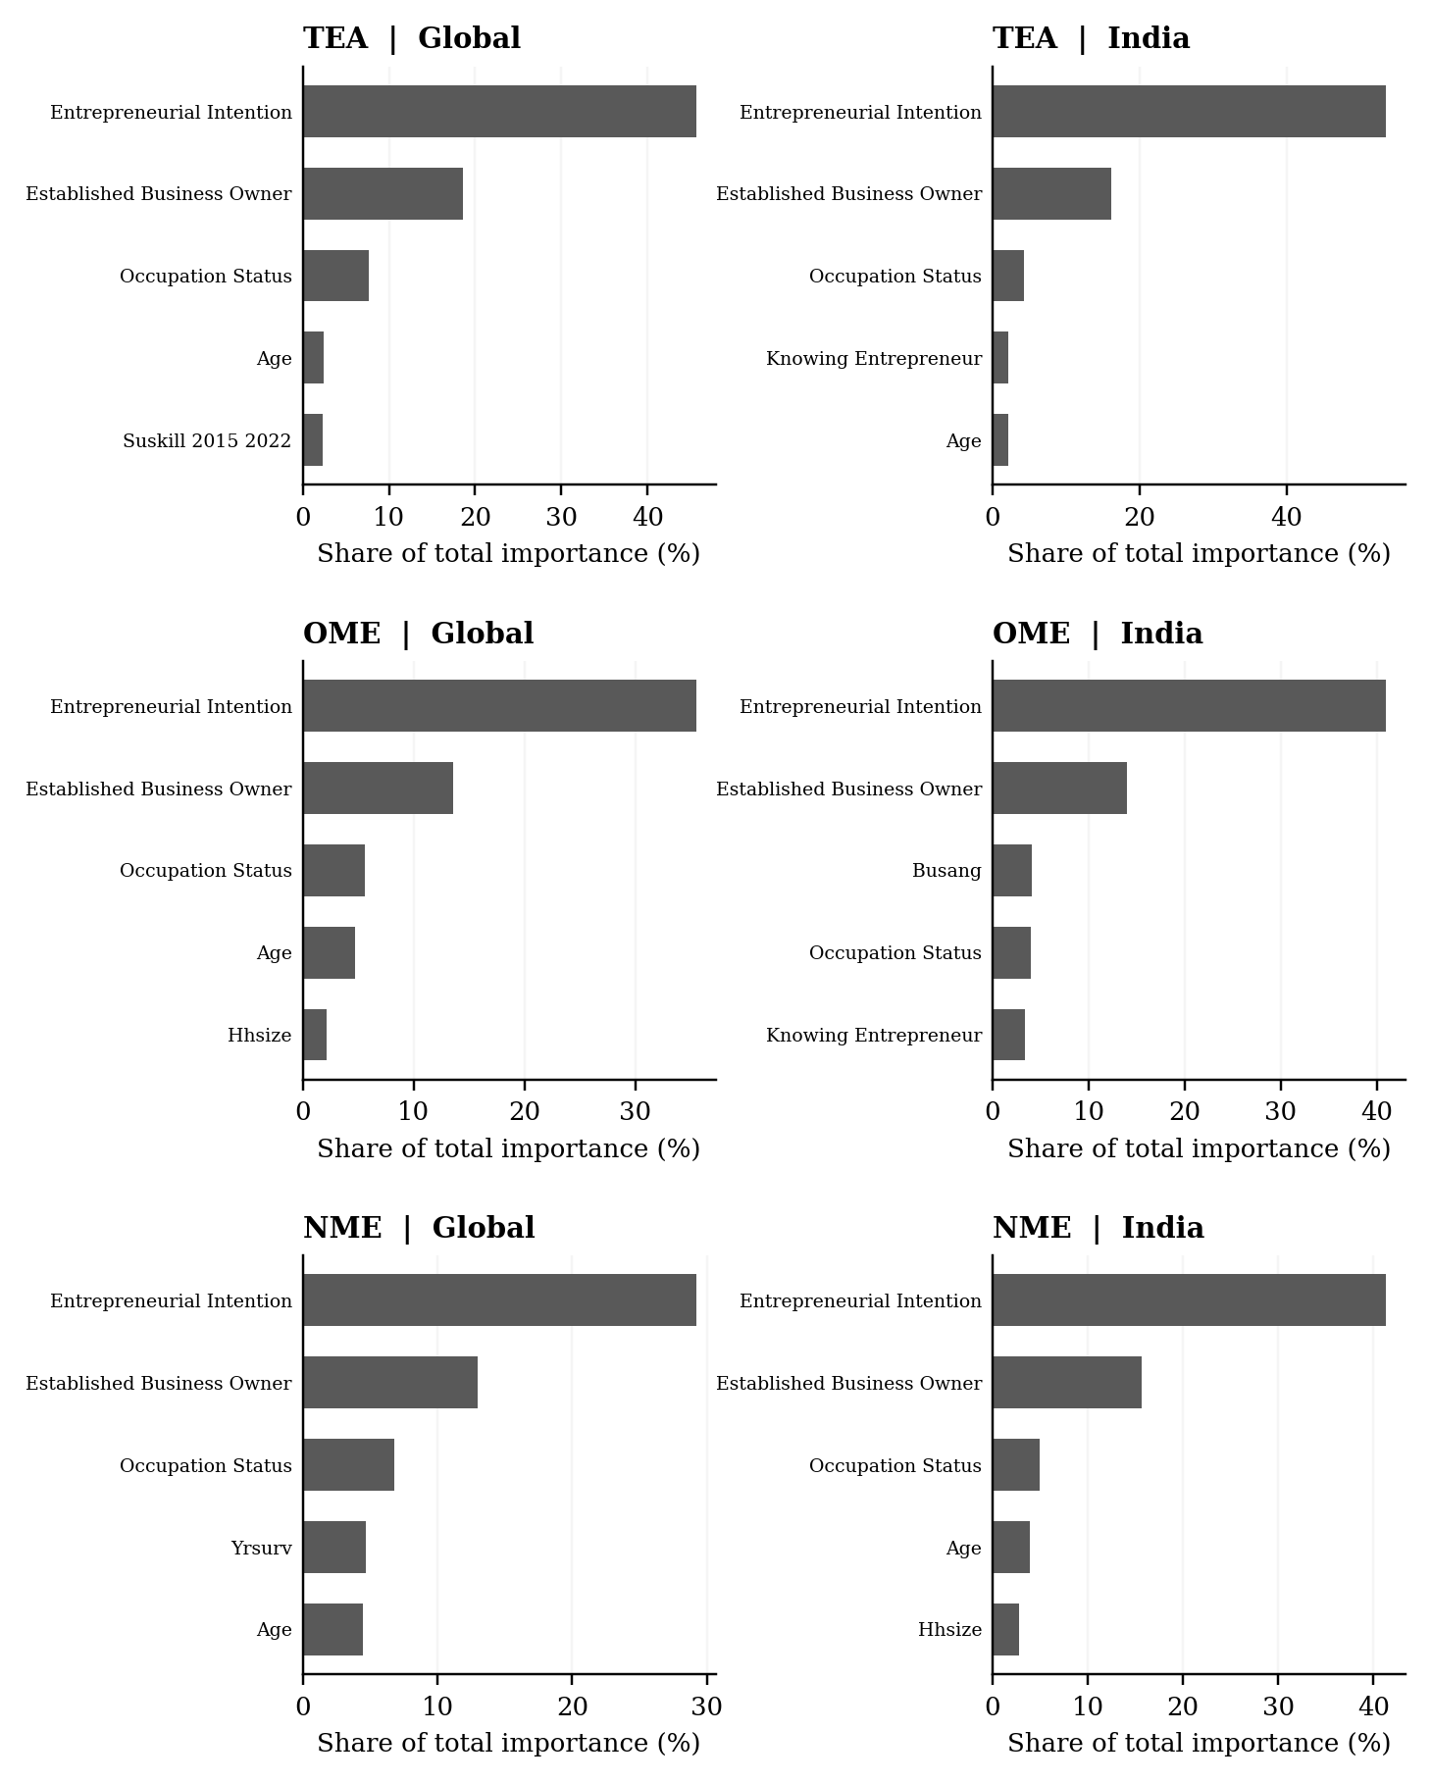
Note. Bars show the five most important inputs in each random forest, expressed as a share of total impurity importance.

Interpretation
Global sample. The leading inputs in the global panels are TEA: Entrepreneurial intention; OME: Entrepreneurial intention; NME: Entrepreneurial intention. The figure also shows that the importance profile changes across the three outcome definitions. Feature importance here records the fitted forest's use of a variable in splitting the data, rather than the direction of its relationship with entrepreneurship.
India sample. The India panels identify TEA: Entrepreneurial intention; OME: Entrepreneurial intention; NME: Entrepreneurial intention as the leading inputs. The narrower country-specific sample and limited variation in national institutional scores can change the ordering relative to the global fits.

Figure 4. Change in precision recall area after adding controls
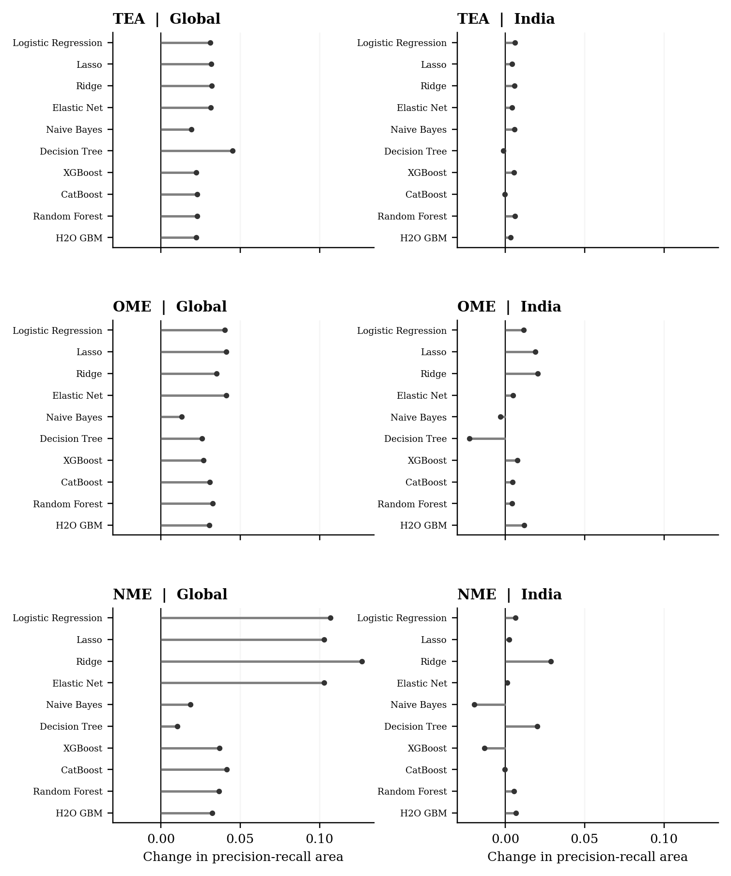
Note. Dots show the change in held-out precision-recall area for each of the ten model families when controls are included.

Interpretation
Global sample. In the global analysis, TEA: 10 of ten models improve; median change +0.027; OME: 10 of ten models improve; median change +0.032; NME: 10 of ten models improve; median change +0.039. The horizontal distance from zero makes the incremental predictive value of the entire control set visible for each classifier and outcome.
India sample. In India, TEA: 8 of ten models improve; median change +0.005; OME: 8 of ten models improve; median change +0.006; NME: 7 of ten models improve; median change +0.004. The spread across model families indicates that adding controls does not contribute a fixed amount of information independent of the learning algorithm.

Figure 5. Institutional feature importance
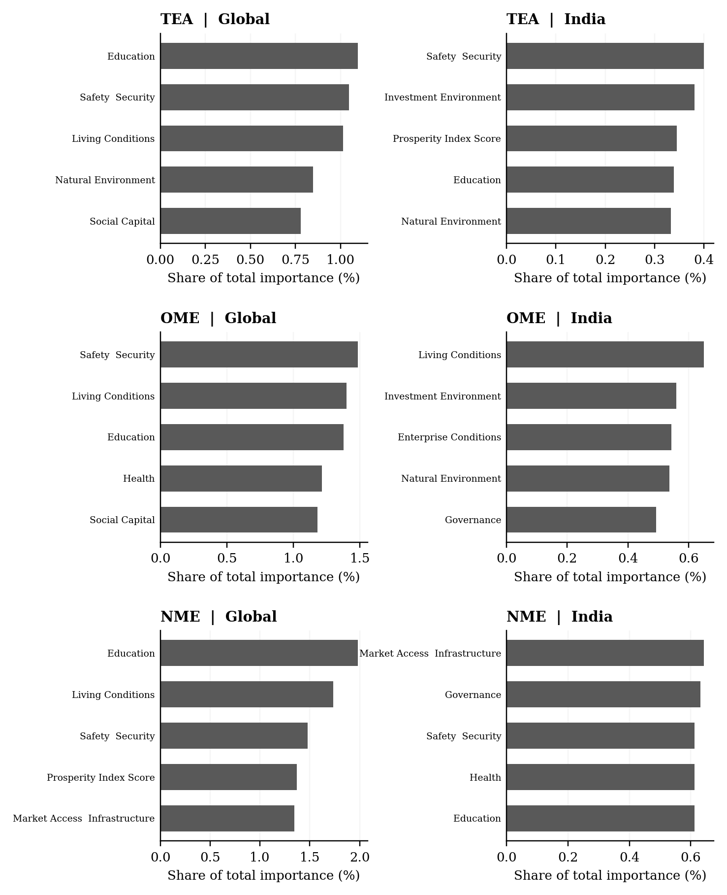
Note. Bars show the five most important raw institutional variables in each random forest, as a share of total model importance.

Interpretation
Global sample. The leading institutional fields in the global panels are TEA: Education (1.1%); OME: Safety and security (1.5%); NME: Education (2.0%). Their bars use all fitted predictors as the denominator, allowing the reader to judge institutional usage in the context of the wider model rather than only relative to other institutional pillars.
India sample. For India, the corresponding leading fields are TEA: Safety and security (0.4%); OME: Living conditions (0.7%); NME: Market access and infrastructure (0.6%). Because the scores are shared by respondents in the same year, the bars primarily summarize how the model uses annual national variation.

Supplementary model tables
The following tables retain all ten fitted model families for each outcome and sample. They are included for auditability; the principal tables in the results section summarize the selected models.
Supplementary Table S1. Complete held-out classifier performance
Sample | Outcome | Model | ROC area | PR area | Precision | Recall | F1
Global | TEA | Logistic Regression | 0.991 | 0.934 | 0.852 | 0.886 | 0.868
Global | TEA | Lasso | 0.992 | 0.935 | 0.851 | 0.888 | 0.869
Global | TEA | Ridge | 0.991 | 0.931 | 0.849 | 0.883 | 0.865
Global | TEA | Elastic Net | 0.992 | 0.935 | 0.851 | 0.888 | 0.869
Global | TEA | Naive Bayes | 0.902 | 0.437 | 0.469 | 0.734 | 0.572
Global | TEA | Decision Tree | 0.989 | 0.895 | 0.856 | 0.869 | 0.863
Global | TEA | XGBoost | 0.994 | 0.953 | 0.885 | 0.885 | 0.885
Global | TEA | CatBoost | 0.993 | 0.951 | 0.882 | 0.884 | 0.883
Global | TEA | Random Forest | 0.994 | 0.952 | 0.867 | 0.908 | 0.887
Global | TEA | H2O GBM | 0.992 | 0.940 | 0.856 | 0.890 | 0.873
Global | OME | Logistic Regression | 0.974 | 0.683 | 0.582 | 0.848 | 0.690
Global | OME | Lasso | 0.974 | 0.684 | 0.581 | 0.847 | 0.689
Global | OME | Ridge | 0.974 | 0.675 | 0.583 | 0.849 | 0.691
Global | OME | Elastic Net | 0.974 | 0.684 | 0.581 | 0.847 | 0.689
Global | OME | Naive Bayes | 0.879 | 0.290 | 0.314 | 0.670 | 0.428
Global | OME | Decision Tree | 0.971 | 0.626 | 0.565 | 0.842 | 0.676
Global | OME | XGBoost | 0.978 | 0.736 | 0.626 | 0.828 | 0.713
Global | OME | CatBoost | 0.978 | 0.732 | 0.623 | 0.825 | 0.710
Global | OME | Random Forest | 0.978 | 0.744 | 0.626 | 0.830 | 0.714
Global | OME | H2O GBM | 0.977 | 0.714 | 0.592 | 0.861 | 0.702
Global | NME | Logistic Regression | 0.975 | 0.659 | 0.584 | 0.671 | 0.625
Global | NME | Lasso | 0.975 | 0.661 | 0.585 | 0.673 | 0.626
Global | NME | Ridge | 0.974 | 0.642 | 0.542 | 0.723 | 0.619
Global | NME | Elastic Net | 0.975 | 0.661 | 0.585 | 0.673 | 0.626
Global | NME | Naive Bayes | 0.885 | 0.227 | 0.257 | 0.583 | 0.357
Global | NME | Decision Tree | 0.969 | 0.588 | 0.629 | 0.604 | 0.616
Global | NME | XGBoost | 0.980 | 0.715 | 0.620 | 0.708 | 0.661
Global | NME | CatBoost | 0.979 | 0.713 | 0.618 | 0.709 | 0.660
Global | NME | Random Forest | 0.979 | 0.716 | 0.624 | 0.710 | 0.664
Global | NME | H2O GBM | 0.978 | 0.691 | 0.603 | 0.690 | 0.644
India | TEA | Logistic Regression | 0.997 | 0.977 | 0.926 | 0.948 | 0.937
India | TEA | Lasso | 0.997 | 0.975 | 0.905 | 0.973 | 0.938
India | TEA | Ridge | 0.997 | 0.975 | 0.920 | 0.959 | 0.939
India | TEA | Elastic Net | 0.997 | 0.975 | 0.923 | 0.947 | 0.935
India | TEA | Naive Bayes | 0.938 | 0.681 | 0.681 | 0.782 | 0.728
India | TEA | Decision Tree | 0.994 | 0.920 | 0.916 | 0.956 | 0.935
India | TEA | XGBoost | 0.998 | 0.981 | 0.924 | 0.953 | 0.938
India | TEA | CatBoost | 0.997 | 0.977 | 0.924 | 0.953 | 0.938
India | TEA | Random Forest | 0.997 | 0.978 | 0.922 | 0.950 | 0.936
India | TEA | H2O GBM | 0.997 | 0.977 | 0.924 | 0.958 | 0.941
India | OME | Logistic Regression | 0.987 | 0.844 | 0.703 | 0.898 | 0.789
India | OME | Lasso | 0.987 | 0.845 | 0.703 | 0.887 | 0.784
India | OME | Ridge | 0.987 | 0.846 | 0.708 | 0.905 | 0.794
India | OME | Elastic Net | 0.986 | 0.839 | 0.703 | 0.887 | 0.784
India | OME | Naive Bayes | 0.910 | 0.561 | 0.563 | 0.612 | 0.586
India | OME | Decision Tree | 0.984 | 0.789 | 0.678 | 0.845 | 0.752
India | OME | XGBoost | 0.987 | 0.846 | 0.715 | 0.887 | 0.792
India | OME | CatBoost | 0.988 | 0.852 | 0.733 | 0.788 | 0.759
India | OME | Random Forest | 0.988 | 0.858 | 0.751 | 0.813 | 0.780
India | OME | H2O GBM | 0.988 | 0.856 | 0.705 | 0.887 | 0.785
India | NME | Logistic Regression | 0.986 | 0.803 | 0.739 | 0.775 | 0.757
India | NME | Lasso | 0.987 | 0.805 | 0.735 | 0.775 | 0.755
India | NME | Ridge | 0.986 | 0.808 | 0.728 | 0.775 | 0.751
India | NME | Elastic Net | 0.987 | 0.804 | 0.734 | 0.770 | 0.751
India | NME | Naive Bayes | 0.868 | 0.461 | 0.493 | 0.566 | 0.527
India | NME | Decision Tree | 0.986 | 0.765 | 0.763 | 0.732 | 0.747
India | NME | XGBoost | 0.988 | 0.809 | 0.757 | 0.775 | 0.766
India | NME | CatBoost | 0.988 | 0.824 | 0.755 | 0.778 | 0.766
India | NME | Random Forest | 0.987 | 0.818 | 0.673 | 0.843 | 0.748
India | NME | H2O GBM | 0.988 | 0.830 | 0.696 | 0.837 | 0.760

Note. All figures are measured on held-out test observations using the full predictor and control specification.
Global sample. Across the global outcomes, model rankings differ in detail but several nonlinear models achieve similar discrimination. The complete table prevents the six selected results in Table 4 from obscuring the performance of alternative model families.
India sample. The India rankings also vary by outcome. Comparison of the full rows is preferable to treating a small difference between the two leading models as conclusive, particularly with the smaller country-specific test sample.
Supplementary Table S2. Complete held-out confusion matrices
Sample | Outcome | Model | True positive | False positive | True negative | False negative
Global | TEA | Logistic Regression | 27,366 | 4,772 | 232,920 | 3,518
Global | TEA | Lasso | 27,417 | 4,782 | 232,910 | 3,467
Global | TEA | Ridge | 27,270 | 4,862 | 232,830 | 3,614
Global | TEA | Elastic Net | 27,418 | 4,788 | 232,904 | 3,466
Global | TEA | Naive Bayes | 22,673 | 25,655 | 212,037 | 8,211
Global | TEA | Decision Tree | 26,837 | 4,503 | 233,189 | 4,047
Global | TEA | XGBoost | 27,329 | 3,540 | 234,152 | 3,555
Global | TEA | CatBoost | 27,298 | 3,666 | 234,026 | 3,586
Global | TEA | Random Forest | 28,054 | 4,293 | 233,399 | 2,830
Global | TEA | H2O GBM | 27,496 | 4,623 | 233,069 | 3,388
Global | OME | Logistic Regression | 16,974 | 12,200 | 236,359 | 3,043
Global | OME | Lasso | 16,953 | 12,205 | 236,354 | 3,064
Global | OME | Ridge | 16,988 | 12,143 | 236,416 | 3,029
Global | OME | Elastic Net | 16,952 | 12,207 | 236,352 | 3,065
Global | OME | Naive Bayes | 13,412 | 29,279 | 219,280 | 6,605
Global | OME | Decision Tree | 16,863 | 12,980 | 235,579 | 3,154
Global | OME | XGBoost | 16,576 | 9,907 | 238,652 | 3,441
Global | OME | CatBoost | 16,523 | 10,014 | 238,545 | 3,494
Global | OME | Random Forest | 16,621 | 9,919 | 238,640 | 3,396
Global | OME | H2O GBM | 17,227 | 11,858 | 236,701 | 2,790
Global | NME | Logistic Regression | 9,391 | 6,683 | 247,907 | 4,595
Global | NME | Lasso | 9,410 | 6,670 | 247,920 | 4,576
Global | NME | Ridge | 10,112 | 8,561 | 246,029 | 3,874
Global | NME | Elastic Net | 9,414 | 6,677 | 247,913 | 4,572
Global | NME | Naive Bayes | 8,156 | 23,559 | 231,031 | 5,830
Global | NME | Decision Tree | 8,449 | 4,977 | 249,613 | 5,537
Global | NME | XGBoost | 9,896 | 6,058 | 248,532 | 4,090
Global | NME | CatBoost | 9,918 | 6,130 | 248,460 | 4,068
Global | NME | Random Forest | 9,925 | 5,975 | 248,615 | 4,061
Global | NME | H2O GBM | 9,655 | 6,352 | 248,238 | 4,331
India | TEA | Logistic Regression | 604 | 48 | 4,825 | 33
India | TEA | Lasso | 620 | 65 | 4,808 | 17
India | TEA | Ridge | 611 | 53 | 4,820 | 26
India | TEA | Elastic Net | 603 | 50 | 4,823 | 34
India | TEA | Naive Bayes | 498 | 233 | 4,640 | 139
India | TEA | Decision Tree | 609 | 56 | 4,817 | 28
India | TEA | XGBoost | 607 | 50 | 4,823 | 30
India | TEA | CatBoost | 607 | 50 | 4,823 | 30
India | TEA | Random Forest | 605 | 51 | 4,822 | 32
India | TEA | H2O GBM | 610 | 50 | 4,823 | 27
India | OME | Logistic Regression | 389 | 164 | 4,913 | 44
India | OME | Lasso | 384 | 162 | 4,915 | 49
India | OME | Ridge | 392 | 162 | 4,915 | 41
India | OME | Elastic Net | 384 | 162 | 4,915 | 49
India | OME | Naive Bayes | 265 | 206 | 4,871 | 168
India | OME | Decision Tree | 366 | 174 | 4,903 | 67
India | OME | XGBoost | 384 | 153 | 4,924 | 49
India | OME | CatBoost | 341 | 124 | 4,953 | 92
India | OME | Random Forest | 352 | 117 | 4,960 | 81
India | OME | H2O GBM | 384 | 161 | 4,916 | 49
India | NME | Logistic Regression | 286 | 101 | 5,040 | 83
India | NME | Lasso | 286 | 103 | 5,038 | 83
India | NME | Ridge | 286 | 107 | 5,034 | 83
India | NME | Elastic Net | 284 | 103 | 5,038 | 85
India | NME | Naive Bayes | 209 | 215 | 4,926 | 160
India | NME | Decision Tree | 270 | 84 | 5,057 | 99
India | NME | XGBoost | 286 | 92 | 5,049 | 83
India | NME | CatBoost | 287 | 93 | 5,048 | 82
India | NME | Random Forest | 311 | 151 | 4,990 | 58
India | NME | H2O GBM | 309 | 135 | 5,006 | 60

Note. All confusion counts use the validation-selected threshold for the indicated classifier.
Global sample. The global counts show how model families with similar ranking measures can produce different threshold classifications. This distinction is particularly relevant for the less prevalent motivated-entrepreneurship outcomes.
India sample. India confusion counts are smaller in absolute terms because fewer observations are tested. Their interpretation depends on the balance between false positive and false negative decisions rather than on total errors alone.
Supplementary Table S3. Complete matched predictor-set comparison
Global sample. The global model-level changes show that the value of the additional control variables is heterogeneous across algorithms and outcomes. These are observed differences in predictive ranking rather than statistical estimates of a structural parameter.
India sample. India changes should also be interpreted in light of the temporal overlap between survey year and national institutional indices. The table quantifies the predictive change from the whole control set and does not separate a year effect from an institutional effect.
Sample | Outcome | Model | PR predictors | PR with controls | Change in PR area
Global | TEA | Logistic Regression | 0.903 | 0.934 | +0.031
Global | TEA | Lasso | 0.903 | 0.935 | +0.032
Global | TEA | Ridge | 0.899 | 0.931 | +0.032
Global | TEA | Elastic Net | 0.903 | 0.935 | +0.031
Global | TEA | Naive Bayes | 0.418 | 0.437 | +0.019
Global | TEA | Decision Tree | 0.849 | 0.895 | +0.045
Global | TEA | XGBoost | 0.930 | 0.953 | +0.022
Global | TEA | CatBoost | 0.928 | 0.951 | +0.023
Global | TEA | Random Forest | 0.929 | 0.952 | +0.023
Global | TEA | H2O GBM | 0.918 | 0.940 | +0.022
Global | OME | Logistic Regression | 0.643 | 0.683 | +0.040
Global | OME | Lasso | 0.643 | 0.684 | +0.041
Global | OME | Ridge | 0.640 | 0.675 | +0.035
Global | OME | Elastic Net | 0.643 | 0.684 | +0.041
Global | OME | Naive Bayes | 0.277 | 0.290 | +0.013
Global | OME | Decision Tree | 0.600 | 0.626 | +0.026
Global | OME | XGBoost | 0.709 | 0.736 | +0.027
Global | OME | CatBoost | 0.701 | 0.732 | +0.031
Global | OME | Random Forest | 0.712 | 0.744 | +0.033
Global | OME | H2O GBM | 0.683 | 0.714 | +0.031
Global | NME | Logistic Regression | 0.552 | 0.659 | +0.107
Global | NME | Lasso | 0.558 | 0.661 | +0.103
Global | NME | Ridge | 0.515 | 0.642 | +0.127
Global | NME | Elastic Net | 0.558 | 0.661 | +0.103
Global | NME | Naive Bayes | 0.209 | 0.227 | +0.019
Global | NME | Decision Tree | 0.578 | 0.588 | +0.010
Global | NME | XGBoost | 0.679 | 0.715 | +0.037
Global | NME | CatBoost | 0.671 | 0.713 | +0.041
Global | NME | Random Forest | 0.679 | 0.716 | +0.037
Global | NME | H2O GBM | 0.659 | 0.691 | +0.032
India | TEA | Logistic Regression | 0.971 | 0.977 | +0.006
India | TEA | Lasso | 0.971 | 0.975 | +0.004
India | TEA | Ridge | 0.969 | 0.975 | +0.006
India | TEA | Elastic Net | 0.971 | 0.975 | +0.004
India | TEA | Naive Bayes | 0.676 | 0.681 | +0.006
India | TEA | Decision Tree | 0.921 | 0.920 | -0.001
India | TEA | XGBoost | 0.975 | 0.981 | +0.006
India | TEA | CatBoost | 0.978 | 0.977 | -0.000
India | TEA | Random Forest | 0.972 | 0.978 | +0.006
India | TEA | H2O GBM | 0.974 | 0.977 | +0.003
India | OME | Logistic Regression | 0.833 | 0.844 | +0.011
India | OME | Lasso | 0.826 | 0.845 | +0.019
India | OME | Ridge | 0.826 | 0.846 | +0.020
India | OME | Elastic Net | 0.834 | 0.839 | +0.005
India | OME | Naive Bayes | 0.564 | 0.561 | -0.003
India | OME | Decision Tree | 0.812 | 0.789 | -0.023
India | OME | XGBoost | 0.839 | 0.846 | +0.007
India | OME | CatBoost | 0.848 | 0.852 | +0.005
India | OME | Random Forest | 0.854 | 0.858 | +0.004
India | OME | H2O GBM | 0.845 | 0.856 | +0.012
India | NME | Logistic Regression | 0.796 | 0.803 | +0.006
India | NME | Lasso | 0.803 | 0.805 | +0.002
India | NME | Ridge | 0.779 | 0.808 | +0.029
India | NME | Elastic Net | 0.803 | 0.804 | +0.001
India | NME | Naive Bayes | 0.480 | 0.461 | -0.020
India | NME | Decision Tree | 0.745 | 0.765 | +0.020
India | NME | XGBoost | 0.823 | 0.809 | -0.013
India | NME | CatBoost | 0.824 | 0.824 | -0.000
India | NME | Random Forest | 0.812 | 0.818 | +0.005
India | NME | H2O GBM | 0.823 | 0.830 | +0.007

Note. Positive change means that the specification with controls has a larger held-out precision-recall area. Every pair uses identical test records.

