Objective 3 results and interpretation
Socio-cognitive traits and the Fraser Economic Freedom of the World Index

Results and analytical scope
This manuscript reports predictive analyses for total early-stage entrepreneurial activity (TEA), opportunity-motivated entrepreneurship (OME), and necessity-motivated entrepreneurship (NME). Each outcome was modeled separately for the global sample, which includes India, and for India alone. The principal specification contains socio-cognitive and institutional predictors together with the pre-specified control variables. Independent-variable-only results are retained for matched comparisons.
All estimates, figures, and tables were reconstructed from the completed saved model outputs. The ten classifiers were not refitted. Precision-recall (PR) area and receiver operating characteristic (ROC) area summarize discrimination; precision, recall, the F1 score, and confusion counts use thresholds selected on validation data and evaluated on held-out test cases. The reported comparisons describe predictive associations and do not identify causal effects.

Sample composition
Table 1. Sample size, outcome prevalence, and analysis splits
Sample | Outcome | Respondents | Positive cases | Prevalence | Test cases
Global | TEA | 1,342,884 | 154,420 | 11.5% | 268,576
Global | OME | 1,342,884 | 100,087 | 7.5% | 268,576
Global | NME | 1,342,884 | 69,931 | 5.2% | 268,576
India | TEA | 27,555 | 3,188 | 11.6% | 5,510
India | OME | 27,555 | 2,167 | 7.9% | 5,510
India | NME | 27,555 | 1,849 | 6.7% | 5,510

Note. Global estimates include India. Training and validation counts are available in the accompanying table file; the same respondents enter paired predictor-set comparisons.

Interpretation
Global sample. The global analytical sample contains 1,342,884 respondents, with 268,576 reserved for testing in each outcome analysis. Positive-case prevalence is TEA 11.5%, OME 7.5%, NME 5.2%. The lower prevalence of opportunity- and necessity-motivated entrepreneurship means that accuracy alone would provide an incomplete assessment of classification performance.
India sample. The India sample contains 27,555 respondents and 5,510 held-out observations per outcome. Its observed prevalence is TEA 11.6%, OME 7.9%, NME 6.7%. The separate India models assess within-country prediction rather than the performance of a global model transported to India.
Interpretive implication. Because the global sample includes India, the two samples are not independent. Differences in performance should therefore be interpreted as descriptive differences between fitted populations, with attention to the much smaller India test set.

Predictor distributions
Table 2. Descriptive statistics and missingness of model predictors
Predictor | Role | Global value | Missing | India value | Missing
Entrepreneurial self-efficacy | Predictor | 53.1% | 7.9% | 61.4% | 9.3%
Opportunity perception | Predictor | 45.9% | 18.1% | 60.4% | 10.4%
Fear of failure | Predictor | 43.7% | 0.6% | 44.0% | 1.0%
Knowledge of an entrepreneur | Predictor | 44.2% | 2.3% | 44.8% | 13.1%
Entrepreneurial intention | Predictor | 2 categories | 23.2% | 2 categories | 20.0%
Media coverage | Predictor | 62.0% | 20.9% | 63.3% | 11.6%
Discent | Predictor | 4.6% | 0.9% | 5.2% | 1.6%
Busang | Predictor | 6.1% | 0.8% | 4.3% | 2.1%
Established business owner | Predictor | 7.8% | 0.0% | 6.6% | 0.0%
Good career choice | Predictor | 1.25 (0.93) | 14.3% | 1.32 (0.91) | 6.5%
Ease start business | Predictor | 43.7% | 22.2% | 59.2% | 11.8%
High status | Predictor | 69.8% | 22.8% | 70.6% | 11.6%
Social enterprise | Predictor | 39.4% | 32.4% | 58.0% | 13.2%
Overall economic freedom score | Predictor | 7.25 (0.82) | 0.9% | 6.51 (0.11) | 0.0%
Economic freedom quartile | Predictor | 4 categories | 0.9% | 1 categories | 0.0%
Government size | Predictor | 6.42 (1.01) | 0.9% | 7.53 (0.14) | 0.0%
Legal system and property rights | Predictor | 6.52 (1.51) | 0.9% | 5.32 (0.09) | 0.0%
Sound money | Predictor | 8.67 (1.12) | 0.9% | 7.81 (0.19) | 0.0%
Freedom to trade | Predictor | 7.87 (1.13) | 0.9% | 5.99 (0.36) | 0.0%
Regulation | Predictor | 6.78 (0.87) | 0.9% | 5.93 (0.06) | 0.0%
Yrsurv | Control | 8 categories | 0.0% | 8 categories | 0.0%
Age | Control | 41.50 (14.53) | 2.8% | 35.71 (12.20) | 0.0%
Gender | Control | 2 categories | 0.0% | 2 categories | 0.0%
Education attainment | Control | 5 categories | 1.6% | 5 categories | 0.5%
Household income | Control | 3 categories | 18.9% | 3 categories | 6.1%
Hhsize | Control | 74.55 (81460.96) | 1.8% | 3.97 (1.66) | 1.1%
Occupation status | Control | 7 categories | 1.8% | 7 categories | 4.5%
Gdp per capita ppp | Control | 35593.44 (21374.64) | 0.0% | 6356.76 (856.84) | 0.0%
Population totalthousands | Control | 96167409.78 (259900716.69) | 0.0% | 1363227202.26 (32494678.65) | 0.0%
Gdp growth | Control | 2.41 (4.02) | 0.0% | 5.63 (4.43) | 0.0%

Note. Binary values are proportions coded one; other numerical values are means with standard deviations in parentheses. Missing percentages refer to the eligible sample. Institutional scores repeat for respondents in the same country and survey year.

Interpretation
Global sample. The global distribution combines respondent-level socio-cognitive variables with country-year institutional measures. The overall economic freedom score has a global summary of 7.25 (0.82) and 0.9% missingness. Several socio-cognitive fields have substantially more missing values than the institutional index, so the handling of missing categories is consequential for the fitted models.
India sample. In India, the same institutional measure has a summary of 6.51 (0.11) and 0.0% missingness. Within India, each respondent surveyed in a given year receives the same national institutional score. The respondent count should therefore not be interpreted as the number of independent observations of institutional conditions.
Interpretive implication. The table describes observed predictor distributions, not adjusted relationships with entrepreneurship. Institutional score differences between India and the global sample may reflect country composition and survey-year coverage as well as substantive differences in the measured conditions.

Survey response pattern
Table 3. Missing entrepreneurial intention by observed outcome
Sample | Outcome | Positive cases missing | Negative cases missing
Global | TEA | 100.0% | 13.2%
Global | OME | 100.0% | 17.0%
Global | NME | 100.0% | 18.9%
India | TEA | 100.0% | 9.5%
India | OME | 100.0% | 13.2%
India | NME | 100.0% | 14.2%

Note. Entrepreneurial intention was retained as a predictor as specified in the analysis plan; its missing state was preserved rather than removed.

Interpretation
Global sample. Entrepreneurial intention is missing for every positive case in all three global outcomes. Among negative cases, the corresponding missingness rates are TEA 13.2%, OME 17.0%, NME 18.9%. Missingness therefore carries substantial information about the observed outcome, independently of the respondent's stated intention value.
India sample. The India analysis exhibits the same complete missingness among positive cases. The negative-case rates are TEA 9.5%, OME 13.2%, NME 14.2%. This pattern applies to all India outcomes and is present in the predictor data used by the classifiers.
Interpretive implication. The survey response pattern is essential to interpreting subsequent discrimination measures. High held-out performance reflects the entire observed-data process, including outcome-linked missingness, and should not be presented as evidence that institutional measures alone predict entrepreneurship with the reported accuracy.

Classifier discrimination
Table 4. Highest precision-recall area model for each outcome and sample
Sample | Outcome | Selected model | ROC area | PR area | Precision | Recall | F1
Global | TEA | Random Forest | 0.994 | 0.953 | 0.868 | 0.908 | 0.888
Global | OME | Random Forest | 0.979 | 0.746 | 0.626 | 0.831 | 0.714
Global | NME | Random Forest | 0.979 | 0.717 | 0.624 | 0.712 | 0.665
India | TEA | XGBoost | 0.998 | 0.980 | 0.924 | 0.951 | 0.937
India | OME | Random Forest | 0.988 | 0.856 | 0.710 | 0.855 | 0.776
India | NME | H2O GBM | 0.988 | 0.829 | 0.748 | 0.780 | 0.764

Note. The selected model has the largest held-out precision-recall area within each sample and outcome. All ten model results appear in Supplementary Table S1. Selection here is descriptive and does not imply a statistically significant advantage.

Interpretation
Global sample. The best observed precision-recall area in the global sample is TEA: Random Forest (precision-recall area 0.953); OME: Random Forest (precision-recall area 0.746); NME: Random Forest (precision-recall area 0.717). Discrimination is strongest for total early-stage entrepreneurial activity, while the two motive-specific outcomes are more difficult to identify because they have fewer positive cases and differ in their outcome composition.
India sample. For India, the corresponding selected classifiers are TEA: XGBoost (precision-recall area 0.980); OME: Random Forest (precision-recall area 0.856); NME: H2O GBM (precision-recall area 0.829). The leading algorithm differs across outcomes, indicating that the relative performance of model families depends on the target. Estimates are based on the smaller India test sample and should be read with this sampling difference in mind.
Interpretive implication. The near-ceiling receiver operating characteristic areas must be interpreted alongside Table 3. They measure ranking on the saved held-out split under the observed survey missingness structure, not the predictive contribution of any one socio-cognitive or institutional variable.

Classification at selected thresholds
Table 5. Confusion counts for the selected classifiers
Sample | Outcome | Selected model | True positive | False positive | True negative | False negative
Global | TEA | Random Forest | 28,051 | 4,276 | 233,416 | 2,833
Global | OME | Random Forest | 16,636 | 9,918 | 238,641 | 3,381
Global | NME | Random Forest | 9,963 | 5,994 | 248,596 | 4,023
India | TEA | XGBoost | 606 | 50 | 4,823 | 31
India | OME | Random Forest | 370 | 151 | 4,926 | 63
India | NME | H2O GBM | 288 | 97 | 5,044 | 81

Note. Each model's threshold was chosen using validation observations. Complete confusion matrices for all ten classifiers are provided in Supplementary Table S2.

Interpretation
Global sample. At their validation-selected thresholds, the selected global classifiers produce TEA: 4,276 false positives and 2,833 false negatives; OME: 9,918 false positives and 3,381 false negatives; NME: 5,994 false positives and 4,023 false negatives. These counts show the operating-point trade-off that is hidden by a single curve-area statistic. In particular, the smaller positive classes make false positive classifications consequential for precision.
India sample. For India, the selected models produce TEA: 50 false positives and 31 false negatives; OME: 151 false positives and 63 false negatives; NME: 97 false positives and 81 false negatives. The absolute counts are lower because the India test set is smaller. Model comparisons should use both these counts and the corresponding precision and recall values rather than the raw number of errors alone.
Interpretive implication. No application-specific cost of a false positive or false negative was specified. Consequently, the reported validation-selected thresholds provide reproducible operating points but do not establish an optimal threshold for a policy or screening decision.

Incremental information from controls
Table 6. Change in precision-recall area after including control variables
Sample | Outcome | Selected model | Predictors only | With controls | Change | Median change all models
Global | TEA | Random Forest | 0.929 | 0.953 | +0.024 | +0.029
Global | OME | Random Forest | 0.712 | 0.746 | +0.034 | +0.036
Global | NME | Random Forest | 0.680 | 0.717 | +0.037 | +0.047
India | TEA | XGBoost | 0.975 | 0.980 | +0.004 | +0.004
India | OME | Random Forest | 0.851 | 0.856 | +0.005 | +0.004
India | NME | H2O GBM | 0.833 | 0.829 | -0.004 | +0.010

Note. Change is the score with controls minus the predictor-only score on exactly the same held-out respondents. Full paired results are shown in Supplementary Table S3.

Interpretation
Global sample. For the selected global model in each outcome, the precision-recall area changes are TEA +0.024; OME +0.034; NME +0.037. The final column summarizes the corresponding change across all ten model families, guarding against an interpretation based only on the selected classifier.
India sample. The selected India model changes are TEA +0.004; OME +0.005; NME -0.004. Survey year is included in the control specification. Since India's institutional scores are annual country-level values, year and the institutional indices capture overlapping temporal variation.
Interpretive implication. These matched test-split differences describe incremental predictive information from the full control set. They do not estimate the independent effect of age, survey year, macroeconomic conditions, or any single institutional pillar.

Institutional predictors
Table 7. Leading institutional predictors in the random forest
Sample | Outcome | Leading institutional variable | Share of all importance | Institutional total
Global | TEA | Government size | 1.6% | 7.3%
Global | OME | Government size | 2.4% | 12.1%
Global | NME | Government size | 2.6% | 13.8%
India | TEA | Freedom to trade | 0.6% | 2.9%
India | OME | Sound money | 0.9% | 4.7%
India | NME | Freedom to trade | 0.8% | 4.1%

Note. Importance is the random forest's impurity-based allocation across fitted inputs. The institutional total sums all raw institutional fields, while the leading-variable column reports the largest one. Missingness indicators enter the denominator but are excluded from the institutional ranking.

Interpretation
Global sample. The most prominent institutional dimensions in the global fits are TEA: Government size (1.6% of all importance); OME: Government size (2.4% of all importance); NME: Government size (2.6% of all importance). The reported shares indicate how often the model used these fields in impurity-reducing splits relative to all predictors, including socio-cognitive variables and controls.
India sample. In the India fits, the leading institutional fields are TEA: Freedom to trade (0.6% of all importance); OME: Sound money (0.9% of all importance); NME: Freedom to trade (0.8% of all importance). These scores vary at the national annual level, yielding only eight distinct survey-year profiles. A large or small importance share is therefore sensitive to the particular temporal pattern and to competition with the year control.
Interpretive implication. Random-forest impurity importance is not an effect estimate and may redistribute importance among correlated institutional pillars. The table supports a descriptive account of model reliance, not a ranking of which policy reform would change entrepreneurship rates.

Figures

Figure 1. Receiver operating characteristic curves
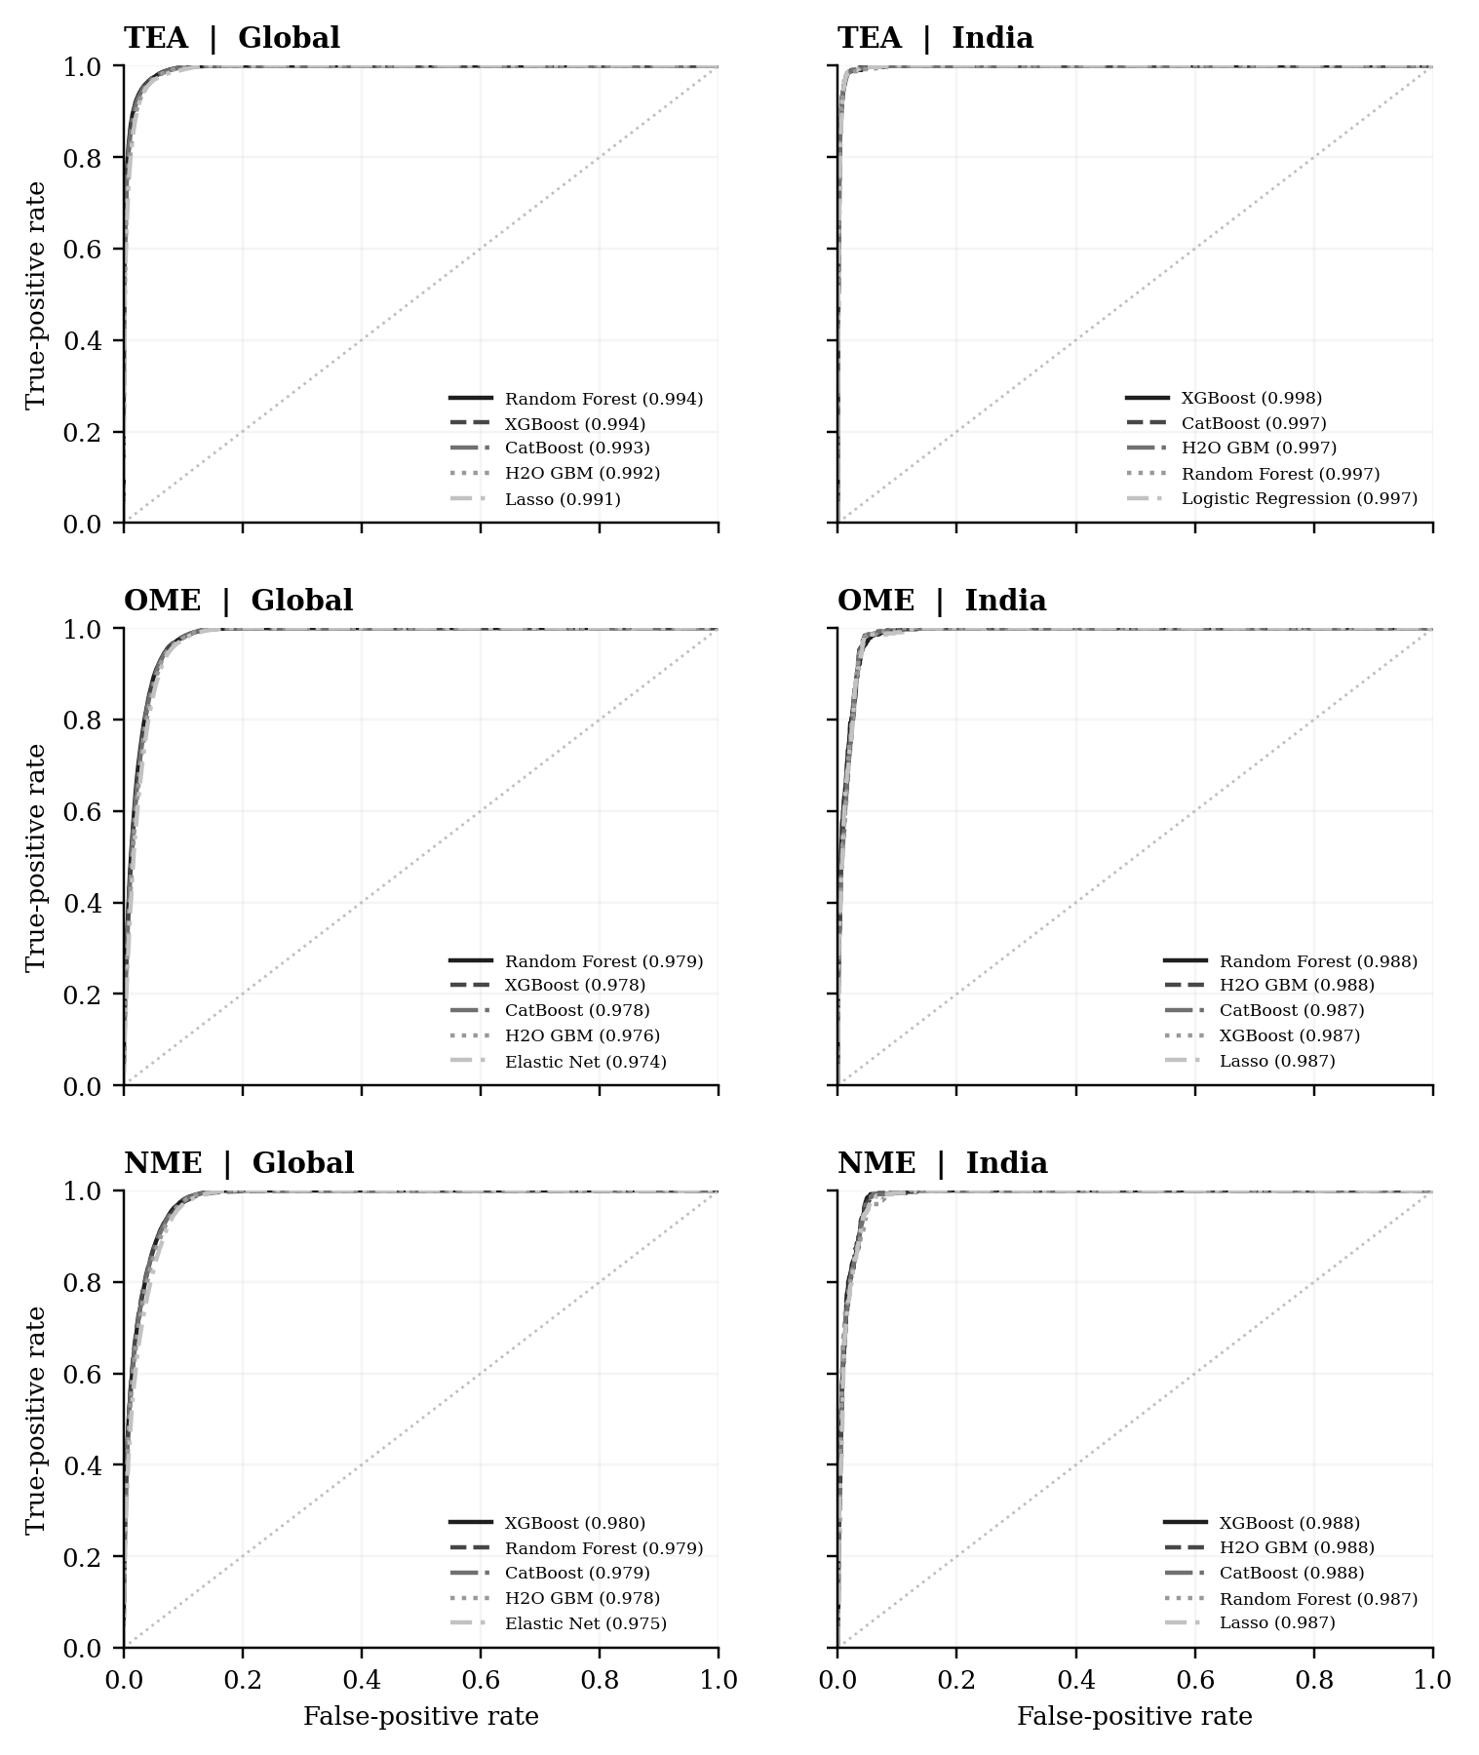
Note. The five largest receiver operating characteristic areas are plotted within each sample and outcome panel. The dotted diagonal represents chance ranking.

Interpretation
Global sample. The global panels show consistently strong ranking across the three outcomes. For the models selected by precision-recall area, the corresponding receiver operating characteristic area values are TEA Random Forest (0.994); OME Random Forest (0.979); NME Random Forest (0.979). The spread between curves is much smaller than the separation from the reference line, indicating that several model families perform similarly on the saved test split.
India sample. The India panels show receiver operating characteristic area values of TEA XGBoost (0.998); OME Random Forest (0.988); NME H2O GBM (0.988) for the selected classifiers. Differences in curve shape should be read against the smaller India test sample and the prevalence of each positive outcome. The India curves describe separately trained country-specific fits.

Figure 2. Precision recall curves
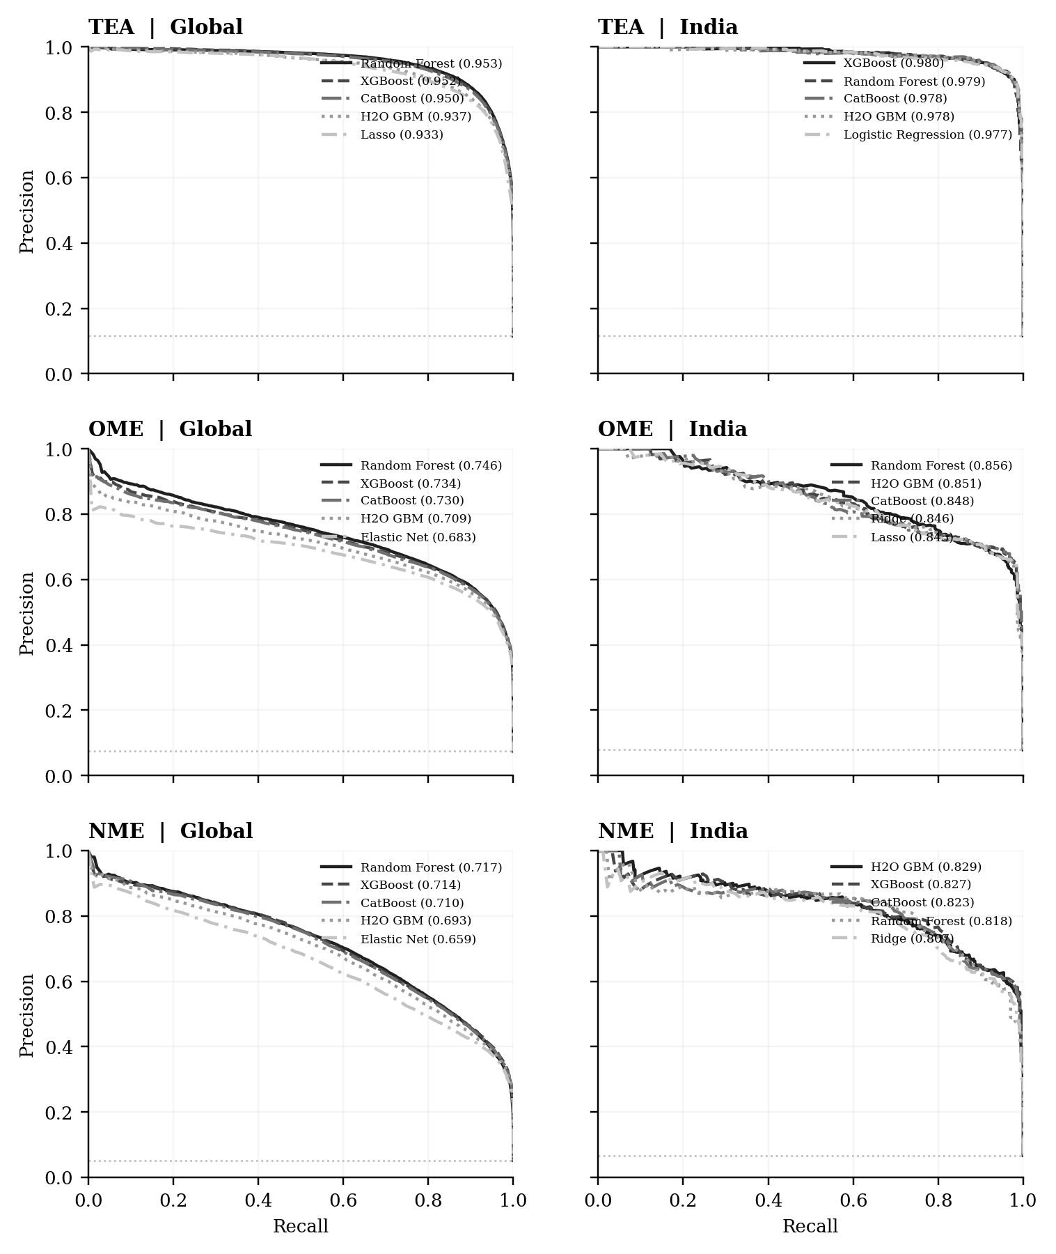
Note. The five largest precision-recall areas are plotted within each panel. The dotted horizontal line marks outcome prevalence.

Interpretation
Global sample. The global panels show consistently strong ranking across the three outcomes. For the models selected by precision-recall area, the corresponding precision-recall area values are TEA Random Forest (0.953); OME Random Forest (0.746); NME Random Forest (0.717). The spread between curves is much smaller than the separation from the reference line, indicating that several model families perform similarly on the saved test split.
India sample. The India panels show precision-recall area values of TEA XGBoost (0.980); OME Random Forest (0.856); NME H2O GBM (0.829) for the selected classifiers. Differences in curve shape should be read against the smaller India test sample and the prevalence of each positive outcome. The India curves describe separately trained country-specific fits.

Figure 3. Random forest feature importance
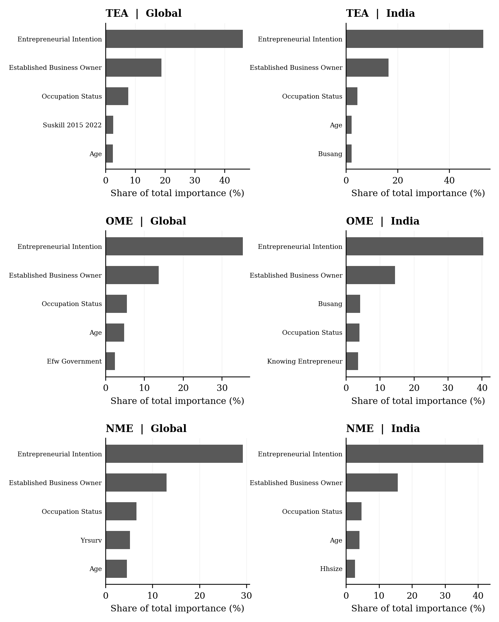
Note. Bars show the five most important inputs in each random forest, expressed as a share of total impurity importance.

Interpretation
Global sample. The leading inputs in the global panels are TEA: Entrepreneurial intention; OME: Entrepreneurial intention; NME: Entrepreneurial intention. The figure also shows that the importance profile changes across the three outcome definitions. Feature importance here records the fitted forest's use of a variable in splitting the data, rather than the direction of its relationship with entrepreneurship.
India sample. The India panels identify TEA: Entrepreneurial intention; OME: Entrepreneurial intention; NME: Entrepreneurial intention as the leading inputs. The narrower country-specific sample and limited variation in national institutional scores can change the ordering relative to the global fits.

Figure 4. Change in precision recall area after adding controls
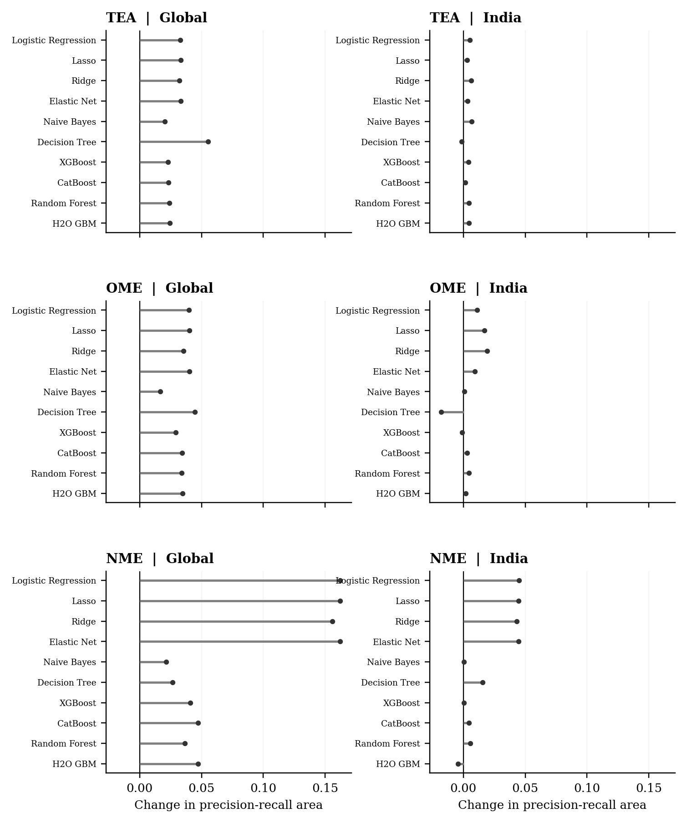
Note. Dots show the change in held-out precision-recall area for each of the ten model families when controls are included.

Interpretation
Global sample. In the global analysis, TEA: 10 of ten models improve; median change +0.029; OME: 10 of ten models improve; median change +0.036; NME: 10 of ten models improve; median change +0.047. The horizontal distance from zero makes the incremental predictive value of the entire control set visible for each classifier and outcome.
India sample. In India, TEA: 9 of ten models improve; median change +0.004; OME: 8 of ten models improve; median change +0.004; NME: 8 of ten models improve; median change +0.010. The spread across model families indicates that adding controls does not contribute a fixed amount of information independent of the learning algorithm.

Figure 5. Institutional feature importance
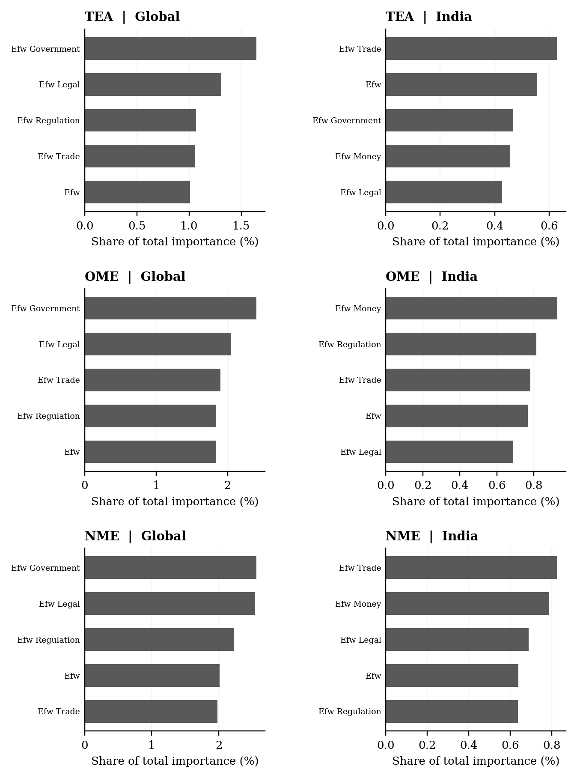
Note. Bars show the five most important raw institutional variables in each random forest, as a share of total model importance.

Interpretation
Global sample. The leading institutional fields in the global panels are TEA: Government size (1.6%); OME: Government size (2.4%); NME: Government size (2.6%). Their bars use all fitted predictors as the denominator, allowing the reader to judge institutional usage in the context of the wider model rather than only relative to other institutional pillars.
India sample. For India, the corresponding leading fields are TEA: Freedom to trade (0.6%); OME: Sound money (0.9%); NME: Freedom to trade (0.8%). Because the scores are shared by respondents in the same year, the bars primarily summarize how the model uses annual national variation.

Supplementary model tables
The following tables retain all ten fitted model families for each outcome and sample. They are included for auditability; the principal tables in the results section summarize the selected models.
Supplementary Table S1. Complete held-out classifier performance
Sample | Outcome | Model | ROC area | PR area | Precision | Recall | F1
Global | TEA | Logistic Regression | 0.991 | 0.932 | 0.849 | 0.886 | 0.867
Global | TEA | Lasso | 0.991 | 0.933 | 0.849 | 0.887 | 0.868
Global | TEA | Ridge | 0.991 | 0.930 | 0.847 | 0.882 | 0.864
Global | TEA | Elastic Net | 0.991 | 0.933 | 0.849 | 0.886 | 0.868
Global | TEA | Naive Bayes | 0.924 | 0.504 | 0.543 | 0.802 | 0.647
Global | TEA | Decision Tree | 0.989 | 0.895 | 0.861 | 0.856 | 0.858
Global | TEA | XGBoost | 0.994 | 0.952 | 0.883 | 0.887 | 0.885
Global | TEA | CatBoost | 0.993 | 0.950 | 0.880 | 0.886 | 0.883
Global | TEA | Random Forest | 0.994 | 0.953 | 0.868 | 0.908 | 0.888
Global | TEA | H2O GBM | 0.992 | 0.937 | 0.853 | 0.890 | 0.871
Global | OME | Logistic Regression | 0.974 | 0.682 | 0.582 | 0.848 | 0.690
Global | OME | Lasso | 0.974 | 0.683 | 0.581 | 0.848 | 0.690
Global | OME | Ridge | 0.974 | 0.675 | 0.582 | 0.849 | 0.691
Global | OME | Elastic Net | 0.974 | 0.683 | 0.581 | 0.848 | 0.690
Global | OME | Naive Bayes | 0.910 | 0.383 | 0.389 | 0.724 | 0.506
Global | OME | Decision Tree | 0.971 | 0.644 | 0.591 | 0.788 | 0.675
Global | OME | XGBoost | 0.978 | 0.734 | 0.598 | 0.871 | 0.709
Global | OME | CatBoost | 0.978 | 0.730 | 0.625 | 0.827 | 0.712
Global | OME | Random Forest | 0.979 | 0.746 | 0.626 | 0.831 | 0.714
Global | OME | H2O GBM | 0.976 | 0.709 | 0.590 | 0.858 | 0.700
Global | NME | Logistic Regression | 0.975 | 0.658 | 0.581 | 0.670 | 0.622
Global | NME | Lasso | 0.975 | 0.659 | 0.582 | 0.671 | 0.623
Global | NME | Ridge | 0.974 | 0.641 | 0.541 | 0.722 | 0.618
Global | NME | Elastic Net | 0.975 | 0.659 | 0.582 | 0.671 | 0.623
Global | NME | Naive Bayes | 0.909 | 0.264 | 0.291 | 0.725 | 0.415
Global | NME | Decision Tree | 0.970 | 0.605 | 0.633 | 0.609 | 0.621
Global | NME | XGBoost | 0.980 | 0.714 | 0.619 | 0.709 | 0.661
Global | NME | CatBoost | 0.979 | 0.710 | 0.616 | 0.708 | 0.659
Global | NME | Random Forest | 0.979 | 0.717 | 0.624 | 0.712 | 0.665
Global | NME | H2O GBM | 0.978 | 0.693 | 0.607 | 0.694 | 0.648
India | TEA | Logistic Regression | 0.997 | 0.977 | 0.928 | 0.948 | 0.938
India | TEA | Lasso | 0.997 | 0.975 | 0.918 | 0.948 | 0.933
India | TEA | Ridge | 0.997 | 0.975 | 0.920 | 0.961 | 0.940
India | TEA | Elastic Net | 0.997 | 0.975 | 0.921 | 0.950 | 0.935
India | TEA | Naive Bayes | 0.938 | 0.679 | 0.645 | 0.824 | 0.724
India | TEA | Decision Tree | 0.994 | 0.920 | 0.916 | 0.956 | 0.935
India | TEA | XGBoost | 0.998 | 0.980 | 0.924 | 0.951 | 0.937
India | TEA | CatBoost | 0.997 | 0.978 | 0.924 | 0.958 | 0.941
India | TEA | Random Forest | 0.997 | 0.979 | 0.926 | 0.945 | 0.936
India | TEA | H2O GBM | 0.997 | 0.978 | 0.915 | 0.965 | 0.940
India | OME | Logistic Regression | 0.987 | 0.844 | 0.704 | 0.901 | 0.790
India | OME | Lasso | 0.987 | 0.845 | 0.708 | 0.885 | 0.786
India | OME | Ridge | 0.987 | 0.846 | 0.708 | 0.896 | 0.791
India | OME | Elastic Net | 0.987 | 0.843 | 0.719 | 0.841 | 0.775
India | OME | Naive Bayes | 0.913 | 0.574 | 0.542 | 0.654 | 0.593
India | OME | Decision Tree | 0.984 | 0.789 | 0.678 | 0.845 | 0.752
India | OME | XGBoost | 0.987 | 0.844 | 0.728 | 0.815 | 0.769
India | OME | CatBoost | 0.987 | 0.848 | 0.722 | 0.811 | 0.764
India | OME | Random Forest | 0.988 | 0.856 | 0.710 | 0.855 | 0.776
India | OME | H2O GBM | 0.988 | 0.851 | 0.737 | 0.804 | 0.769
India | NME | Logistic Regression | 0.986 | 0.803 | 0.739 | 0.775 | 0.757
India | NME | Lasso | 0.987 | 0.805 | 0.694 | 0.829 | 0.756
India | NME | Ridge | 0.986 | 0.807 | 0.735 | 0.780 | 0.757
India | NME | Elastic Net | 0.987 | 0.805 | 0.696 | 0.837 | 0.760
India | NME | Naive Bayes | 0.888 | 0.451 | 0.502 | 0.569 | 0.534
India | NME | Decision Tree | 0.986 | 0.765 | 0.763 | 0.732 | 0.747
India | NME | XGBoost | 0.988 | 0.827 | 0.766 | 0.797 | 0.781
India | NME | CatBoost | 0.988 | 0.823 | 0.701 | 0.827 | 0.759
India | NME | Random Forest | 0.987 | 0.818 | 0.689 | 0.846 | 0.759
India | NME | H2O GBM | 0.988 | 0.829 | 0.748 | 0.780 | 0.764

Note. All figures are measured on held-out test observations using the full predictor and control specification.
Global sample. Across the global outcomes, model rankings differ in detail but several nonlinear models achieve similar discrimination. The complete table prevents the six selected results in Table 4 from obscuring the performance of alternative model families.
India sample. The India rankings also vary by outcome. Comparison of the full rows is preferable to treating a small difference between the two leading models as conclusive, particularly with the smaller country-specific test sample.
Supplementary Table S2. Complete held-out confusion matrices
Sample | Outcome | Model | True positive | False positive | True negative | False negative
Global | TEA | Logistic Regression | 27,368 | 4,865 | 232,827 | 3,516
Global | TEA | Lasso | 27,384 | 4,863 | 232,829 | 3,500
Global | TEA | Ridge | 27,228 | 4,906 | 232,786 | 3,656
Global | TEA | Elastic Net | 27,377 | 4,851 | 232,841 | 3,507
Global | TEA | Naive Bayes | 24,782 | 20,882 | 216,810 | 6,102
Global | TEA | Decision Tree | 26,428 | 4,282 | 233,410 | 4,456
Global | TEA | XGBoost | 27,402 | 3,631 | 234,061 | 3,482
Global | TEA | CatBoost | 27,348 | 3,730 | 233,962 | 3,536
Global | TEA | Random Forest | 28,051 | 4,276 | 233,416 | 2,833
Global | TEA | H2O GBM | 27,472 | 4,731 | 232,961 | 3,412
Global | OME | Logistic Regression | 16,972 | 12,197 | 236,362 | 3,045
Global | OME | Lasso | 16,972 | 12,234 | 236,325 | 3,045
Global | OME | Ridge | 16,994 | 12,182 | 236,377 | 3,023
Global | OME | Elastic Net | 16,969 | 12,220 | 236,339 | 3,048
Global | OME | Naive Bayes | 14,488 | 22,770 | 225,789 | 5,529
Global | OME | Decision Tree | 15,777 | 10,922 | 237,637 | 4,240
Global | OME | XGBoost | 17,425 | 11,729 | 236,830 | 2,592
Global | OME | CatBoost | 16,545 | 9,930 | 238,629 | 3,472
Global | OME | Random Forest | 16,636 | 9,918 | 238,641 | 3,381
Global | OME | H2O GBM | 17,174 | 11,912 | 236,647 | 2,843
Global | NME | Logistic Regression | 9,366 | 6,749 | 247,841 | 4,620
Global | NME | Lasso | 9,382 | 6,747 | 247,843 | 4,604
Global | NME | Ridge | 10,097 | 8,583 | 246,007 | 3,889
Global | NME | Elastic Net | 9,378 | 6,734 | 247,856 | 4,608
Global | NME | Naive Bayes | 10,134 | 24,706 | 229,884 | 3,852
Global | NME | Decision Tree | 8,511 | 4,924 | 249,666 | 5,475
Global | NME | XGBoost | 9,911 | 6,092 | 248,498 | 4,075
Global | NME | CatBoost | 9,898 | 6,169 | 248,421 | 4,088
Global | NME | Random Forest | 9,963 | 5,994 | 248,596 | 4,023
Global | NME | H2O GBM | 9,704 | 6,278 | 248,312 | 4,282
India | TEA | Logistic Regression | 604 | 47 | 4,826 | 33
India | TEA | Lasso | 604 | 54 | 4,819 | 33
India | TEA | Ridge | 612 | 53 | 4,820 | 25
India | TEA | Elastic Net | 605 | 52 | 4,821 | 32
India | TEA | Naive Bayes | 525 | 289 | 4,584 | 112
India | TEA | Decision Tree | 609 | 56 | 4,817 | 28
India | TEA | XGBoost | 606 | 50 | 4,823 | 31
India | TEA | CatBoost | 610 | 50 | 4,823 | 27
India | TEA | Random Forest | 602 | 48 | 4,825 | 35
India | TEA | H2O GBM | 615 | 57 | 4,816 | 22
India | OME | Logistic Regression | 390 | 164 | 4,913 | 43
India | OME | Lasso | 383 | 158 | 4,919 | 50
India | OME | Ridge | 388 | 160 | 4,917 | 45
India | OME | Elastic Net | 364 | 142 | 4,935 | 69
India | OME | Naive Bayes | 283 | 239 | 4,838 | 150
India | OME | Decision Tree | 366 | 174 | 4,903 | 67
India | OME | XGBoost | 353 | 132 | 4,945 | 80
India | OME | CatBoost | 351 | 135 | 4,942 | 82
India | OME | Random Forest | 370 | 151 | 4,926 | 63
India | OME | H2O GBM | 348 | 124 | 4,953 | 85
India | NME | Logistic Regression | 286 | 101 | 5,040 | 83
India | NME | Lasso | 306 | 135 | 5,006 | 63
India | NME | Ridge | 288 | 104 | 5,037 | 81
India | NME | Elastic Net | 309 | 135 | 5,006 | 60
India | NME | Naive Bayes | 210 | 208 | 4,933 | 159
India | NME | Decision Tree | 270 | 84 | 5,057 | 99
India | NME | XGBoost | 294 | 90 | 5,051 | 75
India | NME | CatBoost | 305 | 130 | 5,011 | 64
India | NME | Random Forest | 312 | 141 | 5,000 | 57
India | NME | H2O GBM | 288 | 97 | 5,044 | 81

Note. All confusion counts use the validation-selected threshold for the indicated classifier.
Global sample. The global counts show how model families with similar ranking measures can produce different threshold classifications. This distinction is particularly relevant for the less prevalent motivated-entrepreneurship outcomes.
India sample. India confusion counts are smaller in absolute terms because fewer observations are tested. Their interpretation depends on the balance between false positive and false negative decisions rather than on total errors alone.
Supplementary Table S3. Complete matched predictor-set comparison
Global sample. The global model-level changes show that the value of the additional control variables is heterogeneous across algorithms and outcomes. These are observed differences in predictive ranking rather than statistical estimates of a structural parameter.
India sample. India changes should also be interpreted in light of the temporal overlap between survey year and national institutional indices. The table quantifies the predictive change from the whole control set and does not separate a year effect from an institutional effect.
Sample | Outcome | Model | PR predictors | PR with controls | Change in PR area
Global | TEA | Logistic Regression | 0.900 | 0.932 | +0.033
Global | TEA | Lasso | 0.900 | 0.933 | +0.033
Global | TEA | Ridge | 0.898 | 0.930 | +0.032
Global | TEA | Elastic Net | 0.900 | 0.933 | +0.033
Global | TEA | Naive Bayes | 0.484 | 0.504 | +0.020
Global | TEA | Decision Tree | 0.840 | 0.895 | +0.055
Global | TEA | XGBoost | 0.929 | 0.952 | +0.023
Global | TEA | CatBoost | 0.927 | 0.950 | +0.023
Global | TEA | Random Forest | 0.929 | 0.953 | +0.024
Global | TEA | H2O GBM | 0.913 | 0.937 | +0.025
Global | OME | Logistic Regression | 0.642 | 0.682 | +0.040
Global | OME | Lasso | 0.642 | 0.683 | +0.040
Global | OME | Ridge | 0.639 | 0.675 | +0.036
Global | OME | Elastic Net | 0.642 | 0.683 | +0.040
Global | OME | Naive Bayes | 0.367 | 0.383 | +0.017
Global | OME | Decision Tree | 0.600 | 0.644 | +0.045
Global | OME | XGBoost | 0.705 | 0.734 | +0.029
Global | OME | CatBoost | 0.696 | 0.730 | +0.034
Global | OME | Random Forest | 0.712 | 0.746 | +0.034
Global | OME | H2O GBM | 0.674 | 0.709 | +0.035
Global | NME | Logistic Regression | 0.496 | 0.658 | +0.162
Global | NME | Lasso | 0.497 | 0.659 | +0.162
Global | NME | Ridge | 0.485 | 0.641 | +0.156
Global | NME | Elastic Net | 0.497 | 0.659 | +0.162
Global | NME | Naive Bayes | 0.243 | 0.264 | +0.021
Global | NME | Decision Tree | 0.579 | 0.605 | +0.027
Global | NME | XGBoost | 0.673 | 0.714 | +0.041
Global | NME | CatBoost | 0.663 | 0.710 | +0.047
Global | NME | Random Forest | 0.680 | 0.717 | +0.037
Global | NME | H2O GBM | 0.646 | 0.693 | +0.047
India | TEA | Logistic Regression | 0.972 | 0.977 | +0.005
India | TEA | Lasso | 0.972 | 0.975 | +0.003
India | TEA | Ridge | 0.969 | 0.975 | +0.006
India | TEA | Elastic Net | 0.972 | 0.975 | +0.004
India | TEA | Naive Bayes | 0.672 | 0.679 | +0.007
India | TEA | Decision Tree | 0.921 | 0.920 | -0.001
India | TEA | XGBoost | 0.975 | 0.980 | +0.004
India | TEA | CatBoost | 0.977 | 0.978 | +0.002
India | TEA | Random Forest | 0.974 | 0.979 | +0.004
India | TEA | H2O GBM | 0.973 | 0.978 | +0.004
India | OME | Logistic Regression | 0.833 | 0.844 | +0.011
India | OME | Lasso | 0.828 | 0.845 | +0.017
India | OME | Ridge | 0.826 | 0.846 | +0.019
India | OME | Elastic Net | 0.834 | 0.843 | +0.009
India | OME | Naive Bayes | 0.573 | 0.574 | +0.001
India | OME | Decision Tree | 0.807 | 0.789 | -0.018
India | OME | XGBoost | 0.845 | 0.844 | -0.001
India | OME | CatBoost | 0.845 | 0.848 | +0.003
India | OME | Random Forest | 0.851 | 0.856 | +0.005
India | OME | H2O GBM | 0.849 | 0.851 | +0.002
India | NME | Logistic Regression | 0.758 | 0.803 | +0.045
India | NME | Lasso | 0.761 | 0.805 | +0.045
India | NME | Ridge | 0.764 | 0.807 | +0.043
India | NME | Elastic Net | 0.761 | 0.805 | +0.045
India | NME | Naive Bayes | 0.451 | 0.451 | +0.001
India | NME | Decision Tree | 0.749 | 0.765 | +0.015
India | NME | XGBoost | 0.826 | 0.827 | +0.000
India | NME | CatBoost | 0.819 | 0.823 | +0.005
India | NME | Random Forest | 0.812 | 0.818 | +0.006
India | NME | H2O GBM | 0.833 | 0.829 | -0.004

Note. Positive change means that the specification with controls has a larger held-out precision-recall area. Every pair uses identical test records.

