

Customer Behavior & E-Commerce Analytics

By Pratham Meena

AICTE | IBM SkillsBuild
Data Analytics with AI Academic Internship 2026
BharatCares

Executive Summary

This project presents a Customer Behavior & E-Commerce Analytics study conducted as part of the Data Analytics Hackathon. The objective of the project is to analyze customer purchasing behavior, spending patterns, membership performance, discount usage, satisfaction levels, and behavioral customer segments using data analytics techniques.
The dataset contains 350 customer records with information such as age, gender, city, membership type, total spending, items purchased, average rating, discount usage, days since last purchase, and satisfaction level.
The analysis was performed using Python, Pandas, NumPy, Matplotlib, and Seaborn. The project includes data quality analysis, descriptive statistics, correlation analysis, customer segmentation, membership analysis, discount analysis, satisfaction analysis, and business-focused insights.
Key findings show that Total Spend is strongly associated with Items Purchased (0.972) and Average Rating (0.941). Customer segmentation identified four behavioral groups: High Value Active, Potential High Value, Moderate Value, and Low Value / Less Active. The High Value Active segment contains 106 customers and has an average spend of $1,267.59, while the Moderate Value segment is the largest with 116 customers.
The analysis also identified significant differences across cities and membership types. San Francisco has the highest total customer spending at approximately $84,666.80, while Gold members have the highest average spending at approximately $1,311.14.
The project further examines customer satisfaction, where satisfied customers show an average spend of $1,280.32, compared with $595.14 for unsatisfied customers. The dataset contains 2 missing satisfaction records, while no duplicate rows, duplicate customer IDs, or IQR-based numerical outliers were detected.
Overall, the project demonstrates how customer data can be transformed into actionable business insights for understanding customer value, engagement, satisfaction, and purchasing behavior. The findings are descriptive associations and should not be interpreted as proof of causal relationships.

Problem Statement & Objectives

Problem Statement
E-commerce businesses generate large amounts of customer data, but raw customer information alone does not provide clear insights into purchasing behavior, customer value, satisfaction, or engagement. This project addresses the need to analyze customer-level data to understand how customers spend, how frequently they purchase, how membership and discounts relate to customer behavior, and how satisfaction varies across different customer groups, cities, and segments. By analyzing these patterns, the project aims to identify meaningful customer segments, high-value customers, less-active customers, and important relationships between behavioral variables that can support data-driven business decision-making.
Objectives
The primary objectives of this project are:
- Analyze Customer Purchasing Behavior
Examine customer spending, purchase volume, and purchasing activity to understand overall buying patterns.
- Compare Customer Performance Across Cities
Analyze customer count, total spending, average spending, purchase volume, ratings, and recency across different cities.
- Analyze Membership Types
Compare Bronze, Silver, and Gold customers based on spending, items purchased, ratings, and purchase recency.
- Study Discount Usage
Examine customer behavior based on whether a discount was applied and identify differences in spending and purchasing patterns.
- Analyze Customer Satisfaction
Study satisfaction levels and compare spending, purchase volume, ratings, and recency among satisfied, neutral, and unsatisfied customers.
- Segment Customers Based on Behavior
Classify customers into behavioral segments such as High Value Active, Potential High Value, Moderate Value, and Low Value / Less Active.
- Identify Relationships Between Customer Variables
Analyze correlations between variables such as Total Spend, Items Purchased, Average Rating, Age, and Days Since Last Purchase.
- Check Data Quality and Outliers
Identify missing values, duplicate records, invalid values, inconsistent categories, and potential numerical outliers.
- Identify High-Value and Less-Active Customers
Profile customers based on spending, purchase volume, recency, and ratings to understand different customer-value groups.
- Generate Actionable Business Insights
Convert analytical findings into practical insights and recommendations that can support customer engagement, retention, and business decision-making.

Dataset & Technologies

Dataset Overview
The project uses a customer-level e-commerce dataset containing 350 customer records and 12 variables. The dataset captures demographic information, location, membership details, purchasing behavior, customer ratings, discount usage, satisfaction, and purchase recency.

The dataset was analyzed to understand customer value, purchasing patterns, satisfaction levels, and behavioral differences across customer groups.
Dataset Statistics.

Dataset Metric | Value
Total Records | 350
Total Variables | 12
Duplicate Rows | 0
Duplicate Customer IDs | 0
Missing Satisfaction Records | 2
IQR-Based Outliers | 0

Dataset Variables

Variable | Description
Customer ID | Unique identifier assigned to each customer
Gender | Customer gender
Age | Age of the customer
Age Group | Categorized age range
City | Customer's city
Membership Type | Bronze, Silver, or Gold membership
Total Spend | Total amount spent by the customer
Items Purchased | Number of items purchased
Average Rating | Average customer rating
Discount Applied | Indicates whether a discount was applied
Days Since Last Purchase | Number of days since the customer's most recent purchase
Satisfaction Level | Customer satisfaction category

Technologies & Tools Used
The project was developed using Python-based data analytics tools.

Python
Used as the primary programming language for data analysis and visualization.

Pandas
Used for:
- Data loading
- Data cleaning
- Data transformation
- Grouping and aggregation
- Statistical analysis

NumPy
Used for numerical operations and analytical calculations.

Matplotlib
Used to create charts and visualizations for customer behavior and business analysis.

Seaborn
Used for statistical visualizations such as correlation heatmaps and analytical plots.

Google Collab
Used as the development environment for running the Python-based analysis and generating the project outputs.

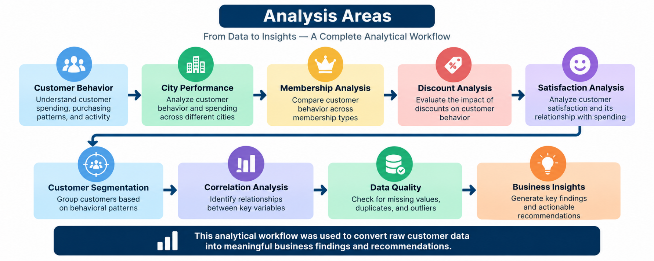

Data Preparation & Quality Analysis

Data Preparation

Before performing the business analysis, the dataset was examined to understand its structure, data types, missing values, duplicate records, numerical ranges, categorical values, and potential outliers. This step helped ensure that the analysis was based on a consistent and reliable dataset.
The dataset contains 350 rows and 12 columns. Numerical variables were reviewed using descriptive statistics, while categorical variables were checked for their unique values and distribution.

Missing Value Analysis

The analysis identified 2 missing values, both in the Satisfaction Level variable.

Variable | Missing Values | Missing %
Satisfaction Level | 2 | 0.57%
All Other Variables | 0 | 0.00%

The two records with missing satisfaction values were retained for data-quality reporting rather than assigning an assumed satisfaction category.

Duplicate Analysis

The dataset was checked for both duplicate rows and duplicate customer IDs.

Quality Check | Result
Duplicate Rows | 0
Duplicate Customer IDs | 0

This indicates that no duplicate observations or repeated customer identifiers were detected.

Outlier Analysis

The Interquartile Range (IQR) method was used to identify potential outliers in the main numerical variables.

Variables examined:
- Age
- Total Spend
- Items Purchased
- Average Rating
- Days Since Last Purchase

Result

No IQR-based outliers were detected in any of the analyzed numerical variables.

The observed ranges were:

Variable | Minimum | Maximum
Age | 26 | 43
Total Spend | $410.80 | $1,520.10
Items Purchased | 7 | 21
Average Rating | 3.00 | 4.90
Days Since Last Purchase | 9 | 63

Logical Range Validation

The dataset was also checked for invalid numerical values.

Validation Check | Invalid Records
Age below 18 | 0
Negative Total Spend | 0
Negative Items Purchased | 0
Rating below 0 | 0
Rating above 5 | 0
Negative Days Since Last Purchase | 0

Data Quality Summary

Overall, the dataset showed good structural quality. No duplicate records, duplicate customer IDs, invalid numerical ranges, or IQR-based outliers were detected. The only missing information identified was 2 Satisfaction Level records (0.57%).

Data Quality Note: IQR-based outliers were not detected; however, absence of statistical outliers does not automatically mean that every observation is error-free. Data should always be interpreted within its business context.

Exploratory Data Analysis

Overview

Exploratory Data Analysis (EDA) was performed to understand the distribution and behavior of customers across different demographic and business attributes. The analysis used Pandas, NumPy, Matplotlib, and Seaborn to summarize the data and identify meaningful patterns.
The initial EDA focused on Age, Gender, City, and Membership Type, followed by deeper analysis of spending, purchasing activity, satisfaction, discounts, and customer engagement.

Age Analysis

The customer age distribution was examined to understand the demographic composition of the dataset.

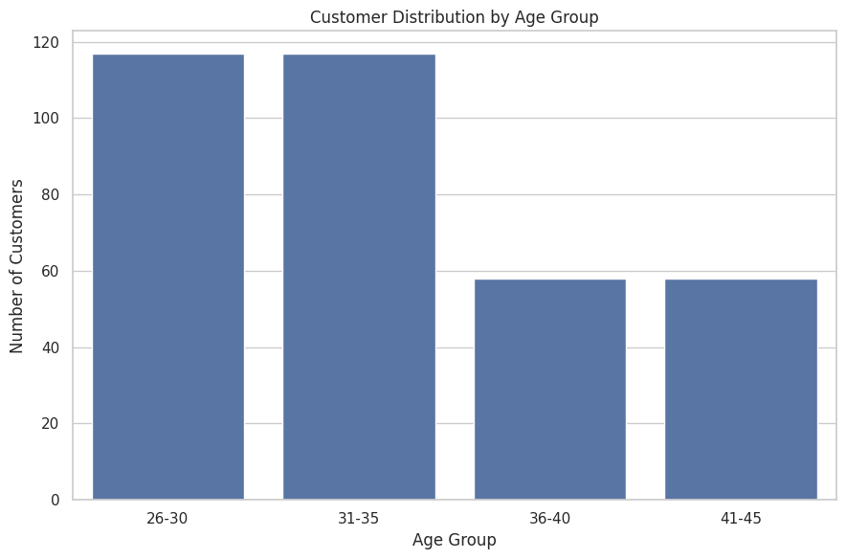

The analysis included:
- Age distribution
- Age-group distribution
- Average spending by age group
- Items purchased by age group
- Average rating by age group
- Purchase recency by age group

Key Observation
The analysis showed differences in customer spending and purchasing behavior across age groups. These differences were further investigated through spending and correlation analysis.

Gender Analysis
The dataset contains an equal number of male and female customers:

Gender | Customers | Percentage
Female | 175 | 50%
Male | 175 | 50%

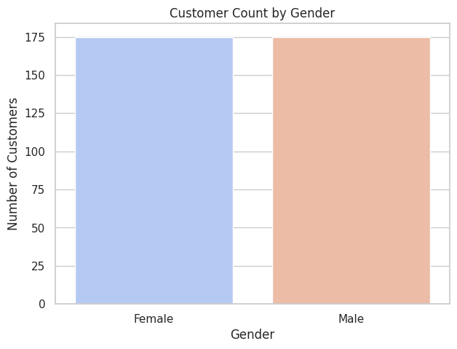

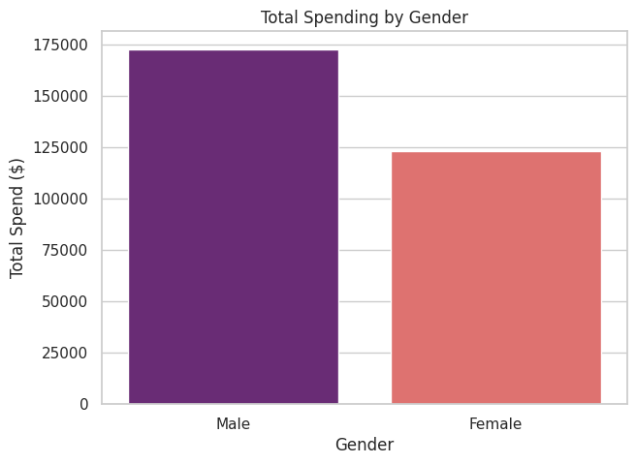

The analysis compared both groups based on:
- Total and average spending
- Items purchased
- Average rating
- Purchase recency
- Discount usage

Key Observation

Male customers showed higher average spending and purchase volume in this dataset, while female customers showed a higher proportion of discount usage. These are descriptive patterns within the dataset and do not establish causal relationships.

City Analysis

Customer behavior was compared across six cities:
- New York
- Los Angeles
- Chicago
- San Francisco
- Miami
- Houston
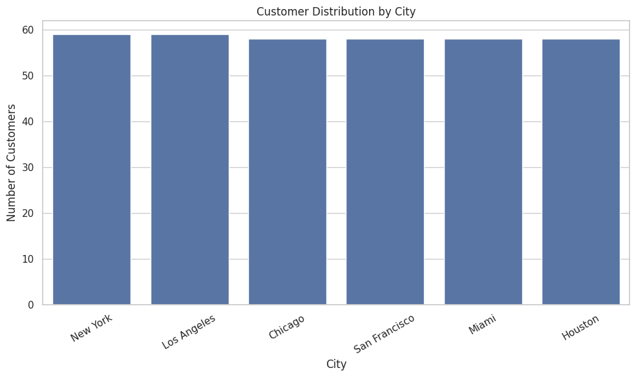

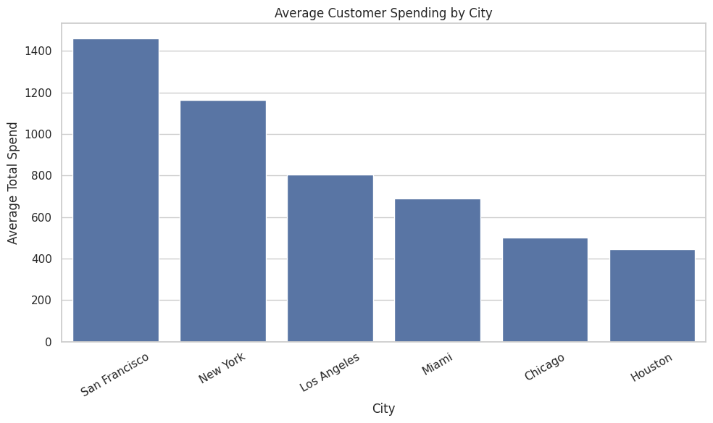

Customer representation was relatively balanced across the cities, with approximately 16.57%–16.86% of customers in each city.

Key Observation

San Francisco recorded the highest average customer spending at approximately $1,459.77, along with the highest average items purchased (20.00) and average rating (4.81).

EDA takeaway: Customer behavior varies across demographic and geographic groups, providing a foundation for the deeper membership, discount, satisfaction, correlation, and segmentation analyses that follow.

Membership Analysis

Membership Overview

Membership type is an important factor for understanding differences in customer purchasing behavior. The dataset contains three membership categories: Bronze, Silver, and Gold. The analysis compares these groups based on spending, number of items purchased, ratings, purchase recency, discount usage, and satisfaction.

Membership Distribution

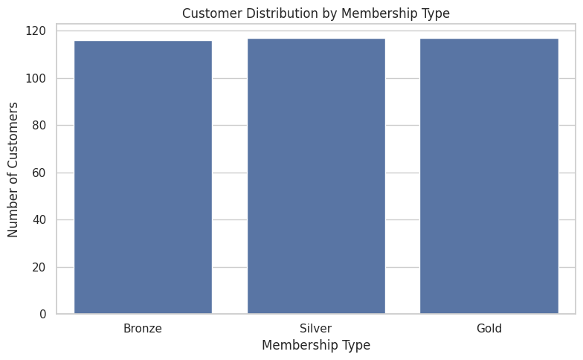

Membership Type | Customers | Percentage
Bronze | 116 | 33.14%
Silver | 117 | 33.43%
Gold | 117 | 33.43%

The customer distribution is almost evenly divided among the three membership categories.

Membership Performance

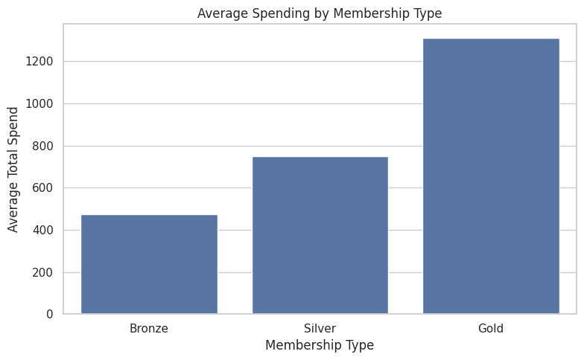

Membership | Avg. Spend | Avg. Items | Avg. Rating | Avg. Recency
Bronze | $473.39 | 8.49 | 3.32 | 31.61 days
Silver | $748.43 | 11.66 | 4.05 | 30.26 days
Gold | $1,311.14 | 17.62 | 4.68 | 17.94 days

Key Findings
- Gold members recorded the highest average spending of $1,311.14.
- Gold members also purchased the highest average number of items (17.62).
- Gold members had the highest average rating (4.68).
- Gold members showed the lowest average purchase recency (17.94 days), indicating more recent purchasing activity in this dataset.
- Bronze members had the lowest average spending, items purchased, and rating.
- Silver members generally showed values between Bronze and Gold.

Membership & Satisfaction

The satisfaction distribution also showed a strong difference across membership groups:

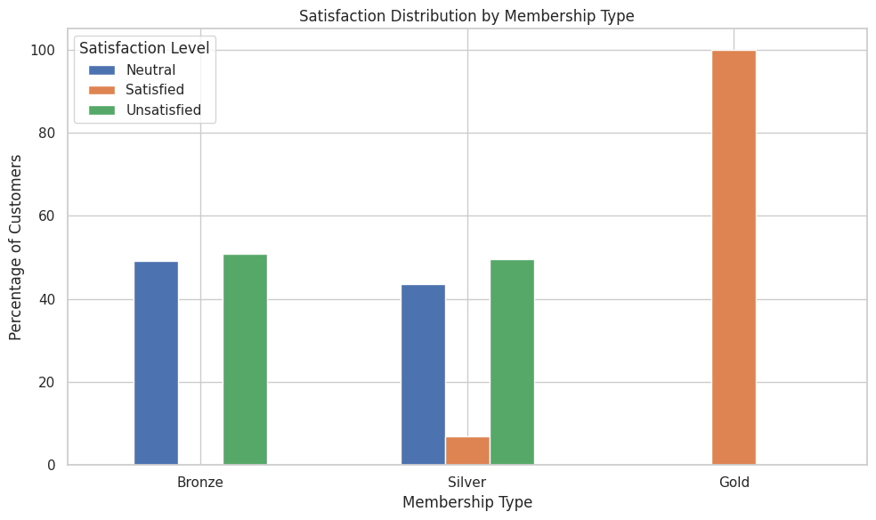

Membership | Neutral | Satisfied | Unsatisfied
Bronze | 49.12% | 0% | 50.88%
Silver | 43.59% | 6.84% | 49.57%
Gold | 0% | 100% | 0%

These results show a strong association between membership category and satisfaction level in this dataset. This should be interpreted as an observed relationship rather than proof that membership status itself causes satisfaction.

EDA Takeaway
Gold membership customers demonstrated the highest spending, purchasing activity, ratings, and recent activity in the dataset. Bronze customers showed comparatively lower values across these measures. Membership and satisfaction also showed a strong association, providing a useful basis for further customer segmentation and business analysis.

Discount Analysis

Discount Usage Overview
Discount usage was analyzed to understand how customers receiving discounts differ from customers who did not receive discounts. The analysis compares spending, items purchased, ratings, and purchase recency.
The dataset contains an equal number of customers in both groups:

Discount Applied | Customers | Percentage
Yes | 175 | 50%
No | 175 | 50%
Discount vs Customer Behavior

Metric | Discount Applied | No Discount
Average Spend | $797.27 | $903.49
Average Items Purchased | 12.13 | 12.87
Average Rating | 3.96 | 4.06
Average Recency | 36.78 days | 16.72 days

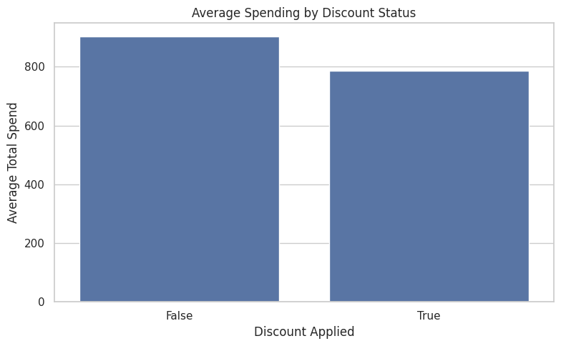
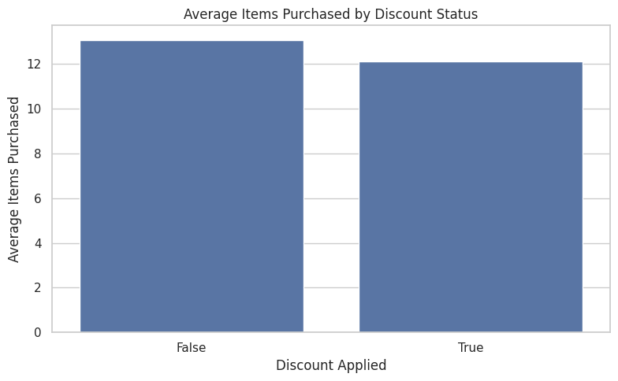
Key Findings
- Customers without discounts had a higher average spend of $903.49 compared with $797.27 for customers who received discounts.
- The average number of items purchased was relatively similar between the two groups.
- Customers without discounts had a slightly higher average rating (4.06) than discount users (3.96).
- Discount users had a higher average recency of 36.78 days, compared with 16.72 days for customers without discounts.
Important Observation
The discount variable has a strong relationship with city in this dataset. Discount usage is completely aligned with certain cities:

- Chicago, Miami, New York → 100% discount applied
- Houston, Los Angeles, San Francisco → 100% no discount
Therefore, the difference in spending between discount and non-discount customers should not be interpreted as evidence that discounts caused lower spending. City-level differences are an important factor that should be considered.
EDA Takeaway
Discount and non-discount customers showed differences in spending and purchase recency. However, discount usage is strongly structured by city in this dataset, so the observed differences should be interpreted as associations rather than direct effects of discounts.

Customer Satisfaction

Customer Satisfaction Overview

Customer satisfaction was analyzed to understand how customers perceived their overall experience. The analysis compares satisfaction levels with spending, items purchased, ratings, purchase recency, city, and membership type.
There are three satisfaction categories in the dataset: Satisfied, Neutral, and Unsatisfied.

Satisfaction Distribution

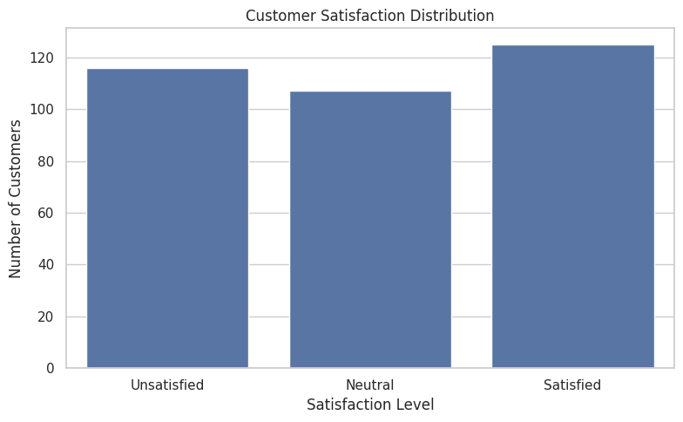

Satisfaction Level | Customers | Percentage
Satisfied | 125 | 35.92%
Unsatisfied | 116 | 33.33%
Neutral | 107 | 30.75%
Missing | 2 | 0.57%

The satisfaction distribution is relatively balanced, with Satisfied customers forming the largest group.

Satisfaction vs Customer Behavior

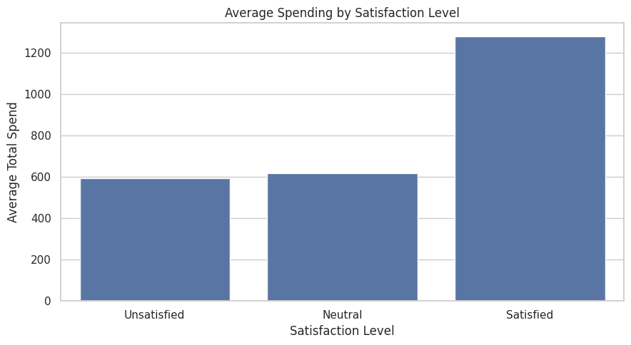

Satisfaction Level | Avg. Spend | Avg. Items | Avg. Rating | Avg. Recency
Satisfied | $1,280.32 | 17.32 | 4.65 | 17.70 days
Neutral | $616.41 | 9.44 | 3.66 | 19.29 days
Unsatisfied | $595.14 | 10.53 | 3.69 | 42.98 days

Key Findings
Satisfied customers had the highest average spending of $1,280.32.
- They also purchased the highest average number of items (17.32).
- Satisfied customers recorded the highest average rating of 4.65.
- Unsatisfied customers had the highest average purchase recency of 42.98 days.
- Neutral and Unsatisfied customers had considerably lower average spending compared with Satisfied customers.
- These are observed associations in the dataset and should not be interpreted as proof that satisfaction directly causes higher spending.

Satisfaction by City

The analysis showed clear differences in satisfaction patterns across cities:

City | Observed Satisfaction Pattern
Chicago | 100% Unsatisfied
Houston | 100% Neutral
Los Angeles | Mostly Neutral
Miami | 100% Unsatisfied
New York | 100% Satisfied
San Francisco | 100% Satisfied

This indicates that satisfaction levels are strongly associated with city in the given dataset.

Missing Satisfaction Values

Only 2 records had missing Satisfaction Level values, representing approximately 0.57% of the dataset.

These records were not artificially filled or imputed. They were kept as missing and excluded only from analyses that specifically required a satisfaction value.

EDA Takeaway

Customer satisfaction showed a strong association with purchasing behavior. Satisfied customers had higher average spending, more items purchased, higher ratings, and more recent purchases, while unsatisfied customers showed lower spending and longer purchase recency. City and membership also showed strong relationships with satisfaction levels in the dataset.

Customer Segmentation

Segmentation Overview
Customer segmentation was performed to divide customers into meaningful behavioral groups based on three key factors:
- Total Spend — how much the customer spends
- Items Purchased — purchasing volume
- Days Since Last Purchase — customer activity/recency
A Behavior Score was created by combining these three measures. Higher spending, more items purchased, and lower purchase recency contributed to a higher behavioral score.
Customer Segments
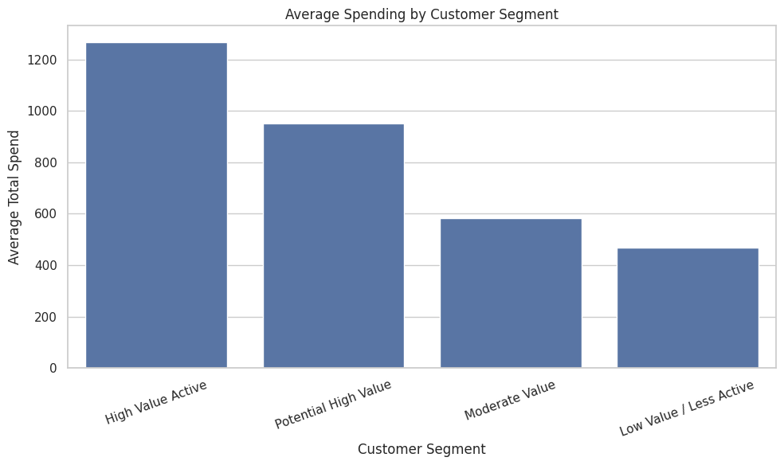
Four behavioral segments were identified:

Customer Segment | Customers | Percentage
Moderate Value | 116 | 33.14%
High Value Active | 106 | 30.29%
Potential High Value | 70 | 20.00%
Low Value / Less Active | 58 | 16.57%
Total | 350 | 100%

Segment Performance

Segment | Avg. Spend | Avg. Items | Avg. Recency | Avg. Rating
High Value Active | $1,267.59 | 17.48 | 14.52 days | 4.65
Potential High Value | $950.90 | 12.81 | 20.87 days | 4.29
Moderate Value | $584.34 | 10.09 | 37.43 days | 3.59
Low Value / Less Active | $468.49 | 8.45 | 33.86 days | 3.40
Key Findings
- High Value Active customers showed the highest average spending, purchasing volume, and ratings, along with relatively recent purchases.
- Potential High Value customers showed moderate-to-high spending and activity.
- Moderate Value customers represented the largest segment with 116 customers (33.14%).
- Low Value / Less Active customers had the lowest average spending and purchasing volume.
- The segmentation provides a structured way to understand different customer behavior patterns.

Segmentation Method
The segmentation used a score-based approach:
Spend Score + Items Score + Recency Score = Behavior Score
Where:
- Higher Spend → higher score
- Higher Items Purchased → higher score
- Lower Days Since Last Purchase → higher score
The resulting behavior scores were grouped into four segments ranging from Low Value / Less Active to High Value Active.
EDA Takeaway
Customer segmentation revealed four distinct behavioral groups. High Value Active customers demonstrated the highest spending and purchasing activity, while Low Value / Less Active customers showed lower spending and activity. This segmentation provides a useful foundation for understanding different customer behavior patterns.

Correlation Analysis

Correlation Overview

Correlation analysis was performed to identify the strength and direction of relationships between important numerical variables in the dataset.

The main variables analyzed were:
- Age
- Total Spend
- Items Purchased
- Average Rating
- Days Since Last Purchase

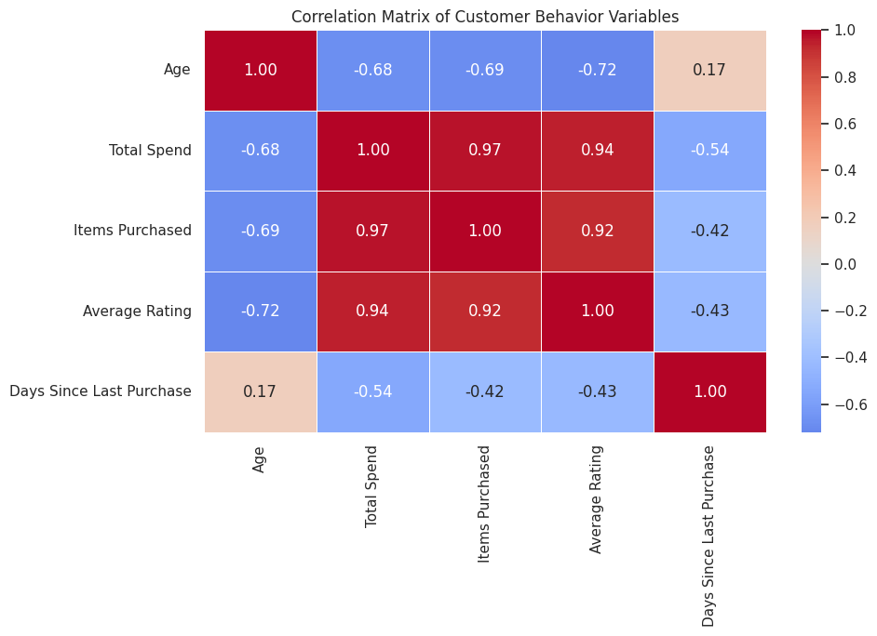

The Pearson correlation coefficient was used, where values closer to +1 indicate a strong positive relationship and values closer to −1 indicate a strong negative relationship.

Important Correlations
Variables | Correlation
Items Purchased ↔ Total Spend | +0.972
Average Rating ↔ Total Spend | +0.941
Age ↔ Total Spend | −0.678
Days Since Last Purchase ↔ Total Spend | −0.540

Key Findings

- Items Purchased vs Total Spend — +0.972

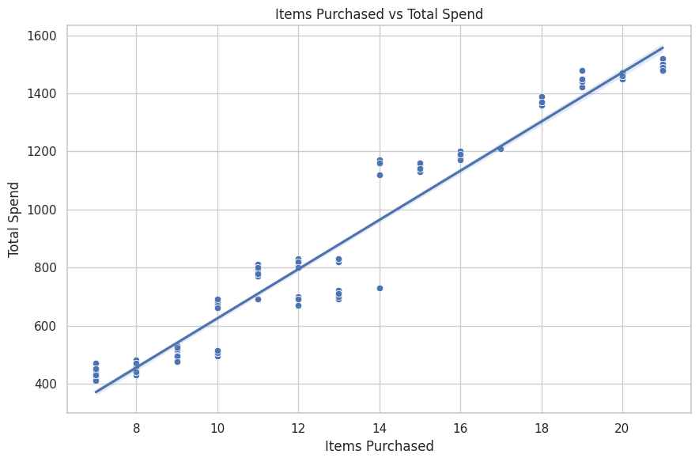

A very strong positive relationship was observed between the number of items purchased and total spending.
Customers purchasing more items generally had higher total spending in this dataset.

- Average Rating vs Total Spend — +0.941

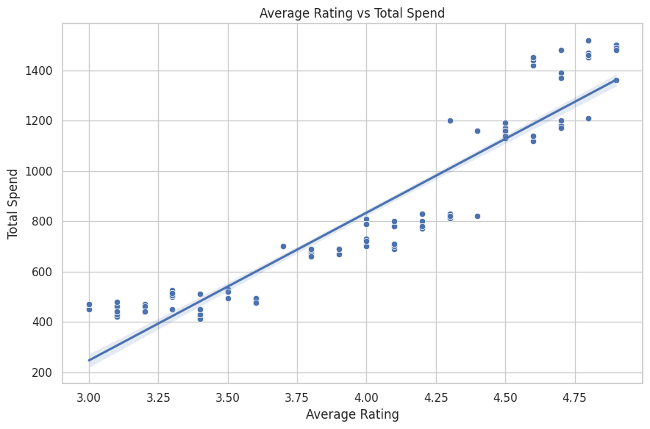

A very strong positive relationship was observed between average rating and total spending.
Higher customer ratings were associated with higher spending values in the dataset.

3. Age vs Total Spend — −0.678
A moderately strong negative relationship was observed between age and total spending.
Higher age values were generally associated with lower spending in this dataset.

4. Days Since Last Purchase vs Total Spend — −0.540
A moderate negative relationship was observed between purchase recency and total spending.
Customers with fewer days since their last purchase generally showed higher spending.

Correlation Interpretation
The analysis indicates that purchasing volume, customer rating, age, and purchase recency are associated with spending behavior.

However, correlation measures association, not causation. Therefore, these relationships should not be interpreted as proof that one variable directly causes changes in another.

EDA Takeaway
Correlation analysis identified strong relationships between customer spending and other behavioral variables. Items Purchased showed the strongest positive correlation with Total Spend (+0.972), followed by Average Rating (+0.941). Age and Days Since Last Purchase showed negative relationships with spending. These findings help identify important patterns in customer behavior while recognizing that correlation does not establish causation

High-Value vs Less-Active Customers

Customer Behavior Comparison

To understand differences between highly engaged and less-active customers, customers were analyzed using spending, purchasing volume, recency, and average rating.

For this analysis, two behavioral groups were identified:
- High-Value Active Customers — customers with high spending and purchasing activity combined with recent purchases.
- Less-Active Customers — customers showing lower spending and longer purchase recency.

Group Comparison

Metric | High-Value Active | Less-Active
Customers | 58 | 89
Average Spend | $1,459.77 | $585.19
Average Items Purchased | 20.00 | 10.75
Average Recency | 11.17 days | 45.63 days
Average Rating | 4.81 | 3.69

Key Findings

High-Value Active Customers
- 58 customers were identified in this group.
- Their average spending was $1,459.77.
- They purchased an average of 20 items.
- Their average purchase recency was only 11.17 days.
- Their average rating was 4.81.

Less-Active Customers
- 89 customers were identified in this group.
- Their average spending was $585.19.
- They purchased an average of 10.75 items.
- Their average purchase recency was 45.63 days.
- Their average rating was 3.69.

Comparison Summary

The two groups show clear differences across the selected behavioral metrics. High-value active customers recorded higher spending, more items purchased, more recent purchases, and higher average ratings than the less-active group.

These results describe patterns observed in the dataset and should not be interpreted as causal relationships.

EDA Takeaway
The analysis identified substantial behavioral differences between high-value active and less-active customers. High-value active customers showed higher spending and purchasing volume, more recent purchases, and higher average ratings, while less-active customers showed lower spending and longer purchase recency.

Top Customers

Top Customers Overview

The top customers were analyzed based on Total Spend to identify customers contributing the highest spending value in the dataset.
This analysis helps understand the characteristics of the highest-spending customers by comparing their spending, items purchased, ratings, membership type, and purchase recency.

Top 10 Customers by Total Spend

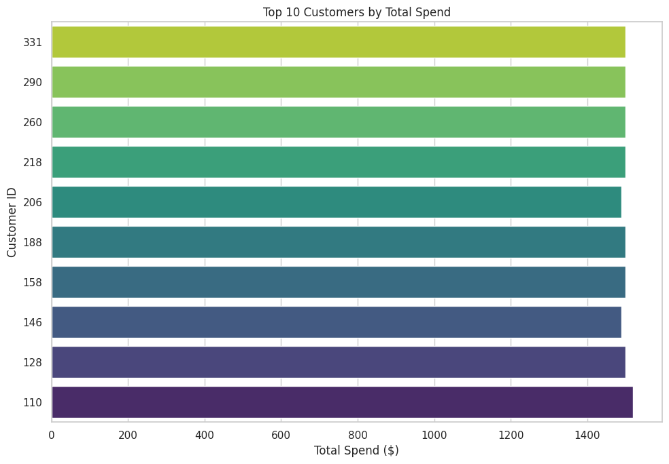

Top Customer Characteristics

The highest-spending customers can be examined using the following characteristics:
- Total Spend — identifies the customers contributing the highest spending.
- Items Purchased — indicates purchasing volume.
- Membership Type — helps understand the membership profile of high-spending customers.
- Average Rating — provides additional information about their customer experience.
- Days Since Last Purchase — indicates how recently they interacted with the business.
The analysis can be used alongside the customer segmentation results to understand high-value customer behavior.

Analysis Takeaway

The Top Customer Analysis identifies the customers with the highest spending contribution in the dataset. Combining spending with purchasing volume, membership, rating, and recency provides a broader view of high-value customer behavior and complements the customer segmentation analysis.

Final Business Insights

Overview

The complete analysis of 350 customer records revealed several important patterns related to customer spending, purchasing activity, membership, satisfaction, location, and engagement.
The following insights summarize the major findings from the E-Commerce Customer Behavior dataset.

Key Business Insights

1. San Francisco Shows the Highest Customer Spending
San Francisco recorded the highest total spending among the analyzed cities:
- Total Spend: $84,666.80
- Average Spend: $1,459.77
- Average Items Purchased: 20.00
- Average Rating: 4.81
- Average Recency: 11.17 days
This city represents a strong concentration of high-spending and active customers within the dataset.

2. Gold Members Show Higher Purchasing Activity
Gold members recorded:
- Average Spend: $1,311.14
- Average Items: 17.62
- Average Rating: 4.68
- Average Recency: 17.94 days
Gold members therefore showed higher values across the major behavioral measures analyzed.

3. Purchasing Volume Has a Strong Relationship with Spending
The correlation between Items Purchased and Total Spend was +0.972.
This indicates a very strong positive association between purchasing volume and total spending in the dataset.

4. Customer Satisfaction Is Associated with Spending Behavior
Satisfied customers recorded:
- Average Spend: $1,280.32
- Average Items: 17.32
- Average Rating: 4.65
- Average Recency: 17.70 days
Unsatisfied customers recorded considerably lower average spending and longer purchase recency.

5. High-Value Active Customers Form an Important Customer Group
The stricter high-value active analysis identified 58 customers with:
- Average Spend: $1,459.77
- Average Items: 20.00
- Average Recency: 11.17 days
- Average Rating: 4.81
This group represents customers showing high spending and active purchasing behavior.

6. Less-Active Customers Show Different Behavioral Patterns
The less-active group contained 89 customers and showed:
- Average Spend: $585.19
- Average Items: 10.75
- Average Recency: 45.63 days
- Average Rating: 3.69
Compared with the high-value active group, these customers showed lower spending and purchasing activity and longer purchase recency.

7. Discount Usage Is Structured by City
Discount usage was evenly divided overall:
- 175 customers — Discount Applied
- 175 customers — No Discount
However, discount usage was completely aligned with city groups in this dataset. Therefore, differences between discount and non-discount customers should be interpreted carefully rather than as a direct effect of discounts.

8. Data Quality Was Strong
The dataset showed:
- 350 customer records
- 0 duplicate rows
- 0 duplicate Customer IDs
- 0 IQR-based outliers
- 2 missing Satisfaction Level values
- No invalid negative values in the major numerical fields
Overall, the dataset was suitable for exploratory analysis.

Overall Insight
The analysis shows that customer value is closely associated with purchasing volume, spending, satisfaction, ratings, membership category, and purchase recency. The combination of EDA, correlation analysis, satisfaction analysis, and behavioral segmentation provides a comprehensive view of customer behavior in the dataset.

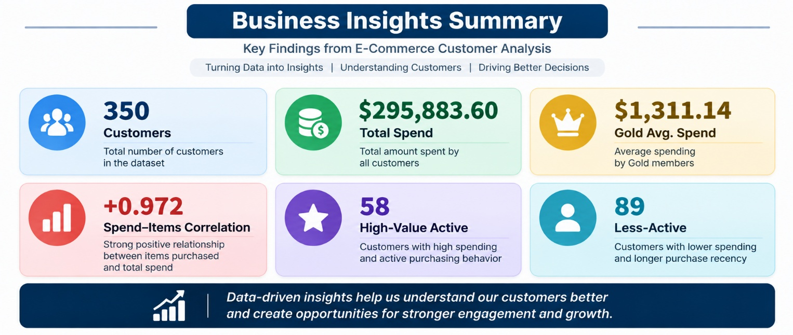

Business Recommendations

Overview

Based on the findings from exploratory data analysis, customer segmentation, satisfaction analysis, and correlation analysis, the following recommendations can be considered to improve customer engagement and support data-driven business decisions.

Recommended Business Actions

1. Focus on High-Value Active Customers
The high-value active group showed an average spend of $1,459.77, with 20 items purchased and only 11.17 days since the last purchase.
Recommendation:
Develop customer retention initiatives for this group, such as personalized product suggestions, loyalty benefits, and targeted communication.

2. Identify Opportunities Among Potential High-Value Customers
The Potential High Value segment recorded:
- Average Spend: $950.90
- Average Items: 12.81
- Average Recency: 20.87 days
Recommendation:
Use personalized offers and relevant product recommendations to encourage these customers to increase purchasing activity.

3. Re-Engage Less-Active Customers
The less-active group showed an average recency of 45.63 days and average spending of $585.19.
Recommendation:
Consider re-engagement campaigns such as personalized reminders, product recommendations, or limited-time offers to encourage customers to return.

4. Monitor Customer Satisfaction
Satisfied customers showed higher average spending and purchasing activity, while unsatisfied customers showed longer purchase recency.
Recommendation:
Regularly monitor satisfaction levels and investigate the reasons behind lower satisfaction through customer feedback, reviews, and surveys.

5. Analyze City-Level Customer Behavior
San Francisco showed particularly high spending and purchasing activity, while other cities showed different behavioral patterns.
Recommendation:
Use city-level analysis to design location-specific marketing strategies rather than applying the same approach to every customer group.

6. Evaluate Discounts Carefully
Discount usage was strongly associated with city in this dataset.
Recommendation:
Future analysis should compare discount performance while controlling for city and other customer characteristics before making decisions about discount strategies.

7. Use Data-Driven Customer Segmentation
The analysis identified four behavioral segments:
- High Value Active
- Potential High Value
- Moderate Value
- Low Value / Less Active
Recommendation:
Use these segments as a starting point for differentiated customer communication, retention, and engagement strategies.

8. Continue Monitoring Key Customer Metrics
Important metrics identified in this project include:
- Total Spend
- Items Purchased
- Average Rating
- Days Since Last Purchase
- Membership Type
- Satisfaction Level

Recommendation:
Track these metrics regularly to identify changes in customer behavior and evaluate the effectiveness of future business initiatives.

Recommendation Summary
Area | Recommended Action
High-Value Customers | Focus on retention and personalized engagement
Potential High Value | Encourage increased purchasing activity
Less-Active Customers | Use re-engagement strategies
Satisfaction | Monitor feedback and satisfaction patterns
City Analysis | Develop location-specific approaches
Discounts | Evaluate after controlling for city
Segmentation | Use behavioral groups for targeted strategies
Analytics | Continuously monitor customer KPIs

Final Recommendation
The business can use customer segmentation, satisfaction patterns, purchasing behavior, and recency metrics to develop more targeted and data-driven customer engagement strategies. Future analysis should also incorporate additional transaction-level and time-based data to validate these patterns and measure the impact of business actions.

Conclusion

Project Conclusion

The Customer Behavior & E-Commerce Analytics project analyzed 350 customer records to understand purchasing behavior, spending patterns, membership performance, discount usage, satisfaction levels, and customer activity.
Using Python, Pandas, NumPy, Matplotlib, and Seaborn, the project transformed the raw customer dataset into meaningful analytical insights through data cleaning, exploratory data analysis, correlation analysis, and customer segmentation.

Major Conclusions
- Customer spending was strongly associated with the number of items purchased, with a correlation of +0.972.
- Gold members recorded the highest average spending at $1,311.14.
- San Francisco recorded the highest total spending among the analyzed cities at $84,666.80.
- Satisfied customers showed higher average spending, purchasing volume, and ratings in the dataset.
- The customer segmentation identified four behavioral groups: High Value Active, Potential High Value, Moderate Value, and Low Value / Less Active.
- The stricter high-value active analysis identified 58 customers with an average spend of $1,459.77.
- The less-active group contained 89 customers, with an average spend of $585.19 and average recency of 45.63 days.
- Data quality analysis found 0 duplicate rows, 0 duplicate Customer IDs, and 0 IQR-based outliers.
- Only 2 Satisfaction Level values were missing.

Project Outcome
The project demonstrates how data analytics can convert raw customer information into structured business insights.

The combination of:
Data Cleaning → EDA → Correlation Analysis → Customer Segmentation → Business Insights → Recommendations
provides a systematic approach for understanding customer behavior.

Future Scope
The analysis can be extended by incorporating:
- Transaction-level historical data
- Customer purchase dates over multiple periods
- Product-level information
- Revenue and profit data
- Marketing campaign data
- Customer lifetime value
- Predictive customer churn analysis
- Machine learning-based customer segmentation
These additional datasets would allow deeper analysis and validation of the patterns identified in the current project.

Final Statement

This project demonstrates the practical application of data analytics techniques to understand customer behavior and generate data-driven business insights. The analysis provides a foundation for customer segmentation, engagement analysis, and future predictive analytics.

