Aurevix — Complete System Architecture & Blueprint
Aurevix Multimodal Gesture & Voice Control System • Visual Technical Report
[SYSTEM OVERVIEW] **Aurevix** is an AI-powered multimodal interaction platform combining Real-Time Computer Vision (MediaPipe), Speech Recognition, Digital Signal Processing (Kalman & OneEuro Filters), Cloud Database Architecture (Supabase PostgreSQL), and PyQt6/PySide6 desktop UI.

—————————————————————————————————————————————

1. High-Level System Architecture
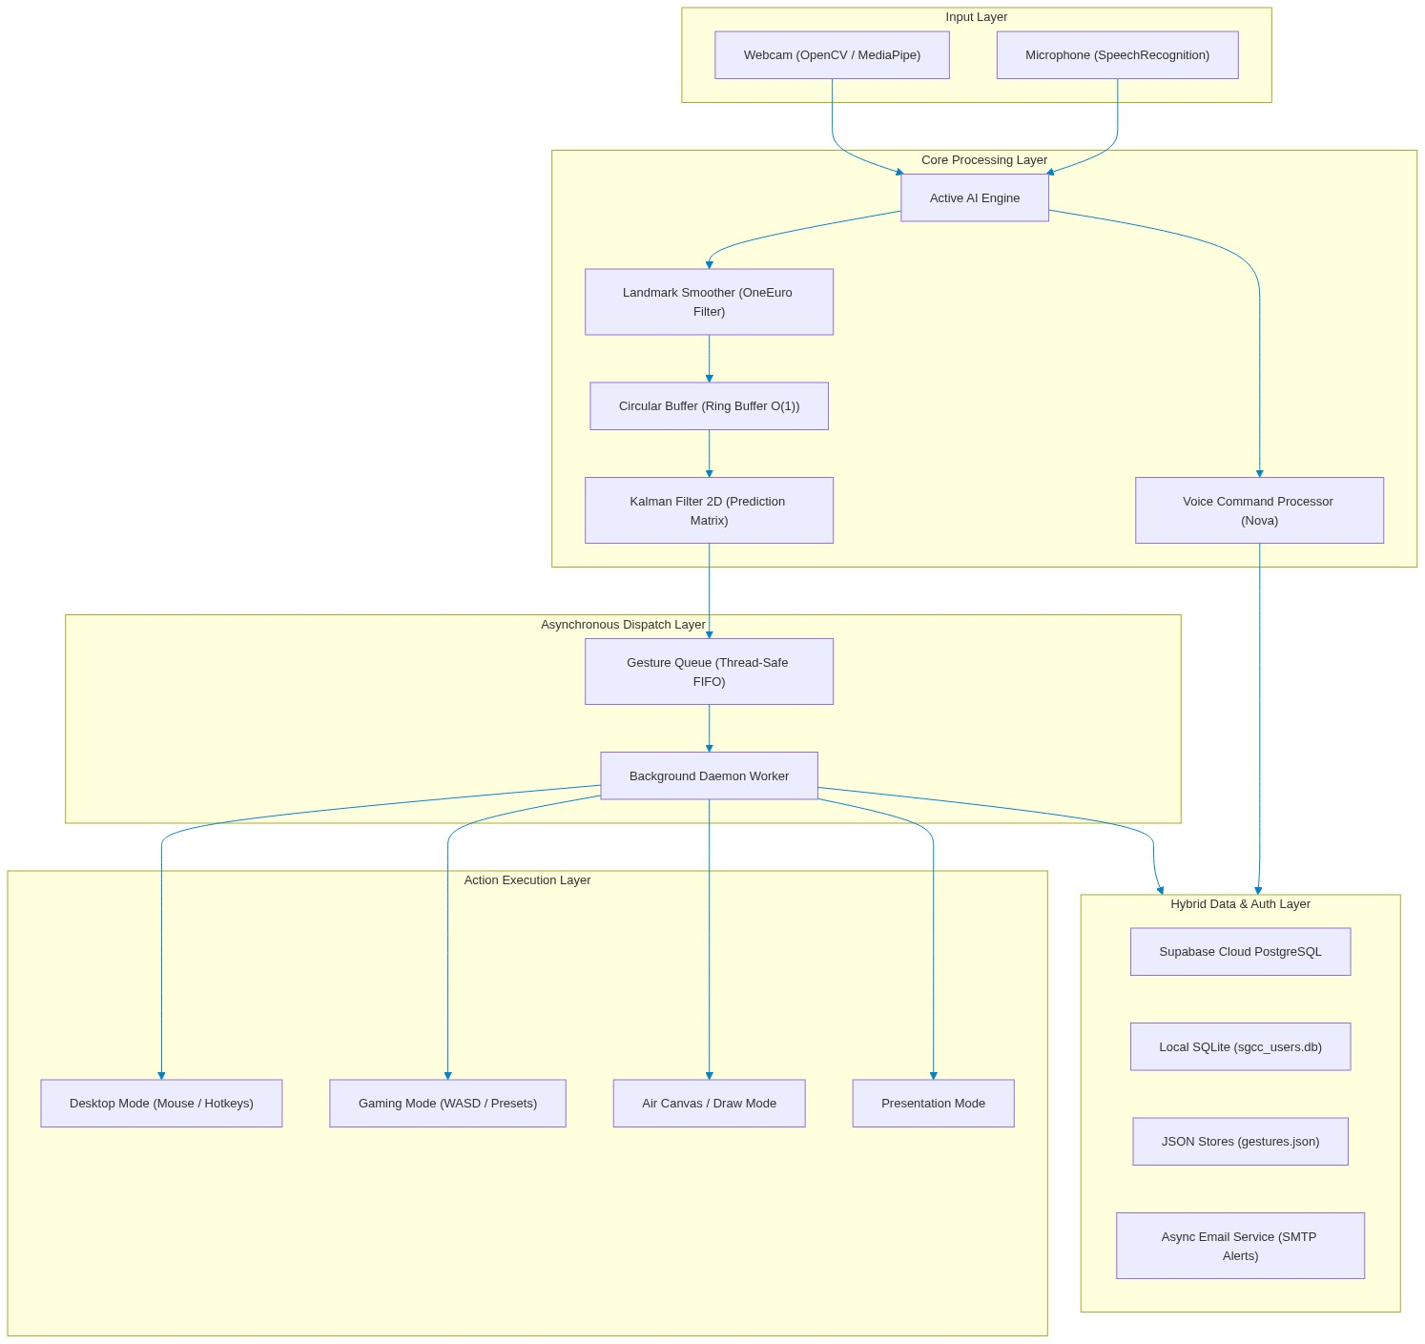
Figure 1: Aurevix End-to-End Multimodal System Architecture
—————————————————————————————————————————————

2. In-Depth Data Structures Breakdown

2.1 Circular Buffer (Ring Buffer) — $O(1)$
- Location: `hand_tracking/ds_pipeline.py`
- Class: CircularBuffer(capacity=10)
- Design & Purpose:
* Fixed-capacity circular array to store the last N landmark positions.
* Eliminates hand jitter/shaking by computing a sliding moving average over recent coordinate tuples without dynamically reallocating memory.
- Complexity:
* Insert (`append`): O(1) via circular modulo pointer (head + 1) % capacity .
* Fetch (`get_latest`): O(1).
* Memory: O(N) bounded, preventing memory leaks during continuous tracking.
class CircularBuffer:
def __init__(self, capacity=10):
self.capacity = capacity
self.buffer = [None] * capacity
self.head = 0
self.size = 0
def append(self, item):
self.buffer[self.head] = item
self.head = (self.head + 1) % self.capacity
if self.size < self.capacity:
self.size += 1
def get_smoothed_point(self):
valid = [p for p in self.get_all() if p is not None]
return tuple(np.mean(valid, axis=0)) if valid else None

—————————————————————————————————————————————

2.2 Thread-Safe FIFO Gesture Queue
- Location: `hand_tracking/ds_pipeline.py`
- Class: GestureQueue(maxsize=50)
- Design & Purpose:
* Implements a classic Producer-Consumer pattern.
* The camera thread produces recognized gesture events at ~30–60 FPS.
* A dedicated background worker thread consumes and executes OS actions (mouse click, key press, volume change).
* Prevents UI freeze/stutter even if an OS action takes a few milliseconds.
- Underlying Structure: collections.deque(maxlen=maxsize) protected by threading.Lock .
—————————————————————————————————————————————

2.3 Mathematical State Vectors & Covariance Matrices (Kalman Filter 2D)
- Location: `hand_tracking/core/filters.py`
- Class: KalmanFilter2D
- Design & Purpose:
* 4-dimensional state vector \mathbf{x} = \begin{bmatrix} x & y & v_x & v_y \end{bmatrix}^T
* 4 \times 4 State Transition Matrix \mathbf{F}:
\mathbf{F} = \begin{bmatrix} 1 & 0 & 1 & 0 \\ 0 & 1 & 0 & 1 \\ 0 & 0 & 1 & 0 \\ 0 & 0 & 0 & 1 \end{bmatrix}
* Dynamically predicts mouse cursor trajectory and filters out noisy sensor data.
* Includes automatic drift protection with periodic covariance resets.
—————————————————————————————————————————————

2.4 Landmark Tensors & Spatial Arrays
- Location: `hand_tracking/core/camera.py`
- Structure: NumPy ndarray of shape (21, 3)
- Design & Purpose:
* Represents 21 landmarks of the human hand (wrist, thumb, index, middle, ring, pinky tips & joints).
* Fast vector math (dot products, Euclidean distance, cross products) used for pinch detection and custom gesture template matching.
—————————————————————————————————————————————

2.5 Hash Tables / Fast Dispatch Dictionaries — $O(1)$
- Location: Multiple modules
- Implementations:
* gaming_gesture_controller.py : GamePreset.bindings (Maps detected gesture \rightarrow Virtual Keyboard key).
* voice_command_processor.py : Command routing dictionary (Maps spoken keyword phrase \rightarrow Callback handler).
* user_gestures.py : Landmark dictionary (Maps gesture ID \rightarrow Vector geometry).
—————————————————————————————————————————————

2.6 Strongly-Typed Dataclasses
- CalibrationData & CalibrationProfile in `calibration_profiles.py`: Screen boundary margins (x_{min}, x_{max}, y_{min}, y_{max}) and hologram visual state.
- GamePreset in `gaming_gesture_controller.py`: FPS, Racing, and Action game presets.
- Notification in `notification_manager.py`: Toast notification model with unread state tracking.
—————————————————————————————————————————————

3. Database Architecture & Schema
Aurevix uses a Hybrid Cloud-Local Database Architecture:
- Cloud PostgreSQL (Supabase): Multi-device sync, secure authentication, and cloud backup.
- Local SQLite (`sgcc_users.db`): Ultra-fast offline operation when internet is unavailable.
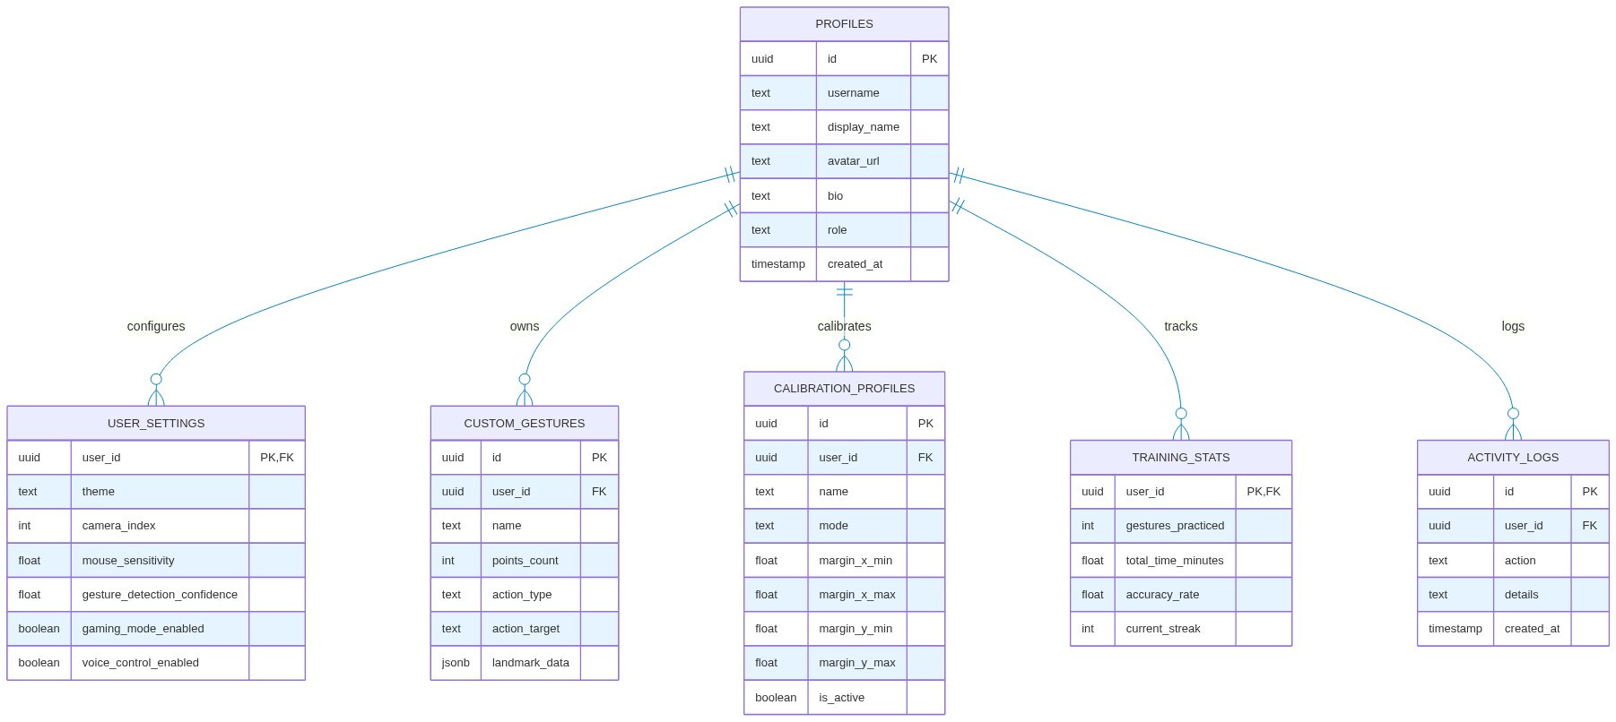
Figure 2: Hybrid Cloud-Local Relational Database Entity-Relationship (ER) Schema
—————————————————————————————————————————————

4. Codebase Directory Map
Aurevix/
│
├── .env # Active Cloud Secrets (Supabase, SMTP, AI Keys)
├── .env.example # Template for configuration
├── .gitignore # Git exclusion (protects .env, *.db, pycache)
├── requirements.txt # Python dependencies (mediapipe, PySide6, supabase, etc.)
├── supabase_schema.sql # Cloud PostgreSQL Schema (Tables, RLS, Triggers)
│
└── PythonApplication2/ # Main Application Source Code
├── main.py # 🚀 Root Application Entry Point & Navigation
├── auth_pages.py # Modern Authentication UI & Google OAuth Flow
├── supabase_manager.py # Supabase Cloud Client & OAuth Callback Server
├── email_service.py # Asynchronous SMTP Security Email Dispatcher
├── database.py # Local SQLite Client (sgcc_users.db) & Hybrid Sync
├── active_ai_engine.py # Multimodal AI Engine (Vision + Voice threads)
├── voice_command_processor.py # Voice Assistant (Nova) Command Dispatcher
├── audio_manager.py # Sound effects (SFX) and TTS audio engine
├── profile_widget.py # Top-right User Profile, Avatar, & Edit Dialog
├── top_navigation.py # Top Navigation Bar, Notification Badge, Theme Switch
├── sidebar.py # Sidebar Navigation Icons & Route Controller
├── futuristic_dashboard.py # Main telemetry dashboard with live visualizers
├── calibration_page.py # Holographic camera boundary calibration UI
├── calibration_profiles.py # Calibration data models & persistence
├── gaming_gesture_controller.py # Gaming Controller (WASD, Presets, Keyboard bindings)
├── ai_trainer_game.py # Interactive gesture training mini-game
├── logs_page.py # Live system audit & user activity log UI
├── notification_manager.py # Real-time in-app notification manager
│
├── hand_tracking/ # 🖐️ Computer Vision Core Package
│ ├── ds_pipeline.py # CircularBuffer & GestureQueue data structures
│ ├── tracker.py # MediaPipe hand tracking lifecycle
│ ├── core/
│ │ ├── camera.py # Video capture, mirror, and frame pipeline
│ │ ├── filters.py # KalmanFilter2D, OneEuroFilter, LandmarkSmoother
│ │ ├── hud.py # Heads-up display visual overlay
│ │ └── state.py # Central tracking runtime state
│ └── modes/
│ ├── desktop_mode.py # Virtual mouse, left/right click, scroll, drag
│ ├── gaming_mode.py # Directional gaming gesture controls
│ ├── draw_mode.py # Air Canvas drawing and painting
│ └── presentation_mode.py # Slide navigation, laser pointer, zoom
│
├── gaming_mode/ # Specialized gaming widgets and AI pattern learner
├── training_modes/ # Adaptive trainer, neural practice, reflex challenge
└── drawings/ # Saved Air Canvas screenshots and exported art

—————————————————————————————————————————————

5. Execution Pipelines Summary

A. Authentication Pipeline
- User clicks "Continue with Google" in auth_pages.py .
- supabase_manager.py starts a local loopback server at http://localhost:54321/callback and opens Google Auth in default browser.
- User selects their Google account; Supabase exchanges code and verifies session.
- Python fetches user metadata, strips trailing digits from email prefix, sets clean name ( Pratha More ) and initials ( PM ), and updates the database.
- email_service.py fires an asynchronous cyberpunk-themed login alert email to the user's Gmail.
- Local SQLite records a linked session for instant offline re-authentication.

B. Tracking & Gesture Pipeline
- Webcam captures frame at 60\text{ FPS} via OpenCV.
- MediaPipe extracts 21 hand landmarks in 3D coordinate space.
- LandmarkSmoother runs 63 individual OneEuroFilter passes (x, y, z for 21 points).
- CircularBuffer computes a moving average to suppress micro-jitters.
- KalmanFilter2D predicts cursor destination.
- Recognized gesture is enqueued in thread-safe GestureQueue .
- Worker thread dequeues event and triggers corresponding Windows input API (via pyautogui / pynput ).

