Aurevix — Core Data Structures & Algorithms
Aurevix Multimodal Gesture & Voice Control System • Visual Technical Report
This document contains visual architectural diagrams, state flows, and structural mappings for the five primary data structures powering the Aurevix Multimodal Interaction Engine.
—————————————————————————————————————————————

1. Circular Buffer (Ring Buffer) — $O(1)$ Moving Average
Used in `hand_tracking/ds_pipeline.py` for real-time landmark stabilization and mouse cursor jitter elimination.
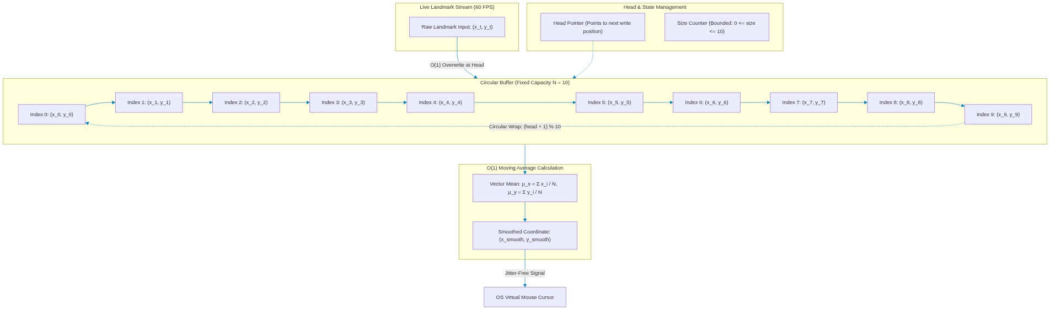
Figure 1: Circular Buffer (Ring Buffer) O(1) Architecture & Moving Average Filter

Mathematical Formulation
Given a capacity N=10, each new measurement p_t = (x_t, y_t) overwrites slot h:
\text{buffer}[h] \leftarrow p_t, \quad h \leftarrow (h + 1) \pmod N
The filtered coordinate \bar{p}_t is computed via vector mean:
\bar{p}_t = \frac{1}{|S|} \sum_{i \in S} \text{buffer}[i], \quad S = \{i \mid \text{buffer}[i] \neq \text{None}\}
—————————————————————————————————————————————

2. Thread-Safe FIFO Gesture Queue (Producer-Consumer)
Used in `hand_tracking/ds_pipeline.py` \rightarrow GestureQueue to decouple video processing from OS action execution.
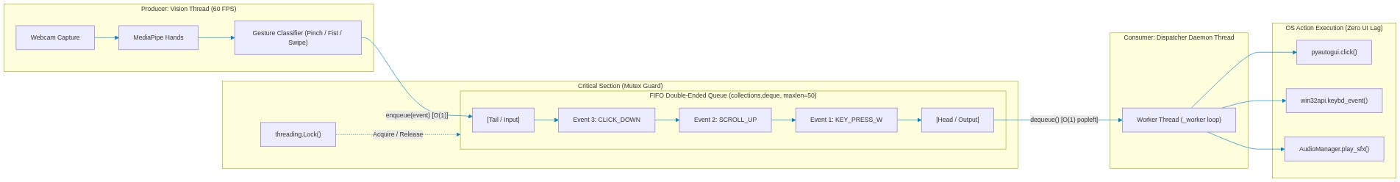
Figure 2: Thread-Safe FIFO Gesture Queue Decoupled Producer-Consumer Architecture
—————————————————————————————————————————————

3. Kalman Filter 2D — State Estimation & Prediction
Used in `hand_tracking/core/filters.py` \rightarrow KalmanFilter2D for predicting cursor coordinates and preventing drift.
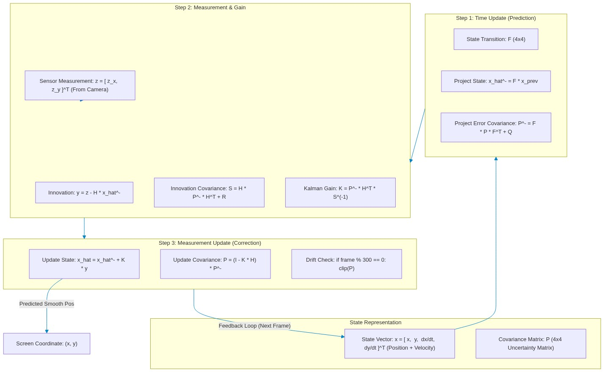
Figure 3: Kalman Filter 2D State Estimation, Covariance Matrices & Drift Prevention
—————————————————————————————————————————————

4. Spatial Landmark Tensors — 3D $(21, 3)$ Hand Graph
Used in `hand_tracking/core/camera.py` and MediaPipe Hands to capture the geometric anatomy of the human hand.
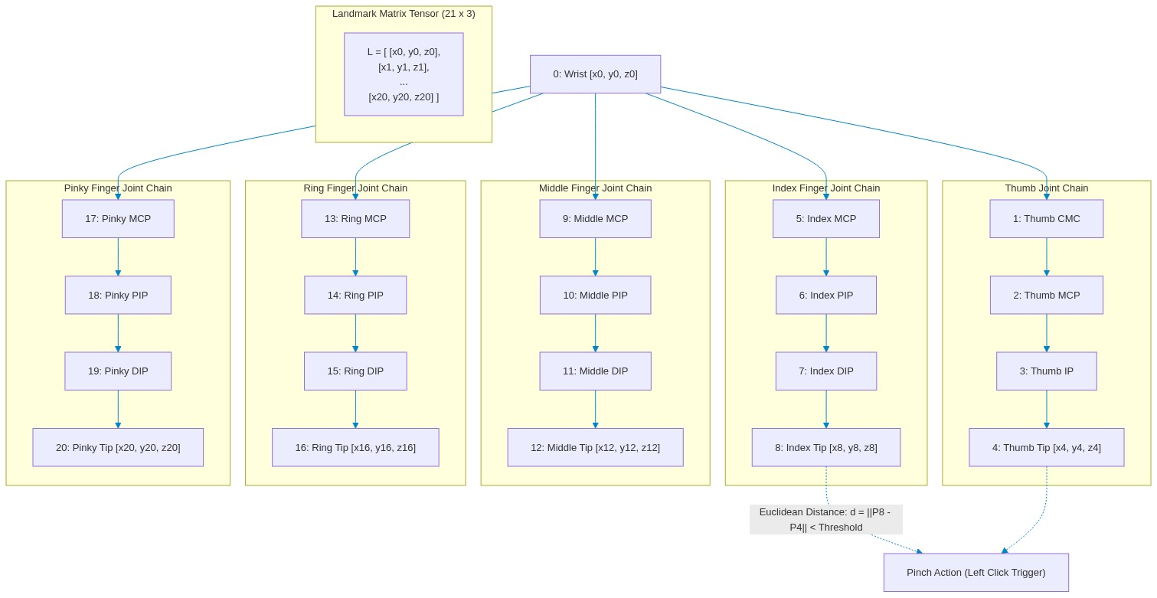
Figure 4: Spatial Landmark Tensors — 3D (21, 3) Anatomical Hand Skeleton Graph
—————————————————————————————————————————————

5. Hash Tables & Dataclasses — $O(1)$ Dispatch Maps
Used across the application for instantaneous action lookup, key-binding resolution, and structured state holding.
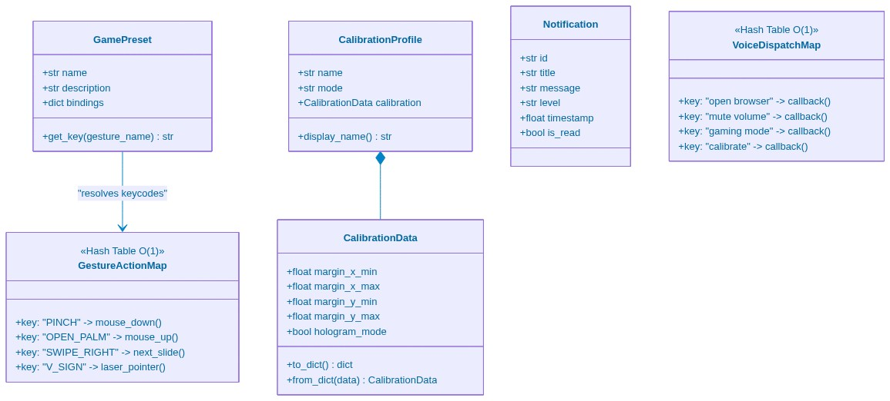
Figure 5: Hash Tables & Strongly-Typed Dataclass Model Architecture
—————————————————————————————————————————————

Summary Matrix
| Data Structure | Primary File | Access Complexity | Insert Complexity | Primary Purpose in Aurevix |
| :--- | :--- | :--- | :--- | :--- |
| CircularBuffer | ds_pipeline.py | O(1) | O(1) | 60 FPS coordinate window for moving average filter |
| GestureQueue | ds_pipeline.py | O(1) | O(1) | Thread-safe FIFO queue decoupling camera and OS actions |
| KalmanFilter2D | filters.py | O(1) | O(1) | 4D state vector & covariance matrix trajectory prediction |
| Spatial Landmark Tensor | camera.py | O(1) | O(1) | 21 \times 3 coordinate matrix for hand skeleton geometry |
| Hash Tables (`dict`) | gaming_gesture_controller.py , voice_command_processor.py | O(1) | O(1) | Instant lookup for voice commands, game keys, and gesture types |
| Dataclasses | calibration_profiles.py , notification_manager.py | O(1) | O(1) | Strongly-typed, validated data representations |

