Aurevix — Complete System Architecture & Blueprint
Aurevix Multimodal Gesture & Voice Control System • Visual Technical Report
[SYSTEM OVERVIEW] **Aurevix** is an AI-powered multimodal interaction platform combining Real-Time Computer Vision (MediaPipe), Speech Recognition, Digital Signal Processing (Kalman & OneEuro Filters), Cloud Database Architecture (Supabase PostgreSQL), and PyQt6/PySide6 desktop UI.

—————————————————————————————————————————————

1. High-Level System Architecture
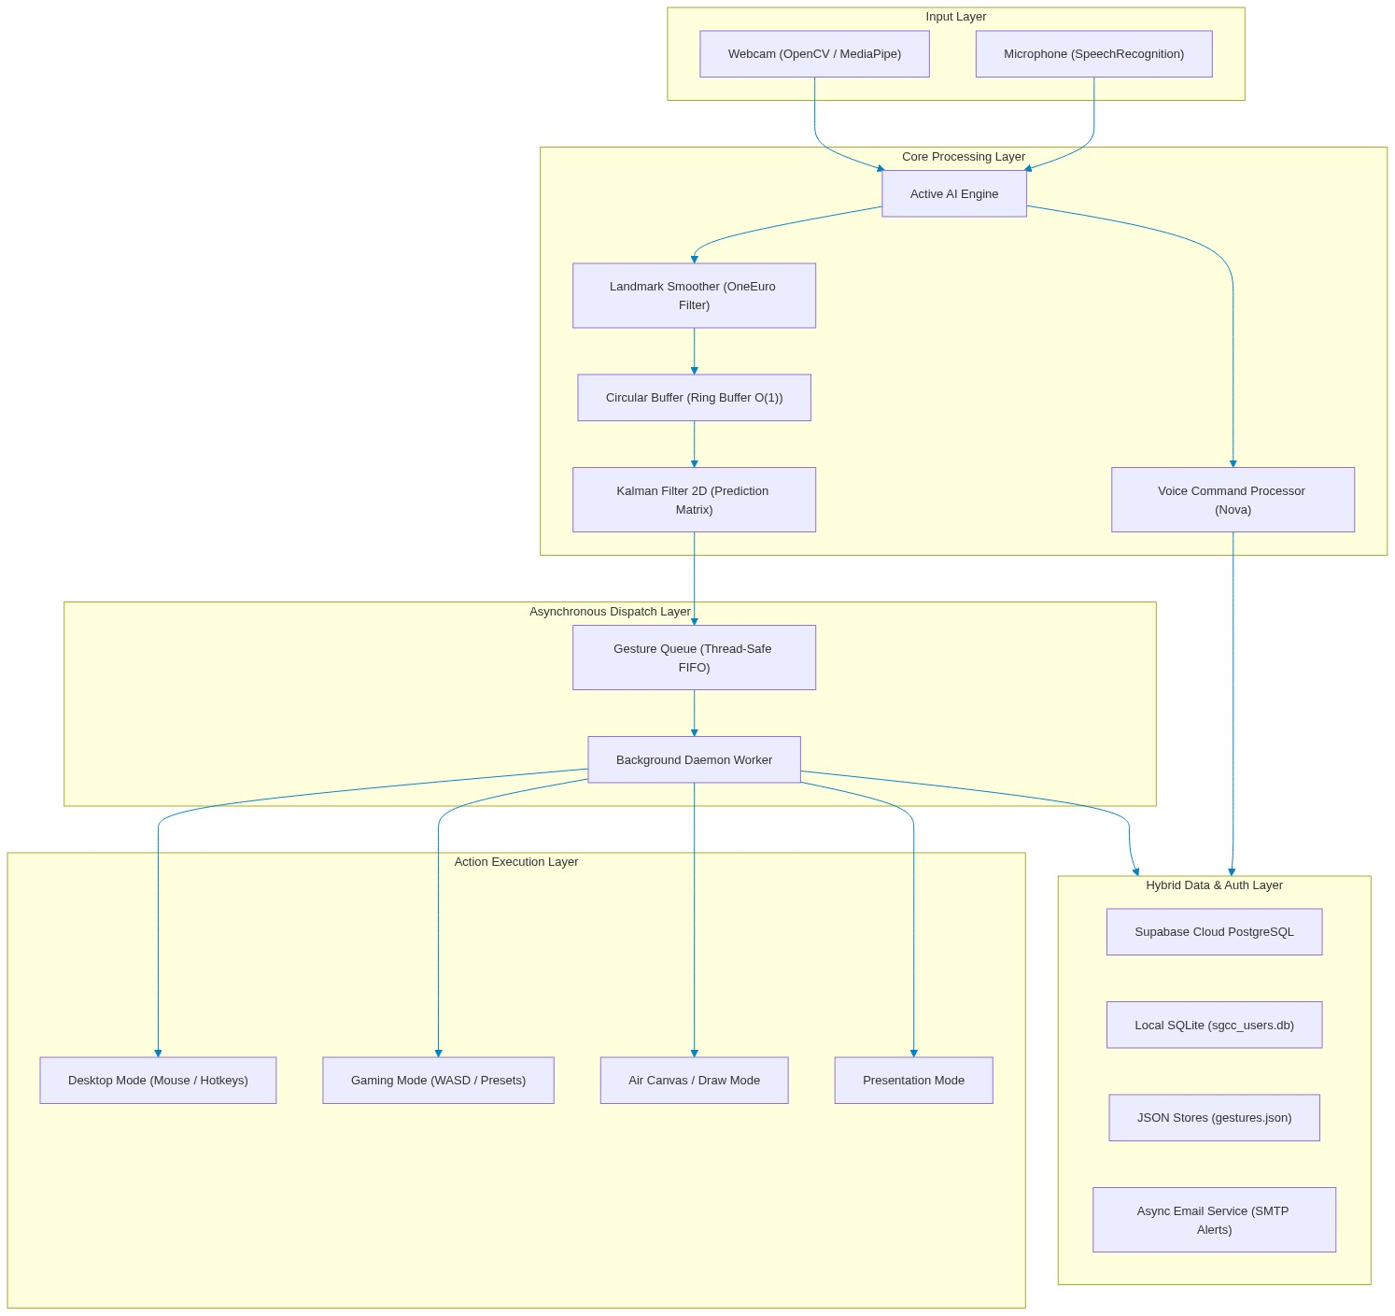
Figure 1: Aurevix End-to-End Multimodal System Architecture
—————————————————————————————————————————————

2. In-Depth Data Structures Breakdown

2.1 Circular Buffer (Ring Buffer) — $O(1)$
- Location: `hand_tracking/ds_pipeline.py`
- Class: CircularBuffer(capacity=10)
- Design & Purpose:
* Fixed-capacity circular array to store the last N landmark positions.
* Eliminates hand jitter/shaking by computing a sliding moving average over recent coordinate tuples without dynamically reallocating memory.
- Complexity:
* Insert (`append`): O(1) via circular modulo pointer (head + 1) % capacity .
* Fetch (`get_latest`): O(1).
* Memory: O(N) bounded, preventing memory leaks during continuous tracking.
class CircularBuffer:
def __init__(self, capacity=10):
self.capacity = capacity
self.buffer = [None] * capacity
self.head = 0
self.size = 0
def append(self, item):
self.buffer[self.head] = item
self.head = (self.head + 1) % self.capacity
if self.size < self.capacity:
self.size += 1
def get_smoothed_point(self):
valid = [p for p in self.get_all() if p is not None]
return tuple(np.mean(valid, axis=0)) if valid else None

—————————————————————————————————————————————

2.2 Thread-Safe FIFO Gesture Queue
- Location: `hand_tracking/ds_pipeline.py`
- Class: GestureQueue(maxsize=50)
- Design & Purpose:
* Implements a classic Producer-Consumer pattern.
* The camera thread produces recognized gesture events at ~30–60 FPS.
* A dedicated background worker thread consumes and executes OS actions (mouse click, key press, volume change).
* Prevents UI freeze/stutter even if an OS action takes a few milliseconds.
- Underlying Structure: collections.deque(maxlen=maxsize) protected by threading.Lock .
—————————————————————————————————————————————

2.3 Mathematical State Vectors & Covariance Matrices (Kalman Filter 2D)
- Location: `hand_tracking/core/filters.py`
- Class: KalmanFilter2D
- Design & Purpose:
* 4-dimensional state vector \mathbf{x} = \begin{bmatrix} x & y & v_x & v_y \end{bmatrix}^T
* 4 \times 4 State Transition Matrix \mathbf{F}:
\mathbf{F} = \begin{bmatrix} 1 & 0 & 1 & 0 \\ 0 & 1 & 0 & 1 \\ 0 & 0 & 1 & 0 \\ 0 & 0 & 0 & 1 \end{bmatrix}
* Dynamically predicts mouse cursor trajectory and filters out noisy sensor data.
* Includes automatic drift protection with periodic covariance resets.
—————————————————————————————————————————————

2.4 Landmark Tensors & Spatial Arrays
- Location: `hand_tracking/core/camera.py`
- Structure: NumPy ndarray of shape (21, 3)
- Design & Purpose:
* Represents 21 landmarks of the human hand (wrist, thumb, index, middle, ring, pinky tips & joints).
* Fast vector math (dot products, Euclidean distance, cross products) used for pinch detection and custom gesture template matching.
—————————————————————————————————————————————

2.5 Hash Tables / Fast Dispatch Dictionaries — $O(1)$
- Location: Multiple modules
- Implementations:
* gaming_gesture_controller.py : GamePreset.bindings (Maps detected gesture \rightarrow Virtual Keyboard key).
* voice_command_processor.py : Command routing dictionary (Maps spoken keyword phrase \rightarrow Callback handler).
* user_gestures.py : Landmark dictionary (Maps gesture ID \rightarrow Vector geometry).
—————————————————————————————————————————————

2.6 Strongly-Typed Dataclasses
- CalibrationData & CalibrationProfile in `calibration_profiles.py`: Screen boundary margins (x_{min}, x_{max}, y_{min}, y_{max}) and hologram visual state.
- GamePreset in `gaming_gesture_controller.py`: FPS, Racing, and Action game presets.
- Notification in `notification_manager.py`: Toast notification model with unread state tracking.
—————————————————————————————————————————————

3. Database Architecture & Schema
Aurevix uses a Hybrid Cloud-Local Database Architecture:
- Cloud PostgreSQL (Supabase): Multi-device sync, secure authentication, and cloud backup.
- Local SQLite (`sgcc_users.db`): Ultra-fast offline operation when internet is unavailable.
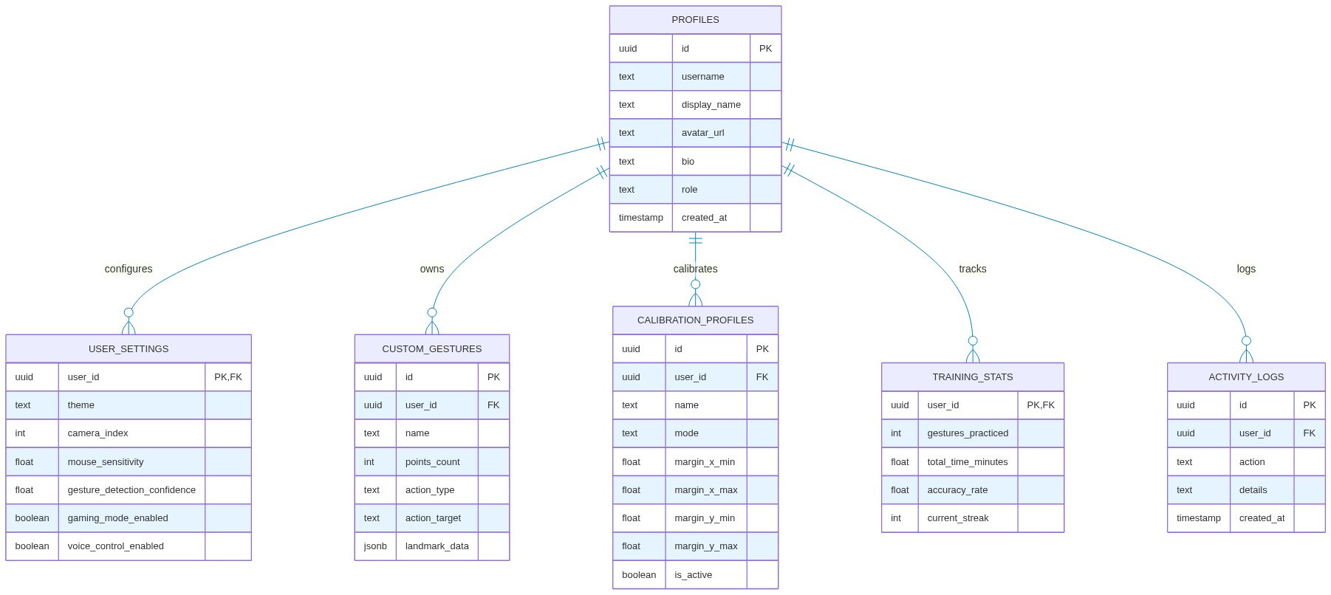
Figure 2: Hybrid Cloud-Local Relational Database Entity-Relationship (ER) Schema
—————————————————————————————————————————————

4. Codebase Directory Map
Aurevix/
│
├── .env # Active Cloud Secrets (Supabase, SMTP, AI Keys)
├── .env.example # Template for configuration
├── .gitignore # Git exclusion (protects .env, *.db, pycache)
├── requirements.txt # Python dependencies (mediapipe, PySide6, supabase, etc.)
├── supabase_schema.sql # Cloud PostgreSQL Schema (Tables, RLS, Triggers)
│
└── PythonApplication2/ # Main Application Source Code
├── main.py # 🚀 Root Application Entry Point & Navigation
├── auth_pages.py # Modern Authentication UI & Google OAuth Flow
├── supabase_manager.py # Supabase Cloud Client & OAuth Callback Server
├── email_service.py # Asynchronous SMTP Security Email Dispatcher
├── database.py # Local SQLite Client (sgcc_users.db) & Hybrid Sync
├── active_ai_engine.py # Multimodal AI Engine (Vision + Voice threads)
├── voice_command_processor.py # Voice Assistant (Nova) Command Dispatcher
├── audio_manager.py # Sound effects (SFX) and TTS audio engine
├── profile_widget.py # Top-right User Profile, Avatar, & Edit Dialog
├── top_navigation.py # Top Navigation Bar, Notification Badge, Theme Switch
├── sidebar.py # Sidebar Navigation Icons & Route Controller
├── futuristic_dashboard.py # Main telemetry dashboard with live visualizers
├── calibration_page.py # Holographic camera boundary calibration UI
├── calibration_profiles.py # Calibration data models & persistence
├── gaming_gesture_controller.py # Gaming Controller (WASD, Presets, Keyboard bindings)
├── ai_trainer_game.py # Interactive gesture training mini-game
├── logs_page.py # Live system audit & user activity log UI
├── notification_manager.py # Real-time in-app notification manager
│
├── hand_tracking/ # 🖐️ Computer Vision Core Package
│ ├── ds_pipeline.py # CircularBuffer & GestureQueue data structures
│ ├── tracker.py # MediaPipe hand tracking lifecycle
│ ├── core/
│ │ ├── camera.py # Video capture, mirror, and frame pipeline
│ │ ├── filters.py # KalmanFilter2D, OneEuroFilter, LandmarkSmoother
│ │ ├── hud.py # Heads-up display visual overlay
│ │ └── state.py # Central tracking runtime state
│ └── modes/
│ ├── desktop_mode.py # Virtual mouse, left/right click, scroll, drag
│ ├── gaming_mode.py # Directional gaming gesture controls
│ ├── draw_mode.py # Air Canvas drawing and painting
│ └── presentation_mode.py # Slide navigation, laser pointer, zoom
│
├── gaming_mode/ # Specialized gaming widgets and AI pattern learner
├── training_modes/ # Adaptive trainer, neural practice, reflex challenge
└── drawings/ # Saved Air Canvas screenshots and exported art

—————————————————————————————————————————————

5. Execution Pipelines Summary

A. Authentication Pipeline
- User clicks "Continue with Google" in auth_pages.py .
- supabase_manager.py starts a local loopback server at http://localhost:54321/callback and opens Google Auth in default browser.
- User selects their Google account; Supabase exchanges code and verifies session.
- Python fetches user metadata, strips trailing digits from email prefix, sets clean name ( Pratha More ) and initials ( PM ), and updates the database.
- email_service.py fires an asynchronous cyberpunk-themed login alert email to the user's Gmail.
- Local SQLite records a linked session for instant offline re-authentication.

B. Tracking & Gesture Pipeline
- Webcam captures frame at 60\text{ FPS} via OpenCV.
- MediaPipe extracts 21 hand landmarks in 3D coordinate space.
- LandmarkSmoother runs 63 individual OneEuroFilter passes (x, y, z for 21 points).
- CircularBuffer computes a moving average to suppress micro-jitters.
- KalmanFilter2D predicts cursor destination.
- Recognized gesture is enqueued in thread-safe GestureQueue .
- Worker thread dequeues event and triggers corresponding Windows input API (via pyautogui / pynput ).

Aurevix — Core Data Structures & Algorithms
Aurevix Multimodal Gesture & Voice Control System • Visual Technical Report
This document contains visual architectural diagrams, state flows, and structural mappings for the five primary data structures powering the Aurevix Multimodal Interaction Engine.
—————————————————————————————————————————————

1. Circular Buffer (Ring Buffer) — $O(1)$ Moving Average
Used in `hand_tracking/ds_pipeline.py` for real-time landmark stabilization and mouse cursor jitter elimination.
Figure 1: Circular Buffer (Ring Buffer) O(1) Architecture & Moving Average Filter

Mathematical Formulation
Given a capacity N=10, each new measurement p_t = (x_t, y_t) overwrites slot h:
\text{buffer}[h] \leftarrow p_t, \quad h \leftarrow (h + 1) \pmod N
The filtered coordinate \bar{p}_t is computed via vector mean:
\bar{p}_t = \frac{1}{|S|} \sum_{i \in S} \text{buffer}[i], \quad S = \{i \mid \text{buffer}[i] \neq \text{None}\}
—————————————————————————————————————————————

2. Thread-Safe FIFO Gesture Queue (Producer-Consumer)
Used in `hand_tracking/ds_pipeline.py` \rightarrow GestureQueue to decouple video processing from OS action execution.
Figure 2: Thread-Safe FIFO Gesture Queue Decoupled Producer-Consumer Architecture
—————————————————————————————————————————————

3. Kalman Filter 2D — State Estimation & Prediction
Used in `hand_tracking/core/filters.py` \rightarrow KalmanFilter2D for predicting cursor coordinates and preventing drift.
Figure 3: Kalman Filter 2D State Estimation, Covariance Matrices & Drift Prevention
—————————————————————————————————————————————

4. Spatial Landmark Tensors — 3D $(21, 3)$ Hand Graph
Used in `hand_tracking/core/camera.py` and MediaPipe Hands to capture the geometric anatomy of the human hand.
Figure 4: Spatial Landmark Tensors — 3D (21, 3) Anatomical Hand Skeleton Graph
—————————————————————————————————————————————

5. Hash Tables & Dataclasses — $O(1)$ Dispatch Maps
Used across the application for instantaneous action lookup, key-binding resolution, and structured state holding.
Figure 5: Hash Tables & Strongly-Typed Dataclass Model Architecture
—————————————————————————————————————————————

Summary Matrix
| Data Structure | Primary File | Access Complexity | Insert Complexity | Primary Purpose in Aurevix |
| :--- | :--- | :--- | :--- | :--- |
| CircularBuffer | ds_pipeline.py | O(1) | O(1) | 60 FPS coordinate window for moving average filter |
| GestureQueue | ds_pipeline.py | O(1) | O(1) | Thread-safe FIFO queue decoupling camera and OS actions |
| KalmanFilter2D | filters.py | O(1) | O(1) | 4D state vector & covariance matrix trajectory prediction |
| Spatial Landmark Tensor | camera.py | O(1) | O(1) | 21 \times 3 coordinate matrix for hand skeleton geometry |
| Hash Tables (`dict`) | gaming_gesture_controller.py , voice_command_processor.py | O(1) | O(1) | Instant lookup for voice commands, game keys, and gesture types |
| Dataclasses | calibration_profiles.py , notification_manager.py | O(1) | O(1) | Strongly-typed, validated data representations |

