DetourTO — Stage 2 Implementation Report
EECS 3311 Software Design · York University · Fall 2026
Pratham Patel · 219467315 · github.com/prathamp18/EECS3311-DetourTO
November 2026

1. Project overview and implementation status
DetourTO is a disruption-aware trip planner for the Toronto Transit Commission (TTC). A rider types a trip in plain English (“York U to Union by 10, no streetcars, step-free please”) or fills in a form. DetourTO returns several real itineraries, explains how they differ, and keeps them up to date when service alerts close stations or lines.
Users. The Stage 1 users are unchanged:
- daily TTC commuters (for example York students);
- riders who need step-free access;
- occasional riders who don’t know the network;
- a developer or tester who replays recorded disruptions from the command line.
AI / LLM integration. The application calls Google Gemini (gemini-flash-latest, AI Studio free tier) through GeminiAdapter, which implements the LLMClient interface. Four agents extend the TransitAgent template:
Agent | What it does
TripRequestAgent | Turns plain English into a trip query, using the find_stop and plan_journey tools
AlertInterpreterAgent | Turns free-text TTC alerts into structured disruptions, using find_stop and get_route_stops
ExplanationAgent | Compares the computed options in plain language
PreferenceExtractorAgent | Picks lasting preferences out of a message (“never put me on the 29”)
The agents take part in reasoning, tool use, memory and multi-step work. They do more than forward a prompt: every model answer is parsed by ResponseParser and checked by GroundingValidator before it is used. All stops, routes, times and itineraries come from the deterministic Java planner (RAPTOR), never from model text. Every model call, tool call and validation result is published on the EventBus and written to trace.jsonl.
Current working functionality. All 13 Stage 1 features (F01–F13) are implemented and run from both interfaces:
- GUI: JavaFX with 5 tabs (Trip Planner with map, Alerts, Arrivals, Commute & Profile, Benchmark), started with java -jar target/detourto.jar gui.
- CLI: the picocli command detour, with sub-commands plan, alerts, arrivals, monitor, places, prefs, commute, replay, refresh-data, validate-feed, llm-check and gui, and --json output.
The code base is about 12,100 lines of Java in 148 classes, plus 36 test classes with 179 JUnit 5 tests. Nine design patterns from the course are implemented (Section 3).
Limitations (stated honestly).
- Default data. The default data is a small synthetic network (data/sample/mini-gtfs: 72 stops, 5 routes) and a recorded GTFS-Realtime feed, so the app and its videos are repeatable. The real TTC schedule can be downloaded with refresh-data and the live feed switched on in .env. Station grouping (step 18) was added for the real feed, but the full real schedule was only checked on the developer’s machine, not in an automated test.
- Map. The map is drawn on a JavaFX Canvas with no street basemap.
- Daylight-saving time. Times are converted as the service date’s midnight plus seconds. The GTFS “noon minus 12 h” rule for daylight-saving days is not handled.
- LLM dependence. The AI features need a Gemini key. Without one, deterministic fallbacks are used: the form planner, rule-based follow-ups and preferences, and structured-alert parsing. Free-text alert interpretation and the natural-language explanation are then not available.
- Monitoring in the CLI. Live monitoring in the CLI is a minute-by-minute replay, because a CLI process cannot wait for a real trip. The GUI monitors on the real clock.
- Stage 3 work. KUMA agent tests and the full deterministic test suite are Stage 3 work.

2. Feature to implementation mapping
Every Stage 1 feature is implemented. No features were removed, and no new top-level features were added. Two feature-level additions inside existing features are listed in Section 4: station grouping for F13/F02 and map controls for F02. In the table, “Det.” means deterministic, “AI” means LLM-based, and “Hybrid” means the LLM proposes and Java validates.

F01 — Natural-language trip request
Field | Entry
Stage 1 reference | F01 · Status: Implemented (Gemini instead of Claude/Bedrock; see Section 4)
Classes / files | TripPlannerPanel (Ask box) and PlanCommand (detour plan "<text>") take the input. TripController is the facade. TripRequestAgent is the AI. FindStopTool and PlanJourneyTool (registered in ToolRegistry) are its tools. ResponseParser turns JSON into a TripQuery. GroundingValidator rejects any stop id that did not come from a tool result. ClarificationRequest is returned when a place is ambiguous.
Key methods | TripController.planFromText(), TransitAgent.run(), TripRequestAgent.parseFinal()/validate(), GroundingValidator.validateQuery(), PlaceResolver.resolve()
Patterns | Facade, Template Method, Adapter, Factory, Observer
Type | Hybrid
Flow: the user’s text → TripController.planFromText → TripRequestAgent.run (system prompt, tool loop through LLMClient.complete) → find_stop resolves each place against TransitNetwork → the model returns a structured query → it is validated → JourneyPlanner.plan computes the options → PlanResult is shown in the GUI options list or printed by the CLI. Ambiguous places produce a clarification question (CLI exit code 4).

F02 — Multi-option journey planning
Field | Entry
Stage 1 reference | F02 · Status: Implemented (map changed; see Section 4)
Classes / files | JourneyPlanner runs a RAPTOR search over TransitNetwork / NetworkView. GtfsStaticLoader builds the network from GTFS. Itinerary, RideLeg, WalkLeg and TripQuery hold the trip data. PlaceResolver handles place names. MapPanel and MapProjection draw the chosen trip. PlanCommand and TextResultWriter / JsonResultWriter handle the CLI output.
Key methods | TripController.planFromForm(), JourneyPlanner.plan(q, view, strategy), MapPanel.drawItinerary()
Patterns | Facade, Strategy
Type | Deterministic
Flow: From, To and a depart or arrive-by time → planFromForm resolves the places → the planner runs rounds of RAPTOR (one round per extra transfer) → up to 5 options, ranked by the chosen strategy → the list and the map in the GUI, text or --json in the CLI. The map zooms to the chosen trip and labels only the start, transfer and end stops.

F03 — Route preference strategies
Field | Entry
Stage 1 reference | F03 · Status: Implemented (interface extended)
Classes / files | The RouteScoringStrategy interface and FastestStrategy, FewestTransfersStrategy, LeastWalkingStrategy, AccessibleStrategy. StrategyKind names them. ChangeStrategyCommand makes a strategy change undoable.
Key methods | score(itinerary, query), canBoard() / canAlight() (used for pruning inside RAPTOR), TripController.setStrategy()
Patterns | Strategy, Command
Type | Deterministic
Flow: the “Rank by” box or --strategy → setStrategy runs a ChangeStrategyCommand → the planner uses that strategy’s pruning and scoring. AccessibleStrategy refuses to board or alight at stops that are not step-free.

F04 — Service alert interpretation
Field | Entry
Stage 1 reference | F04 · Status: Implemented
Classes / files | GtfsRealtimeAdapter (own protobuf reader GtfsRealtimeDecoder) reads the TTC GTFS-RT alerts. AlertService turns each alert into a Disruption. Alerts with structured stop and effect fields are converted directly. Free-text alerts go to AlertInterpreterAgent, which uses FindStopTool and RouteStopsTool. AlertsPanel and AlertsCommand show the results.
Key methods | AlertService.currentDisruptions(), AlertInterpreterAgent.interpret(), GroundingValidator.validateDisruption()
Patterns | Adapter, Decorator, Template Method
Type | Hybrid
Flow: feed → alerts() → for each alert, either a structured mapping or the agent (with stop ids checked against the network) → a Disruption with kind, closed stops, confidence and a one-line summary → a table in the GUI, detour alerts in the CLI. Interpretations below 50% confidence are listed but not applied unless the user asks.

F05 — Disruption-aware re-routing
Field | Entry
Stage 1 reference | F05 · Status: Implemented (closure behaviour refined)
Classes / files | TripController builds a NetworkView with closed stops, closed line sections and outages (TransitNetwork.withDisruptions / withClosures). JourneyPlanner plans on that view. AlertsPanel has a “Re-route my trip around this” button. MapPanel.highlightDisruptions() marks closures.
Key methods | planWithDisruptions(), rerouteAround(disruptionId), NetworkView.isStopClosed()
Patterns | Facade, Strategy
Type | Hybrid (the AI interprets the alert; routing is deterministic)
Flow: active disruptions are applied by default. --avoid-disruption <id> (or the GUI button) also applies a low-confidence one, and --ignore-alerts plans on the plain schedule for comparison.

F06 — Grounded explanation and comparison
Field | Entry
Stage 1 reference | F06 · Status: Implemented
Classes / files | ExplanationAgent writes the comparison, Explanation holds the text and the option ids it refers to, and GroundingValidator.validateExplanation() checks it. The “Explain” button and --explain start it.
Key methods | TripController.explain(), ExplanationAgent.explain(), ExplanationAgent.fallback()
Patterns | Template Method, Facade
Type | Hybrid
Flow: the computed options → the agent → the validator only accepts option ids, minute values and lines that exist in the options → if validation fails, a deterministic comparison is shown instead.

F07 — Live trip monitoring
Field | Entry
Stage 1 reference | F07 · Status: Implemented
Classes / files | TripMonitorService polls the feed. ActiveTrip is the context, with the states PlannedState, OnTrackState, AtRiskState, ReroutedState and CompletedState. TripRisk describes what is wrong. The GUI uses the “Start trip” / “Accept reroute” buttons; the CLI uses MonitorCommand.
Key methods | TripController.startTrip(), TripMonitorService.poll(), ActiveTrip.update(), TripState.handle(), acceptReroute()
Patterns | State, Observer, Facade
Type | Deterministic (alert interpretation inside it may use AI)
Flow: start a trip → on every poll the current state checks the remaining legs against disruptions, delays (missed connections) and the arrive-by deadline → it moves to At risk and publishes an event → the GUI badge and the CLI log update → if the user accepts a reroute, the trip moves to Rerouted, and when the last leg ends it moves to Completed.

F08 — Stop arrivals board
Field | Entry
Stage 1 reference | F08 · Status: Implemented (arrivals moved to the application layer)
Classes / files | ArrivalBoard combines the schedule with the RealtimeSnapshot delays. CachingRealtimeFeed and ResilientRealtimeFeed (with CircuitBreaker) wrap GtfsRealtimeAdapter. ArrivalsPanel and ArrivalsCommand show the board.
Key methods | TripController.getArrivals(), ArrivalBoard.arrivals()
Patterns | Decorator, Adapter
Type | Deterministic
Flow: stop name → the next departures, with the live delay shown where the feed has one. If the feed fails, the circuit breaker falls back to scheduled times.

F09 — Saved places and preference memory
Field | Entry
Stage 1 reference | F09 · Status: Implemented
Classes / files | RiderProfile and PreferenceUpdate hold the profile. ProfileRepository has an SQLite version (SqliteProfileRepository, on SqliteDatabase) and an in-memory version. PreferenceExtractorAgent is the AI, with PreferenceRules as the offline fallback. PlaceResolver.setSavedPlaces() lets “home” work anywhere. The GUI uses CommutePanel; the CLI uses PlacesCommand and PrefsCommand.
Key methods | savePlace(), learnPreferences(), updateProfile(), applyProfile()
Patterns | Template Method, Facade
Type | Hybrid
Flow: “never put me on the 29” → the agent (or the rules) produces a PreferenceUpdate → it is validated against real routes → it is saved in SQLite → it is applied to every new query (avoided routes, the step-free strategy, the default strategy).

F10 — What-if follow-ups with undo/redo
Field | Entry
Stage 1 reference | F10 · Status: Implemented (one command added)
Classes / files | QueryCommand has 5 implementations: ChangeDepartureCommand, AvoidRouteCommand, AvoidModeCommand, ChangeStrategyCommand and ChangeDestinationCommand. CommandHistory holds the undo and redo stacks. QueryCommandFactory builds commands. FollowUpIntent / IntentKind describe the request. TripRequestAgent.interpretFollowUp() is the AI, and FollowUpRules is the offline fallback. The GUI uses the Ask box and the Undo/Redo buttons; the CLI uses --then.
Key methods | followUp(), undo(), redo(), CommandHistory.run()
Patterns | Command, Factory, Template Method
Type | Hybrid
Flow: “leave 15 min later” → an intent (from the AI, validated, or from the rules) → the factory builds a command → run() changes the query and re-plans → undo restores the previous query.

F11 — Commute watch and leave-by alerts
Field | Entry
Stage 1 reference | F11 · Status: Implemented
Classes / files | Commute, CommuteRepository (SQLite and in-memory versions) and CommuteScheduler do the work. CommutePanel checks every minute; the CLI uses CommuteCommand.
Key methods | saveCommute(), CommuteScheduler.today(), checkDue(), extraMinutes()
Patterns | Facade, Observer
Type | Deterministic (uses the disruptions from F04)
Flow: the saved commute → today’s arrive-by plan with current disruptions → the leave-by time and how much earlier than usual to leave → a warning --warn minutes before, once per day.

F12 — Disruption replay and benchmark
Field | Entry
Stage 1 reference | F12 · Status: Implemented
Classes / files | ReplayScenario and ScenarioLoader read scenarios/*.json. ReplayRealtimeFeed plays back the recorded alerts. BenchmarkRunner produces a BenchmarkReport. The GUI uses BenchmarkPanel; the CLI uses ReplayCommand.
Key methods | runReplay(), BenchmarkRunner.runAll()
Patterns | Adapter (replay feed), Observer (metrics)
Type | Hybrid
Flow: each scenario → interpret its alerts → plan around them → compare the interpreted closures with the closures that really happened → report the extra travel time, grounding violations, LLM calls and latency.

F13 — Transit data refresh and validation
Field | Entry
Stage 1 reference | F13 · Status: Implemented (station grouping added)
Classes / files | OpenDataDownloader handles the Toronto Open Data CKAN package and the ZIP download. GtfsStaticLoader.validate() and FeedValidationReport check the feed, and groupStations() groups platforms into stations. The GUI uses the Benchmark tab’s “Refresh transit data” button; the CLI uses RefreshDataCommand and ValidateFeedCommand.
Key methods | TripController.refreshTransitData(), OpenDataDownloader.download(), GtfsStaticLoader.load()
Patterns | Facade
Type | Deterministic
Flow: download → validate → the new network is swapped in only if it is valid; otherwise the old one is kept. TTC platforms named “… Station” are grouped, so “Don Mills” is found.

3. Implemented design patterns
Nine distinct course patterns are in the code. Stage 1 listed eight, plus Factory as a supporting pattern.
Pattern | Problem it solves | Participants (roles) | Source | Matches Stage 1?
Strategy | Different riders rank trips differently, and accessibility must affect the search itself, not only the ranking | RouteScoringStrategy (Strategy), FastestStrategy, FewestTransfersStrategy, LeastWalkingStrategy, AccessibleStrategy (Concrete Strategies), JourneyPlanner (Context) | domain/*Strategy.java; JourneyPlanner.plan() calls canBoard, canAlight and score | Yes; canBoard/canAlight added so RAPTOR can prune
Facade | The GUI and the CLI must not know about the planner, agents, feeds or storage | TripController (Facade); subsystems: JourneyPlanner, the agents, AlertService, the repositories, TripMonitorService | application/TripController.java | Yes
Adapter | Gemini REST and GTFS-RT protobuf don’t match the interfaces the app uses | LLMClient (Target) ← GeminiAdapter (Adapter) → Gemini generateContent (Adaptee); RealtimeFeed (Target) ← GtfsRealtimeAdapter → TTC protobuf feed | agent/GeminiAdapter.java, infrastructure/GtfsRealtimeAdapter.java | Changed: BedrockClaudeAdapter → GeminiAdapter; same role
Template Method | Every agent runs the same loop (prompt → tool calls → parse → validate → retry or fall back), with different prompts, tools and parsing | TransitAgent.run() (template); hooks systemPrompt(), toolNames(), parseFinal(), validate(), onInvalid(); subclasses TripRequestAgent, AlertInterpreterAgent, ExplanationAgent, PreferenceExtractorAgent | agent/TransitAgent.java | Yes
Decorator | Caching and failure handling must wrap any feed without changing it | RealtimeFeed (Component), GtfsRealtimeAdapter (Concrete Component), RealtimeFeedDecorator (Decorator), CachingRealtimeFeed and ResilientRealtimeFeed + CircuitBreaker (Concrete Decorators) | infrastructure/*RealtimeFeed.java | Yes
Observer | The trace log, CLI --verbose, GUI panels and monitor alerts all react to the same events without coupling | EventBus (Subject), EventListener (Observer), TraceLogger, ConsoleNotifier, GUI panels (Concrete Observers), TransitEvent | application/EventBus.java, TraceLogger.java | Yes; agents report through AgentStepListener
Command | Follow-up changes must be undoable and redoable | QueryCommand (Command), 5 concrete commands, CommandHistory (Invoker), TripQuery (Receiver state), TripController (Client) | application/*Command.java, CommandHistory.java | Yes; AvoidModeCommand added
State | A monitored trip behaves differently when planned, on track, at risk, rerouted or completed | ActiveTrip (Context), TripState (State), PlannedState, OnTrackState, AtRiskState, ReroutedState, CompletedState | application/ActiveTrip.java, *State.java | Yes
Factory | Choosing the LLM provider and building the right command from an intent | LLMClientFactory.create(cfg) (gemini or scripted), QueryCommandFactory.create(intent, query) | agent/LLMClientFactory.java, application/QueryCommandFactory.java | Yes (it was a supporting pattern in Stage 1)
Why the patterns help.
- Strategy: adding a ranking means adding one class.
- Facade: the GUI and the CLI share one API, so each feature exists only once.
- Adapter: switching from Claude/Bedrock to Gemini changed only one class.
- Template Method: all four agents share the same validation and fallback loop.
- Decorator: caching and the circuit breaker are tested on their own.
- Observer: the trace file used for KUMA in Stage 3 is just another listener.
- Command: undo and redo are a pair of stacks.
- State: each trip state’s rules live in their own class.
Updated UML class diagrams. These diagrams were generated from the actual Stage 2 source with Graphviz. They are in docs/diagrams/stage2/ (PNG and SVG):
- an overview of the pattern participants (below);
- one diagram for each layer: presentation (CLI), presentation (GUI), application, agent, domain and infrastructure.
Hollow triangles show inheritance (solid) and interface implementation (dashed). Plain arrows are associations from fields, with their multiplicity.
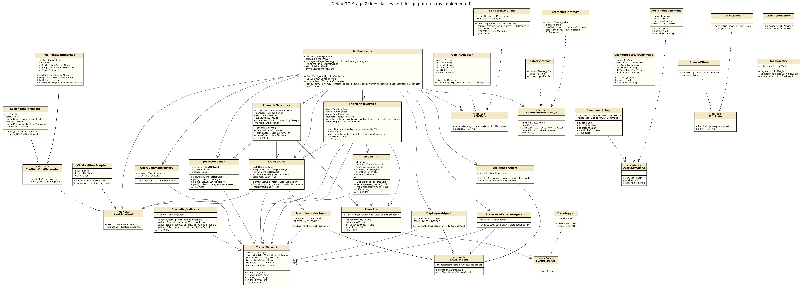
Key classes and design patterns as implemented
Use-case and sequence diagrams. The 19 use cases and 6 actors are unchanged, so the Stage 1 use-case diagram is still accurate. The sequence diagrams are also still accurate in their messages. The only change is that the BedrockClaudeAdapter lifeline is now GeminiAdapter, behind the same LLMClient.complete() call. In SD05, detour monitor is replayed minute by minute in the CLI. Both changes are recorded in Section 4.

4. Changes and rationale
Each row reads: Original design → Implemented change → Reason → Impact.
Original design (Stage 1) | Implemented change | Reason | Impact
LLM = Claude on Amazon Bedrock (BedrockClaudeAdapter) | Google Gemini via GeminiAdapter; LLMClientFactory picks gemini or scripted from LLM_PROVIDER | Every Bedrock per-model daily token quota on the new AWS account was 0 and could not be raised; Gemini has a free tier | Only the adapter class differs; the agents only see LLMClient (Adapter pattern)
Message(role, content) | Also carries tool calls, tool-call id and name, and opaque provider data; Role.TOOL added | A tool-use loop needs tool turns; Gemini requires its “thought signatures” to be sent back | Same class, more fields
LLMClient.complete only | Added describe() and LLMException kinds (AUTH, RATE_LIMIT, BAD_REQUEST, UNAVAILABLE, CONFIG) | Clear errors, and the provider/model is recorded in the trace | The CLI says why a call failed; retries on 503
StopTime holds LocalTime | Trip stores int arrays (seconds after midnight); StopTime is a view | GTFS times pass 24:00; the real feed has millions of stop times | Less memory; faster planner
TransitNetwork.withDisruptions(ds) | Added withClosures(stops, routes, outages); a closure naming a route and stops also closes that line section | Found in testing: trains were still routed through a closed stretch | Correct reroutes for “no service between A and B”
— (new class) | RoutePattern | RAPTOR scans trips that share a stop sequence | Not in the Stage 1 class diagram
RouteScoringStrategy: admissible, score(i) | canBoard / canAlight (prune inside RAPTOR), score(i, q), kind() | Accessible trips must be found, not just ranked; scoring needs the query time | Interface has 2 extra methods
TripQuery fields | Added avoidModes | F01’s “no streetcars” had no field in the Stage 1 class diagram | --avoid-mode option
JourneyPlanner.plan(q, ds, s) | plan(q, view, s) plus shortcuts | The controller builds the network view once | Same behaviour
DetourCli has main() | Main is a thin entry point; DetourCli is the picocli root with one class per sub-command | Single responsibility | Same CLI
PlaceResolver depends on ProfileRepository | PlaceResolver gets a saved-place lookup from TripController | Keeps the domain free of infrastructure | “home” works everywhere
GtfsRealtimeAdapter uses gtfs-realtime-bindings | Own small protobuf reader (ProtoReader, GtfsRealtimeDecoder) | Avoids a large dependency; only a subset of GTFS-RT is needed | Same adapter interface; decoder unit-tested
RealtimeFeed.arrivals(stopId) | Arrivals computed in ArrivalBoard (schedule + live delays); the feed has alerts() and snapshot() | Arrivals need the static schedule; decorators should only wrap network calls | Same F08 behaviour
TransitAgent holds the EventBus | TransitAgent reports through AgentStepListener; TripController forwards to the EventBus | Avoids a package cycle between agent and application | Observer still drives the trace, CLI and GUI
— (new) | RouteStopsTool (get_route_stops) | Free-text alerts name stops in words; the model needs the route’s stop ids to ground them | Extra agent tool
— (new) | Recorded sample GTFS-RT feed and replay scenarios | Live TTC trip ids only match the real schedule; tests and videos need repeatable data | Default TTC_FEED_BASE_URL=data/sample/realtime
Disruption, Arrival, ReplayScenario fields | Added summary; tripId, headsign, scheduled/realtime flags; scenario from, to, strategy, arriveBy | Needed by the UI and for scenarios that run without a key | —
4 follow-up commands | AvoidModeCommand added; ChangeDepartureCommand also switches between depart-at and arrive-by | “no streetcars” and “be there by 10” are common follow-ups | 5 commands
IntentKind not detailed | 8 kinds plus the offline FollowUpRules fallback | F10 must work even if the LLM answer fails validation | Follow-ups never block
setStrategy changes the query directly | Runs a ChangeStrategyCommand | Stage 1 says strategy changes are undoable | Undo covers strategy
PreferenceUpdate in the agent package | Moved to the domain | RiderProfile.apply() would otherwise make the domain depend on the agent package | No package cycle
— (new) | PreferenceRules; preference learning only runs when a message states a lasting preference | Avoids an extra LLM call on every request; works without a key | Fewer LLM calls
ScriptedLLMClient throws when out of responses | Throws LLMException(UNAVAILABLE) | Found in testing: offline mode crashed plan | Agents fall back gracefully
Monitor polls every 30 s | Same in the GUI (plus a fast-replay option); the CLI replays minute by minute | A CLI process cannot wait for a real trip | --accept-reroute, --plan-with-alerts
ActiveTrip states | Missed-connection risk is kept until arrival; reroute options exclude the trip already being taken | Found in testing: the trip went back to on-track after the transfer time, and the “reroute” was the same bus | Correct at-risk behaviour
detour monitor <itineraryId> | detour monitor --from --to [--depart \| --arrive-by] --option opt-N | Each CLI run is a new process with no saved ids | Same feature
Commute origin and destination | Stored as stop ids in SQLite | Survives restarts and data refreshes | Commutes whose stops vanish are skipped
OpenDataDownloader(url) | Accepts a direct .zip URL or the CKAN package URL; --file loads a local zip | The portal’s file URL changes; offline demo | TTC_GTFS_URL in .env.example
Station lookup by name | Platforms named “… Station” without a parent are grouped into generated stations (groupStations) | The real TTC GTFS has no parent stations, so “Don Mills” was not found | Place names resolve on the real feed
MapPanel with WebView + Leaflet/OpenStreetMap | Map drawn on a JavaFX Canvas (MapProjection) | Works offline, with no web tiles or JavaScript; closures can be drawn directly | No street basemap
MapPanel labels every station | Zooms to the chosen trip; labels only start, transfers and end (plus subway names); other names on hover; zoom, pan, Fit trip and Whole map controls | On the full TTC network the map was unreadable | Readable at city scale
MainWindow with 6 panels | 5 tabs; Commute and Profile share a tab; the map is inside Trip Planner | Simpler navigation | Same features
Build | SQLite JDBC, SLF4J no-op, JavaFX added to pom.xml; module-info excluded from the fat jar; Enable-Native-Access | Needed by SQLite and the GUI; removes JDK warnings | One java -jar target/detourto.jar
Factory (supporting pattern) | Counted as an implemented pattern | Both factories solve real choices (provider, command type) | 9 patterns instead of 8

5. AI tools and collaboration log
Tool / platform | Model | Used for | Tokens | Money cost
Claude app (Cowork, coding assistant) | Claude Opus 5.5 (claude-opus-5-5) | Code generation for all 20 implementation steps: Maven setup, GTFS loader, RAPTOR planner, strategies, facade and CLI, LLM layer, the 4 agents and tools, GTFS-RT feed and decorators, alerts, explanations, replay, commands with undo, SQLite profile, trip states, commutes, data refresh, JavaFX GUI, station grouping and the map. Also used for JUnit tests, debugging, the README and drafting this report. | Measured for the last working session (map, README, report): about 6.8 M cached input tokens read, 0.19 M cache-write tokens and 29.5 K output tokens (about 1.27 M input-token equivalents). Earlier sessions were not metered per token. | No per-token charge (covered by a Claude subscription)
Google AI Studio / Gemini API (runtime LLM of the app) | gemini-flash-latest (fallback gemini-flash-lite-latest) | The 4 agents at runtime and during manual testing: trip requests, alert interpretation, explanations, preference extraction | [fill in: total from trace.jsonl, see AI-TOOLS-LOG.md] | $0 (free tier)
Amazon Bedrock (tried, then dropped) | Claude Sonnet on Bedrock | First LLM integration attempt | 0 (quota was 0) | $0
How I worked with the AI. I gave Claude one feature at a time, in the order of the Stage 1 design. For every step I did the same things:
- unzipped the generated changes;
- ran mvn -q package (which compiles and runs the tests);
- ran the new CLI command and the GUI;
- read the diff;
- committed and pushed it myself.
When something was wrong, I described what I saw, and the fix went into the next commit. Representative interactions:
What I asked / reported | What came back | My check
“Implement the RAPTOR planner from the Stage 1 design with arrive-by and closures” | JourneyPlanner, Itinerary, legs, 15 tests | Ran detour plan on the sample network; compared times with the GTFS
Bedrock calls failed (daily quota 0); “just use Gemini, don’t change diagrams” | GeminiAdapter with function calling and thought signatures, retry on 503 | detour llm-check --tools on my key
“plan crashes without a key” | ScriptedLLMClient throws LLMException; agents fall back | Ran offline with LLM_PROVIDER=scripted
The monitor said “risk cleared” after a missed connection, and the reroute offered the same bus | Missed-connection risk kept until arrival; reroute excludes the current trips | detour monitor ... --accept-reroute
SQLite warnings (“restricted method”) on my JDK | Enable-Native-Access in the jar manifest and surefire | mvn package with no warnings
“The GUI can’t find Don Mills on the real TTC data” | Station grouping in GtfsStaticLoader + test | Real feed: Don Mills → Pioneer Village
“Too much text on the map when a trip is chosen” | Fit to trip, key-stop labels only, hover names, zoom/pan | Planned trips in the GUI on the sample and real data
The full log, with the command used to count Gemini tokens, is in AI-TOOLS-LOG.md. No API key appears in the code, the report, the screenshots or the videos. .env is git-ignored, and .env.example holds placeholders only.

6. Development and verification summary

Weekly commit summary
Repository: https://github.com/prathamp18/EECS3311-DetourTO (dates are Toronto time).
Period 1 (Oct 20–26): no code commits. I started implementation on Oct 28, so this period does not meet the minimum, and I accept the 5-point deduction. No commits were backdated.
Period 2 (Oct 27–Nov 2): 11 commits.
Date | Commit | Message
Oct 28 | f51d2dd | Set up Maven project, AppConfig with .env loading, and run instructions
Oct 28 | f531065 | Load GTFS static feeds into the transit network model
Oct 28 | 0f2dab5 | Add RAPTOR journey planner with itineraries, closures and arrive-by
Oct 28 | c9d7fe2 | Add route scoring strategies and use them inside the planner
Oct 28 | c1fb911 | Add TripController facade, place resolver and the detour plan command
Oct 29 | 6dd2383 | Add LLM client layer with Gemini adapter, scripted client and factory
Oct 29 | 9f954f1 | Add trip-request agent for plain-English planning (F01)
Oct 29 | da4be7e | Add GTFS-Realtime feed with caching and circuit breaker, and the arrivals board (F08)
Oct 31 | 4ea5a89 | Interpret service alerts and plan around disruptions (F04, F05)
Oct 31 | f456d88 | Add grounded explanations (F06) and the event bus with trace logging
Oct 31 | 9596f6d | Add disruption replay and benchmark (F12)
Period 3 (Nov 3–9): 7 or more commits.
Date | Commit | Message
Nov 4 | 5c4eaec | Add what-if follow-ups with undo and redo (F10)
Nov 4 | b613214 | Add saved places and learned preferences in SQLite (F09)
Nov 4 | 804639e | Add live trip monitoring with trip states (F07)
Nov 4 | c58dc86 | Add commute leave-by alerts and transit data refresh (F11, F13)
Nov 7 | 7f2d699 | Add JavaFX window with trip planner and map
Nov 7 | 6ee456d | Add alerts, arrivals, commute and benchmark tabs
Nov 7 | d696095 | Group TTC platforms into stations so place names find them
Nov 7–8 | see history | Make the map readable on the full TTC network

Checks performed
- Unit tests. mvn package runs 179 JUnit 5 tests, with no network needed. They cover:
  - the GTFS loader and validation, and station grouping;
  - RAPTOR, including transfers, arrive-by, closures and closed line sections;
  - all 4 strategies;
  - place resolution and clarification;
  - the Gemini adapter against a local fake HTTP server (tool calls, thought signatures, 429/503 retries, auth errors);
  - every agent with scripted LLM answers, including invalid answers and fallbacks, and the grounding validator;
  - the protobuf decoder, the cache and the circuit breaker;
  - the alert service, the command history and every command;
  - the SQLite repositories, trip states and monitoring, the commute scheduler, the downloader, replay metrics and the map projection.
- Manual checks. Every CLI command was run on the sample data and with my Gemini key (detour llm-check --tools). The GUI was checked tab by tab, including plan → explain → start trip → accept reroute. The real TTC schedule was loaded with refresh-data and validate-feed.
- Security checks. git status never lists .env, data/local/ or *.db. A search of the repository for key patterns finds nothing.

Important defects found and corrected
- Closed line sections. Trains still ran through a closed section of a line. Fixed in withClosures.
- Offline crash. The scripted LLM crashed plan when it ran out of answers. It now throws LLMException and the agents fall back.
- Monitor risk and reroute. The monitor cleared a missed-connection risk too early, and the reroute offered the same bus. Both fixed.
- GUI errors. The GUI threw a NullPointerException when there was no clarification. An alert that had not been interpreted was labelled “AI (validated)”. The strategy box showed enum names instead of labels. All fixed.
- XML comment in pom.xml. A comment containing -- broke Maven parsing. Fixed.
- SQLite warnings. SQLite printed native-access warnings on JDK 21+. Fixed with the manifest and surefire settings.
- Real TTC stations. On the real TTC feed, “Don Mills” was not found because there are no parent stations. Fixed with station grouping (step 18).
- Map clutter. The map was unreadable with the full network. Fixed with fit-to-trip, key-stop labels and hover names (step 19).

Remaining limitations
These are the limitations listed in Section 1. KUMA agent tests and broader deterministic testing are planned for Stage 3. The trace.jsonl file and the --json output are already in place for them.

7. Demonstration index
Each feature has its own short video showing the GUI and the CLI, plus the error or alternative case where one applies. All videos are unlisted on YouTube and can be opened without an access request. No API key is shown in any video.
Feature | What the video shows | Video link
F01 Natural-language trip request | GUI Ask box “York U to Union by 10, no streetcars”; CLI detour plan "..." --verbose; ambiguous place → clarification | [paste link]
F02 Multi-option journey planning | GUI form Keele → Finch, options list, map fit and hover; CLI plan --from --to --arrive-by --json | [paste link]
F03 Route preference strategies | Rank by fastest / fewest transfers / accessible; CLI --strategy accessible avoids St Patrick | [paste link]
F04 Service alert interpretation | Alerts tab (structured vs AI-interpreted, confidence); CLI detour alerts | [paste link]
F05 Disruption-aware re-routing | “Re-route my trip around this”, closures on the map; CLI --avoid-disruption vs --ignore-alerts | [paste link]
F06 Grounded explanation | Explain button; CLI --explain; deterministic fallback without a key | [paste link]
F07 Live trip monitoring | Start trip → At risk → Accept reroute → Completed; CLI detour monitor --accept-reroute | [paste link]
F08 Stop arrivals board | Arrivals tab for Dufferin with live delays; CLI detour arrivals "Dufferin" -n 8 | [paste link]
F09 Saved places and preferences | Save “home”; “never put me on the 29”; CLI places add, prefs --learn | [paste link]
F10 What-if follow-ups with undo/redo | “leave 15 min later”, “avoid line 1”, Undo/Redo; CLI --then ... --then undo | [paste link]
F11 Commute watch and leave-by alerts | Add a commute, leave-by time with a disruption; CLI commute add / commute check | [paste link]
F12 Disruption replay and benchmark | Benchmark tab; CLI detour replay scenarios | [paste link]
F13 Transit data refresh and validation | “Refresh transit data”; CLI refresh-data --file, validate-feed; invalid zip rejected | [paste link]

Appendix — class diagrams by layer (as implemented)
Full-resolution PNG and SVG files are in docs/diagrams/stage2/.
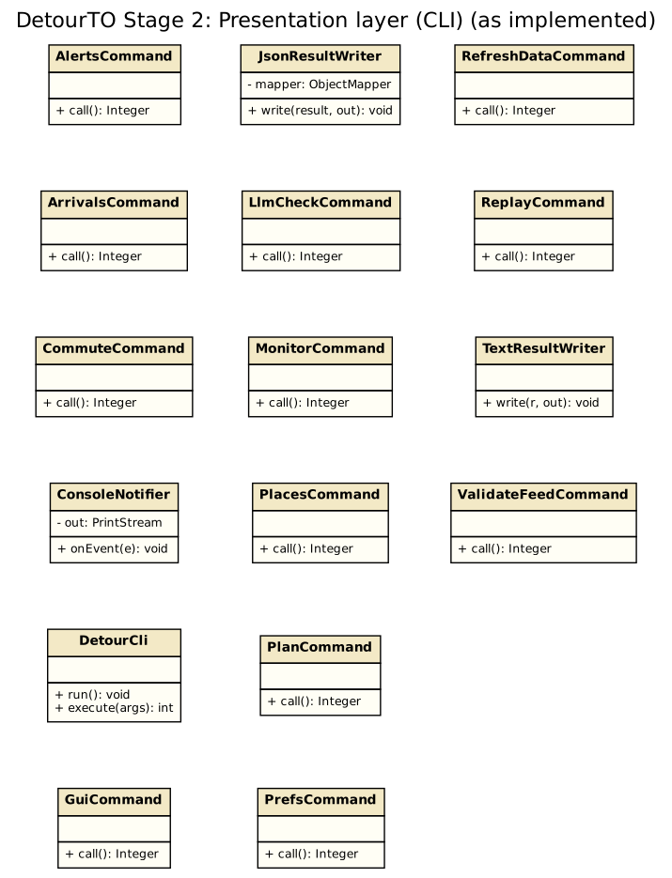
Presentation layer (CLI)
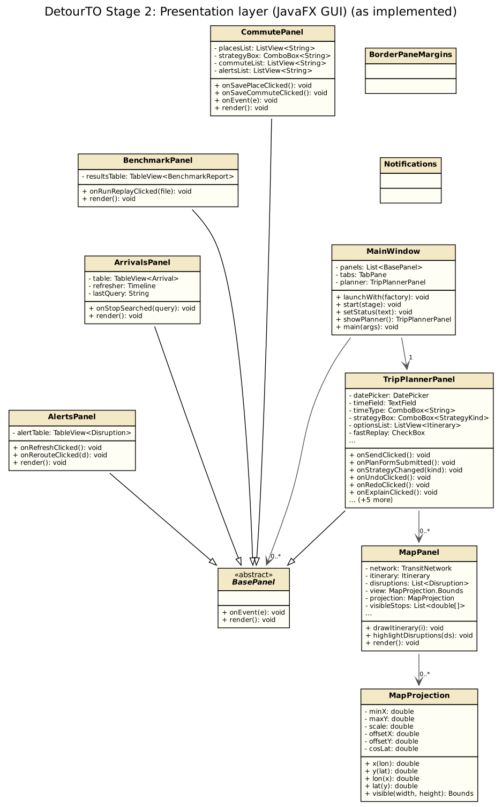
Presentation layer (JavaFX GUI)
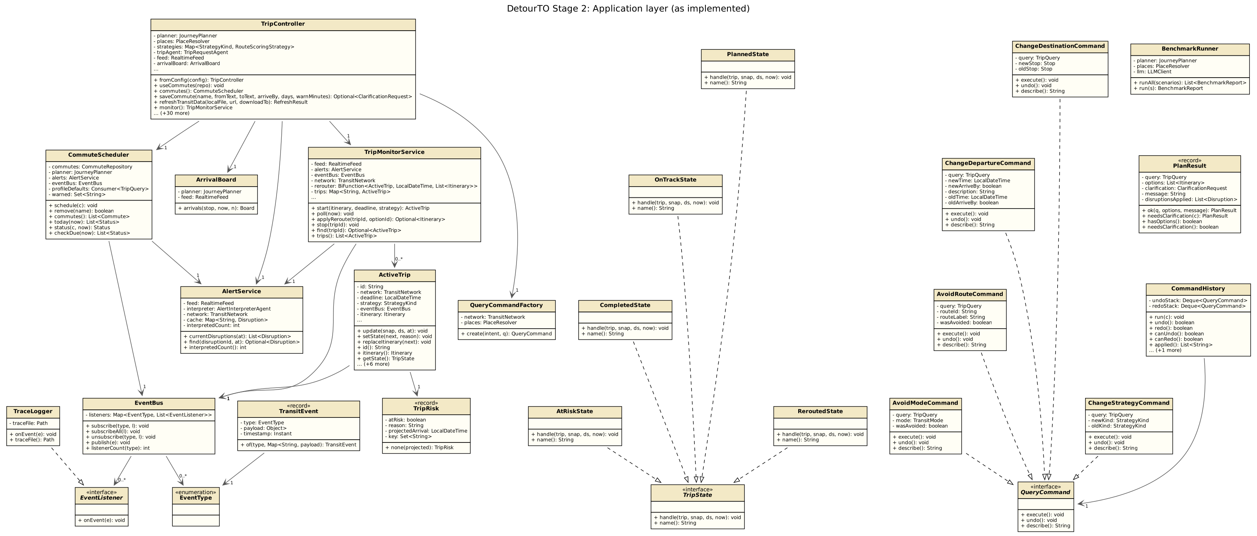
Application layer
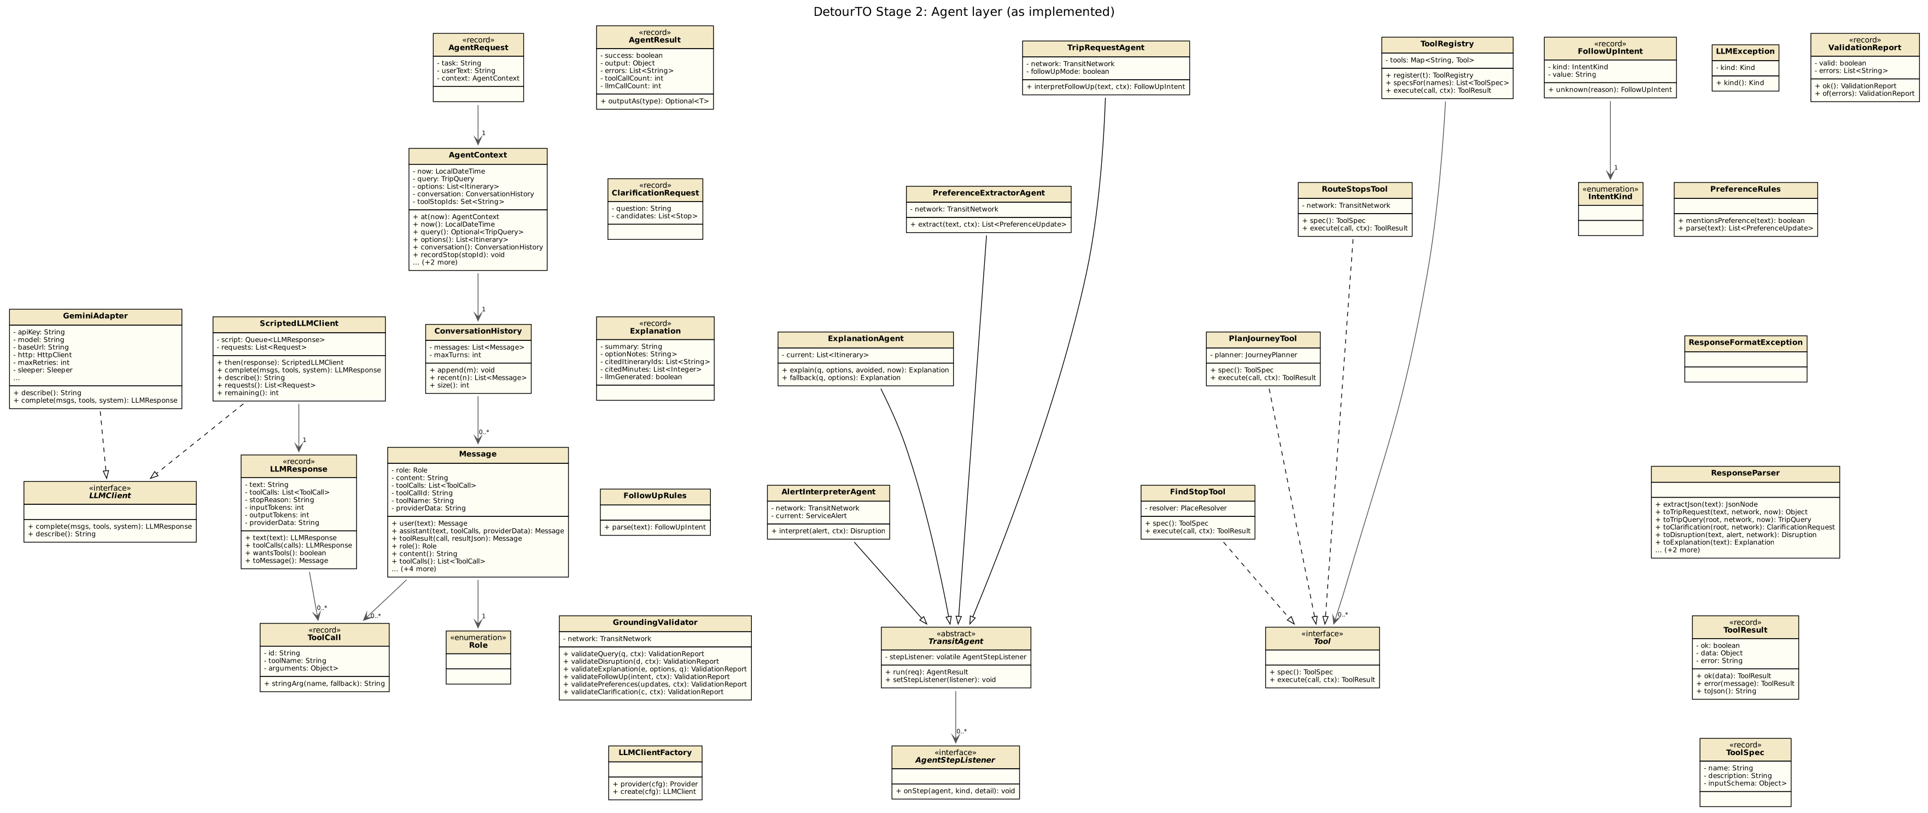
Agent layer
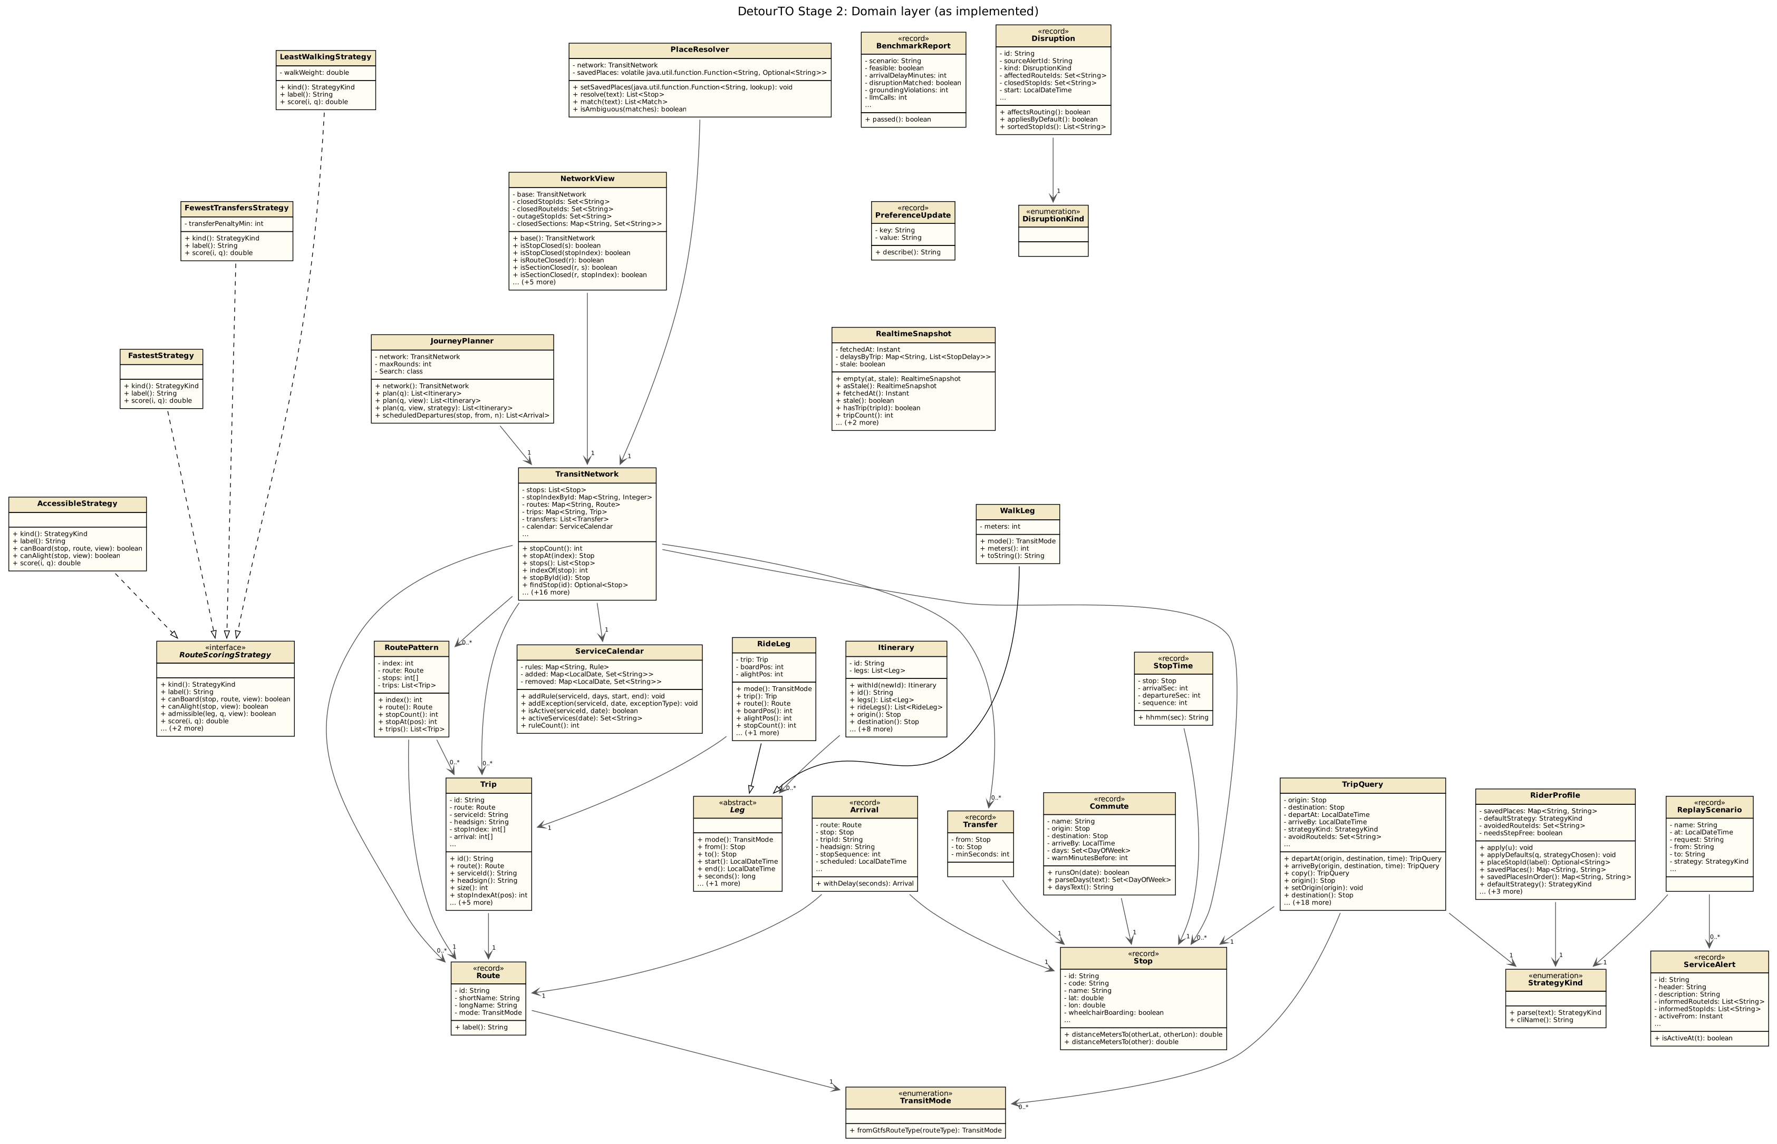
Domain layer
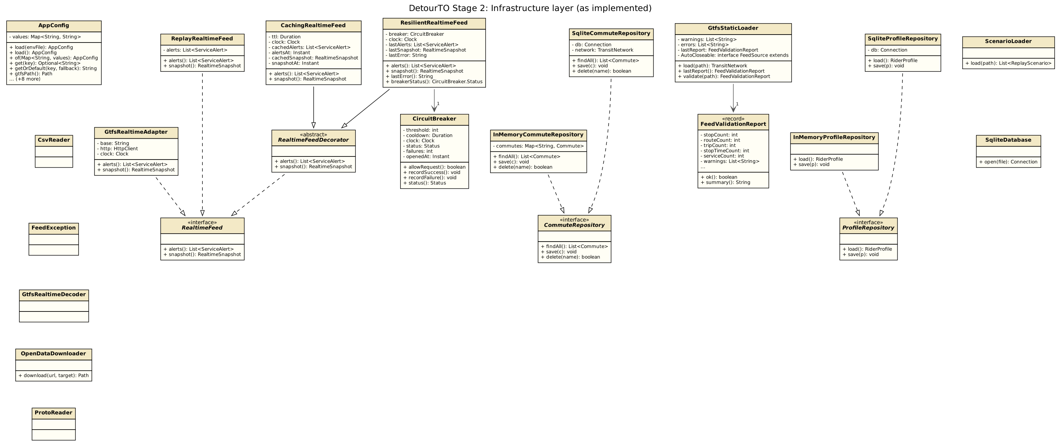
Infrastructure layer

